DRIVERS WEEKLY JOURNEY LOG & CHECK LIST
(Return to Line Manager at end of week)

Vehicle Name/Type ___________________ Vehicle Registration ________________ Department _______________________

Fuel Card No _______________________ Fuel Type Diesel/Petrol/Electric/Other Mileage ___________________________

ALL VEHICLE USE MUST BE FOR APPROVED UNIVERSITY BUSINESS ONLY

Date | Time |  | Mileage |  | Journey Details | Fuel In (Litres) | Driver |  | Daily Check Complete
 | Start | End | Start | End |  |  | Name | Signature

Daily Checks - All lights working; Tyres safe and legal; Windscreen undamaged and clear to drive; Bodywork and trim secure; Tail lifts, refrigeration, winches etc operate effectively.
The following vehicle checks are to be undertaken on a weekly basis for use of the first working day.

Date of Check: ___________________________ Name: ______________________________________________

Mark each item as: Satisfactory X Defective/Missing N/A Not Applicable

Fluids |  | Lights/Electric |  | External Condition |  | Internal Condition
Engine Oil |  | Indicators |  | Door/Wing Mirrors |  | Seat Belts
Brake |  | Side Lights |  | Wiper Blades |  | First Aid Kit
Clutch |  | Headlights (Dipped) |  | Screen Washers |  | Fire Extinguisher
Power Steering |  | Headlights (Main) |  | Tyre Pressure |  | Head Restraint Adjustment
Auto Transmission |  | Number Plate |  | Tyre Wear |  | Torch
Screen Wash |  | Reversing |  | Tyre Damage |  | Warning Triangle
Fuel (Min ¼ full) |  | Warning Lights |  | Spare Wheel |  | General Bodywork
Coolant |  | Horn |  | Cleanliness of number plate, windows, lights |  | Road Fund Licence
 |  | Windscreen Wipers |  | Security of roof-rack, tail lift, winch, refrigeration etc |  | A copy of the ‘Motor Incident Report Form’
 |  | Battery |  | Door Locking

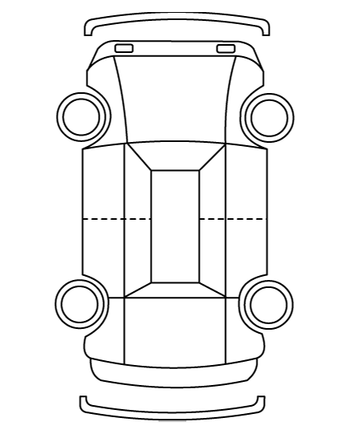
Comments: Damage noted, repairs due etc
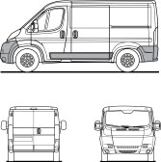
Mark on diagram any damage and date noted

