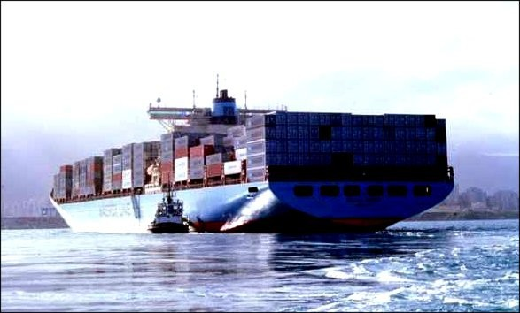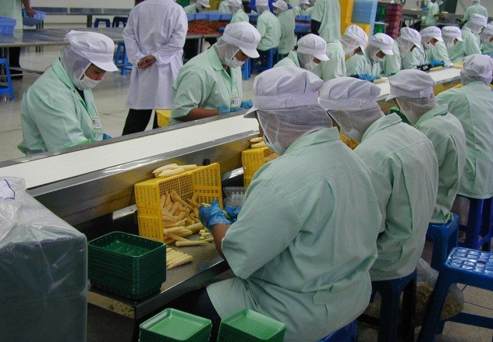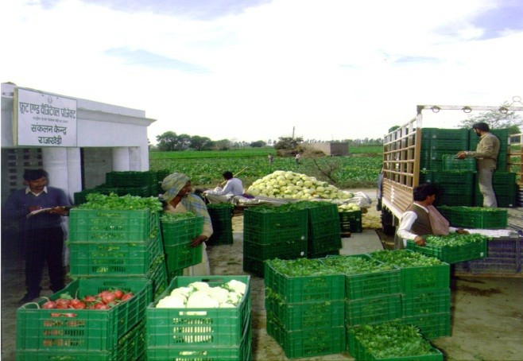

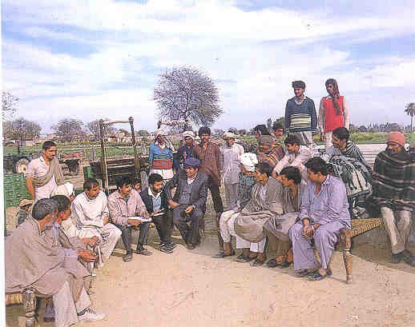

Value Chain: Concept, history and approaches

for

socio-economic and policy analysis

Jean Balié, FAO

International agricultural seminar: The value chain approach.

*Collectif Stratégies Alimentaires (CSA),* 27 November 2013, Brussels

Outline

*1.*

*2.*

*What is a value chain?*

*What is the history / background of this concept?*

*3.*

*What*

*is*

*the*

*relationship*

*between*

*the value*

*producers and other agents in*

*chain really about?*

*Value chain analysis for what?*

*4.*

*Why such*

*interest for value chain-based policies and*

*investment programmes?*

*5.*

*So*

*what*

*?*

*Is*

*value*

*chain*

*analysis*

*the*

*solution for better policy making?*





A value chain is a portion of an economic system where upstream agents

(producers)

are

linked

to

downstream

partners

by

technical,

economic,

territorial, institutional and social relationships.

Producers Country

Collectors

Processors

Exporters/

Wholesalers Importers

Retailers

Consumers

Border

**International Market**

What is a value chain ?

History of value chain

•

•

**Value chain concept**: Michael Porter, 1980s

**Anglophone**: concept of Global Commodity Chains (Gereffi, 1990 s)

→ linking households, enterprises and states to one another within the world economy

**Francophone**: concept of “Filière” (INRA/CIRAD, 1960s)

→ meso-economy; interdependence; technical and technological changes along the chain (Morvan, 1985)

**3 main types of analysis** :

•

•

* Technical / physical
* Economic / financial
* Organizational / institutional

and/or

and/or



Incentives and Governance

Product flow

Financial/economic flows

Information flow

Sale

Processing

Product/Production

Inputs

Critical dimensions in a value chain

Understand how a portion of the

economic system works and could better

work.

Identify the role of the government and

related policy options.

Quantify in physical/monetary terms

the likely impacts of policy options.

Monitor/assess value chain

performances

**VCA dimensions:** Qualitative – quantitative Physical - monetary Private - Public Economic – social Economic-environmental Short - long term

Ex-ante – monitoring

Exhaustive -complementary

Why Value Chain Analysis (VCA) is important for policy-making?

**Comparative Analysis (WiP-WoP)**

**Scenario with policy (WiP)**

**Indicators with policy (WiP)**

**Base Scenario (WoP)**

**Reference Indicators (WoP)**

**Policy Options’ impacts?**

**Policy Options**

**Development Objectives**

Quantitative VCA for policy making: counterfactual analysis

**Qualitative:** assessing in qualitative terms selected VC features, e.g. *“five*

*forces*” (bargaining power of suppliers and customers .....) or the “*diamond*” elements (production factors’ conditions, rivalry stimulating innovation. )

(Porter 1985,1990)

**Quantitative**: assessing in quantitative terms selected dimension above,

possibly building multi-criteria indicators,

Building ***consistent accounting frameworks*** in both physical quantities and monetary terms, encompassing all the value chain’s layers and providing ***consolidated*** accounts of the whole value chain under different ***policy-relevant scenarios for counterfactual analysis***

Qualitative versus quantitative VCA

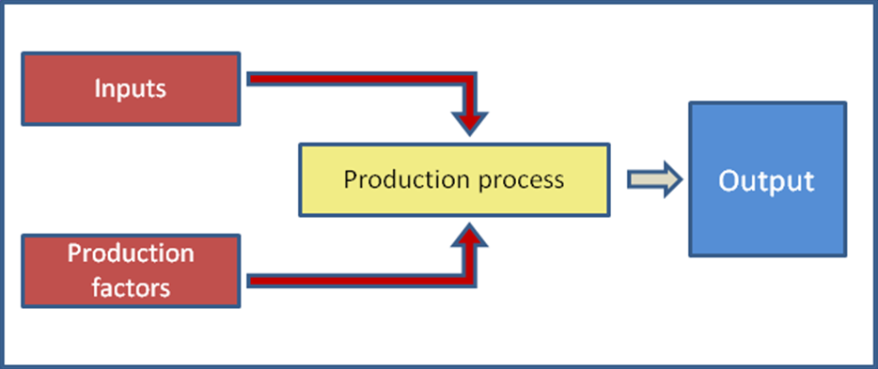

**Physical:** measuring input-output relationships for each upstream-

downstream pair of layers in physical terms to ensure consistency of physical flows along the chain (“*calibrated*” value chains)

**Monetary:** appraise revenues, costs and margins (value added net benefits)

of each activity, each agent, segments of the value chain and the whole value

chain, using specific sets of prices for inputs, production factors and outputs.

Physical versus monetary VCA

**Private perspective**. Agents engage in VC activities only if they see an interest

(monetary or non monetary). In VCA, values, as perceived by private agents are expressed in terms of “***market prices***”.

**Public perspective**. The government (the society) promotes VCs through

public policies only if they increase social welfare. In VCA, social values

are expressed in terms of “***reference prices***”.

VCA is carried out both at “*market*” and “*reference*” prices, to provide decision makers and other stakeholders with ***anticipated evidence*** on both ***social and private net benefits*** brought by a specific policy measure.

Private versus public perspective in VCA

**Economic perspective**. How much value is generated by a given VC? To what

extent a specific policy measure aimed at favouring that VC is likely to increase the GDP? Which policy measures favour a more efficient use of (scarce) domestic resources?

**Social perspective**. Which layers of the society benefit from a specific policy measure? Is that policy measure likely to improve food security and/or reduce poverty? To what extent women (smallholders, children etc) benefit from that policy?

Through disaggregate accounts for specific social categories, VCA helps investigating policy-induced changes in goods/income available to them. Through account aggregation and consolidation instead, VCA provides anticipated evidence on overall value added changes.

Economic versus social perspective in VCA

•

How do we know if producer are receiving incentives to

produce? Consumers to consumer? Traders to trade? Comparing social and private net benefits signals whether private agents in a specific VC are supported or penalized? Are agents receiving **public transfers** which **protect** them from (domestic or international) competition ? (or vice versa To which extent does a specific policy measure alter incentives ? provide protection?

•

•

•

•

The **Policy Analysis Matrices (PAMs): a tool** to analyze

information on VC through indicators on profitability, value added, transfers and protection (Monke and Pearson, 1989) **Cost-Benefit Analysis of public polices**

•

Incentives and disincentives in VCA

**Country**

**Year**

**Value chain**

**Policy measure**

***Burkina Faso***

***2010***

***2010***

***2007***

***Rice***

increase the use of HQ seeds and extension of the rice- growing area

***Fisheries***

increase the purchase of fish eggs and ehance the human capital through specialized trainings to the fishermen

***Firewood***

improve the management and productivity of the

forests

***Kenya***

***2009***

***Sugarcane***

increase the number of the extension agents

***2009***

***Cotton***

increase the use of HQ seeds through subsidies

***2009***

***Mango***

establishment of producer marketing organizations (collective marketing) - input at lower prices

***Nigeria***

***2013***

***Cassava***

Baseline only

***Ecuador***

***2013***

***Bananas***

Conventional scenario / Organic scenario

***Syria***

***2010***

***2010***

***2010***

***2010***

***Fisheries***

no policies

***Cotton***

re-introduction of the cotton seeds in the chain

***Potatoes***

Baseline only

***Haricot***

Baseline only

VCA : country examples of policy measures...

Limits: Accounting framework, partial, comparative static analyses only. Complementarities:

**4.Computable General Equilibrium (CGE)**

**8. Macro-micro integrated approach (Extended CGE)**

**7. Social Accounting Matrix (SAM) multipl.**

**3. Multi-Market equilibrium Models (MMM)**

**Policy impact analysis**

**2. Partial Equilibrium Analysis (PEA)**

**6. Accounting chain frameworks (Value Chain Analysis- VCA)**

**5. Multi-period of Cost- Benefit Analysis (CBA)**

**1. Micro-accounting approaches**

VCA for policy making: limits and complementarities

THANK YOU!

The End

Panel A: Base scenario: inefficient activity

Panel B: Policy option 1 reduction of input costs and increase of factor use

Panel C: Policy option 2 increase of input cost and decrease of factor use

REVENUES

COSTS

PROFITS

Tradable Inputs

Domestic Factors

At market prices

2000

1500

400

100

60

40

At reference prices

1800

1600

140

Wedges

200

-100

260

REVENUES

COSTS

PROFITS

Tradable Inputs

Domestic Factors

At market prices

2000

1100

800

100

250

-150

At reference prices

2100

1050

800

Wedges

-100

50

0

REVENUES

COSTS

PROFITS

Tradable Inputs

Domestic Factors

At market prices

2000

1300

700

0

-50

50

At reference prices

1900

1250

700

Wedges

100

50

0

Policy Analysis Matrices under different policy scenarios

**Expanded Policy Analysis Matrices (PAMs)** (Monke and Pearson, 1989):

Total Wedges = effects of policy and market failures + effects of policies for efficiency

Indicator

Acronym

Base scenario

Policy option 1 Factor intensive technology

Policy option 2 Input intensive technology

Private Cost Ratio

PCR

1.00

0.89

0.80

Private Value Added Ratio

PVAR

0.35

0.45

0.25

Domestic Resource Cost Ratio

DRC

1.08

0.76

0.70

Social Value Added Ratio

SVAR

0.34

0.50

0.11

Nominal Protection Coefficient on Outputs

NPCO

1.05

0.95

1.11

Nominal Protection Coefficient on Inputs

NPCI

1.04

1.05

0.94

Effective Protection Coefficient

EPC

1.08

0.86

2.50

Domestic Factors Ratio

DOFAR

1.00

1.00

0.86

Subsidy Ratio to Private Agents

SURPA

0.026

-0.071

0.022

PAM-based indicators