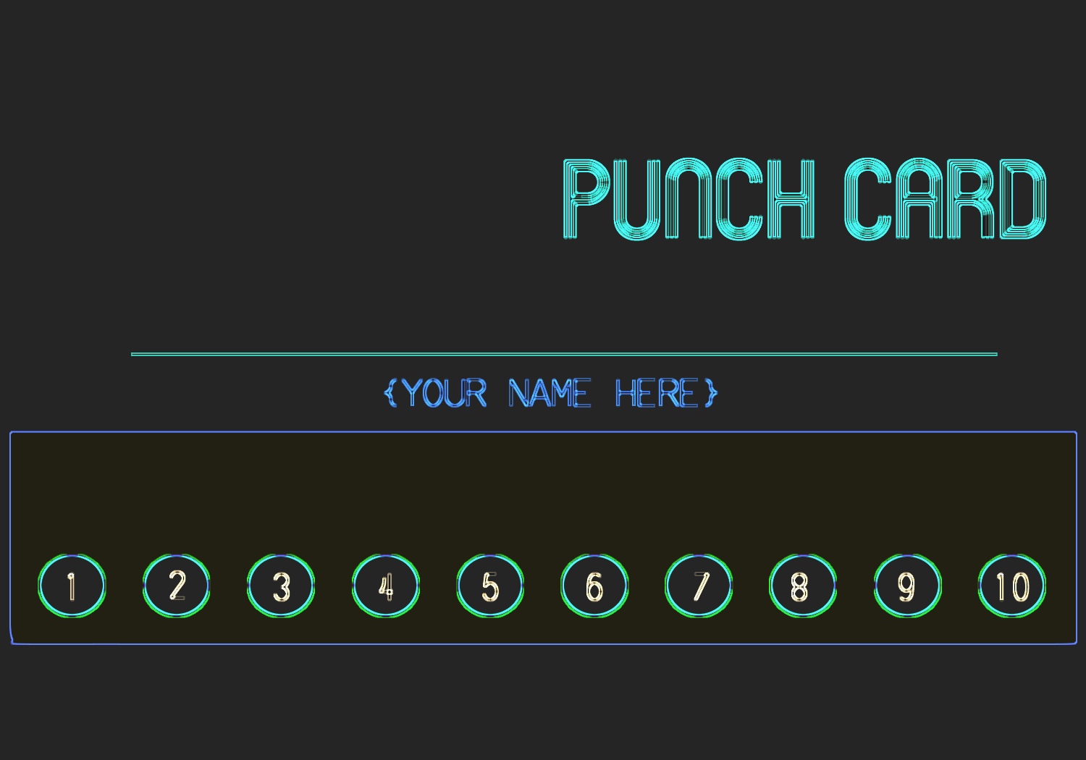

Address: Street, City Phone# 123456798

Logo here