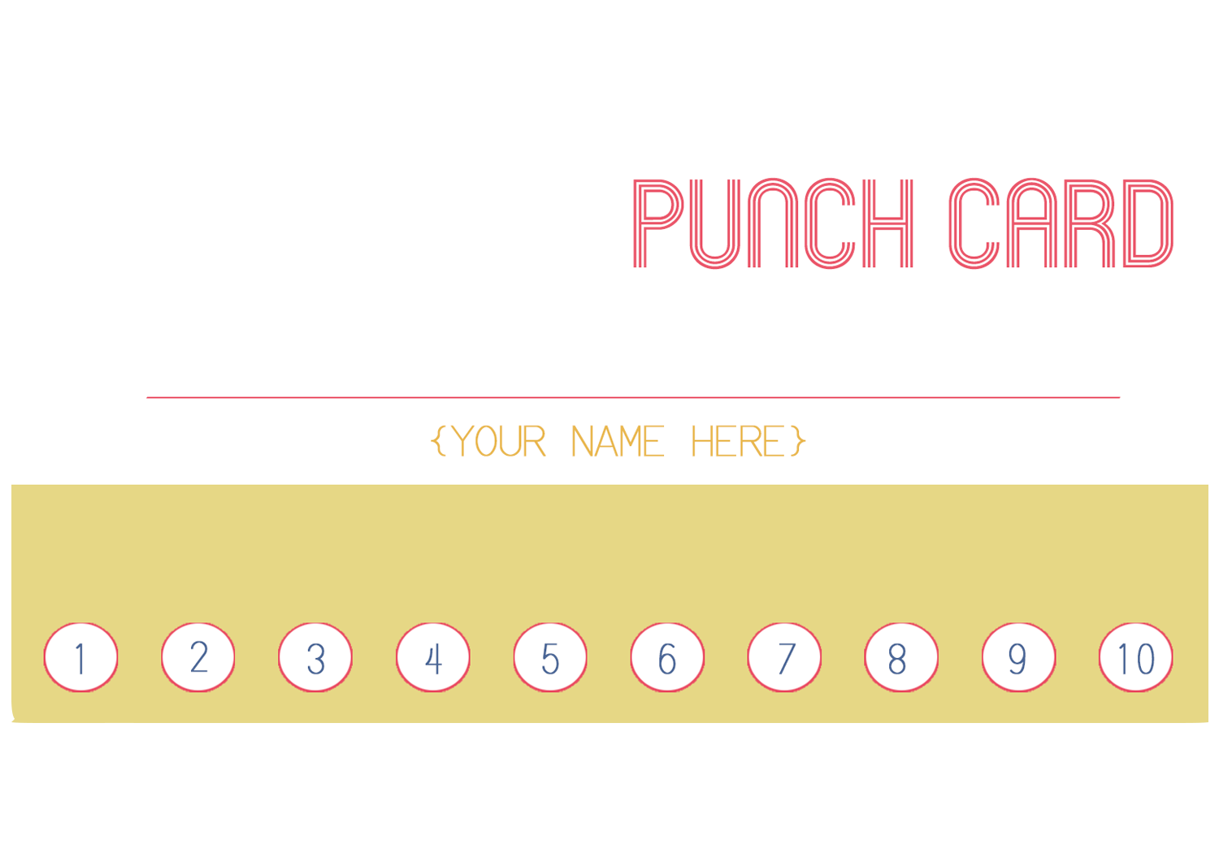

Surprise awaits after a 10th punch

Name here