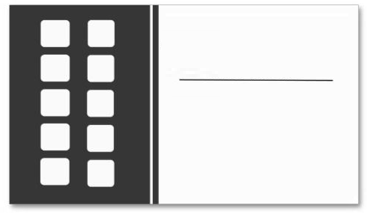

Product Profiles

Buy One & Get One Free

**FREE**

**LOGO**

**LOGO**

**LOGO**

**LOGO**

**LOGO**

**LOGO**

**LOGO**

**LOGO**

**FREE**