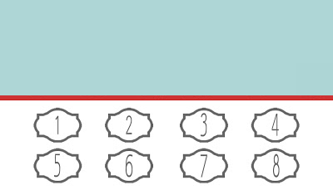

Company Name

Buy One & Get One Free

Address: Street, City Phone# 123456789