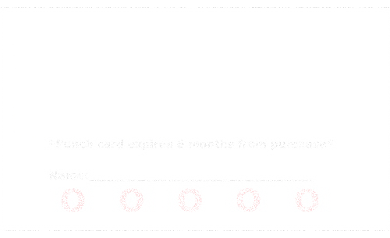

Company Name

Your Title

Address|Phone|e-mail