Acknowledgment

We thi e family of the late Celestine E. Bond wish to express our sincere loving thanks and appreciation for the many acts of kindness and love shown to us during this time of bereavement. May God bless and keep each of you in his tender loving care.

Sincerely, the Family
.

Pallbearers

Lamont Johnson Johnny McArthur Frank Smith
Jonathan Morgan Dray Clark Damon Rawls

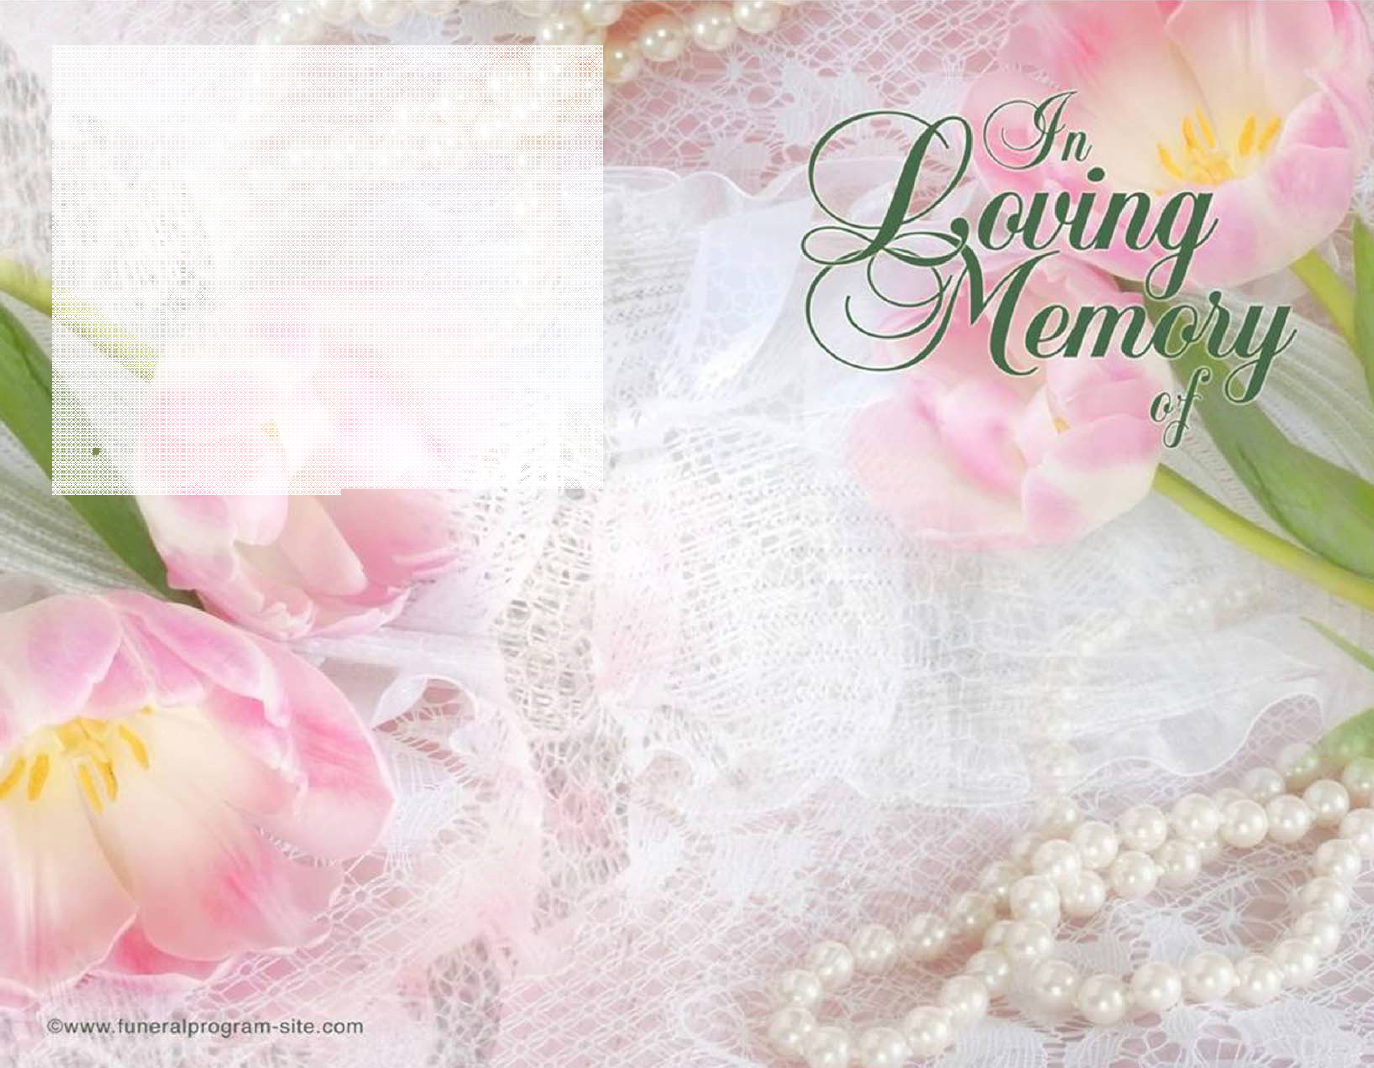
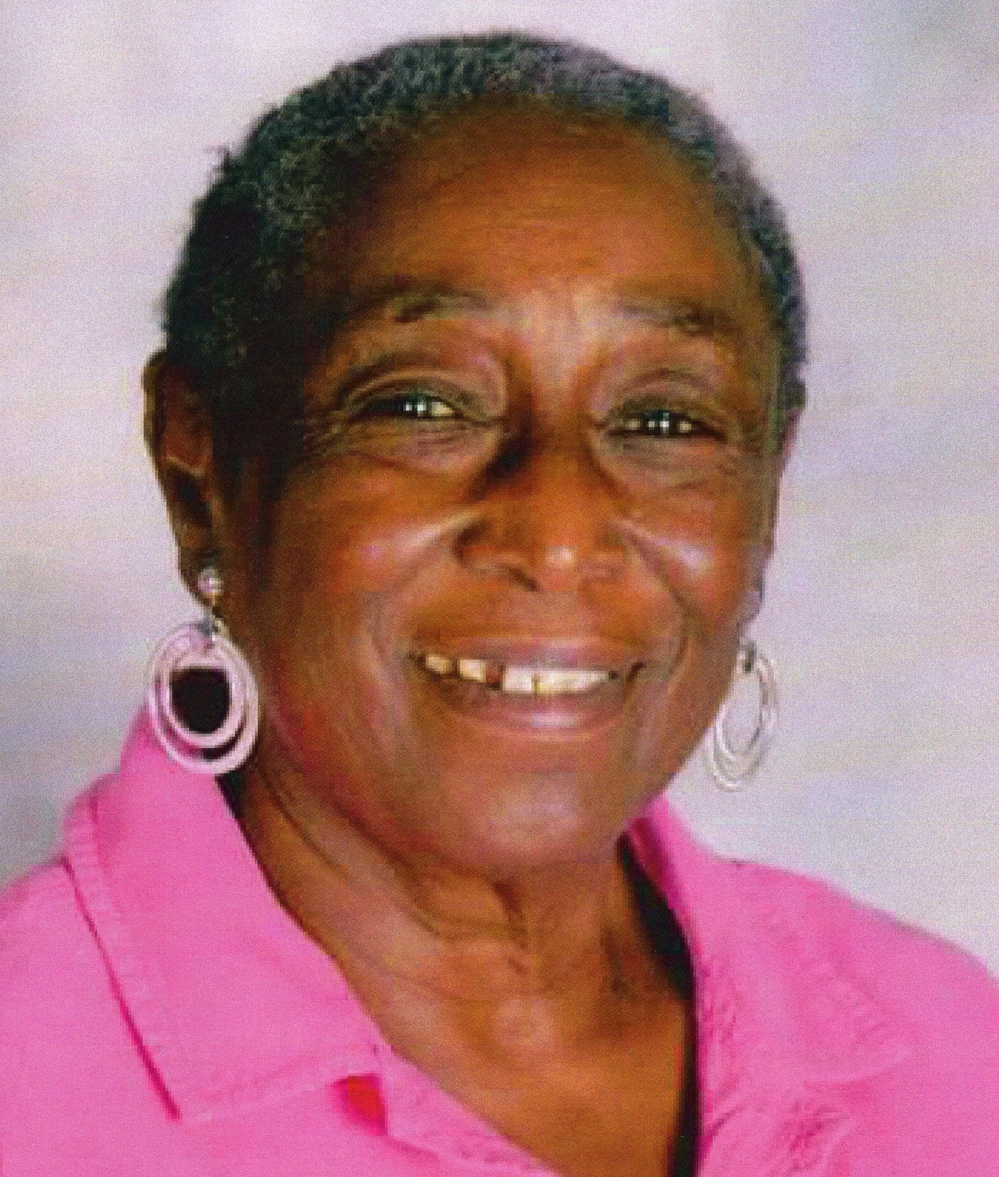
Forget me not, and think of me,the times I made you smile,
Forget me not but don't be sad, I'm. with you all the while
Forget me not when you're in need and feel that no-one's there
Remember that I"m still around, I'm here, I love you, I care***Mary JNC

Arrangements
Hunt Irving Funeral Home 925 Pusey Street
Chester, Pa 19013
Raphael M. Hunt Irving, LFD Proprietor

Celestine E Bond
Sunrise: August 2, 1941
Sunset: September 30, 2016
October 8, 2016 at 10:00 a.m.
Hunt Irving Funeral Home
925 Pusey Street
Chester, Pa 19013

OFFICIANT MINISTER, LAURESE GUY DALE
FIRST PENTECOSTAL HOLY CHURCH
324 Pusey St
Chester, Pa 19013

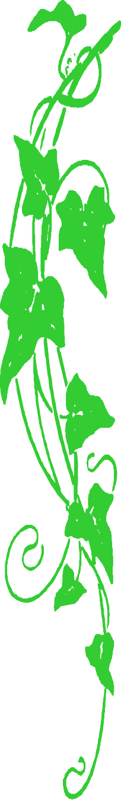

Order of Service

Musical Prelude Delores Jennings

Processional Clergy & Family
Final Viewing. Funeral
Director
Opening Hymn
Prayer of Comfort. Wayne Guy
Scripture Reading. Wayne Guy &
Yolanda Jefferson
Old Testament Psalm 23:1-6

New Testament Romans 8:31-39
Acknowledgments, Resolutions, & Reading of Obituary. Ralph (Chuckie)
Guy

Musical Selection
"It's So Hard To Say Good Bye" Shieem
Green
Eulogy
Minister Laurease Guy Dale
Recessional
Interment
Edgewood Memorial Park 325 Baltimore Pike Glen Mills, Pa 19342
Obituary

CELESTINE BOND (TINE) WAS BORN IN CHESTER, PA ON AUGUST 2, 1941 TO THE LATE IRMA GUY JOHNSON AND CLIFFORD BOND, SR.

CELESTINE WAS RAISED BY BOTH HER MATERNAL GRANDMOTHER (HELEN GUY) AND PATERNAL GRANDMOTHER (ELIZABETH BOND). CELESTINE HAD A SPECIAL RELATIONSHIP WITH HER GRANDMOM LIZZIE. SHE ALSO LOVED HER DOGS WHISKER, PEPE, SASHA, AND DRIZZAL THEY WERE HER CHILDREN.

CELESTINE WAS A FORMER MEMBER OF ST. PAUL’S CME CHURCH, CHESTER, PA WHERE SHE WAS BAPTISE AND ATTENDED THE CHURCH FOR MANY YEARS.

CELESTINE GRADUATED FROM CHESTER HIGH SCHOOL IN 1960. AFTER ATTENDING NURSING SCHOOL, SHE WORKED AS A LPN AT CHESTER HOSPITAL.

CELESTINE HELD SEVERAL JOBS IN HER LIFETIME BUT HER MOST REWARDING JOB WAS AT THE STEVENSON DAYCARE AS A FOSTER GRANDPARENT.

CELESTINE LIVED IN MANY CITIES SUCH AS CHICAGO, MINNESOTA, AND DELAWARE TO NAME A FEW AND WHERE EVER SHE WAS, SHE ENJOYED HER FAMILY AND FRIENDS. HER QUOTE “I ENJOYED MY LIFE AND THE WORLD DON’T OWE ME NOTHING”.

CELESTINE IS PRECEDEDED IN DEATH BY 1 SISTER, OLIVIA L. JOHNSON AND 1 BROTHER, BARRY BOND

SHE LEAVES TO CHERISH HER LOVE AND MEMORIES; 3 BROTHERS OLIVER JOHNSON, DANE BOND OF CHESTER, PA, CLIFFORD BOND, JR OF NORTH CAROLINA. 4 SISTERS VALERIE JEFFERSON, BARBARA GREEN WILSON (KEVIN), CHESTER, PA, CHARLENE WILLIAMS, WILLOW GROVE, PA AND EVOLA JOHNSON OF UPLAND, PA. A DEAR AND LOVING FRIEND, JUDY GURECKI; HER NIECE AND CAREGIVER, LISA MCARTHUR (JOHN) 1 UNCLE, WAYNE GUY (JAN), 1 AUNT, MARVA BOND SMITH.
THE FAMILY

