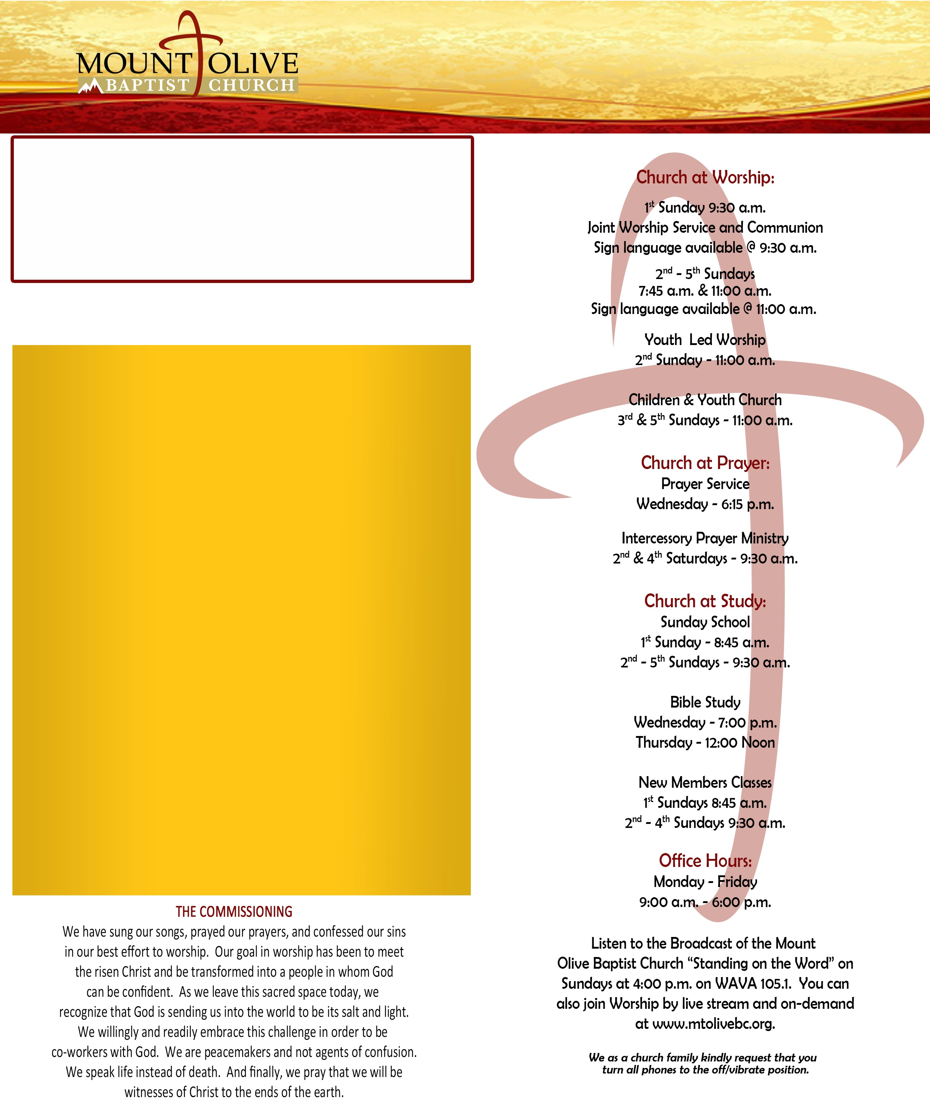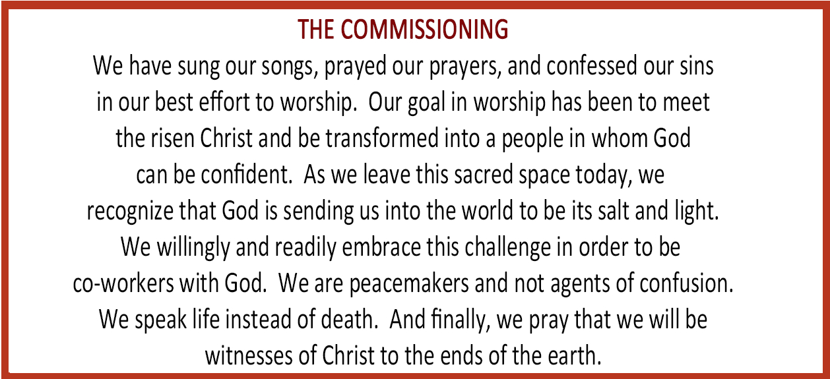

“An inclusive family of believers committed to growth in and spread of the gospel of Jesus Christ showing unity and Christian love in action by reaching out to our immediate community and beyond.”

**1601 South 13th Road Arlington VA 22204**

**WELCOME!**

It is our sincere prayer that something said or done today will be an

inspiration and a blessing to you. If you are searching for a church home, we encourage you to seek God in prayer and ask if this is where you should join. After service today, we invite you to our Welcome Center where we can greet you personally. We thank God for you and hope you

will worship with us again.

Being and Becoming An Acts 2 Church

Order of Service

7:45 a.m. & 11:00 a.m. June 30, 2019 PRAISE & WORSHIP

GREETINGS

THE WORD READ

Colossians 4: 2-5

**THE WORD SUNG**

“To Worship, Work and Witness” *(see insert)*

PRAYER CELEBRATION IN WORSHIP

THE WORD PREACHED

Sermon: “The Missionary Imperative” Sermon Text: Matthew 28: 16-18

**Rev. Dr. James E. Victor, Jr.** INVITATION & PRAYER WORSHIP THROUGH GIVING COMMUNITY NEWS

THE BENEDICTION

Rev. Dr. James E. Victor, Jr., Pastor

(703) 920-7293 Office (703) 920-5268 Fax

[www.mtolivebc.org](http://www.mtolivebc.org/)



**“An inclusive family of believers committed to growth in and spread of the gospel of Jesus Christ showing unity and Christian love in action by reaching out to our immediate community and beyond.”**

**1601 South 13th Road Arlington VA 22204**

**Mount Olive Announcements**

**BEING & BECOMING AN**

**Dance Ministry**

Have you ever wanted to express your love for God through movement? Join Mt. Olive's own Grace in Motion at their "Shifting the Vibe" workshop. The workshop will be held on Friday, August 16th from 7 p.m. to 9 p.m. and Saturday August 17th from 9 a.m. to 6 p.m. The workshop will culminate in a worship celebration on Sunday August 18th during the 9:30 a.m. worship service. Come learn about movement through emotion and technique. All dance levels are welcome and ages 8 to adult. Sign-ups are happening now and space is limited, so don't wait! All participants must register via Eventbrite at [https://www.eventbrite.com/e/shifting-the-vibe-ti](http://www.eventbrite.com/e/shifting-the-vibe-ti) **ckets-63938953130** or see the church website for more information.

**Radical Hospitality Interest Groups**

Mount Olive seeks to Be and Become an Acts 2 Church through radical hospitality. As we explored Radical Hospitality during our last Bible Study series, we identified four areas where we may extend greater hospitality to our guests and to those seeking God. Those areas are our website, proper signage, greeters ministry and the welcome center. So that we might begin working on these areas, we are enlisting members to join one of the interest groups to help us become a more welcoming church community. If you attended the Bible Study series on Radical Hospitality or the workshop held on May 29th please contact Rev. Sabra Jones at 703-920-7293 ext. 238 or by email at [sjones@mtolivebc.org.](mailto:sjones@mtolivebc.org) If you were not at the session and want to participate, please contact Rev. Jones as well. We are being and becoming an Act 2 Church and that means welcoming the stranger among us!

**Quarterly Church Board Meeting**

The next Quarterly Church Board Meeting is scheduled for Tuesday, July 9th at 7 p.m. in the Music Room.

**Church Closed**

In observance of the Independence Day Holiday, all church facilities will be closed on Thursday July 4th, 2019. The Thursday Mid-day bible study will not be held this week.

**Church Family Pictorial Directory**

Mt Olive is producing a Church Family Pictorial Directory. All members are encouraged to “Be Included” in this project. Photo sessions will be held July 9th – July 13th and July 30th - August 3rd at Mt Olive. As our thank you gift; each family will receive one free 8 x 10 portrait. We are also partnering with Lifetouch to expand our Hoffman-Boston Backpack program. For your donation of a box of “Chewy” Brand granola bars and a carton of 6.75oz “NO SUGAR ADDED” Apple Juice boxes, you will receive a discount coupon to use for purchasing additional photos. Your donation will help by reducing the cost per backpack. Scheduling for the photo sessions is available on the church website.

**The MOBC Nursery**

The MOBC Nursery is available during the 9:30

a.m. worship service on 1st Sundays and 11:00

a.m. worship on other Sundays. The nursery is designed for infants to kindergartners, as it is never too early to begin fostering your child’s spiritual growth. For your convenience, you may pre-register your youth by visiting the Church website, [www.mtolivebc.org.](http://www.mtolivebc.org/)

**ACTS 2 CHURCH**

**Bible Reading Plan**

Monday Tuesday Wednesday Thursday Friday Saturday

Is 22-24

Is 25-27

Is 28-30

Is 31-33

Is 33-36

Is 37-39

Ps 83

Ps 84

Ps 85

Ps 86

Ps 87

Ps 88

**Child Safety Training**

New Child Safety Training program sessions for

2019 Spring/Summer have been scheduled for the

following dates: Monday, July 1st at 7:00 p.m. in the Welcome Center and Saturday July at 9:00 a.m. in the Music Room. You may register by visiting the church website [www.mtolivebc.org.](http://www.mtolivebc.org/) For additional information please contact Trustee Minnie Milliner at [reds333@comcast.net](mailto:reds333@comcast.net) or Rev. Sabra Jones at 703-920-7293 ext. 238 and [sjones@mtolivebc.org.](mailto:sjones@mtolivebc.org)

**Whooosh! VBS 2019**

Registration is now open for VACATION BIBLE SCHOOL, “Whooosh! Take Flight to Where God Leads You!” VBS 2019 will be held from Sunday, July 14 to Friday, July 19. This year’s VBS celebrates how throughout the Bible, monuments are built to remember what God has done in the lives of God's people. Register online at [www.mtolivebc.org](http://www.mtolivebc.org/) or return a completed registration form to the church office. There will be a VBS representative in the Welcome Center immediately after 11:00 a.m. service to assist with VBS registration.

6th

Rev. Dr. James E. Victor, Jr., Pastor (703) 920-7293 Office (703) 920-5268 Fax

[www.mtolivebc.org](http://www.mtolivebc.org/)