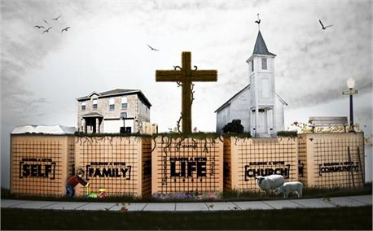

FAITH CHAPEL
Seattle

A Place to Share God’s Word, Faith, Family Life & Fellowship

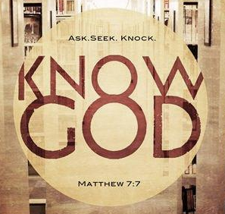
Sunday Services
Sunday School (Ages 5-17) 10:00 AM
Sunday Bible Class (Adults) 10:00 AM
Morning Worship 11:00 AM

Mid-Week Services
Wednesday Bible Study 7:00 PM
Wednesday Youth Bible Study 7:00 PM
Thursday Leadership Training 6:00 PM

Blessed Baby Nursery
Sunday (0-4 Years Old) 9:30 AM
Wednesday (0-4 Years Old) 6:30 PM

Leadership & Involvement
Thursday 6:00 PM
Thank You!
We’re glad you joined us today! We pray that you will experience God’s presence as we share the wisdom found in His Word.

Get involved and serve at FAITH CHAPEL!
We meet to learn Biblical principles for serving others. Call (206) 351-1997 for more info.

“For even the Son of Man did not come to be served, but to serve, and give His life a ransom for many.” Mark 10:45

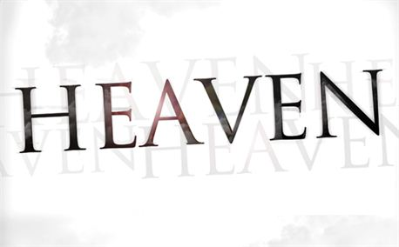
Ministries At A Glance . . .

FAITH CHAPEL Seattle has a variety
of ministries designed to encourage
motive & inspire! Contact our ministry
leaders for information about being
apart of these opportunities to serve!

Real Marriage
Biblical Principals
Come and learn more about God’s plan for your marriage. Engaged, Newlyweds and all Married Couple are encouraged to attend. Contact Mary Wells for more info.

Blessed Baby Nursery (BBN)
Available Sundays & Wednesdays

Blessed Baby Nursery is open 30 minutes before each service for your infant or toddler. Parents, please contact Karen Foss to learn more about BBN.

SENOIR SAGE Ministry
Our seniors need serve and need to be served. Doris Simmons leads a team of volunteers who provide visitation, meals and ministry for adults in the “golden years of life.”
Thriving Youth
Youth, Teens & Young Adults
FCS young people are full of life! Contact Brian Eldridge to find out about the exciting opportunities for faith in the lives of young people.

School of the Bible
New to faith in God? Come and learn about the grace of God in classes for new believers. Pastor Tim Raines shares the goodness of God through Bible teaching.
Prayer & Praise Teams
Pray & Praise God at FCS
Join our ministry prayer and praise teams and learn more about worshipping God! Tom & Alicia McMillan share a life of worship through prayer & praise to God.

Leadership & Involvement
Leadership & Involvement is a time of fellowship and learning for anyone who wants to serve at FAITH CHAPEL Seattle. Contact Mary Wells to find out more about serving others and sharing your faith.

May 27, 2012 Releasing Mistakes of the PAST
Psalm 37: 24 is one of many passages of the Bible that describes God’s grace for what we consider man’s mistakes.

“Though he fall, he shall not be utterly cast down; for the Lord upholds him with His hand.”

It’s been said that “to err is human,” and a part of the human condition. The Bible gives numerous examples of the errors of mankind. It seems that to be human, is at one time or another to miss the mark. Perhaps this is what causes us to pray and seek God‘s mercy.

“I tell you, he will give justice to them speedily. Nevertheless, when the Son of Man comes, will he find faith on earth?”
Luke 18:8

Sermon Notes

Pastor’s Perspective

FAITH CHAPEL Seattle believes that every person has purpose. It is a church for men, women, children, youth and seniors. We desire to serve married, single, divorced individuals and developing families.

We encourage service in our church and the community. We hope you will learn more about our ministries, worship with us and most of all, get involved!

Community Outreach 2012 Missions Trip

Saturday Seek Street Outreach “Follow Me” to the Tri-Cities
Feed the Homeless Outreach Seattle Summer Youth Mission
Ladies Fellowship Tea Seniors Ministering to Seniors
Men’s Fellowship Luncheon Single Moms Support Team

FCS Pastors & Staff Office Staff Prayer
Jim Morrison, Senior Pastor Mary Wells, Admin. Ministry Prayer Team
Phone: (206) 257-1657 Phone: (206) 390-2014 Phone: (206) 280-1930
E-Mail: senpastor@fcstl.org E-Mail: mwells@fcstl.org E-Mail: prayer@fcstl.org

Men’s Ministry Women’s Ministry Musicians & Praise Team
Timothy Raines, Associate Pastor Christine Raines, Admin. Tom & Alicia McMillan
Phone: (206) 305-2020 Phone: (206) 390-2014 Phone: (206) 280-1624
E-Mail: assocpastor@fcstl.org E-Mail: craines@fcstl.org E-Mail: praise@fcstl.org

Thriving Youth Ministry Blessed Baby Nursery Seniors Sage Ministry
Brian Eldridge, Youth Pastor Karen Foss, Childcare Doris Simmons
Phone: (206) 257-1657 Phone: (206) 650-232 Phone: (206) 280-1930
E-Mail: beyp@fcstl.org E-Mail: kfoss@fcstl.org E-Mail: dsimmons@fcstl.org

