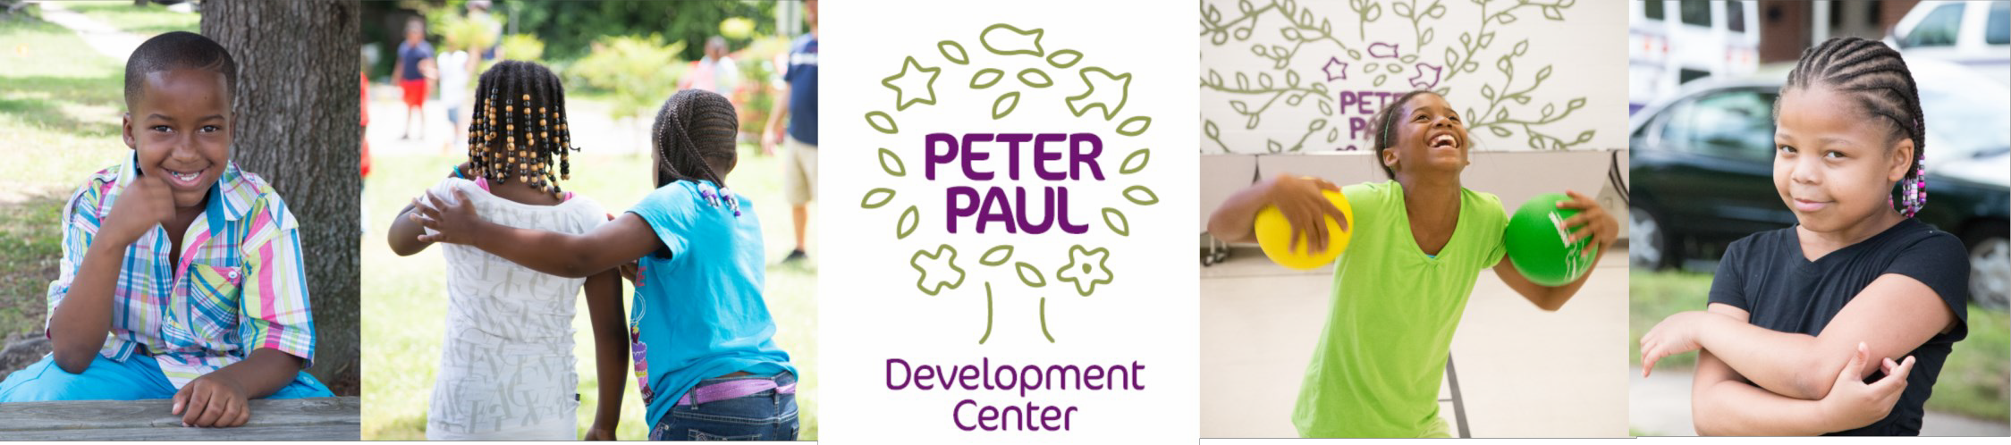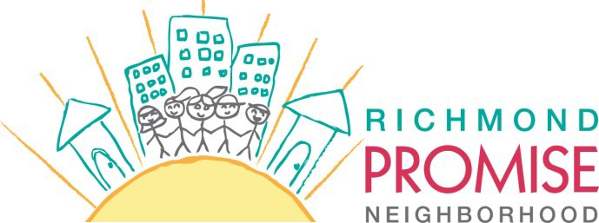

Back-to-School Block Party!

***Welcome the new school year and the newest member of the Peter Paul Family***

**Saturday, September 6 11:00 am—2:00 pm**

**Street in Front of Peter Paul Development Center**

(1708 North 22nd Street)

Rain Location: inside the Peter Paul Gym

Have you heard the news? Richmond Promise Neighborhood is joining the

Peter Paul family of programs! To celebrate our new addition and a new school year, we are throwing a block party for the East End and YOU and

your family are invited.

will be filled with:

On

**September**

**6,** the street in front of Peter Paul

* **Free Grilled Food**
* **Great Music and Dancing**
* **Family Activities**

**Back to School Resources**

**East End Families**

**Flu Vaccinations** (w/ proof of insurance)

•

•

•

***Join the fun! We have a lot to celebrate in the East End.***

To volunteer, please contact Michael at 757-784-8669

or [mparsons@peterpauldevcenter.org](mailto:mparsons@peterpauldevcenter.org)