

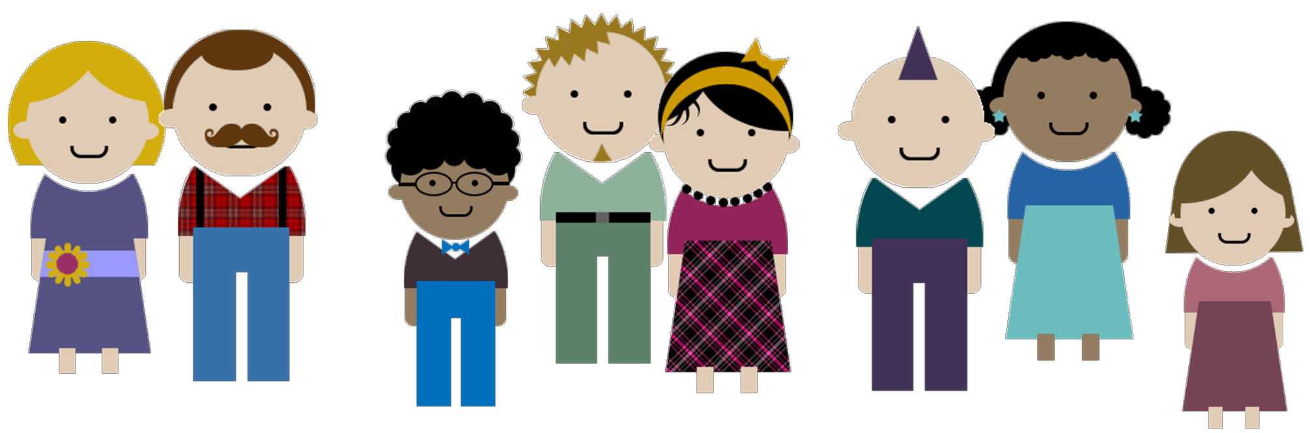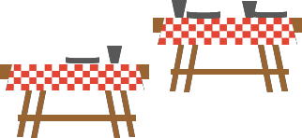

Come have some fun and meet your neighbours at our

**Date:**

**Time:**

**Place:**

**Your host is:**

To contact them, please call or, e-mail

**We are asking each family to bring:**

Chairs to sit on

Meat or vegetarian food to barbeque for your family

1 salad and 1 dessert to share (enough for 6-8 people) Beverages for your family (coffee and tea will be provided) Non-breakable plates, cups and cutlery for you family

Other

Please note: You are responsible for meeting any special dietary needs of family members

**In addition, do you have the following that could be used at the party?**

a barbeque

tables

chairs

**Pets**

are allowed

not allowed

Do you have a talent that you would like to share with us? Any suggestions for activities you could organize? Are you able to help with some of the set-up and/or clean-up?

*Please contact the host if any of the following pertain to you.*

***See you at the party!***

21

The City of Lethbridge Neighbourhood Block Party Planning Guide



24

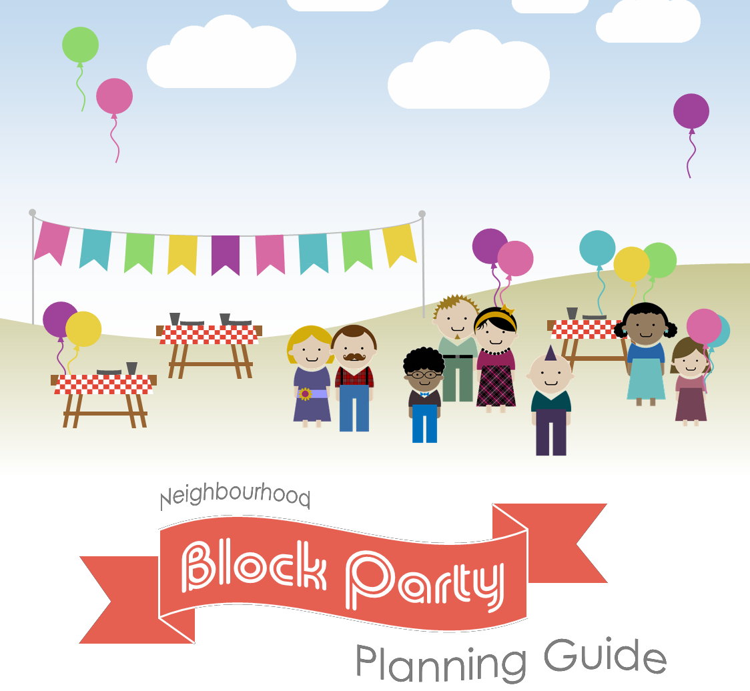

EATS

TREATS

GAMES

FUN

FOOD

FRIENDS

TIME:

DATE:

LOCATION:

Come have some fun and meet your neighbours at our