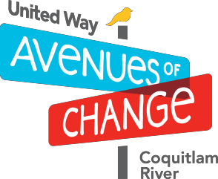

WED SEPT 13TH #HINEIGHBOUR BLOCK PARTY!

#HiNeighbour

Avenues of change would like to invite our neighbours to our annual Block Party to celebrate our time together with good laughs, family games and neighbourhood connections.

**Please bring a potluck item and a blanket or lawn chairs.**

AGGIE PARK, PORT COQUITLAM

WEDNESDAY SEPTEMBER 13TH

4:00 – 7:00PM

Come connect with your neighbors and community partners

Terry Fox Library will be there for story time

You must register to attend potluck and receive a food ticket: https://www.event brite.ca/e/hineighb

our-block-party- tickets- 37108762307