Creating a math board game to play with your family

Maths board games are a great way to get hooked and engaged with maths.

Your activity this week is to plan and design a board game to play with your family.

I've collated a collection of board game templates below which can be drawn and modified to make your own maths game board.

Step One: Design and draw your own board game template. Make sure you use a ruler so it is well presented and colour in the board game so it is appealing to the players.
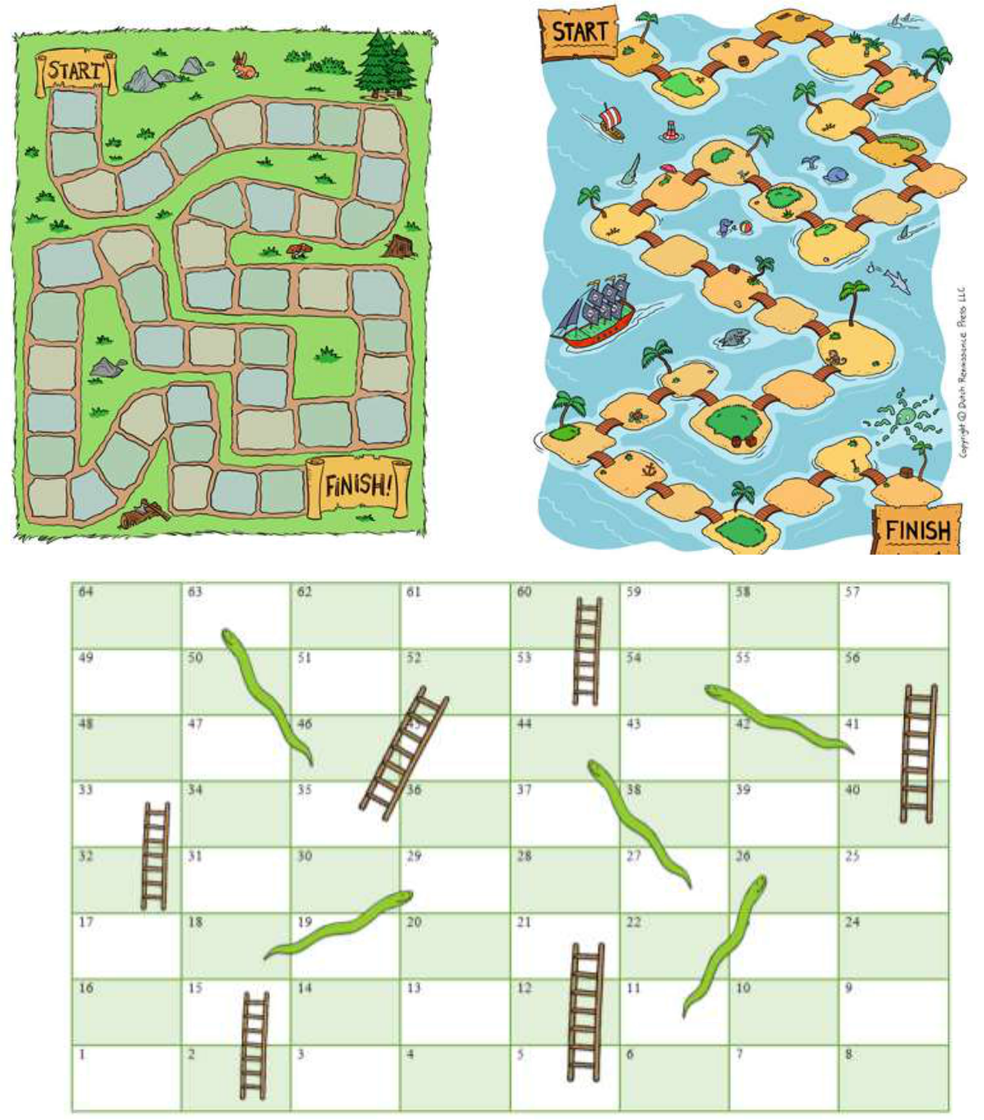

Step Two: Pimp up your board game
Your first job is to change the board itself. You can do this in a generic way so that it can be used to teach all
aspects of maths. The way I changed the game board is by adding a question mark at random places along the
board, the players need to answer the questions correctly to be able to move forward. When the players land on
a question mark they pick up a challenge card and have to answer it. You can decide what they do after this.
 |  |  |  |  |  |  |  |  |  | ?
Here are some examples: |  |  |  | Challenge card
 |  |  |  |  |  |  |  |  |  |  |  | Tim had 43
• | If they answer correctly, they move forward two spaces. |  |  |  | example |  |  |  |  |  | marbles. His
• |  |  |  |  |  |  |  |  |  |  |  |  |  | gran gave
•
• | If they answer correctly, they get another roll.
• |  |  |  |  |  |  |  |  |  | him 53 more.
• | If they get it wrong, they miss a turn next time. |  |  |  |  |  |  |  |  |  |  |  | How many
• | Feel free to add your own ideas here. I'm sure you get the idea. |  |  |  |  |  |  |  |  | does he have
• |  |  |  |  |  |  |  |  |  |  |  |  |  | now?
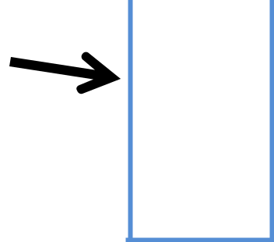
When you make your own maths board game, you can draw a space on the board too to show where the cards should be placed. You could have two different sets of cards. One could be a question mark and one an exclamation mark. This would be a similar way to how Chance and Community Chest are used in Monopoly. The cards could have different types of questions on them or could be used for another purpose.

Here are some examples of how this could work:

- The question marks could be for times table questions and the exclamation marks could be for related division facts.

- The question marks could be for basic facts and the exclamation marks could be for using and applying or maths mastery.

- One may be for maths questions and the other could be something fun like trying to touch your nose with your tongue. Urgh! You get the idea.

See my example below:
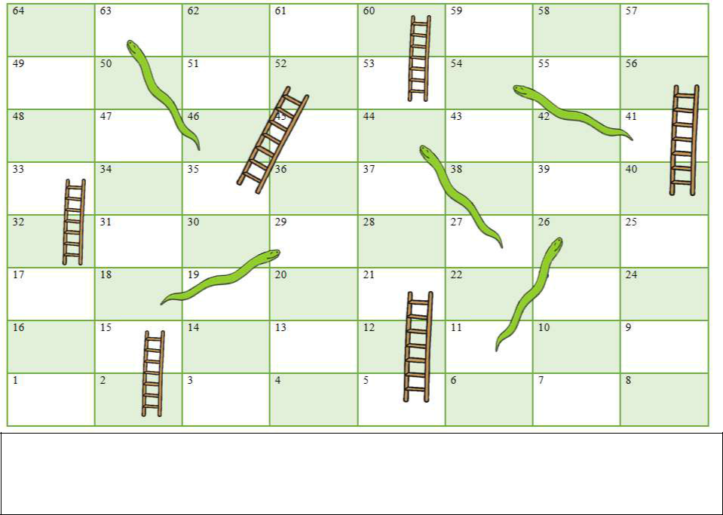

2 less than
? ? 120

?

99+15= 100-23=

! | 35÷5= |  | ? | !
 |  | ! | 6 x 4 = | ?
? |  | 2 less than 56 |  | 10 more than 66
 | 35 + 16= |  |  | 20÷4=
5x 6 = |  | 35-7= | ? | ?

Make sure you fill your board game with lots of questions and challenge symbols.

Make your challenge cards difficult to challenge yourself and your family.
Step Three: Gather your extras

You'll also need a set of counters and a dice to play the games.

If you haven’t got a dice create number cards 1- 6 and face them downwards. Each player will need to pick a card to see how many spaces they need to jump.

Maths Games

Use the math game websites given to you last week to carry on developing your math skills.

