Patient Registration Form

Please take a few minutes to complete this form. There may be times when it is urgent that we contact you, so please try to be as complete and accurate as possible, especially with phone numbers. All information provided is completely confidential. Thank you.

Name: ________________________________________________________________________

First Middle Last

Mailing Address: ________________________________________________________________
Street # Street Name Apt. #
_______________________________________________Home Phone: ___________________

City State Zip

SSN: _______-________-_______DOB: __________________ Cell Phone:_______________________

Race: ___________________ Ethnicity: _______________________ Religion: ___________________

(Hispanic, Non-Hispanic or Declined)

Marital Status: Single Married Separated Divorced Widowed

Emergency Contact: ____________________ Relationship:_____________ Phone:_________________

Referred By: ___________________________ If pregnant, name of father: ________________________

(Internet, phonebook, physician)

Employer Name: _________________________________Phone number: ______________________

__________________________________ | ___________________ | ________________
City | State | Zip

Primary Insurance Carrier: ___________________________ ID#: _______________________

_______________________________ | ______________ | __________________________
Subscriber Name (if different from patient) | DOB | Relationship to Subscriber

Secondary Insurance Carrier: _____________________________________________________

(if applicable)

Pharmacy Name: ______________________________________________________________________

City & Cross Street: _________________________________ Phone Number: _____________________

Patient Portal Access: To access our patient portal, an email address is required for account setup.

Email: __________________________________________________

Do we have permission to:

Leave a message at your place of employment? | Yes | No
Leave a message on your answering machine? | Yes | No
Discuss your medical condition with any member of your household? | Yes | No

If yes, whom: _________________________________ Relationship: _____________________

Signature: ___________________________________________ Date: ____________________

01/2015

Review of Medical History

Date: ________________________

Name: ____________________________________________ By what name do you like to be called? ________________________

Age: _____________ Date of Birth: ______________________ Height: ___________ Weight: __________lbs

Current reason for visit: _______________________________________________________________________________________

______________________________________________________________ Referred by: __________________________________

Marital Status:  Single  Divorced  Married  Domestic Partner: Name, if applicable:________________________________

Allergies

Do you have any allergies to medications?  YES  NO If yes, please list here _____________________________________

Other ______________________________________________________________________________________________________

Habits/Exposures

Do you smoke?  YES  NO |  | How many packs per day? __________ How many years have you smoked? ______________
Do you drink alcohol?  YES  NO |  |  | If yes, how much per day? _____________ Quit for pregnancy?  YES  NO
 Other Drugs |  X-rays this pregnancy |  |  | HIV discussed  YES  NO Other _________________________________
Are you currently taking any medication?  YES |  |  |  |  NO If yes, please list regular meds taken (including over the counter drugs)

____________________________________________________________________________________________________________

Did your mother every take any medication to prevent miscarriage when she was pregnant with you?  YES  NO

Menstrual History

What was the first day of your most recent period? _______________________________ Or onset of menopause? ___________year How many days do you flow? ____________________________ How heavy do you flow? ________________________________

How many days from the first day of one period to the first day of the next? ___________ Are your periods painful?  YES  NO Do you have abnormal bleeding?  YES  NO Do you have PMS symptoms?  YES  NO

How old were you when you had your first period? _________________ When was your last Pap Smear? __________________

Have you ever had an Abnormal Pap?  YES  NO When was your last Mammogram? _______________

Sexual History

Are you currently sexually active with anyone?  YES |  NO |  Male    Female   Both Male and Female
Do you have pain with sexual activity?  YES  NO | Do you feel satisfied with your sexual experiences?  YES  NO

Do you have a sexual issue to discuss?  YES  NO ______________________________________________________________

Do you have a history of sexual abuse?  YES  NO Has anyone hurt you or hit you in the last year?  YES  NO Do you use any method of contraception including vasectomy, condoms or tubal ligation?  YES  NO

If yes, what kind? _____________________________________________________________________________________________

What have you used in the past for birth control? ____________________________________________________________________

Do you have a history of pelvic inflammatory disease?  YES |  NO
Do you have a history of sexually transmitted infections?  chlamydia |  |  gonorrhea    herpes |  genital warts

Obstetrical History

How many times have you actually been pregnant? ______________ |  |  |  |  |  |  | How many living children do you have? ________________
 | Gestation | Labor | Delivery |  |  |  | Place of | Baby’s
Date | Length | Hours | Type | Anesth. | Sex | Wt. | Delivery | Name | Complications

07/2013

Psychological History

Have you ever had a history of drug use?  YES  NO If yes, please list what drugs __________________________________

Are you currently seeing a therapist?  YES  NO If yes, who do you see? ____________________________________________

___________________________________________________________________________________________________________

Do you have any other issues you wish to discuss?  YES  NO Please list here _______________________________________

____________________________________________________________________________________________________________

Hospitalizations

Please list date and nature of hospitalization below:

Operations | Hospitalization for illness or injury
1. ____________________________________________ | 1. __________________________________________________
2. ____________________________________________ | 2. __________________________________________________
3. ____________________________________________ | 3. __________________________________________________
Do you have any chronic or serious illnesses?  YES |  NO

If yes, please list ______________________________________________________________________________________________

General Physical Conditions or Problems

Do you have any problems with any of the following? If yes, please list below:

Hearing, Eyes, Ears, Nose, Throat |  YES  NO | Hepatitis or any kind of liver ailment or jaundice |  YES  NO
Heart problems, or high blood pressure |  YES  NO | Kidney or bladder problems/leaking of urine |  YES  NO
Lung problems/Asthma/Bronchitis |  YES  NO | Anemia/blood disorder/transfusion |  YES  NO
Breast lumps/pain/nipple discharge |  YES  NO | Thyroid/diabetes/other endocrine problems |  YES  NO
Stomach/bowel/gall bladder problems |  YES  NO | Headaches/migraines/nervous disorder |  YES  NO
Varicose veins or phlebitis |  YES  NO | Chicken Pox |  YES  NO

Other ______________________________________________________________________________________________________

Family History

Does anyone in your family have the following? If yes, who?
High Blood Pressure |  YES  NO ______________ | Stroke |  YES  NO ________________
Heart Problems |  YES  NO ______________ | Kidney Problems |  YES  NO ________________
Diabetes |  YES  NO ______________ | Hepatitis/TB/or infectious disease  YES  NO _________

Other ______________________________________________________________________________________________________

Genetic History

Please complete if you are pregnant or contemplating pregnancy in the future.

Do you know of any family history of genetic disorders or birth defects?  YES  NO
Do you know of any family history of the following abnormalities? If yes, please tell us the relationship.
Sickle Cell Anemia |  YES  NO | Fragile X |  YES  NO | Hemophilia |  YES  NO
Thalassemia |  YES  NO | Cystic Fibrosis |  YES  NO | Spinal Bifida |  YES  NO
Tay-Sachs Disease |  YES  NO | Huntington’s Chorea |  YES  NO | Cleft Lip/Palate |  YES  NO
Down’s Syndrome |  YES  NO | Muscular Dystrophy |  YES  NO | Chromosomal Problems |  YES  NO

Is there any family history of developmental delay?  YES  NO

Please List any concerns you may have regarding pregnancy or future pregnancy

____________________________________________________________________________________________________________

____________________________________________________________________________________________________________

____________________________________________________________________________________________________________

____________________________________________________________________________________________________________

____________________________________________________________________________________________________________

____________________________________________________________________________________________________________

07/2013

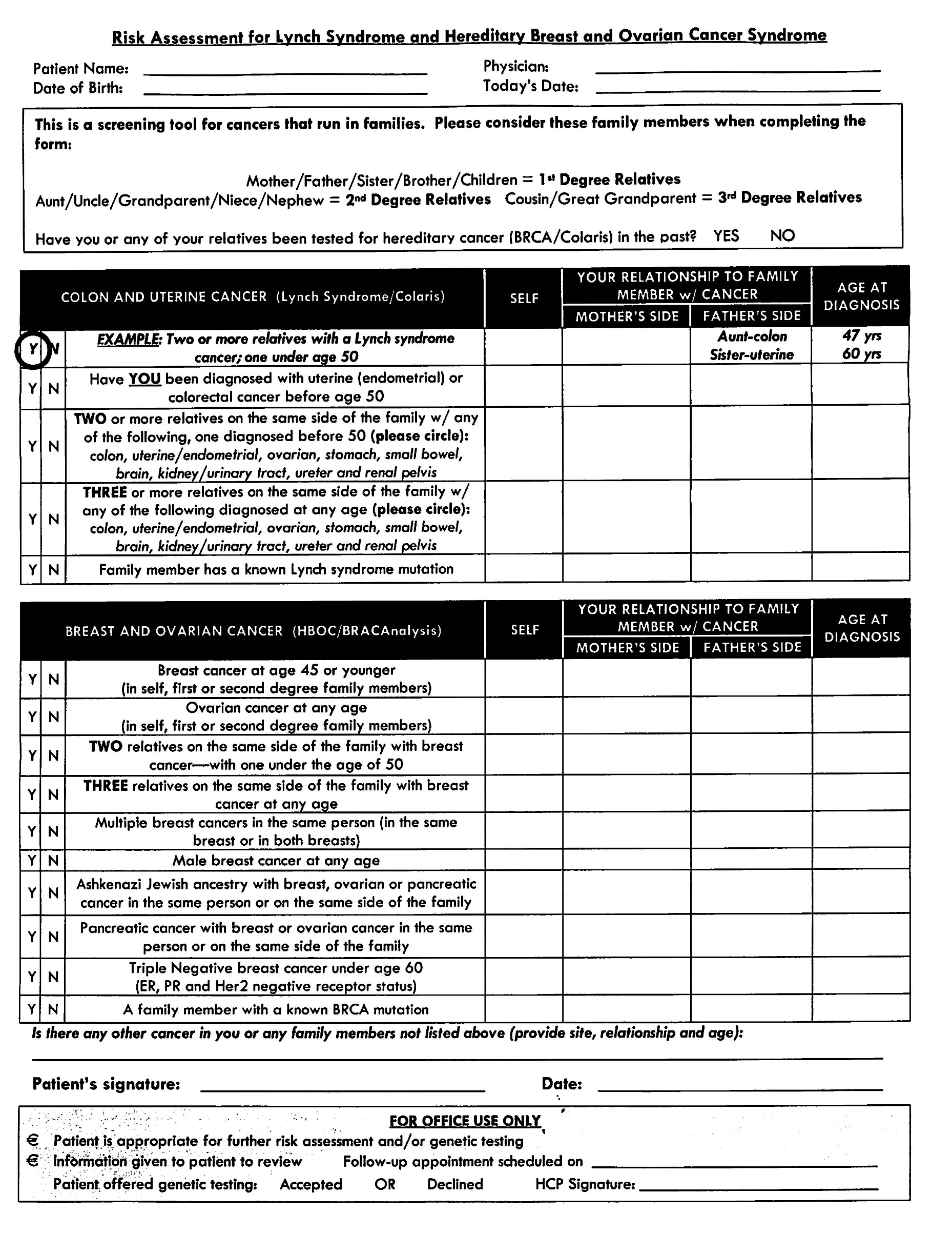
Advanced Women’s Healthcare
Financial Policy

Patient Name: _____________________________________________ DOB: _______________

We would like to share the following policies with you so that you understand your financial responsibility regarding the charges for the services rendered to you by this office.

As a courtesy, we will contact your insurance company to verify your benefits, and also bill your insurance company for services. Any amounts given to us by your insurance company are only quotes and not a guarantee of payment. It is ultimately your responsibility to know what is covered under your insurance and what your share of costs are. You will be financially responsible for any balances not paid by your insurance company.

Depending on the services provided by our office, you may receive additional charges and a bill from, but not limited to, a pharmacy, imaging facility, laboratory, pathologist, anesthesiologist, surgery center or hospital, and radiologist. We do not have access or knowledge to what is covered under your insurance for these other facilities.

Payments due in full, deductibles, co-payments and co-insurance costs will be collected at the time of service. Please note: Any overages collected will only be refunded once treatment has ended, and we have received payment from your insurance company (co-payments, co-insurances, surgery deposits and/or if you meet your deductible early).

Financial Policy Outline:

- Know your insurance plan and what your covered benefits are. You will be responsible for any remaining balances that your insurance does not cover. You may also receive separate charges from other facilities.

- As a courtesy, we will verify your benefits and bill your insurance for services rendered. You will be responsible at the time of service for payment of annual deductibles, co-payments, co-insurance costs, payments due in full, and charges for services not covered by your insurance.

- We accept cash, checks, debit cards, Visa, or Master Cards. There will be a $25 fee for all returned checks.
- There is a $30 fee for missed appointments, or appointments rescheduled or not cancelled more than 48 hours prior to your appointment time.
- If you are scheduled for surgery and cancel within 14 days of the surgery date, your surgery deposit will not be refunded. Surgery deposits are collected at the time of scheduling, and refunded once we have received payment from your insurance company.

- For past due accounts over 30 days, there will be a $10 fee added to all accounts every 30 days for past due balances. Please call the Billing department for payment options.
- In the event that your account must be turned over to collections, a 35% collection fee will be added to your account.
- There is $10 fee for state disability forms and $10 fee for supplemental disability forms.

By signing below, I understand Advanced Women’s Healthcare’s financial policy and my financial responsibility regarding charges incurred in this office.

 | Patient Signature |  | Date
1100 N. Palm Canyon Drive, Suite 212 |  | 7355 Church Street, Suite F | 79-200 Corporate Center Drive, Suite 201
Palm Springs, CA 92262 |  | Yucca Valley, CA 92284 | La Quinta, CA 92253
Phone 760.327.7900 • Fax 760.327.7905 |  | Phone 760.327.7900 • Fax 760.327.7905 | Phone 760.564.7900 • Fax 760.327.7905
 |  | www.advancedwomenshealth.com | 01/2015

Advanced Women’s Healthcare

HIPAA NOTICE PRIVACY PRACTICE

This notice describes how medical information about you may be used and disclosed, and how you can get access to this information.
Please review this carefully.

This notice of Privacy Practices describes how we may use and disclose your protected health information (PHI) to carry out treatment, payment or health care operations (TPO) and for other purposes that are permitted or required by law. It also describes your rights to access and control your protected health information. “Protected Health Information” is information about you, including demographic information that may identify you and that relates to your past, present or future physical or mental health or condition, and related health care services.

Use and Disclosures of Protected Health Information:
Your protected health information may be used and disclosed by your physician, our office staff, and others outside of our office that are involved in your care and treatment for the purpose of providing health care services to you, to pay your health care bills, to support the operation of the physician’s practice, and any other use required by law.

Treatment:

We will use and disclose your protected health information to provide, coordinate, or manage your health care and any related services. This includes the coordination or management of your health care with a third party. For example, your protected health information may be provided to a physician to whom you have been referred to ensure that they physician has the necessary information to diagnose or treat you.

Healthcare Operations:

We may use or disclose, as needed, your protected health information in order to support the business activities of your physician’s practice. These activities include, but are not limited to, quality assessment activities, employee review activities, training of medical students, licensing, and the conducting or arranging for other business activities. For example, we may disclose your protected health sheet at the register desk where you will be asked to sign your name and indicate your physician/practitioner. We may also call you by name in the waiting room when your physician/practitioner is ready to see you. We may use or disclose your protected health information, as necessary, to contact you to remind you of your appointment.

We may use or disclose your protected health information in the following situation without your authorization. These situations include as required by law: Public Health issues: Communicable Diseases: Health Oversight, Abuse or Neglect: Food and Drug Administration requirements: Legal Proceedings: Law Enforcement Coroners, Funeral Directors, and Organ Donation: Research: Criminal Activity: Military Activity and National Security: Workers Compensation: Inmates: Required Uses and Disclosures: Under the Law, we must make disclosures to you when and when required by the Secretary of the Department of Health and Human Services to investigate or determine our compliance with the requirements of Section 164.500.

Other Permitted and Required Uses and Disclosures:

These will only be made with your Consent, Authorization or Opportunity to object, unless required by law.

Revocation:

You may revoke this authorization, at any time, in writing, except to the extent that your physician/practitioner the medical practice has taken an action in reliance on the use or disclosure indication in the authorization.

1100 N. Palm Canyon Drive, Suite 212 | 7355 Church Street, Suite F | 79-200 Corporate Center Drive, Suite 201
Palm Springs, CA 92262 | Yucca Valley, CA 92284 | La Quinta, CA 92253
Phone 760.327.7900 • Fax 760.327.7905 | Phone 760.327.7900 • Fax 760.327.7905 | Phone 760.564.7900 • Fax 760.327.7905
 | www.advancedwomenshealth.com | 06/2014

Advanced Women’s Healthcare

Following is a statement of “Your Rights” with respect to your protected health information:

You have the right to inspect and copy your protected health information. Under federal law, however, you may not inspect or copy the following records; psychotherapy notes, information compiled in reasonable anticipation of, or use in, a civil, criminal, or administrative action or proceeding, and protected health information that is subject to law that prohibits access to protected health information.

You have the right to request a restriction of your protected health information. This means you may ask us not to use or disclose any part of your protected health information for the purposes of treatment, payment or healthcare operations. You may also request that any part of your protected health information not be disclosed to family members or friends who may be involved in your care or for notification purposes as described in this Notice of Privacy Practices. Your request must state specific restrictions and to whom you want the restrictions to apply.

Your physician/practitioner is not required to agree to a restriction that you may request. If your physician/practitioner believes it is in your best interest to permit use and disclosure of your protected health information, your protected health information will not be restricted. You then have the right to obtain services from another Healthcare Professional.

You have the right to request to receive confidential communications from us by alternative location. You have the rights to obtain a paper copy of this notice from us, upon request, even if you have agreed to accept this notice alternatively, i.e., electronically.

You may have the right to have your physician/practitioner amend your protected health information. If we deny your request for amendment, you have the right to file a statement of disagreement with us and we may prepare a rebuttal to your statement, and will provide you with a copy of any such rebuttal.

You have the right to receive an accounting of certain disclosures we have made, if any, of your protected health information. We reserve the rights to change the terms of this notice and will inform you by mail of any changes. You then have the right to object or withdraw as provided in this notice.

Complaints:

You may complain to us or the Secretary of Health and Human Services if you believe your privacy rights have been violated by us. You may file a complaint with us by notifying our privacy contact of your complaint. We will not retaliate against you for filing a complaint.

This notice was published and becomes effective on or before October 1, 2003.

We are required by law to maintain the privacy of, and provide individuals with this notice of our legal duties and privacy practices with the respect to protected health information. If you have any objections to this form, please ask to speak with our HIPAA Compliance Officer in person or by telephone at our main office number.

Your signature below is only an acknowledgement that you have received this Notice of our Privacy Practices:

___________________________________________

Print Name

___________________________________________ |  | _______________________
Signature |  | Date
1100 N. Palm Canyon Drive, Suite 212 | 7355 Church Street, Suite F | 79-200 Corporate Center Drive, Suite 201
Palm Springs, CA 92262 | Yucca Valley, CA 92284 | La Quinta, CA 92253
Phone 760.327.7900 • Fax 760.327.7905 | Phone 760.327.7900 • Fax 760.327.7905 | Phone 760.564.7900 • Fax 760.327.7905
 | www.advancedwomenshealth.com | 06/2014

Advanced Women’s Healthcare

Advanced Directives – The Patient’s Right to Decide

All adult individuals in hospitals, nursing homes, and other health care settings have certain rights. For example, you have a right to confidentiality of your personal and medical records and to know what treatment you will receive.

You also have the right to fill out a paper known as an “Advance Directive”. This paper states, in advance, what kind of treatment you want or do not want under special, serious medical conditions; conditions that would prevent you from telling your doctor how you want to be treated. For Example, if you were taken to a hospital in a coma, would you want the hospital’s medical staff to know your specific wishes about decisions affecting your treatment?

This article answers some questions related to a federal law that took effect in 1991 that requires most hospitals, nursing facilities, hospices, home health care programs and health maintenance organizations (HMO’s) to give you information about advance directives and your legal choices in making decisions about medical care. The law is intended to increase your control over medical treatment decisions.

The information in this article can help you make decisions in advance of treatment. Because this is an important matter, however, you may wish to talk to family, close friends and your doctor before deciding whether you want an advance directive.

Finally, it is important to remember that state laws differ about the legal choices available to individuals for treatment options that can be honored by hospitals and other health care providers and organizations. These health care professionals should have information for you on your state’s advanced directive law.

What is an Advanced Directive?

Generally, an advance directive is a written statement, which you complete in advance of serious illness about how you want medical decisions made. The two most common forms of advanced directives are:

- Living Will

- Durable power of attorney for Health Care
An advanced directive allows you to state your choices for health care or to name someone to make those decisions for you if you become unable to make decisions about your medical treatment. In short, an advance directive can enable you to make decisions about your future medical treatment. You can say “Yes” to treatment you want, or say “No” to treatment you do not want.

1100 N. Palm Canyon Drive, Suite 212 | 7355 Church Street, Suite F | 79-200 Corporate Center Drive, Suite 201
Palm Springs, CA 92262 | Yucca Valley, CA 92284 | La Quinta, CA 92253
Phone 760.327.7900 • Fax 760.327.7905 | Phone 760.327.7900 • Fax 760.327.7905 | Phone 760.564.7900 • Fax 760.327.7905
 | www.advancedwomenshealth.com | 06/2014

Advanced Women’s Healthcare

Advanced Directives Acknowledgement

Patient Name: ___________________________________________________

Date of Birth: ___________________________________________________

Telephone Number: ______________________________________________

Advanced Directives

This is an acknowledgement that the physician, or one of his/her staff members, has provided me with information regarding Advanced Directives.

1. I am age 18 or older. (Circle one): Yes No

- I realize that I have the option of putting together an Advanced Directive for my healthcare. My physician has provided me with written information concerning Advanced Directives. I understand that it is my responsibility to provide my doctor(s) with any documents that are required to carry out my Advanced Directives.

- I am aware that Advanced Directives may be any one of the following:
  - A Durable Power of Attorney for Health Care
  - The Declaration in the a Natural Death Act (i.e., a Living Will)
  - I may write down my wishes on a piece of paper so that my family may use the document in deciding my medical treatment in the event that I am unable to do so.

___________________________________________
Print Name

___________________________________________ _______________________
Signature Date

1100 N. Palm Canyon Drive, Suite 212 | 7355 Church Street, Suite F | 79-200 Corporate Center Drive, Suite 201
Palm Springs, CA 92262 | Yucca Valley, CA 92284 | La Quinta, CA 92253
Phone 760.327.7900 • Fax 760.327.7905 | Phone 760.327.7900 • Fax 760.327.7905 | Phone 760.564.7900 • Fax 760.327.7905
 | www.advancedwomenshealth.com | 06/2014

