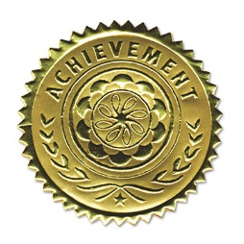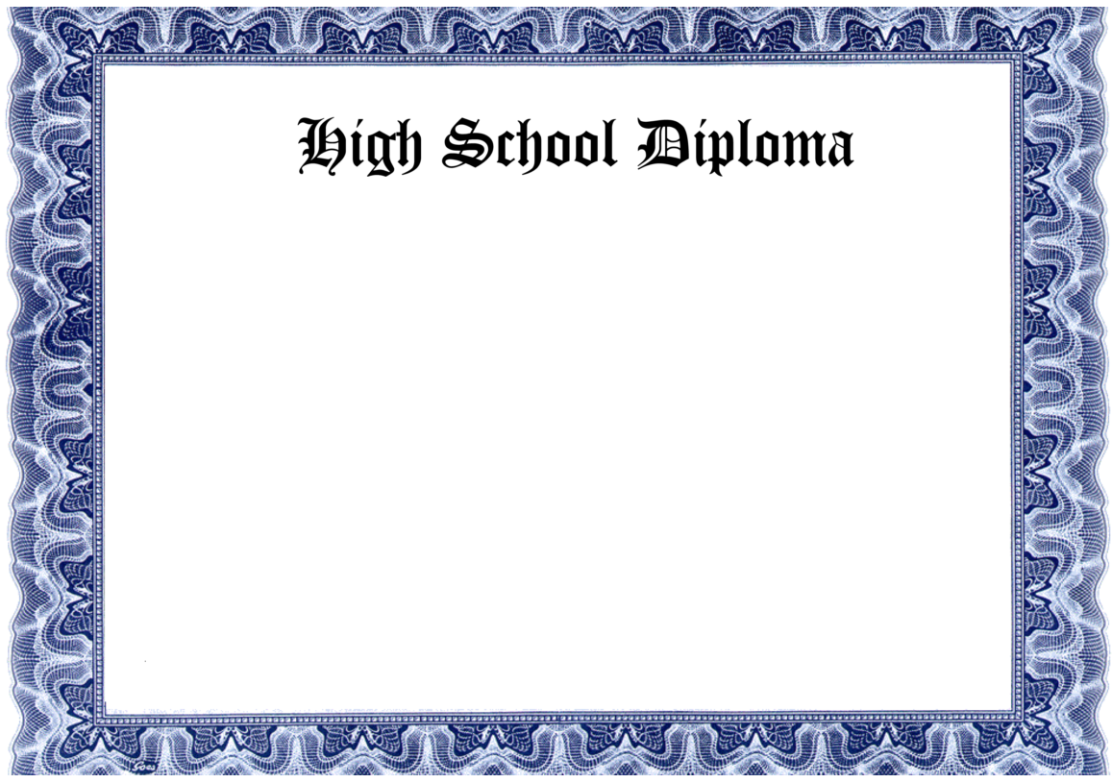

This certifies that

__________________________

Has completed the course of the study as prescribed by the department of education

In testimony whereof, this Diploma is conferred, and the signature of the Principal has been affixed

On the ____ day of the Month of ____, 2020

_____________________