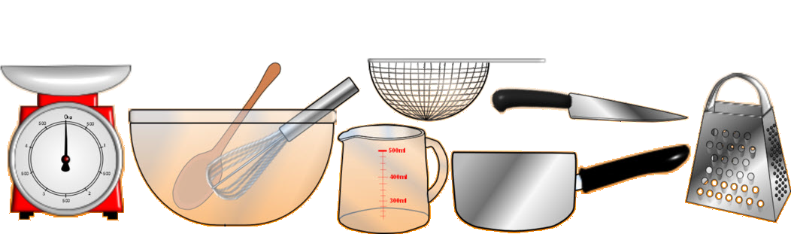A recipe for
Ingredients
Equipment

Step-by-step instructions

© Copyright 2011, www.sparklebox.co.uk

Step-by-step instructions (continued)
How to serve
Picture of finished dish

© Copyright 2011, www.sparklebox.co.uk

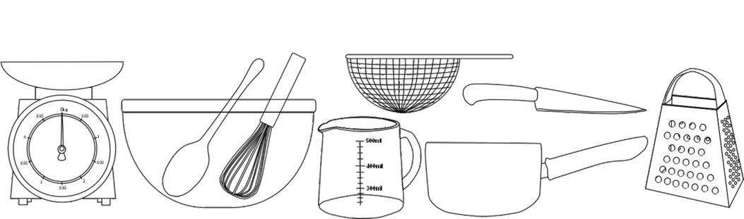A recipe for
Ingredients
Equipment

Step-by-step instructions

© Copyright 2011, www.sparklebox.co.uk

Step-by-step instructions (continued)
How to serve
Picture of finished dish

© Copyright 2011, www.sparklebox.co.uk

