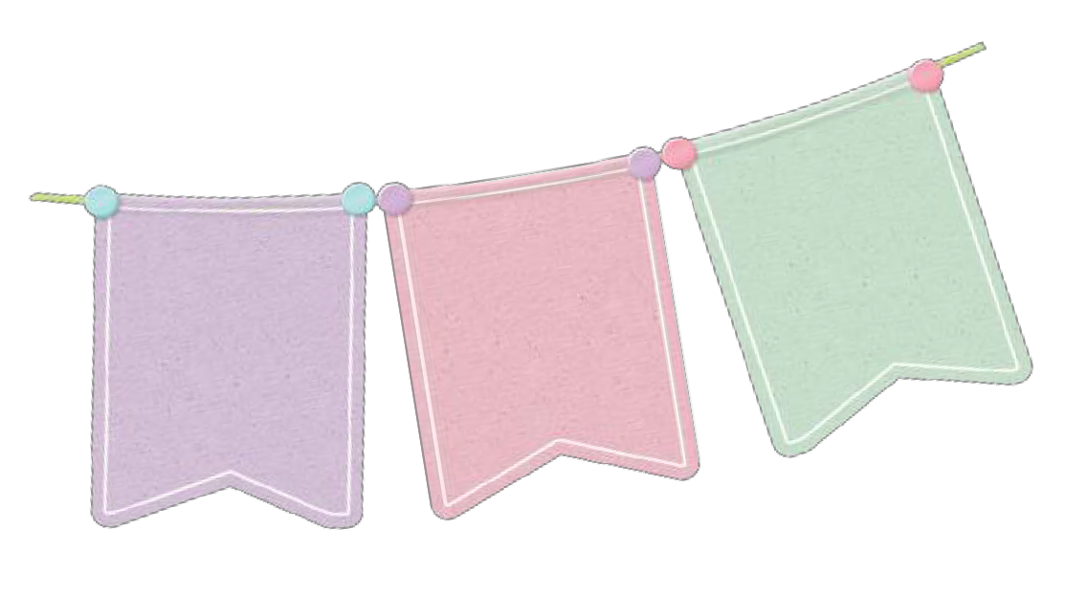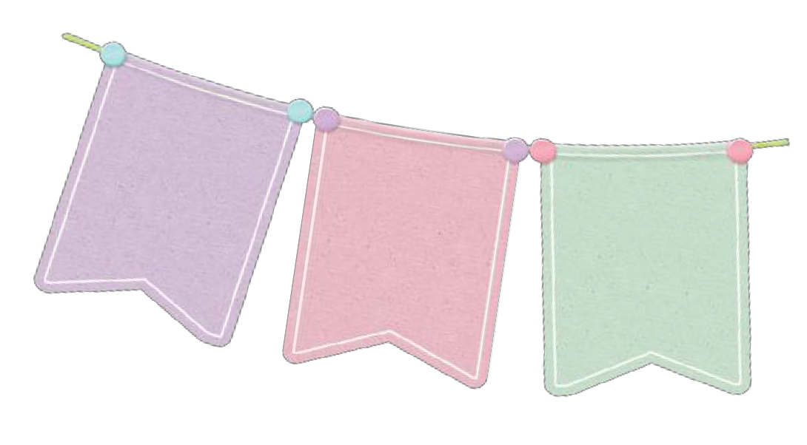RECIPE:
FROM THE KITCHEN OF:

Ingredients Amount

Prep Time

Cook Time Temperature Servings
Cal. per Servings

My Opinion

Directions

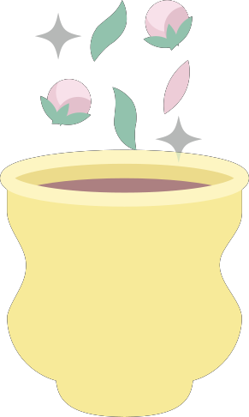©printablesbydesign.org

_
_
_

