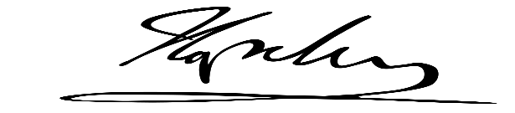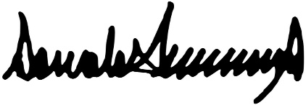

CERTIFICATE OF PERFECT ATTENDANCE

This certificate is presented to

Write Name Here

Lorem ipsum dolor sit amet, Consectetur adipiscing elit. Vivamus vitea luctus Leo, vitae. Dignissim quam.

Sed placerat, neque in ele. Entum euismod, risus.

Sed urna Purus, volute. Pat quis varius id, fragile non-urna.

Date

Signature