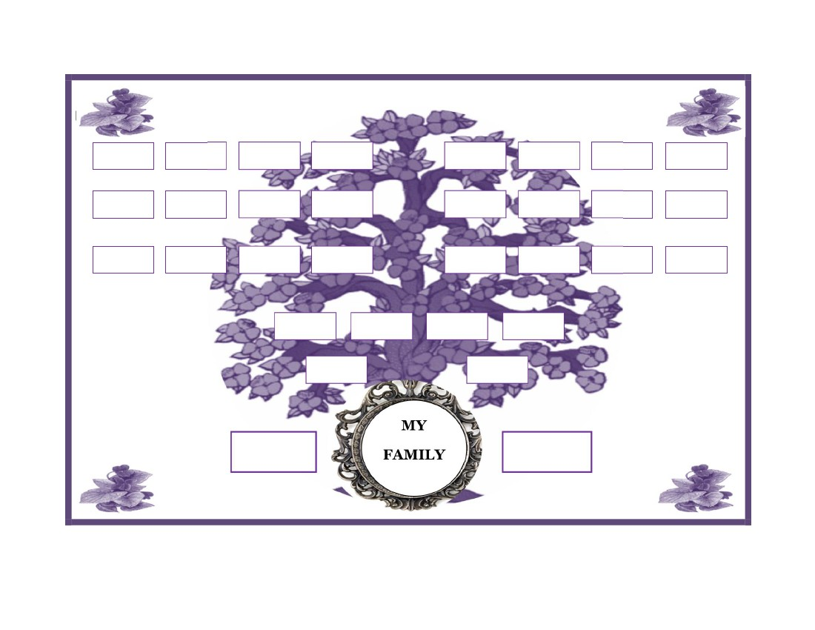
FAMILY HISTORY
MY
FAMILY
www.FamilyTreeTemplates.net

