Training Manual Template

Preface and Purpose of the Manual

Clarity:

Capacity:

Consistency:

Commitment:

Coordination 11

1. Coordination

  - Pre-Training Planning

1.2 Training Logistics Checklist

WHAT YOU NEED | WHERE TO FIND | HOW TO FIND THE
TO KNOW | THE ANSWER | ANSWER (STEPS) | TEAM NOTES

Coordination 13

TRAINING LOCATION

Access

Comfort Comfort

Training facility

Accommodation

Supplies on-site

Food and drink

ADVERTISING

Lead time for advertising

Information for nomination and

enrolment

Direct invitations

Other advertising ideas

REGISTRATION

Online or by email

By post

Other ways of registration

Needs Assessment 15

2. Needs Assessment

2.1 Assessing Needs

3. Design

3.1 Course Design Process

3.2 Learning Outcomes

FACT | ANALYSIS | UNDERSTANDING | APPLICATION | ATTITUDE

STEP 1:

WRITE a

STEP 2:

CONSIDER

For example

STEP 3:

For example

STEP 4:

THINK

Development

Development 31

4. Development

4.1 Developing Material

A. Background and descriptive information.

  - Directions on how to use the curricula.

  - Course planning forms and checklists.

  - Guidance on tailoring each particular workshop so it matches the needs or wants of participants, or fits a program’s needs.

E. Specific, measurable, and realistic learning objectives.

- Clear and complete course content.

- DEVELOPING TRAINING MATERIAL GUIDE

G.Integrated evaluation plan/tools.

  - Process -

  - Outcome -

  - Impact -
The draft stage—

The final stage—
 | Development 35
1. Draft Stage
 | PLANNING
Step 1 | Description

CONTENT DEVELOPMENT

Step 2 | Description | Est. | Date | Staff
 |  | Timeline | Due | Lead
Draft text
Word processing
Editing
Reviewer input
Incorporate
reviewer input
Proofreading

- DEVELOPING TRAINING MATERIAL GUIDE

DRAFT LAYOUT AND PRELIMINARY REVIEW

Step 3 | Description | Est. | Date | Staff
 |  | Timeline | Due | Lead
Preliminary
design concepts
Brief meeting
Photo selection,
illustration
Initial layout
Team review
of designs and
initial layout
Discussion
Revisions
Finalise specs

 |  |  |  | Development 37
2. Final Stage
 | FINAL LAYOUT AND FINAL REVIEW
Step 1 | Description | Est. | Date | Staff
 |  | Timeline | Due | Lead
Text finalised
Design refine-
ment and layout
of final text
Final team
review
Final revisions
 | PRINTING
Step 2 | Description | Est. | Date | Staff
 |  | Timeline | Due | Lead

- DEVELOPING TRAINING MATERIAL GUIDE

AFTER PRINTING

Step 3 | Description | Est. | Date | Staff
 |  | Timeline | Due | Lead

4.2 Developing Presentations

Delivery

Delivery 41

5. Delivery

5.1 Training Methods

- DEVELOPING TRAINING MATERIAL GUIDE

 |  | POSSIBLE
METHOD | ADVANTAGES | DISADVANTAGES | COMMENTS
 | INFORMATIONAL
Lecture | Conveys large sum | Audience is largely | Trainer should be an
Lecture-Forum | of information; fast; | passive. | interesting speaker,
(with question cards | efficient forum allows |  | able to self-limit and
or question/answer | exploration of content |  | stick to time, be able
period) | in more detail. |  | to facilitate questions
 |  |  | effectively.
Panel | Adds different points | Audience is largely | Leader must express
Panel forum | of view to content. | passive with excep- | solid set of ground
 |  | tion of expanding | rules and have skills
 |  | panel; expanding | to enforce them.
 |  | panel not practical
 |  | with groups larger
 |  | than 20.
Debate | Provides different | Audience is largely | Same as for panel.
 | points of view; | passive.
 | thought-provoking.
Presentation | Keeps participants | Learning points can | Trainer should
Presentation with | interested and | be confusing or lost. | structure listening
Listening Teams | involved. | A few participants | assignment with
(participants given | Resources can be dis- | may dominate the | clear purpose; must
listening assignment | covered and shared. | discussion. | select panellists from
before presentation | Learning can be | Time control is more | a cross-section of the
question speaker | observed. | difficult. | group.
afterward) | Lots of information; | Audience is largely
Presentation with | fast; new points | passive; reaction pa-
Reaction Panel | of view; a more | nel may not represent
(small group listens | organised question- | all views of the group.
and forms panel fol- | and-answer format; | Trainer orally presents
lowing presentation) | reaction panel can | new information to
 | speak. | the group.

 |  |  | Delivery 43
Group Discussion | Keeps participants | Learning points can | Trainer divides
(of given topic) | interested and | be confusing or lost. | large group into
Buzz Groups | involved. | A few participants | small groups; groups
(short, time-limited | Resources can be dis- | may dominate the | of 4–6 are most ef-
discussion on given | covered and shared. | discussion. | fective.
subject) | Learning can be | Time control is more | Small group has a
 | observed. | difficult. | short time to discuss
 | Participants are | Inexperienced leader | a topic or solve a pro-
 | active; allows chance | may be unable to use | blem
 | to hear other points | format for attitudinal | Trainer should be
 | of view; quieter | purposes. | able to give clear
 | people can express |  | instructions and keep
 | viewpoints and ideas. |  | discussion on target.
 |  |  | Main function is
 |  |  | judging when to cut
 |  |  | off discussion.
Brainstorming | Can get all partici- | The problem/is- | For idea generation
 | pants involved in | sue must be clearly | and creative group
 | collecting a lot of | defined. | thinking; all partici-
 | information. | Time control is more | pants present many
 | Quickly generate | difficult. | ideas as rapidly as
 | ideas. | Need clear trigger | possible on a problem
 | Good for problem- | questions and evalua- | or issue. Then group
 | solving; quick change | tion/discussion after- | organizes list into
 | of pace; filler; allows | wards; somewhat | categories for further
 | all to participate; | over-used method; | discussion.
 | validates ideas of | requires careful | Do not evaluate, criti-
 | group. | facilitation. | cize, omit, or discuss
 |  |  | contributions until all
 |  |  | are written; record
 |  |  | in contributor’s own
 |  |  | words; use another
 |  |  | person to record if
 |  |  | possible.
 |  | POSSIBLE
METHOD | ADVANTAGES | DISADVANTAGES | COMMENTS
 | ATTITUDINAL
Task Groups | Sustained interac- | Time consuming; | Keep groups small
 | tion allows quieter | requires great degree | and diverse with
 | people to express | of self-direction and | sustained interaction
 | themselves; validates | group maturity. | and clear purpose.
 | participants.

- DEVELOPING TRAINING MATERIAL GUIDE

 |  | POSSIBLE
METHOD | ADVANTAGES | DISADVANTAGES | COMMENTS
 | BEHAVIOURAL
Role-Play | Helps retention. | Requires preparation | Participants act out
Mini-Role-Play | Allows participants to | time. | problem-solving situ-
 | practice new skills in a | May be difficult to | ations similar to those
 | controlled environ- | tailor to all situations. | they will encounter in
 | ment. | Needs sufficient class | their workplace.
 | Participants are | time for exercise com- | Trainer needs skill
 | actively involved. | pletion and feedback | and understanding—
 | Observers can | Requires maturity and | must get people into
 | impact attitude and | willingness of groups; | roles, give directions,
 | behaviour. | requires trainer have | and establish a cli-
 |  | excellent facilitation | mate of trust. Trainer
 |  | skills. | needs insight into
 |  |  | how an activity may
 |  |  | pose a threat to some
 |  |  | individuals; ability to
 |  |  | help group process &
 |  |  | de-brief. Use in well-
 |  |  | formed group. Can be
 |  |  | structured into dyad,
 |  |  | triad, and fishbowl.
“Movie” (role-play | Useful in rehearsing | (Same as for role-
assisted by feedback, | new skills, behaviours. | play, intensive and
“more__, or less __”) |  | time consuming.)
Simulation games | Intense involvement; | Competitive; requires | A package game
 | practice skills in | a game and possibly | requires prep time
 | problem solving and | a consultant to | for the leader to
 | decision-making. | help facilitate; time | learn the rules and
 |  | consuming. | directions.

Delivery 45

Case study | Requires active partic- | Information must | Participants are given
Mini-case study | ipant involvement. | be precise and kept | information about a
(problem situations | Can simulate perfor- | up-to-date. | situation and directed
for small groups to | mance required after | Needs sufficient class | to come to a decision
analyse) | training. | time for participants | or solve a problem
Critical incident | Learning can be | to complete the case. | concerning the
(small section of case | observed. | Participants can be- | situation.
stating most critical or | Opportunity to apply | come too interested | Trainer needs to have
dramatic moment) | new knowledge; | in the case content. | knowledge and skills
 | requires judgment; | Case study must be | to “solve” the prob-
 | good assessment | relevant to learner’s | lem; may need to
 | tool; participants | needs and daily | design own studies;
 | active; chance to | concerns. | compare approaches
 | practice skills. |  | of several groups
 |  |  | and reinforce best
 |  |  | solutions.
Demonstration | Aids comprehension | Must be accurate and | Participants are
Demonstration with | and retention. | relevant to partici- | shown the correct
practice | Stimulates partici- | pants. | steps for completing a
(by participants) | pants’ interest. | Written examples | task or are shown an
 | Can give participants | can require lengthy | example of a correctly
 | model to follow. | preparation time. | completed task.
 | Allows for optional | Trainer demonstra- | Requires skill to
 | modelling of desired | tions may be difficult | model desired
 | behaviour/skill; can | for all participants to | behaviour; break
 | be active; good for | see well. | procedure down into
 | learning simple skills. | Method more effec- | simple steps; ability
 |  | tive if participants are | to provide feedback.
 |  | active; feedback must
 |  | follow immediately
 |  | after practice.
Skills practice lab | Different points of | Group should have | Act as a resource to
(small participant | view and feedback; | enough knowledge or | groups.
groups practice | participant active; | insight to coach one
together). | good for translating | another.
 | information into
 | skills.

- DEVELOPING TRAINING MATERIAL GUIDE

 |  | POSSIBLE
METHOD | ADVANTAGES | DISADVANTAGES | COMMENTS

PLANNING

Group discussion with decision-making re-garding a new action

Individual or group planning session with report

Validates maturity and needs of group members; members have best insight into their problems and needs on-the-job; group leaves session with practical, constructive and mutual goals; groups get ideas from one another...

Requires mature group that can self-direct and stay on task; time consuming.

Leader serves as re-source once directions are given.

Delivery 47

5.2 Effective Communication Skills

- Support the group of participants by building an atmosphere of trust and modelling a positive attitude.

- DEVELOPING TRAINING MATERIAL GUIDE

    - Ensure that the entire course content is covered.

  - Model effective facilitation skills.

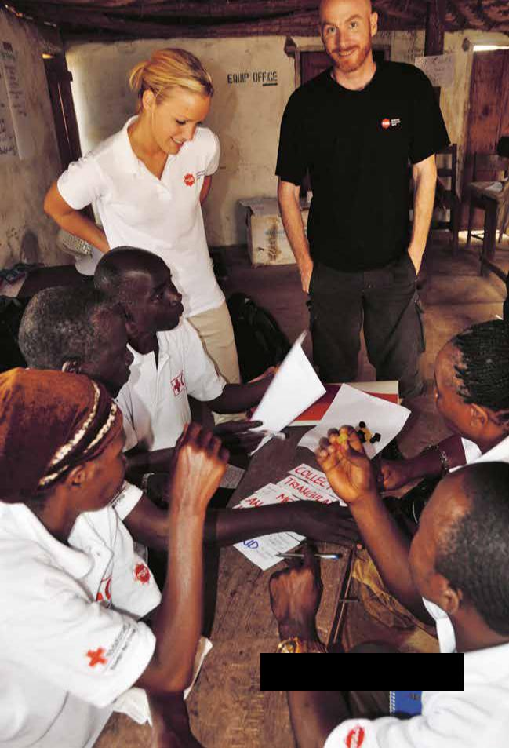

Training within the West Africa Disaster Management

Capacity Building project.

Photo: MSB

Evaluation

Evaluation 51

6. Evaluation

6.1 Forms of Evaluation

  - Keep the questions brief, no more than 10 or 12.

  - Trainer Assessment:

  - Participant Check-

  - Post-training participant feedback: Suggested questions:

6.2 Process Evaluation

Process Evaluation – Needs Assessment

Evaluation 55

Process Evaluation – Training Design

Training-Model: Have training designers:

Structure: Have training designers:

Communication: Have training designers:

Evaluation 57

Process Evaluation – Training Development

References

References 59

References

Swedish Civil Contingencies Agency (MSB) S-651 81 Karlstad Phone +46 (0)771-240 240 www.msb.se/en Order No. MSB507 - December 2012 ISBN 978-91-7383-303-5

