**ROOT CAUSE ANALYSIS**

**TOOLKIT**

**Getting to the Root of the Problem –**

**How Can Root Cause Analysis Help**

**MCj02925880000[1]**

**Purpose**

The purpose of this toolkit is to support the delivery of the ‘Getting to the Root of the Problem’ root cause analysis presentation at the Partners in Patient Safety Conference 2009/10. The document describes the stages in the root cause analysis process and, provides an example of how this information may be pulled together to provide a formal report, which can be used to support communication of key findings within practice.

**1. Getting Started**

**Identify Investigation Team**

Name Designation

__________________________________ _____________________________________

__________________________________ _____________________________________

__________________________________ _____________________________________

__________________________________ _____________________________________

**Develop Terms of Reference for Investigation**

*The Terms of Reference identify the scope of the investigation to be undertaken, best practice would suggest that these include:*

* *The problem to be addressed*
* *The Investigation Team and Designated Lead*
* *Aims/Objectives of the investigation process*
* *Scope of investigation*
* *Timescales*

**Terms of Reference**

**Involving and Supporting Patients and their Families**

**Identify Nature/Consequence of the Incident**

**Incident Date:**

**Incident Type:**

**Nature of Incident – What Happened?:**

**Consequence of Incident:**

**Effect on Patient:**

**2. Gathering Evidence/Facts**

**Identify Resources**

*Identify what resources/evidence is available/required to investigate.*

* *Policies, guidance, protocols and procedures that were in place at the time of the incident*
* *Medical records/other records*
* *Incident reports*
* *Complaints files*
* *Correspondence/e-mails*
* *Staff evidence*
* *Staff rotas*
* *Training schedules*
* *Equipment maintenance logs*

*Gather information and establish a chronology of the events. An example of how to collate the evidence that is gathered is identified as appendix 1.*

**3. Mapping**

*At this stage there may be, in some instances, considerable information collated to support the investigation. In order to make sense of the evidence obtained, information mapping is undertaken. Information mapping is a simple method of organising evidence submitted; example of information mapping methods is detailed below:*

* *Narrative Chronology – An account of what happened in date, time order. It is constructed using information that has been collected from a number of difference sources into one account of the incident being investigated. Example Narrative Chronology identified within appendix 2.*
* *Tabular Timeline – Is mapped in a table format and provides an opportunity to record for each event the nature of the event; the date; the time; supplementary information (if available); good practice (where identified) and care or service delivery problems. The table allows more detail to be recorded, as well as some, early analysis but retains the discipline of the chronology. Example Tabular Timeline identified within appendix 3.*
* *Time Person Grid – Enables a close analysis of concentrated time periods when the investigating team need to understand precisely who was doing what and where. Each column of a table represents a defined period of time (five minute intervals, ten minute intervals). This makes it easier to check one person’s actions throughout an incident, or to see what each individual was doing at one specific point in time. Example Time Person Grid identified within appendix 4.*

**4. Problem Identification**

*The type of problem identification tool to use will be dependent upon the type of incident, its context, complexity and the dynamics of the investigating team.*

*Problem identification tools can help investigators to pinpoint the precise point at which things when wrong.*

*To identify a care management problem it is important to:-*

* *Identify organisation and process Deficiencies*
* *Identify any contributing factors*
* *Identify unsafe acts*

**What Happened - Problem Identification?**

**5. Analysing the Problem**

There are a number of tools available to support the analysis of the care delivery or service delivery problem(s) identified. The type of tool used will depend on the type of problem identified and its complexity:

* Fishbone
* Five Whys

Examples of the tools identified above have been included within appendix 5 of this toolkit.

**6. Root Cause(s)**

*A root cause is the fundamental contributory factor, one which had the greatest impact on the system failure; one which, if resolved, will minimise the likelihood of recurrence across the organisation.*

***Rarely is there ever just one cause, usually there are several.***

*Example NPSA Contributory Factors – Classifications*

* *Patient Factors (capacity)*
* *Individual Factors (clarify of roles)*
* *Task Factors (policies not implemented)*
* *Communication Factors*
* *Team and Social Factors (team working together)*
* *Education and Training Factors (were the staff trained/updated)*
* *Equipment and Resource Factors*
* *Working Conditions Factors (skill mix of staff)*
* *Organisational and Strategic Factors (environment)*

**Why did it happen? (Root Cause(s))**

**What have we learned?**

**7. Recommendations**

*Recommendations should be clear and measurable. The National Patient Agency Incident Decision Making Tree can be used to help decide initial action to take; ensures a fair and consistent approach to decision making and may help to avoid unnecessary and costly suspensions and exclusions of staff involved in patient safety incidents.*

* *The Incident Decision Tree can aide decision making process when considering the next steps.*

**Recommendations**

**Presentation of Key Facts to:**

**Date:**

**8. Action Plan Developed**

*When developing the action plan it is worthwhile considering the following:-*

* *What is trying to be achieved?*
* *What changes need to be made?*
* *How will it be known if a change is an improvement?*
* *Who will be responsible for taking the actions forward?*
* *Timescale for implementation of actions and review of actions*
* *Resources required to implement action*

*An example action plan document is included as appendix 6.*

**9. Monitoring**

*In terms of the success of the changes implemented it is worthwhile considering:-*

* *Sustainability – The extent to which the new ways of working become the norm*
* *Spread – The extent to which the new ways of working have been adopted in other parts of the organisation.*

*Who will monitor the success of the changes implemented (Practice Meeting/Lead Individual) and how often?*

**Date(s) Monitoring Undertaken:**

**By Whom:**

**What has been Changed or Actioned?**

**Appendix 1**

**Example Reference System for Evidence Gathered**

|  |  |  |  |  |
| --- | --- | --- | --- | --- |
| **Information Requested**  **Incident _______** | **Date Information Requested** | **Date Information Received** | **Location of Information** | **Comments** |
| *Pharmacy Records* | 22/10/09 | 27/10/09 | Incident File….. |  |
|  |  |  |  |  |
|  |  |  |  |  |
|  |  |  |  |  |
|  |  |  |  |  |
|  |  |  |  |  |
|  |  |  |  |  |
|  |  |  |  |  |
|  |  |  |  |  |
|  |  |  |  |  |
|  |  |  |  |  |
|  |  |  |  |  |
|  |  |  |  |  |
|  |  |  |  |  |
|  |  |  |  |  |
|  |  |  |  |  |
|  |  |  |  |  |
|  |  |  |  |  |
|  |  |  |  |  |
|  |  |  |  |  |
|  |  |  |  |  |
|  |  |  |  |  |
|  |  |  |  |  |
|  |  |  |  |  |
|  |  |  |  |  |
|  |  |  |  |  |
|  |  |  |  |  |
|  |  |  |  |  |
|  |  |  |  |  |
|  |  |  |  |  |
|  |  |  |  |  |
|  |  |  |  |  |
|  |  |  |  |  |
|  |  |  |  |  |
|  |  |  |  |  |
|  |  |  |  |  |
|  |  |  |  |  |
|  |  |  |  |  |
|  |  |  |  |  |
|  |  |  |  |  |
|  |  |  |  |  |
|  |  |  |  |  |
|  |  |  |  |  |
|  |  |  |  |  |

**Appendix 2**

**Example Narrative Chronology**

Example of a Narrative Chronology

25 August 2003

10.30 Domiciliary visit undertaken by Dr

Taylor

15:30 Mr Klein admitted on an informal

basis to ward 7

16:45 Mental health assessment undertaken

by Staff Nurse Woods, who found him

depressed in mood.

17:40 Mr Klein was sitting in lounge

17:55 Mr Klein threw a cup of coffee over Healthcare support worker

Bull

26 August 2003

* 1. Mr Klein assessed by multidisciplinary team

**Appendix 3**

**Example Tabular Timeline**

|  |  |  |  |
| --- | --- | --- | --- |
| **Event Date & Time** | 18 May 2009  9.25 | 18 May 2009  10.15 | 18 May 2009  11.05 |
| **Event** | Patient admitted to the ward by Duty Doctor | Patient admitted by Primary Nurse | Patient reviewed in clinical team meeting |
| **Problem** | Nursing admission not completed |  |  |
| **Contributory Factor** | Patient abusive during physical examination |  |  |
| **Good Practice** | Medical Notes fully completed |  | Patient observed as requested. |

**Appendix 4**

**Example Time-Person Grid**

|  |  |  |  |
| --- | --- | --- | --- |
| **Staff** | **12.05** | **12.15** | **12.25** |
| Snr Nurse A | With Pt 1 | With Pt 3 | Nurse Station |
| Receptionist | With Pt 2 | ? | On Break |
| Health Visitor | With Pt 1 | With Pt 1 | Nurse Station |
| Dr 1 | ? | ? | With Pt 2 |

**Appendix 5**

**Example Fishbone Diagram**

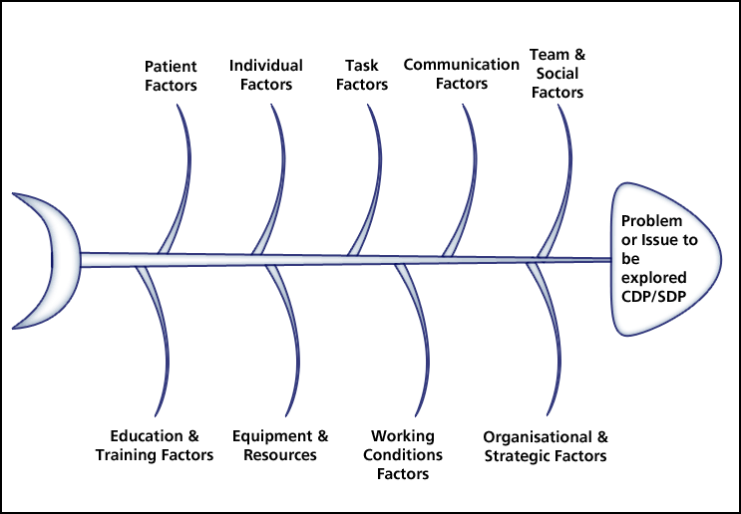

**Appendix Five (continued)**

**Five Whys**

**Issue:**

Why?

Why?

Why?

Why?

Why?

**Appendix 6**

**Example Action Plan**

|  |  |  |  |  |  |  |
| --- | --- | --- | --- | --- | --- | --- |
| **Root Cause** | **Action to Address Root Cause** | **Action to be Completed By** | **Deadline for Action Completion** | **Resource Required** | **Evidence of Completion** | **Date Action Completed** |
|  |  |  |  |  |  |  |
|  |  |  |  |  |  |  |
|  |  |  |  |  |  |  |
|  |  |  |  |  |  |  |
|  |  |  |  |  |  |  |
|  |  |  |  |  |  |  |
|  |  |  |  |  |  |  |
|  |  |  |  |  |  |  |
|  |  |  |  |  |  |  |
|  |  |  |  |  |  |  |
|  |  |  |  |  |  |  |
|  |  |  |  |  |  |  |
|  |  |  |  |  |  |  |
|  |  |  |  |  |  |  |
|  |  |  |  |  |  |  |
|  |  |  |  |  |  |  |
|  |  |  |  |  |  |  |
|  |  |  |  |  |  |  |
|  |  |  |  |  |  |  |
|  |  |  |  |  |  |  |
|  |  |  |  |  |  |  |
|  |  |  |  |  |  |  |
|  |  |  |  |  |  |  |
|  |  |  |  |  |  |  |
|  |  |  |  |  |  |  |
|  |  |  |  |  |  |  |
|  |  |  |  |  |  |  |
|  |  |  |  |  |  |  |
|  |  |  |  |  |  |  |
|  |  |  |  |  |  |  |
|  |  |  |  |  |  |  |
|  |  |  |  |  |  |  |
|  |  |  |  |  |  |  |
|  |  |  |  |  |  |  |
|  |  |  |  |  |  |  |
|  |  |  |  |  |  |  |
|  |  |  |  |  |  |  |
|  |  |  |  |  |  |  |
|  |  |  |  |  |  |  |
|  |  |  |  |  |  |  |
|  |  |  |  |  |  |  |

**Acknowledgements**

With thanks to

National Patient Safety Root Cause Analysis Toolkit

Verita , Training in Systematic Investigation Using Root Cause Analysis