Root Cause Analysis
This root cause analysis template is an analytical framework to assist in the understanding of the root causes of an issue and and assists in determining corrective actions to prevent the issue in the future. After filling in the Issue Information section the remainder of the template is used in an iterative manner. Working through each section should trigger a deeper understanding of the other sections and will allow an iteratively deeper analysis. The analysis can be conducted either through direct authoring of the document or through a facilitated face to face sessions where the template will be completed after the fact.

Discussion of this template is available at <http://use-cases.org>.

Issue Information
This information is static for the issue and should be historical fact or immutable information.
Title
References
Description
Occurrence Date
Impact
RCA Owner

Issue Narrative
The issue narrative is a textual description of the issue and how it occurred. The narrative is intended to ground the reader in the background, the issue and the impact. It can be a mix of timeline, external event and other descriptions of the issue.

Timeline
If appropriate include a timeline of events that occurring around this issue. Include any relevant points in time and the parties involved in that time. Granularity of the timeline is relative to the type of issue and granularity of supporting data.
Time | Involved Parties | Description

Modified Ishikawa Analysis
The analysis is recommended to be a mixture of a modified Ishikawa diagram and 5-Why style analysis. The factors presented have been modified from the traditional manufacturing factors to suit the software domain. Ensure that each factor is examined individually and that the 5-Why analysis remains correct both backwards and forwards. Use a whiteboard to draw and analyse and include an image in the document.

If the recommended analysis framework is not used, replace this section with the root cause method used.

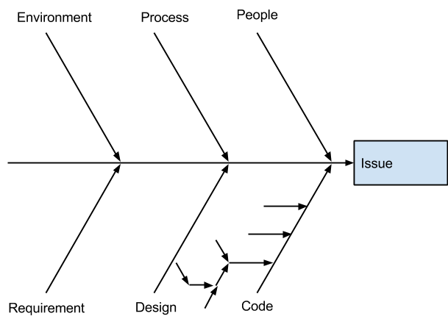

Corrective Actions
The analysis above will generate a set of improvements or corrective actions to continue organizational improvement and prevent the issue or similar issues occurring in the future. The priority of a corrective should be forced ranked to drive appropriate actions.

Pri | Owner | Description | Implementation Target

