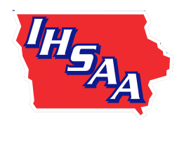
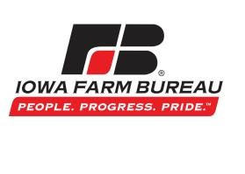
Class 2A

2018 State Basketball Tournament

(1) Trainer

4
:3
0

Monday

3
/
5

(8)

Wapello

6
:
3

0
Wednesday

3
/
7

(4)

South Hamilton, Jewell

6
:
30

Monday

/
3
5

(5)

Aplington
-
Parkersburg

3
:
4

5
Friday

/
3
9

(2)

Sheldon

8
:
15

Mon
day

/
3
5

(7)

Kuemper Catholic
, Carroll

8
:
1
5

Wednesday

/
3
7

(3)

Van Meter

9
:
30

Tuesday

/
3
6

(6)

Cascade
, Western Dubuque

1
2
:
1

5
Thurs
day

/
3
8

