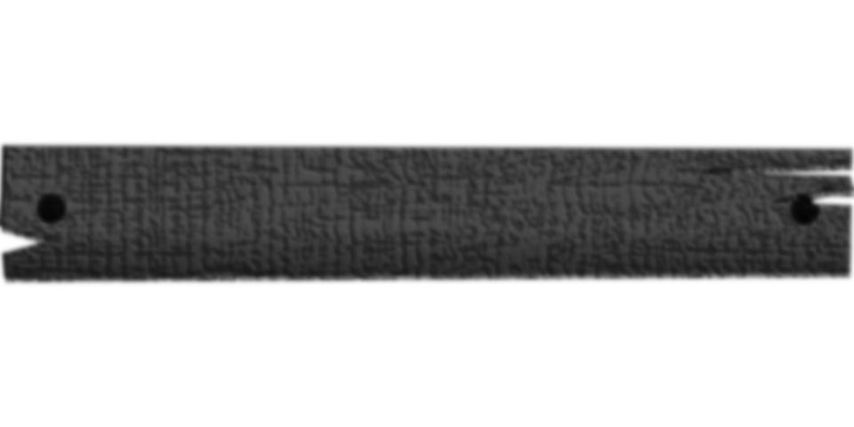

**$2,000.00**

REWARD

**WILSON ASOON**

WANTED

DEAD OR ALIVE

**FOR KIDNAPPING AND ROBBERY**

**IF FOUND CALL 0934**