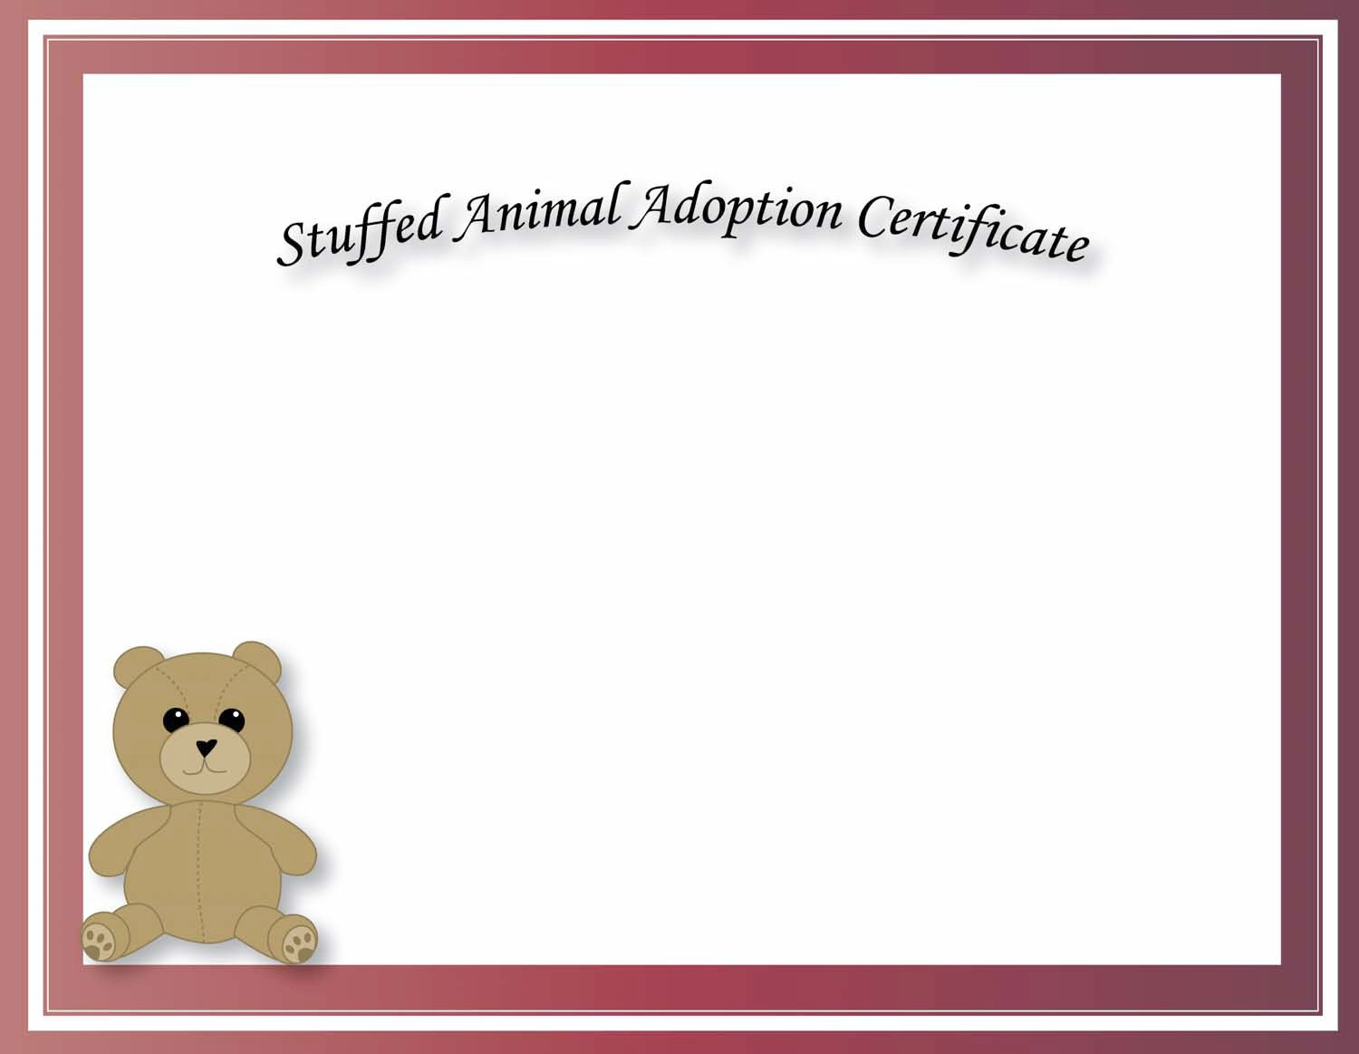

This Is To Certify That

Has Adopted

On

At

