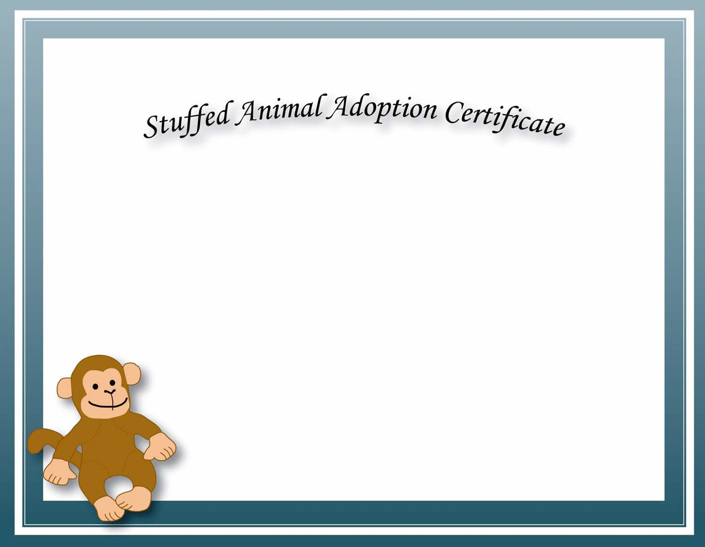

This Is To Certify That

Has Adopted

on

at

