Producer
Director
PM

Breakfast
Lunch
Sunrise
Sunset
Weather
Nearest Hospital

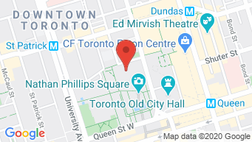
CALL
Additional Notes:

Parking instructions: Street parking available

SCENES | SET AND DESCRIPTION | CHARACTER # | D/N | PAGES | LOCATION/NOTES
 |  | Total Pages:

# | CAST | CHARACTER | CALL TIME | SPECIAL INSTRUCTIONS
1
2
3
4
5
PRODUCTION NOTES

POSITION | NAME | PHONE | EMAIL | CALL TIME
Producer
Director
PM
Dir. of Photography
Cam OP

