Please note a ‘Souvenir Booklet’ is not a requirement for an official opening ceremony.
School to resource graphic designer and collate background information, photographs, etc.

Sample Souvenir Booklet

Eglinton Primary School

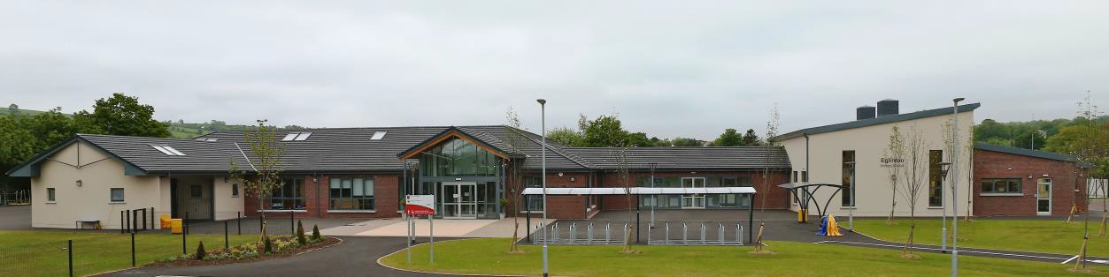
Official Opening

Insert Date
by
Insert Name, MLA Minister for Education

FOREWORD

On behalf of the Principal, Board of Governors and staff, it gives me great pleasure to welcome each and every one of you. Today is a very special day in the history of our school and I am delighted that you have been able to attend our official opening. We are immensely proud of our beautiful new school build, Eglinton village now has a state of the art school fit for 21st century teaching and learning.

The Board of Governors would like to convey their thanks to the officers of the former Western Education and Library Board involved in the project, along with those that completed the process in the newly formed Education Authority and in particular Ms Iris Barker, who was extremely helpful and supportive in the early days.

Mr Peadar Murphy, Mr Donal Coyle and Mr Brian Morrow, Design Section, Property Services Division, and the Contractors Woodvale Construction Ltd are to be congratulated not only on the high standard of workmanship but also on delivering the project six weeks ahead of schedule.
Mr Eugene McMenamin, site manager must be thanked for the meticulous manner in which he attended to every aspect of the work during this time.

We acknowledge the valuable input received from the Department of Education through the design and build process; especially for making available the necessary funding to bring the project to completion. We thank the Department for entrusting our school with this financial investment especially during such a challenging economic climate. Our school community is greatly encouraged by this investment and the boost it has given to our educational provision. We are truly delighted with this bright, modern fully equipped building to support high quality teaching and learning.

It was a slow and lengthy process to get us thus far and today sees the fruition of the vision of many who worked towards the opening of this new school. It will serve this community for many years to come and to all who helped make this happen, we are truly grateful.

Finally, sincerest thanks and congratulations are due to Mrs Lorna Blair, Principal, along with the entire staff of the school for the professional manner in which they made a seamless transition to the new building. We are grateful to each and every one of you that embraced this challenge with such a willing heart. You now have the pleasure of working in an enviable learning environment with resources that are second to none.

Chairperson of the Board of Governors

OFFICIAL CEREMONY

Music on arrival by …………….. Primary School Strings Group

Welcome

………………….
Principal

Opening Remarks

……………..
Chairperson, Board of Governors

Guest Speaker

Minister …………….., MLA Minister for Education

Closing Remarks

……………….
Education Authority

Prayer of Thanks

……………
Former Chairperson, Board of Governors

Vote of Thanks and Presentation

Presentation by ………….. Y7 and ……………. Y7

Entertainment by ……………… Primary School Pupils

Tour of the School

Refreshments in the Assembly Hall

GUEST OF HONOUR

Insert
Photograph

……………, MLA Minister for Education

Background information available from DE website.

BOARD OF GOVERNORS

Chairperson

Vice-Chairperson

Nominated by the Transferors

Nominated by the
Education Authority

Elected by Parents

Elected by Teaching Staff
Principal (Non-Voting)

School Staff

Teaching Staff

Year 7
Year 5
Year 4
Year 3
Year 2
Year 1
Nursery

Clerical Officer

Building
Supervisor

Cleaners
Classroom Assistants

Foundation Stage

Special Needs

Nursery Assistant

Kitchen Staff

Supervisory
Assistants

HISTORY OF EGLINTON PRIMARY SCHOOL

On Thursday 30th September 1954, guests were invited to attend the Opening of Eglinton New Primary School. The new school had been designed by Mr Noel E Campbell, the County Education Architect and was opened by the Mr D. Hall Christie, Chairman of the County Londonderry Education Committee. The school, which was built to accommodate 200 pupils, consisted of five classrooms, an assembly hall, a canteen and an Administrative wing. The total cost was £33,000. It had a heating system, believed to be the first of its kind in Northern Ireland, which worked by means of hot water circulated through heaters and blown into classrooms by electric fans, working on the principle of a car radiator. The primary reason for the erection of the school was because of the increase in numbers attending school in the area – partly due to normal housing developments and partly due to the construction of married quarters at the RNAS Station at Eglinton.

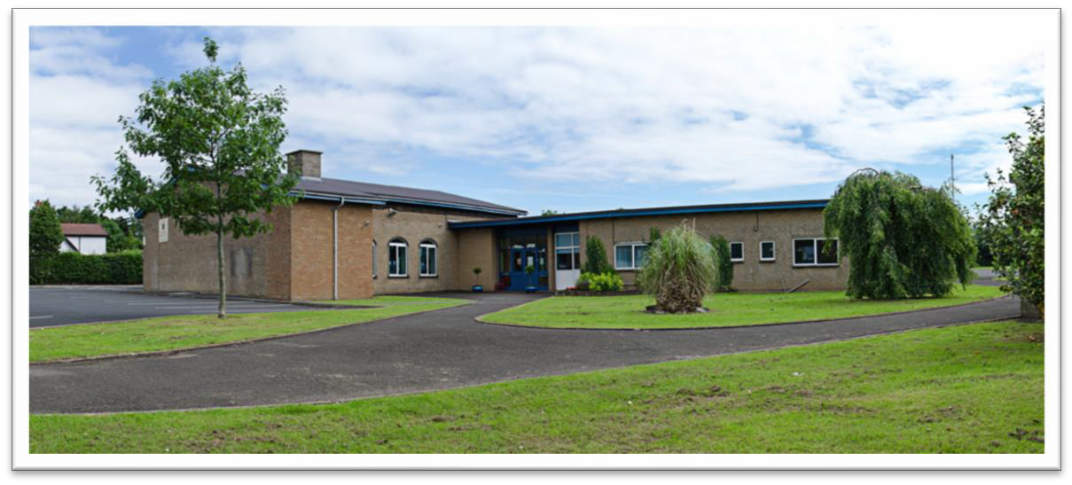

The Principal at this time was Mr A T Robbins and Rev C Morgan, Chair of the Education Committee.

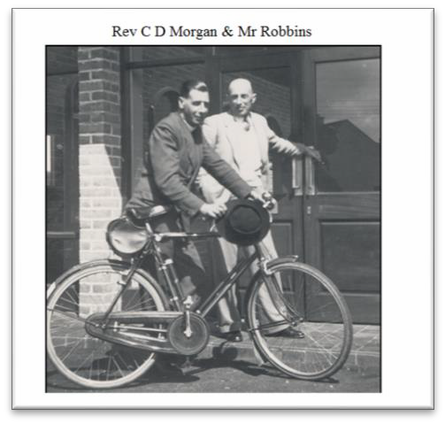

The new school replaced Eglinton Public Elementary School which dated back to 1886. It was located in Main Street in the village. Numbers had grown so much that the original building could no longer accommodate enrolment and an overflow of pupils were taught in the local Orange Hall.

One of the oldest buildings in the village today is the Erasmus Smith schoolhouse erected in 1812 beside the old national school of 1886, both are now private residences.

OUR NEW SCHOOL BUILD

On Friday 8th May 2016, the keys for another new Eglinton Primary School, were handed over.

In 2014 the Department of Education announced that £2.6m (later increased to £3 million) was being made available to build a new school on the existing site. An additional £293,000 was provided for furniture and equipment. Minister for Education, John O’Dowd, cut the first sod on Thursday 18th June 2015. The contractors, Woodvale Construction Ltd., took over the site and ensured that building work progressed without delay. Less than one year later staff and pupils moved into a state of the art new building.

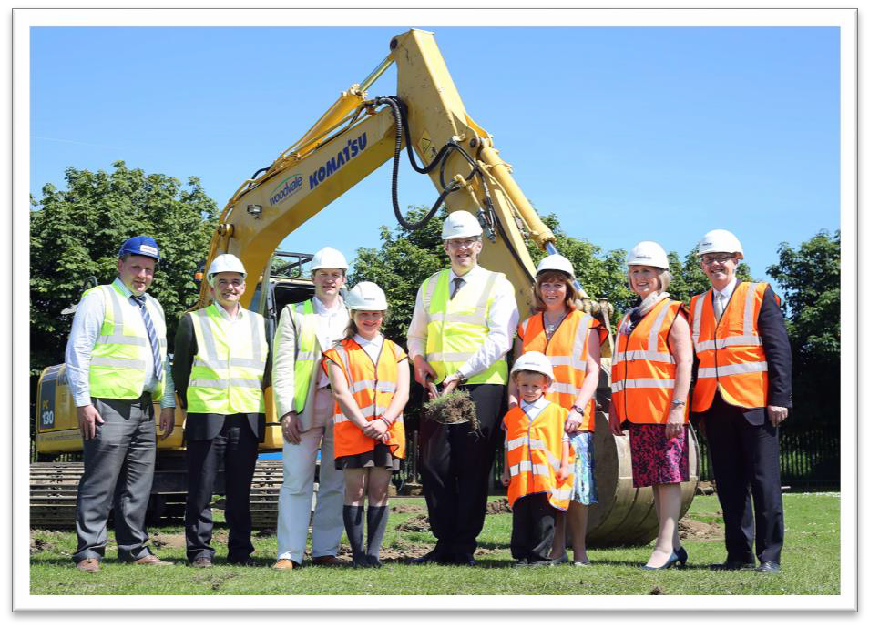

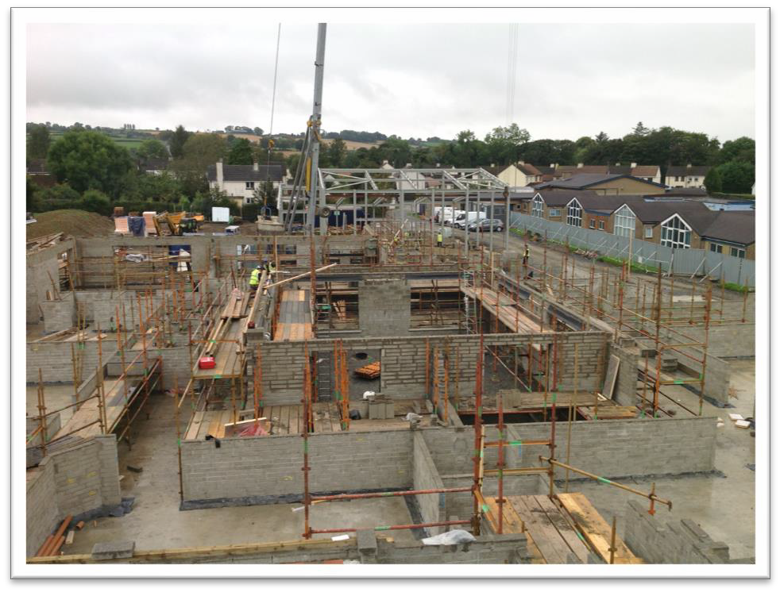

LEARNING EXPERIENCE

During the building process pupils had the opportunity to visit the building site bedecked in high viz vests and protective head gear. Site tours highlighted the properties of building materials, renewable energy, recycling, design and many other World Around Us topics. Pupils were fully engaged during these tours and it had a positive impact on the pupils' learning.

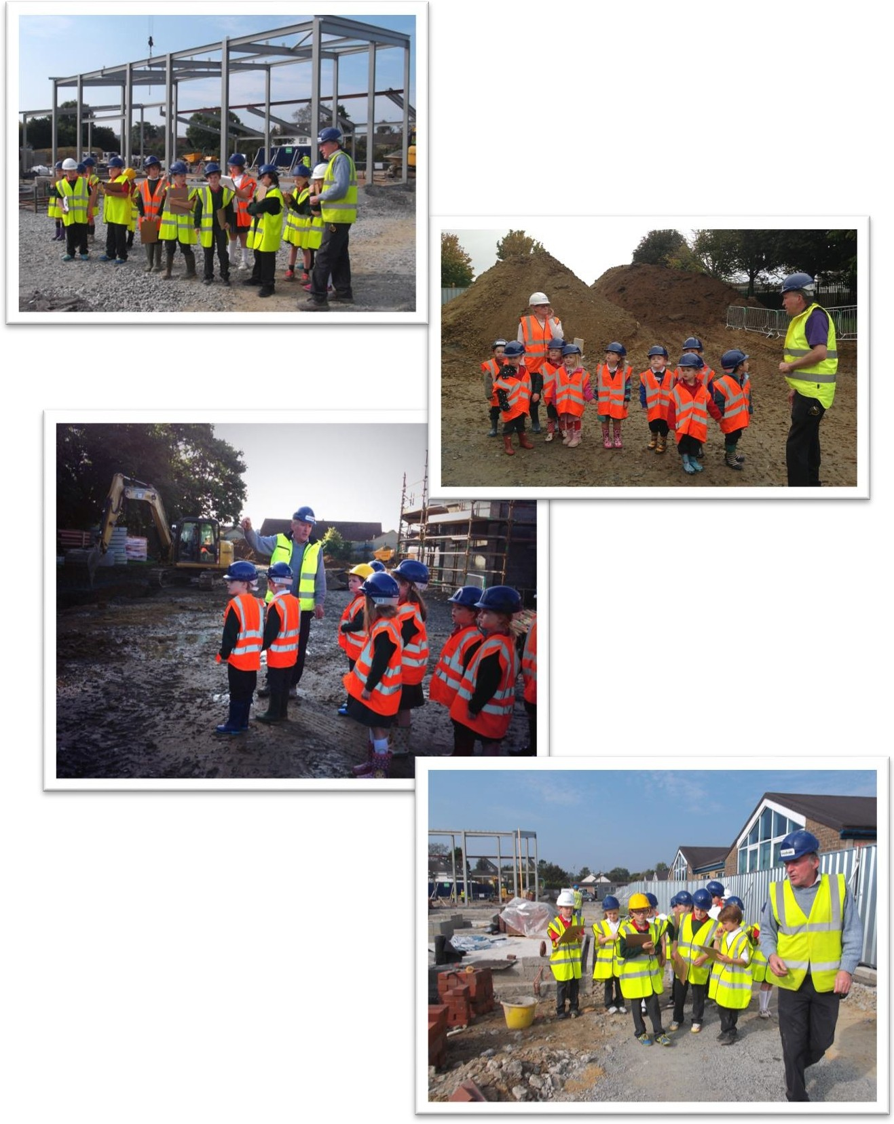

OUR NEW SCHOOL

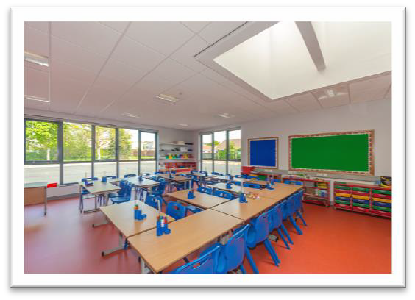
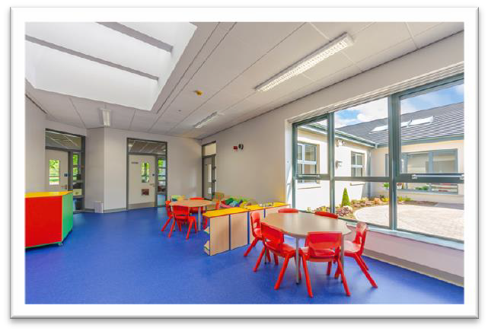
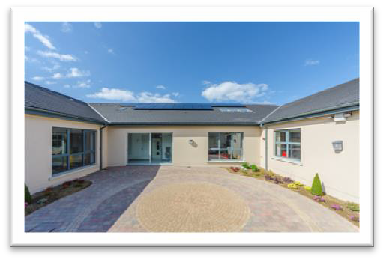
The new school has 8 classrooms clustered around an internal courtyard area which provides natural light to the corridor, Resource Areas and our Library. The classrooms are in three zones, Foundation Stage, KS1 and KS2, each zone having its own allocated Resource area and stores. These areas are active shared learning hubs.

There is also a Medical Inspection Room, a Hygiene room and a modern staffroom. Pupils have access to Changing room facilities located beside our Assembly Hall.

The Multi-Purpose room, is currently used as a Music Room, space for Circle Time and Foundation Stage Assembly. There are two smaller multi-purpose rooms which are invaluable for accommodating outside agencies and small group work.

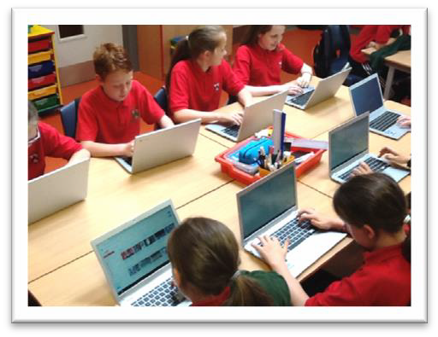
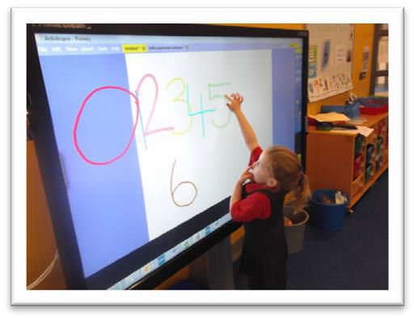

Each classroom is fully equipped with the latest educational resources including ICT provision. Staff and pupils now have access to Touch screens, enhanced C2k wireless provision, class sets of Chromebooks and iPads, along with additional laptops.

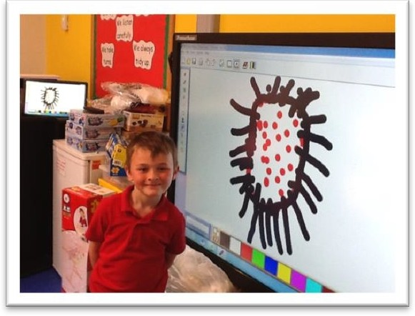
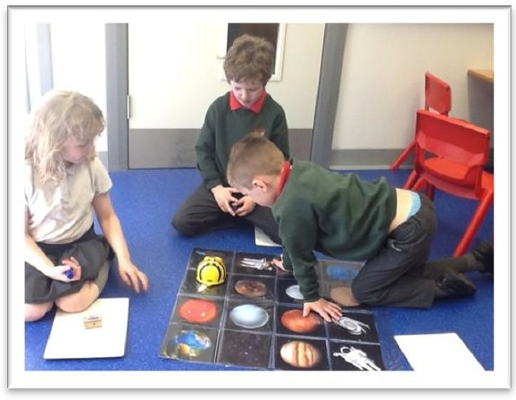
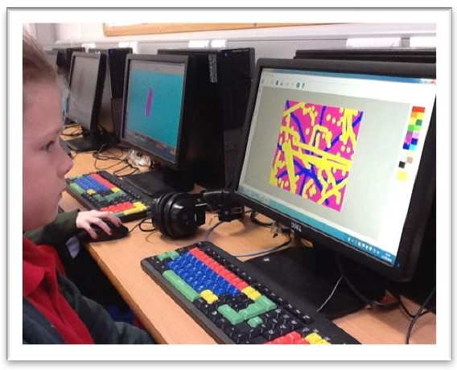
PUPILS ENJOYING THEIR NEW SCHOOL

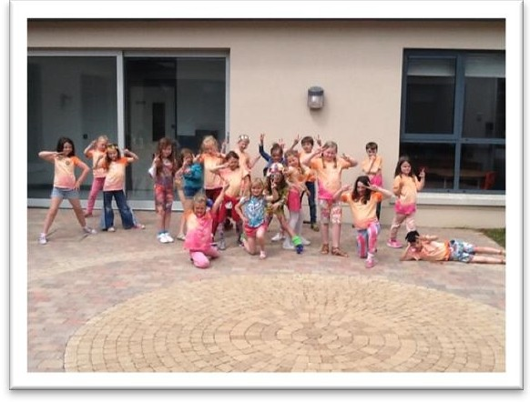

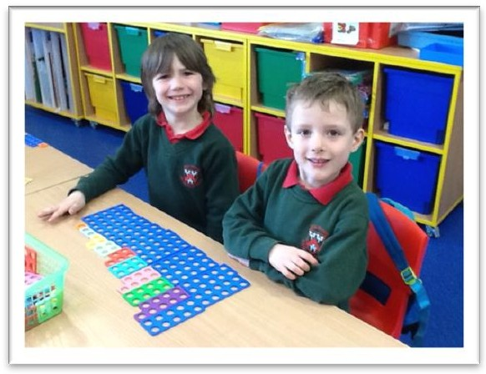

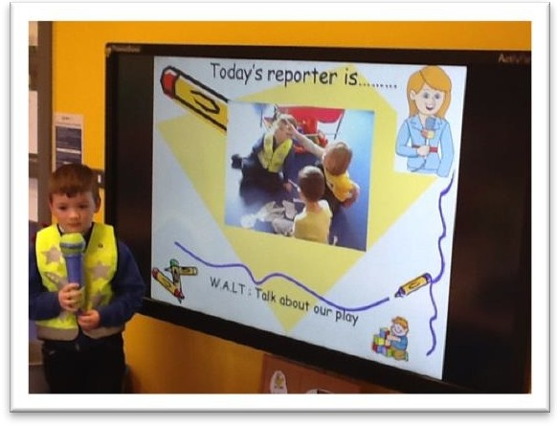

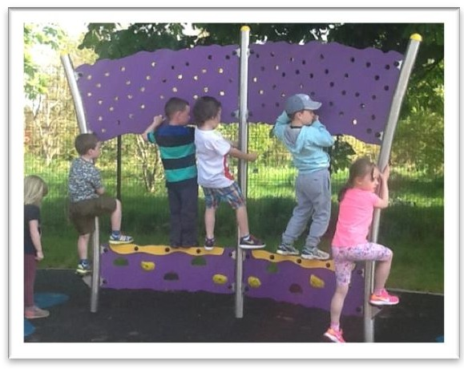

Eglinton Primary School – Floor Plan

Class Base 5 Class Base 6 Class Base 7 Class Base 8

Class Base 4
Resource
Base 2
Resource
Base 3

MI Room

Class Base 3
Multi- Purpose Room 2

Multi- Purpose Room 1

Resource
Base 1

Landscaped
Courtyard

Library

Pupil
Changing

Pupil
Changing

Multi- Purpose Hall

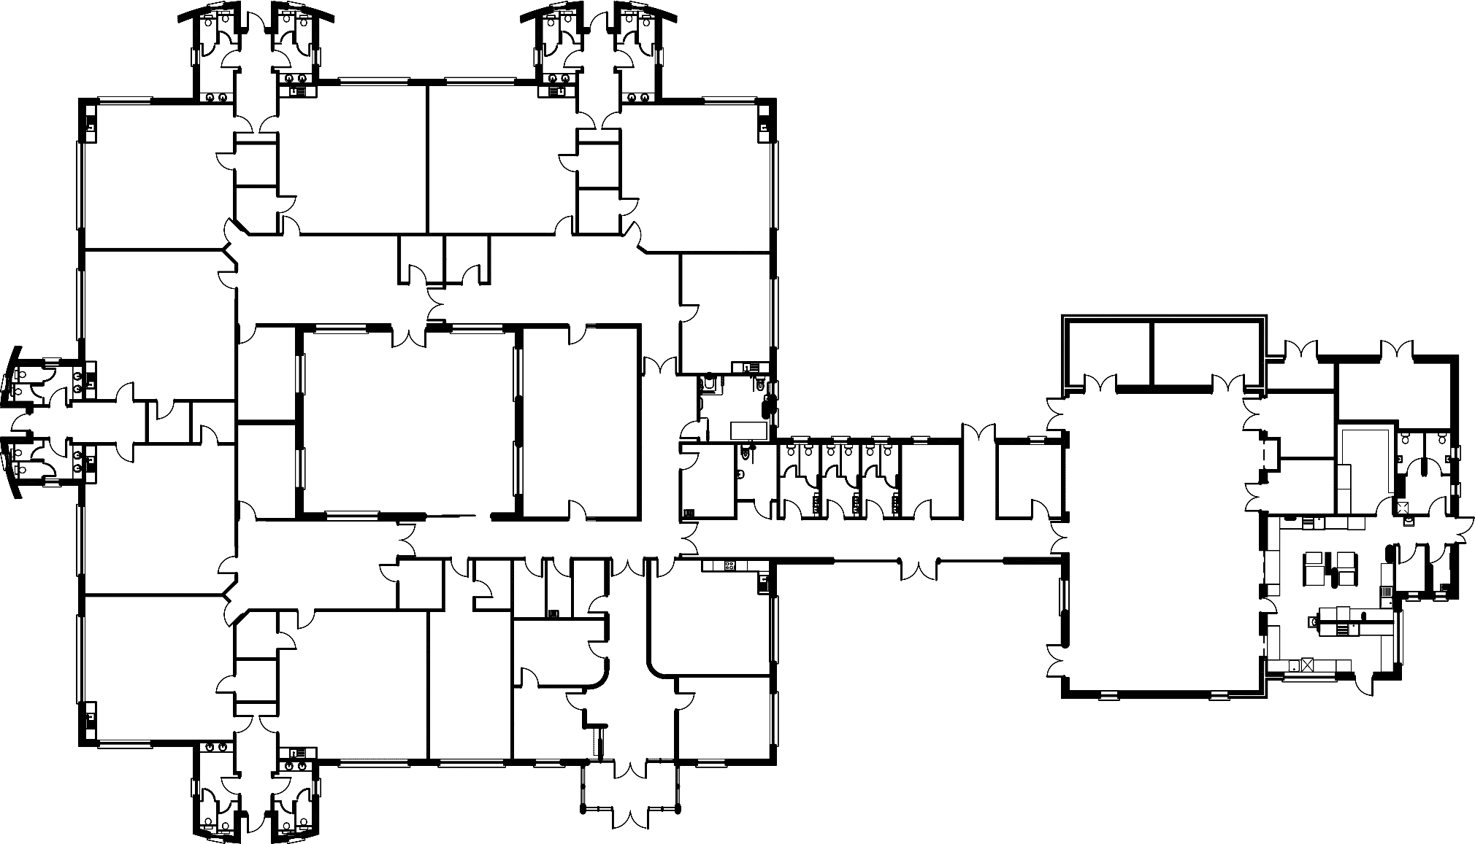
Together We Grow
Class Base 2 Multi- Purpose
Room 1

Foyer
Staffroom

Principal’s
Office

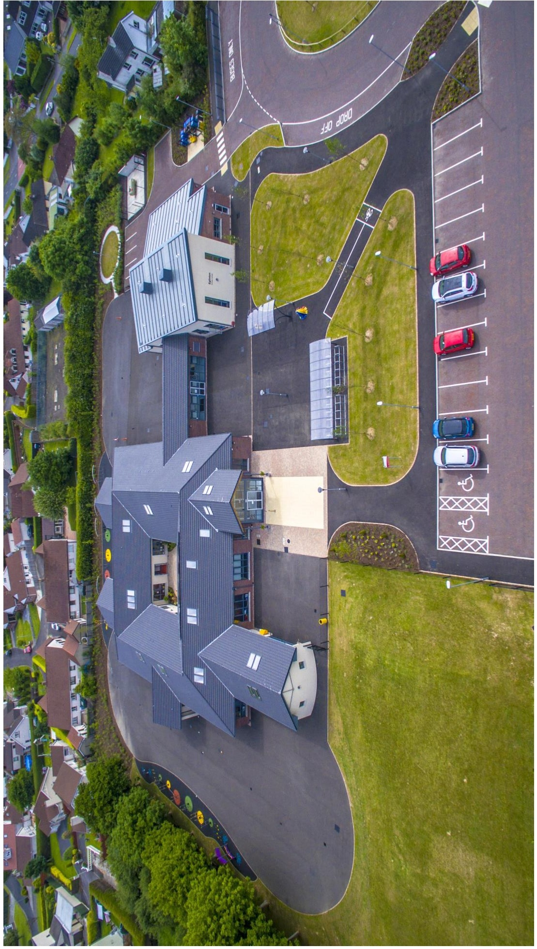

DESIGN AND CONSTRUCTION TEAM

Client Consultants:

EA Project Managers:

Architectural Consultant:
Partners Structural Engineers:
M&E Engineers:

Contractors:

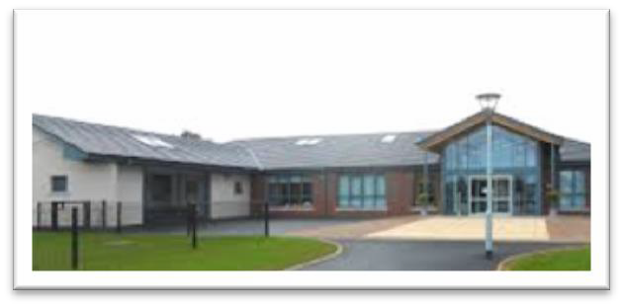
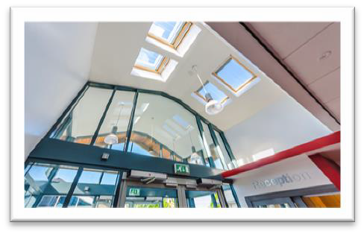
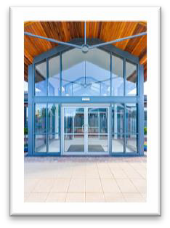
Main Contractor:
Electrical Subcontractor:
Mechanical Subcontractor:

The Board of Governors, staff and pupils of ………….. Primary School would like to take this opportunity to sincerely thank all those who played a part in our building project which has significantly enhanced the quality of our school building and educational provision.

Eglinton Primary School

22 Woodvale Road, Eglinton, Londonderry

Tel No: 028 7181 0510 - Fax no: 028 7181 2297 email: info@eglinton.londonderry.ni.sch.uk

