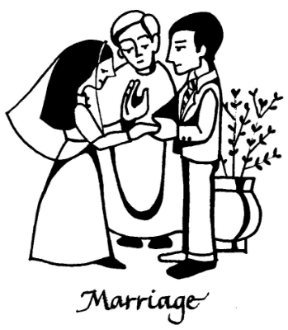

**Our Wedding Mass**

***Mary & Joseph***

**St. ???? Church**

**Date**

**WEDDING PARTY**

**Celebrant:** *Fr. ???*

**Bride:** *??*

**Groom:** *??*

**Bridesmaids:** *??*

*??*

**Best Man:** *??*

**Groomsman:** *??*

*??*

**Flower Girl:** *??*

**Page Boy:** *??*

**Readers:** *??*

*??*

**Prayers of the Faithful:** *??*

*??*

*??*

*??*

**Communion Reflection:***??*

**Music:** *??*



**Entrance:**

(Song)

**MCj03293070000[1]**

**INTRODUCTORY RITE**

**Ceremony of Light** *(Optional)*

(Song)

**MCj03293070000[1]**

*?? and ?? each light a candle*

*as a sign of their individual lives*

*which will soon become one in the bond of marriage*

**PENITENTIAL RITE**

**Opening Prayer**

**LITURGY OF THE WORD**

**First Reading**

**???????????????????????????????????**

??????????????????????????????????????????????????????????????????????????????????????????????????????????????????????????????????????????????????????Insert chosen First Reading here ?????????????????????????????????????????????????????????????????????????????????????????????????????????????????????????????????????????????

The Word of the Lord.

All:Thanks be to God.

**Responsorial Psalm**

(Song)

**MCj03293070000[1]**

**Second Reading**

**????????????????????????????????????????**

????????????????????????????????????????????????????????????????????????????????????????????????????????????????????????????????????????????????????????????????????????????????????????????????????????????????????????????????????????????????Insert preferred Second Reading here ???????????????????????????????????????????????????????????????????????????????????????????????????????????????????????????????????????????????????????????????????????????????????????????????????????????????????????????????????????????????????????????????????????????????????????????????????????????????????????????????????????

The Word of the Lord.

All:Thanks be to God.

**Gospel Acclamation**

Alleluia

MCj03293070000[1]

**Gospel**

**?????????????????????????????????????????????**

??????????????????????????????????????????????????

?????????????????????????????????????????????????

????????????????????????????????????????????

??????????????????????????????????????????????????

???????????????????????????????????????????????????

???????????????????????????????????????????????????

Insert Gospel of your choice here

??????????????????????????????????????????

????????????????????????????????

??????????????????????????????????????????????

?????????????????????????????????

?????????????????????????????

??????????????????????????????????????????????

???????????????????????????????????????????????????

???????????????????????????????????????????????????

???????????????????????????????

1. The Gospel of the Lord.

All:Praise to you, Lord Jesus Christ.

**Homily**

**RITE OF MARRIAGE**

*Choose from options attached*

?

?

?

?  
?

?

?  
?

?

?

**Declaration of Consent**

?

?  
?

?  
?

?

?  
?

**Blessing of the Rings**

??

?

?  
?  
?  
?  
?  
?  
?  
?  
?  
?  
?  
?  
?

?

?

?

?

?

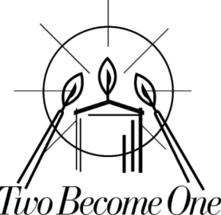

**Candle Ceremony** *(Optional)*

(Song)

MCj03293070000[1]

*?? and ?? now light a single candle from their individual candles to signify their new life together*

Prayer for the Newly Married Couple *(Optional)*

?

?

?  
?  
?  
?  
?  
?

**PRAYERS OF THE FAITHFUL**

*?*

*?*

*?  
?  
?*

*?  
?  
?*

*?  
?  
?  
?  
?  
?  
?  
?  
?  
?  
?  
?  
?  
?  
?  
?  
?  
?*

*?*

*?  
?  
?  
?*

*?*

*?*

*?  
?  
?  
?  
?  
?  
?*

**Offertory Procession**

(Song)



**LITURGY OF THE EUCHARIST**

**COMMUNION RITE**

**Nuptial Blessing**

**Sign of Peace**

(Song)

MCj03293070000[1]

**Communion**

(Song)



**CONCLUDING RITE**

**Signing of the Marriage Register**

(Song)

MCj03293070000[1]

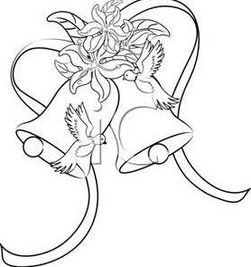

**Recessional**

(Song)