Mass of the Resurrection

[NAME]

Born into Life
[Insert Birth Date]

Entered into Eternal Life
[Insert Date of Death]
presider [INSERT Name]

prelude jesus, remember me

introductory rites

greeting/welcome

sprinkling with holy water

placing of the pall

processional hymn You are mine haas

opening prayer

liturgy of the word

first reading [Insert scripture Reference]

responsorial psalm shepherd me, o god haugen
second reading [Insert scripture Reference]

gospel acclamation

gospel [Insert scripture Reference]

homily

prayers of the faithful
liturgy of the eucharist

preparation of the gifts

the eucharistic prayer

communion rite

The lord’s prayer

the lamb of god

communion hymn on eagle’s wings
Joncas

post communion meditation (If Desired) Ave Mara
oR
Notre Dame Alma Mater
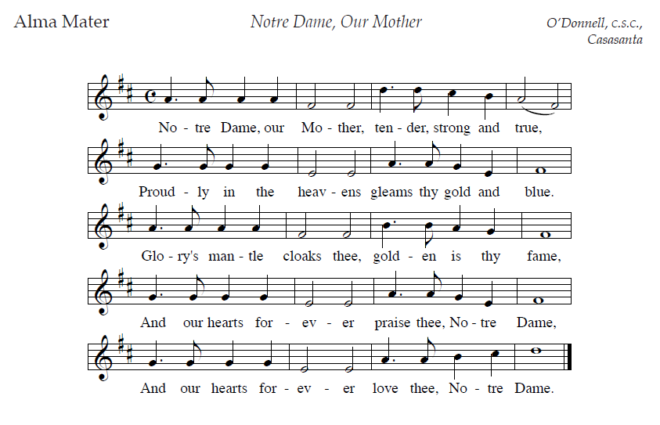
Eulogy
concluding rite

final commendation Song of the angels dufford
refrain:
may the songs of the angels welcome you
and guide you along your way.
May the smiles of the martyrs greet your own as darkness
turns into day.
every fear will be undone and death will be no more,
as songs of the angels bring you home before the face of
god.
recessional hymn we shall rise again Young

you could include some or all of the following on the back page of the Mass Program:

* insert a picture of your loved one, a biography, a story, etc.

*instructions to the cemetery if all are welcome. if you prefer that just family go to the cemetery, indicate that here.

* Instructions/directions to a Luncheon or other social gathering

