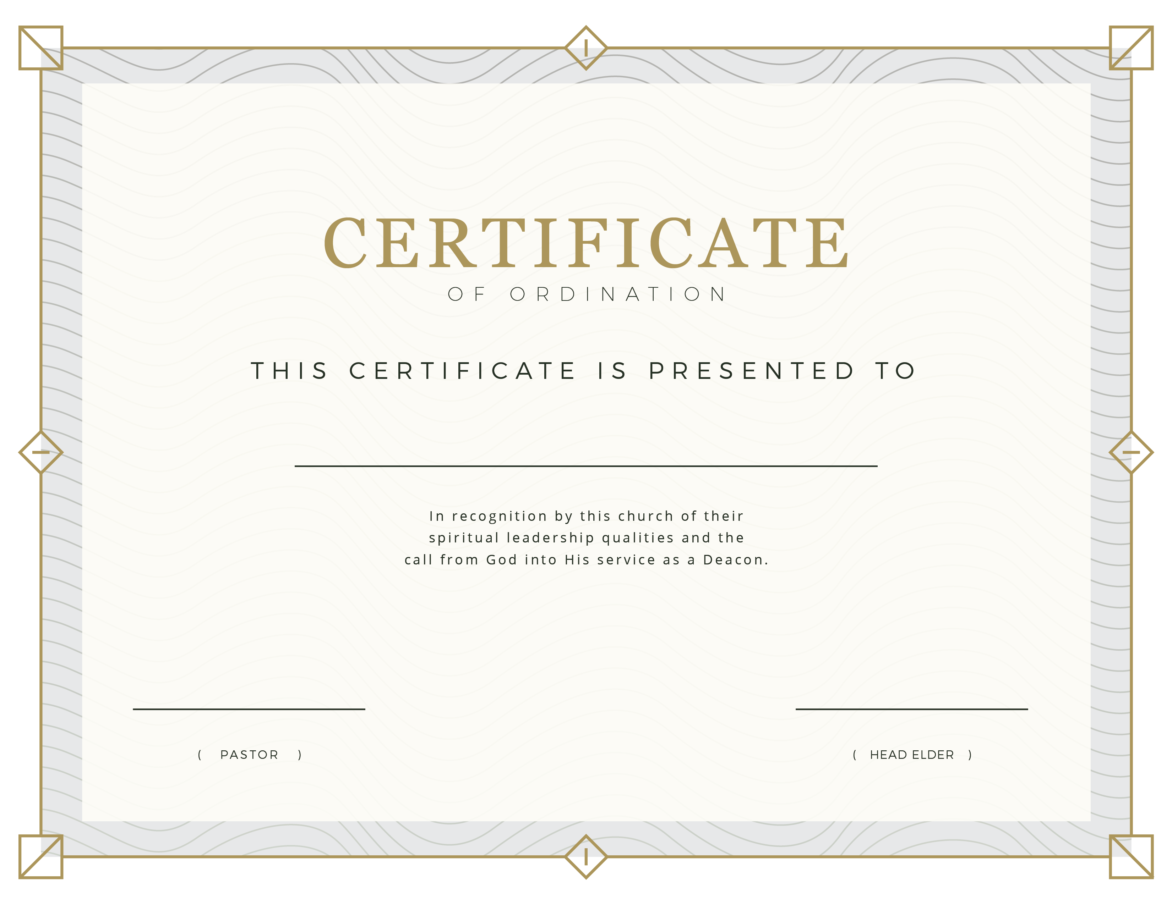

Local Seventh-day

Adventist Church

FEBRUARY, 25 I 2018

BOB SMITH

FRED SOMEBODY

John Smith