
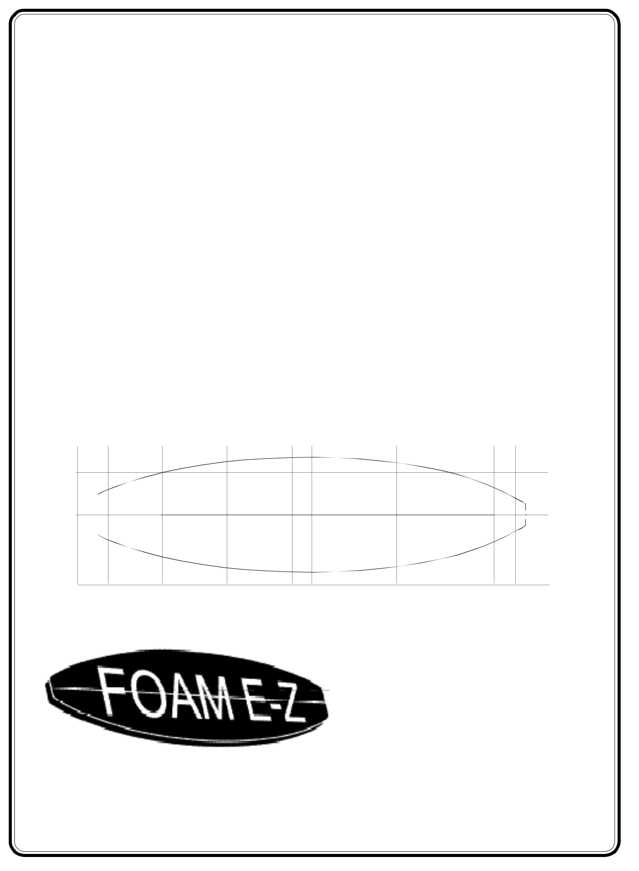


S u r f b o a r d

B l a n k

C a t a l o g

FOAM E-Z

6341 Industry Way #I

Westminster, CA 92683

Phone (714) 896-8233

Fax (714) 896-0001

www.foamez.com

Catalog current as of

October , 2004

1

TABLE OF CONTENTS

INTRODUCTION..................................... | PAGE 1
PURPOSE ................................................. | PAGE 1
CURRENT VERSION OF CATALOG.... | PAGE 1
DESCRIPTION OF BLANK PICTURES.. PAGE 1
DENSITY INFORMATION ..................... | PAGE 2
STRINGER INFORMATION .................. | PAGE 3
ROCKER INFORMATION ..................... | PAGE 3
INVENTORY MANAGEMENT TOOLS . PAGE 6
MATERIAL SAFETY DATA SHEET .... PAGE 7
BLANK CODE DESCRIPTION .............. | PAGE 9
.
REPLACEMENT BLANK LIST ............. | PAGE 10
BLANK PICTURES ................................ | PAGE 13

INTRODUCTION

CLARK FOAM has a commitment to maintain the capability of manufacturing on a custom order basis a wide variety of blank sizes, weights, types of stringers (including extra wide) and stringer combinations, glue colors, and rockers.

PURPOSE

The main purpose of this catalog is to assist shapers in finding the best possible blank to:
- Minimize shaping time
- Use lightly skinned blanks for stronger boards
- Attain the proper rocker
- Insure prompt delivery of orders
- Purchase the cheapest possible blank

CURRENT VERSION OF CATALOG

At CLARK FOAM we are constantly building new molds and throwing away obsolete molds. When we build a new mold we mail all customers on our mailing list a picture of the new mold and add it to our catalog. When a mold is declared obsolete we remove it from our catalog. From time to time we also update some of the data such as “factory stocking,” “limited volume charge,” “comments,” etc.

As a consequence our catalog is often changed. We therefore do not produce a lot of catalogs in ad-vance but instead, make them as we need them. On the lower right corner of the front page we put the date the catalog was printed. At the date of printing the catalog is current. Keep in mind that a few days later it might be changed. We realize the impor-tance of keeping customers updated on new close tolerance blanks, as they save the shaper a lot of time. We have a considerable investment in this technology, and for this reason, we encourage shapers to request a current version of our catalog as often as they wish.

DESCRIPTION OF BLANK PICTURES

TO-SCALE BLANK PICTURES

All blank pictures in this catalog are drawn to the actual scale of the blanks. The blanks under 9 feet are on a scale of 1 to 12 and the blanks 9 feet and longer are on a scale of 1 to 16. The rocker is taken from the “natural” rocker template and is also to scale. The “cross-section” drawing shows the rails at the center or widest point of the blank as well as a line representing roughly the outside of the rail of the blank all the way around the blank.

MEASUREMENTS

All measurements are given in English Units fol-lowed by Metric Units. The measurements along side the blank picture showing width and thickness and rocker are spaced 12 inches apart starting at the nose and tail. There is also a measurement at the very center of the blank. For example the second measurement from the bottom on the far left would represent the width 24 inches from the tail of the blank. The middle measurement on the far left would be the width at the center of the blank. The nose and tail rockers are measured from the bottom of the blank to the bottom of the nose and the bottom of the tail.

As a note the width of the tail block and the nose of a square nose blank are very arbitrary figures. It is difficult to decide how they should be measured. Furthermore there is some unpredictable shrink-age, growth, rough rails, etc. which make some measurements vary from blank to blank.

INDIVIDUAL BLANK INFORMATION

Each blank picture will contain the following infor-mation:

2

Length: Both the overall bottom length and the tip-to-tip deck length are provided for multiple measurement methods.

Maximum Width & Thickness: These will help you determine where the wide point and maximum thickness of a blank is in relation to the center point.

Displacement: This is the cubic feet and meters of foam in the unshaped, stringerless blank. It is measured by the very accurate water displacement method. For the designer this figure more or less indicates the overall thickness profile of one blank relative to another and the flotation of a lightly shaped blank. There are some other potential uses of this measurement.

History: We attempt to review the overall sales record and/or the age of the blank. This is often deceptive as certain blanks are limited to geo-graphic areas or special performance boards.

Rocker: We list, in order of popularity, what our staff speculates are the most commonly used rock-ers. Some rockers listed are recommendations of the plug shaper. “Natural” is the rocker put in by the designer of the blank and the reference point for the catalog measurements. All other rockers are referenced in inches from “natural” by indicating “

- inches” or “ - inches” and “N” for nose and “T” for tail. (For example + 1 1/4" N / - 1/2" T would indicate one and one quarter inch more nose rocker than “natural” and one half inch less tail rocker than “natural.) A letter listed at the end of a rocker measurement indicates the rocker was adjusted other than from center. A rocker catalog is avail-able per request with a complete list of all rocker templates currently available.

Factory Stocking: This is a brief summary of our stocking goals for the blank. It is for the purpose of indicating the type of delivery that can be expected for a particular size. There is no comment indicat-ing the weight (density) we will stock. The high volume blanks are usually being produced on a continuous basis so availability in any weight should be no problem. Information is available at all times on what is in stock and the date we expect to resume production of a specific slower moving size. Our policy is to maintain at least a small inventory of all blank sizes at the factory. All factory stocking is unglued.

Limited Volume Charge: Due to operating costs, we place a surcharge on blanks which we sell in limited volume. We occasionally review this sur-

charge for a change in demand and adjust the price without notice. In choosing a blank, consider the difference in price between a blank with no sur-charge and a similar size blank with a surcharge. We base the surcharge on our maximum discount.

Blanks Per Box: This tells the number of blanks which will fit in a box. Orders which are to be shipped by box should always be made in multiples of the number of blanks which will fit in a box .

Shaper's Comments: Normally this will be the original designer/shaper’s comments on the blank and its original intended use. Experience has shown that different shapers find different uses for the same blank so it is suggested that in addition to reading the comments you carefully study the “to scale” pictures, dimensions, etc.

DENSITY INFORMATION

As part of our commitment to manufacture blanks on a customer order basis, we offer the following weights in all blank sizes:

SUPERGREEN, the heaviest/strongest of the four stock weights.

SUPERBLUE, approximately 5% lighter than Supergreen.

NEW SUPERLIGHT, approximately 9.5% lighter than Supergreen.

ULTRALIGHT, approximately 12% lighter than Supergreen. This is our experimental weight and is subject to density or weight change without notice.

We also offer the three older high density formula-tions and a new tow-in weight on a custom order basis:

CLASSIC, approximately 8.5% heavier than Supergreen.

LIGHT, approximately 22.5% heavier than Supergreen.

REGULAR, approximately 38.5% heavier than Supergreen.

TOW-IN, approximately 185% heavier than Supergreen.

3

The chart below is supplied to put our weight range in perspective:
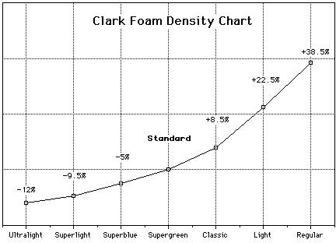

Reference

STRINGER INFORMATION

In stringers we currently offer basswood, red cedar, spruce, and balsawood. All stringer wood is milled from rough lumber at CLARK FOAM and can be made in any thickness or wedge. We also offer colored foam stringers in straight, wedged, flaired, and dia-mond shapes. We can make other shape configura-tions on request. Red cedar is available in a maximum width of 6", therefore it may not fit in many of the larger blanks requiring extra rocker. Glue is available in a wide variety of colors.

CURVED STRINGERS

In 2003 CLARK FOAM began producing for the first time CURVED STRINGERS. The equipment we use is made for high production and all CURVED STRINGER orders should have the same delivery times as regular orders. There are two types: with a center stringer and without a center stringer. The CURVED STRINGER blanks with a center stringer are more accurate and easier to process. Templates for the CURVED STRINGERS are made using the same methods as rocker templates. They are pretty easy to make. Wood stringers will bend quite a bit further than most people think they will in our glue presses. Stringer delamination can be a problem with radical curves. There are certain stringer design limitations due to the nature of our equipment. We also have a limit to the number of templates we can store at our factory. Therefore there may be a limit to the designs we can accept from customers. It is our opinion that certain curved stringer designs could have a signifi-cant impact upon board flex.

ROCKER INFORMATION

ROCKER HISTORY

Surfboard rocker has evolved from a dependence on the way a tree grew to the modern, close toler-ance blank where the rocker is very dependent on the blank manufacturer. Rocker, and especially bottom rocker, is very difficult to measure by eye. Therefore shapers historically have focused on outline, rails, deck shape, bottom shape, thickness, and other board features that are easy to see and measure. The first clue to the real importance of rocker was the so-called “magic board”. The definition of a “magic board” is a board that looks and measures just like other boards but performs a lot better than its copies. As advanced shapers began developing tools for measuring rocker and experimenting with different rockers the biggest mystery of the “magic board” was solved. Begin-ning in the late 1970’s there was a clear increase in interest in precision rocker adjustments and bottom rocker measuring tools. In the 1980’s there was a dramatic increase in the number of rockers used for individual blanks. With the development of very high strength, close tolerance blanks in the early 1990’s the majority of rocker responsibility shifted to the stringer gluing process, as there was less foam available to adjust rocker. This again in-creased the demand for rocker adjustments. In 2003 the rocker template accounting system at CLARK FOAM was put on our large computer using custom software. This was done because the number of templates required to meet the demand for custom rockers became too great to maintain manually.

WHY SO MANY ROCKERS?

There are four reasons. The first reason is that rocker adjustments can dramatically change the performance of a surfboard. Not that long ago there were very few really good surfers and surfing was pretty much limited to the classic, easy to surf wave. Today there are an incredible number of really good surfers riding everything from small, mushy waves to radical waves that could not be successfully ridden with older boards. In all types of waves the really good surfers have different styles of surfing and are constantly developing new styles and increasing the levels of performance. This puts more pressure on shapers for really good surfers know good boards from bad boards. Most of them have a pretty clear picture of what they want out of a board. Rocker, while not so obvious

4

as other board dimensions, is a key part of design. Rocker adjustments are a part of the change good surfers require. The second reason is that chang-ing the rocker can be the equivalent of building a new mold as a blank can be modified for a radically different shape. Often this saves the board builder a significant amount of money as a smaller blank can be used. Overshaping can often be reduced making a stronger, lighter board. The third reason is the fact that close tolerance blanks have shifted the majority of the rocker responsibility to the blank manufacturer. The fourth reason is that the best shaping machine operators use close tolerance blanks to save money and build stronger boards. To achieve this they require a large number of custom rockers. If a properly sized, close tolerance blank is used on a shaping machine there is little room for error.

DECK ROCKER STANDARD

At CLARK FOAM we use the deck for all final measurements and glue all boards by indexing the deck of the blank to a precut stringer. There are several reasons for this method but probably the most important reason is the need to have the deck as close to shape as possible for strength. Blanks are molded deck down. Gravity and mold temperature makes a strong, high-density layer of foam on the deck side of the blank. If one shapes through this area the final board is signifi-cantly weaker.

DESIGN AND THE PRIVATE ROCKER

A number of methods have been used to deter-mine the optimum rocker for an individual surfer riding a specific type of wave. Most methods eventually boil down to feedback from surfers riding a particular type of wave using their indi-vidual style of surfing. In the early days of foam blanks rocker was often specified by copying a famous shaper or well known competitor’s rocker. As shapers began investing more and more time in rocker research some of them began requesting that their rocker templates be kept secret. This is a very reasonable request and to accommodate them CLARK FOAM established what we call the PRIVATE ROCKER program. This pro-gram has become very popular with many of the top name shapers. The new software installed in 2003 extends the PRIVATE ROCKER program to almost all of our customers.

COMMON ROCKER PROBLEMS

There are several things that can cause a rocker to

be off specification. If a blank, both with and without a stringer, is stored improperly the blank can be warped. Whenever the stringer is glued in a blank forcing the blank to bend there is what we call “spring back”. This is where the foam causes wood stringer and glue seam to bend. When the blank is bent a small amount the “spring back” is negligible. The “spring back” is pretty predict-able and is a function of the amount the blank is being bent and the strength of the wood stringer. The “spring back” is repeatable and most of the time trial and error is used to get the proper rocker. (See CLARK FOAM for more details on “spring back” for we have studied this problem extensively.) Occasionally a piece of wood used for a stringer will actually bend after the rocker template is cut out or even during shaping. This is very unpredictable and evidently due to inter-nal stresses in the wood. What we call “bumps” can be induced into a blank by radical rocker templates. This can be a serious problem. From time to time a customer will place a large order for a new rocker and find it was not what he or she wanted. The best way to avoid this problem is to order samples prior to placing a large order. Last, of course, we do make mistakes. We will, how-ever, fix our mistakes as our rocker work is guaranteed.

PRECISION ROCKER

The best way to have precision rockers is to use strong stringers. This is normally not necessary when a rocker is close to the NATURAL ROCKER. When there is an aggressive bend in the blank you should consider a stronger stringer.

NATURAL ROCKER

When we receive a mold plug from a shaper we measure the rocker dimensions of this board referenced to a straight line. We put these dimen-sions in this BLANK CATALOG. We call this the NATURAL ROCKER. (Also in this BLANK CATALOG are listed some recommended rocker adjustments from the NATURAL ROCKER. The person who shaped the mold plug normally makes these recommendations.) In our ROCKER CATALOG all rockers are referenced by MEA-SUREMENT to the NATURAL ROCKER. With some blank sizes we frequently have orders for the NATURAL ROCKER and in other sizes the NATURAL ROCKER is rarely used.

ROCKER MEASUREMENT METHODS

Since advanced surfboard design is very depen-

5

dent on feedback from good surfers, historically rocker adjustments have been referenced to an existing surfboard. In other words a new rocker is measured as the change in rocker from a prior board. At CLARK FOAM custom rockers are almost always ordered as dimension adjustments to the NATURAL ROCKER. For example + 1/4" NOSE. When making a new rocker template CLARK FOAM can receive measurements in any format including reference points from shaping machine databases and actually submitting a fin-ished surfboard. Some shapers still use the old fashioned method which is a line drawn on a stringer held in a cut blank. Almost all methods use the so-called “spline” or bent object technique.

MEASUREMENT AND NAMED ROCKERS

At CLARK FOAM we keep track of rocker tem-plates either by MEASUREMENT or by NAME. The MEASUREMENT and NAMED rockers can be up to 30 characters long. MEASUREMENT ROCKERS are invoiced using a code that is fairly easy to interpret. MEASUREMENT ROCKERS are always described as the variation from NATU-RAL ROCKER. The variation from NATURAL ROCKER will include the locations where the bend in the blank starts to depart from the NATU-RAL ROCKER. NAMED rockers must have the characters “ ROCKER” as the last part of the name.

NAMED ROCKERS have a long and interesting history as they have referenced individual boards, famous surfers, surf spots, shapers, brand names, styles of surfing, and just about anything else you can imagine. NAMED ROCKERS have always been widely used at CLARK FOAM. They have also been a key component of our PRIVATE ROCKER program. Beginning in 2003 CLARK FOAM will encourage all customers with account numbers to switch to NAMED ROCKERS. This is to take advantage of some very efficient soft-ware introduced in 2003.

NEW AND ONE-TIME ROCKERS

We make what we call ONE-TIME rocker tem-plates for customers who are conducting research or are building a single, special purpose board. Permanent rockers are submitted first as a NEW ROCKER on an order. Then we make a permanent rocker template following the customer’s specifi-cations. Normally the decision to make a perma-nent rocker template should be made by the cus-tomer. As a NEW ROCKER template is made it will automatically be put in our computer data-base.
ENTERING ORDERS IN OUR SYSTEM

When we enter a rocker into our computer it will be rejected if we do not have a template for the rocker. We normally do not type in the rocker but pull it directly from a screen display of the rockers for the blank. Therefore we can use complicated MEASUREMENT AND NAMED ROCKERS.

ROCKER USE RECORD KEEPING

When we are entering an order for a customer with an account number we can display the customer’s record of rocker use for each blank size. The information we keep is the date first ordered, the date last ordered, the date last shipped, and the total number shipped to date. This includes NATURAL, MEASURED, and NAMED ROCKERS. This is a powerful tool for customers for we will be doing very accurate record keeping relieving them of this responsibil-ity. Rocker history will be tied to a specific rocker template. We will not throw away tem-plates that have a recent history of use. When we do throw away a template all records for the template will be removed with the template.

ROCKER CATALOG

In 2003 we changed the format of our ROCKER CATALOG so customers can make the majority of their rocker adjustments directly from our catalog. Almost all of the rocker templates in the new ROCKER CATALOG are of the MEA-SUREMENT type described earlier. Unlike our older rocker catalogs the new one describes each template in great detail and they are listed in sequence. The NATURAL ROCKER is also described referenced to a straight line. We are encouraging all customers to use the ROCKER CATALOG as much as possible rather than call-ing in for NEW ROCKER templates or ONE-TIME ROCKERS. Note that our ROCKER CATALOG changes almost daily so there is a date stamp on printed copies of the catalog. The ROCKER CATALOG comes in the following three forms: A full catalog that is a huge docu-ment, a catalog for a single blank, and a current catalog that is quickly accessed on our factory computer screen.

THE FASTEST WAYS TO PICK A ROCKER

The method of referencing each rocker to the NATURAL ROCKER and using our ROCKER

6

CATALOG will always be the fastest method for making rocker changes. The first time a blank is used pick the best method at your disposal for getting as close as possible to your desired rocker. Some suggestions are: the recommendations in this catalog, referring to the template for another size, measuring a finished board, taking measurements, or asking another shaper. Once your rocker has been established it will be a measurement refer-enced to NATURAL ROCKER. Then, whenever possible, make all future changes using the ROCKER CATALOG. Requesting a printed copy of the ROCKER CATALOG for the size you are working with or using the factory computer are the best methods. Using the factory computer is by far the fastest way and the information is always cur-rent. It is easy. You simply phone in and tell us what you want. We will tell you what we have. The best time to do this is when you are placing an order. Normally we will already have a rocker template made close to the change you are requesting. If we do not we will make one.

RESELLERS AND WAREHOUSES

If you purchase blanks from a reseller or our Florida or Hawaii Warehouses the NAMED ROCKER and PRIVATE ROCKER will be a little more complicated. This is because our software treats each of these businesses as a single account. This does not mean these systems will not work for you, it simply means there will be extra steps involved.

THE BEST MANAGEMENT METHOD

The software developed in 2003 was designed around NAMED PRIVATE ROCKERS. It is recommended that everyone use NAMED PRI-VATE ROCKERS for it cuts blank ordering time roughly in half. Using this method you set up your account one time and from that point on we main-tain your records. For most orders you call out the rocker for the entire order with one statement. Our order entry operator uses one keystroke for rocker behind each blank size. Here is how the system works: You give us the rocker you use for every blank size you buy. (Using our customer statistics printout is an easy way to find out what you have used.) You choose a unique name and we attach it as a NAMED ROCKER to the template you have chosen for each blank size. Therefore for each blank size you use a rocker with the exact same name as your other sizes. If you use more than one rocker for a particular blank size you can use second names. All the above NAMED ROCKERS
will be set up as PRIVATE ROCKERS. When we have entered your rockers we can send you a dated printout of your current rocker program. The printout will include the full description of each rocker template.

PICKING ROCKER NAMES

There will be situations where two customers want to use the same name. Since we can only have one blank name per each blank size this will cause problems. To get around these problems it may be necessary to use upper and lower case, numbers, and other keyboard characters. Since we do not type in the NAMED ROCKERS you can use com-plex names and up to 23 characters. (There must be a space and the word “ROCKER” in the 30-charac-ter line.)

RENAMING NAMED ROCKERS

There is a lot of flexibility in our system. We can rename any NAMED ROCKER and still preserve all data associated with the rocker template. This is a powerful tool that allows us to discard an old rocker name to make way for a new rocker with the same name as your older one. The history data from the old name will remain attached to the changed name. After making any name changes we can send you a new, dated printout of your entire rocker program. When placing an order we can give you your rocker use history.

INVENTORY MANAGEMENT TOOLS

Due to the complexity of the custom surfboard market and the wide range of products offered by CLARK FOAM, management of inventory can be a serious problem. Shortages, as well as significant amounts of obsolete or slow moving blanks, are problems encountered by many of our customers. CLARK FOAM maintains a computer database of all blank purchases by size and weight for all individual customers. In 2000, this database soft-ware was expanded to include the so-called MARK on individual blanks that can be specified by our customer. Using these tools available without charge from CLARK FOAM, customers can de-sign very sophisticated methods of purchasing and inventory control. This decreases the money they have tied up in inventory and, at the same time, shortens their delivery time to their customers. Another benefit of this sytem is the ability to efficiently stock a wider range of blanks to save shaping time and blank costs.

7

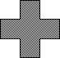
M a t e r i a l S a f e t y D a t a S h e e t


Clark Foam

25887 Crown Valley Parkway Laguna Niguel, California 92677

Date Issued: 10/8/98

Supersedes: 11/14/95

TRANSPORTATION EMERGENCY: CALL CHEMTREC Telephone #: 800-424-9300 Clark Foam Emergency #: (949) 582-2000

I. IDENTIFICATION

PRODUCT NAME: Clark Foam (surfboard cores, sailboard cores).

CHEMICAL FAMILY: Closed cell, rigid Polyurethane Foam.

STRUCTURE: Carbon dioxide blown, Toluene di isocynate/Polyester Rigid Polyurethane Foam.

 | II. HAZARDOUS INGREDIENTS
Not applicable - Rigid Polyurethane Foam is a fully reacted polymer.
 |  | III. PHYSICAL DATA
APPEARANCE: Solid. |  | COLOR: White or brown on surface after prolonged exposure to sunlight.
ODOR: None. |  | SPECIFIC GRAVITY: Will vary with density or "weight" of foam.
SOLUBILITY IN WATER: Insoluble. |  | PERCENT VOLATILES BY VOLUME: None.
 | IV. FIRE AND EXPLOSIVE DATA

FLASH POINT OF SOLID MATERIAL: Not applicable - solid material.

FLASH POINT OF FINE FOAM DUST: Any finely divided combustible solid is capable of producing a dust explosion. Experi-mentally produced dust explosions using 200 mesh polyurethane dust indicate that minimum airborne concentrations of 25-30 grams dust per cubic meter of air are required before an explosion can occur. Other experiments suggest 100 - 200 grams per cubic meter as the lowest critical concentration. Dust monitoring of air at polyurethane fabricating equipment has shown that dust concentrations during normal operations are considerably below the lowest critical level for an explosion to occur, and the probability of an explosion is negligible. Apparently, the polyurethane dust formed is too coarse to remain airborne for long and settles rapidly.1

 | EXTINGUISHING MEDIA |  | Use water spray, carbon dioxide, dry chemical, alcohol-type, or universal-type foams applied
 | EXTINGUISHING MEDIA |  | by manufacturer's recommended technique.
 | SPECIAL FIRE FIGHTING |  | Full emergency equipment with a self-contained breathing apparatus and full protective
 | PROCEDURES |  | clothing should be worn by firefighters.
 |  |  | During a fire, irritating vapors and toxic gases can be generated (see IX). Settled combustible
 |  |  | dust presents a risk in that disturbance could generate a dust cloud of sufficient concentration
UNUSUAL FIRE AND |  |  | to be explosive. A report issued by the National Fire Protection Association points out that
EXPLOSION HAZARDS |  |  | many of the most disastrous dust explosions (none involving polyurethane dust) are caused by
 |  |  | so-called secondary explosions, generated when a combustible dust which has settled is lifted
 |  |  | by a low-order primary explosion to form a highly explosive dust cloud.1
 |  |  |  | V. HEALTH HAZARD DATA
 | TLV AND SOURCE: None established. Considered an inert or nuisance dust.
 | ACUTE EFFECTS OF OVEREXPOSURE
 | ANIMAL TOXICITY - ORAL ( LD50 ) |  |  | Ingestion of Polyurethane Foam by rats in amounts equivalent to 7.5 grams/kilogram
 |  |  |  | eaten over a five day period caused no outward evidence of toxicity.2
 | ANIMAL TOXICITY - INHALATION |  |  | Emphysema of the type typically resulting from exposure to fine dusts
 |  |  |  | was observed in rats after gross exposure |  |  |  | to polyurethane dust.1
 | SWALLOWING |  |  | None currently known.
 | SKIN ABSORPTION |  |  | None currently known.
 | SKIN CONTACT |  |  | No adverse health effects have been observed other than mild abrasions if rubbed hard.
 | INHALATION |  |  | Any type of dust particles that enter the lungs can cause some risk.
 | EYE CONTACT |  |  | Similar to any comparable nuisance dust.
 | CHRONIC EFFECTS OF EXPO- |  |  | 8
 |  |  |  | Repeated/prolonged contact may cause a dehydrating effect..2

VI. EMERGENCY AND FIRST AID PROCEDURES
SOLID FOAM | No adverse health effects have been observed.
FOAM DUST IN EYES | Wash with water and if irritation persists seek medical advice.
FOAM DUST ON SKIN | Wash affected areas with soap and water. Should irritation develop or persist call a physician.
INHALATION OF DUST | Seek medical advice if symptoms of a respiratory problem persist after a reasonable amount of
INHALATION OF DUST | time.
 | There is no specific antidote or treatment. Treatment should be the same as treatment for any inert
NOTES TO PHYSICIAN | plastic or solid material dust or solid. It is believed that the foam dust is slightly abrasive. Treat-
 | ment of overexposure should be directed at the control of symptoms and the clinical condition.

VII. EMPLOYEE PROTECTION RECOMMENDATIONS - SOLID FOAM

EYE PROTECTION: | None required. |  | SKIN PROTECTION: | None required.
RESPIRATORY PROTECTION:None required. |  |  | VENTILATION: | None required.
VIII. EMPLOYEE PROTECTION RECOMMENDATIONS - FOAM DUST
EYE PROTECTION | Use well fitted, side shield goggles.
SKIN PROTECTION | None required.
RESPIRATORY | Use dust masks which mechanically filter and prevent inhalation of the dust
PROTECTION | at all times. Change or clean filters per manufacturer's recommendations.
VENTILATION | Recommended if unusually high concentrations of dust are present.

Keep accumulations of dust on floors, walls, ceilings, tools, lights, etc. to a minimum
OTHER
to keep fire hazard at a minimum and to keep dust out of eyes and lungs.

IX. REACTIVITY DATA

STABILITY: Stable | POLYMERIZATION: Will not occur. | INCOMPATIBILITY (MATERIALS TO AVOID): None.
HAZARDOUS | Burning Polyurethane Foam produces toxic decomposition products which are not significantly
HAZARDOUS | different from those of other nitrogen-containing substances such as wool, leather, nylon and ABS.
DECOMPOSITION
DECOMPOSITION | The major toxicants are carbon monoxide, oxides of nitrogen, hydrogen cyanide and irritants.2
 | Clark Foam does not contain fire retardants or phosphorous compounds.
 | X. SPILL OR LEAK PROCEDURES

STEPS TO BE TAKEN IN CASE MATERIAL IS RELEASED OR SPILLED: Collect as normal waste.

WASTE DISPOSAL METHOD: Common Landfill. All material should be packaged, labeled, transported and disposed in conforfmance with all applicable local, state and federal regulations.

XI. SPECIAL PRECAUTIONS AND STORAGE DATA

 | SPECIAL SENSITIVITY | Store away from sparks, flames or other ignition sources.
 |  | Use administrative controls to keep entire storage and fabrication areas free of foam dust, scraps
 | HOUSEKEEPING | and chips as they present a source of kindling for combustion. In areas where a very high accu-
 | HOUSEKEEPING | mulation of dust has built up, only clean by vacuum as sweeping or blowing by air could result in an
 |  | explosive concentration of dust. Keep floors, walls, ceilings, tools, lights, etc. free of dust.
 | SMOKING | Appropriate Fire Officials should be consulted to determine
 | SMOKING | No Smoking areas in buildings, or simply allow no smoking.
 | HOT WIRE CUTTING | Do not hot wire cut Clark Foam without OSHA approved ventilation or other engineering controls.
 | OTHER | For additional information consult NIOSH publication 76-154, "Urethane
 | OTHER | Foams - Good Practices for Employees' Health and Safety."

1.The Upjohn Company ( now Dow Chemical ) publication titled "Risks of Finished Polyurethane and Polyisocyanurate Products."

2.Bayer Chemical Material Safety Data Sheet for Polyurethane Foam approved by J.H. Chapman on 1/6/95

9

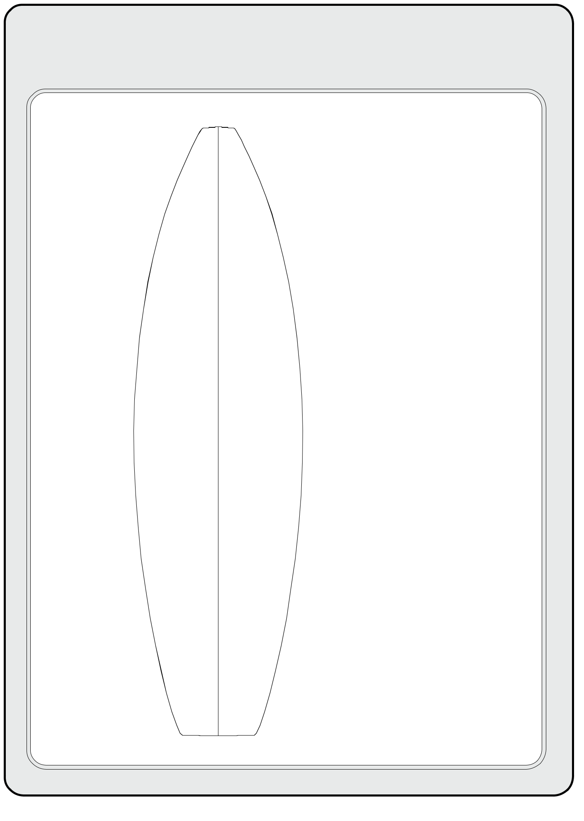
CLARK FOAM

BLANK CODE DESCRIPTION
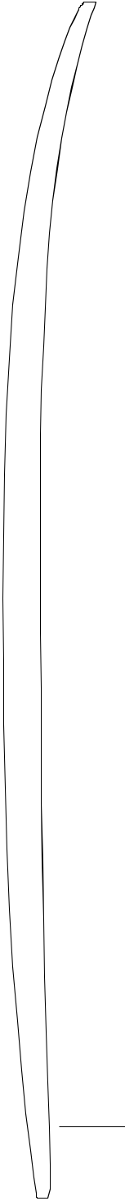

Size |  |  |  |  |  |  |  |  |  |  | 67R | EAS |  |  |  |  | Customer's
Pourer's Name |  |  |  |  |  |  |  |  |  |  |  |  |  |  |  |  | Mark
Pourer's Name |  |  |  |  |  |  |  |  |  |  | HIP | +1/2"N |  |  |  |  | Any
Prepol Batch |  |  |  |  |  |  |  |  |  |  |  |  |  |  |  |  | Any
 |  |  |  |  |  |  |  |  |  |  | ••• |  |  |  |  |  | Special
Number |  |  |  |  |  |  |  |  |  |  | ••• |  |  |  |  |  | Stringers/
Logo |  |  |  |  |  |  |  |  |  |  |  |  |  |  |  |  | Rockers
Blank Status |  |  |  |  |  |  |  |  |  |  |  |  |  |  |  |  | Code Of
 |  |  |  |  |  |  |  |  |  | 1ST QUALITY |  |  |  |  |  |  | Pourer
Weight |  |  |  |  |  |  |  |  |  |  |  | ••• |  |  |  |  | Who
 |  |  |  |  | SUPERBLUE |  |  |  |  |  |  |  |  |  |  |  | Inspected
 |  |  |  |  |  |  |  |  |  |  |  |  |  |  |  |  | Blank
 |  |  |  |  |  |  |  |  |  |  |  | •• |  |  |  |  | Blank
 |  |  |  |  |  |  |  |  |  |  |  |  |  |  |  |  | Current
 |  |  |  |  |  |  |  |  |  |  |  |  |  |  |  |  | Foam
 |  |  |  |  |  |  |  |  |  |  |  |  |  |  |  |  | Batch
 |  |  |  |  |  |  |  |  |  |  |  |  |  |  |  |  | Indicator

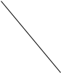
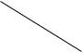

- Note under the name/stringer infor-mation, there are numbers used inter-nally at the factory.

Glue Team

Leadman's

Initials

(On Rail)

10

REPLACEMENT BLANK LIST

This page is updated eaach time we add a new blank or discontinue production of a blank. Caution is advised as this information only represents the opinion of our staff. Reading the individual blank specification sheets or, better yet, actually trying the replacement blank is recommended prior to ordering large quantities of any blank.

SIZE |  |  |  |  |  |  |  |  |  |  |  |  |  |  | REPLACEMENTS
5'9"R |  |  |  |  |  |  |  |  |  |  |  |  |  |  | 6'1"R
6'0"R |  |  |  |  |  |  |  |  |  |  |  |  |  |  | 6'2"C, 6'3"H
6’1"R |  |  |  |  |  |  |  |  |  |  |  |  |  |  | 5'9"R, 6’3"H, 6’3"R
6’2"C |  |  |  |  |  |  |  |  |  |  |  |  |  |  | 6'0"R
6’3"H |  |  |  |  |  |  |  |  |  |  |  |  |  |  | 6’3"R, 6'4"R, 6’5"R
6’3"R |  |  |  |  |  |  |  |  |  |  |  |  |  |  | 6’3"H, 6'4"R, 6’5"R
6'4"R |  |  |  |  |  |  |  |  |  |  |  |  |  |  | 6'3"H, 6'3"R, 6'5"R
6’5"R |  |  |  |  |  |  |  |  |  |  |  |  |  |  | 6’3"H, 6’3"R, 6'4"R, 6'6"P, 6'7"H
6'6"P |  |  |  |  |  |  |  |  |  |  |  |  |  |  | 6'3"H, 6'3"R, 6'4"R, 6'5"R, 6'7"H, 6'7"R
6'7" |  |  |  |  |  |  |  |  |  |  |  |  |  |  | 6'7"A
6’7"A |  |  |  |  |  |  |  |  |  |  |  |  |  |  | 6’7", 6'8"H, 6’8"R
6'7"H |  |  |  |  |  |  |  |  |  |  |  |  |  |  | 6'6"P, 6'7"R
6’7"R |  |  |  |  |  |  |  |  |  |  |  |  |  |  | 6'6"P, 6'7"H, 6'8"H, 6'8"R, 6'9"H
6'8"C |  |  |  |  |  |  |  |  |  |  |  |  |  |  | 6'9"A
6'8"H |  |  |  |  |  |  |  |  |  |  |  |  |  |  | 6'8"R, 6'9"R
6'8"R |  |  |  |  |  |  |  |  |  |  |  |  |  |  | 6'8"H, 6'9"R, 7'0"R
6'9"A |  |  |  |  |  |  |  |  |  |  |  |  |  |  | 6'7", 6'11"A, 7'0"A
6'9"H |  |  |  |  |  |  |  |  |  |  |  |  |  |  | 7'0"R
6’9"R |  |  |  |  |  |  |  |  |  |  |  |  |  |  | 6'8"H, 6'8"R, 7’0"R
6’11"A |  |  |  |  |  |  |  |  |  |  |  |  |  |  | 6'9"A, 6’11"R, 7'0"A
6’11"R |  |  |  |  |  |  |  |  |  |  |  |  |  |  | 7’4"R
7’0"A |  |  |  |  |  |  |  |  |  |  |  |  |  |  | 6’11"A, 7’0"R, 7'3"R
7’0"R |  |  |  |  |  |  |  |  |  |  |  |  |  |  | 7 ’0"A, 7'3"R
7’3" |  |  |  |  |  |  |  |  |  |  |  |  |  |  | 7’4"R
7’3"A |  |  |  |  |  |  |  |  |  |  |  |  |  |  | 7'3"R, 7’4"R
7'3"P |  |  |  |  |  |  |  |  |  |  |  |  |  |  | 7'3"R

11

SIZE |  |  |  |  |  |  |  |  |  |  |  | REPLACEMENTS
 | 7'3"R |  |  |  |  |  |  |  |  |  |  |  | 7'3"A, 7'3"P, 7'7"R
 | 7’4"R |  |  |  |  |  |  |  |  |  |  |  | 7’3", 7'3"R
 | 7’5"A |  |  |  |  |  |  |  |  |  |  |  | 7’3"A, 7'3"R, 7’7"A
 | 7’7"A |  |  |  |  |  |  |  |  |  |  |  | 7’7"R, 7'9"A, 7’11"A
 | 7’7"R |  |  |  |  |  |  |  |  |  |  |  | 7’7"A, 7'9"A, 7’11"A
 | 7’9"E |  |  |  |  |  |  |  |  |  |  |  | 7’10"R, 7'11"H, 7’11"R
 | 7'9"A |  |  |  |  |  |  |  |  |  |  |  | 7'11"A
 | 7’10"R |  |  |  |  |  |  |  |  |  |  |  | 7’9"E, 7'11"H, 7’11"R
 | 7’11"A |  |  |  |  |  |  |  |  |  |  |  | 7'9"A, 7'11"R, 8’5"A
 | 7'11"H |  |  |  |  |  |  |  |  |  |  |  | 7'9"E, 7'10"R, 7'11"R
 | 7’11"R |  |  |  |  |  |  |  |  |  |  |  | 7’9"E, 7’10"R, 7'11"H
 | 8'1"R |  |  |  |  |  |  |  |  |  |  |  | 8'5"A
 | 8’3"E |  |  |  |  |  |  |  |  |  |  |  | 8'4"H, 8’4"R, 8'5"S
 | 8'4"H |  |  |  |  |  |  |  |  |  |  |  | 8'3"E, 8'4"R, 8'5"S
 | 8’4"R |  |  |  |  |  |  |  |  |  |  |  | 8’3"E, 8'4"H, 8'5"S
 | 8'4"S |  |  |  |  |  |  |  |  |  |  |  | NONE
 | 8’5" |  |  |  |  |  |  |  |  |  |  |  | 8'4"R, 8’5"A, 8'7"R (Narrowed)
 | 8’5"A |  |  |  |  |  |  |  |  |  |  |  | 8'4"R, 8’5", 8'9"A
 | 8'5"S |  |  |  |  |  |  |  |  |  |  |  | 8'4"H, 8'4"R, 8'3"E
 | 8'7"R |  |  |  |  |  |  |  |  |  |  |  | 8'8"E
 | 8’8"E |  |  |  |  |  |  |  |  |  |  |  | 8'9"B, 8’10"S, 9’1"Y, 9’3"
 | 8’8"H |  |  |  |  |  |  |  |  |  |  |  | NONE
 | 8'9"B |  |  |  |  |  |  |  |  |  |  |  | 8'8"E, 8'10"S
 | 8’10"S |  |  |  |  |  |  |  |  |  |  |  | 8’8"E, 8'9"B, 9’1"Y
 | 9’1"A |  |  |  |  |  |  |  |  |  |  |  | 8’9"A, 9’9"A, 9'2"R (Narrowed)
 | 9’1"Y |  |  |  |  |  |  |  |  |  |  |  | 9’3", 9'4"B, 9'4"H, 9'4"R, 9’5"S
 | 9'2"R |  |  |  |  |  |  |  |  |  |  |  | 9'1"A (Widened), 9'1"Y (w/Gun Rocker)
 | 9’3" |  |  |  |  |  |  |  |  |  |  |  | 9’1"Y
 | 9'4"B |  |  |  |  |  |  |  |  |  |  |  | 9'1"Y, 9'4"H, 9'4"R
 | 9'4"H |  |  |  |  |  |  |  |  |  |  |  | 9'1"Y, 9'4"B, 9'4"R, 9’5"S
 | 9'4"R |  |  |  |  |  |  |  |  |  |  |  | 9'1"Y, 9'4"B, 9'4"H

12

SIZE |  |  |  |  |  |  |  |  |  |  |  |  |  |  | REPLACEMENTS
9’5"S |  |  |  |  |  |  |  |  |  |  |  |  |  |  | 9’1"Y, 9'4"B, 9'4"H, 9'4"R, 9’7"B
9’7"B |  |  |  |  |  |  |  |  |  |  |  |  |  |  | 9’5"S, 9'8"S, 9’9", 9'9"W
9'8"S |  |  |  |  |  |  |  |  |  |  |  |  |  |  | 9'7"B, 9'9", 9'9"W, 9'10"H
9’9" |  |  |  |  |  |  |  |  |  |  |  |  |  |  | 9’7"B, 9'8"S, 9'9"W, 9'10"H, 10’1"Y
9’9"A |  |  |  |  |  |  |  |  |  |  |  |  |  |  | NONE
9'9"W |  |  |  |  |  |  |  |  |  |  |  |  |  |  | 9'9", 9'10"H, 10'1"Y
9’10"H |  |  |  |  |  |  |  |  |  |  |  |  |  |  | 9'8"S, 9’9", 9'9"W, 10’1"Y
10’1"Y |  |  |  |  |  |  |  |  |  |  |  |  |  |  | 10’3", 10’5"S
10’3" |  |  |  |  |  |  |  |  |  |  |  |  |  |  | 10'1"Y, 10’5"S, 10'7"H
10’4"A |  |  |  |  |  |  |  |  |  |  |  |  |  |  | 10'6"
10’5"S |  |  |  |  |  |  |  |  |  |  |  |  |  |  | 10’1"Y, 10'7"H, 11’3"
10'6" |  |  |  |  |  |  |  |  |  |  |  |  |  |  | 10'8"A
10'7"H |  |  |  |  |  |  |  |  |  |  |  |  |  |  | 10'5"S, 11'3"
10'8"A |  |  |  |  |  |  |  |  |  |  |  |  |  |  | 10'7"H, 11'3"
11'2" |  |  |  |  |  |  |  |  |  |  |  |  |  |  | 11'3" (w/ Rocker Change and Narrowed)
11’3" |  |  |  |  |  |  |  |  |  |  |  |  |  |  | 12’3"
12’3" |  |  |  |  |  |  |  |  |  |  |  |  |  |  | 12'8" Tanker/Paddle/ Rescue
12'8" |  |  |  |  |  |  |  |  |  |  |  |  |  |  | 12'3"

13

3 "—

7.62
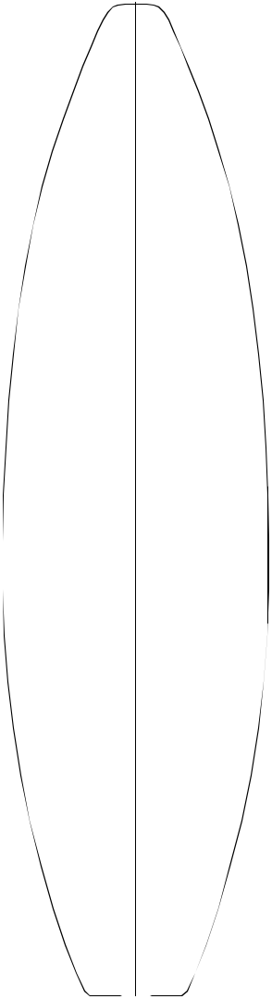

13 ⁵/₁₆"—
33.81

18 ¹/₄"—
46.36

19 ¹⁵/₁₆"—
50.64

19 ⁵/₁₆"—
49.05

15 ⁷/₈"—
40.32

6 ³/₄"—

17.15

Shaped By:

- ⁵/₈"—
11.75

1 | ⁵/ "— | — 1 | ³/ "
 | 16 |  | 8
3.33 _{3.49}

¹/ "— | — 2 "
4 | 5.08
0.64 | 5.08

— 2 ¹/₄"
5.72

³/ "— | — 2 | ³/ "
16 |  | 16
0.48 | 5.56

⁷/ "— | — 1 | ⁵/ "
8 |  | 8
2.22 | 4.13

2 ¹/₁₆"—

5.24
5'9"R


Overall Bottom Length: 5' 9¹/₂" (176.53)

Tip-to-tip Deck Length: 5' 8 ⁵/₈" (174.31)

Maximum Width: 20 " (50.8)

Maximum Thickness: 2 ⁵/₁₆" (5.87)

Displacement: 0.87 cubic feet (0.0247m)

History: Introduced March, 1999

Rockers: Natural

Factory Stocking: Limited

Limited Volume Charge: None

Blanks Per Box: 4 - 7'0"

Shaper's Comments: 5’9"R “Grom” is a scaled down version of the 6’1"R with some rocker updates. Most notable is a relaxed tip and a touch more curve in the entry (12" to 18" back) so the overall effect is a smoother front end rocker.
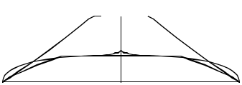

Rusty Preisendorfer and Rick Hamon
14

- ¹/₈"—

38.42

- ³/₁₆"—

51.28

- ¹/₈"—

56.20

- ⁵/₁₆"—

54.13

- ¹⁵/₁₆"—

45.56

- ⁵/₈"—

11.75
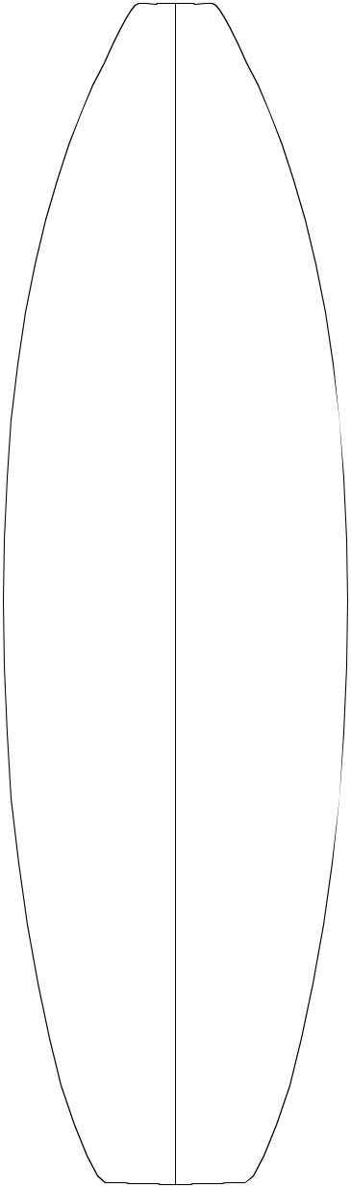

- ³/₄"—

24.77
6'0"R


- "—
10.16 |  | Overall Bottom Length: 6' 1 " |  |  |  |  |  |  |  |  |  |  |  |  |  | (185.42)
 |  | Tip-to-tip Deck Length: 6' |  |  |  |  |  |  |  |  |  |  |  |  | ³/ " | (183.83)
 |  | Maximum Width: 22 ³/ |  |  |  |  |  |  |  |  |  | " |  |  | 8
 |  |  |  |  |  |  |  |  |  |  |  |  |  |  | (56.36)
1 ¹/₄"— | — 1 ³/₄" |  |  |  |  |  | 16
1 ¹/₄"— | — 1 ³/₄" | Maximum Thickness: 2 |  |  |  |  |  |  |  |  |  | /₄" |  |  |  | (6.99)
3.18 | 4.45 |  |  |  |  |  |  |  |  |  |  |  |  |  |  | (6.99)
3.18 | 4.45 |  |  |  |  |  |  |  |  |  |  | 3
 |  | Displacement: 1.50 cubic feet |  |  |  |  |  |  |  |  |  |  |  |  |  | (0.0423m)
 |  | History: Introduced December, 1998
¹/₄"— | —2¹/ "
0.64 | 2 | Rockers: Natural
0.64 | 6.35
 |  | Factory Stocking: Limited
 |  | Limited Volume Charge: None
 | —2³/"
 | 4 | Blanks Per Box: 4 - 7'0"
 | 6.99
 |  | Shaper's Comments: For several years"Fish" shapes
 |  | have varied quite a bit, so it would have been prema-
 |  | ture to make a fish blank up until now. So we've all
 |  | been cutting down bigger blanks and restructuring
 |  | the rocker and foil to make "fish" style boards. Now
¹/₄"— | — 2 ¹/₂" | that designs have settled in, it's time for a modern fish
¹/₄"— | — 2 ¹/₂" | blank. This blank is designed for short, wide boards
0.64 | 6.35 | with a low entry. The deck crown and rail volume are
 |  | similar to the 6'7"R.
⁷/₈"— | —2 "
2.22 | 5.08
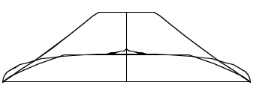

2 "—

5.08

Shaped By:

Rusty Preisendorfer and Rick Hamon 15

- ³/₈"—

34.00

18 ¹/₄"—
46.36

20 ¹/₄"—
51.44

19 ⁵/₁₆"—

49.05

- ⁵/₁₆"—

38.89

- ⁷/₈"—

9.86

5 ³/₈"—
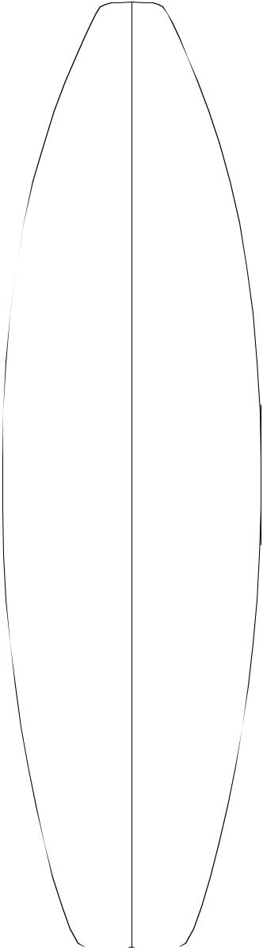
13.67

1 ⁵/₈"—
4.14

³/₈"—
0.97

³/₁₆"—
0.48

⁷/₈"—

2.24

2 ¹/₈"—
5.41
7"—

17.78

Shaped By:
6'1"R


 |  | Overall Bottom Length: 6' 2 |  |  |  |  |  |  |  |  |  |  |  |  | ³/ " |  | (188.93)
 |  |  |  |  |  |  |  |  |  |  |  |  |  |  | 8
 |  | Tip-to-tip Deck Length: |  |  |  |  |  |  |  |  |  | 6' 1 ⁹/₁₆" |  |  |  |  | (186.84)
 |  | Maximum Width: 20 ¹/ " (51.44)
 |  |  |  |  |  |  | 4
 |  | Maximum Thickness: |  |  |  |  |  |  |  | 2 ⁷/₁₆" |  |  |  |  | (6.20)
 |  | Displacement: 1.216 cubic feet |  |  |  |  |  |  |  |  |  |  |  |  |  |  | (0.03443 m)
— 1 | ⁷/ "
— 1 | ⁷/ " | History: Introduced January, 1995
 | 16
 | 3.66
 | 3.66 | Rockers: Natural
 |  | Factory Stocking: Always
— 2 | ¹/ "
 | 4 | Limited Volume Charge: |  |  |  |  |  |  |  |  |  |  |  | None
5.72
 |  | Blanks Per Box: 4 - 7'0"
 |  | Shaper's Comments: 6'1"R uses the same logic as
 |  | the other close tolerance blanks in the "R" series. It is
— 2 ⁷/₁₆" |  | designed to be used for boards in the 5'10"-6' size
 |  | range. The central part of the deck should be very
6.20 |  | close to the finished board with enough volume in the
rail to allow a good range in rail contour.

— 2 ¹/₄"
5.72
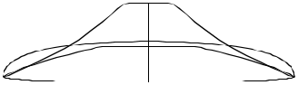

— 1 ³/₄"
4.45

Rick Hamon and Rusty Preisendorfer 16

- ¹/₈"—

48.6

23 ⁹/₁₆"—
59.8

- ¹³/₁₆"—

63.0

23 ⁵/₁₆"—
59.2

- ¹⁵/₁₆"—

50.6

- ³/₄"

17.1

—5"—
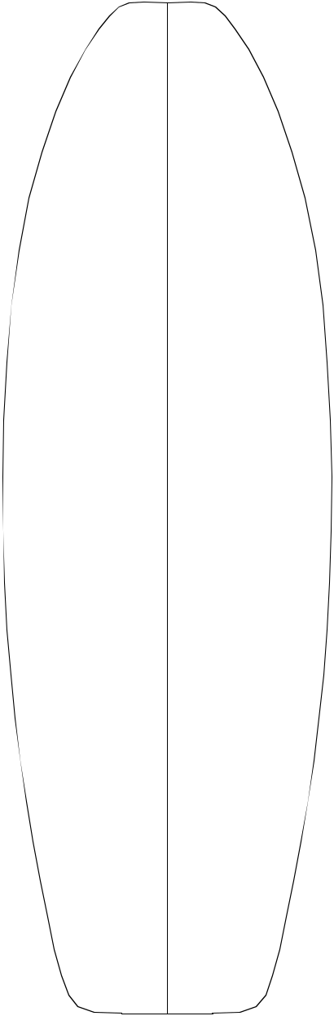
12.7

1 ¹³/₁₆"—
4.6

¹/₂"—

1.3

¹/₄"—
0.63

⁷/₈"—
2.22

1¹³/₁₆ "—

4.6

- ³/₄"—

34.9

Shaped By:

— 1 ¹⁵/₁₆" 4.9

— 2 ⁹/₁₆" 6.5

— 2 ⁷/₈"
7.3

— 2 ⁹/₁₆" 6.5

—1¹⁵/₁₆ "

5.08
6'2"C


Overall Bottom Length: 6' 3 " ⁵/₈ (192.1)

Tip-to-tip Deck Length: 6' 2" ⁷/₈" (190.2)

Maximum Width: 24 ¹³/₁₆" (63.0)

Maximum Thickness: 2 ⁷/₈" (7.3)

Displacement: 2.00 cubic feet (0.0568m)

History: Introduced Summer, 1994. Designed for the "fish revolution." Used for contemporary fish designs as well as the original fish concept and all types of kneeboards.

Rockers: Natural

Factory Stocking: Limited

Limited Volume Charge: None

Blanks Per Box: 3 - 7'0"

4 - 8'4"

Shaper's Comments: Designed to yield a wide range of shapes. The 6'2"C will produce modern rockers and thickness profiles without overshaping the deck, yet can't be considered a close toler-ance blank. Rocker adjustments will play an important role in accommodating the wide range of lengths and shapes this blank is capable of (surfboards and kneeboards).
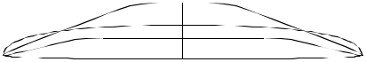

Toby Sullaway & Jim Callaham 17

6'3"H

 |  | Overall Bottom Length: 6' 4 |  |  |  |  |  | 13/ | 16 |  | " (195.10)
 |  | Tip-to-tip Deck Length: 6' 4 |  |  |  |  |  | ¹/ " |  |  | (193.37)
 |  |  |  |  |  |  |  | 8
 |  | Maximum Width: 20 ¹¹/ " |  |  |  |  |  | 8
 | ³/ "— |  |  |  |  |  |  | (52.55)
3 | ³/ "— |  |  | 16
 | 4
 | 9.53
 | 5 ⁷/₁₆"— | Maximum Thickness: |  |  | 2 ⁵/₈" |  |  | (6.68)
 | 13.82
 |  | Displacement: 1.44 cubic feet |  |  |  |  |  |  |  | (0.0407m)
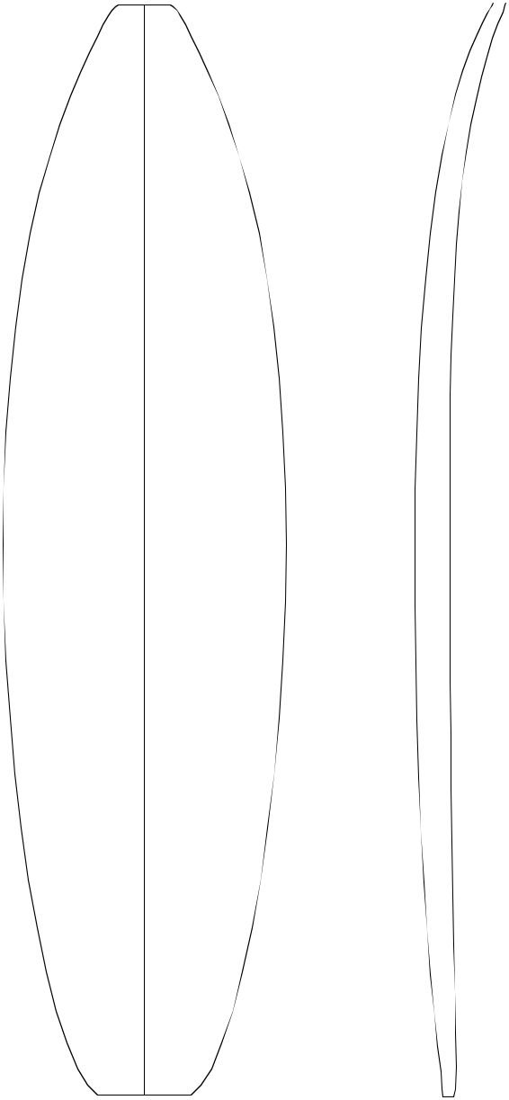

13 | 15/ | 16 | "— | 1 | ⁵/ "— | — 1 | 9/ | 16 | "
 |  | 16 |  |  | 8 |  |  | 16
 | 35.4 |  |  |  | 4.13 |  | 3.96

18 | ⁷/ "— | ³/ "— | — 2 | 5/ | 16 | "
 | 8 | 8 |  |  | 16
 | 47.96 | 0.97 | 5.87

20 | ¹¹/ "— | — 2 | ⁵/ "
 | 16 |  | 8
 | 52.55 | 6.68

19 | ³/ "— | ¹/ "— | — 2 | ⁷/ "
 | 16 | 4 |  | 16
 | 48.74 | 0.62 | 6.20

15 | 7/ | 16 | "— | ⁷/ "— | — 2 "
 |  | 16 |  | 8 | 5.08
 | 39.22 |  |  | 2.24 | 5.08

1 ¹⁵/₁₆"—

History: Introduced March, 1994 as an updated version of the 6'3"R.

Rockers: Natural. Wide variety of rockers. See shaper's comments regarding nose rocker.

Factory Stocking: Always

Limited Volume Charge: None

Blanks Per Box: 4 - 7'0"

Shaper's Comments: The 6'3"H uses the basic proportions of the 6'3"R. It differs in that the tail of the blank is pulled in a little, and the deck contour is carried back through the tail. More rocker was shaped into the tip in an attempt to do away with any distortion created by flipping the tip.
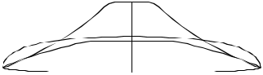

8"—

20.32
4.93

Shaped By:

Rick Hamon and Rusty Preisendorfer 18

3 ⁷/₈"—

9.86
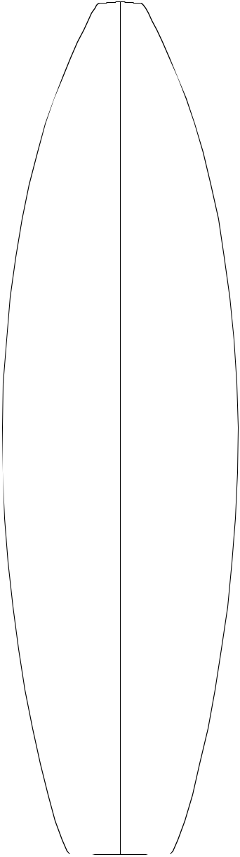

14 "—

35.56

18 ⁷/₈"—
47.96

20 ²⁵/₃₂"—
52.78

19 ¹⁷/₃₂"—

49.61

15 ³¹/₃₂"—
40.56
6'3"R


 |  | Overall Bottom Length: 6' 4 |  |  |  |  |  |  |  |  |  |  |  |  |  |  | ⁵/ " (194.64)
5 "— |  |  |  |  |  |  |  |  |  |  |  |  |  |  |  |  | 8
5 "— |  | Tip-to-tip Deck Length: 6' 3 |  |  |  |  |  |  |  |  |  |  |  |  |  |  | ³/ " (192.41)
12.70 |  |  |  |  |  |  |  |  |  |  |  |  |  |  |  |  | ³/ " (192.41)
 |  |  |  |  |  |  |  |  |  |  |  |  |  |  |  |  | 4
 |  | Maximum Width: 20 ²⁵/ |  |  |  |  |  |  |  |  |  |  |  | " |  |  | 4
 |  |  |  |  |  |  |  |  |  |  |  |  |  |  |  |  | (52.78)
 |  |  |  |  |  |  | 32
 |  | Maximum Thickness: 2 ⁵/ " |  |  |  |  |  |  |  |  |  |  |  |  |  |  | (6.68)
1 ⁵/₈"— | — 1 ⁹/₁₆" |  |  |  |  |  |  |  |  |  |  |  |  |  | 8
1 ⁵/₈"— | — 1 ⁹/₁₆" | Displacement: |  |  | 1.53 cubic feet (0.0433m)
4.13 | 3.96
 |  | History: Introduced Summer, 1993.
 |  | Rockers: Tip tweak (+1/4"N Last 4" A),
¹³/ "— | —2¹/" | + 3/8"N Last 6" A, Natural.
32 | 4
1.04 | 5.72 | Factory Stocking: Always
 |  | Limited Volume Charge: None
 |  | Blanks Per Box: 4 - 7'0"
 | — 2 ⁵/₈"
 | — 2 ⁵/₈" | Shaper's Comments: |  |  |  |  |  |  |  |  |  |  |  | Same basic philosophy as
 | 6.68 | 6'7"R. This blank is obviously close tolerance. More
 |  | than ever, personal rockers are important. I have left
 |  | a little thickness in the very tip of the nose to allow for
 |  | minor adjustments and to hopefully minimize acci-
 |  | dental damage. Also note the deck contour; the
⁹/₃₂"— | — 2 ³/₈" | centerline, a few inches to either side of the stringer
⁹/₃₂"— | — 2 ³/₈" | is relatively flat. The tail portion has been foiled for
0.71
6.05 | little or no vee. Please note actual length: 6'4" 5/8".

29/ |  | 32 | "— | — 1 ¹⁵/₁₆"
 | 2.31 |  |  |  | 4.93
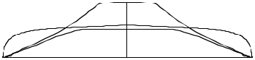

 | 2 | ¹/ "—
 |  | 8
9 | ¹/ "— | 5.41
 | 4
 | 23.50

Shaped By:

Rusty Preisendorfer and Rick Hamon 19

- "—

35.56

- ³/₄"—

9.53

5 "—
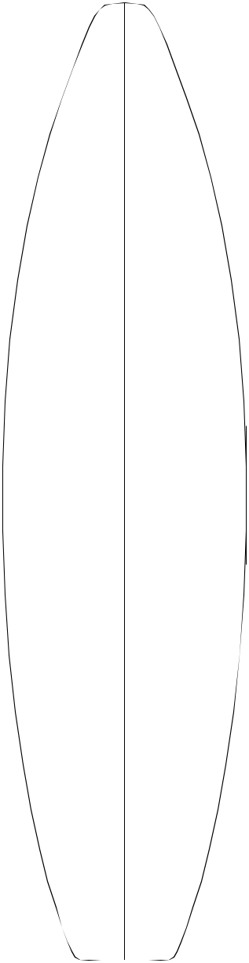

12.70

1 ⁵/₈"—
4.13
6'4"R
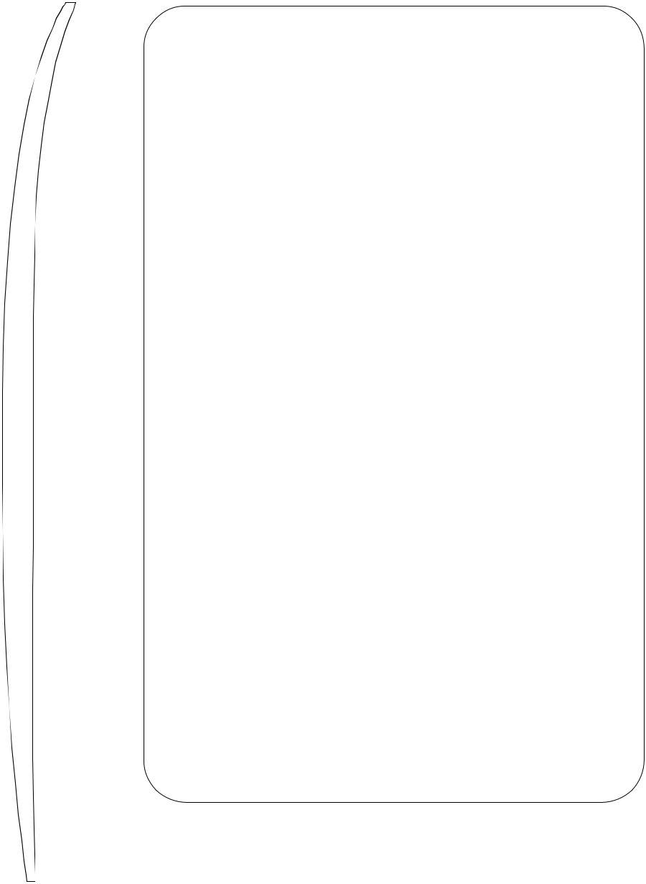

Overall Bottom Length: 6' 4 ³/₄" (194.95)

Tip-to-tip Deck Length: 6' 3 ⁷/₈" (192.72)
— 1 | 7/ | " | Maximum Width: 20 |  | 15/ | 16 |  | " | (53.18)
 | 16
 | 3.65 |  | Maximum Thickness: 2 |  |  |  | ¹/ " |  | (6.35)
 |  |  |  |  |  |  |  | 2

Displacement: 1.42 cubic feet (0.0402m)

- "—

48.26

- ¹⁵/₁₆"—

53.18

- ¹/₂"—

49.53

- ¹¹/₁₆"—

39.85

³/₈"—
0.95

⁵/₁₆"—
0.79

1 ¹/₁₆"—

2.70

2 ¹/₄"—

5.72

- ³/₄"—

17.15

— 2 ¹/₄"
5.72

— 2 ¹/₂"
6.35

— 2 ⁵/₁₆" 5.87

— 1 ³/₄"
4.45

History: Introduced Summer, 1999

Rockers: Natural

Factory Stocking: Always

Limited Volume Charge: None

Blanks Per Box: 4 - 7'0"

Shaper's Comments: The natural rocker features a “relaxed” tip that is a little thinner than previous short production blanks (6’5"R, 6’3"R & 6’3"H). The flip look is over and a gradual, smoother curve feeding the entry seems to be the norm these days. I’ve also added some curve in the back half of the blank to accommodate what seems to be an almost universal use of concave in the bottom. The center line on the deck is flatter with a little more volume carried out into the rails relative to the 6’5"R and slightly less rail volume than the 6’3"R or 6’3"H. Along with taking out the crown in the deck the ends of the blank are also relatively thinner.
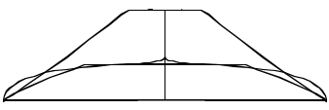

Shaped By:

20
Rusty Preisendorfer and Rick Hamon

- ¹³/₁₆"—

35.08

- ³/₄"—

47.63

- ¹³/₁₆"—

52.86

- ⁵/₈"—

49.86

- ³/₄"—

40.01

4"—

10.16

5 ³/₁₆"—
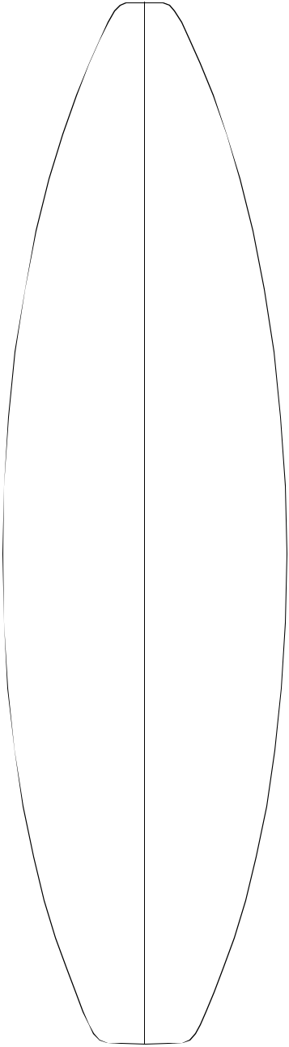

13.18

1 ⁹/₁₆"—

3.96

³/₈"—

0.95

⁵/₁₆"—
0.80

1 "—

2.54

2 ¹/₈"—

5.41

- ¹/₂"—

19.05

Shaped By:
6'5"R
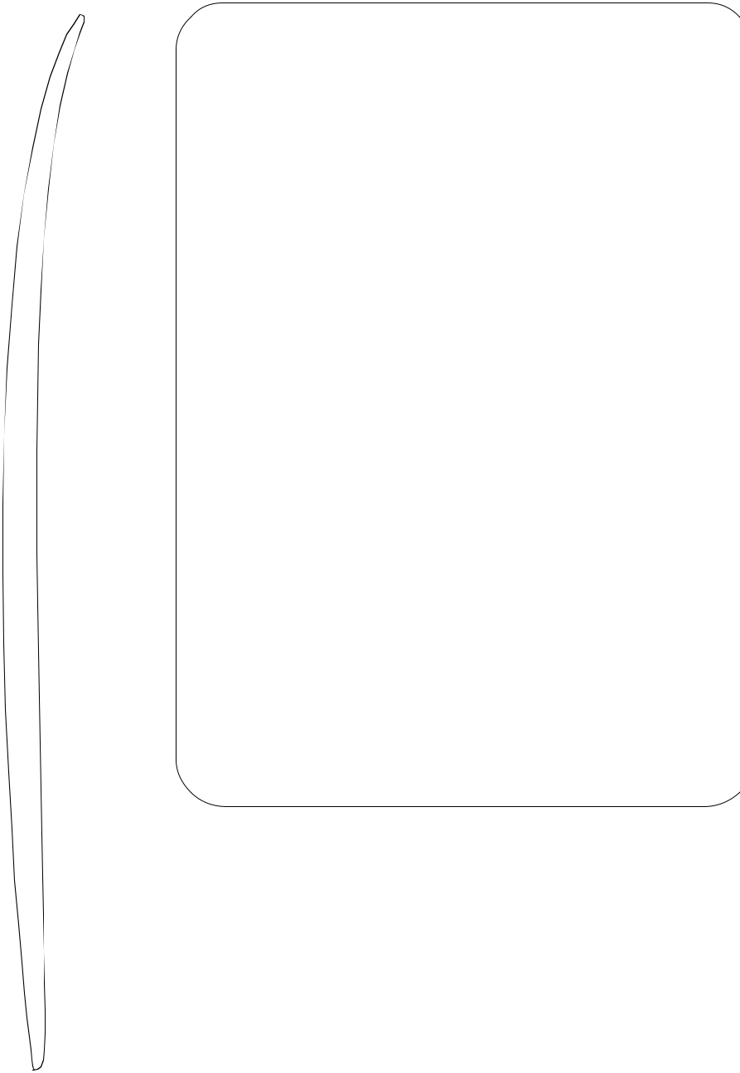

 | Overall Bottom Length: |  |  |  |  |  |  |  |  |  | 6' 4 ¹⁵/₁₆" |  |  | (195.43)
 | Tip-to-tip Deck Length: 6' 4 |  |  |  |  |  |  |  |  |  |  |  | ³/ " | (193.52)
 |  |  |  |  |  |  |  |  |  |  |  |  | 16
 | Maximum Width: |  |  |  |  | 20 ¹³/₁₆" |  |  |  |  |  |  | 16
—1¹/ " |  |  |  |  |  |  |  |  |  |  |  |  | (52.86)
2
3.81 | Maximum Thickness: 2 ¹/ " |  |  |  |  |  |  |  |  |  |  |  | (6.35)
 |  |  |  |  |  |  |  |  | 2
 | Displacement: 1.42 cubic feet (0.0405m)
—2³/ " | History: Introduced March, 1994
16
5.56 | Rockers: Natural, also a wide range of popular
 | rockers for this size.
 | Factory Stocking: Always
 | Limited Volume Charge: None
—2¹/ " | Blanks Per Box: 4 - 7'0"
2
6.35 | Shaper's Comments: The 6'5"R is designed to up-
 | date and complement the 6'3"R. It is long enough to
 | comfortably net a 6'4". The blank is thinner through
 | the rails and tail. The tail is narrower, and in conjunc-
 | tion with the foil, should be less work and yield a
 | stronger board. The nose is slightly thinner 12 to 18
— 2 ³/₈" | inches back, but still maintains a little thickness at the
6.05 | tip. The natural nose rocker features more flip.

— 1 ¹³/₁₆"
4.60
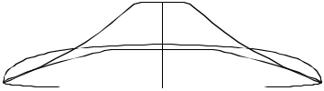

Rusty Preisendorfer 21

- ³/₈"—

36.51

- ¹/₄"—

48.90

- ⁵/₁₆"—

54.13

- ⁵/₈"—

49.85

- ⁹/₁₆"—

39.53

- "—

10.16

5 ¹/₂"—
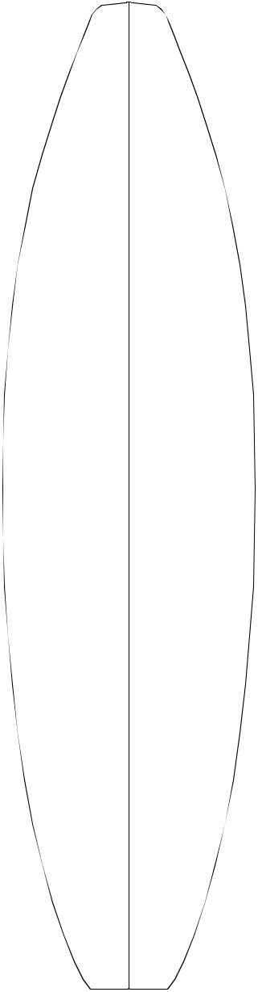
13.97

1 ¹⁵/₁₆"—
4.92

¹/₂"—

1.27

¹/₂"—
1.27

1 ³/₈"—
3.49

2 ⁷/₈"—
7.30
- ⁵/₈"—
16.83

—1¹/₂"
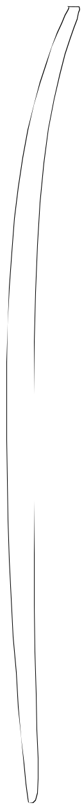
3.81

— 2 ¹/₄"
5.72

— 2 ⁵/₈"

6.67

— 2 ⁵/₁₆" 5.87

— 1 ³/₄"

4.45
6'6"P


Overall Bottom Length: 6' 6 ^{7/}₈" (200.36)

Tip-to-tip Deck Length: 6' 5 ⁷/₈" (197.80)

Maximum Width: 21 ⁵/₁₆" (54.13)

Maximum Thickness: 2 ⁵/₈" (6.67)

Displacement: 1.47 cubic feet (0.0415m)

History: Introduced January, 1999

Rockers: Natural, 6'7"R +1/4"Nose F Bottom Matched to Nose (-1/8"N -5/16"T A)

Factory Stocking: Limited

Limited Volume Charge: None

Blanks Per Box: 4 - 7'0"

Shaper's Comments: This blank was designed for high performance surfing, primarily for Team riders. The deck was contoured to minimize overshaping in the rail area.
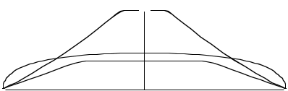

Shaped By:

Timmy Patterson 22

- ³/₄ "—

34.93

- ¹/₄ "—

5.72
5 ¹¹/₁₆"—
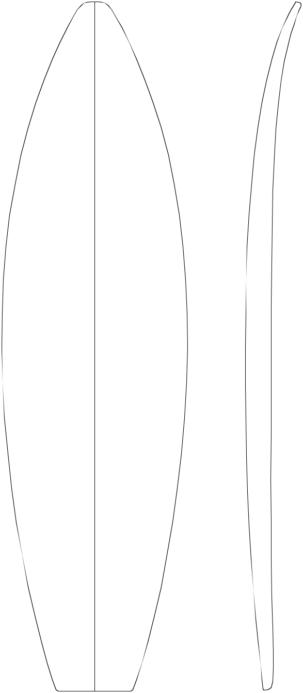
14.45

1 ⁷/₈"—
4.78
6'7"


Overall Bottom Length: 6' 7 ¹³/₁₆ " (202.72)

Tip-to-tip Deck Length: 6' 6 ⁷/₈" (200.36)

Maximum Width: 21 ³/₈" (54.31)

Maximum Thickness: 3 " (7.62)

Displacement: 1.72 cubic feet (.0487m)

—1 ⁷/₈"

4.78 | History: Introduced Summer, 1995

- ³/₁₆ "—

48.74

- ¹/₄"—

53.98

- ³/₈ "—

54.31

- ¹/₄"—

53.98

¹/₂"—

1.27

—2 ⁵/₈"

6.68

—2 ¹⁵/₁₆"

7.48

—3 "

7.62

—2 ¹⁵/₁₆"

7.48

Rockers: Natural

Factory Stocking: Limited

Limited Volume Charge: None

Blanks Per Box: 4- 8'4"

Shaper's Comments: The 6'7" is an update to the 6'7"A. The foil has been "modernized" , but like its predecessor, the 6'7" will still net a 2-5/8" finished board. Also, can cut back on nose for fishes.
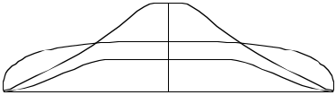

- ¹/₂"—

49.53

⁵/₁₆"—

0.79

— 2 ¹¹/₁₆" 6.83

- ⁵/₈"—

39.70

 | 1"— | — 2 ¹/₈"
2.54 |  |  | 5.41

2 ¹/₈"—
5.41
- ¹/₂"—
21.59

Shaped By:

Pat Rawson 23

3 "

7.62
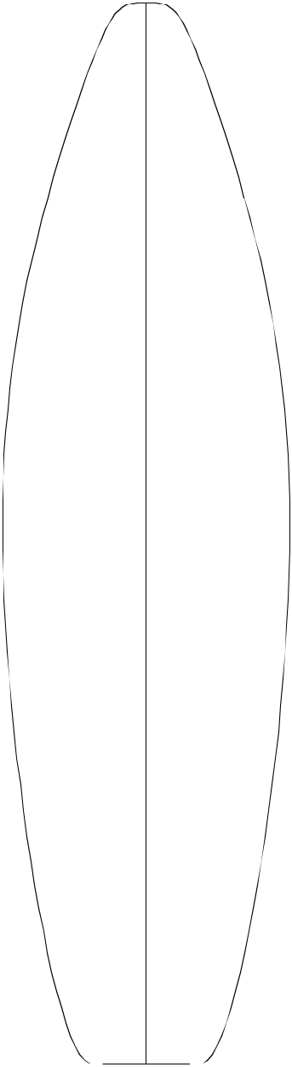

- ⁷/₈ "—
32.2
6'7"A


 |  |  | Overall Bottom Length: 6' 7 |  |  |  |  |  | ¹/ " | (201.3)
 |  |  |  |  |  |  |  |  | 4
 |  |  | Tip-to-tip Deck Length: 6' 6 " |  |  |  |  |  | 4
 |  |  |  |  |  |  |  |  | (198.1)
 |  |  | Maximum Width: 21 ¹/ " (54.6)
4 ⁷/₈ "— |  |  |  |  |  | 2
4 ⁷/₈ "— |  |  | Maximum Thickness: |  |  |  | 2 ⁷/₈" |  | (7.3)
12.4
 |  |  | Displacement: 1.781 cubic feet |  |  |  |  |  |  | (.0504m)
 |  |  | History: Introduced in 1988. Still good for
 |  |  | thicker boards and flat deck 80's shapes. Check
1⁵/"— | —2 | ¹/ "out the 6'7" by Rawson, an update of this blank.
8 |  | 16
4.13 | 5.24

19 ³/₁₆ "—
48.7

21 ¹⁵/₁₆ "—

54.1
21 ¹/₂ "—
54.6

- ⁷/₁₆ "—

- 5

20"—

50.8

16 ⁷/₁₆ "—
41.8

5/ | 16 | "— | —2 | ⁵/ "
 | 16 |  |  | 8
.80 _{6.7}

— 2 ⁷/_{8"}
7.3

— 2 ¹³/_{16"}

7.1
— 2 ¹³/_{16"}

7.1

7/ | 32 | "— | — 2 | ⁵/ "
 | 32 |  |  | 8
 | .59 |  | 6.7
3/ |  | "— | — 2 | 13/
 | 4 |  |  | 16"
1.9 7.1

Rockers: Contemporary rockers suggested over natural. Wide variety of rockers are available.

Factory Stocking: Always

Limited Volume Charge: None

Blanks Per Box: 4- 7'0"

Shaper's Comments: Versatile for thicker pro-duction shaping. Inspired by Tom Carroll.
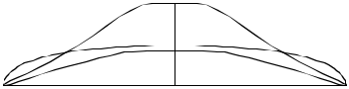

9"

22.9

1 ¹/₂"—
3.8

Shaped By:

Pat Rawson

24

6'7"H


 |  |  |  |  |  | Overall Bottom Length: |  |  |  |  | 6' 7 |  |  | ³/₄ |  | " (202.57)
 |  |  |  |  |  | Tip-to-tip Deck Length: 6' 7 |  |  |  |  |  |  |  | ¹/ " |  | (200.99)
4 | ¹/ "— |  |  |  |  |  |  |  |  |  |  |  |  | 8
 | 4 |  |  |  | ⁵/ "— | Maximum Width: |  | 20 ³/₄" |  |  |  |  | (52.71)
 | 10.80 |  |  | 4
 |  |  |  |  | 8
 |  |  |  |  | 11.75 | Maximum Thickness: 2 |  |  |  |  |  |  | ³/ " | (6.99)
 |  |  |  |  |  |  |  |  |  |  |  |  | 4
 |  |  |  |  |  | Displacement: 1.385 cubic feet |  |  |  |  |  |  |  |  |  | (0.0392m)
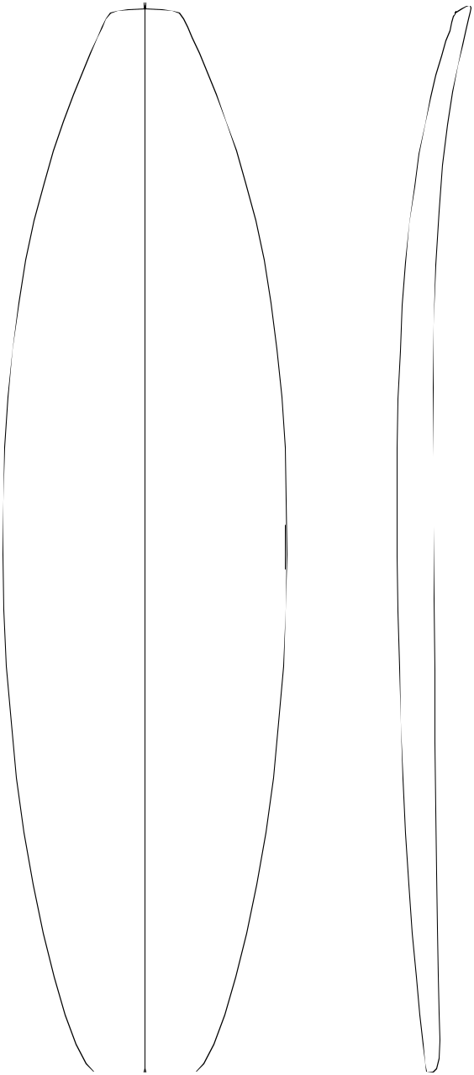

14 "—

35.56

18 ³/₄"—
47.63

20 ⁹/₁₆"—
52.23
- ³/₄"—
52.71

20 ⁵/₈"—
52.39

19 ¹/₄"—
48.90

15 ¹¹/₁₆"—

39.85

8 ¹/₂"—

21.59

1 | ³/ "— | — 1 | ¹/ "
 | 4 |  | 2
 | 4.45 | 3.81

¹/ "— | — 2 | ⁵/ "
2 |  | 16
1.27 5.87

¹/ "— | — 2 | 11/ "
16 |  | 16
0.16 | — 2 | 6.83
 | — 2 | ³/ "
 |  | 4
 | 6.99
¹/ "— | — 2 | ³/ "
16 |  | 4
0.16 | 6.99

³/ "— | — 2 | ⁷/ "
8 |  | 16
0.95 | 6.19

1 | ³/ "— | — 1 | ⁷/ "
 | 16 |  | 8
 | 3.02 | 4.76

2 ⁷/₁₆"—

6.19

History: Introduced January, 2002

Rockers: Natural

Factory Stocking: Usually in stock

Limited Volume Charge: $2.00

Blanks Per Box: 4 - 7'0"

Shaper's Comments: The 6'7"H is similar to the 6'4"R. It is designed for thinner, narrower boards in the 6'4" to 6'6" range . The blank is also designed to accept a concave in the back half while the nose rocker is relaxed. Some shapers may require a little extra flip in the tip.
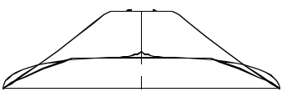

Shaped By:

Rusty Preisendorfer and Rick Hamon

25

4 "

10.16
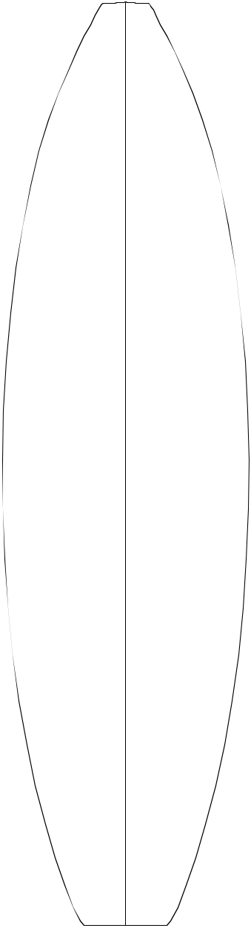

14 ³/₁₆ "—
36.04

19 ¹/₈ "—
48.59

21"—

53.34
21 ¹/₁₆ "—
53.49
21 "—

53.34

19 ¹/₂"—
49.53

15 ¹/₂"—
39.37

7¹/₄"—

18.42

Shaped By:

5 ¹/₈ "—
13.03

1 ²⁵/₃₂ "—

4.52

¹³/₃₂ "—

1.04

³/₈ "—

.95

1 ¹/₈ "—
2.86

2 ¹/₄"—
5.72

—1 ⁹/₁₆"

3.96

—2 ⁵/₁₆"

5.87

— 2 ⁵/_{8"} 6.68

— 2 ⁵/_{8"} 6.68
— 2 ⁵/_{8"} 6.68

— 2 ³/₈"

6.05

— 1 ³/_{4"} 4.45
6'7"R


Overall Bottom Length: 6' 7 ³/₈ " (201.62)

Tip-to-tip Deck Length: 6' 5 ⁵/₈" (199.72)

Maximum Width: 21 ¹/₁₆" (53.49)

Maximum Thickness: 2 ⁵/₈" (6.68)

Displacement: 1.525 cubic feet (.0432m)

History: Introduced June, 1993 Number one blank in this size range.

Rockers: +3/8"N Last 4" EE, Natural.

Wide variety of rockers.

Factory Stocking: Always

Limited Volume Charge: None

Blanks Per Box: 4- 7'0"

Shaper's Comments: This blank is obviously close tolerance. More than ever, personal rock-ers are important. I have left a litttle thickness in the very tip of the nose to allow for minor adjust-ments and to hopefully minimize accidental dam-age. Also note the deck contour; the centerline, a few inches to either side of the stringer, is relatively flat. The tail portion has been foiled in anticipation of the trend toward little or no vee.
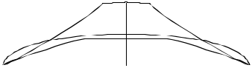

Rusty Preisendorfer and Rick Hamon ₂₆

- "—

35.56

5 | ⁷/ "—
 | 8
 | 14.92 | ¹/ "—
 | 5 | ¹/ "—
 |  | 8
 |  | 13.02
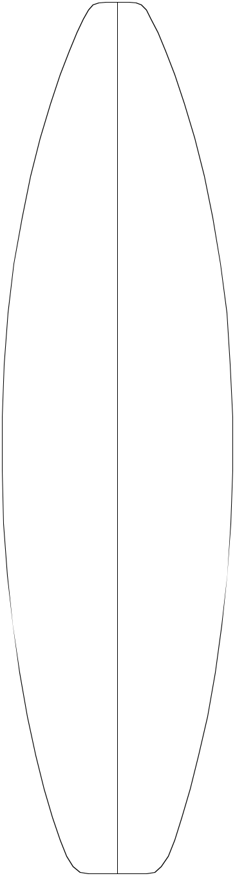

1 ³/₄"—

4.45
6'8"H
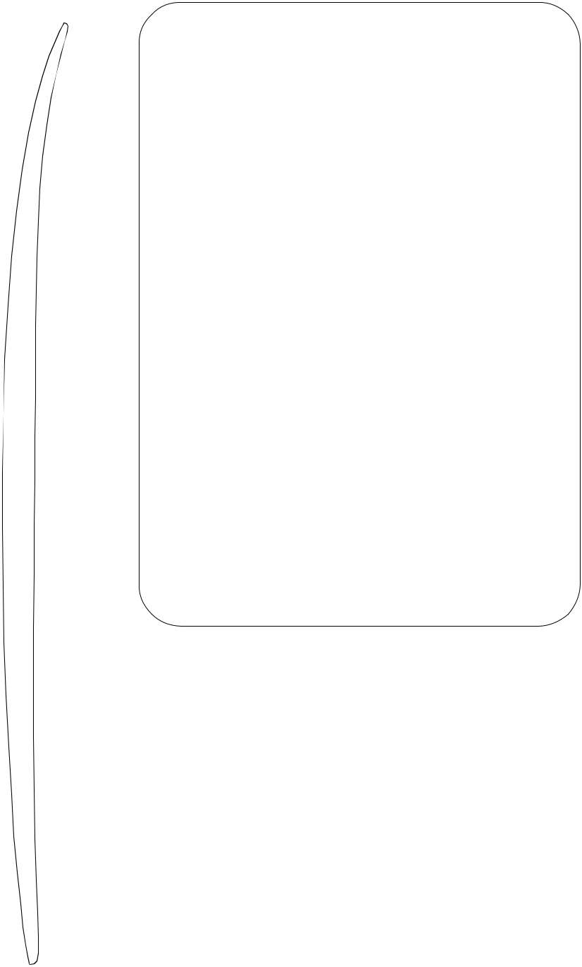

Overall Bottom Length: 6' 8 " (203.2)

Tip-to-tip Deck Length: 6' 7 ¹/₈" (200.98)

Maximum Width: 21 ¹/₄" (53.98)

— ₁ ¹⁵_{/16"} Maximum Thickness: 2 ⁷/₈" (7.30)

4.93
Displacement: 1.58 cubic feet (0.0447m)

- "—

48.26

- "—

53.34

- ¹/₄"—

53.98

- ¹/₈"—

53.37

- ³/₈"—

49.21

- ⁷/₁₆"—

39.20

¹/₂"—
1.27

³/₈"—

0.95

1 ¹/₁₆"—

2.72

2 ¹/₄"—

5.72

- ³/₄"—

17.15

Shaped By:

— 2 ¹/₂"

6.35

— 2 ⁷/₈"

7.30

— 2 ⁷/₈"
7.30

— 2 ⁷/₈"
7.30

— 2 ⁵/₈"

6.68

— 2 ¹/₁₆" 5.23

History: Reconstructed 6'8"R mold, but 1/8" thicker.

Rockers: Natural/ all 6'8"R rockers

Factory Stocking: Always

Limited Volume Charge: None

Blanks Per Box: 4 - 7'0"

Shaper's Comments: The 6'8"H (formerly known as the 6'8"RR) is the product of reconstructing a second mold for the 6'8"R. The reconstruction resulted in a blank slightly thicker than the 6'8"R. All 6'8"H and 6'8"R Rockers are interchangeable.
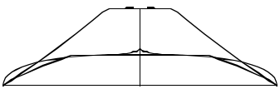

Rusty Preisendorfer and Rick Hamon 27

- "—
6'8"P

- ³/₈"—

46.67

22 ⁷/₈"—

58.10

- ⁷/₁₆"—

62.07

- ¹/₂"—

62.23

- ⁵/₁₆"—

61.75

22 ⁵/₈"—

57.47

17.78 | 4 | ⁵/ "—
 |  | 8
 |  | 11.75
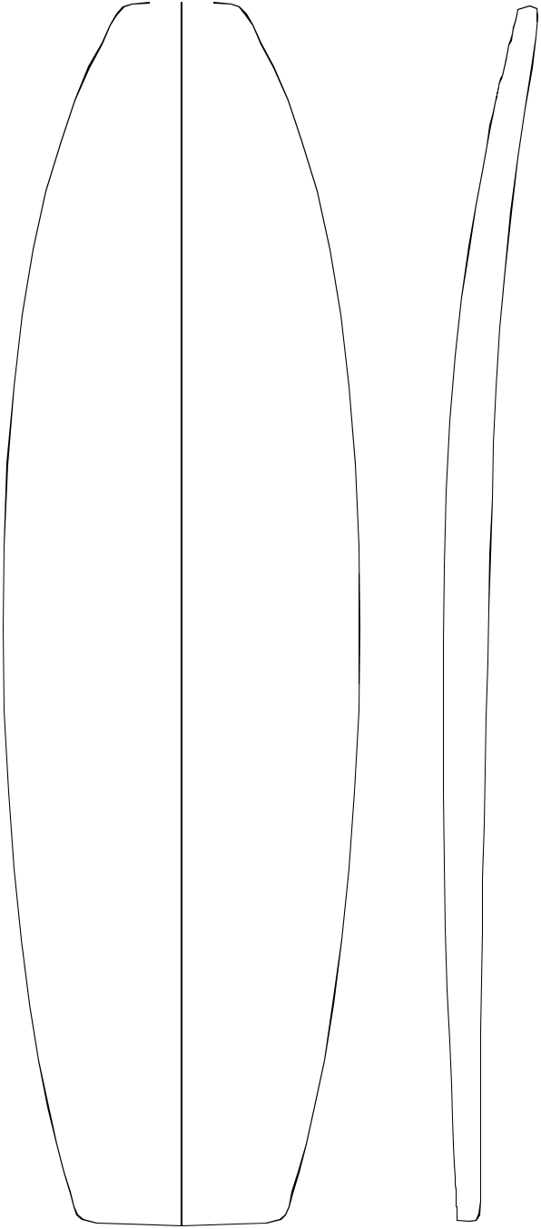

1 ³/₄"—
4.45

⁷/₁₆"—

1.11

¹/₄"—

0.64

— 2 ⁵/₁₆" 5.87

— 3 "

7.62

— 3 ¹/₄"
8.26

— 3 ³/₁₆" 8.10

— 3 ¹/₈"
7.94

— 2 ³/₄"
6.99

Overall Bottom Length: 6' 9 ⁵/₈ " (207.34)


Tip-to-tip Deck Length: 6' 8 ¹⁵/₁₆" (205.59)

Maximum Width: 24 ¹/₂" (62.23)

Maximum Thickness: 3 ¹/₄" (8.26)

Displacement: 2.398 cubic feet (0.0679m)

History: Introduced Autumn of 2004. Versatile design as a follow through to the "Fish Revolution.” Used for contemporary Lis - Fish as well as multiple eras. Example: Free-Ride (think SHAWN,RABBIT, & M.R.), Big Brother to the universally accepted 6'2"C.

Rockers: Natural, wide range available.

Factory Stocking: Limited

Limited Volume Charge: None

Blanks Per Box: 4 - 8'4" Box

Shaper's Comments: Designed to produce boards of multiple eras. With input from some of surf design's best minds the 6'8"P is influenced by a universal rocker with profiles that are integrated and timeless. The 6'8"P will play an important role in the current generation of shapers emerging not only as technicians but also designers at the genesis of what is possible in their craft. This in turn will set a new precedent for the next era of surfing.

Paying close attention to and working with all the elements of design in the 6'8"P opens the door to a new level of performance and self expression for all shapers and designers.

19 | ¹/ "— | ¹³/ "—
 | 4 | 16
 | 48.90 | 2.06

1⁹/ "—
12 "— | 16
12 "— | 3.97
30.48

Shaped By:

— 2 ³/₁₆" 5.56
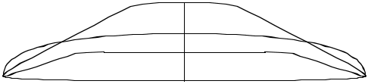

Rich Pavel ₂₈

- "—

35.56

- "—

48.26

- "—

53.34

- ⁷/₈"—

14.92

5 ¹/₈"—
13.02

1 ³/₄"—

4.45

¹/₂"—
1.27
6'8"R


Overall Bottom Length: 6' 8 " (203.2)

 |  |  | Tip-to-tip Deck Length: 6' 7 ¹/ " |  |  |  |  |  |  |  | (200.99)
 |  |  |  |  |  |  |  |  |  | 8
 |  |  | Maximum Width: 21 ¹/ " |  |  |  |  |  |  | 8
 |  |  |  |  |  |  |  |  |  | (53.98)
— 1 | 11/ | " |  |  |  |  | 4
 | 16 |  | Maximum Thickness: 2 |  |  |  |  |  |  | /₄" (6.99)
 | 4.29 |  |  |  |  |  |  |  |  | 3
 |  |  | Displacement: 1.58 cubic feet |  |  |  |  |  |  |  | (0.0447m)
 |  |  | History: Introduced Spring, 1995
— 2 | ³/ "
— 2 | ³/ " |  | Rockers: |  | Natural, wide range available.
 | 8
6.05

Factory Stocking: Always

Limited Volume Charge: None
— 2 ³/₄"
6.99 | Blanks Per Box: 4 - 7'0" Box

- ¹/₄"—

53.98

- ¹/₈"—

53.37

- ³/₈"—

49.21

³/₈"—

0.95

— 2 ³/₄"

6.99

— 2 ³/₄"

6.99

— 2 ¹/₂"

6.35

Shaper's Comments: The 6'8"R is designed to com-pliment--not replace--the 6'7"R. The blank is slightly thicker throughout, and the deck has a little more crown which runs full length. The nose rocker is slightly "relaxed" and should easily accommodate any extra flip. The concept behind this blank is to offer something slightly thicker; a close tolerance hot dog blank for middle weight (160-190 lbs.) surfers. For a slightly thicker version of this blank, see the 6'8"H.
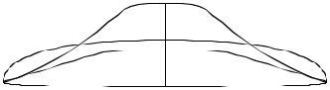

- ⁷/₁₆"—

39.20

1 ¹/₁₆"—

2.72

2 ¹/₄"—

5.72

- ³/₄"—

17.15

Shaped By:

— 1 ⁷/₈"

4.76

Rusty Preisendorfer and Rick Hamon 29

7 ¹/₂"—

19.05
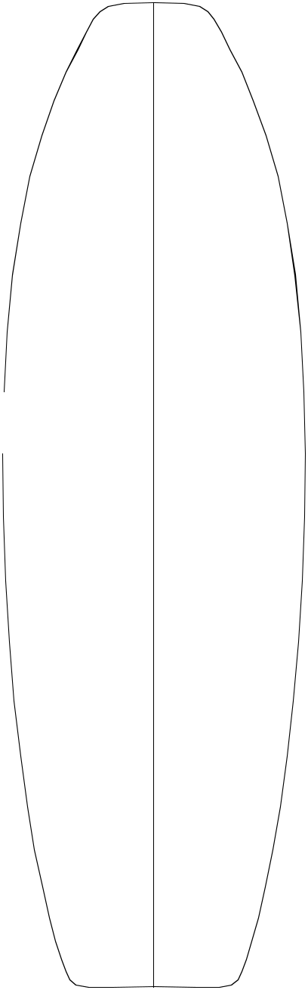

18 ⁵/₁₆"—
46.51

"—

58.42

24 ⁷/₁₆"—
62.07

¹/₂"—

62.23

⁹/₁₆"—

57.31

22 ¹/₁₆"—
56.04

18 ¹/₂"—
46.99

13 "—

33.02

Shaped By:

³/₈"—

13.65

2 "—

5.08

¹/₂"—
1.27

⁷/₁₆"—

1.11

¹/₁₆"—

2.70

¹⁵/₁₆"—

4.92

— 2 ⁵/₁₆" 5.87

— 3 ¹/₈"

7.94

— 3 ⁷/₁₆" 8.73

— 3 ³/₈"

8.57

— 3 ³/₈"

8.57

— 2 ¹⁵/₁₆" 7.46

— 2 ¹/₄"
5.72
6'9"A


Overall Bottom Length: 6' 10 ¹³/₁₆ " (210.34)

Tip-to-tip Deck Length: 6' 10" (208.28)

Maximum Width: 24 ⁹/₁₆" (62.38)

Maximum Thickness: 3 ³/₈" (8.57)

Displacement: 2.536 cubic feet (0.0718m)

History: Introduced Spring, 2002

Rockers: Natural, wide range available.

Factory Stocking: Limited

Limited Volume Charge: None

Blanks Per Box: 4 - 8'4" Box

Shaper's Comments: Built around the need for a longer "fish" style board. From the deck, this blank should comfortably net 6'8" x 23" x 3" to 3-1/8". The natural rocker should be great for "fish" style boards, "big guy" floaties, and also for retro style boards. Definitely the "Swiss Army knife" of blanks under 6'10"!
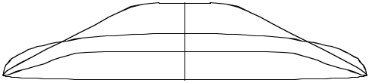

Pat Rawson 30

3 ¹/₂"
8.89
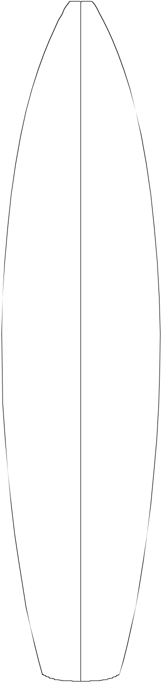

13 ⁷/₁₆ "—
34.13

18 ¹/₄ "—
46.36

20 ³/₈"—
51.75

20 ¹/₂ "—
52.07

20 ³/₈"—
51.75

18 ¹¹/₁₆"—
47.47

15 ¹/₁₆"—
38.26

8 ¹/₂"
21.59

Shaped By:

"—
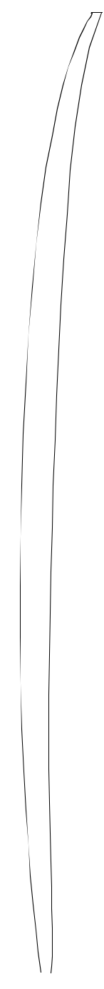
12.70

1 ³/₄"—
4.45

⁷/₁₆ "—
1.11

³/₈"—
.95

1 ³/₁₆ "—
3.02

³/₈"—

03
6'9"H


Overall Bottom Length: 6' 9 ⁵/₈ " (207.34)

 |  |  | Tip-to-tip Deck Length: |  |  |  |  |  |  |  | 6'9 " | (205.74)
 |  |  | Maximum Width: 20 ¹/ " |  |  |  |  |  |  |  | (52.07)
 |  |  |  |  |  |  | 2
 |  |  | Maximum Thickness: 2 |  |  |  |  |  |  |  | ⁹/ " | (6.50)
—1 | ¹/ " |  |  |  |  |  |  |  |  |  | 16
—1 |  |  | Displacement: 1.422 cubic feet (0.0402 m)
 | 2
3.81
 |  |  | History: Introduced November, 2001
 |  |  | Rockers: Natural
—2 | 3/ | "
—2 | 3/ | " | Factory Stocking: Limited
 | 16
5.56

Limited Volume: $2.00

Blanks Per Box: 4- 7'0"

— 2 ¹/₂"
6.35 | Shaper's Comments: | Designed to accommodate
 | thinner mid-range boards. Similar in design to the
 | 6'8"R, but longer, thinner, and slightly narrower.
— 2 ⁹/₁₆" 6.51

— 2 ⁹/₁₆" 6.51

— 2 ³/₈"
6.03
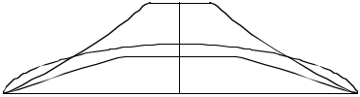

— 1 ⁷/₈"
4.76

Rusty Preisendorfer & Rick Hamon 31

—1 ⁵/₈"
4.1
—2 ³/₈"
6.0
— 2 ¹³/₁₆" 7.1

³/₈ "—

5

19 ¹/₂ "—
49.5

¹¹/₁₆ "—
1

21 ⁷/₈ "—
55.6

¹¹/₁₆ "—

1

19 ¹³/₁₆"—
50.3

⁵/₈"—

39.7

4"

10.2

5 ³/₈ "—
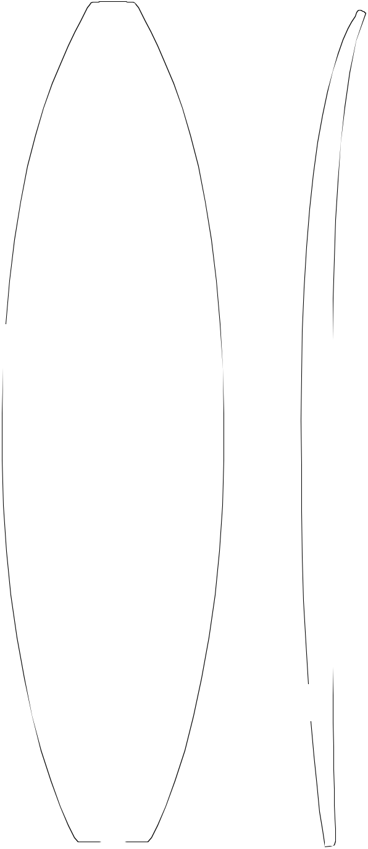
13.6

1 ¹³/₁₆ "—

4.6

¹/₂ "—
1.3

⁵/₁₆ "—
.8

1 ¹/₁₆ "—

2.7

 | 2 | ¹/ "—
6 ³/₄" |  | 4
6 ³/₄" | 5.7
17.1

Shaped By:
6'9"R


Overall Bottom Length: 6' 10 ¹/₄ " (208.9)

Tip-to-tip Deck Length: | 6' 9 ¹/₄" | (206.4)

Maximum Width: 21 ⁷/₈" (55.6)

Maximum Thickness: 2 ¹³/₁₆" (7.1)

Displacement: 1.69 cubic feet (.0480 m)

History: Introduced July, 1994

Rockers: Natural, wide range available.

Factory Stocking: Always

Limited Volume Charge: None

Blanks Per Box: 4- 7'0"

Shaper's Comments: The 6'9"R is designed to fill the gap between the 6'7"R and the 7'0"R. Proportion-

— 2 ¹³/₁₆" ately, it is probably a little closer to the 6'7"R. We have

7.1also taken into consideration a need for a slightly thicker, more versatile blank in this size range.

— 2 ³/₄"
7.0

— 2 ¹/₂"
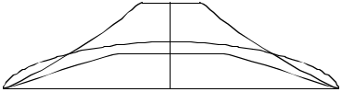
6.4

— 2"

5.1

Rusty Preisendorfer & RIck Hamon 32

⁷/₈ "—

35.26

³/₁₆ "—

48.74

¹³/₃₂ "—

54.38

²¹/₃₂ "—

55.02

³/₈ "—

54.31

³/₈"—

49.23

³/₁₆"—

38.58

3"

7.62

5 ¹/₂ "—
13.97
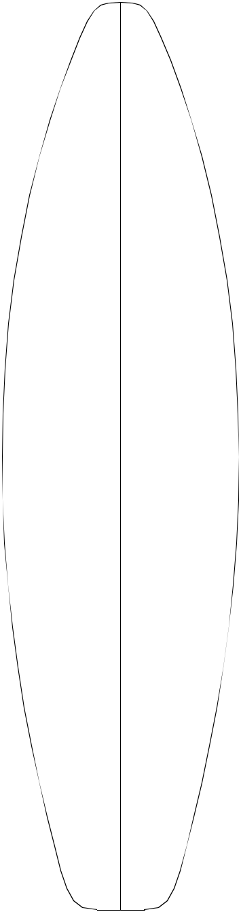

2 ¹/₈ "—
5.40

⁹/₁₆ "—
1.42

⁵/₁₆ "—

.79

⁷/₈ "—
2.22

—2 ¹/₁₆"

5.23

—2 ⁷/₈"

7.32

— 3 ⁷/₃₂" 8.18

— 3 ¹/₄"

8.26

— 3 ³/₁₆" 8.10

— 2 ¹³/₁₆"

7.14

— 2 ⁵/₁₆" 5.87
6'11"A


Overall Bottom Length: 6' 11 ¹/₂ " (212.09)

Tip-to-tip Deck Length: 6' 10 ⁷/₈ " (210.52)

Maximum Width: 21 ²¹/₃₂" (55.02)

Maximum Thickness: 3 ¹/₄" (8.26)

Displacement: 1.965 cubic feet (.0556 m)

History: Introduced 1987. For thicker, small guns. Still used as a "big guy" blank and for 80's retro boards .

Rockers: Natural, +3/8"T

Factory Stocking: Very Limited

Limited Volume Charge: None

Blanks Per Box: 4- 8'4"

Shaper's Comments: The 6'11"A was designed to be a longer version of the once popular 6'5"P...the original thruster blank.
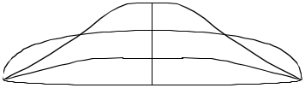

1 ⁵/₈"—
4.14

¹/₂"

19.05

Shaped By:

Pat Rawson

33

—2 ¹³/₁₆"
—1 ³/₄ "
4.4
—2 ¹/₂ "
6.4

⁹/₁₆ "—

5

³/₈"—

8

⁵/₁₆ "—

7

¹/₂ "—

2

⁵/₁₆ "—

7

¹/₂ "—

52.1

¹/₁₆ "—

40.8

4"—
10.2 | 9/ | "—
5 | 9/ | "—
 | 16
14.1
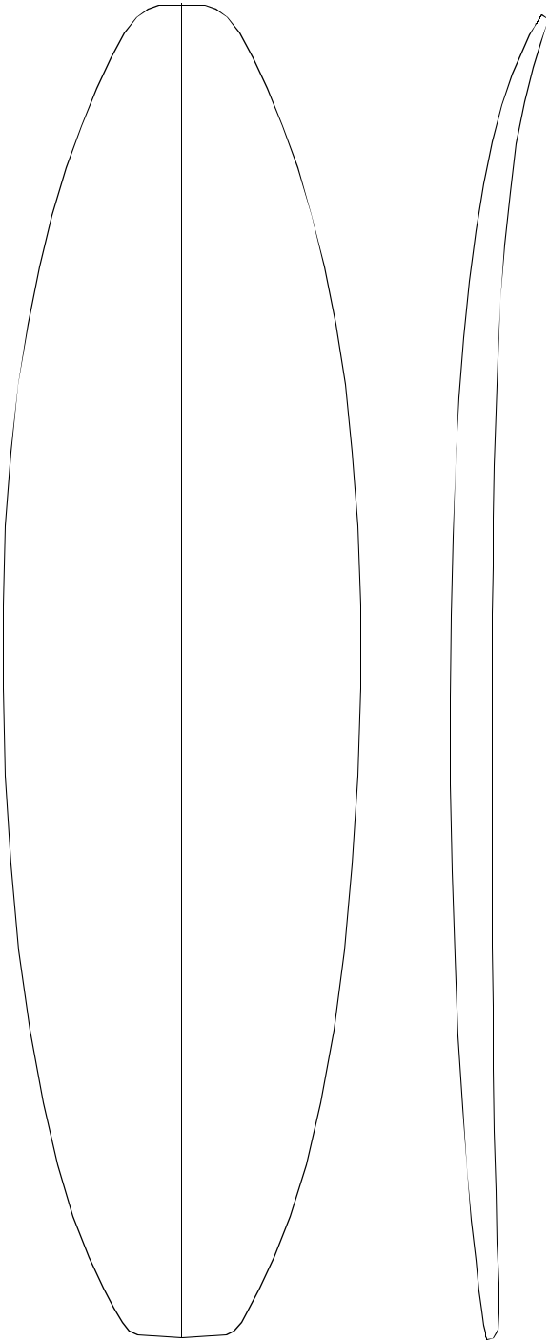

1 ⁷/₈ "—

4.8

¹/₂ "—

1.3

⁵/₁₆ "—

.8

1"—

2.5

2 ¹/₄"—
5.7
6"

15.2

Shaped By:
6'11"R


Overall Bottom Length: 6'11 1/2" (212.1)

Tip-to-tip Deck Length: 6'10 1/2" (209.6)

Maximum Width: 22 ¹/₂" (57.2)

Maximum Thickness: 2 ⁷/₈" (7.3)

Displacement: 1.906 cubic feet (.0540m)

History: Introduced May, 1994

Rockers: Natural, +1/4"T Last 18" B

Factory Stocking: Always

Limited Volume Charge: None

Blanks Per Box: 4- 8'4"

Shaper's Comments: The 6'11"R is a shorter version of the 7'4"R "hybrid" blank. The crowned deck carries off the tail and should require minimal

7.1 foiling.

—2⁷/₈"
7.3

—2⁷/₈"
7.3
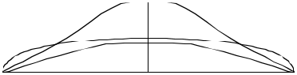

— 2 ⁹/₁₆"
6.5

— 1 ¹⁵/₁₆"
4.9

Rusty Preisendorfer 34

2 ¹/₂ "—
6.35
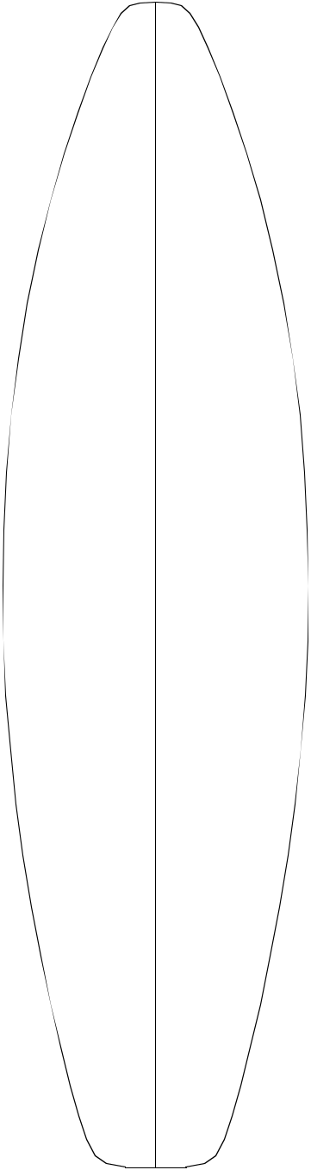

13 ¹⁹/₃₂ "—
34.52

19 ³/₃₂"—
48.49

21 ³/₈ "—
54.31

21 ¹⁹/₃₂ "—
54.84

21 ⁹/₃₂ "—
54.1

19 ¹¹/₃₂ "—
49.12

15 ⁵/₈ "—
39.70

8 ¹/₂"—
21.59

Shaped By:

5 ¹/₈ "—
13.03

1 ⁷/₈ "—
4.76

¹⁷/₃₂ "—

1.35

¹¹/₃₂ "—

.86

⁷/₈ "—

2.22

1 ¹⁹/₃₂"—
4.04

—2 ¹/₁₆ "
5.23

—2 ²¹/₃₂ "
6.76

—2 ²⁹/₃₂"
7.39

— 2 ¹⁵/₁₆ "

7.45

—2⁷/₈"
7.32

— 2 ¹⁷/₃₂"

6.43

— 2 ¹/₁₆"
5.23
7'0"A


Overall Bottom Length: 7' 0 1/2" (214.63)

Tip-to-tip Deck Length: 6' 11 ³/₈" (211.79)

Maximum Width: 21 ¹⁹/₃₂" (54.84)

Maximum Thickness: 2 ¹⁵/₁₆" (7.47)

Displacement: 1.765 cubic feet (.0499m)

History: Introduced November, 1990. Was work-horse in this size range. Considered by today's standards to be a thick blank.

Rockers: Rawson/Hawaii (+1/4"N +1/4"T EE), Natural

Factory Stocking: Limited

Limited Volume Charge: None

Blanks Per Box: 4- 8'4"

Shaper's Comments: The 7'0"A was designed to work with the other "A" series blanks (6'7"A, 7'3"A, 7'7"A, and 7'11"A). The 6'11"A, 7'5"A, and the 8'5" were designed for thicker surfboards 2 5/8" and up.
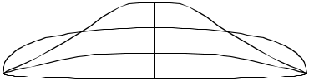

Pat Rawson ³⁵

3 ¹/₂ "—
8.89
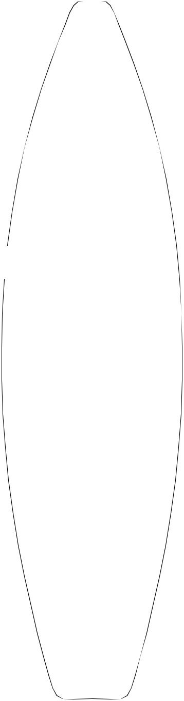

13 ⁷/₃₂ "—
33.58

18 ¹³/₁₆"—
47.78

21 ¹¹/₃₂ "—
54.20

21 ²³/₃₂ "—
55.17

21 ¹³/₃₂ "—
54.38

19 ²⁵/₃₂ "—
50.24

15 ³/₁₆ "—
38.58

8 ¹/₄"—
20.96

Shaped By:

⁵/₈ "—

14.30

"—

5.08

⁹/₁₆"—
1.42

⁷/₁₆ "—
1.12

1 ⁷/₃₂ "—
3.10

⁷/₁₆"—

6.20

—1 ²¹/₃₂"

4.22

—2 ⁷/₁₆ "

6.20

—2 ¹³/₁₆"

7.14

—2⁷/₈"
7.32

—2 ¹³/₁₆"

7.14

— 2 ⁹/₁₆" 6.50

— 2 "

5.08

7'0"R


Overall Bottom Length: 7' 1 ³/₄" (217.81)

Tip-to-tip Deck Length: 7' 0 ¹⁵/₁₆" (215.75)

Maximum Width: 21 ²³/₃₂" (55.17)

Maximum Thickness: 2 ⁷/₈" (7.32)

Displacement: 1.915 cubic feet (.0542m)

History: Introduced Winter 1993.

Most popular size in this range.

Rockers: Natural, +1/4"N Last 6" A.

Wide variety of rockers.

Factory Stocking: Always.

Limited Volume Charge: None

Blanks Per Box: 4- 8'4"

Shaper's Comments: Designed to be an exten-sion of the 6'3"R and 6'7"R. Because of the crowned deck, I've limited the width. This should minimize rail-line distortion after templating.
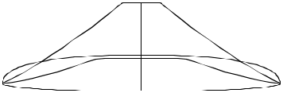

36

Rusty Preisendorfer and Rick Hamon

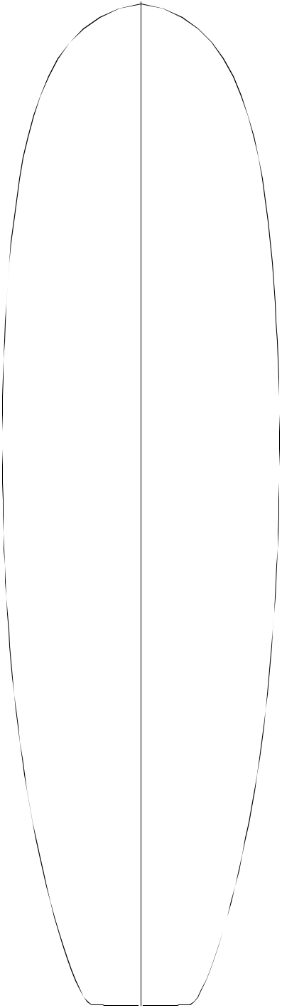

19 ⁷/₁₆ "—
49.38

22 ⁹/₁₆"—
57.30

23 ¹⁵/₁₆ "—
60.81

21 "—

53.34

23¹/₄ "—
59.06

21 ³/₈ "—
54.31

16 ¹⁵/₁₆ "—
43.03

8 ¹/₂"—
21.59

Shaped By:

3 ⁷/₈ "—
9.86

1 ³/₄ "—
4.45

¹⁹/₃₂ "—
1.50

⁷/₁₆ "—
1.12

1 ¹¹/₃₂ "—

3.40

2 ¹/₂"—
6.35

—2 ⁷/₁₆ "
6.20

—3 "

7.62

—3 ¹/₄"
8.26

—3 ³/₈"
8.59

—3¹/₄"
8.26

— 2 ¹⁵/₁₆"

7.47

— 2 ³/₁₆" 5.56
7'3"


Overall Bottom Length: 7' 3 ¹/₄" (221.62)

Tip-to-tip Deck Length: 7' 3 ¹/₂" (222.25)

Maximum Width: 24" (60.96)

Maximum Thickness: 3 ³/₈" (8.59)

Displacement: 2.565 cubic feet (.0726m)

History: Great blank for egg/saucer shapes.

Rockers: Eaton (+5/8"N -1/2"T E),Natural

Factory Stocking: Limited

Limited Volume Charge: None

Blanks Per Box: 4- 8'4"

Shaper's Comments: Can net 7'2" and 3 1/8" maximum thickness. Rocker is easily adjusted. Crown deck and bottom.
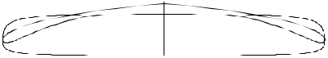

Phil Becker
37

3 ¹/₈ "— | 5 | ¹/ "—
7.95 |  | 4
 | 13.34
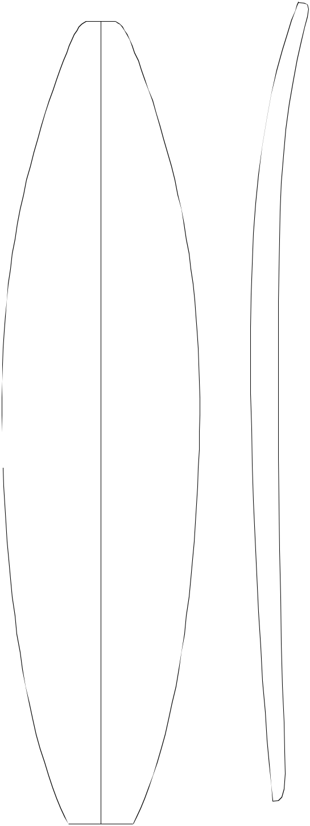

13 ³/₄ "— | 2 ¹/₁₆"—
34.93 | 5.24

18 | 31/ | 32 | "— | ¹⁹/ "—
 |  | 32 |  | 32
48.18 |  |  |  | 1.50
7'3"A


 | Overall Bottom Length: 7' 3 ⁵/ " |  |  |  |  |  |  |  | (222.58)
 |  |  |  |  |  |  |  | 8
 | Tip-to-tip Deck Length: 7' 2 |  |  |  |  |  |  | ³/ " | (220.35)
 |  |  |  |  |  |  |  | 4
 | Maximum Width: 21 ⁵/ " |  |  |  |  |  |  | 4
 |  |  |  |  |  |  |  | (54.94)
—2 " |  |  |  | 8
—2 " | Maximum Thickness: 3 " |  |  |  |  |  |  | (7.62)
5.08 |  |  |  |  |  |  |  | (7.62)
 | Displacement: 1.978 cubic feet |  |  |  |  |  |  |  | (.0560m)
 | History: Introduced June, 1989. Versatile
—2 ⁵/₈" | blank; good for small guns, "hot dogs", thicker
6.68 | boards, and 80's retro shapes.

21 ⁵/₁₆ "—
54.13

21 ⁵/₈ "—
54.94

21³/₃₂ "—
53.57

—2 ³¹/₃₂"

7.54

— 3 "

7.62

— 2 ¹⁵/₁₆ " 7.47

Rockers: Hawaii/Rawson (+5/8"N E), Natural, +1/4"T

Factory Stocking: Limited

Limited Volume Charge: None

Blanks Per Box: 4- 8'4"

Shaper's Comments: The 7'3"A and 7'11"A were designed to work with the other "A" series blanks, offering a less expensive and easier to shape alternative (the 6'11"A, 7'5"A, and the 8'5" were designed for thicker surfboards 2-5/8" and up).

18 | ²⁹/ "— | ⁷/₁₆"—
 | 32 | 1.12
48.03 |  | 1.12

14 ²⁷/₃₂ "— | 1 ³/₃₂"—
37.69 | 2.78

1 ³/₄"—
4.45

¹/₄"—

18.42

Shaped By:

— 2 ²³/₃₂"

6.92

— 2 ³/₁₆" 5.56
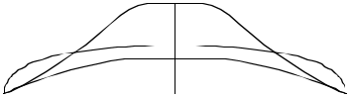

Pat Rawson
38

6.83
Shaper's Comments: This blank was designed for high
— 2 3/₄"
performance surfing, primarily for Team riders. The
6.99
deck was contoured to minimize overshaping in the rail area.
— 2 ³/₄"
6.99
— 2 ³/₈"
6.03
—1 ³/₄"
4.45
History: Introduced Fall, 1999
Rockers: Natural, -1/4"N Last 8" A.
Factory Stocking: Very Limited
Limited Volume Charge: $2.00
Blanks Per Box: 4 - 8'4"
Displacement: 1.752 cubic feet
Maximum Thickness: 2 ¹³/₁₆"
— 2 ¹¹/₁₆"
— 2 ³/₁₆" 5.56
3.49
— 1 ³/₈"

¹/₂"—

8.89
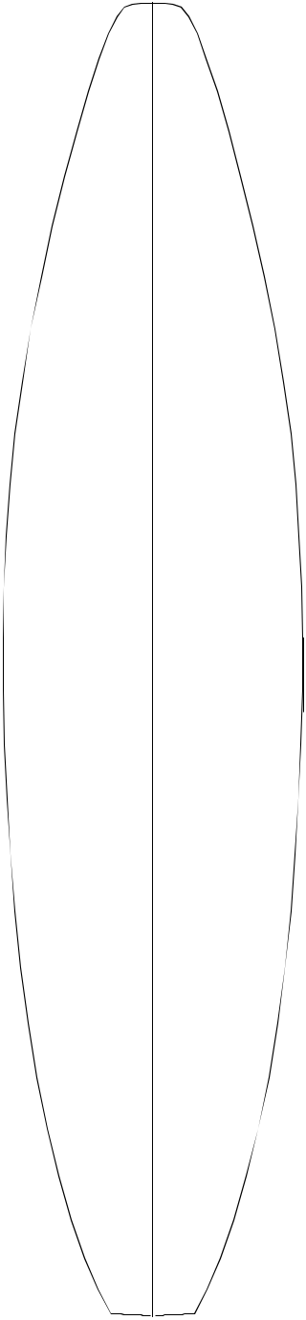
7'3"P


5 ³/₄"— | Overall Bottom Length: |  | 7' 4 ³/₄" |  | (225.43)
14.61
 | Tip-to-tip Deck Length: 7' 3 |  |  | ⁵/ " | (222.58)
 |  |  |  | 8

¹/₄"—

33.66

¹/₄"—

46.36

³/₄"—

52.71

21⁵/₁₆"—

54.13

¹⁵/₁₆"—

53.18

⁷/₈"—

47.94

⁷/₁₆"—

36.67

³/₄"

14.61

⁵/₁₆"—

5.87

³/₄"—
1.91

⁵/₈"—

1.59

⁹ /₁₆"—

3.97

¹⁵/₁₆"—

7.46

Maximum Width: 21 ⁵/₁₆" (54.13)

(7.14)

(0.0496m)
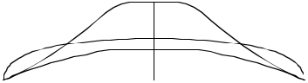

Shaped By:

Timmy Patterson

39

¹¹/₁₆"—

34.77

³/₈"—

49.21

22"—

55.88

¹/₂"—

57.15

¹/₈"—

56.20

20"—

50.80

¹¹/₁₆"—

39.85

¹/₈"—

7.94
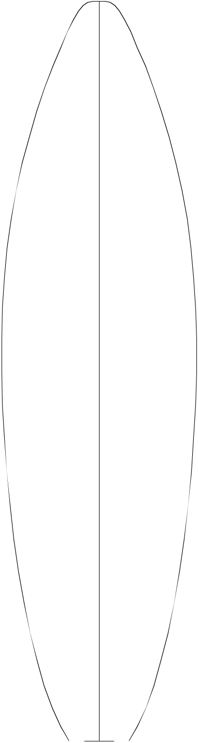

³/₄"

14.61

5 ¹¹/₁₆"—

14.45

2 | ¹/ "— | — 1 | ³/ "
 | 4 |  | 4
 | 5.72 | 4.45

¹¹/ "— | — 2 | ¹/ "
16 |  | 2
1.75 6.35

— 2 ¹⁵/₁₆"

7.46

— 3"

7.62

— 2 ¹⁵/₁₆"

7.46

¹/ "— | — 2 | ⁹/ "
2 |  | 16
1.27 | 6.51

1 | ³/ "— | —1 | ⁷/ "
 | 16 |  | 8
3.02 4.76

2 ¹/₄"—
5.72

Shaped By:
7'3"R


Overall Bottom Length: 7' 4 ⁹/₁₆" (224.95)

Tip-to-tip Deck Length: 7' 3 ⁵/₈" (222.56)

Maximum Width: 22 ¹/₂" (57.15)

Maximum Thickness: 3" (7.62)

Displacement: 1.962 cubic feet (0.0555m)

History: Introduced March, 1997

Rockers: Natural

Factory Stocking: Limited

Limited Volume Charge: None

Blanks Per Box: 4 - 8'4"

Shaper's Comments: The 7'3"R is intended to fill the gap between the 7'0"R & 7'7"R. It is similar to the rest of the close tolerance blanks. It is, however, a little wider. In addition, it has a slightly "relaxed" rocker, especially the back 1/3. Also, note actual length, it should be possible to net a full 7'4".

Rusty Preisendorfer ⁴⁰

— 1 ¹⁵/₁₆" 4.93
— 2 ¹¹/₁₆" 6.35
— 3 ¹/₁₆" 7.77
— 3 ³/₃₂" 7.85

"—

40.64

²⁹/₃₂"—
53.11

22 ²⁵/₃₂"—
57.86

23 "—

¹/₂"—

8.89
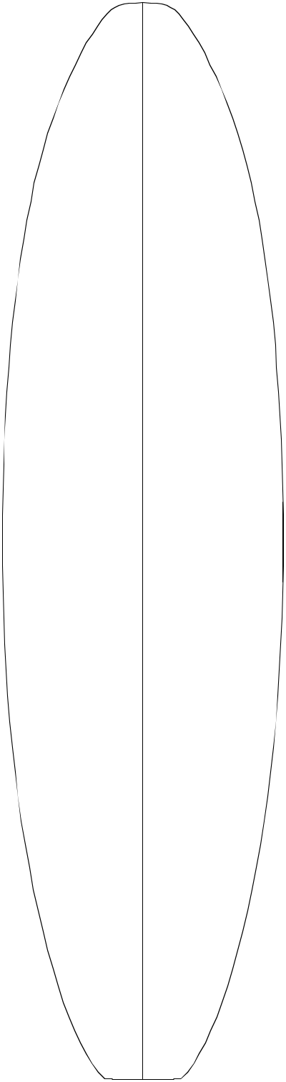

¹³/₁₆"—

14.76

2 ⁵/₃₂"—

5.49

¹¹/₁₆"—
1.75
7'4"R


Overall Bottom Length: 7' 5 ¹/₈" (226.39)

Tip-to-tip Deck Length: 7' 4 ¹/₄" (224.16)

Maximum Width: 23 " (58.42)

Maximum Thickness: 3 ³/₃₂" (7.85)

Displacement: 2.18 cubic feet (0.06183m)

History: Introduced Winter, 1993. Well accepted in all areas for newer, wider boards. Has inspired shorter and longer plugs for hybrids.

Rockers: Natural. Rusty recommends plus tail adjustment for hybrids.

Factory Stocking: Always.

Limited Volume Charge: None

Blanks Per Box: 4 - 8'4"

58.42

22 ¹⁵/₃₂"—

57.07

20 ¹¹/₃₂"—

51.66

16 ³/₃₂"—
40.87

¹/₂"

16.51

Shaped By:

 |  | Shaper's Comments: Designed as a "little brother" to the
 |  | 7'10"R. Based on feedback and current design direc-
 |  | tion, the nose has been thinned out and flipped up, and
 | — ³ ^{1/}₁₆" the deck has been crowned. Primarily created as an
 | 7.77 | updated mid-range funboard blank. Its profile propor-
 |  | tions and rocker should easily yield "big boys" and semi-
 |  | guns up to 7'4".
¹⁵/ "— | —2¹¹/ "
32 | 16
1.19 | 6.83
1 ⁵/₃₂"— | —2 "
2.95 | 5.08
2 ⁵/₁₆"—
5.87
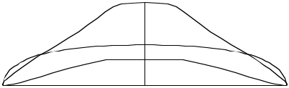

41
Rusty Preisendorfer and Rick Hamon

⁷/₁₆"—

36.68

⁵/₁₆"—

50.6

"—

55.88

³/₁₆"—

56.36

¹⁷/₃₂"—

54.69

19 ¹/₄"—

48.90

¹⁷/₃₂"—

39.45

5 ⁵/₈"—
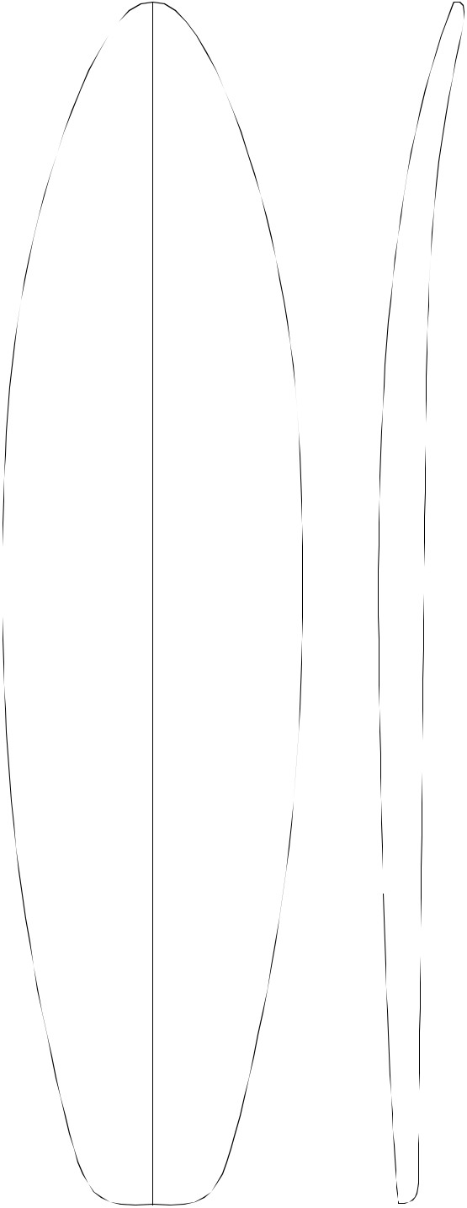
14.3

1 ¹⁵/₁₆"—
4.92

¹⁷/₃₂"—
1.35

³/₈"—

.95

¹³/₁₆"—
2.07

1 ⁵/₈"—
4.14

¹/₂"

21.59

— 2 ¹/₄"
5.72

— 3"

7.62

— 3 ³/₈"
8.6

— 3 ⁷/₁₆" 8.7

— 3 ¹/₄"
8.26

— 2 ⁷/₈"
7.32

— 2 ¹/₄"
5.72
7'5"A


Overall Bottom Length: 7' 5 " (226.06)

Tip-to-tip Deck Length: 7' 4 ³/₈" (224.49)

Maximum Width: 22 ³/₁₆" (56.36)

Maximum Thickness: 3 ⁷/₁₆" (8.74)

Displacement: 2.27 cubic feet (0.0643m)

History: Once a popular gun blank, sales are now limited to Big-Gun boards, especially in Fall/Winter.

Rockers: Natural, Hawaii (+3/16"N +3/8"T), Rawson (+1/2"N +1/2"T E)

Factory Stocking: Seasonal with supply increasing in Fall and Winter.

Limited Volume Charge: None

Blanks Per Box: 4 - 8'4"

Shaper's Comments: It features a universal natural rocker and is designed for versatility.
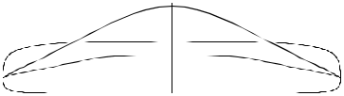

Shaped By:
42
Pat Rawson

³/₈"

6.05
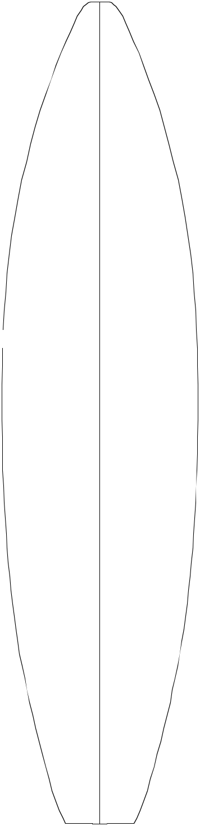

5 ³/₈"—
13.67
7'7"A


³/₃₂"—

33.25

18 ²¹/₃₂"—
47.40

⁵/₃₂"—

53.75

¹¹₁₆"—

55.09

¹/₈"—

53.67

18 ¹³/₁₆"—

47.78

³/₄"—

37.47

¹/₂"

19.05

2 ¹/₄"—
5.72

/₄"—

1.91

/₈"—

.32

/₃₂"—

.24

/₁₆"— 1.11

¹/₃₂"—

2.62

²⁷/₃₂"—

4.67

— 1 ¹⁵/₁₆" 4.93

— 2 ¹/₂"

6.35

— 2 ¹³/₁₆" 7.14

—2 ¹⁵/₁₆"

7.47

— 2 ¹³/₁₆"

7.14

— 2 ¹/₂"

6.35

— 2 ¹/₁₆"

5.23

Overall Bottom Length: 7' 5 " (232.74)

Tip-to-tip Deck Length: 7' 6 ³/₈" (230.51)

Maximum Width: 21 ¹¹/₁₆" (55.09)

Maximum Thickness: 2 ¹⁵/₁₆" (7.47)

Displacement: 2.109 cubic feet (0.0597m)

History: Introduced November, 1990. Once popular with year-round demand, it's now declining due to newer 7'7"R.

Rockers: Hawaii/Rawson (+1/2"N E)

Wide variety of rockers available.

Factory Stocking: Limited, at times seasonal

Limited Volume Charge: $ 1.00

Blanks Per Box: 3 - 8'4"

4 - 9'6"

Shaper's Comments: The 7'7"A was designed to work with other "A" series blanks (6'7"A, 7'0"A, 7'3"A, and 7'11"A). (The 6'11"A, 7'5"A and the 8'5" were designed for thicker surfboards 2-5/8" and up).
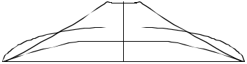

Shaped By:
43
Pat Rawson

³/₁₆"—

33.5

18 ⁷/₈"—
47.9

¹/₂"—
54.6

22 ¹/₁₆"—

56.0

⁵/₁₆"—
54.1

"—

48.3

¹¹/₁₆"—

37.3

"—
7.6
6 ⁵/₁₆"—
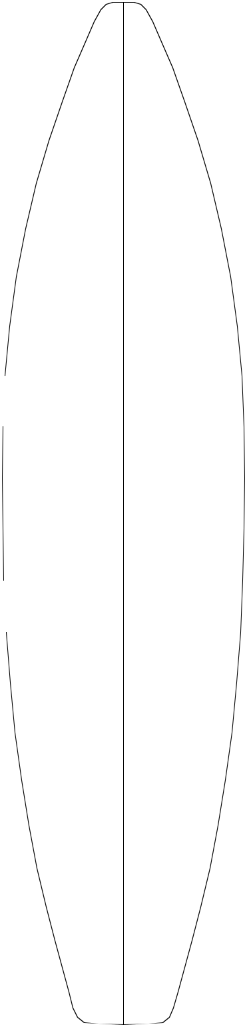
14.92

2 ⁵/₁₆"—

5.9

³/₄"—
1.9

¹/₈"—
0..32

¹/₈"—
0..32

9/₁₆"—
1.4

1 ³/₈ "—
3.5

2 ⁵/₈"—
₈" 6.7

20.3

Shaped By:

— 1 ⁵/₈"
4.1

— 2 ³/₈"

6.0

— 2 ¹³/₁₆" 7.1

— 3 "

7.6

— 2 ¹⁵/₁₆" 7.5

— 2 ¹/₂"
6.4

— 1 ⁷/₈"
4.8
7'7"R


Overall Bottom Length: 7' 8 1/2" (232.4)

Tip-to-tip Deck Length: 7' 7 ¹/₂" (234.9)

Maximum Width: 22 ¹/₁₆" (56.0)

Maximum Thickness: 3" (7.6)

Displacement: 1.981 cubic feet (0.0561m)

History: Introduced May, 1994.

Rockers: Natural

Factory Stocking: Limited

Limited Volume Charge: None

Blanks Per Box: 3 - 8'4"

4 - 9'6"

Shaper's Comments: The 7'7"R is an extension of the R series blanks. It is primarily designed to be a "gun" blank. The template is very similar to the 7'7"A, though all other aspects have been updated. The nose is thinned out and flipped up. The deck is crowned, and that contour carries into a relatively thin tail. One special footnote; most of the thin rail/ crowned-deck blanks have been prone to "cup" (develop a slight bottom concave) in the production process. I have shaped a slight (1/16") convex into the bottom to try and compensate for this.
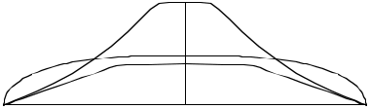

Rusty Preisendorfer 44

14"—

35.56

³/₄"

12.07
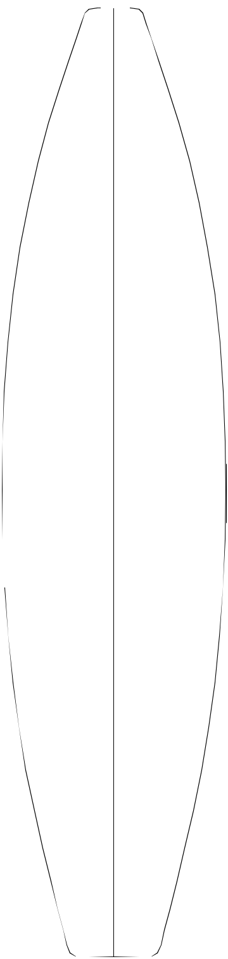

⁷/₁₆"—

16.36

2 ¹³/₁₆"—

7.14
7'9"A


Overall Bottom Length: 7' 9 ⁵/₈" (237.82)
— 1 ¹³/₁₆"
4.60 | Tip-to-tip Deck Length: 7' 8 |  |  |  | ³/ " (235.59)
 |  |  |  |  | 4
 | Maximum Width: 22 |  | ¹/ " (56.52)
 |  |  | 4

19 ³/₁₆"—
48.74

21 ³/₄"—
55.25

22 ¹/₄"—
56.52

¹/₂"—
54.61

¹⁵/₁₆"—

2.38

³/₁₆"—

0.48

¹/₈"—
0.32

— 2 ⁵/₈"

6.67

— 3 ¹/₁₆" 7.78

—3 ¹/₈"
7.94

— 3 "

7.62

Maximum Thickness: 3 ¹/₈" (7.94)

Displacement: 2.563 cubic feet (0.0725m)

History: Introduced November, 2001.

Rockers: Natural

Factory Stocking: Limited

Limited Volume Charge: $2.00

Blanks Per Box: 4 - 9'6"

Shaper's Comments: I designed the 7'9"A to be a versatile blank intended for the 7'4" - 7'8 " sized boards for high-performance surfing at breaks like Pipeline, Mainland Mexico, and Tahiti's pass breaks. I used Kalani Robb's "magic" Pipeline favorite he won the Pipe "Shoot Out" on to set up the bottom curve.

19 ¹/₈"—

48.58

14 ⁷/₈"—
37.78

"

20.32

⁹/₁₆"—

1.43

1 ⁵/₁₆"—
3.33

¹/₂"—

6.35

The 7'9"A will easily net 7'8" x 20 -1/2 x 2- 7/8 for the big boys like Kai Henry, or with 2 open planer cuts on the bottom before starting, it should be easy to make 2-1/4" 2-1/2" thick boards for lighter riders with deck strength

— 2 ⁵/₈" still maintained.
6.67
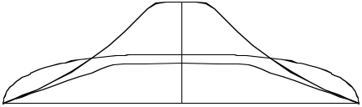

— 2 "

5.08

Shaped By: | Pat Rawson | 45

¹¹/₁₆"—

47.47

¹⁵/₁₆"—

55.73

⁷/₃₂"—

58.98

⁵/₃₂"—

58.83

³/₁₆"—

56.36

¹/₁₆"—

50.95

³/₃₂"—

40.87

4 ³/₄"—
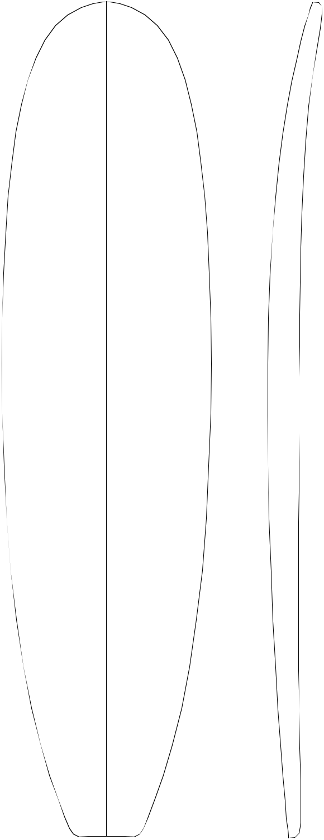
12.07

2 ³/₁₆"—
5.56

²³/₃₂"—

1.83

³/₃₂"—

.24

⁵/₃₂"—

.40

⁹/₁₆"—

1.43

1 ¹/₄"—
3.18

2 | ³/ "—
1 | 16
1 | 5.56
7 /₈"
18.11

— 2 ³/₈"
6.05

— 3 ¹/₁₆" 7.77

— 3 ⁷/₁₆" 8.74

—3 ¹/₂"
8.89

— 3 ¹¹/₃₂"

8.48

— 2 ¹⁵/₁₆"

7.47

— 2 ⁷/₃₂"

5.64

7'9"E


Overall Bottom Length: 7' 9 ¹/₂" (237.49)

Tip-to-tip Deck Length: 7' 8 ³/₈" (234.65)

Maximum Width: 23 ⁷/₃₂" (58.98)

Maximum Thickness: 3 ¹/₂" (8.89)

Displacement: 2.625 cubic feet (0.0743m)

History: Introduced November,1989. Steady demand for "Egg and Funboards".

Rockers: Natural, +3/8"T A

Factory Stocking: Limited

Limited Volume Charge: $.50

Blanks Per Box: 3 - 8'4"

4 - 9'6"

Shaper's Comments: Slightly rolled deck to maxi-mize strength & flotation without a bulky rail. Smooth rocker that can be altered without distorting blank. Versatile with rocker changes; anything from "racy" shapes to "egg" shapes can be shaped out of it. Also, with rocker adjustment, good for guns with fuller outline.
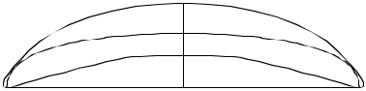

46

Shaped By:
Mike Eaton

⁵/₈"—

44.78

22 ⁷/₁₆"—

57.00

5 ²⁵/₃₂"—
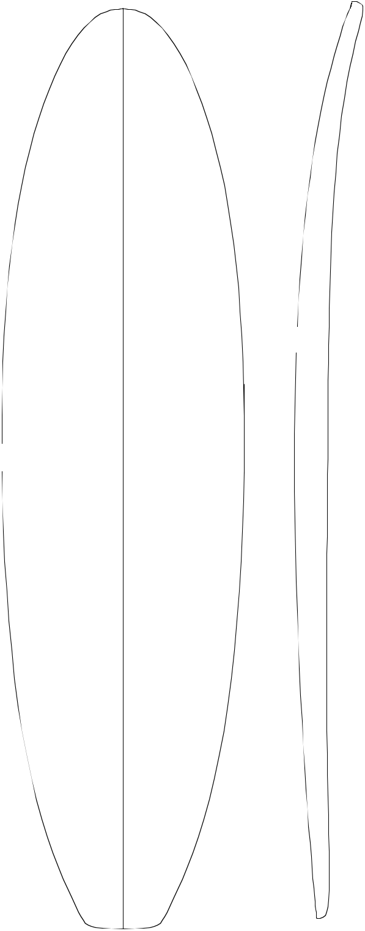

14.68

2 ¹⁹/₃₂"—

6.59

²⁹/₃₂"—

2.30

7'10"R


—2³/ " | Overall Bottom Length: 7' 10 |  |  |  |  |  | ¹/ " (239.09)
16 |  |  |  |  |  |  | 8
5.56
 | Tip-to-tip Deck Length: |  |  |  |  | 7'9" | (236.22)
 | Maximum Width: 24 ⁵/ " |  |  |  |  | (62.56)
 |  | 8
— 2 ⁷/₈" | Maximum Thickness: |  | 3 ⁵/₁₆" |  |  |  | (8.41)
7.32

Displacement: 2.813 cubic feet (0.0797m)

24 ⁹/₃₂"—
61.67

⁵/₈"—
62.56

²⁷/₃₂"—

60.55

21 ¹¹/₁₆"—
55.09

⁷/₃₂"—

43.74

³/₁₆"—

.48

¹/₈"—
.32

¹⁵/₃₂"—
1.19

1 ³/₁₆"—
3.02

2 ¹/₄"—
5.72

¹/₂"

16.51

— 3 ⁹/₃₂" 8.33

—3 ⁵/₁₆"
8.41

— 3 ⁵/₃₂"

8.02

— 2 ³/₄"
6.99

— 2 ¹/₁₆"

5.23

History: Introduced June, 1992. Thicker, fuller railed version of the 7'11"R.

Rockers: Natural

Factory Stocking: Limited

Limited Volume Charge: $.50

Blanks Per Box: 3 - 8'4"

4 - 9'6"

Shaper's Comments: 7'10"R is designed for making fun boards. The rocker should also allow the shaper to make a wide range of boards. Deck was left somewhat flat so there will be less rail distortion after templating and to allow fuller rail shapes.
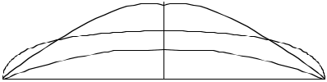

Shaped By: |  | 47
 |  | Rusty Preisendorfer

¹/₈"

7.95

5 ²⁹/₃₂"—
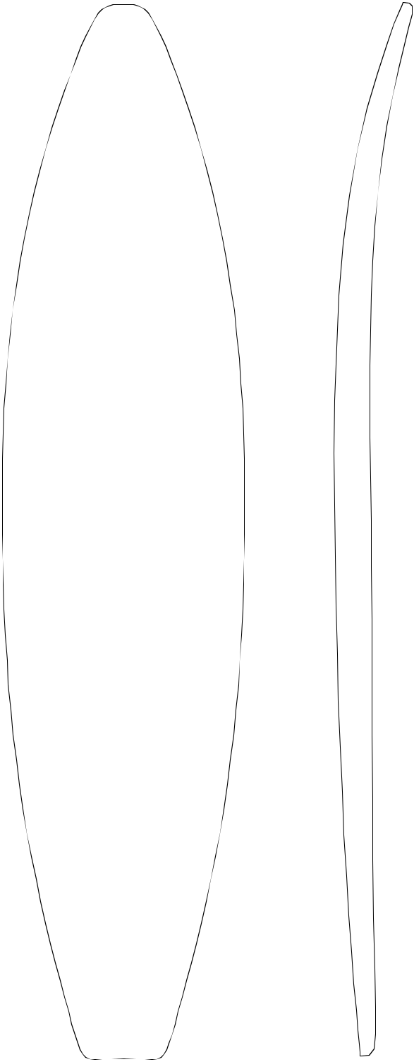

15.01
7'11"A


"—

33.02

⁷/₁₆"—

46.84

¹/₃₂"—

53.42

²¹/₃₂"—

55.02

¹¹/₁₆"—

52.55

2 ¹/₂"—

6.35

²⁹/₃₂"—

2.30

³/₁₆"—

.48

¹/₈"—

.32

— 2 ¹/₁₆" 5.23

— 2 ⁵/₈"
6.68

— 3 "

7.62

—3 ¹/₈"
7.95

— 3 "

7.62

Overall Bottom Length: 7' 11 ¹/₄" (241.94)

Tip-to-tip Deck Length: 7' 10 " (238.76)

Maximum Width: 21 ²¹/₃₂" (55.02)

Maximum Thickness: 3 ¹/₈" (7.95)

Displacement: 2.178 cubic feet (0.0617m)

History: Introduced June, 1989

Rockers: Hawaii/Rawson (+1/4"N -1/8"T E), Natural. Wide variety of rockers available.

Factory Stocking: Limited. Used year round but heavier demand during fall/winter season.

Limited Volume Charge: $2.00

Blanks Per Box: 4 - 9'6"

Shaper's Comments: The 7'3"A and 7'11"A were designed to work with the other "A" series blanks (6'7"A, 7'0"A). The 6'11"A, 7'5"A and the 8'5" were designed for thicker surfboards 2-5/8" and up.

¹/₈"—

46.05

²⁵/₃₂"—

35.00

¹⁷/₃₂"—
1.35

1 ³/₁₆"—
3.02

2 ¹/₁₆"—
5.23
¹/₂"
16.51
Shaped By:

— 2 ⁵/₈"

6.68
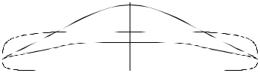

— 2 ¹/₁₆"

5.23

Pat Rawson
48

7'11"H

3 ⁵/₈"—
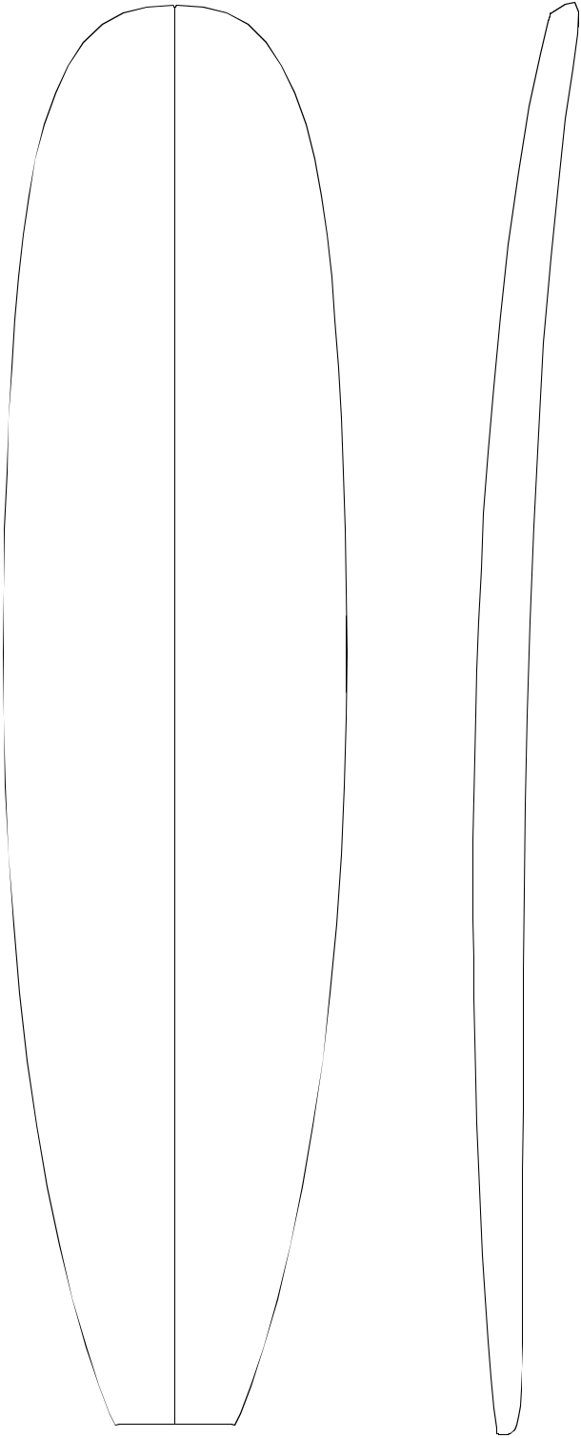
9.21 | Overall Bottom Length: 7'11 " (241.30)

⁹/₁₆"—

49.69

³/₈"—

56.83

¹/₂"—

59.69

1 | ⁵/ "— | — 2 | ¹/ "
 | 8 |  | 8
 | 4.13 | 5.40

¹/ "— | — 2 | ³/ "
2 |  | 4
1.27 | 6.99

¹/ "— | — 3 | ¹/ "
8 |  | 16
0.32 |  | 7.78

Tip-to-tip Deck Length: 7' 10 ¹/₂" (240.03)

Maximum Width: 23 ³/₄" (60.33)

Maximum Thickness: 3 ¹/₈ (7.95)

Displacement: 2.723 cubic feet (0.0771m)

History: Introduced January, 2002

Rockers: Natural, +1/2"N

Factory Stocking: Usually in stock.

Limited Volume Charge: $ .50

Blanks Per Box: 4 - 9'6"

¹¹/₁₆"—

60.17

⁷/₈"—

58.10

⁷/₈"—

53.02

¹³/₁₆"—

42.70

 |  |  |  |  |  |  | Shaper's Comments: Designed for wide nose, wide
 |  | — 3 ¹/₈" |  |  |  |  | tail, egg retro, and fun shapes. It has a little more
 |  |  |  |  |  |  | foam at both ends to allow shaper more versatility.
 |  | 7.94 |  |  |  |  | The blank does not dictate the design. Flat bottom
 |  |  |  |  |  |  | and even foil makes for easy shape.
 | ¹/ "— | — 3 | 1/ | 16 |  | "
 | 8
 | 0.32 | 7.78
 | ¹/ "— | — 2 | 3/ |  | "
 | 2 |  |  | 4
 | 1.27 | 6.99
1 | ¹/ "— | — 2 | 3/ | 16 |  | "
 | 4
 | 3.18 | 5.56
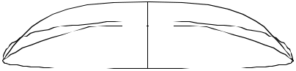

2 | ⁵/ "—
1 | 16
1 | 5.87
8 /₄"
20.96

Shaped By:

Roger Hinds & Rich Harbour
49

¹/₂"—

8.9

6 ³/₁₆"—
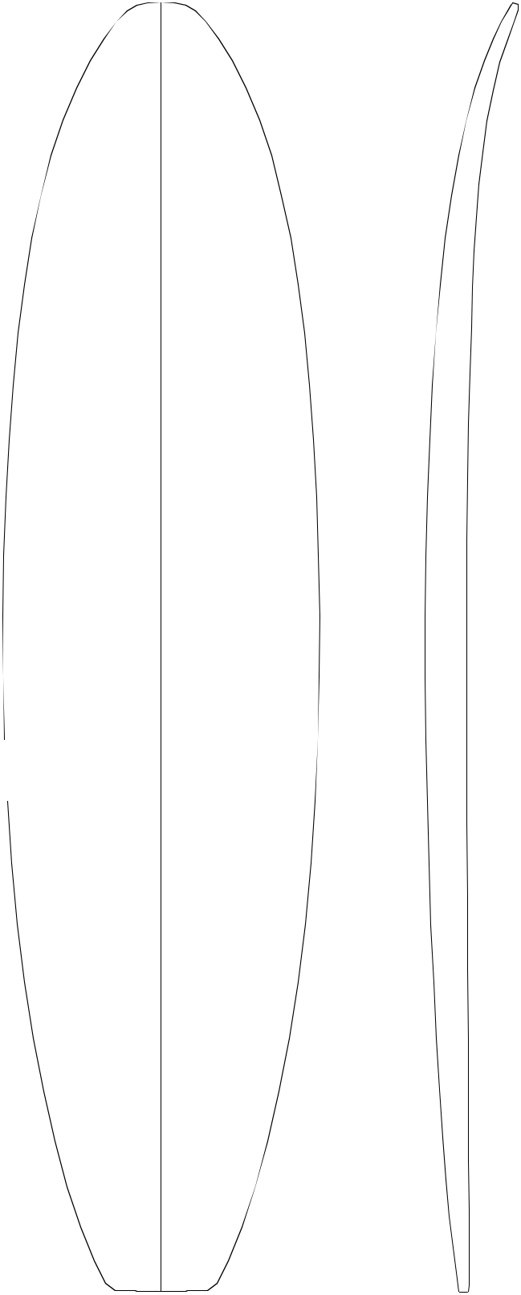
15.7
7'11"R


³/₈"—

44.1

21 ⁷/₈"—
55.6

23 ³/₄"—
60.3

24 ¹/₄"—
61.6

⁹/₁₆"—

59.8

2 ¹/₂"—

6.4

⁷/₈"—
2.22

³/₁₆"—

.5

¹/₈"—

.3

— 2 ¹/₁₆" 5.2

— 2 ¹¹/₁₆" 6.8

— 3 ¹/₈"
7.9

— 3 ³/₁₆" 8.1

— 3 ¹/₁₆" 7.8

Overall Bottom Length: 7'10 ¹/₂" (240.03)

Tip-to-tip Deck Length: 7' 11 ³/₈" (242..27)

Maximum Width: 24 ¹/₄" (61.6)

Maximum Thickness: 3 ³/_{16" (8.1)}

Displacement: 2.506 cubic feet (0.0710m)

History: Introduced June, 1994

Rockers: Natural

Factory Stocking: Usually in stock.

Limited Volume Charge: None

Blanks Per Box: 4 - 9'6"

Shaper's Comments: The 7'11"R is designed to update the 7'10"R. It is an extension of the 7'4"R and like the 7'4"R, it has a crowned deck. In relation to the 7'10"R, it is proportionately thinner in the nose. It is primarily designed as a funboard blank and is quite wide. However, the contemporary proportions and rocker should make it fairly easy to shape a gun out of this blank.

21 ³/₈"—

54.3

"—

43.2

⁹/₁₆"—
1.4

1 ⁵/₁₆ "—
3.3

2 ⁵/₈"—
7 | ¹/ " | 6.7
 | 2
19.0
Shaped By:

— 2 ³/₄"

7.0
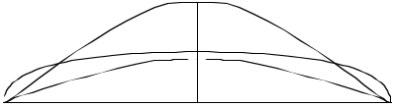

— 2"

5.1

Rusty Preisendorfer ₅₀

¹/₄"—

33.66

¹¹/₁₆"—

47.47

⁵/₁₆"—

54.13

"—

55.88

⁷/₈"—

53.02

¹/₄"—

46.36

¹/₄"—

36.20

³/₄"—

9.53
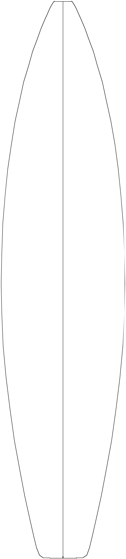

³/₄"

19.69

Shaped By:

⁷/₈"—

14.92

2 ⁷/₁₆"—
6.19

⁷/₈"—
2.22

/₁₆"— 0.48

³/₁₆"—
0.48

³/₄"—
1.91

1 ⁹/₁₆ "—

3.97

2 ¹¹/₁₆"—

6.83

— 1 ⁷/₈"

4.76

— 2 ⁵/₈"

6.67

— 3 "

7.62

— 3 ¹/₈"

7.94

— 2 ⁷/₈"
7.30

— 2 ¹/₂"
6.35

— 1 ⁷/₈"
4.76
8'1"R


Overall Bottom Length: 8' 1 ⁷/₈" (248.60)

Tip-to-tip Deck Length: 8' 1 ¹/₄" (247.02)

Maximum Width: 22 ¹/₁₆" (56.03)

Maximum Thickness: 3 ¹/₈" (7.94)

Displacement: 2.21 cubic feet (0.0626m)

History: Introduced December, 1998

Rockers: Natural

Factory Stocking: Limited

Limited Volume Charge: $2.00

Blanks Per Box: 4 - 9'6"

Shaper's Comments: I've tried to combine the best elements of the 7'7"R and the 8'5"A to make a Gun blank that is fairly close tolerance but still somewhat versatile. The foil and rails are similar to the 7'7"R with a slight shift forward . The entry is a longer, more relaxed curve closer to the 8'5"A natural rocker.
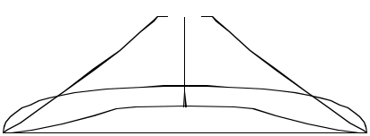

Rusty Preisendorfer and Rick Hamon

51

5 ⁷/₁₆"—
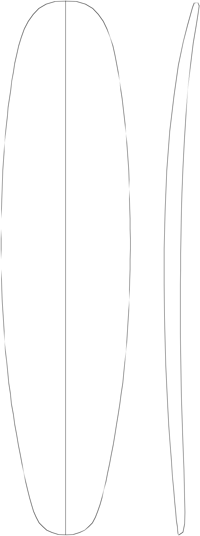
13.8

19 | ³/ "— | 2 | ³/ "—
 | 16 |  | 4
 | 48.7 |  | 7.0

22 | ¹³/ "— | 1 | ¹/ "—
 | 32 |  | 8
 | 57.0 |  | 2.9

23 | ²³/ "— | 9/ | 32 | "—
 | 32 |  | 32
 | 60.2 |  | .7
8'3"E


— ₂ ¹_{/8"} Overall Bottom Length: 8' 3 ¹/₄" (250.5)

5.4

Tip-to-tip Deck Length: 8' 2 ⁵/₈" (252.1)

Maximum Width: 24 ¹/₃₂" (61.0)

— ₂ 3_{/4"}Maximum Thickness: 3 ¹/₄" (8.3)
7.0

Displacement: 2.88 cubic feet (0.0816m)

History: Introduced September, 1993

_{—3} ¹_{/8"} Rockers: Natural
8.0

Factory Stocking: Limited

Limited Volume Charge: None

24"—

61.0

22 ²⁵/₃₂"—
57.9

20 ¹¹/₃₂ "
51.7

16 ⁵/₁₆ "—

41.4

Shaped By:

/₄"—

.6

³/₄"—
1.9

1 ⁷/₁₆ "—

3.7

2¹/₂"—

6.4

 |  | Blanks Per Box: 3 |  | - 8'4"
— 3 | ¹/ " |  | 4 | - 9'6"
 | 4
8.3

Shaper's Comments: The balanced thickness flow and flatter deck will allow a wide range of rocker changes without distorting the blank. This feature allows shapes from eggs to guns out of the blank.

—3 ³/₃₂"
7.8

— 2 ³/₄"
7.0
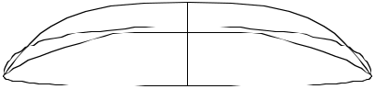

— 2 ³/₁₆"
5.6

52

Mike Eaton

¹⁵/₁₆"—

50.64

22 | ³/ "—
 | 4
 | 57.79
23 | ⁷/ "—
 | 8
 | 60.64

3⁷/ "— |  |  |  |  |  |  |  |  |  |  | 8'4"H
 |  | 8
 |  | 9.84 |  |  |  |  |  |  |  |  | Overall Bottom Length: |  |  |  |  |  |  | 8' 4 ¹/₁₆" |  |  |  | (254.15)
1 | ³/ "— |  |  |  |  | — 2 | 3/ |  | "
 |  | 4 |  |  |  |  | 16 |  |  |  | Tip-to-tip Deck Length: 8' 3 |  |  |  |  |  |  |  |  | 7 | /₁₆" | (252.58)
 | 4.45 |  |  |  |  |  | 5.56
 |  |  |  |  |  |  |  |  |  |  | Maximum Width: |  |  |  | 24 ³/₁₆" |  |  |  |  | (61.44)
 |  |  |  |  |  |  |  |  |  |  | Maximum Thickness: 3 ¹/ " |  |  |  |  |  |  |  |  |  | (8.25)
 | 5/ |  | "— |  | — 2 |  | 13/ | 16 |  | " |  |  |  |  |  | 4
 |  | 8 |  |  |  |  |  |  |  |  | Displacement: 2.975 cubic feet |  |  |  |  |  |  |  |  |  |  | (0.0842m)
 |  | 1.59 |  |  |  |  | 7.14
 |  |  |  |  |  |  |  |  |  |  | History: Introduced January, 2002
 |  |  |  |  |  |  |  |  |  |  | Rockers: Natural, +1/2"N
3/ |  | 16 | "— |  |  | — 3 | ¹/ "
 |  | 16 |  |  |  |  | 8 |  |  |  | Factory Stocking: Usually in stock.
 |  | 0.48 |  | 7.94
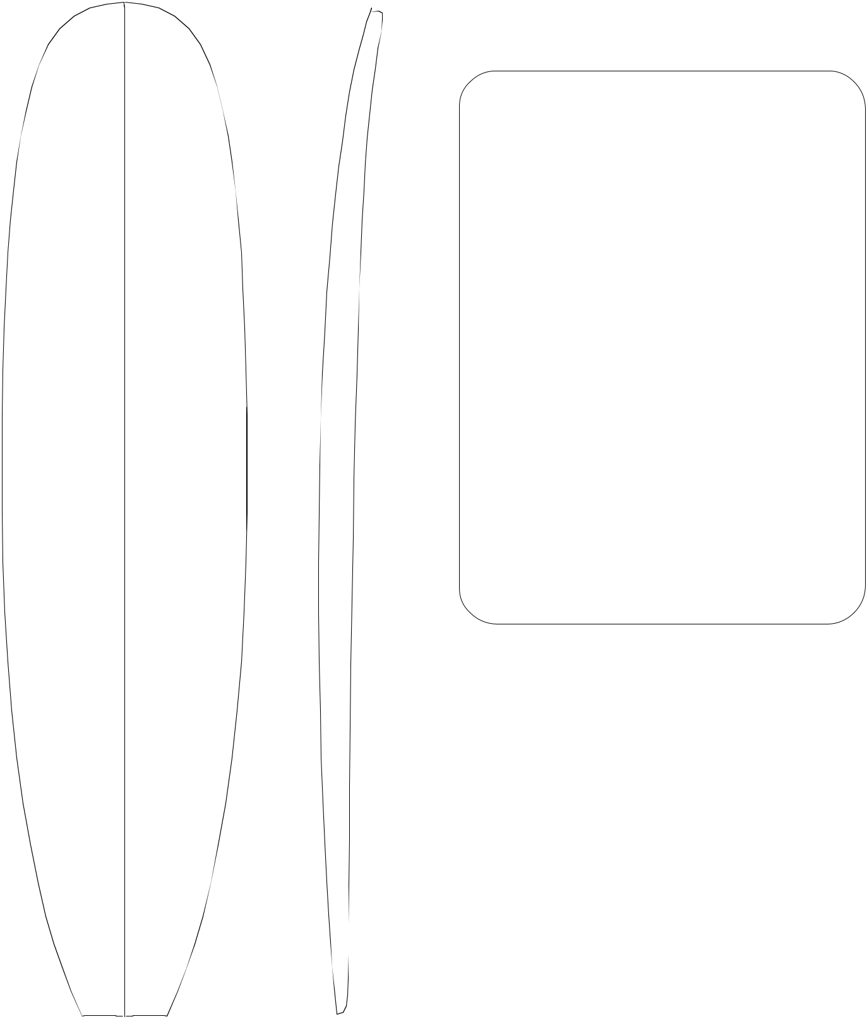

Limited Volume Charge: $ .50

Blanks Per Box: 4 - 9'6"

24 | ¹/ "—
 | 8
 | 61.28

23 ¹/₄"—
59.06

¹/₄"—

53.98

¹/₈ "—

43.50

¹/₂"

21.59

— 3 ¹/₄"
8.26

¹/ "— | —3 | ¹/ "
8 |  | 8
0.32 | 7.94

¹/ "— | — 2 | 13/ "
2 |  | 16
1.27 |  | 7.14

1 | ¹/ "— | — 2 | ³/ "
 | 4 |  | 16
 | 3.18 | 5.56

⁵/₁₆"—

5.87

Shaper's Comments: Designed for wide nose, wide tail, egg retro, and fun shapes. It has a little more foam at both ends to allow shaper more versatility. The blank does not dictate the design. Flat bottom and even foil makes for easy shape.
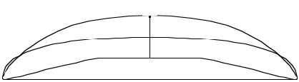

Shaped By:

Roger Hinds & Rich Harbour

53

2 ¹/₂"—
6.4
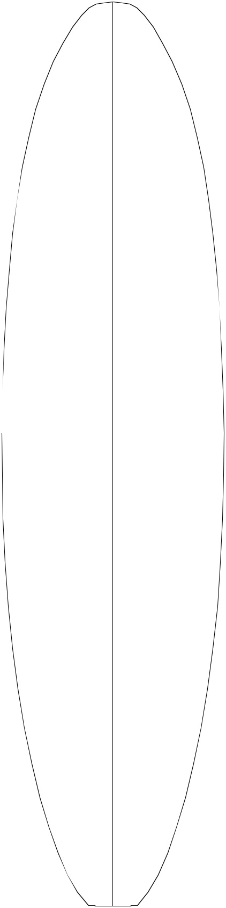

17 ¹/₁₆"—

43.3

21 ¹³/₁₆"—
55.4

⁷/₁₆"—

16.4

¹¹/₁₆"—

6.8

¹/₁₆"—

2.7
8'4"R
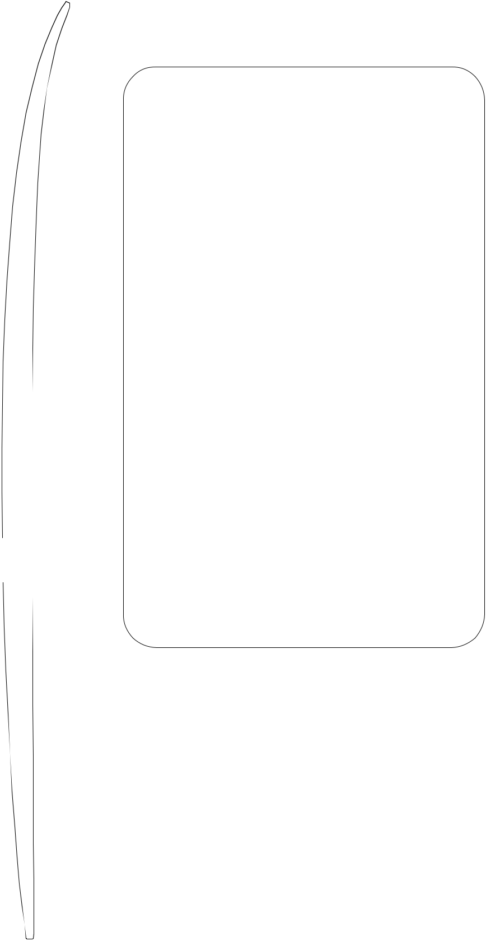

 | 7 | Overall Bottom Length: 8' 4 ⁵/ " |  |  |  |  |  |  | (256.00)
— 1 | /₈" |  |  |  |  |  |  | 8
 | 4.8 | Tip-to-tip Deck Length: 8' 3 |  |  |  |  |  | ⁵/ "
 |  |  |  |  |  |  |  | ⁵/ " | (253.00)
 |  |  |  |  |  |  |  | 8
 |  | Maximum Width: 24 ³/ " (62.9)
 |  |  |  | 4
— 2 | ⁵/ " | Maximum Thickness: |  |  | 3 ³/₁₆" |  |  | (8.1)
 | 8
 | 6.7 | Displacement: 2.724 cubic feet |  |  |  |  |  |  | (0.0771m)

History: Introduced June, 1994

23 ¹⁵/₁₆"—

60.8

³/₄"—

62.9

23 ⁹/₁₆"—

59.8

/₄"—

.6

/₁₆"—
.5

— 3 ¹/₁₆" 7.8

— 3 ³/₁₆" 8.1

—3"

7.6

Rockers: Natural

Factory Stocking: Always

Limited Volume Charge: None

Blanks Per Box: 4 - 9'6"

Shaper's Comments: The 8'4"R is a member of the hybrid family of blanks made in spring of 1994. The philosophy behind this whole series is extra width in conjunction with a contemporary profile and a slightly crowned deck. With some minor rocker adjustments, this blank works for guns as well.

Note: Because the tail is relatively thin, your starting rocker is somewhat critical if you plan on using the entire length of this blank.

¹⁵/₁₆ "—

53.2

"—

40.6

5 ¹/₂"

14.0

⁵/ "— | — 2 | ⁵/ "
8 |  | 8
1.6 |  | 6.7
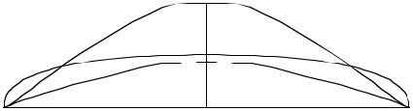

1 ³/ | 8 | "— | — 1 | 15/ "
 | 8 |  |  | 16
3.5 4.9

2 ¹/₂"—

6.4

Shaped By:

Rusty Preisendorfer

54

¹/₁₆"—

45.88

³/₈"—

54.29

¹³/₁₆"—

57.94

3³/ "— |  |  |  |  | 8'4"S
 | 4
 | 9.53
 |  |  |  |  | Overall Bottom Length: 8' 5 |  |  |  |  |  |  |  |  |  | ⁵/ " (258.13)
1 ¹⁵/₁₆"— |  |  | — 1 ¹¹/₁₆" |  |  |  |  |  |  |  |  |  |  |  | 8
 |  |  |  |  | Tip-to-tip Deck Length: |  |  |  |  |  |  | 8' 5 |  |  | ¹/ " (256.86)
4.92 |  |  |  | 4.29 |  |  |  |  |  |  |  |  |  |  | 8
 |  |  |  |  | Maximum Width: 23 ¹/ " |  |  |  |  |  |  |  |  | (58.74)
 |  |  |  |  |  |  |  |  | 8
 |  |  |  |  | Maximum Thickness: 2 |  |  |  |  |  |  |  |  | ⁷/ " | (7.30)
13/ |  | "— | — 2 | ⁵/ " |  |  |  |  |  |  |  |  |  | 8
13/ |  | "— | — 2 | ⁵/ " | Displacement: 2.58 cubic feet (0.0730m)
 | 16 |  |  | 16
2.06 |  |  |  | 5.87
 |  |  |  |  | History: Introduced November, 1998
 |  |  |  |  | Rockers: Natural, +1/2"N Last 18" A
¹/ "— |  |  | — 2 | ³/ " | Factory Stocking: Limited
 | 4 |  |  | 4
 | 0.64 |  | 6.99
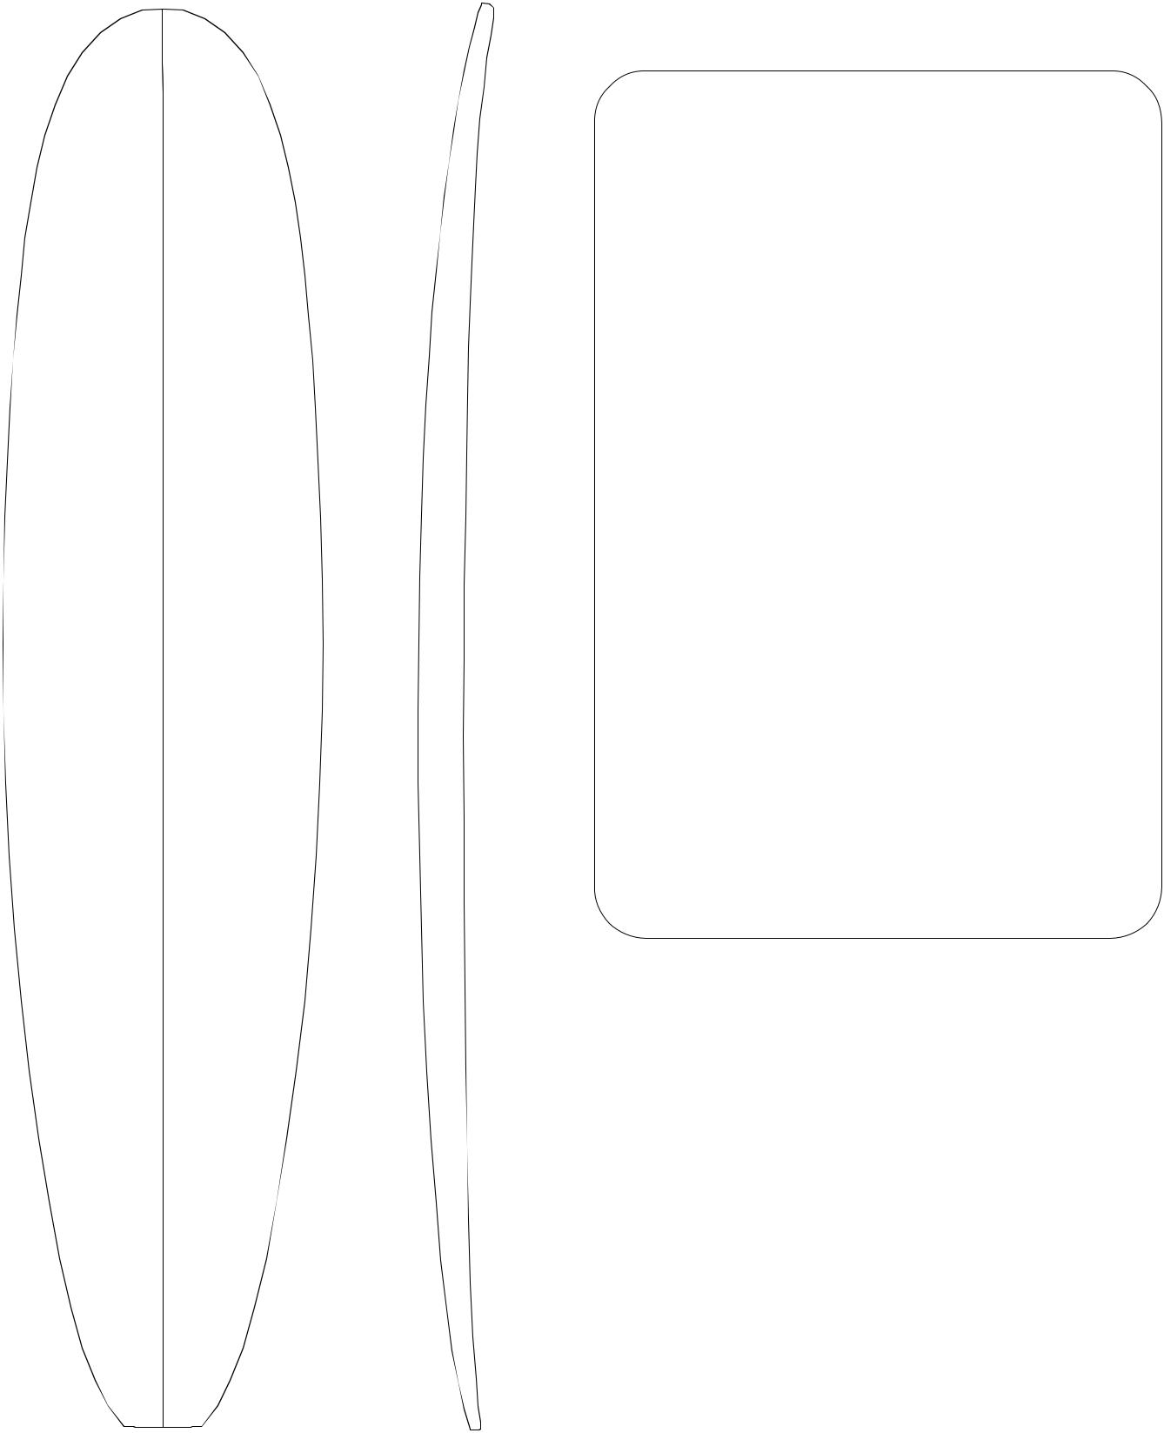

Limited Volume Charge: $ 0.50

Blanks Per Box: 4 - 9'6"

¹/₁₆"—

58.58

21 ¹⁵/₁₆"—

55.72

¹¹/₁₆ "—

50.01

¹/₄ "—

38.74

— 2 ⁷/₈"

7.30

¹/ "— | —2 | ³/ "
4 |  | 4
0.64 | 6.99

⁷/ "— | — 2 | ¹/ "
8 |  | 4
2.22 | 5.72

1 | 7/ | 8 | "— | — 1 | ⁵/ "
 |  | 8 |  |  | 8
 | 4.76 |  |  | 4.13

3 | ¹/ "—
1 | 4
1 | 8.26
5 /₄"
13.34
Shaped By:

Shaper's Comments: This mini longboard blank is scaled down for light smaller surfers. This surfboard will fit under their arm for ease of carrying. This easy quick shape blank is the first of its kind to fill this market need. The nose rocker has a flat entry for easy paddling and the tail has more rocker so you can turn farther forward on the board. This should get kids on their first longboard, and "you never forget your first board!"
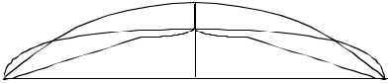

Bill Stewart

55

⁵/₈"—

32.62

¹/₈"—

48.59

¹¹/₁₆"—

55.09

³/₈"—

56.85

¹⁵/₁₆"—

53.19

¹/₈ "—

46.05

¹⁵/₃₂ "—

34.21

"

7.62
6 ¹/₂"—
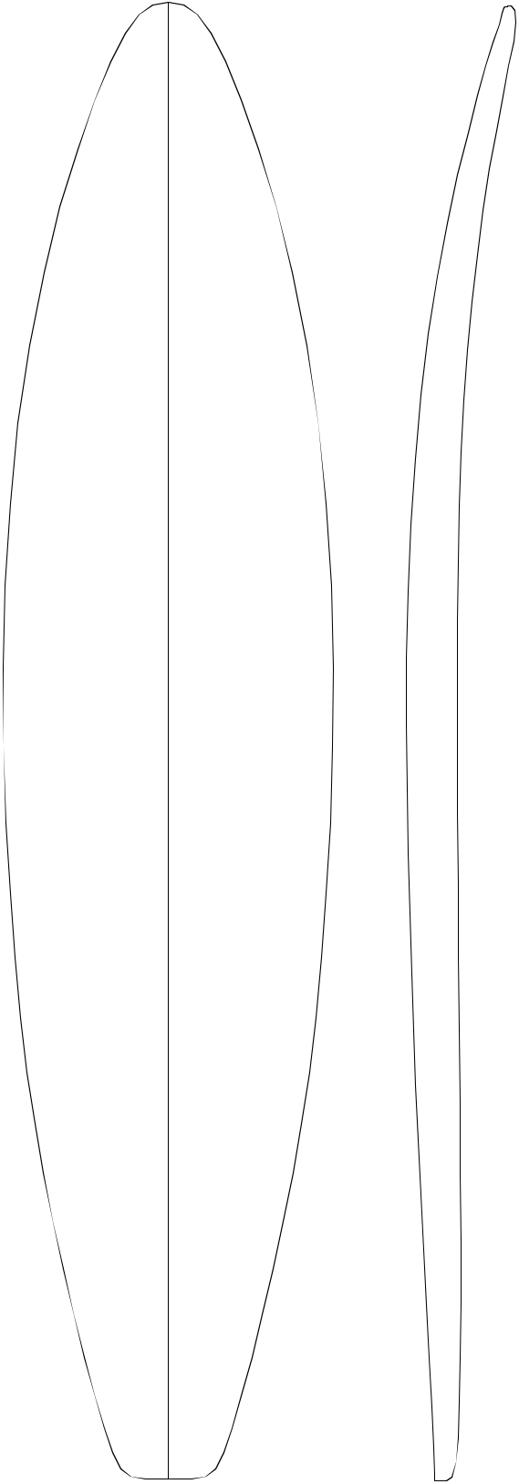
16.51

2 ¹⁵/₁₆"—

7.46

1 ¹/₈"—

2.86

⁵/₈"—
1.59

1 ³/₁₆ "—
3.02

—2¹/₄"
5.72

— 3 "

7.62

— 3 ³/₈"
8.59

— 3 ¹/₂"
8.89

—3 ³/₁₆"
8.10

—2 ¹³/₁₆ "

7.14

—2 ⁹/₃₂"
5.79
8'5"


Overall Bottom Length: 8' 5 ³/₄" (258.45)

Tip-to-tip Deck Length: 8' 4 ⁷/₈" (256.24)

Maximum Width: 22 ³/₈" (56.85)

Maximum Thickness: 3 ¹/₂" (8.89)

Displacement: 2.68 cubic feet (0.0759m)

History: Gun blank introduced in September, 1986. This is mainly used for thicker guns since 8'5"A was introduced.

Rockers: Rawson (+3/8"N +3/8"T E), Hawaii (-3/8"N +3/4"T E), Natural

Factory Stocking: Limited. Stocked primarily in Fall and Winter.

Limited Volume Charge: $2.00

Blanks Per Box: 4 - 9'6"

Shaper's Comments: Designed to replace classic Brewer 8'1".
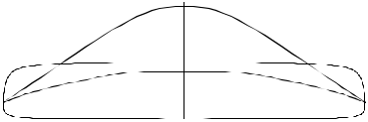

1 ³/₄ "—
4.45
6³/₄ "
17.15

Shaped By:
Pat Rawson

56

⁷/₁₆"—

31.6

17 ⁷/₈"—
45.4

20 ³/₁₆"—
52.9

¹¹/₁₆"—
55.1

20 ¹/₂"—
52.1

"—

45.7

³/₄ "—

34.9

2 | ⁷/ "—
 | 8
 | 7.3 | ⁷/ "—
 | 6 | ⁷/ "—
 |  | 16
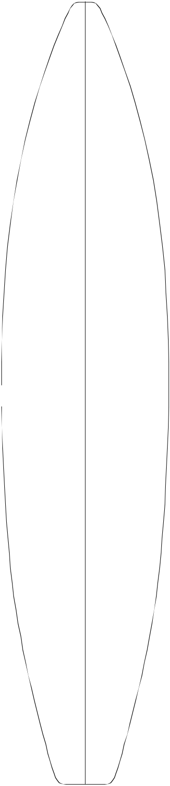
16.3

2 ²⁷/₃₂"—

7.22

1 ¹/₁₆"—
2.70

¹/₄"—
.64

³/₁₆"—

.48

³/₁₆"—
.48

²¹/₃₂"—
1.67

1 ¹¹/₃₂ "—
3.41

—2 "

5.0

—2⁵/₈"
6.7

— 3 ¹/₁₆" 7.8

— 3 ⁵/₃₂" 8.0

—2 ¹⁵/₁₆"
7.5

—2 ⁹/₁₆ "

7.5

—2 ¹/₁₆"
5.2
8'5"A


Overall Bottom Length: 8' 5 ³/₄" (258.4)

Tip-to-tip Deck Length: 8' 4 ¹/₂" (225.2)

Maximum Width: 21 ¹¹/₁₆" (55.1)

Maximum Thickness: 3 ⁵/₃₂" (8.0)

Displacement: 2.588 cubic feet (0.0732m)

History: Gun blank introduced December, 1991 More popular than original 8'5".

Rockers: Rawson +3/8"T (+5/8"N E), Natural

Factory Stocking: Limited. Stocked primarily in Fall and Winter.

Limited Volume Charge: $2.00

Blanks Per Box: 4 - 9'6"

Shaper's Comments: Basically a big brother to the 7'11"A, with a similar volumes and deck roll. De-signed to net 8'4" and under and work with the other "A" series blanks.
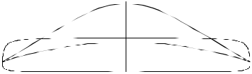

2 ¹/₄ "—
5.7
6¹/₄ "
15.9

Shaped By:
Pat Rawson

57

18 ¹/₁₆"—
45.88

22"—

55.88

⁵/₈"—
60.01

24"—

60.96

⁷/₈"—
60.64

23 ³/₄"—
60.33

22 ¹/₂"—
57.15

20 ¹/₁₆"—
50.96

15 ⁷/₈ "—
40.32

5 ¹/₄"—
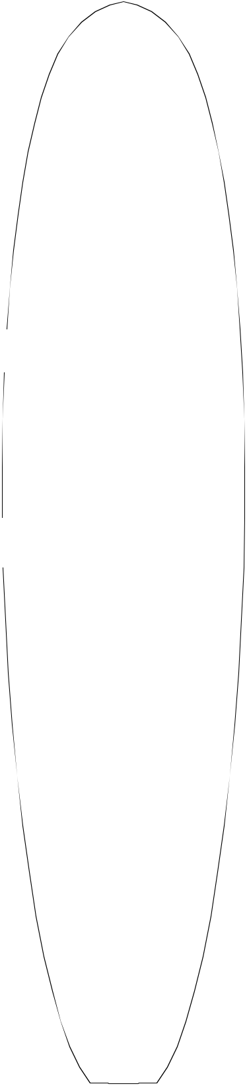
13.34

2 ⁹/₁₆"—

6.51

1 ¹/₁₆"—
2.70

⁵/₁₆"—

0.79

¹/₄"—

0.64

¹ ¹/₁₆"—

1.75

1 ⁵/₈ "—

4.13

3 ¹/₁₆ "—
7.78
6¹/₄ "
15.88
8'5"S
—2¹/ "
8
5.40
 |  |  | Overall Bottom Length: 8' 5 |  |  |  |  |  |  |  |  |  |  |  | ⁷/ " | (258.76)
 |  |  |  |  |  |  |  |  |  |  |  |  |  |  | 8
 |  |  | Tip-to-tip Deck Length: 8' 5 |  |  |  |  |  |  |  |  |  |  |  | ¹/ " | (257.17)
 |  |  |  |  |  |  |  |  |  |  |  |  |  |  | 4
—2¹³/ |  | " | Maximum Width: 24" (60.96)
16
7.14
 |  |  | Maximum Thickness: |  |  |  |  |  | 3 ⁵/₁₆" |  |  |  |  |  | (8.41)
 |  |  | Displacement: 2.86 cubic feet |  |  |  |  |  |  |  |  |  |  |  |  | (0.0809m)
— 3 ¹/₄"
— 3 ¹/₄" |  |  | History: Introduced March, 1997
8.26
8.26 |  |  | Rockers: Natural
 |  |  | Factory Stocking: Limited
—3⁵/ | "
—3⁵/ | " |  | Limited Volume Charge: $1.00
8.41
16
—3⁵/ | " |  | Blanks Per Box: |  |  |  | 4 - 9'6"
16
8.41
 |  |  | Shaper's Comments: This funboard blank has a
— 3 ¹/₄" |  |  | wide, flat nose entry for a full plan shape. The
8.26 |  |  | thickness in the nose carries out to the rail to net a
 |  |  | wide nose funboard.
 |  |  | For a bigger wave board and narrower outline, in-
— 3" |  |  | crease the nose rocker. An 8' board is what I had in
— 3" |  |  | mind when I designed this blank.
7.62


—2 ¹/₂ "
6.35
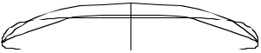

— 1 ⁷/₈"
4.76

Shaped By:

Bill Stewart 58

⁹/₁₆"—

39.53

³/₄"

12.07
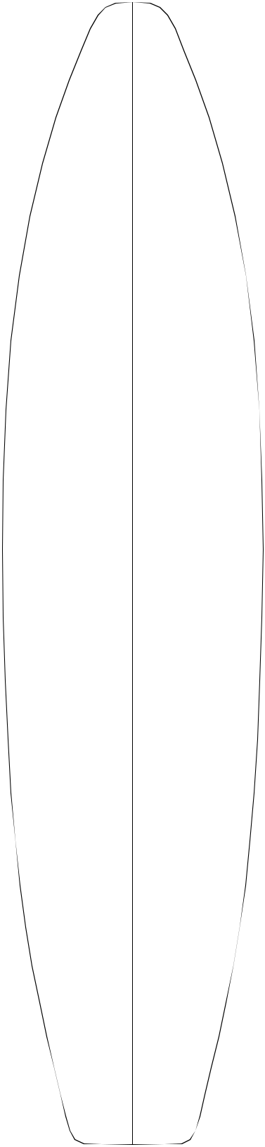

 | 6 "— |  | 8'7"R
 | 15.24
2 | ¹¹/ "— | —2 "
 | 16 |  |  |  |  | 1
 | 6.83 | 5.08 |  |  |  | 1
 | 6.83 | 5.08 | Overall Bottom Length: |  | 8' 7 | /₂" | (262.89)
 |  |  | Tip-to-tip Deck Length: 8' 6 |  |  | ³/ " | (260.99)
 |  |  |  |  |  | 4
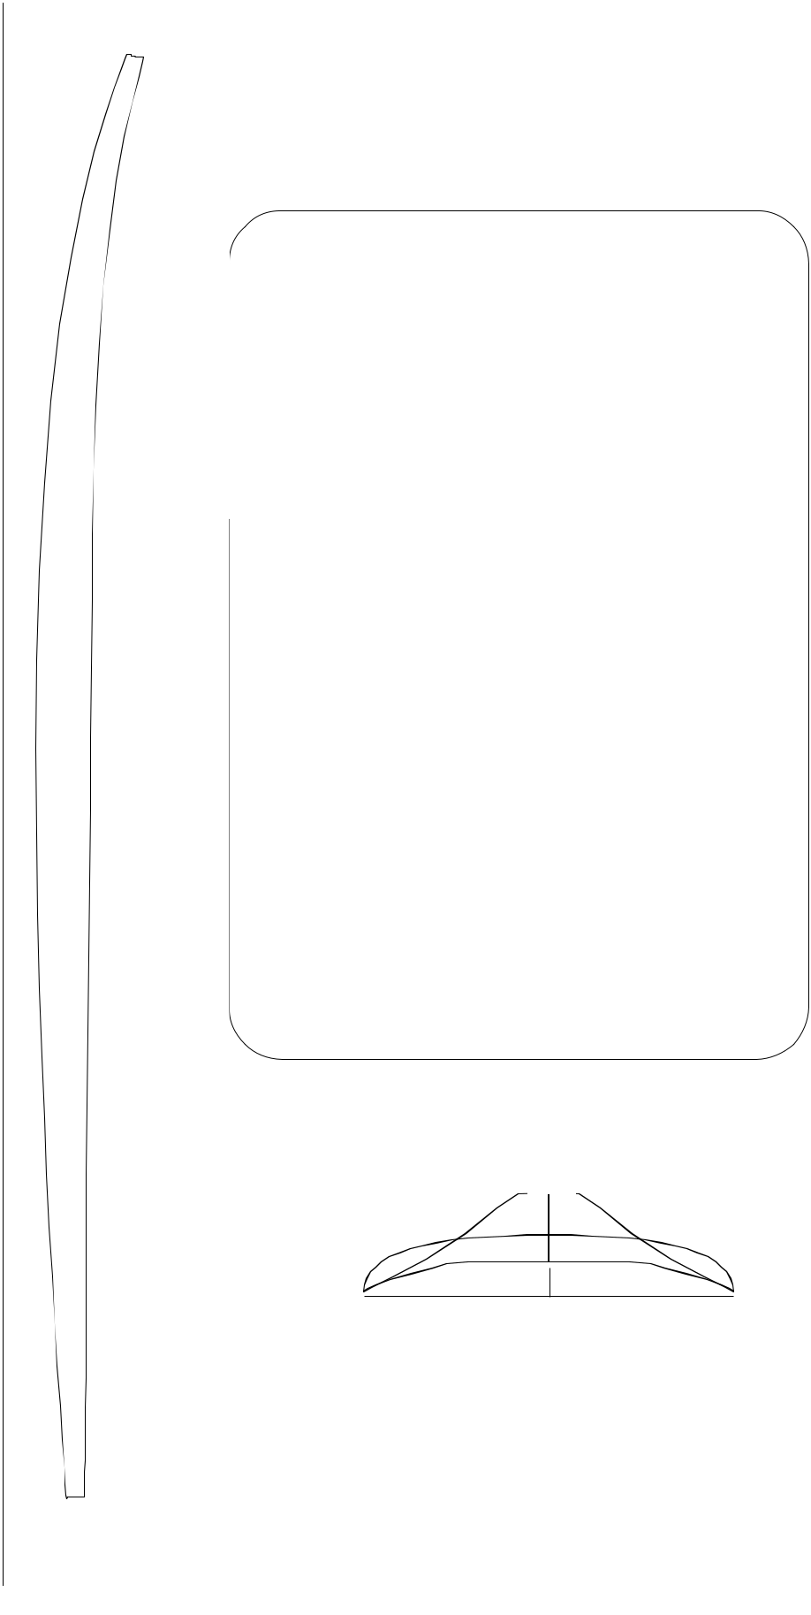

¹³/₁₆"—

52.86

⁷/₁₆"—

59.53

³/₈"—

61.91

¹⁵/₁₆"—

58.26

1 | ¹/ "— | — 2 | ³/ "
 | 8 |  | 4
 | 2.86 | 6.99

5/ | 16 | "— | — 3 | ¹/ "
 | 16 |  |  | 4
 | 0.79 |  | 8.26

— 3 ⁷/₁₆"

8.73

3/ | 16 | "— | — 3 | ¹/ "
 | 16 |  |  | 8
 | 0.48 |  | 7.94

Maximum Width: 24 3/8" (61.93)

Maximum Thickness: 3 ¹/₂" (8.89)

Displacement: 2.94 cubic feet (0.0834m)

History: Introduced January, 1999

Rockers: Natural, +1/2"T Last 36"

Factory Stocking: Limited

Limited Volume Charge: $0.50

Blanks Per Box: 4 - 9'6"

Shaper's Comments: For the most part this blank is just a shorter version of the 9'2"R "Fun Gun". It is designed to build XXL (big guy) short boards. One shortcoming of the 8'4"R is that the blank is a little too thin on the ends, especially in the tail, to net anything much over 8'0". The 8'7"R should help fill that gap as well.

⁷/₁₆"—

51.91

⁹/₁₆ "—

42.07

9³/₄ "
24.77

Shaped By:

1 1/ | 16 | "— | —2 | 11/ "
 | 16 |  |  | 16
1.75 |  |  |  | 6.83

1 | 1/ | 2 | "— | — 2 | ¹/ "
 |  | 2 |  |  | 16
 | 3.81 |  |  | 5.24

2 ¹¹/₁₆ "—

6.83

Rusty Preisendorfer and Rick Hamon ₅₉

¹/₃₂"—

50.09

²⁵/₃₂"—

57.9

¹⁵/₁₆"—

60.8

¹/₁₆"—

61.1

3 | 15/ |  | "— |  |  |  | 8'8"E
 |  | 16
 | 10.0
 | 5.00 |  |  | — | 6.0 | "
1 | 31/ | 32 | "— | — | 2 ³/ | "
 |  | 32 |  |  | 8
 |  |  |  |  |  |  | Overall Bottom Length: 8' 8 |  |  |  |  |  |  |  |  |  |  |  | ⁵/ "" | (265.71)
 |  |  |  |  |  |  |  |  |  |  |  |  |  |  |  |  |  |  | 8
 |  |  |  |  |  |  | Tip-to-tip Deck Length: 8' 5 |  |  |  |  |  |  |  |  |  |  |  | ¹/ " | (257.17)
 | ⁷/₈"— |  |  | — 2 ¹⁵/₁₆" |  |  |  |  |  |  |  |  |  |  |  |  |  |  | 4
 |  |  |  |  |  |  | Maximum Width: 24 |  |  |  |  |  | 1 | /₁₆"" |  |  |  |  | 4
 |  |  |  |  |  |  |  |  |  |  |  |  |  |  |  |  |  | (61.1)
 |  | 2.22 |  |  | 7.5
 |  |  |  |  |  |  | Maximum Thickness: 3 ⁷/ |  |  |  |  |  |  |  |  |  |  | " | (8.7)
 |  |  |  |  |  |  |  |  |  |  |  |  |  | 16
 |  |  |  |  |  |  | Displacement: 3.2421 cubic feet |  |  |  |  |  |  |  |  |  |  |  |  | (0.0918m)
 | ¹/₄"— |  |  | — 3 ⁵/₁₆"
 |  |  |  |  |  |  | History: Introduced June, 1989
 |  | .64 |  |  | 8.4
 |  |  |  |  | 8.4 |  | Rockers: Natural
 |  |  |  |  |  |  | Factory Stocking: Limited
 |  |  |  | —3⁷/ |  | "
 |  |  |  |  | 16 |  | Limited Volume Charge: None
 |  |  |  |  | 8.7
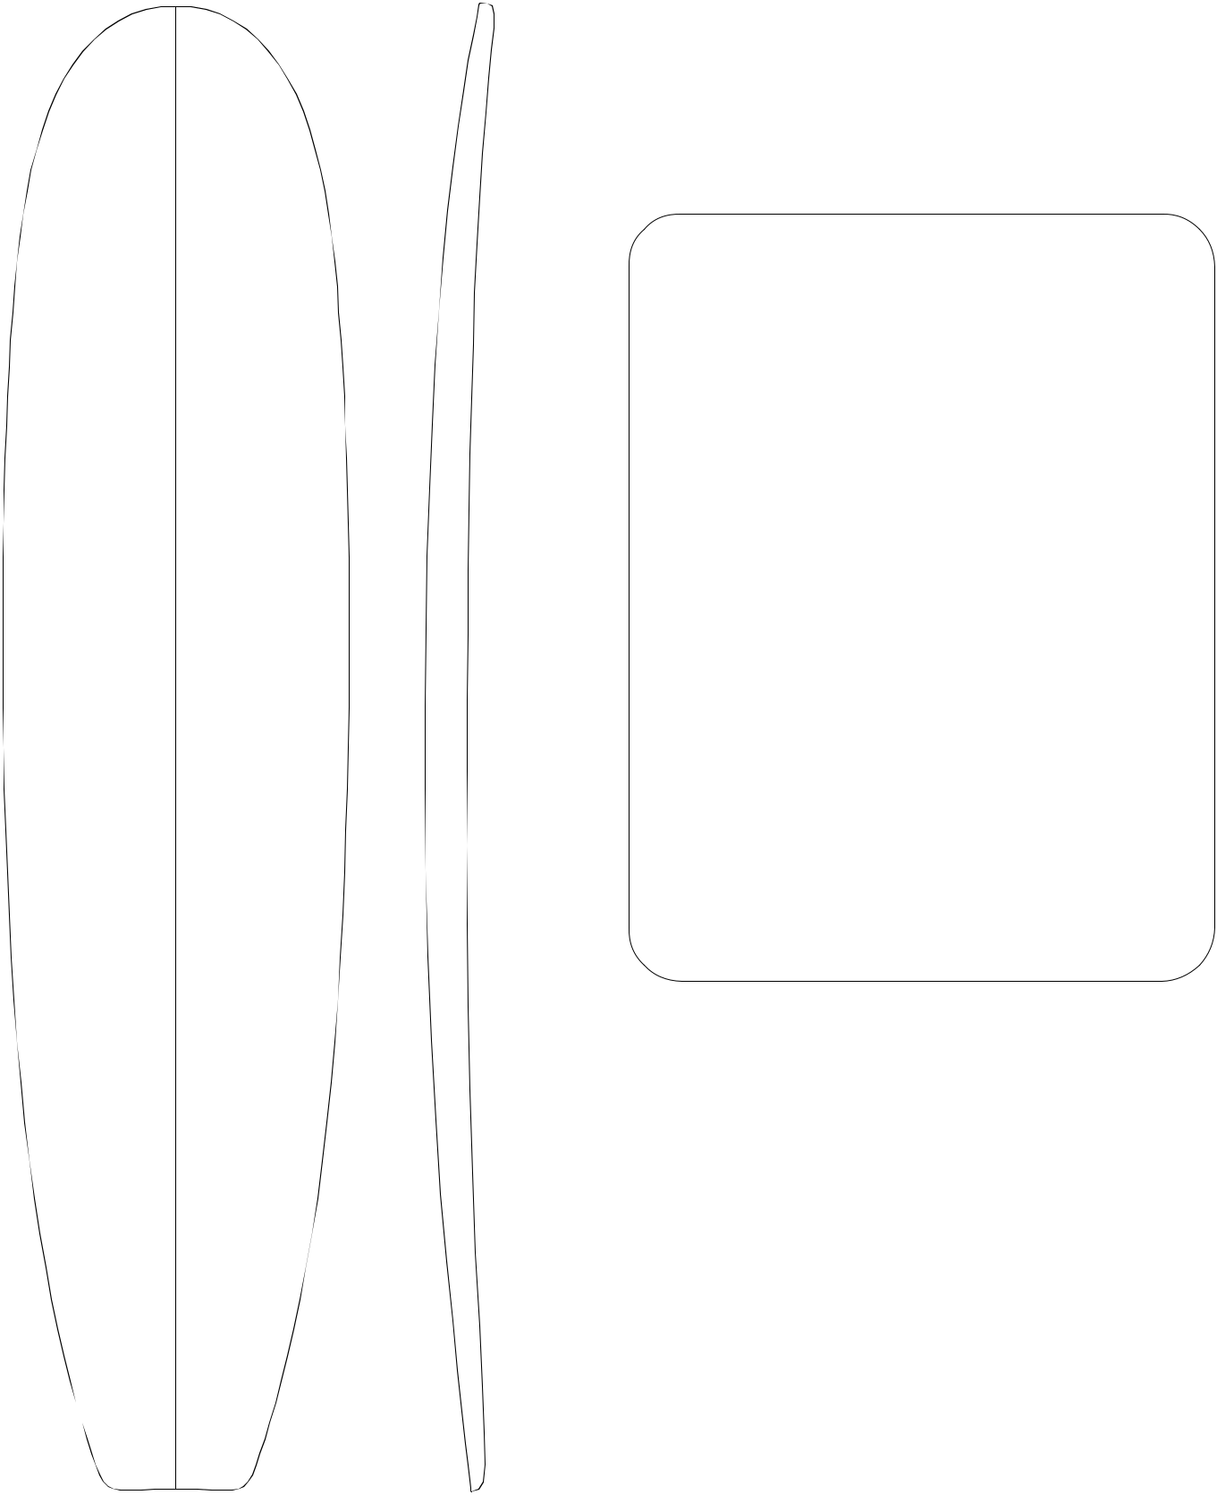

Blanks Per Box: 3 - 9'6"

²³/₃₂"—

60.2

¹⁷/₃₂"—

57.2

⁵/₁₆"—

51.6

⁹/₁₆ "—

42.1

¹/₄ "

23.5

 | —3³/"
 | 8
 | 8.6
⁹/ "— | —3¹/"
32 | 8
.71 | 7.9
¹³/₁₆"— | —2 ³/₄"
2.07 | 7.0
1 ³/₄ "— | — 2 ³/₁₆"
4.45 | 5.6
3 ⁷/₃₂ "—
8.2

Shaped By:
Mike Eaton

Shaper's Comments: Slightly rolled deck to maxi-mize strength and flotation without a bulky rail. Smooth rocker that can be altered without distorting blank. Versatile. With rocker changes, anything from guns to nose riders can be shaped out of it.
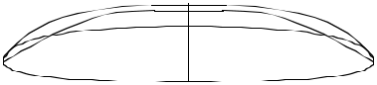

60

13 ¹⁷/₃₂"—

34.37

19 ¹³/₁₆ "—

50.32

23 ³/₈"—
59.39
"
7.62 | 13/ |  | "—
7 | 13/ | 16 | "—
19.84 |  | 16
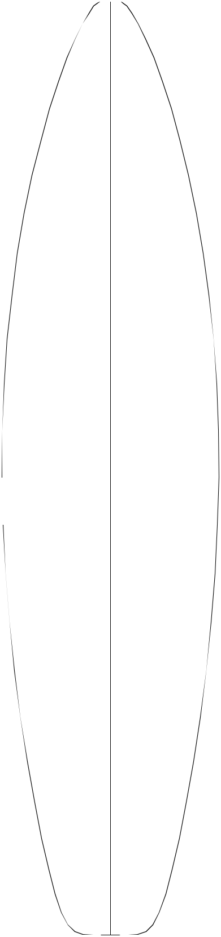

3 ⁹/₁₆"—

9.04

1 ¹¹/₃₂"—

3.40

³/₈"—
0.97

2 ⁵/ | 8'8"H
—_{5.87}16"
 |  | Overall Bottom Length: 8' 9 |  |  |  |  | ¹/ " | (267.34)
 |  |  |  |  |  |  | 4
3 |  | Tip-to-tip Deck Length: 8' 8 ³/₈" |  |  |  |  |  | (265.13)
—3 /₁₆"
8.10 |  | Maximum Width: 24 ¹⁵/ " |  |  |  |  | (63.35)
 |  |  | 16
 |  | Maximum Thickness: |  | 4 ³/₁₆" |  |  | (10.64)
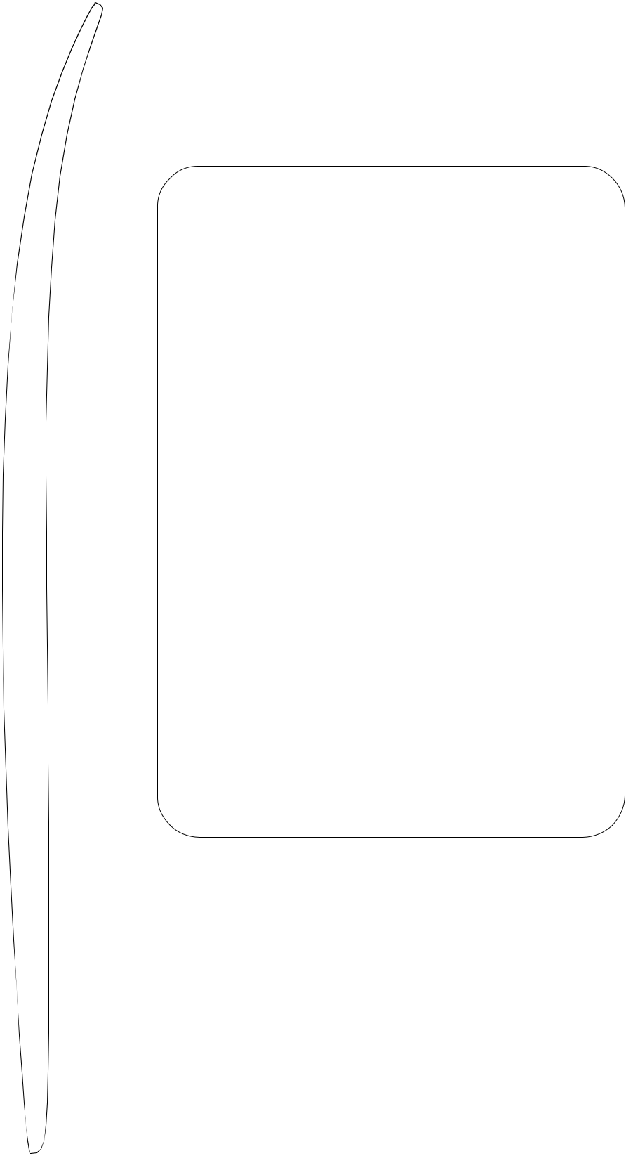

Displacement: 3.790 cubic feet (0.1073m)
— 3 ¹³/₁₆"

9.68 | History: Introduced September, 1993

¹³/₁₆"—

63.02

¹⁵/₁₆"—
63.35

²³/₃₂"—

62.79

23 ⁹/₃₂"—
59.13

⁷/₃₂"—

.56

— 4 ⁵/₃₂"

10.57

—4 ³/₁₆"
10.64

—4 ⁵/₃₂"
10.57

— 3 ¹⁵/₁₆" 10.01

Rockers: Hawaii (+1"N Last 42" B), Natural, Gorge (+3/8"N -1/8"T B)

Factory Stocking: Very Limited

Limited Volume Charge: $4.00

Blanks Per Box: 3 - 10'8"

Shaper's Comments: A low tolerance blank for 8'6" and under contemporary sailboards. Features dome deck for stronger thin rails, thickness more aft, and "flipped up" nose rocker. Can be glued up with surfboard rocker for "big guy" boards.

Note: Natural rocker will not yield a deep straight entry board. Rocker/entry adjustments are recom-mended to meet individual requirements.

20 ⁹/₁₆"—

52.22

16 ¹/₃₂"—
40.72

⁵/₈"—

1.59

1 ³/₁₆"—
3.02

—3 ⁷/₁₆"

8.74
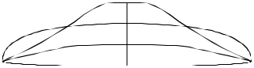

—2 ²⁵/₃₂"

7.06

1 ³/₄"—
4.45

"

17.78

Shaped By:
Karl Hill

61

0"

00.00
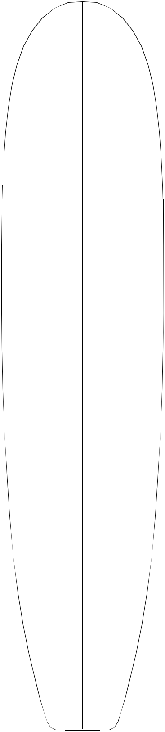

20 ¹/₄"—

51.44

4 ¹/₄"—
10.80

2 ¹/₄"—

5.72
8'9"B


—2 "
5.08 Overall Bottom Length: 8' 9 ³/₈" (267.65)

Tip-to-tip Deck Length: 8' 8 ⁷/₈" (266.38)

23 ¹/₈"—
58.74

24 ¹/₈"—
61.28

23 ¹⁵/₁₆"—

60.80

22 ⁷/₁₆"—
56.99

¹⁵/₁₆"—
2.38

/₁₆"—
0.79

/₁₆"—

0.79

— 2 ⁵/₈"

6.67

— 3 ¹/₈"

7.94

— 3 ³/₈"

8.57

— 3 ¹/₄"

8.26

Maximum Width: 24 1/4" (61.60)

Maximum Thickness: 3 ¹/₂" (8.89)

Displacement: 3.14 cubic feet (0.0889m)

History: Introduced November, 2000

Rockers: Natural

Factory Stocking: Limited

Limited Volume Charge: $ 1.00

Blanks Per Box: 3 - 9'6"

Shaper's Comments: Designed for the 8'8" and shorter mini-longboard with enough thickness to float most adults. It has a nice deck roll to stay close to shape and will accomodate a variety of rockers.

¹/₈"—

51.12

16 ³/₈ "—
41.59

8¹/₈ "
20.64

Shaped By:

⁷/₈"—

2.22

1 ¹⁵/₁₆ "—

4.92

3 ⁷/₁₆ "—

8.73

—2 ³/₄ "
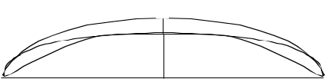
6.99

— 2 ¹/₈"

5.40

Bruce Jones

62

8'10"S


¹¹/₁₆"—

50.01
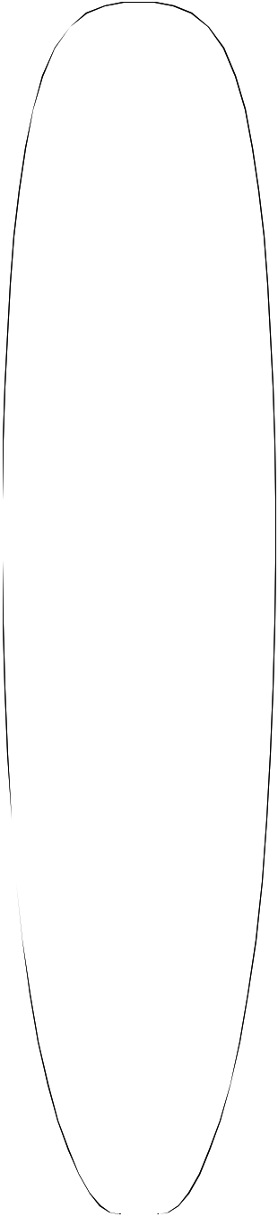

23"—

58.42

⁹/₁₆"—

62.39

"—

63.50

⁷/₈"—

63.18

⁹/₁₆"—

62.39

³/₁₆"—

58.90

⁵/₈ "—

52.39

³/₈"—

13.65

⁷/₈"—

7.30

⁵/₁₆"—

3.33

/₁₆"— 1.11

⁵/₁₆"—
0.79

"—

2.54

Overall Bottom Length: 8' 11" (271.78)

Tip-to-tip Deck Length: 8' 10 ³/₈" (270.20)

Maximum Width: 25 " (63.5)

Maximum Thickness: 3 ¹/₈" (7.94)

Displacement: 2.80 cubic feet (0.0793m)
— 1 ³/₄"
4.45
History: Introduced May, 1996

Rockers: Natural

— 2 ³/₈"

6.03 | Factory Stocking: Limited

 |  | Limited Volume Charge: $ 0.50
— 2 | ⁷/ "
— 2 | ⁷/ " | Blanks Per Box: 4 - 10'8"
 | 8
7.30

Shaper's Comments: Similar to the 9'5" S but is slightly thicker for a wider variety of shapes. This
— ₃ 1_{/8"} blank can be flattened out for an easier paddling, trim

7.94 style blank. The thickness is forward of center, like the other plugs from the Stewart series of blanks.
— 3 ¹/₈"
7.94

— 3 ¹/₁₆" 7.78

—2 ³/₄"
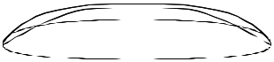
6.99

— 2 ¹/₄"
5.72

16 | ¹/ "— | 1 | ⁷/ "—
 | 4 |  | 8
 | 41.28 |  | 4.76

3 ¹/₄"—
8.26

6¹/₄"
15.88

Shaped By:

— 1 ³/₄"

4.45

Bill Stewart 63

9'1"A


1 ¹/₂"

3.81
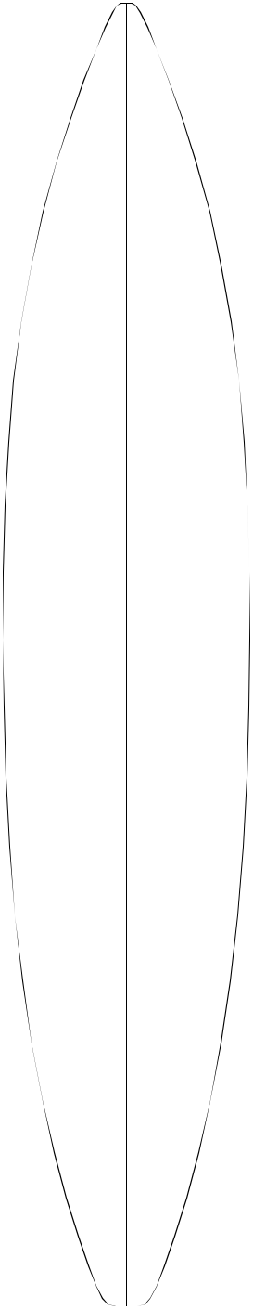

11 ³/₁₆ "—
28.42

7 ⁷/₈"—
20.02

3 | ⁹/ "— | —1 | 15/ "
 | 16 |  | 16
9.04 |  | 4.93

Overall Bottom Length: 9' 4 ⁷/₈" (286.72)

Tip-to-tip Deck Length: 9' 3 ⁷/₈" (284.18)

Maximum Width: 21 ¹¹/₁₆" (55.09)

Maximum Thickness: 3 ³/₈" (8.59)

Displacement: 2.882 cubic feet (0.0816m)

17 ¹/₈"—
43.51

20 ⁵/₁₆"—
51.59

21 ⁵/₈"—
54.94

21 ¹¹/₁₆"—
55.09

21 ³/₁₆"—
53.82

19 ¹/₂"—
49.53

16 ¹/₂"—
41.91

11 ¹¹/₁₆"—
29.69

3 ¹/₂"

8.89

1 ¹/₂"—
3.81

¹/₂"—
1.27

¹/₁₆"—
.16

/₁₆"—
.16

³/₈"—
.97

¹⁵/₁₆"—
2.39

1 ³/₄"—
4.45

2 ⁷/₈"—
7.32

—2 ⁵/₈"

6.68

— 3 ¹/₄"
8.26

— 3 ³/₈"
8.59

—3 ³/₈"
8.59

—3 ¹/₄"
8.26

— 2 ¹⁵/₁₆" 7.47

—2 ⁹/₁₆"

6.50

— 1 ¹⁵/₁₆" 4.93

History: Introduced November,1989. In July, 1994 this blank was extended to 9'4" in length. This was done by adding 2" to the nose and 1" to the tail.

This modification was based on customer re-quests.

Rockers: Natural

Factory Stocking: Limited. Stocked primarily in Fall & Winter.

Limited Volume Charge: $2.00

Blanks Per Box: 3 - 10'8"

Shaper's Comments: This blank can accommodate from 8'2" to 9'0" with the blank thickness similar to the old 8'4", the 8'5", and the 8'5"A. The 9'1"A is designed to be ordered with custom rocker adjustments without distorting the deck curve significantly. Extra length added in July 1994 allows you to easily net a 9' board.
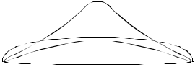

Shaped By:

Pat Rawson 64

65
—3 ³/₈"
8.59
— 3 ³/₁₆" 8.10
—2 ³/₄"
6.99
— 2 ⁵/₃₂"
5.49
Rennie Yater
8.59
—3 ³/₈"
^{8.40}
Shaper's Comments: Blank was done specifically to meet the demand for lightweight, high performance 9' longboards. Since blanks always cure out thicker, this blank will net a 9'0" x 23" x 3" longboard shape.
— 3 ⁵/₁₆"
Limited Volume Charge: None
Blanks Per Box: 4 - 10'8"

¹/₁₆ "—

50.95

⁵/₃₂"—

58.83

⁷/₁₆"—

62.08

¹⁵/₁₆"—

63.35

⁷/₈"—

63.20

⁷/₁₆"—

62.08

³/₁₆"—

58.90

¹⁵/₁₆"—

53.19

⁹/₁₆"—

42.06
9'1"Y


 |  |  |  |  |  |  |  |  |  | Overall Bottom Length: 9' 3 |  |  |  |  |  |  |  |  |  |  |  | ⁷/ " | (284.18)
 |  |  |  |  |  |  |  |  |  |  |  |  |  |  |  |  |  |  |  |  |  | 8
 |  |  |  |  |  |  |  |  |  | Tip-to-tip Deck Length: 9' 2 ⁷/ " |  |  |  |  |  |  |  |  |  |  |  |  | (281.64)
4 ⁵/ |  | "— |  |  |  |  |  |  |  |  |  |  |  |  |  |  |  |  |  |  |  | 8
32 |  |  |  |  |  |  |  |  |  | 15
10.57
 |  |  |  |  |  |  |  |  |  | Maximum Width: |  |  |  |  | 24 /₁₆" |  |  |  |  |  |  | (63.35)
 |  |  |  |  |  |  |  |  |  | Maximum Thickness: 3 ³/ " |  |  |  |  |  |  |  |  |  |  |  | (8.59)
2 ⁷/ |  |  |  |  |  |  | "— | —2 | ¹/ " |  |  |  |  |  |  |  |  |  |  | 8
 | 32 |  |  |  |  |  |  |  | 4 | Displacement: |  |  | 3.48 cubic feet |  |  |  |  |  |  |  |  |  | (0.0985m)
5.64 |  |  |  |  |  |  |  | 5.72 |  |  |  |  |  |  |  |  |  |  |  |  |  |  | (0.0985m)
 |  |  |  |  |  |  |  |  |  | History: Introduced in Spring, 1988, this popular
 |  |  |  |  |  |  |  |  |  | longboard was increased in length by 1" at the nose
1 ¹/ |  |  |  |  |  |  | "— | —2 | ³/ " | and tail (2" overall) in July 1992 to increase versatility.
1 ¹/ | 16 |  |  |  |  |  |  | —2 | ³/ " | Very popular longboard blank.
 |  |  |  |  |  |  |  |  | 4
2.69 |  |  |  |  |  |  |  | 6.99
 |  |  |  |  |  |  |  |  |  | Rockers: A wide variety of rockers availeble.
13/ |  |  |  | "— |  |  |  | — 3 | ³/ " | Factory Stocking: |  |  |  |  |  | Always
32 |  |  |  |  |  |  |  |  | 16
1.04 |  |  |  |  |  |  |  | 8.10
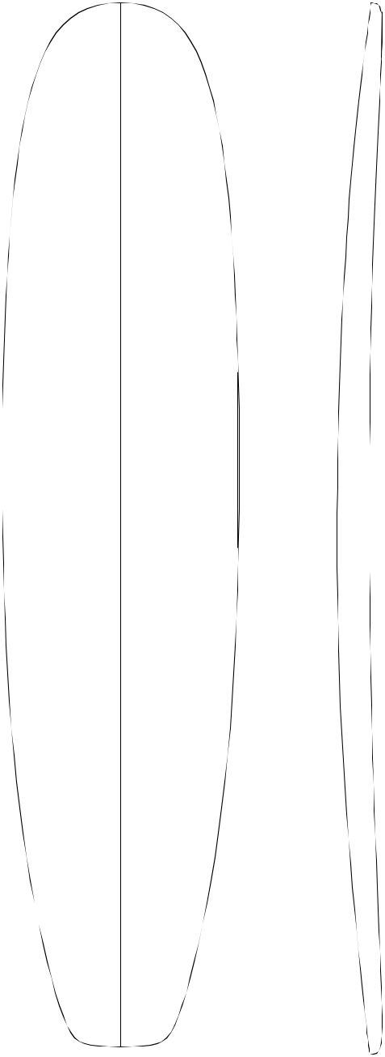

⁷/₁₆"—
1.18
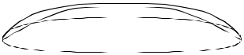

1 ⁷/₃₂"—
3.10

2 ¹¹/₃₂"—
5.94

3 ¹³/₁₆"—
9.68

"

15.24

Shaped By:

3 ³/₄"
9'2"R


9.53
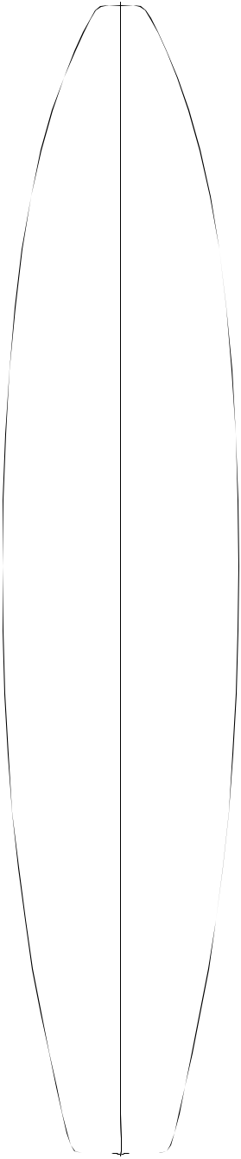

15 ¹/₈"—
38.42

³/₈"—

16.19

¹⁵/₁₆"—

46

—1 ¹³/₁₆"
4.60

Overall Bottom Length: 9' 2 ⁷/₈" (281.62)

Tip-to-tip Deck Length: 9' 2" (279.40)

Maximum Width: 24 " (60.96)

20 ³/₈ "—

51.75

¹/₄"—

18
Maximum Thickness: 3 ⁷/₁₆" (8.73)

Displacement: 3.02 cubic feet (0.0855m)

History: Introduced February, 1999
—2 ⁵/₈"
6.67 | Rockers: Natural, +1/2"T Last 36"
 | Factory Stocking: Limited

"—

58.42

24 "—

60.96

22 ⁵/₁₆ "—

56.67

19 ⁹/₁₆"—

49.69

/₁₆"—

11

/₁₆"—

.79

¹³/₁₆"—

2.06

— 3 ¹/₈"
7.94

—3 ⁷/₁₆"

8.73

— 3 ¹/₈"
7.94

—2 ¹¹/₁₆"

6.83

Limited Volume Charge: $2.00

Blanks Per Box: 3 - 10'8"

Shaper's Comments: I have been building more and more boards for older, heavier surfers that require the center width of a longboard but the rocker and foil of a gun. The choices have been; glue gun rocker into a longboard blank and completely restructure the foil (a giant hassle and a weaker board) or add foam wideners (expensive) to a gun blank. This blank combines a gun profile with the extra width necessary for this type of hybrid “Fun Gun”. See 87R for shorter version of this blank.
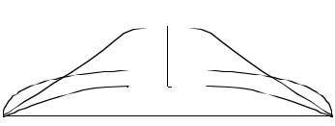

15 ¹/₄"—
38.74

7 ⁷/₈"—

20.00

⁹/₁₆"—

97

¹¹/₁₆"—

83

— 2 "

5.08

Shaped By:

Rusty Preisendorfer & Rick Hamon

66

19 ¹/₂ "—
49.53

23 ¹/₈"—

58.75

24 ¹¹/₁₆"—

62.71

25 ¹⁵/₃₂"—
64.69

⁵/₁₆"—
64.29

24 ³¹/₃₂"—
63.42

¹/₂"—
59.69

20 ¹⁵/₁₆"—
53.19

16 ⁵/₈"—
42.24

4 ¹/₄"—
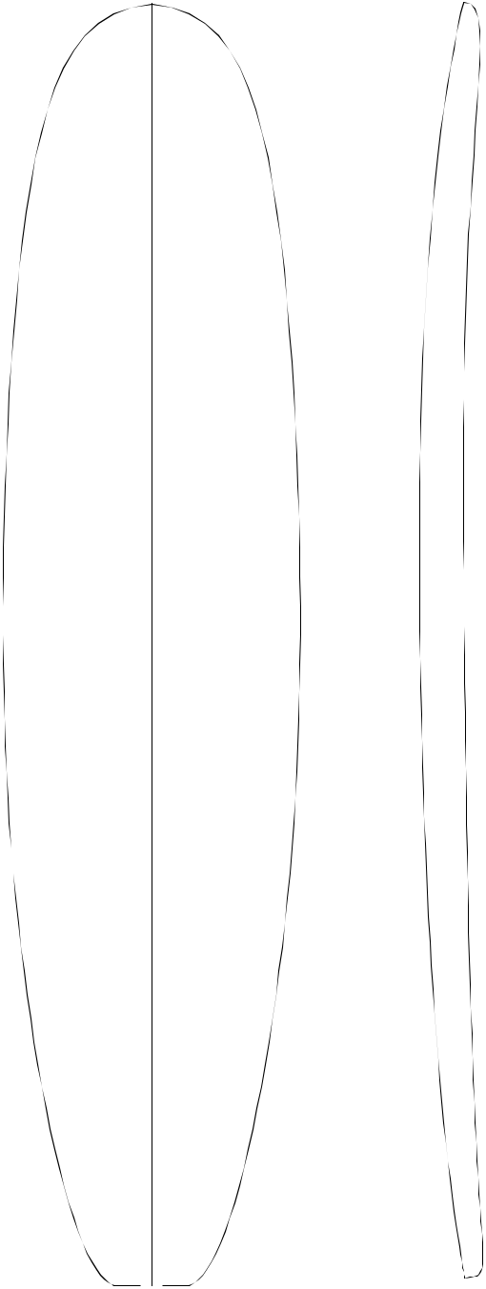
10.80

2 |  |  | ¹/ "— |  |  |  |  | —2 ¹¹/₁₆"
 |  |  |  | 4 |  |  |  | 6.83
5.72
1 | ¹/ "— |  |  |  |  |  |  | —3³/"
 |  |  | 16 |  |  |  |  | 8
2.70 |  |  |  |  |  |  |  | 8.59
 |  |  | 3/ |  | "— |  |  | —3¹³/ |  | 16 | "
 |  |  |  | 8 |  |  |  |  |  | 16
 |  |  | 0.95 |  |  |  |  | 9.68
 |  |  |  |  |  |  |  | — 4 "
 |  |  |  |  |  |  |  | 10.16
 |  |  |  |  |  |  |  | —3⁷/"
 |  |  |  |  |  |  |  | 8
 |  |  |  |  |  |  |  | 9.86
 |  |  |  |  |  |  |  | —3³/"
 |  |  |  |  |  |  |  | 4
 |  |  |  |  |  |  |  | 9.53
 |  |  | 5/ | 16 |  | "— |  | — 3 ⁹/₁₆"
 |  | 0.79 |  |  |  |  | 9.04

13/ | 16 | "— | —3¹/"
 | 16 |  | 8
2.06 |  |  | 7.95
1 ⁵/₈"— |  |  | — 2 ⁷/₁₆"
4.13 ^{6.20}

3 ³/₁₆"—
8.10
¹/₂"—
19.05

Shaped By:
9'3"


Overall Bottom Length: 9' 2 ¹/₂" (280.57)

Tip-to-tip Deck Length: 9' 1 ³/₄" (278.77)

Maximum Width: 25 ¹⁵/₃₂" (64.69)

Maximum Thickness: 4 " (10.16)

Displacement: 3.898 cubic feet (0.1103m)

History: Oldest longboard blank, still used for thicker proportioned boards.

Rockers: Natural, +3/8"N +3/8"T A

Factory Stocking: Very Limited

Limited Volume Charge: $ 2.00

Blanks Per Box: 4 - 10'8"

Shaper's Comments: Best suited for recreational uses where flotation is the prime consideration. Will net 9'1". A classic tanker!
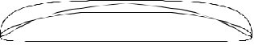

Sid Madden 67

9'4"B

Overall Bottom Length: 9' 4 ¹/₄" (285.12)

Tip-to-tip Deck Length: 9' 3 ⁵/₈" (283.53)

³/₈"—

51.75
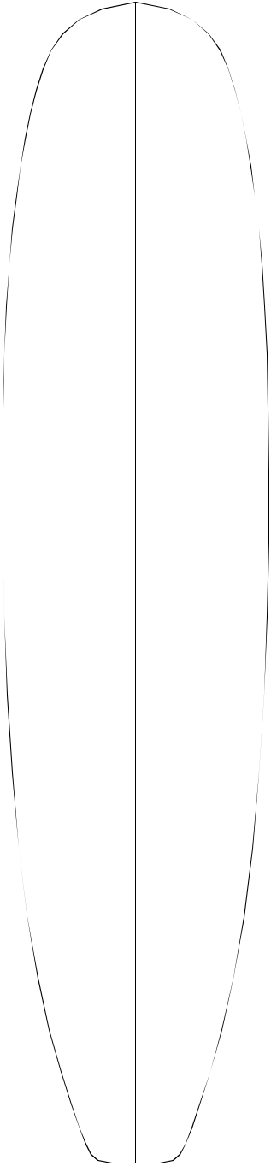

"—

12.70

2 | ¹/ "—
 | 2
 | 6.35

—1 ³/₈" | Maximum Width: 25 |  | ¹/ " | (63.82)
3.49 |  |  | 8
 | Maximum Thickness: 3 |  |  | ³/ " (8.57)
 |  |  |  | 8

Displacement: 3.22 cubic feet (0.0911m)
— 2 ¹/₁₆"
5.24 | History: Introduced March, 1998

23 | ¹/ "—
 | 2
 | 59.69
24 | ⁷/ "—
 | 8
 | 63.18

1 | ³/ "—
 | 16
 | 3.02

⁷/₁₆"—

1.11

— 2 ¹¹/₁₆" 6.83

— 3 ¹/₁₆" 7.78

Rockers: Natural, +1/2"N Last 24" +1/2"T Last 10", +1/8"N Last 8" +3/8"T Last 8", BJNR (+3/4"T), 9'3" Bottom Centered

Factory Stocking: Always

Limited Volume Charge: None

Blanks Per Box: 4 - 10'8"

25 | ¹/ "—
 | 8
 | 63.82

³/₄"—

62.87

¹/₈"—

61.28

— 3 ¹/₄"
8.26

— 3 ⁵/₁₆" 8.41

— 3 ¹/₄"

8.26

Shaper's Comments: Designed to compliment the 9'1"Y, with a thinner nose and tail, and more roll in the deck to stay closer to shape. Will net bottom mea-sured 9-4's at 3 1/8" max thickness. The thickness flow is very close to shape, and close attention must be paid to the correct rocker! +3/4" tail is good for noseriders. +1/2" nose last 24" +1/2" tail last 10" is good for all around boards. Existing bottom rockers for the 9'4"R should work well with this blank.

22 ¹¹/ "— |  |  | ⁷/ "— | —3 | ¹/ "
 | 16 |  | 16 |  | 16
57.63 |  |  | 1.11 | 7.78
20 | ¹/ "— | 1 | ¹/ "— | — 2 | ⁵/ "
 | 4 |  | 16 |  | 8
 | 51.44 |  | 2.70 | 6.67
16 | ³/ "— | 2¹/ "— |  | — 1 | 15/ | 16 | "
 | 8 |  | 16 |  |  | 16
 | 41.59 |  | 5.24 | 4.92
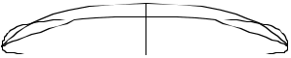

3 ¹/₂"—
8.89

¹/₄"

18.42

Shaped By:

Bruce Jones

68

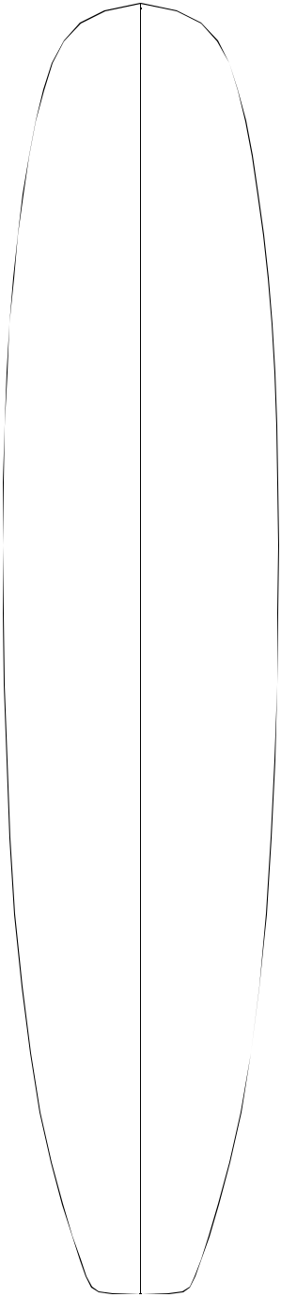

⁵/₈"—

52.39

⁵/₈"—

60.01

³/₄"—

62.87

³/₁₆"—

63.98

¹/₈"—

63.82

³/₄"—

62.87

⁵/₈"—

60.01

¹/₈ "—

53.66

¹¹/₁₆ "—

42.39

4 ⁵/₈"—
11.75

2 ⁵/₈"—
6.67

1 ¹/₄"—
3.18

/₁₆"—
1.11

³/₈"—
0.95

1 ¹/₁₆ "—

2.70

2 ³/₁₆ "—

5.56

— 2 ¹/₈"

5.40

— 2 ⁵/₈"

6.67

— 3 "

7.62

— 3 ¹/₈"
7.94

— 3 ¹/₈"

7.94

— 3 ¹/₈"
7.94

—3"

7.62

— 2 ⁵/₈"
6.67

— 2 ¹/₁₆" 5.24
9'4"H


Overall Bottom Length: 9' 4 ⁵/₁₆" (285.27)

Tip-to-tip Deck Length: 9' 3 ¹³/₁₆" (284.00)

Maximum Width: 25 ³/₁₆" (63.98)

Maximum Thickness: 3 ¹/₈" (7.95)

Displacement: 3.48 cubic feet (0.0985m)

History: Introduced May, 2001

Rockers: Natural

Factory Stocking: Limited

Limited Volume Charge: $ 0.50

Blanks Per Box: 4 - 10'8"

Shaper's Comments: This blank should easily net 9-2 deck measured and 9-3 bottom measured surf-boards. This blank will fill the need for those who can't find enough foam to work with on the 9-5S. It has a center thickness 2 7/8 or less with enough in the ends to shape in your own foil. The deck has less roll so that you can create your own deck crown.

3 ⁵/₈"—

7 " | 9.21
17.78

Shaped By:
Rich Harbour

69

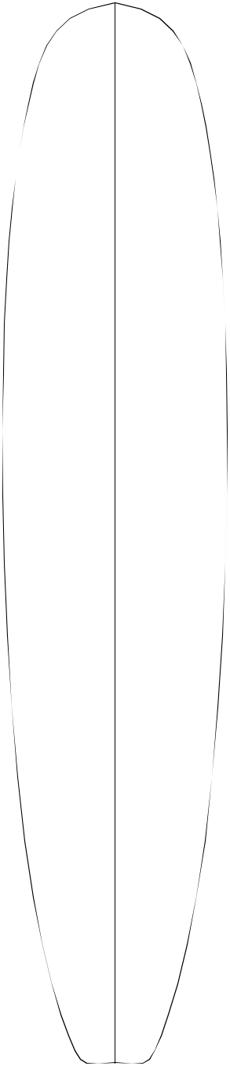

⁷/₁₆"—

51.91

⁷/₁₆"—

59.53
9'4"R


5¹/ "— |  | —1 | 11/ " | Overall Bottom Length: 9' 4 ³/ " |  |  |  |  |  |  |  | (286.38)
 | 16 |  | 16 |  |  |  |  |  |  |  | 4
 | 12.86 |  | 4.29
 |  |  | 4.29 | Tip-to-tip Deck Length: 9' 4 |  |  |  |  |  |  | ¹/ "
 |  |  |  |  |  |  |  |  |  |  | ¹/ " | (284.79)
 |  |  |  |  |  |  |  |  |  |  | 8
 |  |  |  | Maximum Width: |  |  | 25 ⁹/₁₆" |  |  |  | 8
 |  |  |  |  |  |  |  |  |  |  | (64.92)
2 | ¹/ "— | — 2"
 | 2 | 5.08 |  | Maximum Thickness: 3 ³/ "
 | 6.35 |  |  |  |  |  |  |  |  |  | (8.57)
 |  |  |  |  |  |  |  | 8
 |  |  |  | Displacement: 3.40 cubic feet |  |  |  |  |  |  |  | (0.0962m)
1 | ¹/ "— | — 2 | ⁵/ "
 |  |  |  | History: | Introduced April, 1996
 | 4 |  | 8 | History:
 | 3.18 | 6.67 |  | History:

¹⁵/₁₆"—

63.34

¹/₂"—

64.77

⁷/₁₆"—

64.61

⁷/₈"—

63.18

¹/₄"—

59.06

¹¹/₁₆ "—

52.55

⁹/₁₆ "—

42.07

Rockers: Natural

 | ¹/ "— | — 3 | ³/ "
 | 2 |  | 16
 | 1.27 | 8.10
 |  | — 3 | ³/ "
 |  |  | 8
 |  | 8.57
 |  | — 3 | ³/ "
 |  |  | 8
 |  | 8.57
 |  | — 3 | ¹/ "
 |  |  | 4
 |  | 8.26
 | ¹/ "— | —3"
 | 4
 | 0.64 | 7.62
¹³/ "— |  | — 2 | ⁵/ "
 | 16 |  | 8
 | 2.06 | 6.67
1 ³/₄ "— |  | — 2"
 | 4.45 | 5.08
3 | ³/ "—
 | 8
 | 8.57

"

17.78

Shaped By:

Factory Stocking: Limited

Limited Volume Charge: $ 0.50

Blanks Per Box: 4 - 10'8"

Shaper's Comments: Rick Hamon, Rusty Preisendorfer, and Stu Kenson, with input from a number of other shapers from throughout the indus - try, got together to come out with a modern compro - mise between the 9'1"Y and 9'5"S.

Rick Hamon
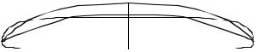

70

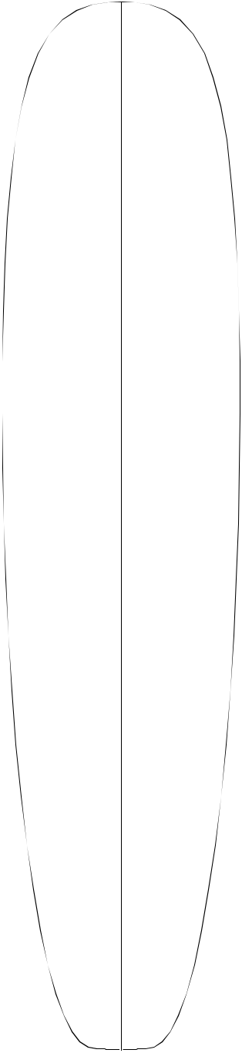

¹/₈"—

51.13

⁹/₃₂"—

59.13
9'5"S


5¹/"— |  |  |  |  |  | Overall Bottom Length: 9' 5 |  |  |  |  |  |  |  | 1 | /₁₆" (287.17)
 | 13.97
 | 2
 |  |  |  |  |  | Tip-to-tip Deck Length: 9' 4 |  |  |  |  |  |  |  | ¹/ " |  | (284.81)
2 | ³/ "— | — 1 | 15/ |  | " |  |  |  |  |  |  |  |  |  | 8
 | 4 |  |  | 16 |  | Maximum Width: 24 |  |  | 11 | /₁₆" |  |  |  | (62.71)
 | 6.99 |  | 4.93 |  |  |  |  |  | 11
 |  |  |  |  |  | Maximum Thickness: 2 ³¹/ |  |  |  |  |  |  | " |  |  | (7.5)
 |  |  |  |  |  |  |  |  |  | 32
 | ¹/ "— | — 2 | 15/ |  | " | Displacement: 3.04 cubic feet |  |  |  |  |  |  |  |  |  | (0.0860m)
1 | ¹/ "— | — 2 | 15/ | 32 | "
 | 4 |  |  | 32
 | 3.18 |  | 6.27
History: Introduced May, 1993. Revolutionized shaping

of modern high-performance longboards. Accepts + or -
rocker adjustments very well.

¹/₂"—

62.23

¹¹/₁₆"—

62.71

¹³/₃₂"—

61.9

¹³/₁₆"—

60.48

¹⁵/₃₂"—

57.07

7/ | "— | — 2 | 13/ |  |  | "
 | 16 |  |  | 16
 | 1.11 |  | 7.14
 |  | — 2 ¹⁵/₁₆"
 |  |  | 7.47
 |  | —2³¹/ |  |  |  |  |  | "
 |  |  |  | 32
 |  |  | 7.54
 |  | — 2 | 15/ |  |  | "
 |  |  |  | 16
 |  |  | 7.47
13/ | "— | — 2 | 23/ | 32 | "
32 |  |  |  | 32
1.03 |  | 6.91

Rockers: Natural. Wide variety of rockers avaliable.

Factory Stocking: Always

Limited Volume Charge: None

Blanks Per Box: 4 - 10'8"

Shaper's Comments: The 9'5"S was designed with cost, strength, and labor efficiency in mind. Progressive pro longboards will come out of this blank with ease.

Keep on surfing - have fun!

¹/₁₆ "—

50.95

16 ¹/₁₆ "—

40.79

¹/₂ "

16.51

1 ¹/ |  |  | "— | —2⁵/ | "
 |  | 16 |  | 16
 | 2.70 |  |  | 5.87
1 | 15/ | 16 | "— | —1¹³/ |  | "
 |  | 16 |  | 16
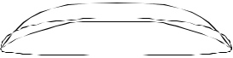
4.92 4.60

3 ⁷/₁₆"—

8.73

Shaped By:
Bill Stewart

71

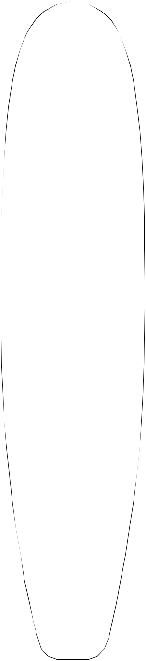

¹/₄"—

51.0

23 | ¹⁹/ "—
 | 32
 | 59.92
9'7"B


 |  |  |  | Overall Bottom Length: 9' 7 |  |  |  |  |  |  | ¹/ " | (293.37)
4 |  | ³/ "— |  |  |  |  |  |  |  |  | 2
 |  | 4 |  | Tip-to-tip Deck Length: |  |  |  |  |  |  | 1
 |  | 12.1 |  |  |  |  |  |  |  |  | 1
 |  |  |  |  |  |  |  |  | 9' 6 |  | /₂" | (290.83)
 |  |  |  | Maximum Width: |  |  | 25 ⁷/₃₂" (64.90)
2 | ⁵/ "— |  | — 2 "
 |  | 16 |  | Maximum Thickness: |  |  |  | 3 ⁷/₁₆" |  |  | (8.74)
 |  | 5.88 | 5.08
 |  |  |  | Displacement: 3.40 cubic feet |  |  |  |  |  |  |  | (0.0962m)
1 | ³/ "— |  | —2⁵/"
 |  | 32 | 8 | History: | Introduced in 1987.
 |  | 2.78 | 6.68 | History:

Rockers: Stewart (+3/4"T E), Natural

24 ¹³/₁₆"—

63.02

³/₃₂"—

64.1

⁷/₈"—

63.20

¹/₈"—

61.29

"—

58.42

¹/₃₂"—

50.88

"—

40.64

³/₄"—

1.91

³/₈"—

.95

1 ¹/₂"—

3.81

2 ³/₁₆"—

5.56

3 ¹/₂"—

7 " | 8.89
17.78

— 3 ¹/₁₆" 7.77

— 3 ⁵/₁₆" 8.41

— 3 ⁷/₁₆" 8.74

— 3 ⁵/₁₆" 8.41

— 3 "

7.62

— 2 ⁵/₈"
6.68

— 2 "

5.08

Factory Stocking: Limited

Limited Volume Charge: $0.50

Blanks Per Box: 4 - 10'8"

Shaper's Comments: Lightly "rolled" deck for stron-ger finished boards. Bottom rocker is similar to 9'3" blank with more continuous curve. Ask for "Stewart" rocker (extra tail) for looser turning, progressive, longboards. It is possible to get a 9'6" out of this blank and still have a full nose.
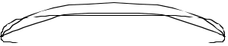

Shaped By:

Bill Stewart

72

9'8"S


20 "—
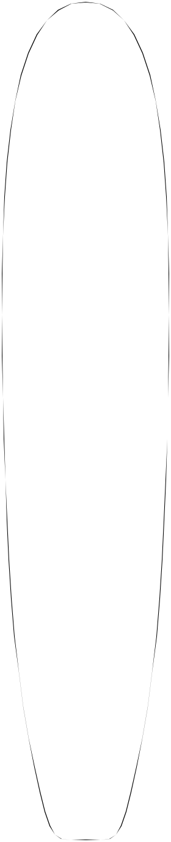
50.80

23 ¹/₄"—

59.06

24 ¹¹/₁₆"—

62.71

"—

63.50

24 ¹¹/₁₆"—

62.71

23 ¹⁵/₁₆"—

60.80

22 ¹/₂"—

57.15

4 | ³/ "—
 | 4
 | 12.07
2 ¹¹/ "— |  | — 2 "
 | 16 | 5.08
 | 6.83
1 | ³/ "— | — 2 | 11/ | 16 |  | "
 | 8
 | 3.49 |  | 6.83
 | ¹/ "— | — 3 | 1/ | "
 | 2 |  | 8
 | 1.27 | 7.94
 | ¹/ "— | — 3 | ³/ "
 | 16 |  | 8
 | 0.16 | 8.57
 |  | — 3 | 7/ |  | "
 |  |  | 16
 |  | 8.73
 | ¹/ "— | — 3 | 5/ |  | "
 | 8 |  | 16
 | 0.32 | 8.41
⁷/ "— |  | — 3 | 1/ |  | "
 | 16 |  | 16
 | 1.11 | 7.78

Overall Bottom Length: 9' 8 ⁷/₈" (296.86)

Tip-to-tip Deck Length: 9' 8 ¹/₄" (295.28)

Maximum Width: 25 ¹/₁₆" (63.66)

Maximum Thickness: 3 ⁷/₁₆" (8.73)

Displacement: 3.66 cubic feet (0.1037m)

History: Introduced July, 1997

Rockers: Natural

Factory Stocking: Always

Limited Volume Charge: None

Blanks Per Box: 4 - 10'8"

Shaper's Comments: This plug is to update the 9'7"B. Natural rocker will give you a fast paddling board. Clean thickness flow and added rocker won’t hurt the flow.
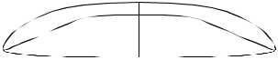

20 "—

50.80

16 "—

40.64

6 ⁵/₈"
16.83

 | 1 "— |  | —2 | ⁵/ "
 |  |  |  | 8
 | 2.54 |  | 6.67
1 ¹⁵/ | 16 | "— | — 2 | ¹/ "
 | 16 |  |  | 16
4.92 5.24

3 ³/₈"—
8.57

Shaped By:

Bill Stewart 73

¹³/₃₂"—

51.8

¹⁹/₃₂ "—

59.9

¹/₂"—

62.3

⁷/₃₂"—

64.1

25"—

63.5

¹⁷/₃₂"—

62.3

³/₁₆"—

58.8

⁵/₈"—

52.5

17"—

43.2

"
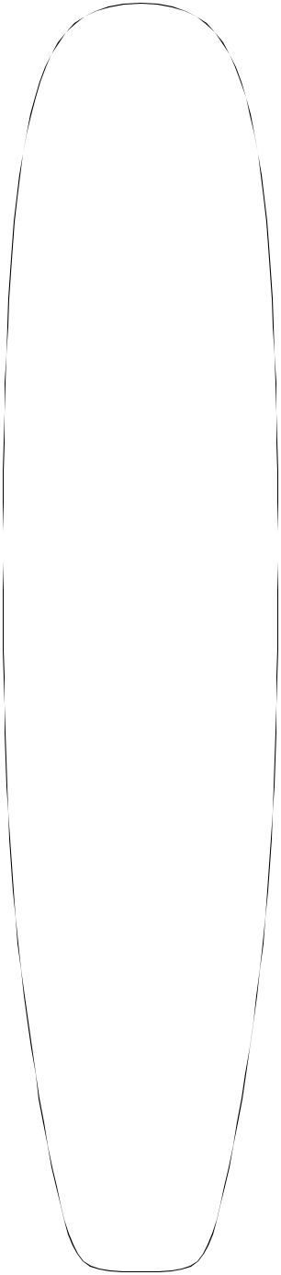
22.9

4 ¹/₂"—
11.4

2 ⁵/₁₆"—

5.88

¹/₈"—

2.86

⁷/₁₆"—
1.11

⁵/₁₆"—
,80

1"—

2.54

1¹⁵/₁₆"—

4.92

3 ⁵/₈"—

9.2

—2 ³/₈"
6.1

— 3 ¹/₁₆" 7.8

— 3 ³/₈"
8.5

— 3 ⁵/₈"
9.2

— 3 ⁵/₈"
9.2

— 3 ¹⁷/₃₂" 9.0

—3 ⁷/₁₆"
8.8

— 2 ¹⁵/₃₂" 6.3

— 2 ⁵/₁₆" 5.8
9'9"


Overall Bottom Length: 9' 8 " (294.06)

Tip-to-tip Deck Length: 9'6 ¹/₂" (290.8)

Maximum Width: 25 ⁷/₃₂" (64.0)

Maximum Thickness: 3 ⁵/₈" (9.24)

Displacement: 3.80 cubic feet (0.1076m)

History: Introduced October, 1986. Widely used for this size/thickness range.

Rockers: Natural

Factory Stocking: Always

Limited Volume Charge: None

Blanks Per Box: 4 - 10'8" box

Shaper's Comments: A versatile (satisfy all) blank made to accomodate all shapes of long boards up to 9'6" in length. Thicker and good for traditional designs. Mold was available before the 9'1"Y and the 10'1"Y molds were introduced and parts from this mold are not recommended for thin ultra light boards. This blank will easily net a 9'6" x 24" x 3-5/16". Blank has slight outline symmetry problem causing one side to be slightly wider/thicker in the rail at center.
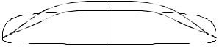

Shaped By:

Rennie Yater 74

— 3 ¹/₂"

11¹¹/₁₆"—

29.68
9'9"A


2 ⁷/₈"— |  |  | Overall Bottom Length: 9' 9 |  |  |  |  |  |  |  | ¹¹/ " (298.92)
7.30 | ³/ "— |  |  |  |  |  |  |  |  |  | 16
7 | ³/ "—
 | 8 |  | Tip-to-tip Deck Length: 9' 8 |  |  |  |  |  |  |  | ³/ " (295.61)
 | 18.73 |  |  |  |  |  |  |  |  |  | ³/ " (295.61)
 |  |  |  |  |  |  |  |  |  |  | 8
 |  |  | Maximum Width: | 22 ⁷/₃₂" |  |  |  |  |  |  | 8
 |  |  | Maximum Width: |  |  |  |  |  |  | (56.4)
3¹/"— |  | — 2 "
 |  | — 2 " | Maximum Thickness: 3 |  |  |  |  | 1 | /₂" |  | (8.89)
 | 7.94 | 5.08 |  |  |  |  |  |  | /₂" |  | (8.89)
 | 8
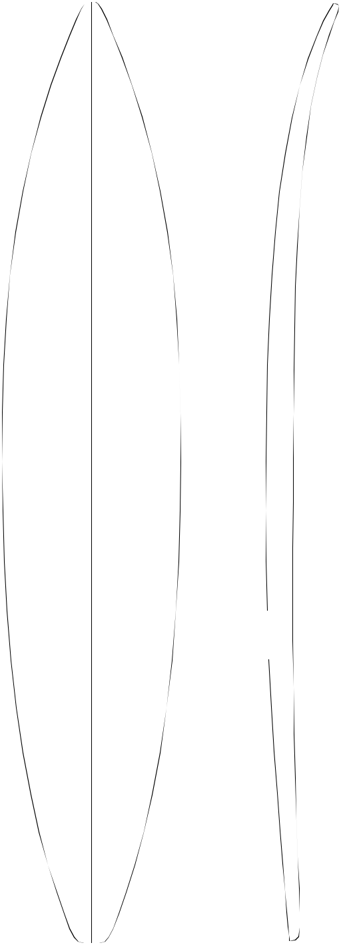

Displacement: 3.146 cubic feet

¹/₄"—

43.81

¹³/₃₂"—

51.83

1 ¹¹/₁₆"—

4.92

³/₈"—

.95

— 2 ¹¹/₁₆" 6.82

— 3 ³/₁₆" 8.09

History: Introduced November, 1991. Said to be "Finest" gun blank produced of all gun blanks.

Rockers: Natural

Factory Stocking: Seasonal demand. Stocked pri-marily in Fall and Winter.

Limited Volume Charge: $ 2.00

³¹/₃₂"—

55.0

⁷/₃₂"—

56.4

⁹/₁₆"—

54.76

²⁹/₃₂"—

50.56

³¹/₃₂"—

43.10

¹/₂"—

31.75

¹/₄"—
.64

¹³/₁₆"—
2.07

1 ⁹/₁₆"—
3.97

2 ²⁹/₃₂"—
7.38
³/₈"
13.65

— 3 ⁷/₁₆"

8.73 | Blanks Per Box: 3 - 10'8"

Shaper's Comments: Basically a longer version of the 9'1"A. Should accommodate rocker changes

^{8.89} gracefully.

— 3 ³/₈"
8.57
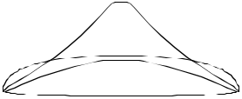

— 3 ¹/₁₆"
7.77

—2 ⁹/₁₆"
6.51

— 1 ¹⁵/₁₆" 4.92

Shaped By:

Pat Rawson

75

9'9"W

3 ⁵/₁₆"—
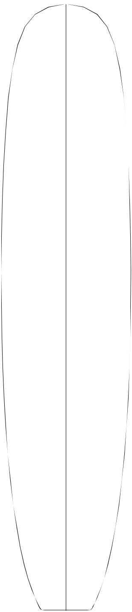
8.41


Overall Bottom Length: 9' 11 ¹/₄" (302.90)

Tip-to-tip Deck Length: 9' 10 ⁷/₈" (301.94)

21 | ¹/ "— | 1 | ³/ "— | — 2 | ³/ "
 | 4 |  | 4 |  | 8
 | 53.98 |  | 4.45 | 6.03

24³/ | 16 | "— | ⁷/ "— | — 2 | ⁷/ "
 | 16 |  | 8 |  | 8
61.44 |  |  | 2.22 | 7.30

25 | ¹/ "— | ⁵/ "— | — 3 | ¹/ "
 | 8 | 16 |  | 4
 | 63.82 | .79 | 8.26
25 ⁹/ "— |  |  | — 3 | ¹/ "
 | 16 |  |  | 2
64.93 |  |  | 8.89
24 | ¹/ "— | ¹/ "— | — 3 | ¹/ "
 | 8 | 2 |  | 4
61.28 |  | 1.27 | 8.26

21 | ¹³/ "— | 1 | ¹/ "— | — 2 | ⁷/ "
 | 16 |  | 8 |  | 8
 | 55.40 |  | 2.86 | 7.30

17 ³/₄"— | 1 ¹⁵/₁₆"— | — 2 ¹/₄"
45.09 | 4.92 | 5.72

3 ¹/₁₆"—
7.78
¹/₄"
23.50

Maximum Width: 25 ⁵/₈" (65.09)

Maximum Thickness: 3 ¹/₂" (8.89)

Displacement: 4.36 cubic feet (0.1235)

History: Introduced February, 2002

Rockers: Natural, WR-JA(+1/2N last 18”+1/2T last 21”/A)

Factory Stocking: Limited

Limited Volume Charge: $2.00

Blanks Per Box: 4 -10’8”

Shaper's Comments: The graceful style, feeling, and glide of traditional 60’s longboarding is timeless. As in the past, it continues to mesmerize surfers the world over. Due to increasing popularity of surfers revisiting “The Dance," I have designed this blank with the following features: a low continu-ous (natural) rocker with a lightly crowned deck profile and minimum deck rail line foil, allowing room for a true 50/50 rail or a contemporary rail shape. Planshapes with very wide nose and tail dimensions will be easy to layout, while main-taining a clean flowing deck line. The bottom is almost flat from nose to tail, allowing creativity from a neutral foundation. Designed to net a deck measured 9’-4” to 9’-9”, up to 24” wide by 3” - 3-1/4”+ thick. With added nose and tail rocker, I believe this blank will be quite versatile.
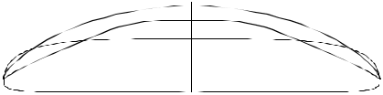

Shaped By:
Wayne Rich

76

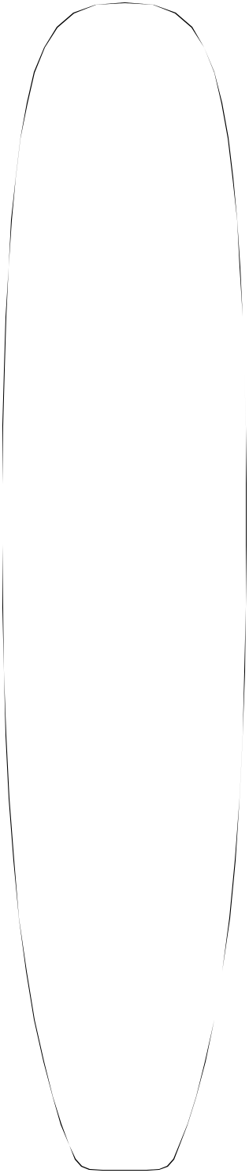

20 ¹¹/₁₆"—

52.6

5"—

12.7

2 ⁵/₈"—
6.7
9'10"H

— 2 ³/₁₆"

5.6 | Overall Bottom Length: 9' 10 |  | ³/ " | (301.6)
 |  |  | 4
 | Tip-to-tip Deck Length: 9' 10" |  | 4 | (299.7)

23 ³/₈"—
59.4

24 ⁵/₈"—
62.6

25 ¹/₈"—
63.8

25 ¹/₈"—
63.8

24 ⁵/₈"—
62.6

23 ¹/₄"—
59.1

20 ¹⁵/₁₆"—
53.2

17 ¹/₁₆"—

43.3

8¹/₄"
21.0

³/₁₆"—
3.0

¹/₂"—
1.3

¹/₂"—
1.3

1 ³/₁₆"—

3.0

2 ¹/₄"—
5.7

3 ⁷/₈"—
9.8

— 2 ¹³/₁₆" 7.1

— 3 ¹/₈"

7.9

— 3 ⁵/₁₆" 8.4

— 3 ¹/₂"

8.9

— 3 ³/₈"

8.6

— 3 ¹/₄"
8.3

—2 ⁷/₈"
7.3

— 2 ³/₁₆" 5.6

Maximum Width: 25 ¹/₈" (63.8)

Maximum Thickness: 3 ¹/₂" (8.9)

Displacement: 3.93 cubic feet (.1112 m)

History: Introduced March, 1995

Rockers: Natural, -1/2"N Last 24"

Factory Stocking: Limited

Limited Volume Charge: $ .50

Blanks Per Box: 4 - 10'8"

Shaper's Comments: This blank is designed for 9'6" to 9'8" deck measurement shapes. For those who measure the bottom, you will easily get a 9'9". It was designed with the 10'1"Y, +1/2" nose rocker as the natural. The bottom is flat in the center with a very slight crown near the rail.
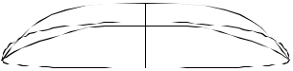

Shaped By:

Rich Harbour

77

5 ¹/8"— 10'1"Y
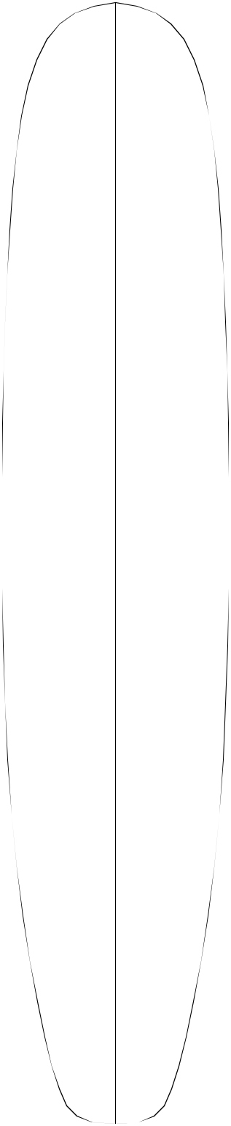
13.00


⁵/₈"—

52.4

2 ¹³/₁₆"—

7.1

 |  | Overall Bottom Length: 10' 3 |  |  | ⁵/ " | (314.0)
—2 | ¹/ " |  |  |  | 8
 | 4 | Tip-to-tip Deck Length: 10' 3" |  |  |  | (312.4)
 | 5.7 |  |  |  |  | (312.4)

¹/₈ "—

58.7

⁹/₁₆"—

62.4

³/₁₆"—

64.00

³/₁₆"—

64.00

⁷/₁₆"—

62.1

¹/₈"—

58.7

¹/₁₆"—

53.5

1 ¹/₂"—

3.8

⁵/₈"—
1. 6

³/₁₆"—
.5

¹/₈"—
.3

¹/₂"—
1.3

1 ¹/₈"—
2.9

—2 ⁷/₈"

7.3

— 3 ¹/₈"
7.9

— 3 ⁵/₁₆" 8.4

— 3 ⁷/₁₆" 8.7

— 3 ³/₈"

8.6

—3 ¹/₄"
8.3

— 2 ¹³/₁₆" 7.1

Maximum Width: 25 ¹/₄" (64.1) (Not shown in picture. This measurement point is just forward of center).

Maximum Thickness: 3 ⁷/₁₆" (8.7)

Displacement: 4.18 cubic feet (0.1183m)

History: In 1994 this blank was extended to 10'3" in length, allowing blank to easily net 10'0". This was done by adding 2" to the nose.

Rockers: Natural, +1/2"N Last 24" C.

Factory Stocking: Always

Limited Volume Charge: None

Blanks Per Box: 4 - 10'8"

Shaper's Comments: Intended to fill the gap of a suitable blank for longboard shapes in the 9'7" to 10' even range. The thinner, more close to tolerance profile makes this blank the more logical one to use for lighter weight pours than the 9'9". Since the lengthening in '94, this blank will easily net out 10'0" x 24" x 3-1/4" longboard shapes.
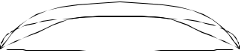

³/₁₆"—

43.7

2 ¹/₁₆"—

5.3

 | 3 | ⁵/ "—
 | ³/ "— | 8
8 | ³/ "— | 9.1
 | 4
 | 22.2

— 2 ¹/₄"

5.7

Shaped By:

Rennie Yater

78

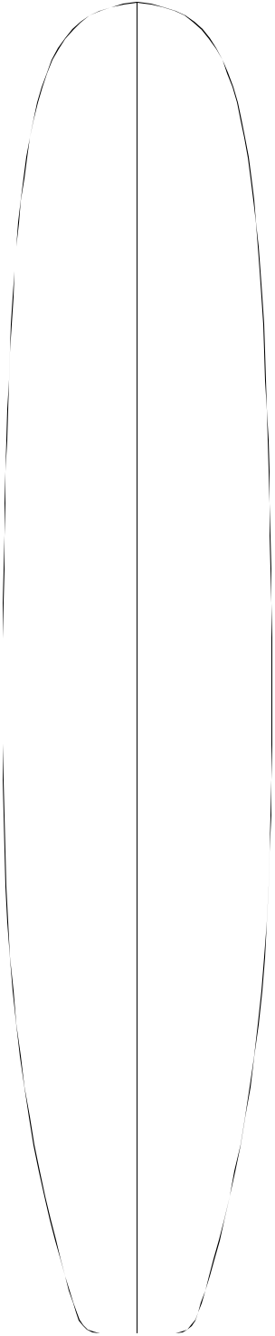

20 ²¹/₃₂"—

52.5

23 ⁵/₈ "—
60.00

3 ²⁷/₃₂"—
9.8

2 ¹/₄"—
5.72

1 ⁷/₃₂"—

3.10
10'3"


Overall Bottom Length: 10' 3 ¹/₄" (313.1)

 |  |  |  | Tip-to-tip Deck Length: 10' 2 |  |  |  |  |  | ¹/ " | (310.2)
—2 | 23/ | 32 | " |  |  |  |  |  |  | 8
 |  |  |  | Maximum Width: 26 ¹/ " |  |  |  |  |  | 8
 |  |  |  |  |  |  |  |  | (66.2)
 | 6.9
 |  |  |  |  |  | 16
 |  |  |  | Maximum Thickness: 4 ³/ |  |  |  |  | " | (11.4)
—3 ⁵/₁₆" |  |  |  |  |  |  | 16
 |  |  |  | Displacement: | 5.049 cubic feet |  |  |  |  |  | (0.1430m)
 | 8.4

25 "—

63.5

25 ³/₄"—

⁹/₁₆"—

1.43

⁵/₃₂"—

—3 ³/₄"
9.5

— 4 ¹/₁₆"

History: Introduced July, 1990. This blank has limited demand due to thickness profile.

Rockers: Downing/Hawaii (+7/8"N +1/2"T E), Natural

Factory Stocking: Very Limited

65.4

26 ¹/₁₆"—

66.2

.40

10.3 |  |  |  | Limited Volume Charge: $ 2.00
 |  |  |  | Blanks Per Box: 3 - 10'8"
— 4 |  | ³/ " |  | Shaper's Comments: 1960's style long board. It has
 |  | 16
 | 10.6 |  | minimum rocker throughout in effort to minimize
 |  |  | distortion when rocker is increased. It also has an
 |  |  | extra flat bottom rail to rail.

25 ³/₄"—
65.4

24 ³/₄"—
62.9

⁵/₃₂"—

.40

¹⁹/₃₂"—

1.51

— 4 ⁵/₃₂" 10.6

— 3 ¹³/₁₆" 9.7

Special Note: This blank has a thickness discrep-ancy problem rail to rail in the front 1/4" of nose that makes bottom portion of the nose appear to be twisted. It does not affect the deck. Unlike a twist problem, it is a thickness problem in the plug which could not be corrected prior to making the mold.

21 ¹³/₁₆"—

55.4

17 ¹³/₃₂"—

44.2

9 ³/₄"

24.8

1 ¹/₄"—
3.18

2 ³/₁₆"—

5.56

3 ¹/₂"—
8.9

Shaped By:

— 3 ³/₈"

8.6
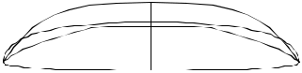

—2 ⁵/₈"

6.7

Phil Edwards 79

3"—

7.6
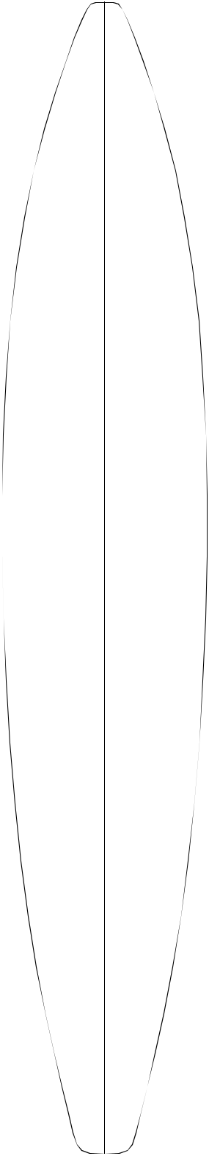
10'4"A
8 ⁵/₁₆"—
21.1


12 "—

30.5

17 ⁷/₁₆ "—

44.3

20 ³/₄"—
52.7

22 ⁵/₁₆"—
56.7

22 ⁹/₁₆"—
57.3

21 ³/₁₆"—
53.8

"—

48.3

15 ¹⁵/₁₆ "—

40.5

¹/₈"—

10.5

2"—

5.1

¹³/₁₆"—
2.1

/₄"—

. 64

¹/₈"—
0.32

/₂"—

1.3

³/₁₆"—

3.0

—1 ³/₄"
4.4

—2 ⁹/₁₆"

6.5

— 3 ³/₁₆" 8.1

— 3 ¹/₂"

8.9

— 3 ⁹/₁₆" 9.0

— 3 ¹/₄"

8.3

—2 ¹⁵/₁₆"

7.5

— 2 ⁷/₁₆" 6.2

Overall Bottom Length: 10' 5 ¹/₂" (318.8)

Tip-to-tip Deck Length: 10' 4 ³/₈" (315.90)

Maximum Width: 22 ⁹/₁₆" (57.3)

Maximum Thickness: 3 ⁹/₁₆" (9.0)

Displacement: 3.43 cubic feet (.0972 m)

History: Introduced July, 1994

Rockers: Natural

Factory Stocking: Seasonal. Stocked primarily in fall and winter. Advance orders are recommended.

Limited Volume Charge: $ 2.00

Blanks Per Box: 3 - 10'8"

Shaper's Comments: I designed the 10'4"A with thickness flow and bottom curves cloning the 9'9"A. Those who already use the 9'9"A will have no trouble adapting to the 10'4"A. This blank should work well for guns from 9'6" to 10'3", with a max thickness of 3 ³/₈".

Special Note: All rockers for this blank will not fit on Redwood or Cedar.
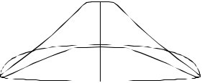

11 ¹¹/₁₆ "—

29.7

5¹/₄"
13.3

2 | ¹/ "— | — 1 | ⁷/ "
 | 8 |  | 8
 | 5.40 | 4.8

3 ¹⁵/₁₆"—

8.4

Shaped By:

Pat Rawson

80

 |  |  | 13.7 |  | 10'5"S
 |  | 5 | ³/ "—
 |  |  | 8
19 ¹⁵/₁₆"— |  | 3 ¹/₁₆"— |  | —2 " |  | Overall Bottom Length: |  |  |  |  |  |  |  | 10' 6 ³/₁₆" |  |  |  |  | (320.05)
 | 50.6 |  | 7.8 | 5.1
 |  |  |  |  |  | Tip-to-tip Deck Length: 10' 5 ¹/ " |  |  |  |  |  |  |  |  |  |  |  |  | (318.8)
 |  |  |  |  |  |  |  |  |  |  |  |  |  |  |  |  |  | 2
 |  |  |  |  |  | Maximum Width: 25 ¹/ " |  |  |  |  |  |  |  |  |  |  |  | 2
 |  |  |  |  |  |  |  |  |  |  |  |  |  |  |  |  | (63.8)
22 | ⁷/ "— | 1 | ⁵/ "— | —2⁵/" |  |  |  |  |  | 8
 | 8 |  | 8 | 8 |  | Maximum Thickness: 3 |  |  |  |  |  |  |  |  |  | 9 | /₁₆" | (9.1)
 | 58.1 |  | 4.1
 | 58.1 |  | 4.1 | 6.7 |  |  |  |  |  |  |  |  |  |  |  |  | /₁₆" | (9.1)
 |  |  |  | 6.7 |  | Displacement: 3.89 cubic feet |  |  |  |  |  |  |  |  |  |  |  | (.1102 m)
24 | ³/ "— | ¹¹/ "— |  | —3¹/" |  | History: |  | Introduced Winter, 1995
 | 8 |  | 16 | 8
 | 61.9 |  | 1.7 | 7.9
 |  |  |  |  |  | Rockers: Natural, Stewart (+1/8" N +3/8"T A)
 |  |  |  |  |  | Factory Stocking: Limited
25 ¹/₁₆"— |  |  | ³/₁₆"— | — 3 ⁷/₁₆"
 |  |  | ³/₁₆"— | — 3 ⁷/₁₆" |  | Limited Volume Charge: |  |  |  |  |  |  |  |  |  | $2.00
 | 63.7 |  | . 48 | 8.7
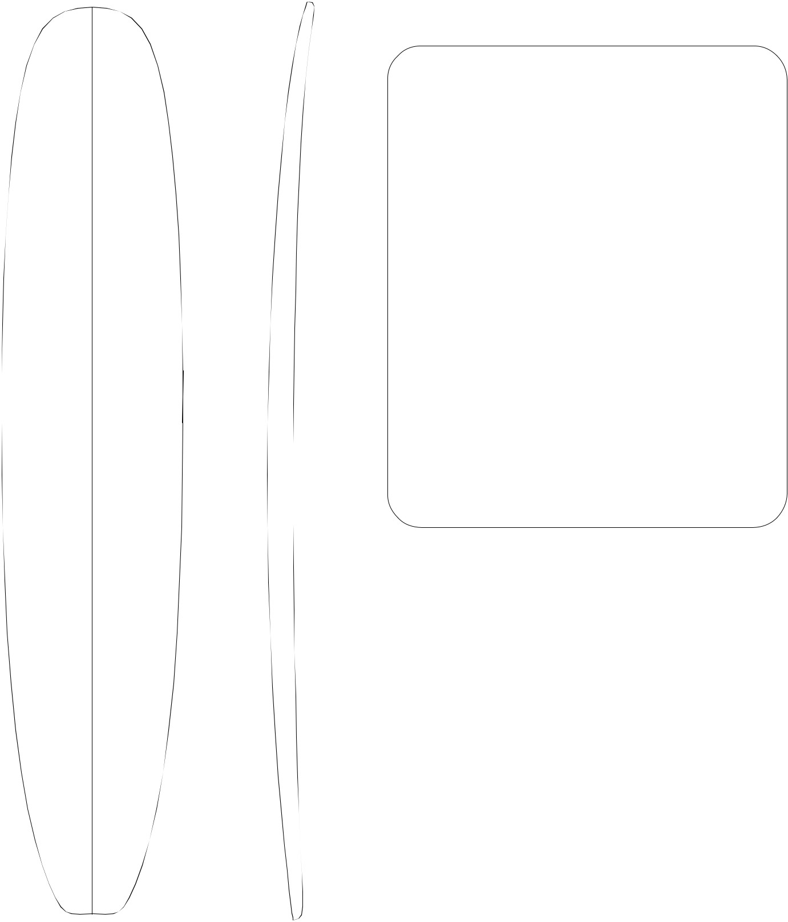

Blanks Per Box: 3 - 10'8"

¹/₈"—

63.8

¹/₄"—

61.6

⁷/₈"—

58.1

20 ¹/₂ "—
52.1

⁷/₁₆ "—

41.8

 |  | — 3 | 9/ |  |  |  |  | "
 |  |  |  | 16
 |  |  | 9.0
 | ¹/ "— | — 3 | 3/ | 16 |  | "
 | 4
 | .64 |  | 8.1
¹¹/₁₆"— |  | —3 ¹/₁₆"
 | 1.7 |  | 7.8
1 | ⁵/ "— | —2¹/"
 | 16 |  |  |  | 2
 | 3.3 |  | 6.4
2 | ³/ "— | — 2"
 | 16
 | 5.6 | 5.1

3 ¹/₂"—
8.9
¹/₂"
16.5

Shaped By:

Shaper's Comments: 10'5"S has a thin nose and tail, with a flatter deck and thinner rails. The thickest point extends forward of (and includes) center and you may want more tail rocker for better nose riding.
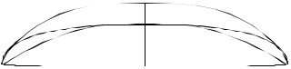

Bill Stewart 81

"—

33.0

⁵/₁₆ "—

46.5

⁵/₃₂"—

53.7

¹/₂"

6.4
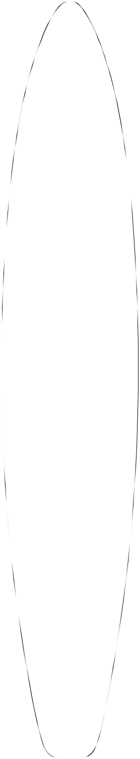
10'6"


 | —7 | ⁵/ "—
 |  | 8
 | 19.4
 |  |  |  | Overall Bottom Length: 10' 6 ¹/ " (320.68)
 |  |  |  | Tip-to-tip Deck Length: |  |  |  |  |  |  | 10'5" |  |  | 4
3 | ¹⁵/ "— | —2 | ³/ " |  |  |  |  |  |  |  |  |  |  | (317.50)
 | 16 |  | 16
 | 10.01 |  | 5.6
 |  |  |  | Maximum Width: 22 ⁷/ " |  |  |  |  |  |  |  | (58.10)
 |  |  |  |  |  |  |  | 8
 | 1 ⁵/₈ "— | —3 ¹/₁₆" |  | Maximum Thickness: 3 ¹³/ |  |  |  |  |  |  |  | 16 | " | (9.68)
 | 1 ⁵/₈ "— |  |  | Displacement: 3.81 cubic feet
 | 4.14 |  | 7.8 |  |  |  |  |  |  |  |  |  |  | (0.1079 m)
 |  |  | 7.8 | History: Introduced September, 1986
 | ⁹/ "— | —3⁵/"
 | 16 |  | 8 | Rockers: |  | Natural, Rawson
 | 1.42 |  | 9.2

¹⁷/₃₂"—

57.2

⁷/₈"—

58.1

¹¹/₁₆"—

57.6

⁹/₃₂"—

54.1

¹/₃₂"—

50.9

⁹/₃₂ "—

43.9

13 ¹/₄ "—
33.7

"

17.8

³/₁₆ "—
.48

¹/₄ "—
.64

⁵/₈ "—
1.6

1¹/₁₆ "—

2.69

1⁹/₁₆ "—

3.96

2 ¹/₄"—

5.7

— 3 ³/₄"
9.5

— 3 ¹³/₁₆" 9.7

— 3 ³/₄"
9.5

— 3 ¹⁵/₃₂" 9.8

—3 ¹/₈"
7.9

— 2 ¹¹/₁₆" 6.8

— 2 ¹/₁₆" 5.2

Factory Stocking: Seasonal. Stocked primarily in Fall and Winter. Advance orders are recommended.

Limited Volume Charge: $ 2.00

Blanks Per Box: 3 - 10'8"

Shaper's Comments: The blank is primarily designed for boards in the 9' through 10' range while allowing room to adjust your rocker. While the nose and tail may seem thin at first glance, their proportions fit very well and require very little shaping.

Special Note: All rockers for this blank will not fit on Redwood or Cedar.
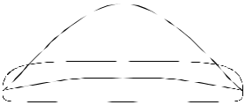

Shaped By:

Bill Barnfield 82

4"—
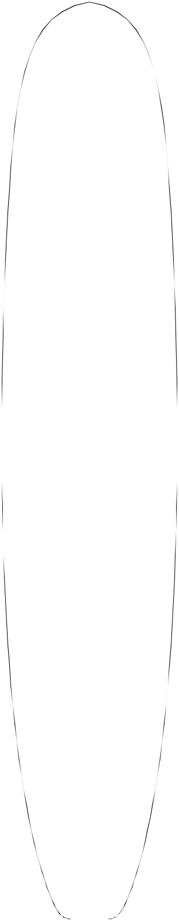

10.16
10'7"H

20 ⁷/₈"—

53.02

 |  |  |  |  | Overall Bottom Length: 10' 8 |  |  | ³/ " | (326.07)
2 | ¹/ "— | —2 | 5/ | " | Tip-to-tip Deck Length: |  |  | 8
 |  |  |  |  |  |  |  | 7
 | 2 |  | 16 |  | Tip-to-tip Deck Length: |  |  | 7
 | 6.35 |  | 5.87 |  | Tip-to-tip Deck Length: | 10' 7 |  | /₈" | (324.80)

Maximum Width: 26 ⁵/₈" (67.63)

23 ³/₄ "—

60.33

25 ⁵/₁₆"—

64.29

1 | ³/ "— | —2 | 15/ |  |  |  | "
 | 8 |  |  | 16
 | 3.49
 |  |  | 7.46
 | ⁵/ "— | — 3 | 7/ | 16 | "
 | 8 |  |  | 16
1.59 8.73

Maximum Thickness: 3 ⁷/₈" (9.84)

Displacement: 4.85 cubic feet (0.1373m)

History: Introduced January, 1996

Rockers: Natural, +3/4"N Last 24" +1/4"T Last 24", +7/8"T Last 36" A.

26 ¹/₄"—
66.68

26 ⁵/₈"—
67.63

26 ⁵/₈"—
67.63

26 ¹/₂"—
67.31

25 ⁵/₈"—
65.09

23 ⁷/₈"—
60.64

21 ¹/₈ "—
53.66

16 ¹⁵/₁₆ "—

43.02

7 "

17.78

 | ¹/ "— | — 3 | 5/ |  |  | "
 | 4 |  | 8
 | 0. 64 | 9.21
 |  | — 3 | ⁷/ "
 |  |  | 8
 |  | 9.84
 |  | — 3 | ⁷/ "
 |  |  | 8
 |  | 9.84
 |  | — 3 | ⁷/ "
 |  |  | 8
 |  | 9.84
 | ¹/ "— | — 3 | 3/ | "
 | 4 |  | 4
 | 0.64 | 9.53
 | ⁵/ "— | —3¹/"
 | 8 |  | 2
 | 1.59 | 8.89
1 | ¹/ "— | — 2 | 15/ |  |  | "
 | 4 |  |  | 16
 | 3.18 |  | 7.46
2 | ¹/ "— | — 2 | ¹/ "
 | 8 |  | 4
 | 5.40 | 5.72

3 ¹/₈"—
7.94

Shaped By:

Factory Stocking: Very Limited

Limited Volume Charge: $ 1.00

Blanks Per Box: 3 - 10'8"

Shaper's Comments: The blank is designed to create 10'-3" to 10'6" deck-measured big boy boards. One pass top and bottom, template and round the rails. You now have a no hassle, well-proportioned board, for a 250 pound customer. The natural deck rocker closely resembles that of the 11'3". This is a very flat, '60's style curve. I have provided two optional rock-ers: One is a very contemporary +3/4"N +1/4"T (both bends start at 24" from the tips) and the other is the ultimate nose rider, +7/8"T (starting at 36" from the tail.)
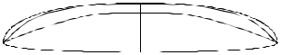

Rich Harbour ₈₃

⁷/₁₆"—

39.21

20 ¹/₄ "—

51.44

¹³/₁₆"—

57.94

¹/₄"—

61.60

¹¹/₁₆"—

62.71

⁵/₈"—

62.55

⁹/₁₆"—

62.39

⁵/₁₆"—

59.21

³/₈"—

54.29

¹/₂ "—

46.99

¹/₂"

3.81
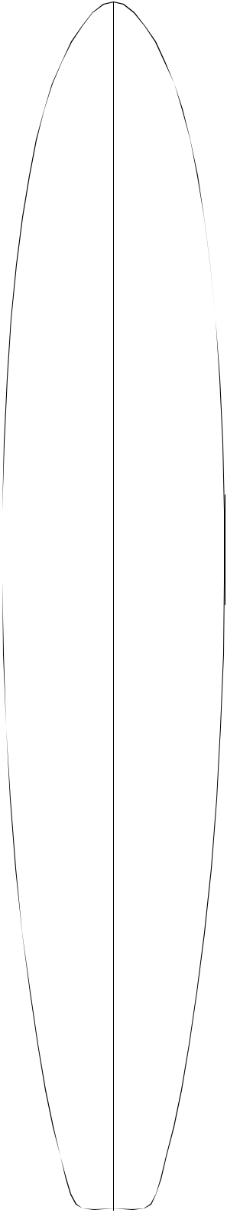

¹/₄"—

18.42

³/₄"—

9.53

¹³/₁₆"—

4.60

³/₄"—
1.91

¹/₄"—
0. 64

¹/₄"—
0.64

³/₄"—
1.91

⁷/₁₆"—

3.65
10'8"A
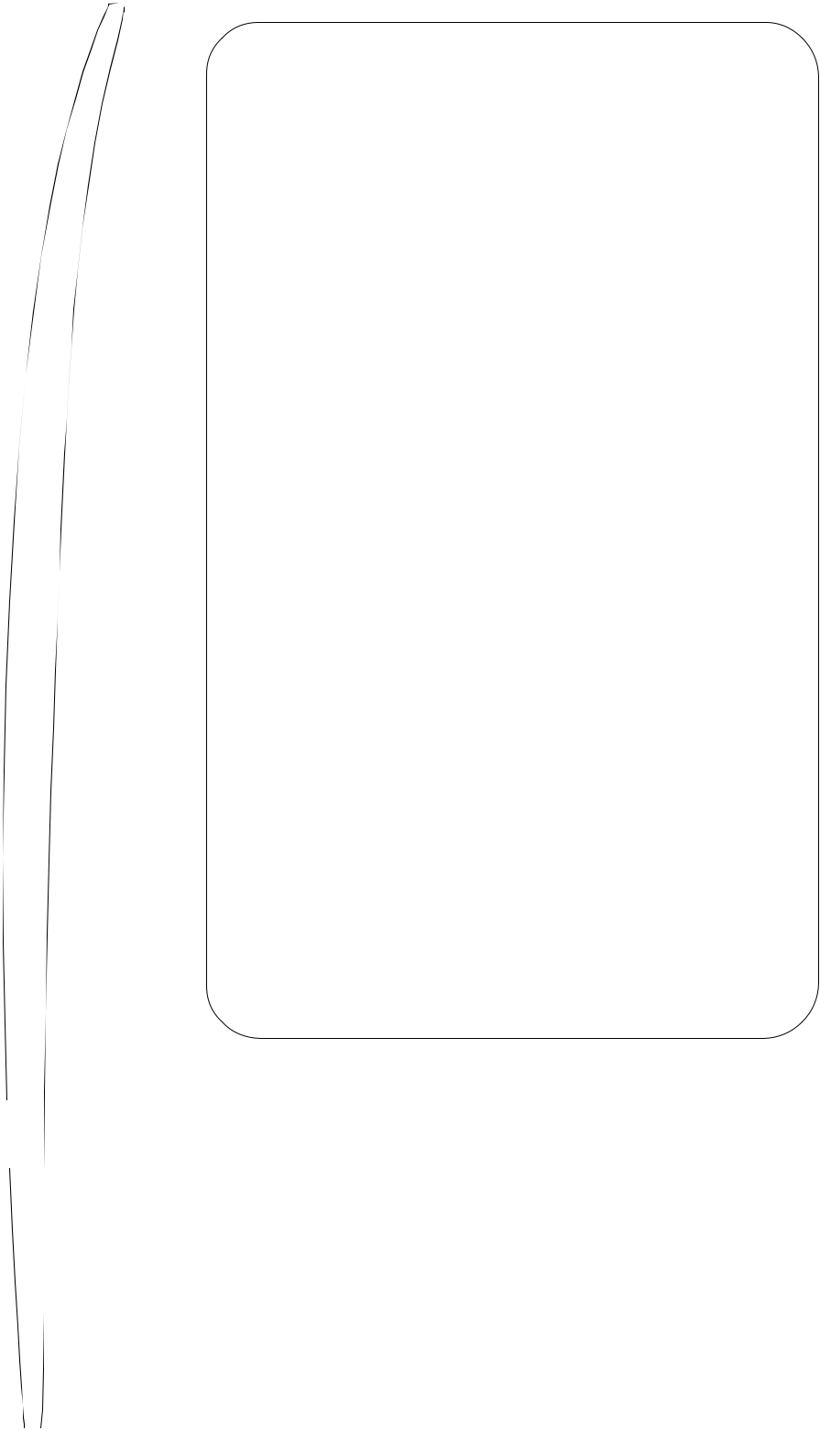

 |  |  |  | Overall Bottom Length: 10' 8 |  |  |  |  |  |  |  |  |  |  |  |  | ³/ " | (327.03)
—2 " |  |  |  |  |  |  |  |  |  |  |  |  |  |  |  |  | 4
—2 " |  |  |  | Tip-to-tip Deck Length: 10' 7 |  |  |  |  |  |  |  |  |  |  |  |  | ⁵/ " | (324.18)
5.08 |  |  |  |  |  |  |  |  |  |  |  |  |  |  |  |  | 8
5.08 |  |  |  | Maximum Width: 24 ¹¹/ " |  |  |  |  |  |  |  |  |  |  |  |  | 8
 |  |  |  |  |  |  |  |  |  |  |  |  |  |  |  | (62.71)
 |  |  |  |  |  |  |  |  | 16
—2 ⁷/₈" |  |  |  | Maximum Thickness: |  |  |  |  |  |  |  | 4 " |  |  |  | (10.16)
7.30 |  |  |  | Displacement: 4.395 cubic feet |  |  |  |  |  |  |  |  |  |  |  |  |  | (0.1245m)
—3¹/ " |  |  |  | History: Introduced October, 2003
2
8.39 |  |  |  | Rockers: Natural
 |  |  |  | Factory Stocking: Very Limited
—3⁷/"
8 |  |  |  | Limited Volume Charge: $ 4.00
9.84
 |  |  |  | Blanks Per Box: 3 - 10'8"
— 4 "
— 4 " |  |  |  | Shaper's Comments: Designed using the 10-6 thick-
10.16
10.16 |  |  |  | ness flow as a desired design point, but with my
— 4 " |  |  |  | bottom rocker curve added. The main design change
10.16 |  |  |  | was to add extra nose width, as well as adding overall
— 4 " |  |  |  | width throughout.
10.16 |  |  |  | The 10-8 A is capable of state-of-the-art guns, as
 |  |  |  | well as the "fun gun" styles that are still gaining
 |  |  |  | popularity worldwide. The max yield should comfort-
—3³/" |  |  |  | ably hit 10-6 X 23 1/2 + X 3 3/4 and 13 3/4 + nose
 |  |  |  | width 12" back.
4
9.53
 |  |  |  | Special thanks go to Dave Parmenter and Terry
—3 ⁵/ |  | " |  | Chung for their insights.
16
8.41
—2¹³/ | 16 |  | "
7.14
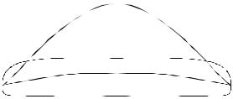

¹/₂"—

36.83

"

17.78

2 | 7/ | 16 | "— | — 2 | ¹/ "
 |  | 16 |  |  | 8
 | 6.19 |  |  | 5.40

3 ¹³/₁₆"—

9.68

Shaped By:

Pat Rawson ₈₄

 |  |  | 2 | ⁷/ "
 |  |  |  | 8
 |  |  | 7.30
 |  |  |  | 8 | ³/ "—
 |  |  |  |  |  | 8
 |  |  |  |  | 21.27
11 | 7/ | 8 | "— | 4 | ¹/ "— |  |  | —2 | ¹/ "
 |  | 8 |  |  |  | 2 |  |  | 16
 | 30.16 |  |  |  | 11.43 |  |  | 5.24
17 | 1/ | 2 | "— | 2 ⁵/ |  | 16 | "— | — 2 | ⁷/ "
 |  | 2 |  |  |  | 16 |  |  |  | 8
 | 44.45 |  |  |  | 5.87 |  |  | 7.30
21 ¹/ "— |  |  |  | 1 |  | ¹/ "— |  | — 3 | 1/ | 2 | "
 |  | 8 |  |  |  | 8 |  |  |  | 2
 | 53.66 |  |  |  |  | 2.86 |  | 8.89
 | 23 "— |  |  | ⁷/ "— |  |  |  | — 4"
 | 58.42 |  |  |  |  | 16
 |  |  |  |  |  | 1.11 |  | 10.16
23 ¹⁵/ |  |  | "— |  |  |  |  | — 4 | ¹/ "
 | 16 |  |  |  |  |  |  |  |  | 4
60.80 |  |  |  |  |  |  |  | 10.80
23 ¹⁵/ |  |  | "— |  |  |  |  | — 4 | ¹/ "
 | 16 |  |  |  |  |  |  |  |  | 4
60.80 |  |  |  |  |  |  |  | 10.80
23 | 9/ |  | "— |  |  |  |  | — 4 | ¹/ "
 | 16 |  |  |  |  |  |  |  |  | 8
 | 59.85 |  |  |  |  |  |  | 10.48
22 | ⁵/ "— |  |  |  | ³/ "— |  |  | — 3 | ⁷/ "
 | 16 |  |  |  |  | 8 |  |  |  | 8
 | 56.67 |  |  |  |  | 0.95 |  | 9.84
20 | ³/ "— |  |  |  | ⁷/ "— |  |  | — 3 | ³/ "
 | 16 |  |  |  |  | 8 |  | 8.57 |  | 8
 | 51.28 |  |  |  |  | 2.22
 | 17 "— |  |  | 1⁹/ "— |  |  |  | — 2 | 7/ | 8 | "
 |  |  |  |  |  | 16 |  |  |  | 8
 | 43.18 |  |  |  | 3.97 |  |  | 7.30
12 | 3/ | 8 | "— | 2 | ¹/ "— |  |  | — 2 | ¹/ "
 |  | 8 |  |  |  | 2 |  |  |  | 8
 | 31.43 |  |  |  |  | 6.35 |  | 5.40
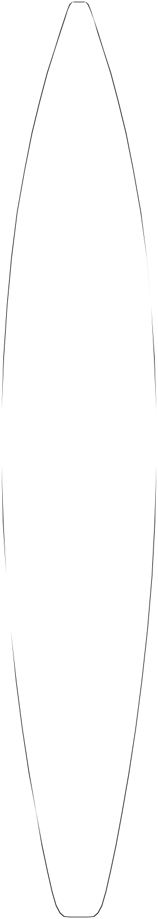

3 ¹¹/₁₆ "—
9.37

¹/₈ "

13.02

Shaped By:
11'2"


Overall Bottom Length: 11' 3 ¹/₂" (344.17)

Tip-to-tip Deck Length: 11' 2 ³/₈" (341.31)

Maximum Width: 24" (60.96)

Maximum Thickness: 4 ¹/₄" (10.80)

Displacement: 4.53 cubic feet (0.1284m)

History: Introduced August, 1997

Rockers: Natural

Factory Stocking: Seasonal. Stocked primarily in Fall and Winter. Advance orders are recommended.

Limited Volume Charge: $ 2.00

Blanks Per Box: 1 - Using (2) 10'6" boxes (sleeved) or 3 - Using (2) 10'8" boxes.

Shaper's Comments: Due to the need for a longer, larger volume, Hi-performance gun blank - the 11'2' was a culmination of two shapers ideas to be used mainly for 15' to 25'. Hollow waves; or specifically "Mavericks". The 11'2" should work well in the 10' to 11' length range, & should yield 3-7/8" with care

should take a straighter open-ocean type rocker without distorting the deck curve sig-nificantly.

Special note: All rockers for this blank will not fit on Redwood or Cedar.
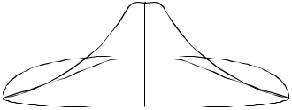

Pat Rawson & Jeff Clark 85

—3³/₈"
8.6
— 2 ¹¹/₁₆"
6.8
9.7
10.2
—4 ¹/₃₂ "
— 4 ³/₁₆"
— 4 ³/₁₆" 10.6
—4¹/₈"
10.5
—2 ³/₈"
6.0
— 3 ⁵/₃₂" 8.0

²¹/₃₂ "—

49.9

⁵/₈ "—

60.0

¹⁹/₃₂"—

14.2
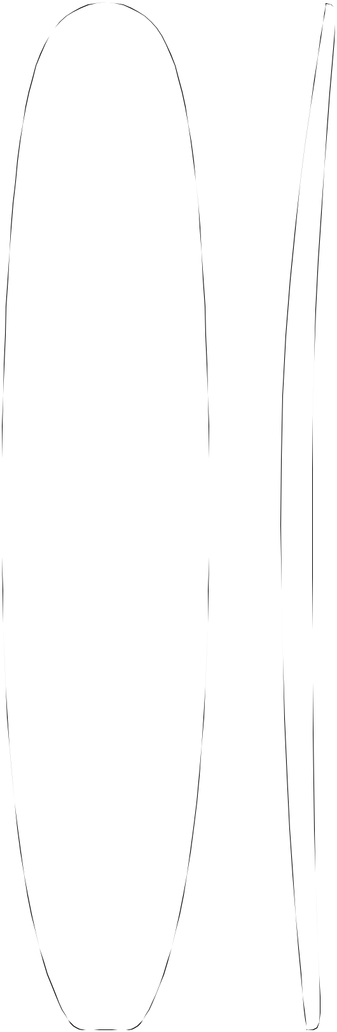

¹³/₃₂"—

8.65

²⁹/₃₂"—

4.84
11'3"


Overall Bottom Length: 11' 3 ³/₈" (343.90)

Tip-to-tip Deck Length: 11' 2 ¹/₄" (341.00)

Maximum Width: 27" (68.6)

Maximum Thickness: 4 ⁷/₃₂" (10.7)

Displacement: 5.296 cubic feet (.1500 m)

²¹/₃₂"—

65.2

⁷/₈"— | —3³/₄ | " | History: Introduced January, 1990. Has proved to be as
2.22 | 9.5

versatile as outlined in comments. Good proportions for

large guns.

⁵/₈"—

67.6

"—

68.6

³¹/₃₂"—

68.5

²⁷/₃₂"—

68.2

³/₁₆"—

66.5

³/₄"—

62.9

¹/₄ "—

56.5

¹⁹/₃₂ "—

44.7

¹/₂ "

19.1

⁹/₃₂"—

.71

⁵/₃₂"—

.40

⁷/₁₆"—

1.11

1 "—

2.54

1 ⁷/₈"—

4.76

3 ³/₃₂ "—

7.9

Rockers: Downing/Hawaii +1" N last 18" (+1-¹/₄"N/+³/₄"T
"A"), Gun: 10'6" bottom centered (+4 ¹/₈"N/-¹/₂"T "E").

Factory Stocking: Very Limited
— 4 ⁷/₃₂"
10.7
Limited Volume Charge: $ 4.00

Blanks Per Box: 1 - Using (2) 10'8" boxes (sleeved)

Shaper's Comments: "Shaper's Delight" will yield an excel-lently proportioned 10'6". When finished, will easily float

10.6 persons up to 250 lbs. An excellent rental board. Nose rocker

can be adjusted up to 6 ¹/₂" or lowered to 4 ¹/₂". Tail rocker can be adjusted up 1" or down ¹/₂". Excellent family board. Perfect San Onofre board or for those crowded days at your favorite point break. Great for giving lessons. Perfect for noseriding. May be used for guns with rocker adjustment and width removed from center prior to gluing. Suggested minimum stringer thickness: ³/₁₆".
— 3 ¹³/₁₆"
Special note: All rockers for this blank will not fit on Red-wood or Cedar.
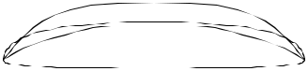

Shaped By:

George Downing & Dale Velzy

86

"—

48.3

5 ³/₄ "—
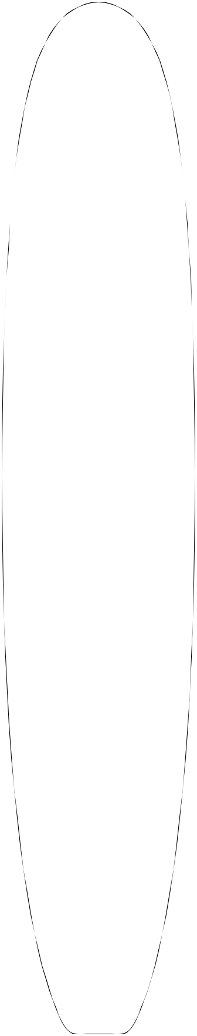
14.6

3 ⁵/₈ "—

9.21
—3 " 12'3"
7.6


¹/₈"—

58.7

¹/₂ "—

64.8

¹/₄"—

69.2

2 ¹/₁₆ "—

5.24

²⁹/₃₂ "—

2.30

¹¹/₃₂ "—

.87

—3 ¹¹/₁₆"

9.4

— 4 ¹/₄"
10.8

— 4 ¹/₂"
11.4

Overall Bottom Length: 12' 3 ³/₄" (375.3)

Tip-to-tip Deck Length: 12' 0 ⁷/₈" (368.00)

Maximum Width: 27 ¹/₄" (69.2)

Maximum Thickness: 4 ³/₄" (12.1)

Displacement: 6.562 cubic feet (.1858m)

History: Introduced January, 1990. Has proved to be as versatile as outlined in comments. Good proportions for large guns.

¹/₄"—

69.2

¹/₁₆ "—

.16

Rockers: Downing/Hawaii (+1/4"N +1" T E),

— 4 ³/₄" Natural. Tandem: Infinity #1,(+1-3/4"N +5/8"T E).

12.1 | Gun: 10'9"B bottom centered (+4-3/4"N +1/2"T E).

¹/₈"—

68.9

¹/₂"—

67.3

¹/₂"—

64.8

¹⁵/₁₆ "—

60.8

¹/₄ "—

.64

¹³/₃₂ "—

1.03

¹³/₁₆ "—

2.07

— 4 ¹¹/₁₆" 11.9

— 4 ⁹/₁₆"

11.6

—4¹/₄"

10.8

—3 ¹⁵/₁₆"

10.0

Factory Stocking: Very Limited

Limited Volume Charge: $ 4.00

Blanks Per Box: 1 using (2) 10'8" boxes (sleeved)

Shaper's Comments: Excellent tandem board blank, ("Hello, Sweetie!") versatile, for use also as a rental board/sailboard. It can be used as a fishboard. Push the rocker out of the nose and it makes an excellent stock racing paddle board. Can also be used as a lifeguard rescue board or a gun with rocker adjust-ment and width removed from center before gluing. See rockers.

Special Note: Any rocker for this blank adding more than +1-1/2" Nose will not fit on Redwood or Cedar.
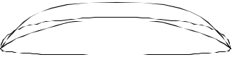

21 ³/₈ "—
54.3

"—

43.2

1 ¹¹/₃₂"—

3.41

2 ⁵/₃₂"—

5.48

7 | ⁷/ " | 3 ³/₃₂"—
7 | ⁷/ " | 7.9
 | 8
20.0

Shaped By:

—3 ⁹/₁₆"

9.1

— 3"

7.6

Dale Velzy & George Downing ₈₇

21 ⁷/₁₆"—

54.45

25 ¹/₈"—

63.82

⁷/₈ "—

68.26

³/₈"—

26.35
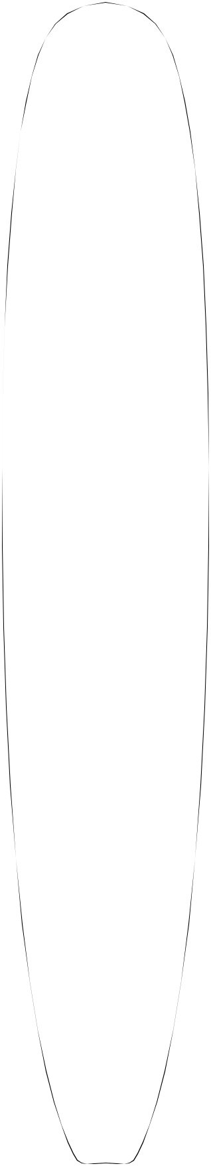

6 ⁷/₁₆"—

16.35

3 ⁷/₈"—
9.84

¹/₈ "—

5.40

—2 | ⁵/ " | 12'8"
 | 8
6.67
 |  | Overall Bottom Length: 12' 9 |  |  | ³/ " | (390.52)
—3 | ⁵/ " |  |  |  | 4
 | 16
 | 8.41 | Tip-to-tip Deck Length: 12' 8" |  |  |  | (386.08)
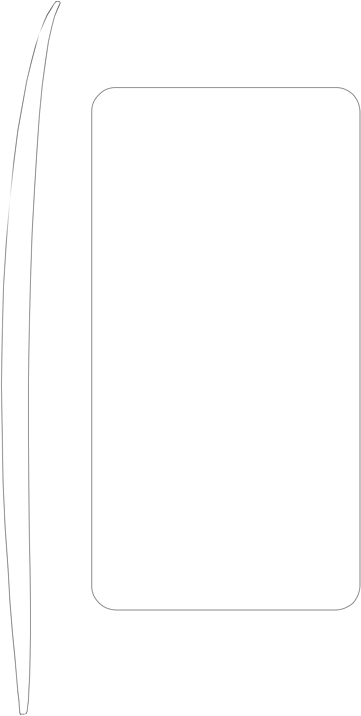

Maximum Width: 28 ⁷/₁₆" (72.23)
— 4 ³/₁₆"
10.64 | Maximum Thickness: 5 |  | /₁₆" (14.12)
10.64 |  |  | 9

⁷/₈"—

70.80

⁵/₁₆"—

71.91

⁷/₁₆"—

72.23

³/₈"—

72.07

¹/₄"—

71.76

⁹/₁₆"—

70.01

¹/₄"—

66.68

¹/₄ "—

61.60

21 ⁷/₁₆ "—

54.45

1"—

2.54

³/₈"—

0.95

⁵/₁₆"—

0.79

³/₄"—

1.91

⁷/₈"—

4.76

¹/₈"—

5.40

—4⁷/₈"
12.38

— 5 ¹/₄"
13.34

—5⁷/₁₆" 13.81

— 5 ¹/₂"

13.97

— 5 ¹/₂"

13.97

—5¹/₄"

13.34

— 5 ¹/₁₆" 12.86

—4¹/₂"

11.43

— 4"

10.16

Displacement: 8.184 cubic feet (0.2317m)

History: Introduced January, 1997

Rockers: Old style tandem (-2" N/+¹/₄" T) A, Tanker (-2 ¹/₄" N - ¹/₂" T) A, Modern tandem (-1³/₈"

+⁵/₈" T) A, Paddle board (-4⁷/₈" N) A. Factory Stocking: Very Limited Limited Volume Charge: $ 4.00

Blanks Per Box: 1 using (2) 10'8" boxes (sleeved)

Shaper's Comments: Below is a paragraph to assist in the shaping of a tandem board:

I shape tandem boards with the thickness towards the back because the girl is in the front and the guy is in the rear. This blank is designed for tandem boards from 5" to 5 ¹/₄ " thick and 26" to 27" wide. The nose on my tandem boards appear fairly thin; 12" = 2 ¹/₄" ± and the tails are relatively thick; T @ 12" = 2 ³/₄" to 4". The extra nose kick really helps in chop or steep take-offs. Rocker changes make a big difference in performance.

For a 12 ft. paddle board, cut 7" from the nose. This will allow for a thicker nose entry. Also a paddle board rocker is recommended.

Special Note: All rockers for this blank will not fit on Redwood or Cedar.
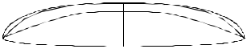

16 ³/₄ "—
42.55

6³/₄"
17.15

3 ¹/₈ "—

7.94

4 ¹/₄"—

10.80

— 3 ¹/₄"

8.26

Shaped By:
Steve Boehne

88

 SHAPING TOOLS
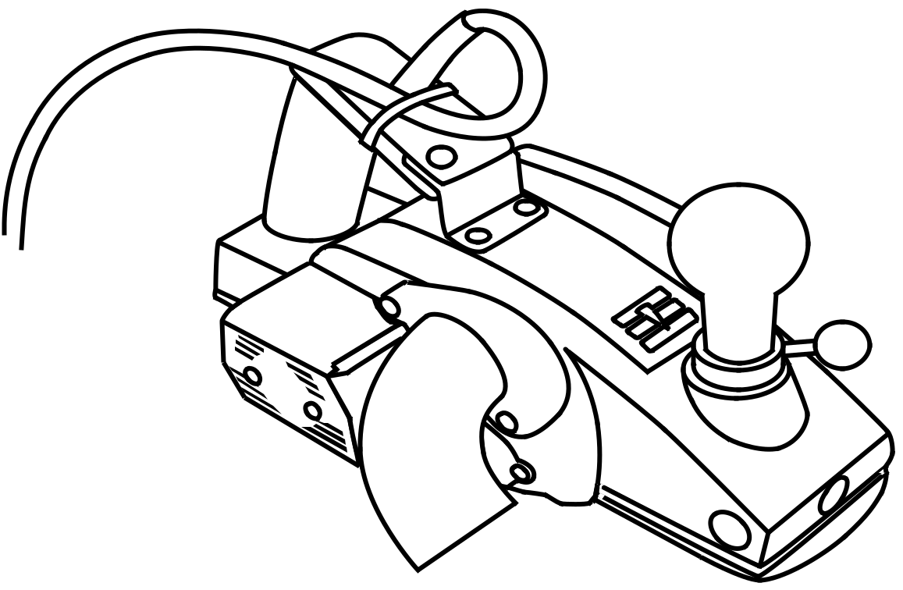

2003 MODEL CLARK FOAM PLANER

Introduced in June of 2003 this planer is designed for the professional surfboard shaper. All new features are a 5 minute blade change exchange service, modified rear handle, two way pass clearance, precision depth adjustment mechanism, sealed depth adjustment mechanism, 25 foot cord positioned for a vacuum, improved bearings for more power, and blueprinted base plates. The depth adjustment mechanism can be customized to fit the individual shaper’s style. Included with the planer is a tool kit, parts for customizing the depth adjustment mechanism, and a very complete manual. Clark Foam also offers parts, a help line, and a repair service. We can also build custom planers from components we stock.

BLADE EXCHANGE SERVICE

In June of 2003 Clark Foam installed a state-of-the-art, automatic blade sharpener at our factory. For increased productivity and cleaner-cutting we sharpen all blades at a special angle designed specifically for surfboard shaping. For the power planers and the hand planers we sell, we stock extra blades so we can offer a straight-across blade exchange service. The exchanged blade may be brand new or it could be on its last sharpening. Power planer blades come indexed to the 2003 Model’s base plates with the sharp blade already attached to the back plate. This makes a blade change take less than 5 minutes. Our delivery trucks will carry sharpened blades. A number of resellers and our warehouses will stock sharpened blades. Customers who are far from an exchange source should buy extra blades and back plates and do the exchange by mail to our factory.

89
STRINGER HAND PLANER



Introduced in 1989 for finish planing of stringers. Uses special razor type blades stocked at Clark Foam. A valuable tool for finish work, this planer keeps chipping and tearing of wood grain to a minimum. 5 double-edged blades come with the planer and extra blades are sold at a quantity of 5 blades per package.

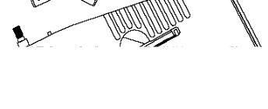

JAPANESE WOODEN BLOCK PLANE

Introduced in 1995 for finish planing of stringers, this specialty plane is of two piece construction, consisting of the smooth, wooden base and a removable blade. The curved base makes this plane ideal for trimming deck stringers near the nose on blanks where nose flip may make other planes impractical. We have a blade exchange service for this planer.
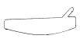



STANLEY 3” TRIMMING PLANE

This planer’s base is 3-1/2 X 1 inches. It is inexpensive and relatively hard to find. We modified the cutting angle of the blade edge for surfboard shaping and it is included in our blade exchange program.

STANLEY 6” LOW ANGLE BLOCK PLANE
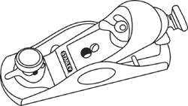

This planer’s base is 6 X 1-3/8 inches. Note that Stanley makes multiple planers of this size. This is the harder to find version that has a lower blade angle, making it the better planer for surfboard shaping by allowing for a smoother cut on end-grains. We also modified the cutting angle of the blade edge. This planer is inexpensive and it is included in our blade exchange program. It is common practice for shapers to have two or three of these planers with different depth cut settings.

STANLEY 10” SPOKESHAVE

The classic Stanley spokeshave was added to our line to take advantage of the blade exchange service. The cutting angle for the blade edge has been modified for surfboard shaping. This tool was widely used for shaping wood boards but it is not as popular today.

90

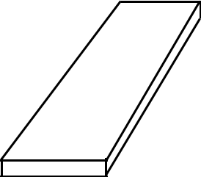

11"

3/4"

4"
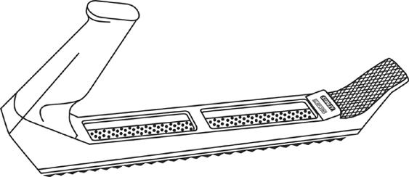
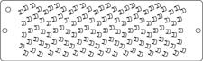

5-1/2” X 1-11/16”
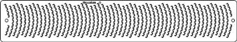

9-7/16” X 1-11/16”

5/8"(diameter) X 8"(length of blade)
HIGH DENSITY CLARK FOAM

SANDING BLOCK

The high density Clark Foam sanding block is a product that has had an underground demand within the shaping community. Due to its growing popularity, we are now offering it as one of our standard products and we will stock it all of the time. It is an 11” X 4” X 3/4” block of high-density foam similar to the density used in tow-in big wave boards. It can be used with sandpaper or as a foam to foam abrasive.

STANLEY SURFORM PLANE

The Stanley Surform planers are made of a die-cast metal alloy and come in two lengths: 6 inches and 12-1/2 inches. The 6 inch (Pocket) planer is a useful one-handed tool ideal for end-grain work and the 12-1/2 inch version is a resilient, two-handed tool, meant to file, cut and shave. These planers can be used directly on foam prior to sand-ing and are especially good for shaping the rail bands and other areas of the board where contours are needed. Both sizes come with a Stanley Surfom Fine Cut Blade, but we recommend using the Microplane replacements listed be-low. We do not stock Stanley Surform Blade replacements.

MICROPLANE SURFORM REPLACEMENT BLADES BY GRACE MANUFACTURING

The Microplane Surform Blades have proven to be a great blade replacement option for the Stanley Surform Planer. Unlike a Stanley Surform Blade that tears the foam and wood stringer, these blades have a shaving effect on both wood and foam, providing an ideally clean finish. They are smooth enough to be used for flattening and finishing and do not cause chipping when working against the grain of a wood stringer. These blades are relatively difficult to find.

MICROPLANE LARGE ROUND RASP

The Microplane Large Round Rasp is an excellent tool for shaping swallowtails. It does not tear the foam or wood. Instead, it leaves a clean, smooth finish. The handle design allows reversing the blade to cut when pulling or pushing.

91

CLARK FOAM VACUUM SWITCH

The Clark Foam vacuum switch is a unit that uses a current sensor to start the vacuum when the planer is turned on. An adjustable timer turns off the vacuum between 1 and 180 seconds after the planer is turned off. There is also a toggle switch on the top of the box that will turn the vacuum on manually. The purpose of this switch is to use the vacuum to clean the shaping room. See Vacuum Switch Instructions for safety and repair information.
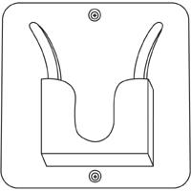

CLARK FOAM PLANER HOLDER

The holder is made of 3/8" powder coated steel plate. Runners quickly guide the planer into the holder. The design keeps the planer blades from touching any material. Since many planers are damaged when dropping off shelves or any resting places this tool is recommended as insurance. When using the Clark Foam Planer Vauum this holder is required to hold the vacuum hose safely out of the shaper's work area. This holder only works with the Clark Foam 2003 Planer.

INEXPENSIVE, HEAVY DUTY TRASH BAG

This is a 2 mil thick, 55 gallon size trashbag. There are 100 in each box. While many stores carry similar bags, we have found these bags are both cheaper and tougher. We have used these bags as a single bag system for over a decade at our wood mill and have had no complaints from the local landfill. Our local landfill requires double bagging when using conventional bags. We tie the bag at the top.

92



PLANER VACUUM SYSTEM

We sell our planer vacuum system either as a complete unit or as components. This vacuum system can be adapted to any shaping room configuration. The vacuum/dust collector may be located anywhere in the building using readily available 2" PVC pipe and efficient, wide-angle PVC ells stocked at Clark Foam.

At the Clark Foam factory we stock all components of the vacuum system and will maintain or repair all components of the system including the vacuum. In certain locations, Clark Foam will install the vacuum system if the shaper will assist in the installation. For simplicity and to make sure the assembled components work properly, the system has only one configuration and must be assembled following our specifications.

To attach to the planer there is a custom-built, small diameter hose that retracts with the vacuum. We use ball bearing pulleys for the planer cord and run the cord independent of the hose. The result is a very light, smooth pull compared to other planer vacuum systems. We are also able to run the hose from a single location eliminating track pulleys, elastic cords, and swinging arms.

We recommend using our planer holder to securely fasten the planer to the wall and hold the hose and cord out of the way. We also recommend using our current sensing Vacuum Switch. Both of these are included with the system.

We use a modified American-made Shop-Vac brand, two stage, industrial vacuum. It is more powerful and durable than the imported home shop vacuums sold at discount stores. The extra power is required for our small, flexible hose. We do not use the stock internal filter. We use an internal filter that is made of a special fabric that is self-cleaning in the surfboard shaping environment. We use the stock filter mounted outside the vacuum exhaust as an air diffuser.

The dust is dropped into a 44 gallon container through an easy sliding aluminum gate type dumping mechanism mounted on a very heavy duty steel stand. We stock an inexpensive, 2mil, very heavy duty, 55 gallon bag that fits inside the 44 gallon container. The bag is large enough to hold the rail and tail cuttings on top of the dust. There is a sight hole for determining how full the container is and a smaller hole used to judge how far the aluminum gate has been pulled.

Included with the vacuum system is a conventional vacuum hose and cleaning attachment. By disconnecting from the planer vacuum unit and attaching to a conventional industrial vacuum hose we carry, the shaping room and nearby areas can be vacuumed.

All steel parts are powder coated and very heavy duty. Our planer cuts cleaner with our vacuum. When installed the unit takes up surprisingly little room, looks good, and is incredibly efficient.

93
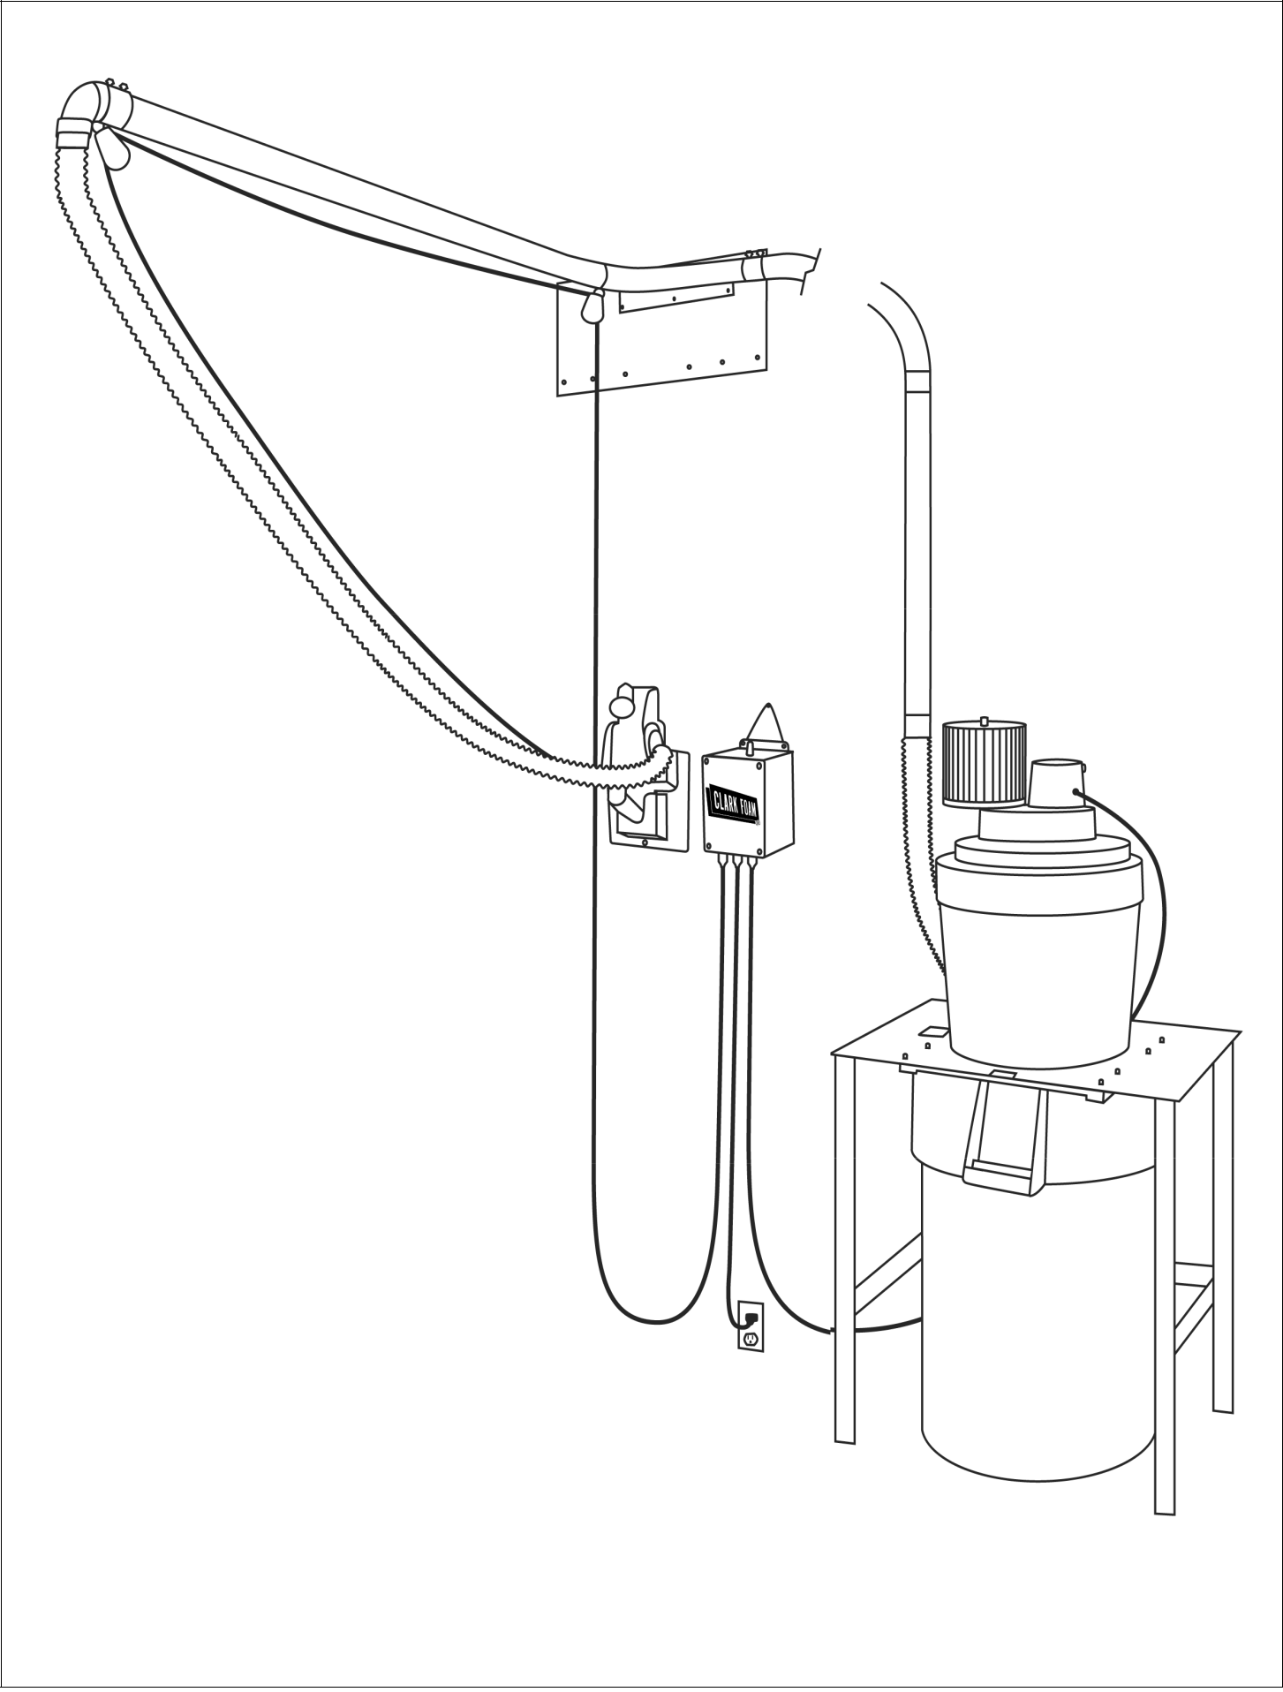

94
MULTI BOARD BOXES

WITH BOX ENDS

All sizes on this sheet are normally stocked, as well as staplers and other packaging materials.

 |  |  |  |  | INSIDE DIMENSIONS
BOX SIZE: |  |  | LENGTH |  |  | WIDTH |  | HEIGHT
1. | 7’0" | 6’10" |  | (2.08m) | 25" | (63.5cm) | 12" | (30.5cm)
2. | 8’4" | 8'2" |  | (2.49m) | 25" | (63.5cm) | 12" | (30.5cm)
3. | 8’10" |  | 8’8" | (2.64m) | 24" | (61.0cm) | 14" | (35.5cm)
4. | 9’6" | 9'4" |  | (2.84m) | 25" | (63.5cm) | 12" | (30.5cm)
5. | 10’8" | 10'6" |  | (3.32m) | 26" | (76.2cm) | 14" | (35.5cm)
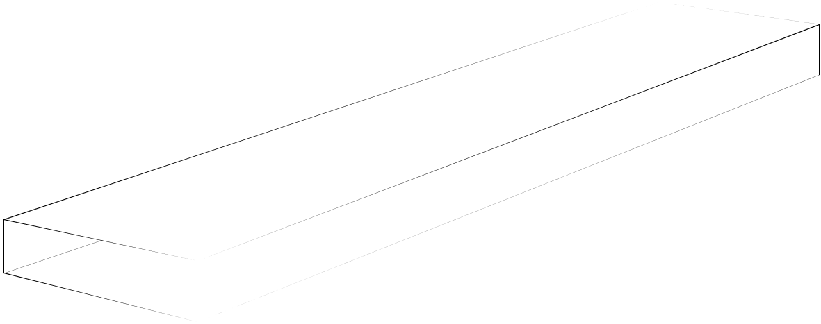

SINGLE OR TWO BOARD BOXES

WITH BOX ENDS

 |  |  |  |  | INSIDE DIMENSIONS
BOX SIZE: |  |  | LENGTH |  | WIDTH |  |  | HEIGHT
1. | 6'10* (UPS) |  | 6’8" | (2.07m) | 19" | (48.2cm) | 5" | (12.7cm)
2. | 8'0" |  | 7'10" | (2.39m) | 22" | (15.2cm) | 6" | (15.2cm)
3. | 10’6" |  | 10’4" | (3.15m) | 24" | (61.0cm) | 8" | (20.3cm)
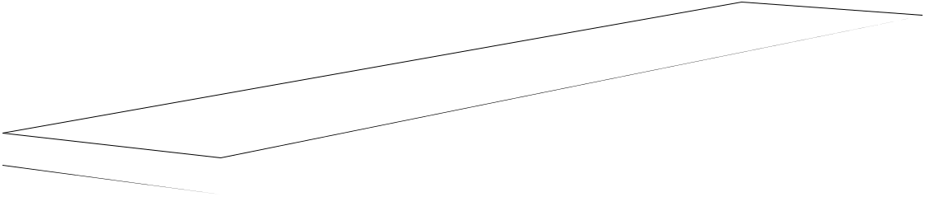

95

