Republic of the Philippines Department of Education Region V - Bicol

Division of Legazpi City Legazpi District 5

BIGAA ELEMENTARY SCHOOL
Bigaa, Legazpi City

CERTIFICATE OF EMPLOYMENT
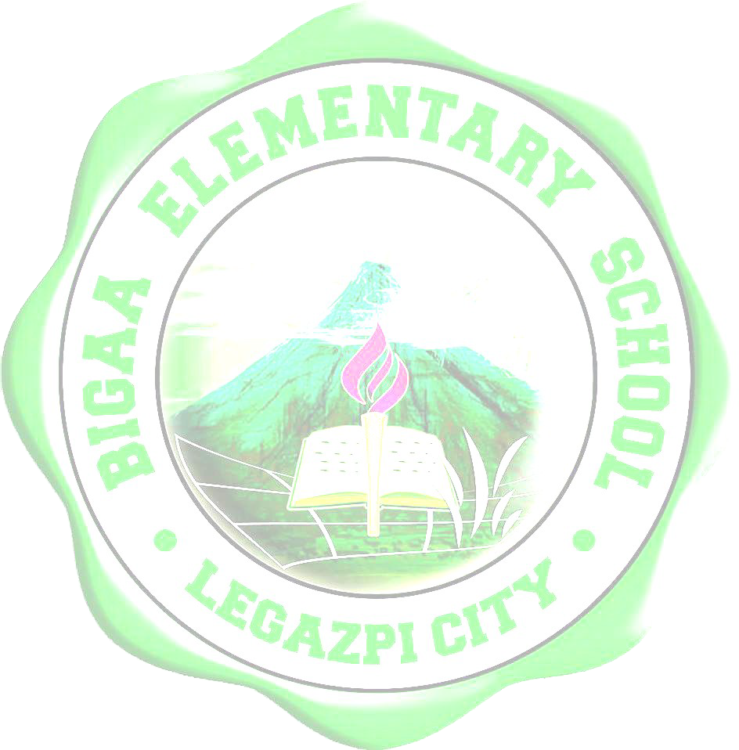

To Whom It May Concern:
This is to certify that Ms. Salvacion G. Losantas has been employed with Department of Education, Legazpi City Division as Teacher III from July 1, 1974 to present.
This certification is being issued upon his/ her request for record purposes.

RIVERA, CESO V

Superintendent

CECILLE BERNADETTE P.

Schools Division

