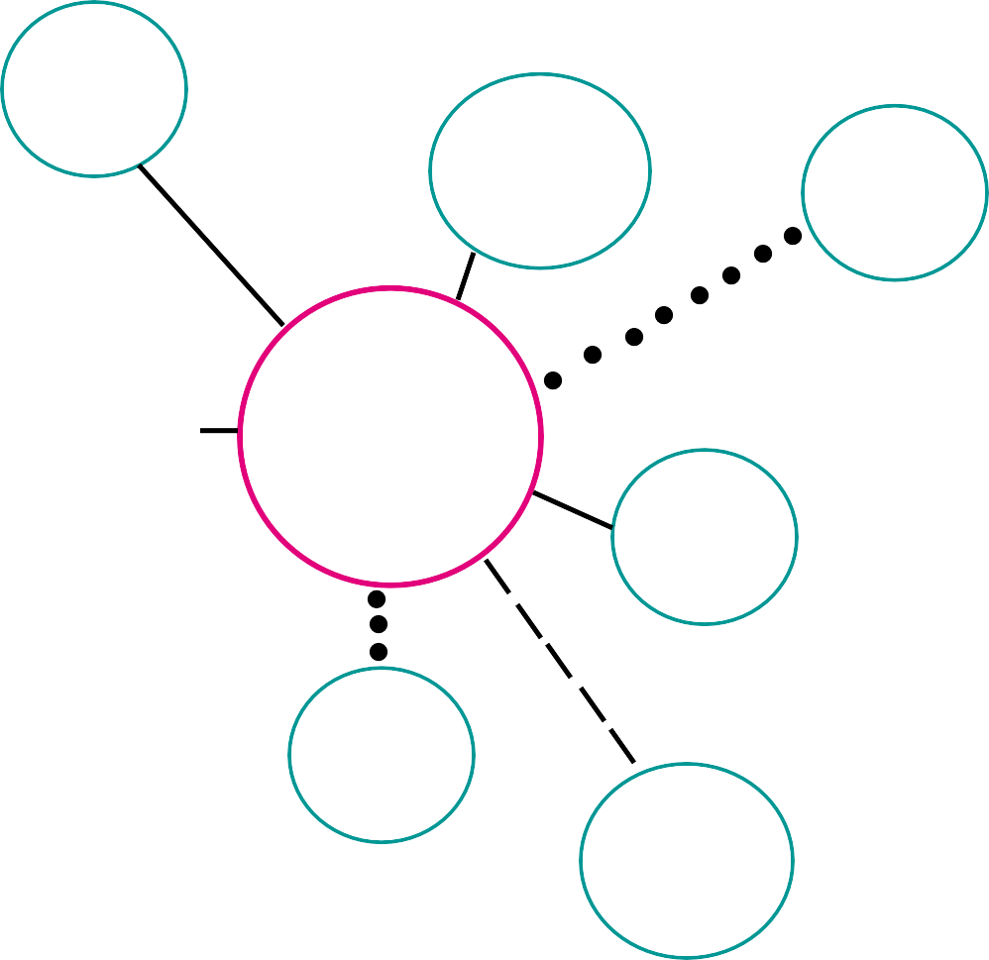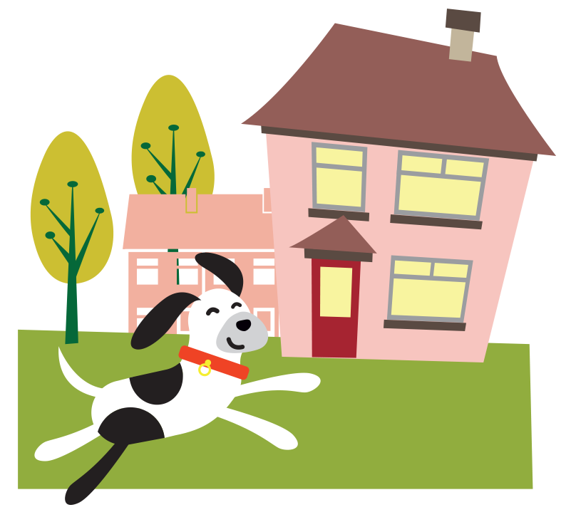

4. When working with children it is preferable to use moveable objects to represent their ecomap.

The child can then move them around to indicate what their feelings are and how they may change. This is similar to sculpting exercises.

Depending upon the age of the child it may take two sessions to complete the Ecomap. At the end of

the exercise make sure the child or young person is able to have a copy of their Ecomap.

This can change over time therefore you may wish to repeat the process during your time with the

child or young person.

**Example Ecomap**

**Youth**

**Group**

**Grandma**

**School**

**Dad**

**Child**

**Friends**

**Mum**

**Counsellor**

*Page 2 - Practitioner’s Tool Kit*

*Leeds Safeguarding Children Partnership*

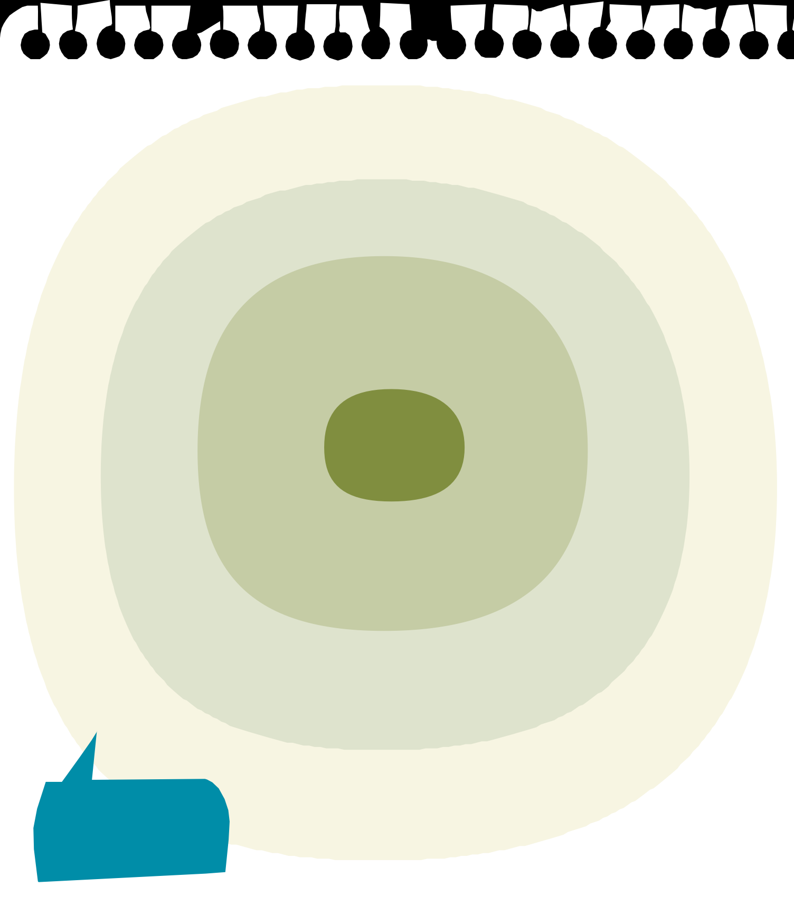

Who

are the

important

people in your life?

Think of all the relationships that you have. Put the names of those closest to you in the inner circle, the names of the next closest people in the next circle, and so on until you have put down everyone that you want to.

Who is closest to you?

me

*name*

Would you like us to talk to any of these people?

What are their names?