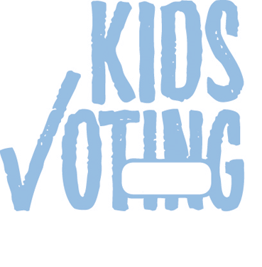

**Kids Voting Prior Lake- Savage Schools November 4, 2014 Ballot**

SCHOOL BOARD ISD 719 (PRIOR LAKE)

To fill vacancy in term expiring Jan. 2, 2017 (VOTE FOR ONE)

Melissa Bednarek Enger

`

` **Write-in, if any**

U.S. REPRESENTATIVE DISTRICT 2

(VOTE FOR ONE)

Paula Overby

*Independence*

`

John Kline

*Republican*

`

Mike Obermueller

*Democratic-Farmer-Labor*

`

SCHOOL BOARD ISD 719 (PRIOR LAKE)

(VOTE FOR UP TO FOUR)

Ben Hanson

`

Richard Wolf

`

Todd Sorensen

`

Stacey Ruelle

`

SECRETARY OF STATE (VOTE FOR ONE)

Bob Helland

*Independence*

`

Dan Severson

*Republican*

`

**Steve Simon** *Democratic-Farmer- Labor*

`

Bob Odden

*Libertarian Party*

`

` **Write-in, if any**

ATTORNEY GENERAL (VOTE FOR ONE)

Brandon Borgos

*Independence*

`

Scott Newman

*Republican*

`

**Lori Swanson** *Democratic-Farmer- Labor*

`

Andy Dawkins

*Green Party*

`

Mary O’Connor

*Libertarian Party*

`

Dan R. Vacek

*Legal Marijuana Now*

`

` **Write-in, if any**

STATE AUDITOR (VOTE FOR ONE)

Patrick Dean

*Independence*

`

Randy Gilbert

*Republican*

`

**Rebecca Otto** *Democratic-Farmer- Labor*

`

Keegan Iversen

*Libertarian Party*

`

**Judith Schwartzbacker** *Grassroots-Legalize Cannabis*

`

` **Write-in, if any**

GOVERNOR AND LIEUTENANT GOVERNOR (VOTE FOR ONE TEAM)

**Hannah Nicollet/ Tim Gieseke** *Independence*

`

**Jeff Johnson/ Bill Kuisle** *Republican*

`

**Mark Dayton/ Tina Smith** *Democratic-Farmer- Labor*

`

**Chris Holbrook/ Chris Dock** *Libertarian Party*

`

**Chris Wright/ David Daniels** *Grassroots-Legalize Cannabis*

`

` **Write-in, if any**

UNITED STATES SENATOR (VOTE FOR ONE)

Steve Carlson

*Independence*

`

Mike McFadden

*Republican*

`

**Al Franken** *Democratic-Farmer- Labor*

`

Heather Johnson

*Libertarian Party*

`

` **Write-in, if any**

**MARKING INSTRUCTIONS**

IMPORTANT: USE A #2 PENCIL OR THE MARKING PENCIL PROVIDED. DO NOT USE INK OF

ANY COLOR. To vote for the candidate of your choice, completely fill in the circle BELOW each candidate’s name like this: ~

**School**

**Grade**

0

0

0

0

1

1

1

1

2

2

2

2

3

3

3

3

4

4

4

4

5

5

5

5

6

6

6

6

7

7

7

7

8

8

8

8

9

9

9

9

º

¡

™