

Product Catalog

© 2013 Best Medical International, Inc.

Best Medical International, Inc. 7643 Fullerton Road, Springfield, Virginia 22153 USA Tel: 703-451-2378 800-336-4970 Fax: 703-451-5228 www.bestmedical.com

BMI_CATALOG_Complete_v22_12122016_web



Best Medical can provide any standard or customized configuration made to your exact specifications, sterile or non-sterile, shipped within 24 hours — worldwide!

Contact us:


Best Medical International

7643 Fullerton Road

Springfield, Virginia 22153 USA

Tel: 703-451-2378 • 800-336-4970

Fax: 703-451-5228

www.bestmedical.com • www.teambest.com

Best Medical International, Inc. 7643 Fullerton Road, Springfield, Virginia 22153 USA
2 Tel: 703-451-2378 800-336-4970 Fax: 703-451-5228 www.bestmedical.com



Mission Statement

Everyone deserves the best health care. Our goal is to work with medical

fessionals to provide the Best oducts and services. As a
ader in innovative technology, ur mission is to uphold our

eputation for excellence in the health care field by developing, manufacturing, and delivering ost-effective, high quality roducts to benefit patients

ound the world.

rporate Values

Fulfilling our mission requires a dedicated employee team—one that is

committed to uncompromised quality and safety, and fostering a sense of pride in the company.

Best employees will:

- Honor the dignity and uniqueness of each person, including fellow employees, customers, distributors, and vendors, through their actions, words, and behavior. They will treat others with respect, as they would wish to be treated.

- Embrace the spirit of cooperation and teamwork for which Best Medical is known, an environment which supports and recognizes effort and results.

- Promote and practice open and honest communication at all times.

- Listen to others and remain open to suggestions at all times, as we focus on achieving excellence in our work.

- Attract and retain leaders with exceptional abilities and integrity.

- Ensure all resources are managed in a responsible and effective manner.


© 2013 Best Medical International, Inc.

3

Best
ADVANTAGE


- Best Medical International is the ONLY supplier of Iridium-192 and Gold-198 seeds.

- We are the first and only provider of Iridium-192 in nylon ribbons in a wide range of activities.

- We are the first and only company to provide custom service for Gold-198 permanent implants, as well as a wide range of activities.

- We are the first and only company that will call our customers the morning after shipping to inform them of mode of transportation and expected arrival time.

- We can supply Ir-192, Au-198, Pd-103, I-125 and Brachytherapy accessories on a single Purchase Order.

- We ship most materials within 24 hours of receipt of the order.

Best Medical International, Inc. 7643 Fullerton Road, Springfield, Virginia 22153 USA Tel: 703-451-2378 800-336-4970 Fax: 703-451-5228 www.bestmedical.com

Catalog 2013 Table of Contents

Afterloading Catheters & Buttons

Nylon Afterloading Tubes. . . . . . . . . . . . . . . . . . . . . . . . . . . . . . . . . . . . . . . . . . . . . . . . . . . . . . . . . . . . . . . . . 1

Buttons. . . . . . . . . . . . . . . . . . . . . . . . . . . . . . . . . . . . . . . . . . . . . . . . . . . . . . . . . . . . . . . . . . . . . . . . . . . . . . 3

Bronchial Tube . . . . . . . . . . . . . . . . . . . . . . . . . . . . . . . . . . . . . . . . . . . . . . . . . . . . . . . . . . . . . . . . . . . . . . . . 5

Esophageal Applicator (Single Tube) . . . . . . . . . . . . . . . . . . . . . . . . . . . . . . . . . . . . . . . . . . . . . . . . . . . . . . . . 7

HDR Remote Afterloading Accessories . . . . . . . . . . . . . . . . . . . . . . . . . . . . . . . . . . . . . . . . . . . . . . . . . . . . . . 8

Applicators

Round-Handle Fletcher-Suit-Delclos Applicator Set (640R) . . . . . . . . . . . . . . . . . . . . . . . . . . . . . . . . . . . . . . . 10 Round Handle Fletcher-Suit-Delclos Applicator Set with Bracket (640RB) . . . . . . . . . . . . . . . . . . . . . . . . . . . . 11 Fletcher-Suit-Delclos Mini-Ovoid Applicator Set (640M) . . . . . . . . . . . . . . . . . . . . . . . . . . . . . . . . . . . . . . . . . 12 Delclos Mini-Ovoid Applicator Set with Bracket Assembly (640MRB) . . . . . . . . . . . . . . . . . . . . . . . . . . . . . . . . 13 Burnett Afterload Vaginal Applicator (700A) . . . . . . . . . . . . . . . . . . . . . . . . . . . . . . . . . . . . . . . . . . . . . . . . . . . 14 Delclos Uterine/Vaginal Afterloading Applicator and Dome Assembly (670) . . . . . . . . . . . . . . . . . . . . . . . . . . . 15 Dummy Sources (Cesium) . . . . . . . . . . . . . . . . . . . . . . . . . . . . . . . . . . . . . . . . . . . . . . . . . . . . . . . . . . . . . . . . 16 Mick® 200-TPV Applicator Kit . . . . . . . . . . . . . . . . . . . . . . . . . . . . . . . . . . . . . . . . . . . . . . . . . . . . . . . . . . . . . 17 Ordering Information: Optional Instrumentation and Accessories . . . . . . . . . . . . . . . . . . . . . . . . . . . . . . . . . . . 18

Brachytherapy Kits

Interstitial Implant Instrument Set . . . . . . . . . . . . . . . . . . . . . . . . . . . . . . . . . . . . . . . . . . . . . . . . . . . . . . . . . . 19

Brachytherapy Kit . . . . . . . . . . . . . . . . . . . . . . . . . . . . . . . . . . . . . . . . . . . . . . . . . . . . . . . . . . . . . . . . . . . . . . 20

Sterile Brachytherapy Kits . . . . . . . . . . . . . . . . . . . . . . . . . . . . . . . . . . . . . . . . . . . . . . . . . . . . . . . . . . . . . . . . 21

Brain Implant Kit . . . . . . . . . . . . . . . . . . . . . . . . . . . . . . . . . . . . . . . . . . . . . . . . . . . . . . . . . . . . . . . . . . . . . . . 23

(Continued on next page)

© 2013 Best Medical International, Inc.

Brachytherapy Needles

Best Mick Type Needles . . . . . . . . . . . . . . . . . . . . . . . . . . . . . . . . . . . . . . . . . . . . . . . . . . . . . . . . . . . . . . . . . 24

Best Prostate Seeding Needles . . . . . . . . . . . . . . . . . . . . . . . . . . . . . . . . . . . . . . . . . . . . . . . . . . . . . . . . . . . . 25

Prostate Stabilization Set Needles. . . . . . . . . . . . . . . . . . . . . . . . . . . . . . . . . . . . . . . . . . . . . . . . . . . . . . . . . . 26

Needles . . . . . . . . . . . . . . . . . . . . . . . . . . . . . . . . . . . . . . . . . . . . . . . . . . . . . . . . . . . . . . . . . . . . . . . . . . . . . 27

Dummy Ribbons

Nylon and Cable Dummy Ribbons . . . . . . . . . . . . . . . . . . . . . . . . . . . . . . . . . . . . . . . . . . . . . . . . . . . . . . . . . . 28

Flexi-Needles

Flexi-Needles . . . . . . . . . . . . . . . . . . . . . . . . . . . . . . . . . . . . . . . . . . . . . . . . . . . . . . . . . . . . . . . . . . . . . . . . . 29

Flexi-Needle Combinations . . . . . . . . . . . . . . . . . . . . . . . . . . . . . . . . . . . . . . . . . . . . . . . . . . . . . . . . . . . . . . . 30

Sterile Flexi-Needles . . . . . . . . . . . . . . . . . . . . . . . . . . . . . . . . . . . . . . . . . . . . . . . . . . . . . . . . . . . . . . . . . . . . 35

Gold Fiducial Markers & Marker Kits

Marker Kit/Gold Fiducial Markers . . . . . . . . . . . . . . . . . . . . . . . . . . . . . . . . . . . . . . . . . . . . . . . . . . . . . . . . . . 40

Sterile Loose Gold Markers with Forceps . . . . . . . . . . . . . . . . . . . . . . . . . . . . . . . . . . . . . . . . . . . . . . . . . . . . 41

Sterile Loose Stainless Steel Markers with Forceps. . . . . . . . . . . . . . . . . . . . . . . . . . . . . . . . . . . . . . . . . . . . . 41

Sterile Iodine Dummy Sources in a Vial . . . . . . . . . . . . . . . . . . . . . . . . . . . . . . . . . . . . . . . . . . . . . . . . . . . . . . 41

Sterile Fiducial Marker Kits • 18 GAUGE • 0.8 mm OD
- 10 cm Long Needles . . . . . . . . . . . . . . . . . . . . . . . . . . . . . . . . . . . . . . . . . . . . . . . . . . . . . . . . . . . . . . . . . . 42 - 15 cm Long Needles . . . . . . . . . . . . . . . . . . . . . . . . . . . . . . . . . . . . . . . . . . . . . . . . . . . . . . . . . . . . . . . . . . 43 - 20 cm Long Needles . . . . . . . . . . . . . . . . . . . . . . . . . . . . . . . . . . . . . . . . . . . . . . . . . . . . . . . . . . . . . . . . . . 43 - 30 cm Long Needles . . . . . . . . . . . . . . . . . . . . . . . . . . . . . . . . . . . . . . . . . . . . . . . . . . . . . . . . . . . . . . . . . . 44

Sterile Fiducial Marker Kits • 18 GAUGE • 1.0 mm OD
- 10 cm Long Needles . . . . . . . . . . . . . . . . . . . . . . . . . . . . . . . . . . . . . . . . . . . . . . . . . . . . . . . . . . . . . . . . . . 45 - 15 cm Long Needles . . . . . . . . . . . . . . . . . . . . . . . . . . . . . . . . . . . . . . . . . . . . . . . . . . . . . . . . . . . . . . . . . . 46 - 20 cm Long Needles . . . . . . . . . . . . . . . . . . . . . . . . . . . . . . . . . . . . . . . . . . . . . . . . . . . . . . . . . . . . . . . . . . 47 - 30 cm Long Needles . . . . . . . . . . . . . . . . . . . . . . . . . . . . . . . . . . . . . . . . . . . . . . . . . . . . . . . . . . . . . . . . . . 48

(Continued on next page)

Best Medical International, Inc. 7643 Fullerton Road, Springfield, Virginia 22153 USA Tel: 703-451-2378 800-336-4970 Fax: 703-451-5228 www.bestmedical.com

Sterile Fiducial Marker Kits • 17 GAUGE • 1.2 mm OD
- 20 cm Long Needles . . . . . . . . . . . . . . . . . . . . . . . . . . . . . . . . . . . . . . . . . . . . . . . . . . . . . . . . . . . . . . . . . . 49 - 30 cm Long Needles . . . . . . . . . . . . . . . . . . . . . . . . . . . . . . . . . . . . . . . . . . . . . . . . . . . . . . . . . . . . . . . . . . 50

Sterile Fiducial Marker STRAND Kits • 18 GAUGE • 0.8 mm OD
- 10 cm Long Needles . . . . . . . . . . . . . . . . . . . . . . . . . . . . . . . . . . . . . . . . . . . . . . . . . . . . . . . . . . . . . . . . . . 51 - 15 cm Long Needles . . . . . . . . . . . . . . . . . . . . . . . . . . . . . . . . . . . . . . . . . . . . . . . . . . . . . . . . . . . . . . . . . . 52 - 20 cm Long Needles . . . . . . . . . . . . . . . . . . . . . . . . . . . . . . . . . . . . . . . . . . . . . . . . . . . . . . . . . . . . . . . . . . 53

Sterile Fiducial Marker STRAND Kits • 17 GAUGE • 0.8 mm OD
- 30 cm Long Needles . . . . . . . . . . . . . . . . . . . . . . . . . . . . . . . . . . . . . . . . . . . . . . . . . . . . . . . . . . . . . . . . . . 54

Sterile Fiducial Marker STRAND Kits • 17 GAUGE • 1.0 mm OD
- 10 cm Long Needles . . . . . . . . . . . . . . . . . . . . . . . . . . . . . . . . . . . . . . . . . . . . . . . . . . . . . . . . . . . . . . . . . . 55 - 20 cm Long Needles . . . . . . . . . . . . . . . . . . . . . . . . . . . . . . . . . . . . . . . . . . . . . . . . . . . . . . . . . . . . . . . . . . 56

Sterile Fiducial Marker STRAND Kits • 16 GAUGE • 1.2 mm OD
- 20 cm Long Needles . . . . . . . . . . . . . . . . . . . . . . . . . . . . . . . . . . . . . . . . . . . . . . . . . . . . . . . . . . . . . . . . . . 57

Sterile ROUND HUB Needles with Marker Strand & Iodine Dummy Seed • 18 GAUGE • 0.8 mm OD

- 10 cm Long Needles . . . . . . . . . . . . . . . . . . . . . . . . . . . . . . . . . . . . . . . . . . . . . . . . . . . . . . . . . . . . . . . . . . 58 - 15 cm Long Needles . . . . . . . . . . . . . . . . . . . . . . . . . . . . . . . . . . . . . . . . . . . . . . . . . . . . . . . . . . . . . . . . . . 58 - 20 cm Long Needles . . . . . . . . . . . . . . . . . . . . . . . . . . . . . . . . . . . . . . . . . . . . . . . . . . . . . . . . . . . . . . . . . . 59

Sterile SQUARE HUB Needles with Marker Strand & Iodine Dummy Seed • 18 GAUGE • 0.8 mm OD

- 10 cm Long Needles . . . . . . . . . . . . . . . . . . . . . . . . . . . . . . . . . . . . . . . . . . . . . . . . . . . . . . . . . . . . . . . . . . 60 - 15 cm Long Needles . . . . . . . . . . . . . . . . . . . . . . . . . . . . . . . . . . . . . . . . . . . . . . . . . . . . . . . . . . . . . . . . . . 60 - 20 cm Long Needles . . . . . . . . . . . . . . . . . . . . . . . . . . . . . . . . . . . . . . . . . . . . . . . . . . . . . . . . . . . . . . . . . . 61

Sterile Fiducial Marker with SPACERS Kits • 18 GAUGE • 0.8 mm OD
- 20 cm Long Needles . . . . . . . . . . . . . . . . . . . . . . . . . . . . . . . . . . . . . . . . . . . . . . . . . . . . . . . . . . . . . . . . . . 62

Sterile Fiducial Marker with SPACERS Kits • 18 GAUGE • 1.0 mm OD
- 20 cm Long Needles . . . . . . . . . . . . . . . . . . . . . . . . . . . . . . . . . . . . . . . . . . . . . . . . . . . . . . . . . . . . . . . . . . 63

Sterile Fiducial Marker with SPACERS Kits • 17 GAUGE • 1.2 mm OD
- 20 cm Long Needles . . . . . . . . . . . . . . . . . . . . . . . . . . . . . . . . . . . . . . . . . . . . . . . . . . . . . . . . . . . . . . . . . . 64

Non-Sterile Loose Gold Markers with Forceps. . . . . . . . . . . . . . . . . . . . . . . . . . . . . . . . . . . . . . . . . . . . . . . . . 65

Rectal Marker Kit with Anus Marker . . . . . . . . . . . . . . . . . . . . . . . . . . . . . . . . . . . . . . . . . . . . . . . . . . . . . . . . 66

Anderson Marker Kit . . . . . . . . . . . . . . . . . . . . . . . . . . . . . . . . . . . . . . . . . . . . . . . . . . . . . . . . . . . . . . . . . . . . 67

Adjustable Marker Kit . . . . . . . . . . . . . . . . . . . . . . . . . . . . . . . . . . . . . . . . . . . . . . . . . . . . . . . . . . . . . . . . . . . 67

Stainless Steel Markers . . . . . . . . . . . . . . . . . . . . . . . . . . . . . . . . . . . . . . . . . . . . . . . . . . . . . . . . . . . . . . . . . 67

(Continued on next page)

© 2013 Best Medical International, Inc.

Radioactive Seeds

Best® Iodine-125 and Best® Palladium-103 Sources . . . . . . . . . . . . . . . . . . . . . . . . . . . . . . . . . . . . . . . . . . . . 68 Breast Localization Needles with Iodine-125 Seeds . . . . . . . . . . . . . . . . . . . . . . . . . . . . . . . . . . . . . . . . . . . . 69 Sterile & Non-Sterile Seed Products . . . . . . . . . . . . . . . . . . . . . . . . . . . . . . . . . . . . . . . . . . . . . . . . . . . . . . . . 70 Iridium-192 and Gold-198 Information . . . . . . . . . . . . . . . . . . . . . . . . . . . . . . . . . . . . . . . . . . . . . . . . . . . . . . 72 Flood Sources. . . . . . . . . . . . . . . . . . . . . . . . . . . . . . . . . . . . . . . . . . . . . . . . . . . . . . . . . . . . . . . . . . . . . . . . . 73 Dose Calibrator Vials . . . . . . . . . . . . . . . . . . . . . . . . . . . . . . . . . . . . . . . . . . . . . . . . . . . . . . . . . . . . . . . . . . . . 75 Markers and Rulers . . . . . . . . . . . . . . . . . . . . . . . . . . . . . . . . . . . . . . . . . . . . . . . . . . . . . . . . . . . . . . . . . . . . 75

Stainless Steel Needles

Implant Needles . . . . . . . . . . . . . . . . . . . . . . . . . . . . . . . . . . . . . . . . . . . . . . . . . . . . . . . . . . . . . . . . . . . . . . . 76

Curved Needles . . . . . . . . . . . . . . . . . . . . . . . . . . . . . . . . . . . . . . . . . . . . . . . . . . . . . . . . . . . . . . . . . . . . . . . 77

Template Needles With Funnel and Cap . . . . . . . . . . . . . . . . . . . . . . . . . . . . . . . . . . . . . . . . . . . . . . . . . . . . . 78

Template Needles . . . . . . . . . . . . . . . . . . . . . . . . . . . . . . . . . . . . . . . . . . . . . . . . . . . . . . . . . . . . . . . . . . . . . . 79

Needle Implanters. . . . . . . . . . . . . . . . . . . . . . . . . . . . . . . . . . . . . . . . . . . . . . . . . . . . . . . . . . . . . . . . . . . . . . 80

Diddler-Needle Adjustment Tool . . . . . . . . . . . . . . . . . . . . . . . . . . . . . . . . . . . . . . . . . . . . . . . . . . . . . . . . . . . 81

(Continued on next page)

Best Medical International, Inc. 7643 Fullerton Road, Springfield, Virginia 22153 USA Tel: 703-451-2378 800-336-4970 Fax: 703-451-5228 www.bestmedical.com

Templates

Syed/Neblett Gyn Template #1/Kit . . . . . . . . . . . . . . . . . . . . . . . . . . . . . . . . . . . . . . . . . . . . . . . . . . . . . . . . . . 82

Syed/Neblett Gyn Template #2/Kit . . . . . . . . . . . . . . . . . . . . . . . . . . . . . . . . . . . . . . . . . . . . . . . . . . . . . . . . . . 83

Syed/Neblett Gyn Template #3/Kit . . . . . . . . . . . . . . . . . . . . . . . . . . . . . . . . . . . . . . . . . . . . . . . . . . . . . . . . . . 84

Syed/Neblett Prostate Template/Kit . . . . . . . . . . . . . . . . . . . . . . . . . . . . . . . . . . . . . . . . . . . . . . . . . . . . . . . . . 85

Syed/Neblett Rectal Template/Kit . . . . . . . . . . . . . . . . . . . . . . . . . . . . . . . . . . . . . . . . . . . . . . . . . . . . . . . . . . 86

Syed/Neblett Urethral Template/Kit . . . . . . . . . . . . . . . . . . . . . . . . . . . . . . . . . . . . . . . . . . . . . . . . . . . . . . . . . 87

Disposable Gyn Template/Kit. . . . . . . . . . . . . . . . . . . . . . . . . . . . . . . . . . . . . . . . . . . . . . . . . . . . . . . . . . . . . . 88

Disposable Prostate Template (with Needle Hole) . . . . . . . . . . . . . . . . . . . . . . . . . . . . . . . . . . . . . . . . . . . . . . 90

Disposable Prostate Template (with Small Hole) . . . . . . . . . . . . . . . . . . . . . . . . . . . . . . . . . . . . . . . . . . . . . . . 91

Disposable Rectal Template . . . . . . . . . . . . . . . . . . . . . . . . . . . . . . . . . . . . . . . . . . . . . . . . . . . . . . . . . . . . . . 92

Templates (B&K) . . . . . . . . . . . . . . . . . . . . . . . . . . . . . . . . . . . . . . . . . . . . . . . . . . . . . . . . . . . . . . . . . . . . . . . 94

© 2013 Best Medical International, Inc.

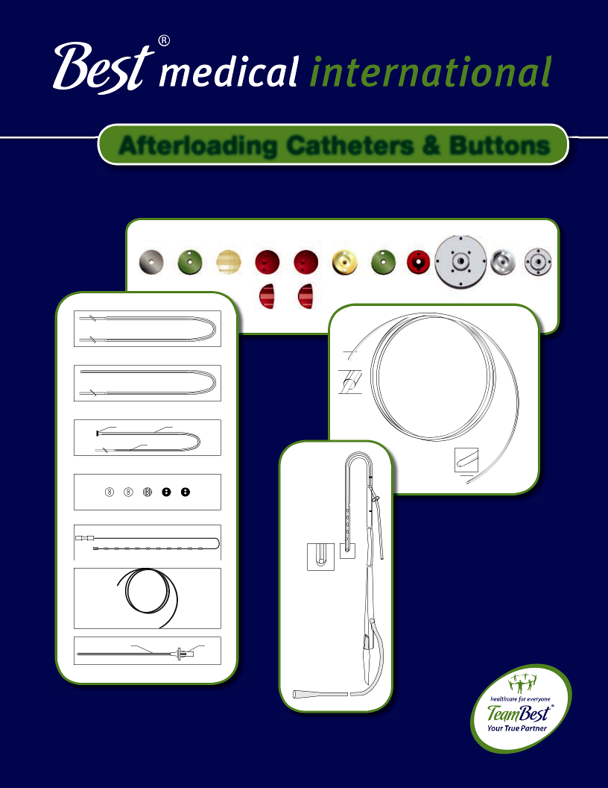

Afterloading Catheters & Buttons

Radiopaque Button Catheter

Filament

Closed-End Catheter Stylet

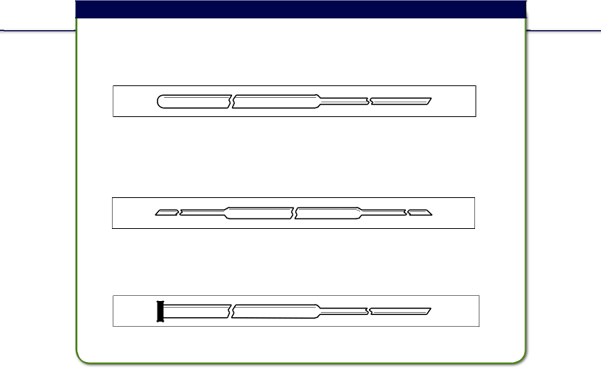
Nylon Afterloading Tubes

The Nylon Afterloading Tubes are of different types: Single Leader, Double

Leader, and G.B. Technique Tube [Outer Diameter: 0.065”; Inner Diameter: 0.051”]

Single Leader Tube Part # 180-30 Sterile Part # 1099

This tube is of 16G and will have a leader at one end so as to thread through the implant needle. Standard length of these tubes are 30 cm and leader 30 cm. One end of this tube is closed. This tube is also known as Blind End Tube.

Double Leader Tube Part # 184-30 Sterile Part # 1101

This tube is the same as Single Leader, but with leaders on both ends.
The length of the tube is 30 cm and both leaders measure 30 cm each.

Single Leader G.B. Tech Tube Part # 187-30 Sterile Part # 1103

This 16G Single Leader Tube has a fl at end closed and will have a fl at or half moon button at the end. Other end will have 30 cm leader.

Above Tubes Are Also Available Sterile With:

Custom lengths and diameters with Filament, Cable, or Cable Dummy Ribbon.


Part # | Description
962 | V Source Catheters in a Pouch
1074 | 0.061” G.B. Catheters with Cable in a Pouch | (quantity of 5)
1094 | 0.065” G.B. Catheters with Cable in a Pouch | (quantity of 5)
1155 | 1.9 mm Polyacetyl G.B. Catheter without Filament in a Pouch
 | (quantity of 5)
1195 | 1.9 mm Polyacetyl G.B. Catheter with Filament in a Pouch
 | (quantity of 5)
1198 | 1.9 mm Polyacetyl G.B. Catheter with Cable in a Pouch
 | (quantity of 5)

continues on next page
!Catheters are for one time use only.

CAUTION: This product should be carefully inspected by your staff prior to clinical use and should be used by authorized personnel only.

© 2013 Best Medical International, Inc.

1
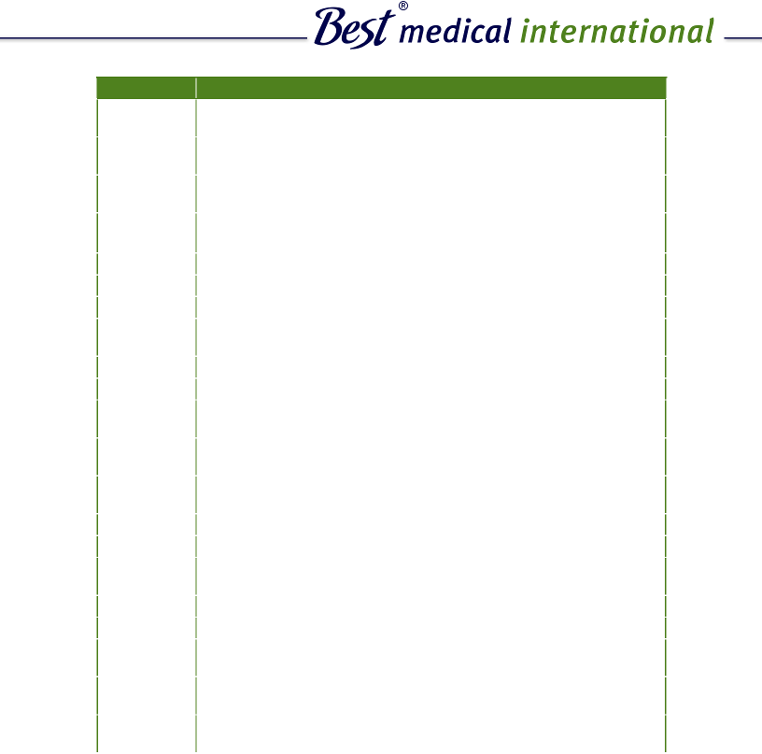

Part # | Description
1342 | 1.7 mm O.D. Blind End Catheters with Marking in a Pouch
 | (quantity of 5)
1345 | 1.7 mm O.D. Double Leader Catheters with Marking in a Pouch
 | (quantity of 5)
1348 | 1.7 mm O.D. G.B.T. Catheters with Marking in a Pouch
 | (quantity of 5)
1411 | 0.065” O.D. Single Leader Catheter with Luer Lock in a Pouch
 | (quantity of 5)
1415 | 13G Blind End Catheter with Male Connector in a Pouch
1426 | Varisource Connecting Tube in a Pouch
1495 | Nylon Filament in a Pouch
1497 | 1.7 mm O.D. After Loading Double Leader Catheters with
 | Cables in a Pouch
1502 | Brain Implant Kit
1506 | Five Colors of 0.065” O.D. Blind End Catheters in a Pouch
1716 | Single Leader Catheter 0.078” O.D. with Luer Lock & Button in a
 | Pouch (quantity of 5)
1727 | 1.8 mm O.D. G.B.T. Catheters with Filament in a Pouch
 | (quantity of 5)
1733 | 1.7 mm O.D. Blind End Catheters with Filament in a Pouch
 | (quantity of 5)
1742 | Buttons in a Pouch
1780 | 0.061” Blind End Catheters with Cable in a Pouch
1782 | 1.9 mm O.D. G.B.T. Catheters with Filament and Marking in a
 | Pouch (quantity of 5)
1793 | 0.078” O.D. with Male Luer Lock on Both Ends in a Pouch
1796 | 0.078” O.D. with Male & Female Luer Lock on the Ends in a Pouch
1807 | 0.065” O.D. Blind End Catheters with Cable in a Pouch
 | (quantity of 5)
1825 | 1.9 mm O.D. Blind End Catheters with Markings in a Pouch
 | (quantity of 5)
1834 | 0.068” Closed End Tube with Female Luer Lock & Markings
 | in a Pouch

!

2

Catheters are for one time use only.

CAUTION: This product should be carefully inspected by your staff prior to clinical use and should be used by authorized personnel only.

Best Medical International, Inc. 7643 Fullerton Road, Springfield, Virginia 22153 USA Tel: 703-451-2378 800-336-4970 Fax: 703-451-5228 www.bestmedical.com

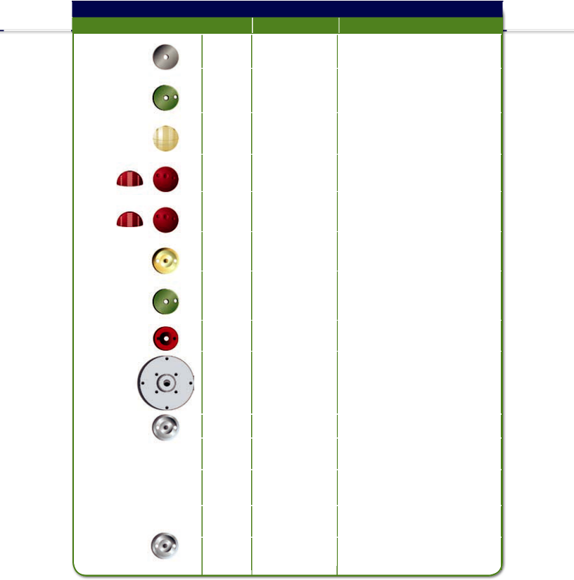 | Buttons
 |  | Part # Sterile Part # |  | Discription
 | 494 |  |  | Flat Tungsten
 | 208 |  | 1078 | Flat Nylon
 | 240 |  | 1673 | Full Moon Nylon
 | 312 |  | 1111 | Half Moon Nylon
 | 242 |  | 1109 | Half Moon Radiopaque
 | 239 |  |  | Aluminum
 | 221 |  | 1107 | Flat Radiopaque
 | 244 |  | 1625 | Flat Countersink
 | 300 |  | 1865 | Flat Large Flexible
 | 238 |  | 1080 | Flat Stainless Steel
 | 238-1 |  |  | Non-sterile Stainless Steel
 |  |  |  | Buttons in a Bag (1.6 mm)
 | 238-2 |  |  | Non-sterile Stainless Steel
 |  |  |  | Buttons in a Bag (1.7 mm)
 | 238-3 |  |  | Non-sterile Stainless Steel
 |  |  |  | Buttons in a Bag (1.9 mm)
! | 301 |  | 1863 | Flat Small Flexible
! | Different hole sizes are available. |  |  | continues on next page

CAUTION: This product should be carefully inspected by your staff prior to clinical use and should be used by authorized personnel only.

© 2013 Best Medical International, Inc.

3


Part # | Description
1138 | Colored Radiopaque Half Moon Buttons in Pouch (1.6 mm)
1140 | Colored Radiopaque Half Moon Buttons in Pouch (1.7 mm)
1142 | Colored Radiopaque Half Moon Buttons in Pouch (1.9 mm)
1489 | Colored Nylon Half Moon Buttons in Pouch (1.6 mm)
1491 | Colored Nylon Half Moon Buttons in Pouch (1.7 mm)
1493 | Colored Nylon Half Moon Buttons in Pouch (1.9 mm)
1680 | Colored Radiopaque Flat Buttons in Pouch (1.6 mm)
1682 | Colored Radiopaque Flat Buttons in Pouch (1.7 mm)
1684 | Colored Radiopaque Flat Buttons in Pouch (1.8 mm)
1686 | Colored Radiopaque Flat Buttons in Pouch (1.9 mm)
1688 | Colored Nylon Flat Buttons in Pouch (1.6 mm)
1690 | Colored Nylon Flat Buttons in Pouch (1.7 mm)
1692 | Colored Nylon Flat Buttons in Pouch (1.9 mm)
1747 | Colored Radiopaque Countersunk Buttons in a Pouch (1.9 mm)
1787 | Nylon Flat Countersunk Buttons in a Pouch
1790 | Colored Nylon Countersunk Buttons in a Pouch (1.9 mm)

!

4

CAUTION: This product should be carefully inspected by your staff prior to clinical use and should be used by authorized personnel only.

Best Medical International, Inc. 7643 Fullerton Road, Springfield, Virginia 22153 USA Tel: 703-451-2378 800-336-4970 Fax: 703-451-5228 www.bestmedical.com

Bronchial Tube
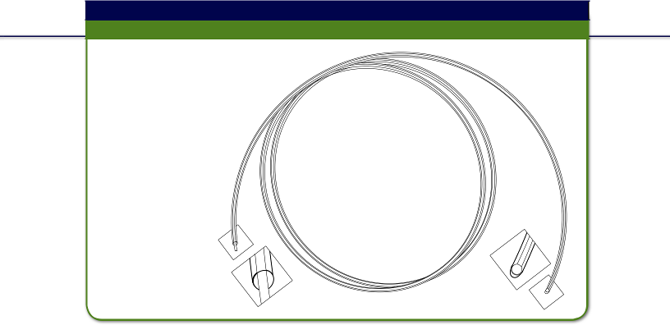Custom lengths and different OD/ID also available.

Part # 191-; Part # 192-; Part #518-

Discription: This tube is
closed at one end with a
cable throughout and a
marker at the closed
end. The cable enables
the tube to take the
curvature when
it is pushed in,
without kinking.
The marker is to
show position of
the tube in
radiograph. See
below for list of
available lengths

and diameters.


Part # | Product
791 | Nylon Bronchial Tube 120 cm 1.7 mm O.D. (sterile)
191-120 | Nylon Bronchial Tube 120 cm 1.7 mm O.D. (non-sterile)
191-150 | Nylon Bronchial Tube 150 cm 1.7 mm O.D. (non-sterile)
191-180 | Nylon Bronchial Tube 180 cm 1.7 mm O.D. (non-sterile)
191-240 | Nylon Bronchial Tube 240 cm 1.7 mm O.D. (non-sterile)
191-300 | Nylon Bronchial Tube 300 cm 1.7 mm O.D. (non-sterile)
1082 | Nylon Bronchial Tube 120 cm 1.8 mm O.D. (sterile)
518-120 | Nylon Bronchial Tube 120 cm 1.8 mm O.D. (non-sterile)
518-150 | Nylon Bronchial Tube 150 cm 1.8 mm O.D. (non-sterile)
518-180 | Nylon Bronchial Tube 180 cm 1.8 mm O.D. (non-sterile)
518-240 | Nylon Bronchial Tube 240 cm 1.8 mm O.D. (non-sterile)
518-300 | Nylon Bronchial Tube 300 cm 1.8 mm O.D. (non-sterile)
793 | Nylon Bronchial Tube 120 cm 1.9 mm O.D. (sterile)
192-120 | Nylon Bronchial Tube 120 cm 1.9 mm O.D. (non-sterile)

continues on next page

!CAUTION: This product should be carefully inspected by your staff prior to clinical use and should be used by authorized personnel only.

© 2013 Best Medical International, Inc.

5


Part # | Description
192-150 | Nylon Bronchial Tube 150 cm 1.9 mm O.D. (non-sterile)
192-180 | Nylon Bronchial Tube 180 cm 1.9 mm O.D. (non-sterile)
192-240 | Nylon Bronchial Tube 240 cm 1.9 mm O.D. (non-sterile)
192-300 | Nylon Bronchial Tube 300 cm 1.9 mm O.D. (non-sterile)
1044 | Bronchial Catheter 0.061” in a Pouch
1134 | Bronchial Catheter, Clear 0.078” O.D. (1.9 mm) in a Pouch
1153 | Bronchial Catheter 0.065” O.D. in a Pouch
1772 | 0.065” O.D. Bronchial Catheter with Gold Marker & S.S. Ball
 | in a Pouch
1785 | 0.068” O.D. Bronchial Catheter with Female Luer Lock in a Pouch
1520 | Marked Polyacetyl 1.8 mm O.D. Bronchial Catheter in a Pouch
1523 | Marked 0.065” O.D. Bronchial Catheter in a Pouch
1465 | Marked 0.078” O.D. Bronchial Catheter in a Pouch
1517 | Polyacetyl 0.072” O.D. Bronchial Catheter in a Pouch

!

6

CAUTION: This product should be carefully inspected by your staff prior to clinical use and should be used by authorized personnel only.

Best Medical International, Inc. 7643 Fullerton Road, Springfield, Virginia 22153 USA Tel: 703-451-2378 800-336-4970 Fax: 703-451-5228 www.bestmedical.com

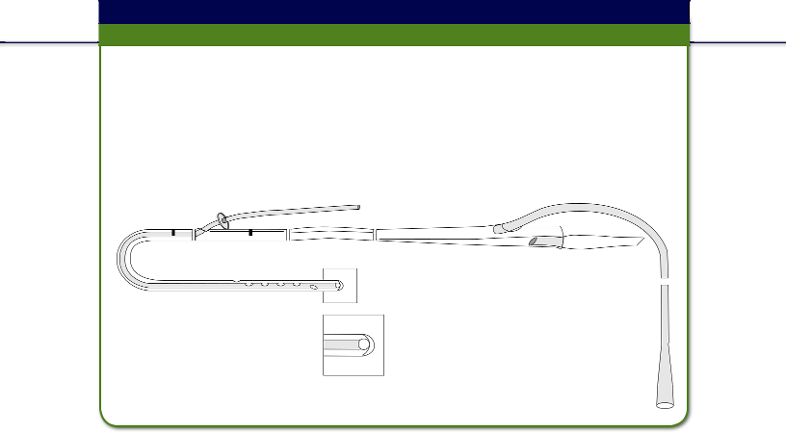
Esophageal Applicator (single tube)

Part # 287-1

Discription: The Esophageal Applicator is a Nasogastric (NG) tube modifi ed to have one additional afterloading tube in one of the lumens. The afterloading tube is closed at one end and enters through a hole made at 60 cm from the bottom of the NG tube and reaches up to the bottom. A small stainless steel ball is kept at theclosed end for checking the position of the tube in the radiograph. A stainless steel button is slid onto the afterloading tube nearer to the open end for suturing to skin.

References:

Intraluminal Radiation for Esophageal Cancer: A Howard University Technique. Chitti R. Moorthy, J. Rao Nibhanupudy, Ebrahim Ashayeri, Alfred L. Goldson, Maria C. Espinoza, Joseph J. Nidiry, Oswald G. Warner and Vincent J. Roux.

“Journal of the National Medical Association, Vol. 74, No. 3, 1982”, Pages 261-266.

!This product is for one time use only.
CAUTION: This product should be carefully inspected by your staff prior to clinical use and should be used by authorized personnel only.

© 2013 Best Medical International, Inc.

7




HDR Remote Afterloading
Accessories

Double Leader Catheter

with Filament

Part #
542-30 1.7 mm O.D. (non-sterile)

1148 1.7 mm O.D. (sterile)
522-30 1.8 mm O.D. (non-sterile)

186-30 1.9 mm O.D. (non-sterile)

1252 1.9 mm O.D. (sterile)


Single Leader, Blind End

Catheter with Filament

Part #

538-30 | 1.7 mm O.D. (non-sterile)
1146 | 1.7 mm O.D. (sterile)
564-30 | 1.8 mm O.D. (non-sterile)
1733 | 1.8 mm O.D. (sterile)
182-30 | 1.9 mm O.D. (non-sterile)
1092 | 1.9 mm O.D. (sterile)


GB Tech Tube with

Button and Filament

Part #
616-30 1.7 mm O.D. (non-sterile)

1150 1.7 mm O.D. (sterile)
633-30 1.8 mm O.D. (non-sterile)

1727 1.8 mm O.D. (sterile)
190-30 1.9 mm O.D. (non-sterile)

1105 1.9 mm O.D. (sterile)

Discription: The Best Afterloading Catheters are indicated for use in HDR brachytherapy procedures.
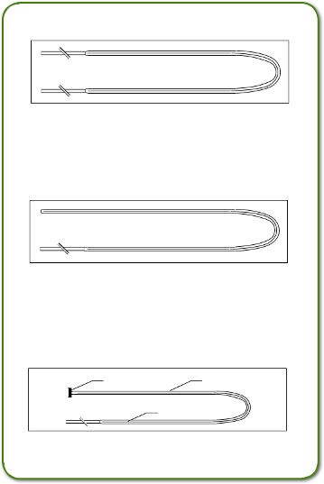

Radiopaque Button Catheter

Filament

- CAUTION: This product should be carefully inspected by your staff prior to clinical use and should be used by authorized personnel only.

Best Medical International, Inc. 7643 Fullerton Road, Springfield, Virginia 22153 USA
8 Tel: 703-451-2378 800-336-4970 Fax: 703-451-5228 www.bestmedical.com

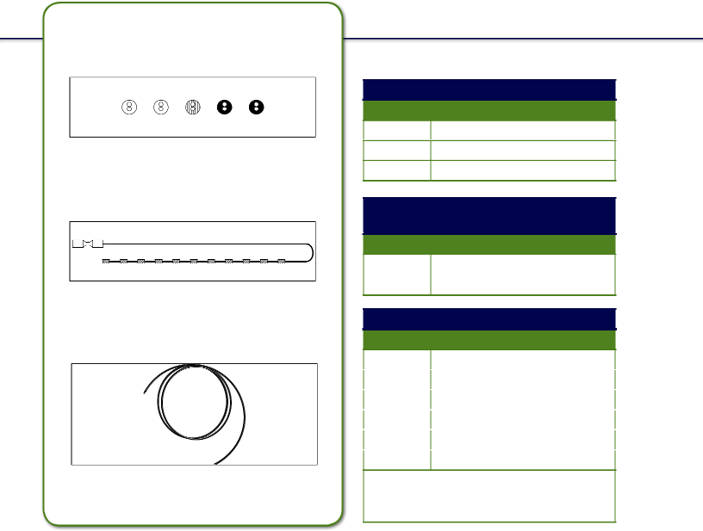

Radiopaque Buttons

Part #

244-1 1.7 mm hole

244-2 1.8 mm hole

244-3 1.9 mm hole

X-Ray Catheter (cable

dummy ribbon)

Part #

530 X-Ray Catheter (cable dummy ribbon)

Nylon Bronchial Catheter Part #

191 | 1.7 mm O.D. (non-sterile)
791 | 1.7 mm O.D. (sterile)
518 | 1.8 mm O.D. (non-sterile)
1082 | 1.8 mm O.D. (sterile)
192 | 1.9 mm O.D. (non-sterile)
793 | 1.9 mm O.D. (sterile)

All catheters are available in custom lengths, with or without cable/cable dummy ribbon.

!CAUTION: This product should be carefully inspected by your staff prior to clinical use and should be used by authorized personnel only.
© 2013 Best Medical International, Inc.

9

g

Applicators
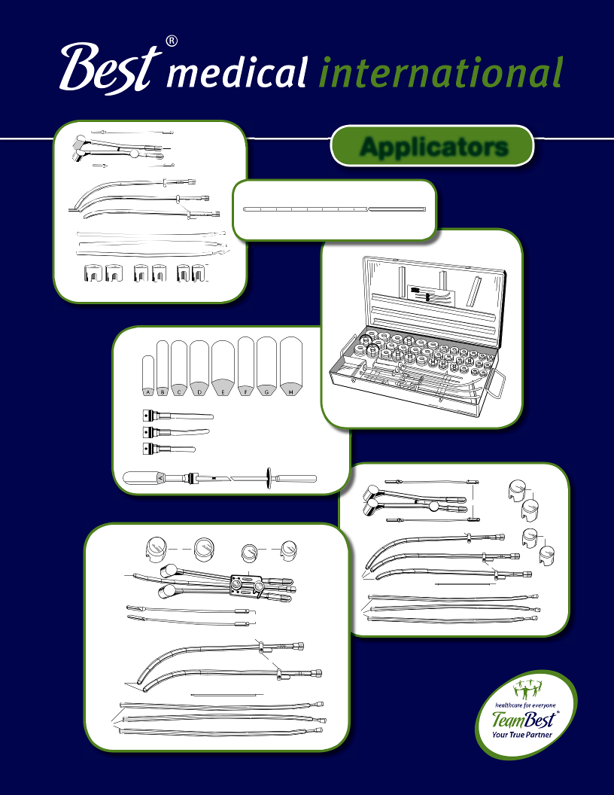

 | b
a |  |  |  |  | b
 |  |  |  |  |  |  |  |  |  |  | Dummy Source |  | Spacer
 |  |  | d
 |  |  |  |  |  |  |  |  | c
 |  |  |  |  |  |  | *Optional
 |  |  |  |  |  |  | parts not
 |  |  |  |  |  |  | included in
 |  |  |  |  |  |  | set

 |  | h
 | e | f
 |  | b
 |  | g
i | h
 | f | b
a | a
 | a | i

g

b

c

b

a

d

c


Round-Handle Fletcher-Suit-Delclos Applicator Set (640R)

Part # 5005-0082

Set Contains:

3 (a) Central Tandems

3 (b) Cervical Stops (1 with fl ag, 2 without fl ag)

3 (c) Plastic Tandems and Pushers

1 (d) Storage/Sterilization Tray (not shown)

1 (e) Pair Colpostat w

2 ( f) Bucket Type Source Carriers

1 (g) Pair Nylon Caps 2.5 cm Diameter for Ovoids

1 (h) Pair Nylon Caps 3.0 cm Diameter for Ovoids

1 (i) Allen Wrench
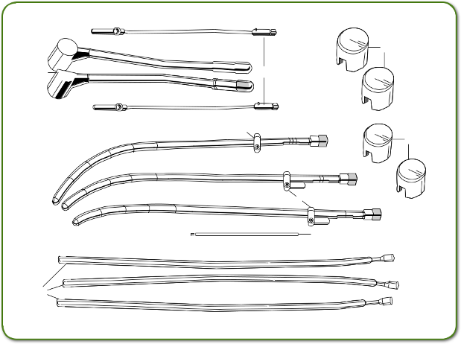

e  f

b

h

g

b

a

i

c

!CAUTION: This product should be carefully inspected by your staff prior to clinical use and should be used by authorized personnel only.
© 2013 Best Medical International, Inc.

10

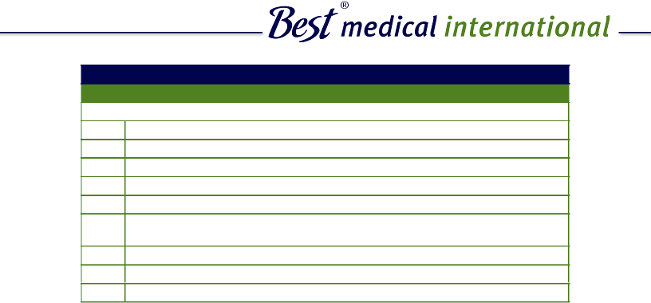

Round Handle Fletcher-Suit-Delclos Applicator Set with Bracket (640RB)

Part # 5005-0083

Set Contains:

3 | (a) | Central Tandems
3 | (b) | Cervical Stops (1 with fl ag, 2 without fl ag)
3 | (c) | Plastic Tandems and Pushers
2 | (d) | Allen Wrenches)
1 | (e) | Storage/Sterilization Tray (not shown)
1 | (f) | Pair Colpostat with Bracket (to hold central tandem along
 |  | with colpostat and also to separate the ovoids)
1 | (g) Pair Bucket Type Source Carriers
1 | (h) Pair Nylon Caps 2.5 cm Diameter for Ovoids
1 | (i) | Pair Nylon Caps 3.0 cm Diameter for Ovoids
 |  | i | h
 |  | f
 | a
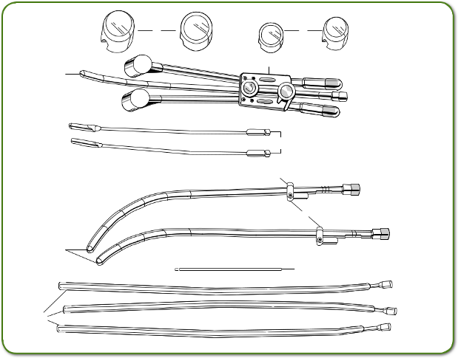

g

b

b

a

d

- CAUTION:^{c}This product should be carefully inspected by your staff prior to clinical use and should be used by authorized personnel only.

Best Medical International, Inc. 7643 Fullerton Road, Springfield, Virginia 22153 USA
11 Tel: 703-451-2378 800-336-4970 Fax: 703-451-5228 www.bestmedical.com

Fletcher-Suit-Delclos Mini-Ovoid Applicator Set (640M)

Part # 5005-0084

Set Contains:

3 | (a) | Central Tandems
3 | (b) | Cervical Stops (1 with fl ag, 2 without fl ag)
3 | (c) | Plastic Tandems and Pushers
1 | (d) | Allen Wrench
1 | (e) | Storage/Sterilization Tray (not shown)
1 | ( f) | Pair Colpostat
2 | (g) | Bucket Type Source Carriers
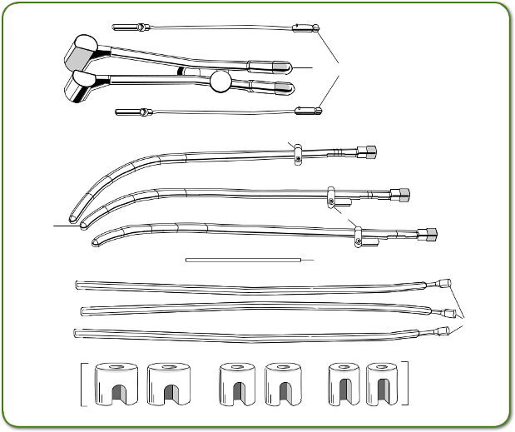

f g

b

b
a

d

c

*Optional

parts not

included in

set

* Optional: Shielded Caps 2 cm, 2.5 cm, 3 cm Diameters.

!CAUTION: This product should be carefully inspected by your staff prior to clinical use and should be used by authorized personnel only.
© 2013 Best Medical International, Inc.

12


Delclos Mini-Ovoid Applicator Set with Bracket Assembly (640MRB)

Part # 5005-0085

Set Contains:

3 | (a) | Central Tandems
3 | (b) | Cervical Stops (1 with fl ag, 2 without fl ag)
3 | (c) | Plastic Tandems and Pushers
2 | (d) | Allen Wrenches
1 | (e) | Storage/Sterilization Tray (not shown)
1 | (f) | Pair Colpostat with Bracket
2 | (g) | Bucket Type Source Carriers
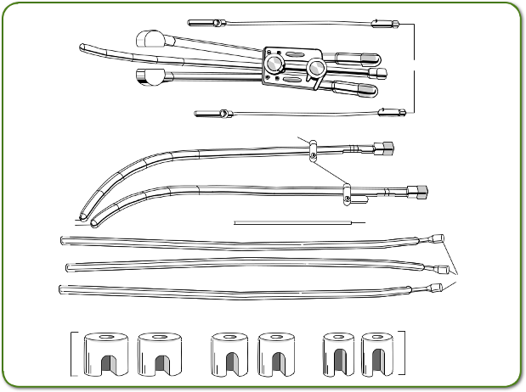

f

a

g

b

b

a | d

c

*Optional

parts not

included in

set

- * Optional: Shielded Caps 2 cm, 2.5 cm, 3 cm Diameters.CAUTION:Thisproductshouldbecarefullyinspectedbyyourstaffpriortoclinicaluseandshouldbeusedbyauthorizedpersonnelonly.

Best Medical International, Inc. 7643 Fullerton Road, Springfield, Virginia 22153 USA
13 Tel: 703-451-2378 800-336-4970 Fax: 703-451-5228 www.bestmedical.com
Burnett Afterload Vaginal Applicator (700A)
G
30 x 95 mm
H
35 x 95 mm
!CAUTION: This product should be carefully inspected by your staff prior to clinical use and should be used by authorized personnel only.

Part # 5005-0088

Set Contains:
8 Cylon Cylinders

- Plastic tandems with metal screws and special long handle (cap holder) and tube source adapter assembly arranged in a stainless steel tray.
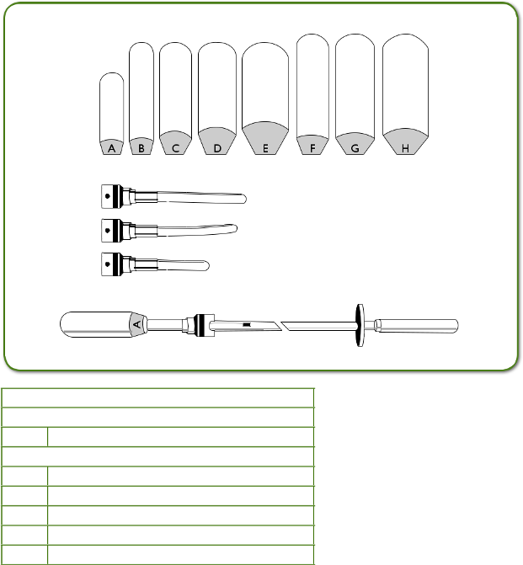

External Dimensions of Cylinders:
A 20 x 66 mm

B 20 x 87 mm
C 25 x 87 mm

D 30 x 87 mm

E 35 x 87 mm

F 25 x 95 mm

© 2013 Best Medical International, Inc.

14


Delclos Uterine/Vaginal Afterloading Applicator and Dome Assembly (670) Part # 5005-0089

Set Contains:

- Sets of Cylinders with Diameters 20 mm, 25 mm, 30 mm, 35 mm, 40 mm and 45 mm
6 Domes (matching cylinder diameters)

3 Uterine Tandems
1 Vaginal Tandem (dome assembly)

1 Vaginal Tandem (with a fl at end)
1 Storage/Sterilization Tray

1 Standard Allen Wrench
1 Extended Allen Wrench

1 Cylinder Extractor
1 Cervical Stop

4 Plastic Tandems and Pushers
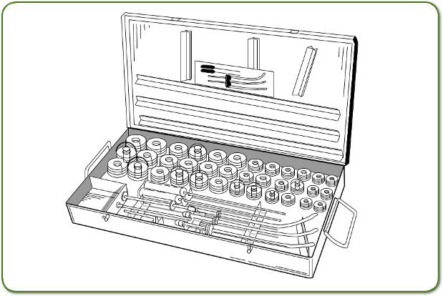

- CAUTION: This product should be carefully inspected by your staff prior to clinical use and should be used by authorized personnel only.

Best Medical International, Inc. 7643 Fullerton Road, Springfield, Virginia 22153 USA
15 Tel: 703-451-2378 800-336-4970 Fax: 703-451-5228 www.bestmedical.com

Dummy Sources (Cesium)

Part # 513-1

These are Dummy Tungsten Sources with a length of 20 mm and a diameter of 3 mm to simulate Cesium sources, arranged with 20 mm long spacers in a plastic tube so as to load conveniently in a central tandem. Because of the high density of Tungsten a better Radiograph is obtained. Custom arrangements of these sources are available.

Four (4) Cesium Dummy Sources Arranged in a Plastic Tube
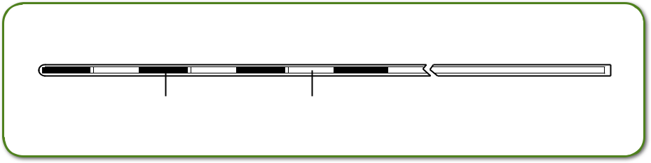

Dummy Source Spacer


Dummy Sources (Cesium)

Part # 513-2

Instead of total length of 20 mm, active length of 14 mm also could be used for loading in plastic tube. Custom arrangements of these are available.

Also Available:
513 Cesium Dummy Sources for 3M Sources

696 Cesium Dummy Sources for Amersham Sources

Other Custom Loadings Available
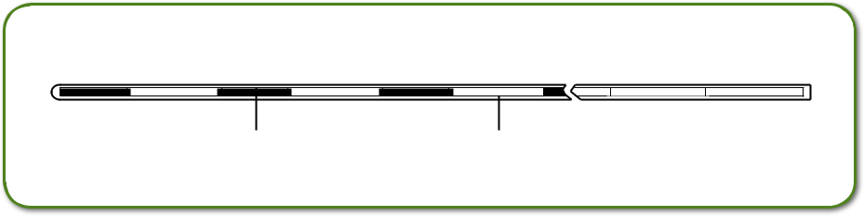

Dummy Source Spacer

!CAUTION: This product should be carefully inspected by your staff prior to clinical use and should be used by authorized personnel only.
© 2013 Best Medical International, Inc.

16
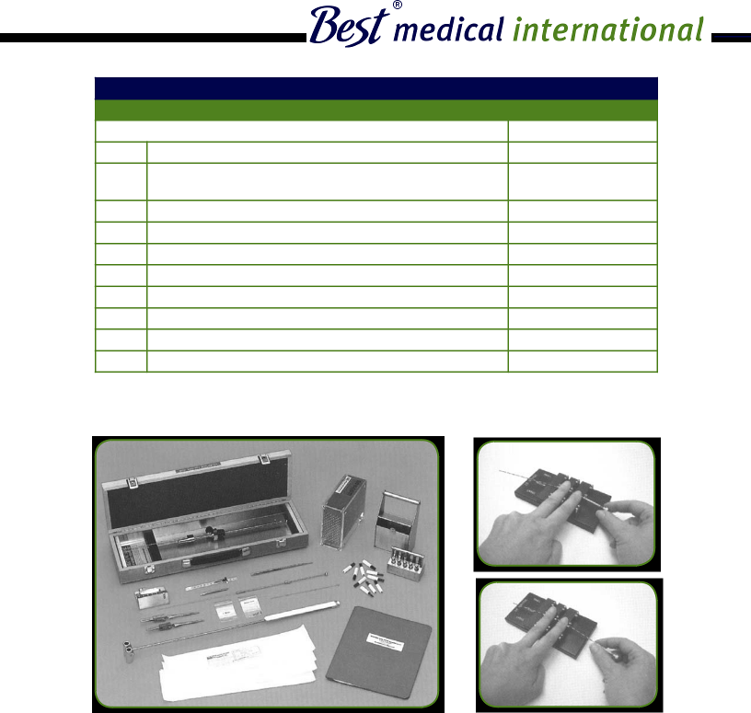Steerable “Authentic” Mick TP Needles!
Circumvent pubic arch interference with the use of the Mick Needle Former.
!CAUTION: This product should be carefully inspected by your staff prior to clinical use and should be used by authorized personnel only.
Best Medical International, Inc. 7643 Fullerton Road, Springfield, Virginia 22153 USA
17
Tel: 703-451-2378 800-336-4970 Fax: 703-451-5228 www.bestmedical.com
1 ea. Mick 200-TPV Applicator (instrument only)
1 ea. 8x Mick TP Needles, 17 or 18 Gauge “Authentic” (carton)
1 ea. Diddler (needle adjustment tool)
1 ea. Seed Loading V-Block with Seed Gauge
1 ea. Pushwire Rod Assembly (spare)
2 ea. Reverse Action Tweezer
1 ea. Loop Wire, 22 cm (needle cleaning device)
1 ea. Stainless Steel Screwdriver/Allen Wrench Combo
1 ea. Sterilization & Storage Cassette
1 ea. Instruction Manual
Part #
5005-9701-1
10203-25 (17G) or
10209-25 (18G)
5002-0010
5005-7509
5005-9707-PW
5002-0009
5005-7702
5005-7311-C
5005-0505
405-06
Mick® 200-TPV Applicator Kit
Part # 5005-9707
Set Includes:

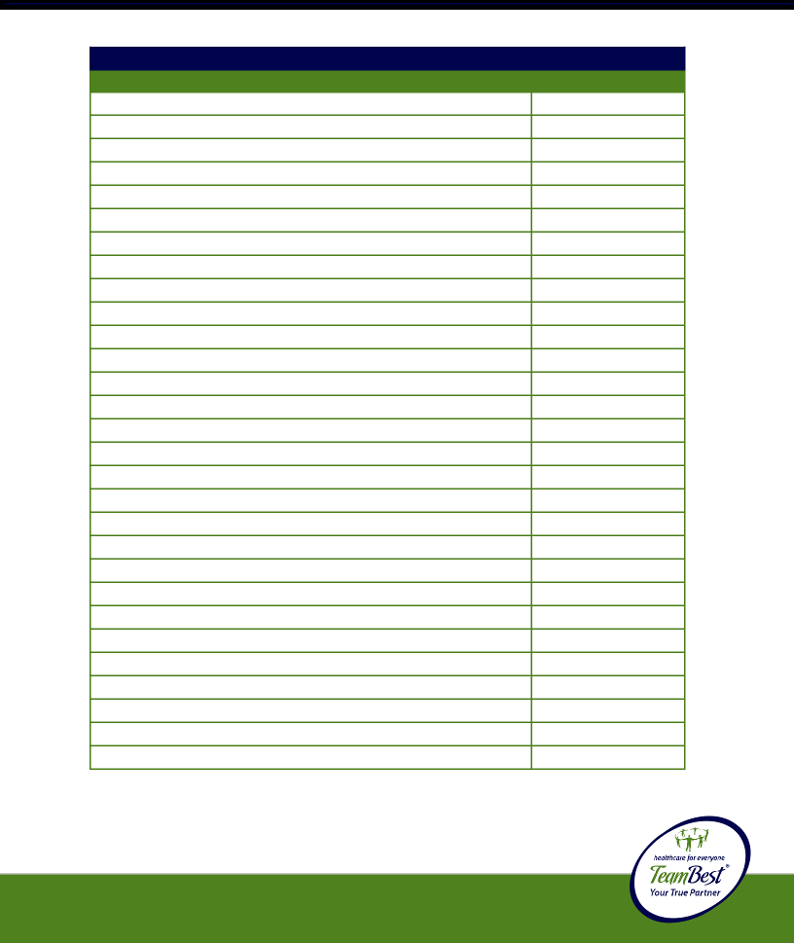!CAUTION: This product should be carefully inspected by your staff prior to clinical use and should be used by authorized personnel only.
5002-0009
5002-0010
5005-8813-17
5005-8813-18
5005-0226
5005-7509
5005-7308-STI
5005-7611
10207
5005-8113-PIP
5005-9512
5005-963ERAD
5005-9609-SP
5005-9609-E
5005-9603-53
5005-7609
10113-7
10209-25
10203-25
5005-9707-PRA
5005-7311-C
5005-1000
5005-FMS
5005-UTMS
1830
5005-5327005
5005-7908-10TH
5005-8212-DS
Reverse Action Tweezer
Diddler (needle adjustment tool)
Transperineal Template – Transparent, 17 Gauge
Transperineal Template – Transparent, 18 Gauge
Mick Needle Former (steerable Mick needles)
V-Block (cartridge seed-loading device)
Stainless Steel Sterilization Tray with Instrument Holder
Wooden Carrying Case
Morgenstern, Stabilizing Needle, 18 Gauge
Practice Phantom with 100 Dummy Seeds
KGM Passer (radiation shielding device)
Inspector (radiation survey meter)
Springs (for magazines)
E-Rings (for magazines)
Prostate Phantom, CIRS
Mick Magazine, Reusable (10 seed capacity)
Mick Magazine, Disposable (15 seed capacity)
Mick TP Needle, 18 Gauge “Authentic”
Mick TP Needle, 17 Gauge “Authentic”
Pushwire Rod Assembly (Mick 200-TPV applicator)
Stainless Steel Allen Wrench/Screwdriver (combination)
Brachystand 6 Ultra for Use with E&K or Siemens Stepper
Sure-Point I (floor mount with Siemens stepper)
Sure-Point II (table mount with Siemens stepper)
Disposable Templates, B&K
Leaded Gloves – Radiation Attenuation Gloves
Ultrasonic Cleaner with Timer and Heater
Stainless Steel Dummy Seeds
Ordering Information: Optional Instrumentation and Accessories
Part # 5005-9707
Product:
Part #

© 2013 Best Medical International, Inc.

18
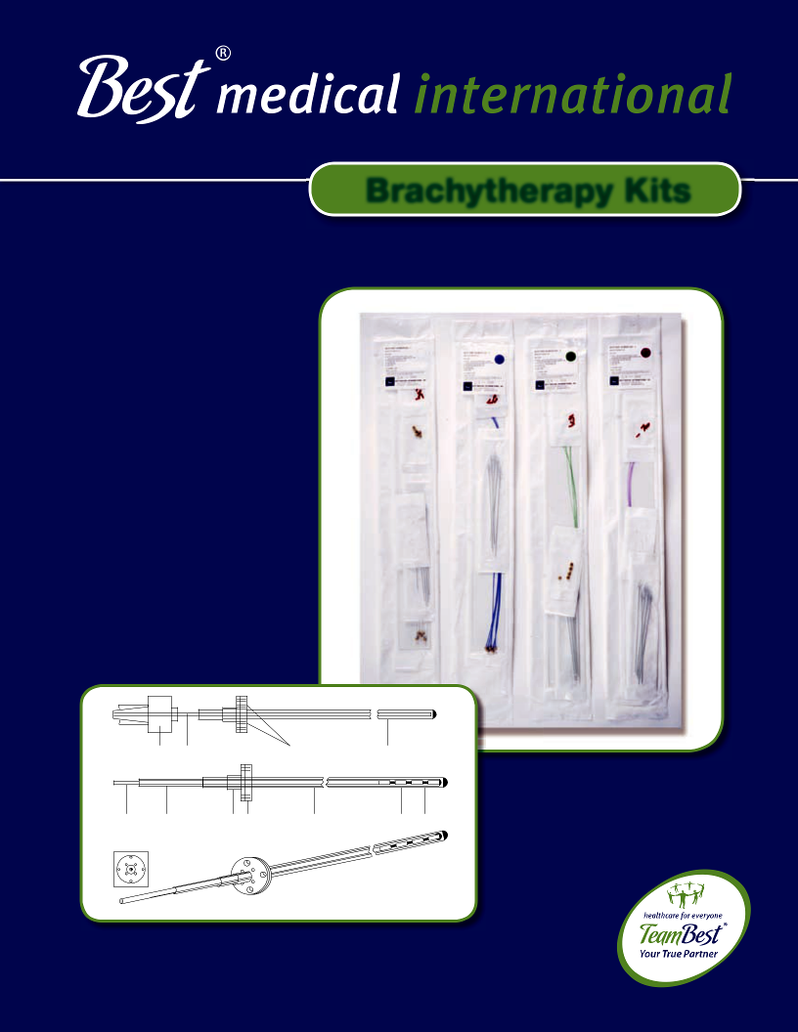

Brachytherapy Kits

Luer Lock Obturator Suture Holes Outer Catheter

Filament Inner Stem Flexible Outer Radioactive Spacer
Catheter Button Catheter Seed

New Flexible Silicone Button with 8 Holes


Interstitial Implant Instrument Set

Part # 1074-0012 (cable dummy ribbon) &

Part # 1074-0013 (nylon dummy ribbon)

Set Contains:

1 | Crile Needle Holder for Crimping Buttons
1 | M.G.H. Needle Holder, 10 inch
1 | Curved Scissors, 10 inch
1 | Special Cutter for Nylon Implant Tubes
10 | Implant Needles, 10 cm Long, 17 Gauge
10 | Implant Needles, 15 cm Long, 17 Gauge
10 | Implant Needles, 20 cm Long, 17 Gauge
10 | Implant Needles, 25 cm Long, 17 Gauge
5 | Implant Needles, 10 cm Long, 14 Gauge
5 | Implant Needles, 15 cm Long, 14 Gauge
5 | Implant Needles, 20 cm Long, 14 Gauge
1 | Iridium Funnel
30 | Nylon Retaining Buttons (Syed)
30 | Stainless Steel Retaining Buttons (Henschke)
15 | Dummy Ribbons with 12 Seeds Each (specify cable or nylon dummy)
20 | Nylon Implant Tubes (double leader)
3 | Stylets
1 | Quick-charge Sealer

© 2013 Best Medical International, Inc.

19
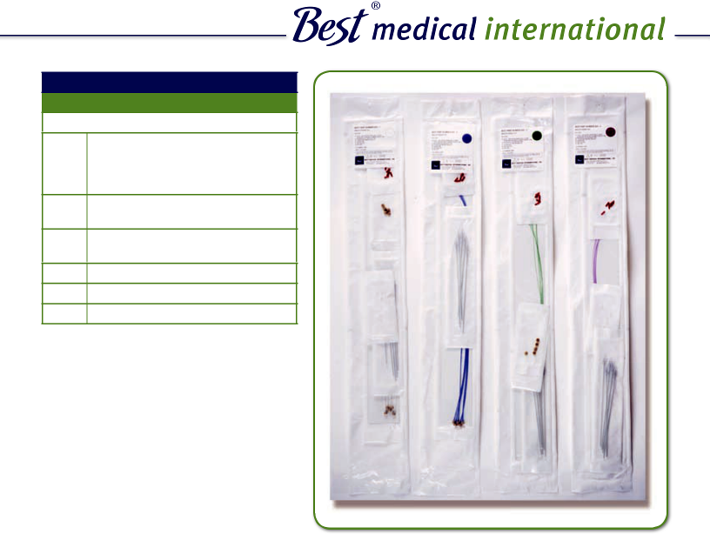

The Best® Brachytherapy Kit Sterile

Consists of:

- 6.0 FR-30 or 5.0 FR-30 cm Afterloading Single Leader Catheters with Filaments and Buttons

- Radiopaque or Clear Nylon Half Moon Buttons

- 17 Gauge or 16 Gauge
20 cm Implant Needles

5 Obturators

5 Friction Cups

5 Red Caps

The catheter tubes are available in four colors (clear, blue, green or purple) and with either radiopaque or clear nylon buttons.

Best Medical International, Inc. 7643 Fullerton Road, Springfield, Virginia 22153 USA
20 Tel: 703-451-2378 800-336-4970 Fax: 703-451-5228 www.bestmedical.com
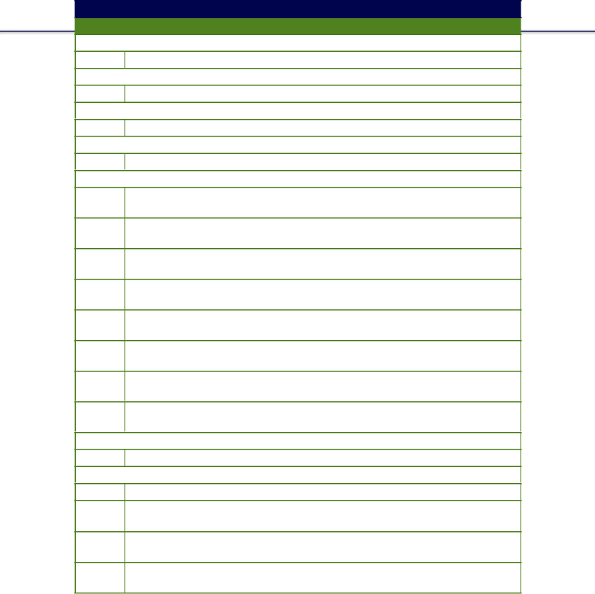
Sterile Brachytherapy Kits

Most Brachytherapy kits are available in four different colors.
Part # Description

829 HDR Brachytherapy Kit with Radiopaque Button and 17 Gauge Needles
848 LDR Brachytherapy Kit with Nylon Button and 17 Gauge Needles

856 LDR Brachytherapy Kit with Radiopaque Button and 17 Gauge Needles
862 HDR Brachytherapy Kit with Nylon Button and 17 Gauge Needles

867 HDR Brachytherapy Kit with Radiopaque Button and 16 Gauge Needles
868 LDR Brachytherapy Kit with Nylon Button and 16 Gauge Needles

870 LDR Brachytherapy Kit with Radiopaque Button and 16 Gauge Needles
872 HDR Brachytherapy Kit with Nylon Button and 16 Gauge Needles

- HDR Brachytherapy Kit without Printing with Radiopaque Button and 17 Gauge Needles

- LDR Brachytherapy Kit without Printing with Nylon Button and 17 Gauge Needles

- LDR Brachytherapy Kit without Printing with Radiopaque Button and 17 Gauge Needles

- HDR Brachytherapy Kit without Printing with Nylon Button and 17 Gauge Needles

- HDR Brachytherapy Kit without Printing with Radiopaque Button and 16 Gauge Needles

- LDR Brachytherapy Kit without Printing with Nylon Button and 16 Gauge Needles

- HDR Brachytherapy Kit without Printing with Nylon Button and 16 Gauge Needles

- LDR Brachytherapy Kit without Printing with Radiopaque Button and 16 Gauge Needles
1202 Polyacetal Brachytherapy Kit

1283 HDR Brachytherapy Kit with Blind End Catheters
1363 Brachytherapy Kit with Radiopaque Buttons, Catheters without Filament

1366 Brachytherapy Kit with Nylon Buttons, Catheters without Filament

1401 Brachytherapy Kit with Radiopaque Buttons and Markings (catheters without fi lament)

1404 Brachytherapy Kit with Nylon Buttons and Markings (catheters without fi laments)

1421 Polyacetal Brachytherapy Kit, Catheter Leaders with Cable and Nylon Buttons

contiues on next page

© 2013 Best Medical International, Inc.

21
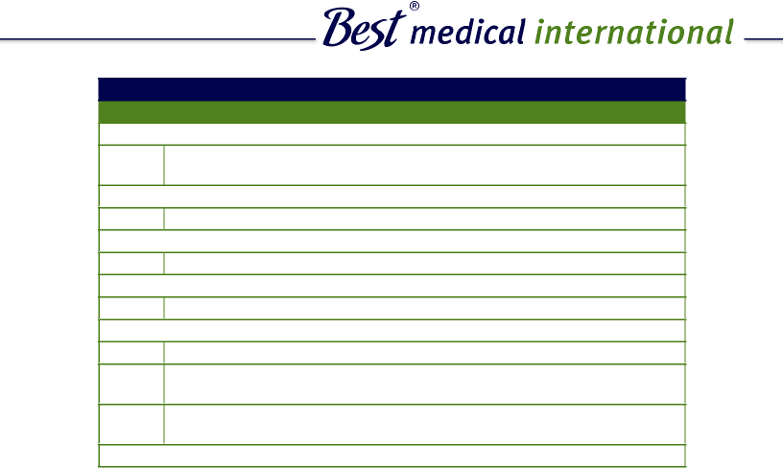

Sterile Brachytherapy Kits (continued)

Most Brachytherapy kits are available in four different colors.
Part # Description

1424 Polyacetal Brachytherapy Kit, Catheter Leaders with Cable and Radiopaque Buttons
1470 13 Gauge Brachytherapy Kit

1480 1.9 mm PA Brachytherapy Kit with Nylon Buttons
1484 1.9 mm PA Brachytherapy Kit with Nylon Buttons and Markings

1487 1.9 mm PA Brachytherapy Kit with Radiopaque Buttons and Markings
1627 HDR Brachytherapy Kit with Blind End Catheters and Nylon Buttons

1630 LDR Blind End Brachytherapy Kit with Nylon Buttons
1632 LDR Blind End Brachytherapy Kit with Radiopaque Buttons

1667 50 cm Brachytherapy Kit with Markings and Nylon Buttons

1702 1.9 mm Polyacetal Brachytherapy Kit with Nylon Buttons and

16 Gauge Needles

1704 1.9 mm Polyacetal Brachytherapy Kit with Radiopaque Buttons and

16 Gauge Needles
1731 Brachytherapy Kit with XX cm Blind End Catheters Radiopaque Buttons

** please specify length

Best Medical International, Inc. 7643 Fullerton Road, Springfield, Virginia 22153 USA
22 Tel: 703-451-2378 800-336-4970 Fax: 703-451-5228 www.bestmedical.com
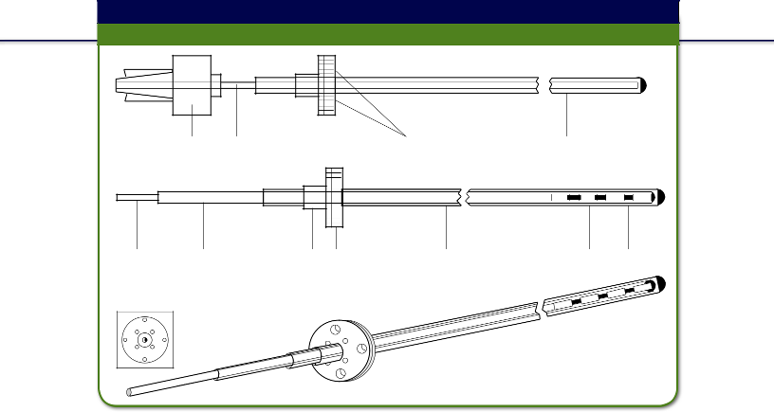
Brain Implant Kit

Part # 289-1; Sterile Kit Part # 1502

 | Luer
 | Luer |  | ObturatorObtrator |  |  |  |  |  | SutSuturereHoles |  | Outer
 | Luer Lock |  |  |  |  |  |  |  | SutSuturereHoles |  | Outer Catheter
 | Lock |  |  |  |  |  |  |  | Holes |  | Catheter

FilamentFilaent
FilamentFilaent |  | InnerIer |  | StemSt | FlexibleFleible |  | Outeruter |  | RadioactiveRaactive |  | SpacerSacer
 |  | CatheterCaeter |  |  | ButtonBon |  | Catheterthetr |  | SeedsS

NewewFlexibleFlexibleSiiconeSiliconeButtonwithButton8Hleswith 8 Holes

The Brain Implant Kit consists of an outer catheter made of celcon and an inner catheter made of nylon with a nylon fi lament. The outer catheter has a standard length of 25 cm (other lengths available) with a special obturator and fl exible button, closed smoothly on one end. The O.D. of the outer catheter is approximately 0.080” and the I.D. is 0.057”. The inner catheter has a standard length of 26 cm (other lengths available) with O.D. of approximately 0.052” and I.D. of 0.038”. It is designed for use with standard Iridium-192 and Iodine-125 sources. The fi lament can be used as spacers and can be heat sealed. The buttons can be positioned along the outer catheter using the appropriate glue. They have suture holes and the stem can be crimped or heat sealed. Each kit is supplied with 3 buttons: fl exible large, fl exible small, and stainless steel.


Part #

300-1 Flexible Button (large)

238-3 Stainless Steel Button

301-1 Flexible Button (small)

!This product is for one time use only.
CAUTION: This product should be carefully inspected by your staff prior to clinical use and should be used by authorized personnel only.

© 2013 Best Medical International, Inc.

23
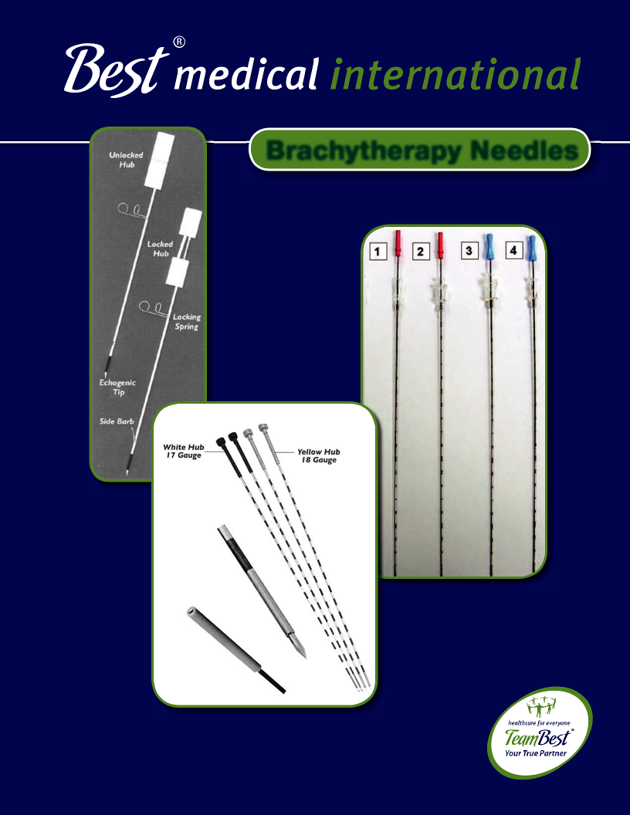

Brachytherapy Needles

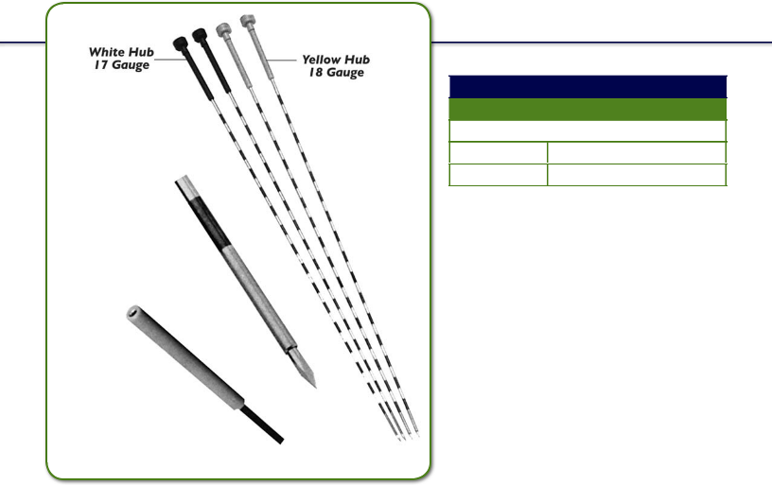
White Hub
White Hub |  | Yellow Hub
17 Gauge |  | 18 Gauge

The Mick type needle’s
obturator is provided
with a sharp trocar point
while the echogenic canula
tip is ground-beveled to
facilitate the
penetration
of the skin.

The Mick type needle's
hub canula is “honed”
for smooth transfer
of seeds from the
applicator into and
through

the needle.

Best Mick Type Needles

Part #

10203 17 Gauge White Hub

10209 18 Gauge Yellow Hub

Best Mick Type Needles
- Sterile/disposable

- Mirror fi nish stylet

- Siliconized/calibrated

- Flared canula hub

- Improved sharpness

- Color coded hubs

- Trocar point

- Available 17 and 18 gauge

- Rigid stylet

- Echogenic bevel

Packaged, Sterile and Disposable
- 25 Needles per carton

- 4 Pouches with 5 needles

- 5 Pouches with 1 needle

Specifications (For Single Use Only)

© 2013 Best Medical International, Inc.

24

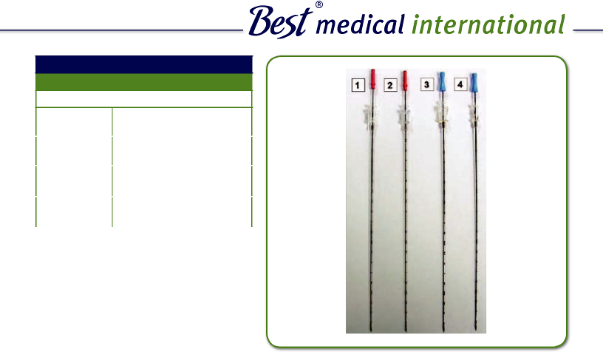

Best Prostate Seeding Needles

Part #

10215 | Best C.P. Type Round
 | Hub Needles
10201 | Best C.P. Type Square
 | Hub Needles
10197 | Best Square Hub
 | Needles
10199 | Best Round Hub
 | Needles

Best Prostate Seeding Needles
- Sterile/disposable

- Low price

- Echogenic bevel

- Siliconized

- Calibrated stylet

- Improved sharpness

- Bevel point

- Available 17 and 18 Gauge

Packaged, Sterile and Disposable
- 25 Needles per carton

- 5 Pouches with 1 ceedle

- 4 Pouches with 5 Needles each

Specifications (For Single Use Only)

“A” and “B” bevel needles are available.

Best Medical International, Inc. 7643 Fullerton Road, Springfield, Virginia 22153 USA
25 Tel: 703-451-2378 800-336-4970 Fax: 703-451-5228 www.bestmedical.com
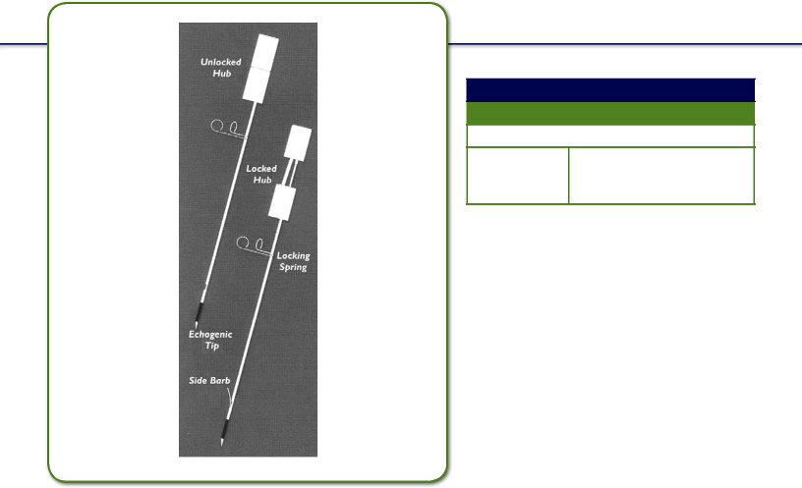

Prostate Stabilization Set Needles

Part #

10207 18 Gauge x 20 cm Sterile; Box of 10 Sets; 2 Needles per Set

Improved Seed Distribution by Means of Prostate Gland Immobilization

Prostate Stabilization Set

The Stabilizing Needle (patented) is designed to prevent prostate movement during the insertion of prostate seeding needles. Immobilization is accomplished by deployment of a “side barb” in the prostate tissue and then securing a “lock spring” against the proximal side of the template. Two stabilizing needles must be used to adequately stabilize the prostate gland.

Features

•
•
•
•

•

Two-part hub design Locking side barb

Sharp bevel-point needle tip Echogenic tip

10 Pouches with 2 needles

Packaged:
18 Gauge x 20 cm sterile; box of
10 sets; 2 needles per set

© 2013 Best Medical International, Inc.

26

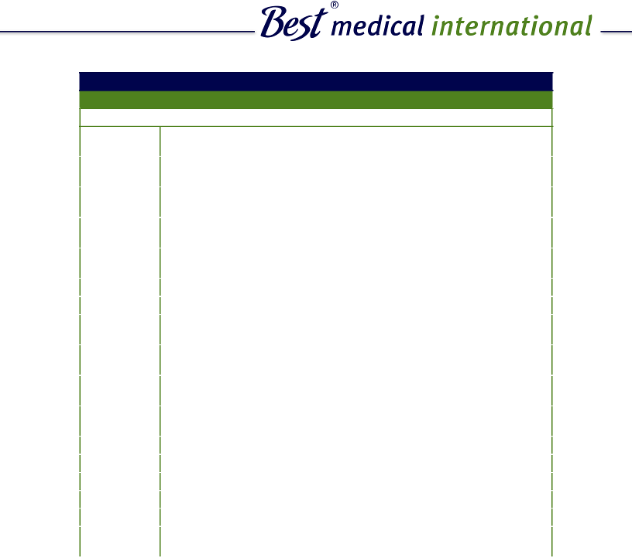

Needles

Part #

10171 | Brachytherapy Needles Round Hub 18 Gauge x 10 cm with Wax
 | in a Pouch
10180 | Brachytherapy Needles Square Hub 18 Gauge x 20 cm with Wax
 | in a Pouch
10183 | Brachytherapy Needles Square Hub 17 Gauge x 20 cm without Wax
 | in a Pouch
10222 | Brachytherapy Needles Square Hub 17 Gauge x 20 cm with Wax
 | in a Pouch
10191 | Brachytherapy Needles Round Hub 18 Gauge x 20 cm with Wax
 | in a Pouch
10195 | Best Applicator Needles with “B” Bevel Blunt Stylet in a Pouch
10207 | Prostate Stabilizing Needles 18 Gauge x 20 cm in a Pouch
10211 | Brachytherapy Needles Round Hub 18 Gauge x 20 cm Pink Stylet with
 | Wax in a Pouch
10213 | Brachytherapy Needles Square Hub 18 Gauge x 20 cm Pink Stylet with
 | Wax in a Pouch
10220 | Brachytherapy Needles Round Hub 18 Gauge x 30 cm with Wax
 | in a Pouch
10221 | Brachytherapy Needles Round Hub 18 Gauge x 30 cm without Wax
 | in a Pouch
10224 | Needles Round Hub 16 Gauge x 20 cm without Wax (sterile)
10226 | Needles Square Hub “B” Bevel 18 Gauge x 20 cm with Wax (sterile)
10229 | Needles Round Hub “B” Bevel 18 Gauge x 20 cm with Wax (sterile)
10232 | Brachytherapy Needle Metal Hub Zebra 18 Gauge x 20 cm
10211 | Needles Square Hub 18 Gauge x 20 cm with Pink Stylet without Wax
5006-0033 | 18 Gauge x 20 cm Long Best Custom Stylet Applicator Needle
 | (dittoli type)

Best Medical International, Inc. 7643 Fullerton Road, Springfield, Virginia 22153 USA
27 Tel: 703-451-2378 800-336-4970 Fax: 703-451-5228 www.bestmedical.com

© 2013 Best Medical International, Inc.

28
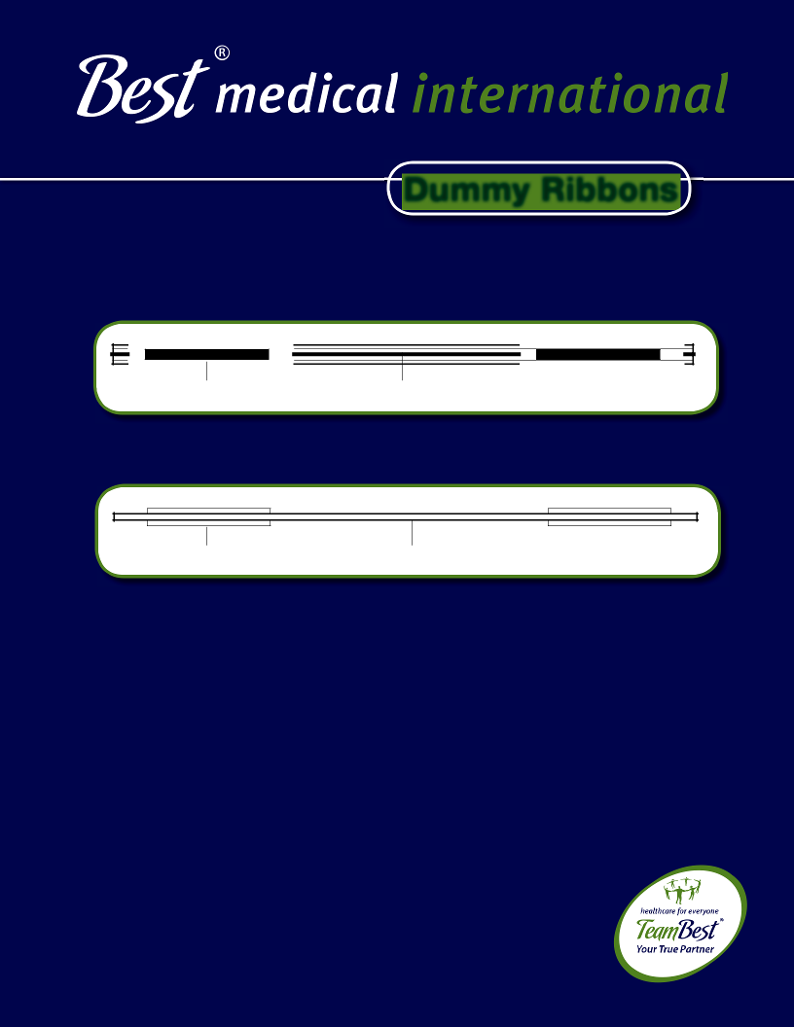

Dummy Ribbons

High Density Seed High Density Spacer

High Density Seed Stainless Steel Cable


Anderson Forell Suthanthiran Nylon Dummy Ribbon Set Part # 5006-0003

Set Contains:

One Ribbon with 12 Seeds each of 1.2 mm Length

One Ribbon with 12 Seeds each of 1.8 mm Length

One Ribbon with 12 Seeds each of 2.4 mm Length

One Ribbon with 12 Seeds each of 3.0 mm Length

One Ribbon with 12 Seeds each of 4.0 mm Length

This enables identifi cation of ribbons in complex implants, facilitates implant radiography and improves localization accuracy. Dr. Lowell L. Anderson of Memorial Sloan-Kettering Cancer Center and Mr. Bruce Forell of City of Hope Medical Center have been very instrumental in bringing about this design concept.


Nylon Dummy Ribbon
Nylon Dummy Ribbon
Part # 220

High Density Seed High Density Spacer

The diameter of the Nylon Dummy Ribbon and High Density Seed are 0.85 mm and 0.5 mm respectively. Nylon Dummy Ribbons are also available with seed lengths of 0.6 mm, 1.2 mm, 1.8 mm, 2.4 mm, 3.0 mm, 4.0 mm and 5.0 mm.
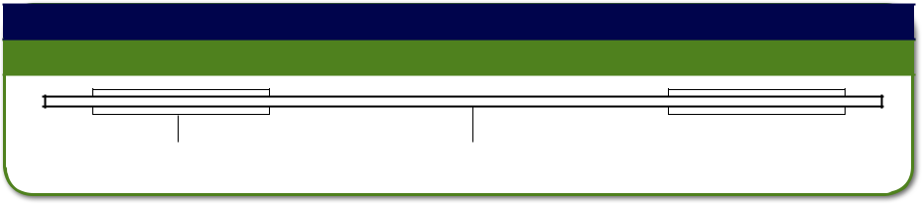

Cable Dummy Ribbon | Cable Dummy Ribbon
Part # 423/HDR Part # 530 | Cable Dummy Ribbon

High Density Seed Stainless Steel Cable

Cable Dummy Ribbons are similar to the Nylon Dummy Ribbons. The diameters of the cable and the dummy seeds are 0.5 mm and 0.85 mm respectively. Custom made Cable Dummy Ribbons are available with or without alternate markers using seed lengths of 0.6 mm, 1.2 mm, 1.8 mm, 2.4 mm and 3.0 mm.

!CAUTION: This product should be carefully inspected by your staff prior to clinical use and should be used by authorized personnel only.
© 2013 Best Medical International, Inc.

28
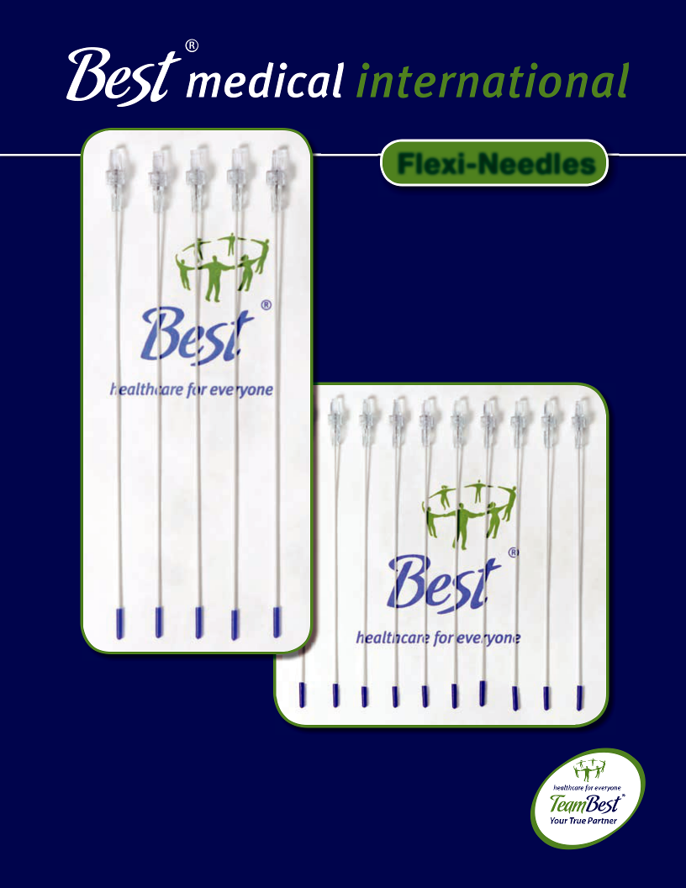

Flexi-Needles
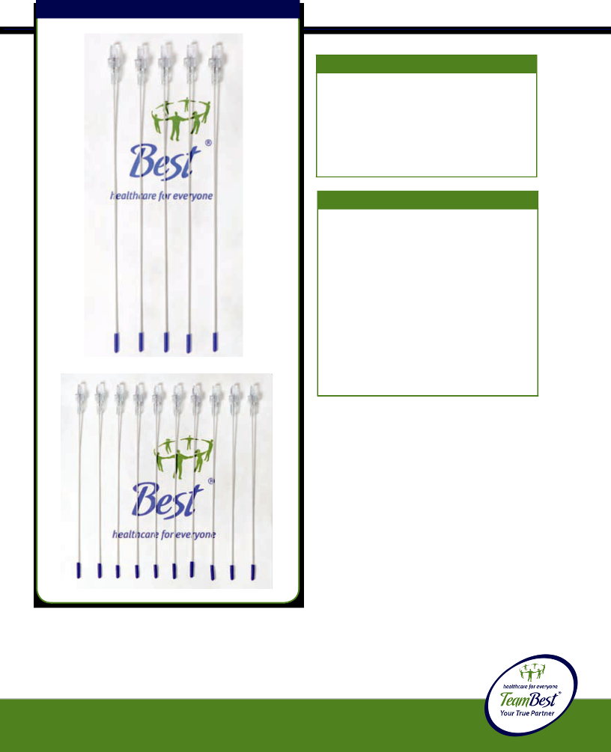Flexi-Needles
Description
Flexi-Needles are sharp or blunt, with closed-ended needle guides, and have a nominal 0.3 cm long tip. They are made of biologically compatible material. (Custom lengths are available upon request.)
Intended Use
Flexi-Needles are inserted transcutaneously, using special obturators. They are designed to be afterloaded with Iridium-192 or Iodine-125 ribbon sources. Two types of caps are available (Luer Cap or Slip Cap) to place over the loaded Flexi-Needle to hold the ribbons in place during irradiation. Simulator sources can be used for localization; obturators are left in place until the time each is afterloaded with the appropriate radioactive source.
PRECAUTIONS
Caution: Device is shipped Non-Sterile or Sterile.
Caution: Flexi-Needles and Obturators are for single use only.
Caution: Federal law restricts this device to sale by or on the order of a physician.
Caution: Ensure Obturator is all the way to the tip of the Flexi-Needle prior to insertion.
Caution: Luer hubs may separate from the Flexi-Needle and Obturators
if excessive force is applied.
!Warning: Obturators are made of Tungsten or Stainless Steel. BothCAUTION:obturatorThisandproductFlexi-shouldNeedle bemaycarefullybreak ifinspectedbone,hardbyskin,your staff hardprior surfaces,toclinical oruseexcessiveandshouldforcesbe usareencounteredbyauthorized. personnel only.
© 2013 Best Medical International, Inc.

29

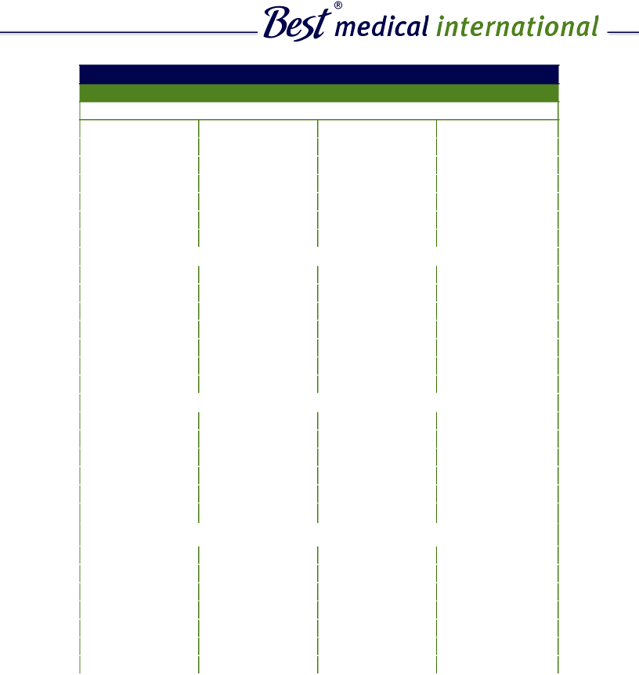

Flexi-Needle Combinations
Gauge Part # Outer Diameter Inner Diameter

1. Flexi-Needle Sharp without Luer Lock, without Obturator**

 | 13 Gauge | 251-** | 0.095” | 0.078”
 | 14 Gauge | 252-** | 0.083” | 0.062”
 | 15 Gauge | 253-** | 0.078” | 0.057”
 | 15.5 Gauge | 491-** | 0.072” | 0.054”
 | 16 Gauge | 254-** | 0.066” | 0.050”
 | 17 Gauge | 255-** | 0.058” | 0.040”
 | 18 Gauge | 256-** | 0.050” | 0.031”
 | 2. Flexi-Needle Sharp, with Luer Lock, without Obturator**
 | 13 Gauge | 263-** | 0.095” | 0.078”
 | 14 Gauge | 264-** | 0.083” | 0.062”
 | 15 Gauge | 265-** | 0.078” | 0.057”
 | 15.5 Gauge | 554-** | 0.072” | 0.054”
 | 16 Gauge | 266-** | 0.066” | 0.050”
 | 17 Gauge | 267-** | 0.058” | 0.040”
 | 18 Gauge | 268-** | 0.050” | 0.031”
 | 3. Flexi-Needle Sharp, with Luer Lock and Tungsten Obturator**
 | 14 Gauge | 282-** | 0.083” | 0.062”
 | 15 Gauge | 283-** | 0.078” | 0.057”
 | 15.5 Gauge | 555-** | 0.072” | 0.054”
 | 16 Gauge | 284-** | 0.066” | 0.050”
 | 17 Gauge | 285-** | 0.058” | 0.040”
 | 18 Gauge | 286-** | 0.050” | 0.031”
 | 4. Flexi-Needle Sharp, with Luer Lock and Stainless Steel Obturator**
 | 13 Gauge | 281-** | 0.095” | 0.078”
 | 14 Gauge | 755-** | 0.083” | 0.062”
 | 15 Gauge | 733-** | 0.078” | 0.057”
 | 15.5 Gauge | 1568-** | 0.072” | 0.054”
 | 16 Gauge | 749-** | 0.066” | 0.050”
! | 17 Gauge | 741-** | 0.058” | 0.040”
 | 18 Gauge | 763-** | 0.050” | 0.031”

** please specify length ^{continues on next page}

CAUTION: This product should be carefully inspected by your staff prior to clinical use and should be used by authorized personnel only.

Best Medical International, Inc. 7643 Fullerton Road, Springfield, Virginia 22153 USA
30 Tel: 703-451-2378 800-336-4970 Fax: 703-451-5228 www.bestmedical.com
 | Gauge | Part # | Outer Diameter | Inner Diameter
 | 5. Flexi-Needle Sharp, without Luer Lock, with Tungsten Obturator**
 | 14 Gauge | 355-** | 0.083” | 0.062”
 | 15 Gauge | 356-** | 0.078” | 0.057”
 | 15.5 Gauge | 1136-** | 0.072” | 0.054”
 | 16 Gauge | 357-** | 0.066” | 0.050”
 | 17 Gauge | 358-** | 0.058” | 0.040”
 | 18 Gauge | 359-** | 0.050” | 0.031”

6. Flexi-Needle Sharp, without Luer Lock, with Stainless Steel Obturator**

13 Gauge | 354-** | 0.095” | 0.078”
14 Gauge | 757-** | 0.083” | 0.062”
15 Gauge | 735-** | 0.078” | 0.057”
15.5 Gauge | 971-** | 0.072” | 0.054”
16 Gauge | 751-** | 0.066” | 0.050”
17 Gauge | 743-** | 0.058” | 0.040”
18 Gauge | 765-** | 0.050” | 0.031”

- Flexi-Needle Sharp, without Luer Lock, with Rod (Tungsten Obturator without Luer Lock)**

14 Gauge | 403-** | 0.083” | 0.062”
15 Gauge | 404-** | 0.078” | 0.057”
16 Gauge | 405-** | 0.066” | 0.050”
17 Gauge | 406-** | 0.058” | 0.040”
18 Gauge | 407-** | 0.050” | 0.031”

- Flexi-Needle Sharp, without Luer Lock, with Rod (Stainless Steel Obturator without Luer Lock)**

 | 13 Gauge | 402-** | 0.095” | 0.078”
 | 14 Gauge | 759-** | 0.083” | 0.062”
 | 15 Gauge | 737-** | 0.078” | 0.057”
 | 16 Gauge | 753-** | 0.066” | 0.050”
 | 17 Gauge | 745-** | 0.058” | 0.040”
 | 18 Gauge | 767-** | 0.050” | 0.031”
** please specify length |  |  |  | continues on next page


!CAUTION: This product should be carefully inspected by your staff prior to clinical use and should be used by authorized personnel only.

© 2013 Best Medical International, Inc.

31
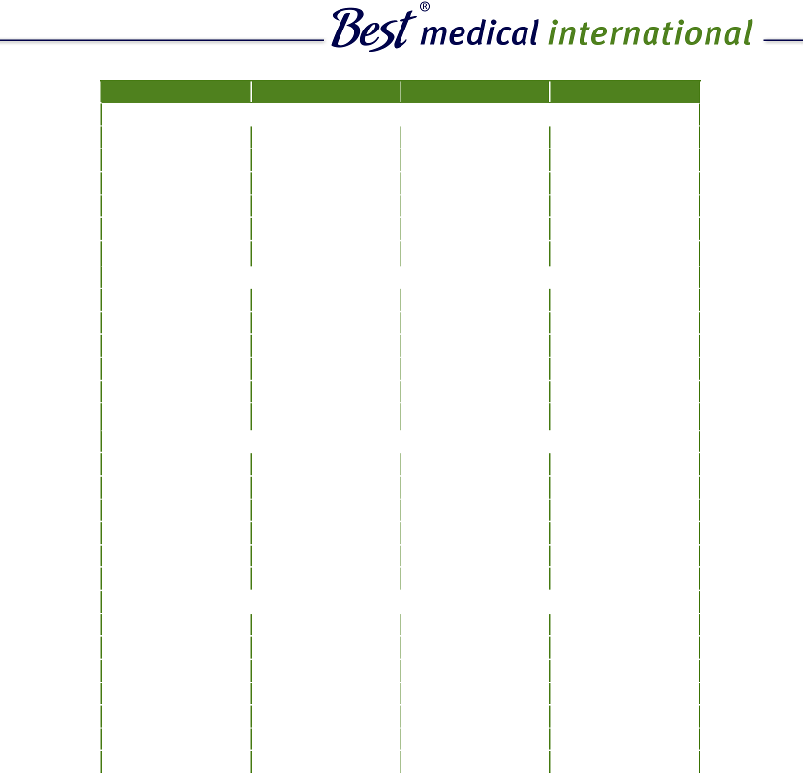

 | Gauge | Part # | Outer Diameter | Inner Diameter
 | 9. Flexi-Needle Blunt End, without Luer Lock, and without Obturator**
 | 13 Gauge | 257-** | 0.095” | 0.078”
 | 14 Gauge | 258-** | 0.083” | 0.062”
 | 15 Gauge | 259-** | 0.078” | 0.057”
 | 16 Gauge | 260-** | 0.066” | 0.050”
 | 17 Gauge | 261-** | 0.058” | 0.040”
 | 18 Gauge | 262-** | 0.050” | 0.031”
 | 10. Flexi-Needle Blunt End with Luer Lock, without Obturator**
 | 13 Gauge | 269-** | 0.095” | 0.078”
 | 14 Gauge | 270-** | 0.083” | 0.062”
 | 15 Gauge | 271-** | 0.078” | 0.057”
 | 16 Gauge | 272-** | 0.066” | 0.050”
 | 17 Gauge | 273-** | 0.058” | 0.040”
 | 18 Gauge | 274-** | 0.050” | 0.031”
 | 11. Flexi-Needle Blunt End with Luer Lock and Tungsten Obturator**
 | 14 Gauge | 276-** | 0.083” | 0.062”
 | 15 Gauge | 277-** | 0.078” | 0.057”
 | 15.5 Gauge | 1695-** | 0.072" | 0.054”
 | 16 Gauge | 278-** | 0.066” | 0.050”
 | 17 Gauge | 279-** | 0.058” | 0.040”
 | 18 Gauge | 280-** | 0.050” | 0.031”
 | 12. Flexi-Needle Blunt End with Luer Lock and Stainless Steel Obturator
 | 13 Gauge | 275-** | 0.095” | 0.078”
 | 14 Gauge | 756-** | 0.083” | 0.062”
 | 15 Gauge | 734-** | 0.078” | 0.057”
 | 15.5 Gauge | 1137-** | 0.078” | 0.054”
 | 16 Gauge | 750-** | 0.066” | 0.050”
 | 17 Gauge | 742-** | 0.058” | 0.040”
 | 18 Gauge | 764-** | 0.050” | 0.031”
** please specify length |  |  |  | continues on next page

- CAUTION: This product should be carefully inspected by your staff prior to clinical use and should be used by authorized personnel only.

Best Medical International, Inc. 7643 Fullerton Road, Springfield, Virginia 22153 USA
32 Tel: 703-451-2378 800-336-4970 Fax: 703-451-5228 www.bestmedical.com


Gauge Part # Outer Diameter Inner Diameter

13. Flexi-Needle Blunt End, without Luer Lock, with Tungsten Obturator**

14 Gauge | 361-** | 0.083” | 0.062”
15 Gauge | 362-** | 0.078” | 0.057”
16 Gauge | 363-** | 0.066” | 0.050”
17 Gauge | 364-** | 0.058” | 0.040”
18 Gauge | 365-** | 0.050” | 0.031”
14. Flexi-Needle Blunt End, without Luer Lock, with Stainless Steel Obturator**

13 Gauge | 360-** | 0.095” | 0.078”
14 Gauge | 758-** | 0.083” | 0.062”
15 Gauge | 736-** | 0.078” | 0.057”
16 Gauge | 751-** | 0.066” | 0.050”
17 Gauge | 744-** | 0.058” | 0.040”
18 Gauge | 766-** | 0.050” | 0.031”

- Flexi-Needle Blunt End, without Luer Lock, with Rod (Tungsten Obturator without Luer Lock)**

14 Gauge | 409-** | 0.083” | 0.062”
15 Gauge | 410-** | 0.078” | 0.057”
15.5 Gauge | 970-** | 0.072” | 0.054”
16 Gauge | 411-** | 0.066” | 0.050”
17 Gauge | 412-** | 0.058” | 0.040”
18 Gauge | 413-** | 0.050” | 0.031”

- Flexi-Needle Blunt End without, Luer Lock, with Rod (Obturator Stainless Steel without Luer Lock)

13 Gauge | 408-** | 0.095” | 0.078”
14 Gauge | 760-** | 0.083” | 0.062”
15 Gauge | 738-** | 0.078” | 0.057”
16 Gauge | 754-** | 0.066” | 0.050”
17 Gauge | 746-** | 0.058” | 0.040”
18 Gauge | 768-** | 0.050” | 0.031”
** please specify length |  |  | continues on next page

!CAUTION: This product should be carefully inspected by your staff prior to clinical use and should be used by authorized personnel only.
© 2013 Best Medical International, Inc.

33


Gauge | Part # | Outer Diameter | Inner Diameter
17. Tungsten Obturator only, with Luer Lock**
14 Gauge | 295-** | 0.055”
15 Gauge | 296-** | 0.055”
16 Gauge | 297-** | 0.042”
17 Gauge | 298-** | 0.038”
18 Gauge | 299-** | 0.028”
18. Stainless Steel Obturator only, with Luer Lock
13 Gauge | 294-** | 0.071”
14 Gauge | 732-** | 0.055”
15 Gauge | 732-** | 0.055”
16 Gauge | 748-** | 0.042”
17 Gauge | 740-** | 0.038”
18 Gauge | 762-** | 0.028”
19. Rod only (Tungsten Obturator, without Luer Lock)**
14 Gauge | 440-** | 0.055”
15 Gauge | 440-** | 0.055”
16 Gauge | 438-** | 0.042”
17 Gauge | 436-** | 0.038”
18 Gauge | 435-** | 0.028”
20. Rod only (Stainless Steel Obturator, without Luer Lock)
13 Gauge | 472-** | 0.071”
14 Gauge | 731-** | 0.055”
15 Gauge | 731-** | 0.055”
16 Gauge | 747-** | 0.042”
17 Gauge | 739-** | 0.038”
18 Gauge | 761-** | 0.028”

  - please specify length

- CAUTION: This product should be carefully inspected by your staff prior to clinical use and should be used by authorized personnel only.

Best Medical International, Inc. 7643 Fullerton Road, Springfield, Virginia 22153 USA
34 Tel: 703-451-2378 800-336-4970 Fax: 703-451-5228 www.bestmedical.com

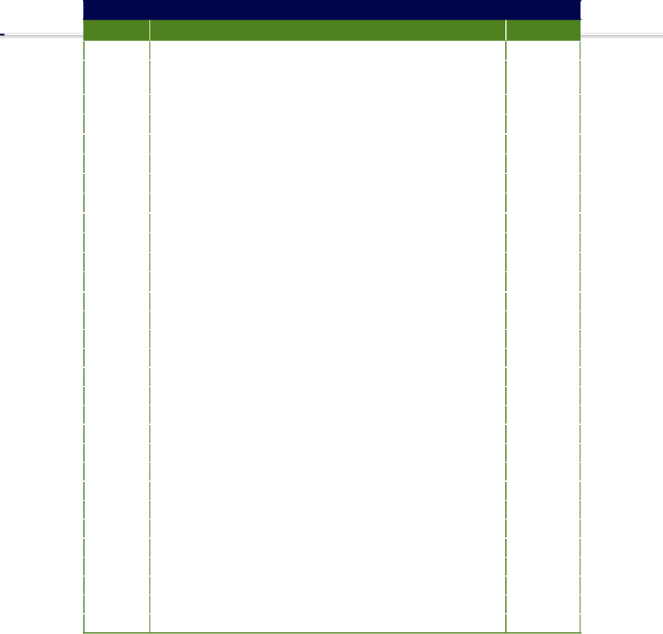
Sterile Flexi-Needles

 | Part # | Needle Type |  | Quantity
1500 |  | 13 | Gauge Flexi-Needle with Stainless Steel Obturator | Up to 5
1723 |  | 13 | Gauge Printed Needle with Stainless Steel Obturator | Up to 5
 |  | in a Pouch
1545 |  | Stainless Steel Obturators for 13 Gauge Flexi Needles |  | Up to 5
1547 |  | 13 | Gauge with Luer Lock without Obturator | Up to 10
1814 |  | 13 Gauge Blunt with Luer Lock without Obturator in a Pouch |  | Up to 10
1816 |  | 13 | Gauge Blunt with Stainless Steel Obturator in a Pouch | Up to 5
1543 |  | 13 | Gauge Sharp Needles | Up to10
1549 |  | 14 | Gauge Sharp Needles | Up to 10
1551 |  | 14 | Gauge with Luer Lock without Obturator | Up to 10
1597 |  | 15 | Gauge Set with Tungsten Obturator | 20
1569 |  | 15 | Gauge Set with Tungsten Obturator | 15
900 |  | 15 | Gauge Set with Tungsten Obturator | 10
 | 1036 | 15 | Gauge Set with Tungsten Obturator | 5
 | 1605 | 15 | Gauge Set with Stainless Steel Obturator | 20
 | 1577 | 15 | Gauge Set with Stainless Steel Obturator | 15
 | 912 | 15 | Gauge Set with Stainless Steel Obturator | 10
 | 1040 | 15 | Gauge Set with Stainless Steel Obturator | 5
 | 1117 | 15 | Gauge Set with Stainless Steel Obturator | 1
 | 1599 | 15 | Gauge without Luer Lock with Obturator | 20
 | 1571 | 15 | Gauge without Luer Lock with Obturator | 15
 | 903 | 15 | Gauge without Luer Lock with Obturator | 10
 | 1037 | 15 | Gauge without Luer Lock with Obturator | 5
 | 1634 | 15 | Gauge without Luer Lock with Obturator in a Pouch | Up to 4
 | 1525 | 15 | Gauge Obturator Assembly with Tungsten Rod | Up to 5
 | 1161 | 15 | Gauge Obturator Assembly with Stainless Steel Rod | 5 or 10
 | 1607 | 15 | Gauge without Luer Lock with Stainless Steel Obturator | 20
 | 1579 | 15 | Gauge without Luer Lock with Stainless Steel Obturator | 15
 | 915 | 15 | Gauge without Luer Lock with Stainless Steel Obturator | 10
 | 1041 | 15 | Gauge without Luer Lock with Stainless Steel Obturator | 5
1613 |  | 15 | Gauge Printed without Luer Lock with Obturator | 20

continues on next page

!CAUTION: This product should be carefully inspected by your staff prior to clinical use and should be used by authorized personnel only.
© 2013 Best Medical International, Inc.

35
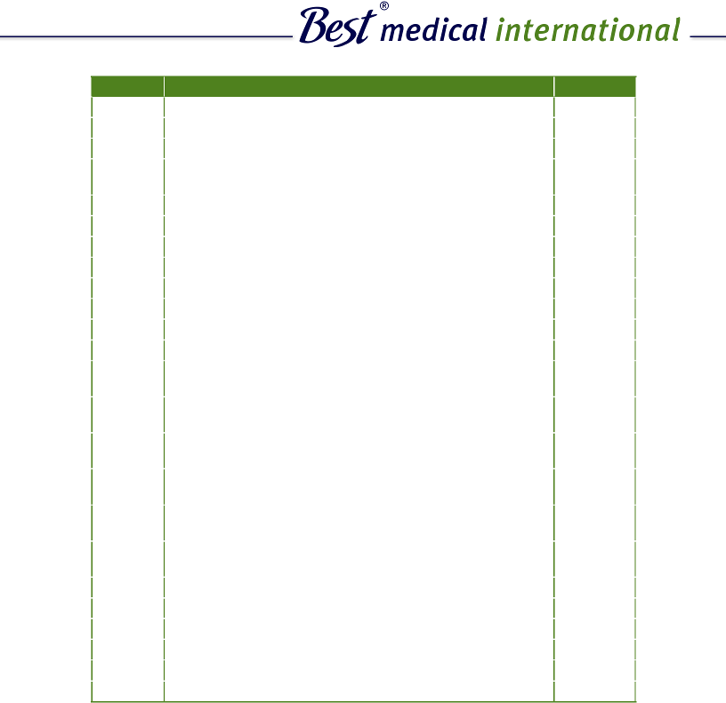

Part # | Needle Type |  | Quantity
1585 | 15 | Gauge Printed without Luer Lock with Obturator | 15
940 | 15 | Gauge Printed without Luer Lock with Obturator | 10
942 | 15 | Gauge Printed without Luer Lock with Obturator | 5
1718 | 15 | Gauge Printed, Sharp End with Tungsten Obturator | 1
 | in a Pouch
1144 | 15 | Gauge Flexi-Needle with Luer Lock w/o Obturator | Up to 10
1051 | 15 | Gauge Sharp Needles | 10
1164 | 15 | Gauge Sharp Needles | 5
1166 | 15 | Gauge Sharp Needles | 1
1272 | 15 | Gauge Blunt Needles | Up to 10
1769 | 15 | Gauge Sharp End Flexi Needles 3-colors in a Pouch | 18
1778 | 15 Gauge Flexi Needles Blunt End with Tungsten Obturator |  | 10
1776 | 15 Gauge Flexi Needles Blunt End with Tungsten Obturator |  | 5
1800 | 15 | Gauge Flexi Needles without Luer Lock, Blunt End, | 10
 | with Stainless Steel Obturator in a tray
1798 | 15 | Gauge Flexi Needles without Luer Lock, Blunt End, | 5
 | with Stainless Steel Obturator in a tray
1804 | 15 | Gauge Flexi Needles without Luer Lock, Blunt End, | 10
 | with Tungsten Obturator
1802 | 15 | Gauge Flexi Needles without Luer Lock, Blunt End, | 5
 | with Tungsten Obturator
1855 | 15 | Gauge Flexi Needles Blunt End without Luer Lock | 10
 | with Stainless Steel Obturator in a Tray/Pouch
1859 | 15 | Gauge Flexi Needle Blunt End with Luer Lock with | 5
 | Stainless Steel Obturator with Hub and Cap in a Tray
1303 | 15 | Gauge Flexi-Needle with Stainless Steel Sleeve | 5
1660 | 0.055” Dia. Tungsten Obturator with Sleeve and Cap |  | Up to 5
1658 | 0.055” Dia. Stainless Steel Obturator with Sleeve and Cap |  | Up to 5
1053 | 15.5 Gauge Sharp Needles |  | 10
1615 | 15.5 Gauge Printed without Luer Lock with Obturator |  | 20
1587 | 15.5 Gauge Printed without Luer Lock with Obturator |  | 15

continues on next page

- Custom lengths available. Needles up to 25 cm long will be packed inatray.Needlesover25cmlongwillbepackedinapouch.CAUTION:Thisproductshouldbecarefullyinspectedbyyourstaffpriortoclinicaluseandshouldbeusedbyauthorizedpersonnelonly.

Best Medical International, Inc. 7643 Fullerton Road, Springfield, Virginia 22153 USA
36 Tel: 703-451-2378 800-336-4970 Fax: 703-451-5228 www.bestmedical.com

 | Part # | Needle Type |  |  | Quantity
944 |  | 15.5 |  | Gauge Printed without Luer Lock with Obturator | 10
 | 946 | 15.5 |  | Gauge Printed without Luer Lock with Obturator | 5
 | 1527 | 15.5 |  | Gauge with Luer Lock without Obturator | Up to 10
 | 1339 | 15.5 |  | Gauge Flexi-Needle with Stainless Steel Sleeve | Max of 10
1840 |  | 15.5 Gauge Flexi Needle without Luer Lock with Obturator |  |  | 10
 |  | in a Tray
1838 |  | 15.5 |  | Gauge Flexi Needle without Luer Lock with Obturator | 5
 |  | in a TrayPouch
1836 |  | 15.5 |  | Gauge Flexi Needle without Luer Lock with Obturator | Max of 4
 |  | in a Pouch
1842 |  | 15.5 |  | Gauge Flexi Needle Blunt End without Luer Lock | 5
 |  | with Stainless Steel Obturator in a Tray/Pouch
1844 |  | 15.5 |  | Gauge Flexi Needle Blunt End without Luer | 10
 |  | Lock with Stainless Steel Obturator in a Tray
 | 1601 | 16 | Gauge Set with Tungsten Obturator |  | 20
 | 1573 | 16 | Gauge Set with Tungsten Obturator |  | 15
 | 906 | 16 | Gauge Set with Tungsten Obturator |  | 10
 | 1036 | 16 | Gauge Set with Tungsten Obturator |  | 5
 | 1609 | 16 | Gauge Set with Stainless Steel Obturator |  | 20
 | 1581 | 16 | Gauge Set with Stainless Steel Obturator |  | 15
 | 918 | 16 | Gauge Set with Stainless Steel Obturator |  | 10
 | 1042 | 16 | Gauge Set with Stainless Steel Obturator |  | 5
 | 1212 | 16 | Gauge Blunt End with Stainless Steel Obturator |  | 1
 | 1514 | 16 | Gauge Sharpe End with Stainless Steel Obturator |  | Up to 4
 | 1531 | 16 | Gauge with Luer Lock without Obturator in a Pouch |  | Up to 10
 | 1621 | 16 | Gauge without Luer Lock with Obturator |  | 20
 | 1593 | 16 | Gauge without Luer Lock with Obturator |  | 15
 | 974 | 16 | Gauge without Luer Lock with Obturator |  | 10
 | 1055 | 16 | Gauge Sharp Needles |  | 10
 | 1350 | 16 | Gauge Printed Sharp End Flexi-Needles |  | 5
 | 1617 | 16 | Gauge Printed without Luer Lock with Obturator |  | 20
 | 1589 | 16 | Gauge Printed without Luer Lock with Obturator |  | 15
 | 948 | 16 | Gauge Printed without Luer Lock with Obturator |  | 10
950 |  | 16 | Gauge Printed without Luer Lock with Obturator |  | 5

continues on next page

! Custom lengths available. Needles up to 25 cm long will be packed in a tray. Needles over 25 cm long will be packed in a pouch.
CAUTION: This product should be carefully inspected by your staff prior to clinical use and should be used by authorized personnel only.

© 2013 Best Medical International, Inc.

37
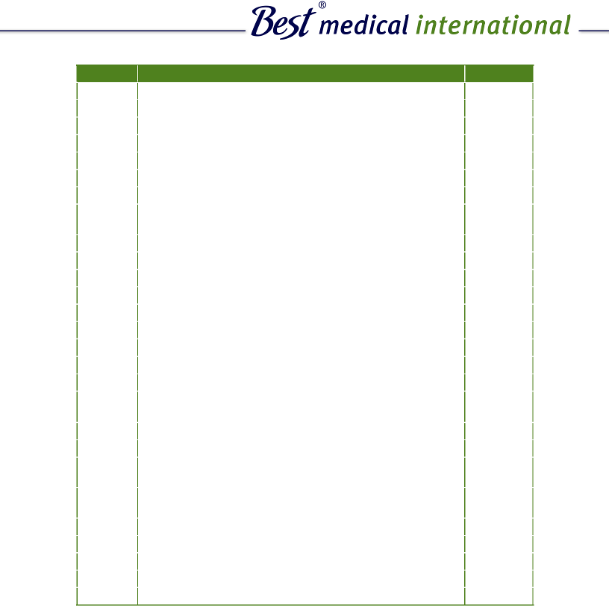continues on next page

Part # | Needle Type |  | Quantity
1060 | 16 | Gauge Blunt End with Luer Lock | 1
1216 | 16 | Gauge Sharp Needles | 5
1179 | 16 | Gauge Flexi-Needle without Luer Lock with Hub Stylet | 5
1529 | 16 | Gauge Tungsten Obturators | Up to 5
1352 | 16 | Gauge Tungsten Stylets for Needles with Hub | Up to 5
1218 | 16 | Gauge Stainless Steel Obturator | 5
1214 | 16 | Gauge Stainless Steel Obturator | 1
1861 | 16 | Gauge Flexi Needle Blunt End with Luer Lock | 5
 | with Stainless Steel Obturator in a Pouch
1603 | 17 | Gauge Set with Tungsten Obturator | 20
1575 | 17 | Gauge Set with Tungsten Obturator | 15
909 | 17 | Gauge Set with Tungsten Obturator | 10
1669 | 17 | Gauge Set with Tungsten Obturator in a Pouch | Up to 4
1039 | 17 | Gauge Set with Tungsten Obturator | 5
1611 | 17 | Gauge Set with Stainless Steel Obturator | 20
1583 | 17 | Gauge Set with Stainless Steel Obturator | 15
921 | 17 | Gauge Set with Stainless Steel Obturator | 10
1671 | 17 | Gauge Set with Stainless Steel Obturator in a Pouch | Up to 4
1867 | 17 | Gauge Flexi Needle Blunt End with Luer Lock | 5
 | with Stainless Steel Obturator in a Tray/Pouch
1533 | 17 | Gauge Tungsten Obturators with Rod | Up to 5
1043 | 17 | Gauge Set with Stainless Steel with Obturator in a Tray | 5
1698 | 17 | Gauge Flexi Needle without Luer Lock with Stainless | 10
 | Steel Obturators
1556 | 17 | Gauge Flexi Needle without Luer Lock with Stainless | 5
 | Steel Obturators
1057 | 17 | Gauge Sharp Needles in a pouch | 10
1220 | 17 | Gauge Sharp Needles | 5
1535 | 17 | Gauge with Luer Lock without Obturator | Up to 10
1619 | 17 | Gauge Printed without Luer Lock with Obturator | 20
1591 | 17 | Gauge Printed without Luer Lock with Obturator | 15

!Custom Lengths Available. Needles up to 25 cm long will be packed in

a trayCustom.Needleslengthsover 25availablecmlong.Needleswillbe packedupto25incma plonguchwill. be packed in _{CAUTION:}atray. Needles over 25 cm long will be packed instaff pouch.
This product should be carefully inspected by your
prior to clinical use and should be used by authorized personnel only.

Best Medical International, Inc. 7643 Fullerton Road, Springfield, Virginia 22153 USA
38 Tel: 703-451-2378 800-336-4970 Fax: 703-451-5228 www.bestmedical.com
 | Part # | Needle Type |  | Quantity
952 |  | 17 | Gauge Printed without Luer Lock with Obturator | 10
 | 954 | 17 | Gauge Printed without Luer Lock with Obturator | 5
 | 1222 | 17 | Gauge Stainless Steel Obturator for Needle | Up to 5
 | 1623 | 18 | Gauge Set with Tungsten Obturator | 20
 | 1595 | 18 | Gauge Set with Tungsten Obturator | 15
 | 1276 | 18 | Gauge Set with Tungsten Obturator | 10
 | 1278 | 18 | Gauge Set with Tungsten Obturator | 5
 | 1541 | 18 | Gauge with Luer Lock without Obturators | Up to 10
 | 1280 | 18 | Gauge Sharp Needles | Up to 10
 | 1774 | 18 | Gauge Set with Tungsten Obturators | Max of 4
 | 1537 | 18 | Gauge Tungsten Obturators in a Pouch | Up to 5
 | 1539 | 18 | Gauge Stainless Steel Obturators in a Pouch | Up to 5
 | 1157 | Flexi-Needle Insertion Kit |  | 1 Kit

!Custom lengths available. Needles up to 25 cm long will be packed in ^{a tray}CAUTION:^{.Needles}This ^{over}product²⁵should^{cmlong}becarefully^{willbe}inspectedpacked by^{in} your^{apouch}staff.

prior to clinical use and should be used by authorized personnel only.

© 2013 Best Medical International, Inc.

39

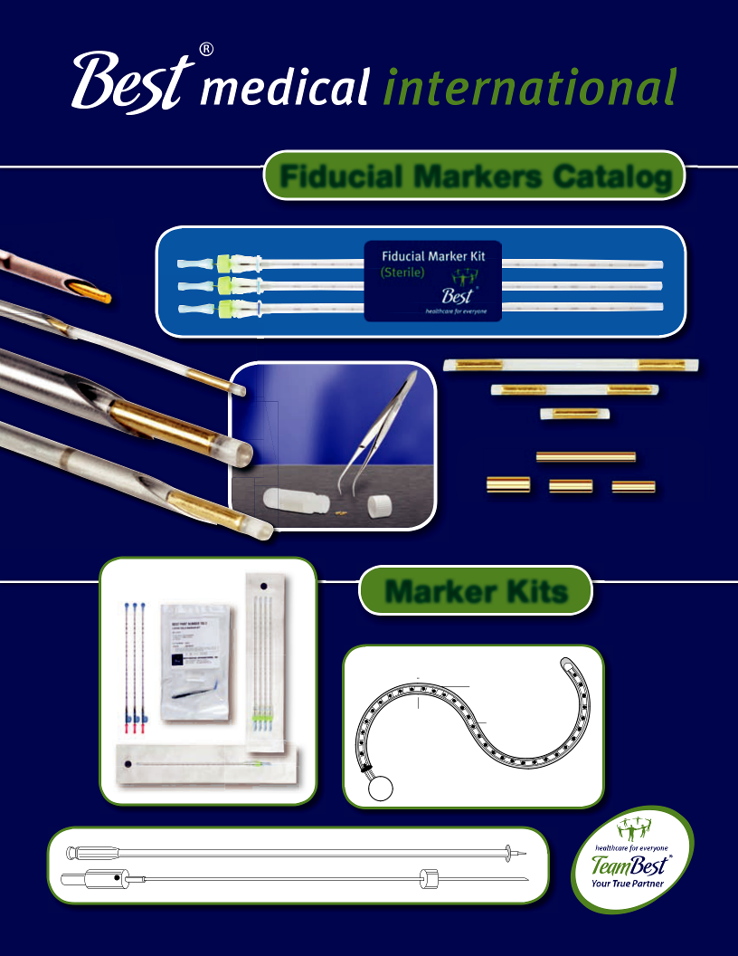

Fiducial Markers Catalog

Marker Kits

Disposable Rubber Sleeve

Adjustable Anus

Marker Rectal

Marker
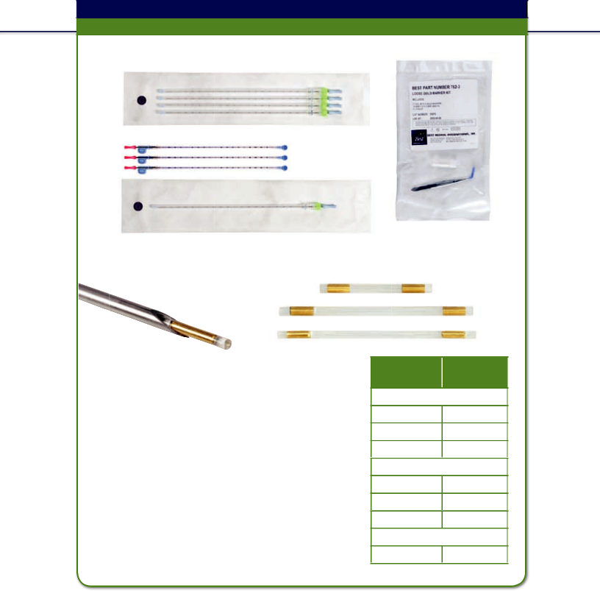
Marker Kit/Gold Fiducial Markers

Accurate localization for soft tissue targets

Best® Fiducial Marker Kit

Sterile Kit of 4 Needles with Marker in Each

Sterile Kit with Single Marker in Needle

Best® Gold Markers

Best Medical’s gold markers are available in a variety of diameters and lengths to meet your needs for soft tissue localization such as prostate, liver, pancreas, lung, and breast.

- Best® gold markers are available now in tissue-absorbable strands (patent pending)

- Standard strand consists of two markers at 2 cm apart center to center

- Special marker strands with custom spacing are also available

- Excellent visualization under X-ray, Fluoro, CT, MRI, Ultrasound and other imaging modalities

- Sold individually, stranded, and in pre-loaded, pre-sterilized needle sets

- Can be used for Brachytherapy, IMRT and IGRT

Sterile Kit with 5 Markers (loose)

Diameters Varying Lengths
0.8 1.5 mm

3 mm

5 mm

7 mm
1.0 mm 1.5 mm

3 mm

5 mm

7 mm
1.2 mm 3 mm

5 mm

!CAUTION: This product should be carefully inspected by your staff prior to clinical use and should be used by authorized personnel only.
© 2013 Best Medical International, Inc.

40



Sterile Loose Gold Markers with Forceps

Part # | Description
782-1 | 0.8 mm Diameter, 3 mm Long (5 markers)
782-2 | 0.8 mm Diameter, 5 mm Long (5 markers)
782-3 | 0.8 mm Diameter, 7 mm Long (5 markers)
782-5 | 0.8 mm Diameter, 1.5 mm Long (5 markers)
784-1 | 1.0 mm Diameter, 3 mm Long (5 markers)
784-2 | 1.0 mm Diameter, 5 mm Long (5 markers)
784-3 | 1.0 mm Diameter, 7 mm Long (5 markers)
784-5 | 1.0 mm Diameter, 1.5 mm Long (5 markers)
785-1 | 1.2 mm Siameter, 3 mm Long (5 markers)
785-2 | 1.2 mm Diameter, 5 mm Long (5 markers)


Sterile Loose Stainless Steel Markers with Forceps

Part # | Description
1700 | Stainless Steel Marker Kit (5 markers)

Sterile Iodine Dummy Sources in a Vial

Part # | Description
10113-50 | 0.8 mm OD, 5 mm Long Iodine Dummy Sources in a Vial in a Pouch

- CAUTION: This product should be carefully inspected by your staff prior to clinical use and should be used by authorized personnel only.

Best Medical International, Inc. 7643 Fullerton Road, Springfield, Virginia 22153 USA
41 Tel: 703-451-2378 800-336-4970 Fax: 703-451-5228 www.bestmedical.com

Sterile Fiducial Marker Kit • 18 GAUGE • 0.8 mm OD 10 cm Long Needle • 1 per pack
Part # Description

1323-1 18 Gauge, 10 cm Long Pre-waxed Needle (1) Preloaded with
0.8 mm OD, 3 mm Long Gold Marker (1)

1323-2 18 Gauge, 10 cm Long Pre-waxed Needle (1) Preloaded with
0.8 mm OD, 5 mm Long Gold Marker (1)

1323-3 18 Gauge, 10 cm Long Pre-waxed Needle (1) Preloaded with
0.8 mm OD, 7 mm Long Gold Marker (1)

1323-5 18 Gauge, 10 cm Long Pre-waxed Needle (1) Preloaded with
0.8 mm OD, 1.5 mm Long Gold Marker (1)


Sterile Fiducial Marker Kit • 18 GAUGE • 0.8 mm OD 10 cm Long Needle • 2 per pack
Part # Description

1428-1 18 Gauge, 10 cm Long Pre-waxed Needles (2) Preloaded with

0.8 mm OD, 3 mm Long Gold Marker (1)

1428-2 18 Gauge, 10 cm Long Pre-waxed Needles (2) Preloaded with

0.8 mm OD, 5 mm Long Gold Marker (1)

1428-3 18 Gauge, 10 cm Long Pre-waxed Needles (2) Preloaded with
0.8 mm OD, 7 mm Long Gold Marker (1)

1428-5 18 Gauge, 10 cm Long Pre-waxed Needles (2) Preloaded with
0.8 mm OD, 1.5 mm Long Gold Marker (1)


Sterile Fiducial Marker Kit • 18 GAUGE • 0.8 mm OD 10 cm Long Needle • 3 per pack
Part # Description

1325-1 18 Gauge, 10 cm Long Pre-waxed Needles (3) Preloaded with
0.8 mm OD, 3 mm Long Gold Marker (1)

1325-2 18 Gauge, 10 cm Long Pre-waxed Needles (3) Preloaded with
0.8 mm OD, 5 mm Long Gold Marker (1)

1325-3 18 Gauge, 10 cm Long Pre-waxed Needles (3) Preloaded with
0.8 mm OD, 7 mm Long Gold Marker (1)

1325-5 18 Gauge, 10 cm Long Pre-waxed Needles (3) Preloaded with
0.8 mm OD, 1.5 mm Long Gold Marker (1)

!CAUTION: This product should be carefully inspected by your staff prior to clinical use and should be used by authorized personnel only.
© 2013 Best Medical International, Inc.

42



Sterile Fiducial Marker Kit • 18 GAUGE • 0.8 mm OD 15 cm Long Needle • Select 1–4 per pack
Part # Description

1643-1-X* 18 Gauge, 15 cm Long Pre-waxed Needle(s) Preloaded with
0.8 mm OD, 3 mm Long Gold Marker (1)

1643-2-X* 18 Gauge, 15 cm Long Pre-waxed Needle(s) Preloaded with
0.8 mm OD, 5 mm Long Gold Marker (1)

1643-3-X* 18 Gauge, 15 cm Long Pre-waxed Needle(s) Preloaded with
0.8 mm OD, 7 mm Long Gold Marker (1)

1643-5-X* 18 Gauge, 15 cm Long Pre-waxed Needle(s) Preloaded with
0.8 mm OD, 1.5 mm Long Gold Marker (1)

- X refers to selected number of needles per pack, maximum 4 needles


Sterile Fiducial Marker Kit • 18 GAUGE • 0.8 mm OD 20 cm Long Needle • 1 per pack

 |  | Part # | Description
 |  | 1004-1 | 18 | Gauge, 20 cm Long Pre-waxed needle (1) Preloaded with
 |  |  | 0.8 mm OD, 3 mm Long Gold Marker (1)
 |  | 1004-2 | 18 | Gauge, 20 cm Long Pre-waxed needle (1) Preloaded with
 |  |  | 0.8 mm OD, 5 mm Long Gold Marker (1)
 |  | 1004-3 | 18 | Gauge, 20 cm Long Pre-waxed needle (1) Preloaded with
 |  |  | 0.8 mm OD, 7 mm Long Gold Marker (1)
 |  | 1004-5 | 18 | Gauge, 20 cm Long Pre-waxed needle (1) Preloaded with
 |  |  | 0.8 mm OD, 1.5 mm Long Gold Marker (1)
 |  | Sterile Fiducial Marker Kit • 18 GAUGE • 0.8 mm OD
 |  | 20 cm Long Needle • 2 per pack
 |  | Part # | Description
 |  | 1430-1 | 18 | Gauge, 20 cm Long Pre-waxed Needles (2) Preloaded with
 |  |  | 0.8 mm OD, 3 mm Long Gold Marker (1)
 |  | 1430-2 | 18 | Gauge, 20 cm Long Pre-waxed Needles (2) Preloaded with
 |  |  | 0.8 mm OD, 5 mm Long Gold Marker (1)
 |  | 1430-3 | 18 | Gauge, 20 cm Long Pre-waxed Needles (2) Preloaded with
! |  |  | 0.8 mm OD, 7 mm Long Gold Marker (1)
! |  | 1430-5 | 18 | Gauge, 20 cm Long Pre-waxed Needles (2) Preloaded with

0.8 mm OD, 1.5 mm Long Gold Marker (1)

CAUTION: This product should be carefully inspected by your staff prior to clinical use and should be used by authorized personnel only.

Best Medical International, Inc. 7643 Fullerton Road, Springfield, Virginia 22153 USA
43 Tel: 703-451-2378 800-336-4970 Fax: 703-451-5228 www.bestmedical.com


Sterile Fiducial Marker Kit • 18 GAUGE • 0.8 mm OD 20 cm Long Needle • 3 per pack
Part # Description

1017-1 18 Gauge, 20 cm Long Pre-waxed Needles (3) Preloaded with
0.8 mm OD, 3 mm Long Gold Marker (1)

1017-2 18 Gauge, 20 cm Long Pre-waxed Needles (3) Preloaded with
0.8 mm OD, 5 mm Long Gold Marker (1)

1017-3 18 Gauge, 20 cm Long Pre-waxed Needles (3) Preloaded with
0.8 mm OD, 7 mm Long Gold Marker (1)

1017-5 18 Gauge, 20 cm Long Pre-waxed Needles (3) Preloaded with
0.8 mm OD, 1.5 mm Long Gold Marker (1)


Sterile Fiducial Marker Kit • 18 GAUGE • 0.8 mm OD 20 cm Long Needle • 4 per pack
Part # Description

1168-1 18 Gauge, 20 cm Long Pre-waxed Needles (4) Preloaded with
0.8 mm OD, 3 mm Long Gold Marker (1)

1168-2 18 Gauge, 20 cm long Pre-waxed needles (4) Preloaded with
0.8 mm OD, 5 mm Long Gold Marker (1)

1168-3 18 Gauge, 20 cm long Pre-waxed needles (4) Preloaded with
0.8 mm OD, 7 mm Long Gold Marker (1)

1168-5 18 Gauge, 15 cm long Pre-waxed needles (4) Preloaded with
0.8 mm OD, 1.5 mm Long Gold Marker (1)

Sterile Fiducial Marker Kit • 18 GAUGE • 0.8 mm OD 30 cm Long Needle • Select 1–4 per pack
Part # Description

1509-1-X* 18 Gauge, 30 cm Long Pre-waxed Needle(s) Preloaded with
0.8 mm OD, 3 mm Long Gold Marker (1)

1509-2-X* 18 Gauge, 30 cm Long Pre-waxed Needle(s) Preloaded with
0.8 mm OD, 5 mm Long Gold Marker (1)

1509-3-X* 18 Gauge, 30 cm Long Pre-waxed Needle(s) Preloaded with
0.8 mm OD, 7 mm Long Gold Marker (1)

1509-5-X* 18 gauge, 30 cm Long Pre-waxed Needle(s) Preloaded with
0.8 mm OD, 1.5 mm Long Gold Marker (1)

- X refers to selected number of needles per pack, maximum 4 needles

!CAUTION: This product should be carefully inspected by your staff prior to clinical use and should be used by authorized personnel only.
© 2013 Best Medical International, Inc.

44



Sterile Fiducial Marker Kit • 18 GAUGE • 1.0 mm OD 10 cm Long Needle • 1 per pack
Part # Description

1318-1 18 Gauge, 10 cm Long Pre-waxed Needle (1) Preloaded with
1.0 mm OD, 3 mm Long Gold Marker (1)

1318-2 18 Gauge, 10 cm Long Pre-waxed Needle (1) Preloaded with
1.0 mm OD, 5 mm Long Gold Marker (1)

1318-3 18 Gauge, 10 cm Long Pre-waxed Needle (1) Preloaded with
1.0 mm OD, 7 mm Long Gold Marker (1)

1318-5 18 Gauge, 10 cm Long Pre-waxed Needle (1) Preloaded with
1.0 mm OD, 1.5 mm Long Gold Marker (1)

Sterile Fiducial Marker Kit • 18 GAUGE • 1.0 mm OD 10 cm Long Needle • 2 per pack
Part # Description

1432-1 18 Gauge, 10 cm Long Pre-waxed Needles (2) Preloaded with
1.0 mm OD, 3 mm Long Gold Marker (1)

1432-2 18 Gauge, 10 cm Long Pre-waxed Needles (2) Preloaded with
1.0 mm OD, 5 mm Long Gold Marker (1)

1432-3 18 Gauge, 10 cm Long Pre-waxed Needles (2) Preloaded with
1.0 mm OD, 7 mm Long Gold Marker (1)

1432-5 18 Gauge, 10 cm Long Pre-waxed Needles (2) Preloaded with
1.0 mm OD, 1.5 mm Long Gold Marker (1)

Sterile Fiducial Marker Kit • 18 GAUGE • 1.0 mm OD 10 cm Long Needle • 3 per pack
Part # Description

1320-1 18 Gauge, 10 cm Long Pre-waxed Needles (3) Preloaded with
1.0 mm OD, 3 mm Long Gold Marker (1)

1320-2 18 Gauge, 10 cm Long Pre-waxed Needles (3) Preloaded with
1.0 mm OD, 5 mm Long Gold Marker (1)

1320-3 18 Gauge, 10 cm Long Pre-waxed Needles (3) Preloaded with
1.0 mm OD, 7 mm Long Gold Marker (1)

1320-5 18 Gauge, 10 cm Long Pre-waxed Needles (3) Preloaded with
1.0 mm OD, 1.5 mm Long Gold Marker (1)

!CAUTION: This product should be carefully inspected by your staff prior to clinical use and should be used by authorized personnel only.

Best Medical International, Inc. 7643 Fullerton Road, Springfield, Virginia 22153 USA
45 Tel: 703-451-2378 800-336-4970 Fax: 703-451-5228 www.bestmedical.com

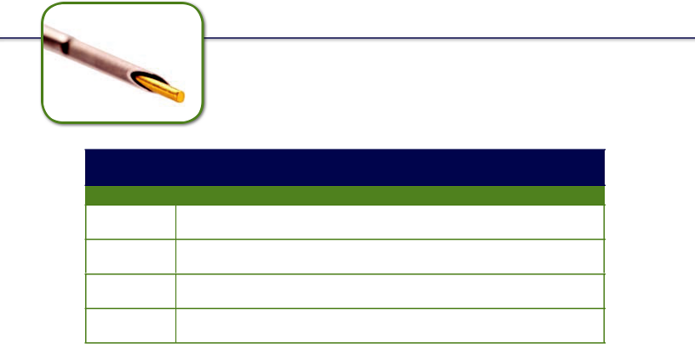

Sterile Fiducial Marker Kit • 18 GAUGE • 1.0 mm OD 10 cm Long Needle • 4 per pack
Part # Description

1713-1 18 Gauge, 10 cm Long Pre-waxed Needles (4) Preloaded with
1.0 mm OD, 3 mm Long Gold Marker (1)

1713-2 18 Gauge, 10 cm Long Pre-waxed Needles (4) Preloaded with
1.0 mm OD, 5 mm Long Gold Marker (1)

1713-3 18 Gauge, 10 cm Long Pre-waxed Needles (4) Preloaded with
1.0 mm OD, 7 mm Long Gold Marker (1)

1713-5 18 Gauge, 10 cm long Pre-waxed Needles (4) Preloaded with
1.0 mm OD, 1.5 mm Long Gold Marker (1)

Sterile Fiducial Marker Kit • 18 GAUGE • 1.0 mm OD 15 cm Long Needle • Select 1–4 per pack
Part # Description

1646-1-X* 18 Gauge, 15 cm Long Pre-waxed Needle(s) Preloaded with
1.0 mm OD, 3 mm Long Gold Marker (1)

1646-2-X* 18 Gauge, 15 cm Long Pre-waxed Needle(s) Preloaded with
1.0 mm OD, 5 mm Long Gold Marker (1)

1646-3-X* 18 Gauge, 15 cm Long Pre-waxed Needle(s) Preloaded with
1.0 mm OD, 7 mm Long Gold Marker (1)

1646-5-X* 18 Gauge, 15 cm Long Pre-waxed Needle(s) Preloaded with
1.0 mm OD, 1.5 mm Long Gold Marker (1)

- X refers to selected number of needles per pack, maximum 4 needles

!CAUTION: This product should be carefully inspected by your staff prior to clinical use and should be used by authorized personnel only.
© 2013 Best Medical International, Inc.

46

Sterile Fiducial Marker Kit • 18 GAUGE • 1.0 mm OD 20 cm Long Needle • 1 per pack
Part # Description

1008-1 18 Gauge, 20 cm Long Pre-waxed Needle (1) Preloaded with
1.0 mm OD, 3 mm Long Gold Marker (1)

1008-2 18 Gauge, 20 cm Long Pre-waxed Needle (1) Preloaded with
1.0 mm OD, 5 mm Long gold marker (1)

1008-3 18 Gauge, 20 cm Long Pre-waxed Needle (1) Preloaded with
1.0 mm OD, 7 mm Long gold marker (1)

1008-5 18 Gauge, 20 cm Long Pre-waxed Needle (1) Preloaded with
1.0 mm OD, 1.5 mm Long Gold Marker (1)

Sterile Fiducial Marker Kit • 18 GAUGE • 1.0 mm OD 20 cm Long Needle • 2 per pack
Part # Description

1434-1 18 Gauge, 20 cm Long Pre-waxed Needles (2) Preloaded with
1.0 mm OD, 3 mm Long Gold Marker (1)

1434-2 18 Gauge, 20 cm Long Pre-waxed Needles (2) Preloaded with
1.0 mm OD, 5 mm Long Gold Marker (1)

1434-3 18 Gauge, 20 cm Long Pre-waxed Needles (2) Preloaded with
1.0 mm OD, 7 mm Long Gold Marker (1)

1434-5 18 Gauge, 20 cm Long Pre-waxed Needles (2) Preloaded with
1.0 mm OD, 1.5 mm Long Gold Marker (1)

Sterile Fiducial Marker Kit • 18 GAUGE • 1.0 mm OD 20 cm Long Needle • 3 per pack
Part # Description

1019-1 18 Gauge, 20 cm Long Pre-waxed Needles (3) Preloaded with
1.0 mm OD, 3 mm Long Gold Marker (1)

1019-2 18 Gauge, 20 cm Long Pre-waxed Needles (3) Preloaded with
1.0 mm OD, 5 mm Long Gold Marker (1)

1019-3 18 Gauge, 20 cm Long Pre-waxed Needles (3) Preloaded with
1.0 mm OD, 7 mm Long Gold Marker (1)

- 1019-518 Gauge, 20 cm Long Pre-waxed Needles (3) Preloaded with 1.0 mm OD, 1.5 mm Long Gold Marker (1)CAUTION:Thisproductshouldbecarefullyinspectedbyyourstaffpriortoclinicaluseandshouldbeusedbyauthorizedpersonnelonly.

Best Medical International, Inc. 7643 Fullerton Road, Springfield, Virginia 22153 USA
47 Tel: 703-451-2378 800-336-4970 Fax: 703-451-5228 www.bestmedical.com

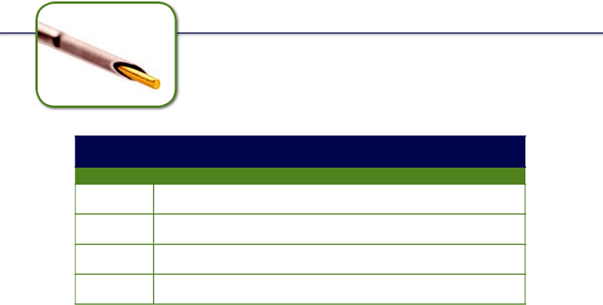

Sterile Fiducial Marker Kit • 18 GAUGE • 1.0 mm OD 20 cm Long Needle • 4 per pack
Part # Description

1170-1 18 Gauge, 20 cm Long Pre-waxed Needles (4) Preloaded with
1.0 mm OD, 3 mm Long Gold Marker (1)

1170-2 18 Gauge, 20 cm Long Pre-waxed Needles (4) Preloaded with
1.0 mm OD, 5 mm Long Gold Marker (1)

1170-3 18 Gauge, 20 cm Long Pre-waxed Needles (4) Preloaded with
1.0 mm OD, 7 mm Long Gold Marker (1)

1170-5 18 Gauge, 20 cm Long Pre-waxed Needles (4) Preloaded with
1.0 mm OD, 1.5 mm Long Gold Marker (1)

Sterile Fiducial Marker Kit • 18 GAUGE • 1.0 mm OD 30 cm Long Needle • Select 1–4 per pack
Part # Description

1512-1-X* 18 Gauge, 30 cm Long Pre-waxed Needle(s) Preloaded with
1.0 mm OD, 3 mm Long Gold Marker (1)

1512-2-X* 18 Gauge, 30 cm Long Pre-waxed Needle(s) Preloaded with
1.0 mm OD, 5 mm Long Gold Marker (1)

1512-3-X* 18 Gauge, 30 cm Long Pre-waxed Needle(s) Preloaded with
1.0 mm OD, 7 mm Long Gold Marker (1)

1512-5-X* 18 Gauge, 30 cm Long Pre-waxed Needle(s) Preloaded with
1.0 mm OD, 1.5 mm Long Gold Marker (1)

- X refers to selected number of needles per pack, maximum 4 needles

!CAUTION: This product should be carefully inspected by your staff prior to clinical use and should be used by authorized personnel only.
© 2013 Best Medical International, Inc.

48



Sterile Fiducial Marker Kit • 17 GAUGE • 1.2 mm OD 20 cm Long Needle • 1 per pack
Part # Description

1088-1 17 Gauge, 20 cm Long Pre-waxed Needle (1) Preloaded with
1.2 mm OD, 3 mm Long gold marker (1)

1088-2 17 Gauge, 20 cm Long Pre-waxed Needle (1) Preloaded with
1.2 mm OD, 5 mm Long Gold Marker (1)

Sterile Fiducial Marker Kit • 17 GAUGE • 1.2 mm OD 20 cm Long Needle • 2 per pack
Part # Description

1436-1 17 Gauge, 20 cm Long Pre-waxed Needles (2) Preloaded with
1.2 mm OD, 3 mm Long Gold Marker (1)

1436-2 17 Gauge, 20 cm Long Pre-waxed Needles (2) Preloaded with
1.2 mm OD, 5 mm Long Gold Marker (1)

Sterile Fiducial Marker Kit • 17 GAUGE • 1.2 mm OD 20 cm Long Needle • 3 per pack
Part # Description

1090-1 17 Gauge, 20 cm Long Pre-waxed Needles (3) Preloaded with
1.2 mm OD, 3 mm Long Gold Marker (1)

1090-2 17 Gauge, 20 cm Long Pre-waxed Needles (3) Preloaded with
1.2 mm OD, 5 mm Long Gold Marker (1)

Sterile Fiducial Marker Kit • 17 GAUGE • 1.2 mm OD 20 cm Long Needle • 4 per pack
Part # Description

1172-1 17 Gauge, 20 cm Long Pre-waxed Needles (4) Preloaded with
1.2 mm OD, 3 mm Long Gold Marker (1)

1172-2 17 Gauge, 20 cm Long Pre-waxed Needles (4) Preloaded with
1.2 mm OD, 5 mm Long Gold Marker (1)

- CAUTION: This product should be carefully inspected by your staff prior to clinical use and should be used by authorized personnel only.

Best Medical International, Inc. 7643 Fullerton Road, Springfield, Virginia 22153 USA
49 Tel: 703-451-2378 800-336-4970 Fax: 703-451-5228 www.bestmedical.com

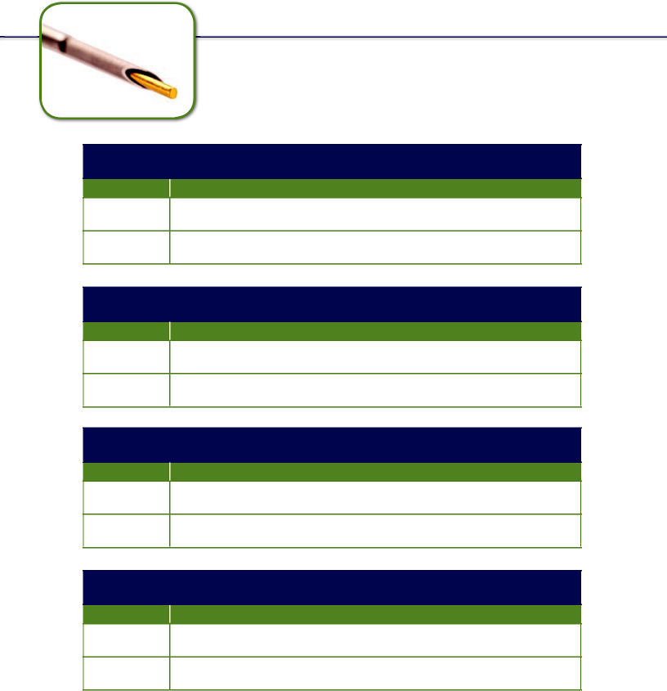© 2013 Best Medical International, Inc.
!CAUTION: This product should be carefully inspected by your staff prior to clinical use and should be used by authorized personnel only.
1662-2
17 Gauge, 30 cm Long Pre-waxed Needles (4) Preloaded with 1.2 mm OD, 5 mm Long Gold Marker (1)
1662-1
17 gauge, 30 cm Long Pre-waxed Needles (4) Preloaded with 1.2 mm OD, 3 mm Long Gold Marker (1)
Part #
Description
Sterile Fiducial Marker Kit • 17 GAUGE • 1.2 mm OD 30 cm Long Needle • 4 per pack
1033-2
17 Gauge, 30 cm Long Pre-waxed Needles (3) Preloaded with 1.2 mm OD, 3 mm Long Gold Marker (1)
17 Gauge, 30 cm Long Pre-waxed Needles (3) Preloaded with 1.2 mm OD, 5 mm Long Gold Marker (1)
Part #
1033-1
Description
Sterile Fiducial Marker Kit • 17 GAUGE • 1.2 mm OD 30 cm Long Needle • 3 per pack
1438-2
17 Gauge, 30 cm Long Pre-waxed Needles (2) Preloaded with 1.2 mm OD, 5 mm Long Gold Marker (1)
1438-1
17 Gauge, 30 cm Long Pre-waxed Needles (2) Preloaded with 1.2 mm OD, 3 mm Long Gold Marker (1)
Part #
Description
Sterile Fiducial Marker Kit • 17 GAUGE • 1.2 mm OD 30 cm Long Needle • 2 per pack
1031-2
17 Gauge, 30 cm Long Pre-waxed Needle (1) Preloaded with 1.2 mm OD, 5 mm Long Gold Marker (1)
1031-1
17 Gauge, 30 cm Long Pre-waxed Needle (1) Preloaded with 1.2 mm OD, 3 mm Long Gold Marker (1)
Part #
Description
Sterile Fiducial Marker Kit • 17 GAUGE • 1.2 mm OD 30 cm Long Needle • 1 per pack

50

Sterile Fiducial Marker STRAND Kit • 18 GAUGE • 0.8 mm OD 10 cm Long Needle • 1 per pack
Part # Description

1293-1-X* 18 Gauge, 10 cm Long Pre-waxed Needle (1) Preloaded with Absorbable Strand Enclosing 0.8 mm OD, 3 mm Long Gold Marker(s)

1293-2-X* 18 Gauge, 10 cm Long Pre-waxed Needle (1) Preloaded with Absorbable Strand Enclosing 0.8 mm OD, 5 mm Long Gold Marker(s)

1293-3-X* 18 Gauge, 10 cm Long Pre-waxed Needle (1) Preloaded with Absorbable Strand Enclosing 0.8 mm OD, 7 mm Long Gold Marker(s)

1293-5-X* 18 Gauge, 10 cm Long Pre-waxed Needle (1) Preloaded with Absorbable Strand Enclosing 0.8 mm OD, 1.5 mm Long Gold Marker(s)

- X refers to selected number of markers per needle


Sterile Fiducial Marker STRAND Kit • 18 GAUGE • 0.8 mm OD 10 cm Long Needle • 2 per pack

 |  | Part # | Description
 |  | 1440-1-X* | 18 Gauge, 10 cm Long Pre-waxed Needles (2) Preloaded with
 |  |  | Absorbable Strand Enclosing 0.8 mm OD, 3 mm Long Gold Marker(s)
 |  | 1440-2-X* | 18 Gauge, 10 cm Long Pre-waxed Needles (2) Preloaded with
 |  |  | Absorbable Strand Enclosing 0.8 mm OD, 5 mm Long Gold Marker(s)
 |  | 1440-3-X* | 18 Gauge, 10 cm Long Pre-waxed Needles (2) Preloaded with
 |  |  | Absorbable Strand Enclosing 0.8 mm OD, 7 mm Long Gold Marker(s)
 |  | 1440-5-X* | 18 Gauge, 10 cm Long Pre-waxed Needles (2) Preloaded with
 |  |  | Absorbable Strand Enclosing 0.8 mm OD, 1.5 mm Long Gold Marker(s)
 |  | * X refers to selected number of markers per needle
 |  | Sterile Fiducial Marker STRAND Kit • 18 GAUGE • 0.8 mm OD
 |  | 10 cm Long Needle • 3 per pack
 |  | Part # | Description
 |  | 1295-1-X* | 18 Gauge, 10 cm Long Pre-waxed Needles (3) Preloaded with
 |  |  | Absorbable Strand Enclosing 0.8 mm OD, 3 mm Long Gold Marker(s)
 |  | 1295-2-X* | 18 Gauge, 10 cm Long Pre-waxed Needles (3) Preloaded with
 |  |  | Absorbable Strand Enclosing 0.8 mm OD, 5 mm Long Gold Marker(s)
! |  | 1295-3-X* | 18 Gauge, 10 cm Long Pre-waxed Needles (3) Preloaded with
! |  |  | Absorbable Strand Enclosing 0.8 mm OD, 7 mm Long Gold Marker(s)
 |  | 1295-5-X* | 18 Gauge, 10 cm Long Pre-waxed Needles (3) Preloaded with
 |  |  | Absorbable Strand Enclosing 0.8 mm OD, 1.5 mm Long Gold Marker(s)


CAUTION: This product should be carefully inspected by your staff * X refers to selected number of markers per needle
prior to clinical use and should be used by authorized personnel only.

Best Medical International, Inc. 7643 Fullerton Road, Springfield, Virginia 22153 USA
51 Tel: 703-451-2378 800-336-4970 Fax: 703-451-5228 www.bestmedical.com

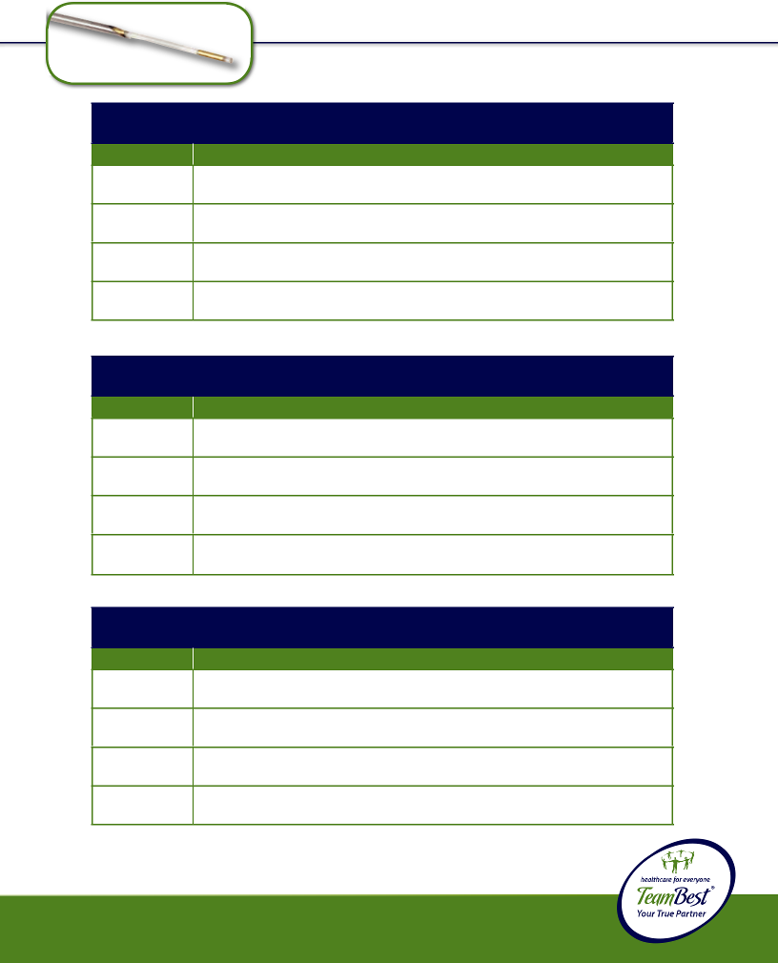© 2013 Best Medical International, Inc.
* X refers to selected number of markers per needle
1653-5-X*
18 Gauge, 15 cm long Pre-waxed Needles (3) Preloaded with Absorbable Strand Enclosing 0.8 mm OD, 1.5 mm Long Gold Marker(s)
!CAUTION: This product should be carefully inspected by your staff prior to clinical use and should be used by authorized personnel only.
1653-3-X*
18 Gauge, 15 cm Long Pre-waxed Needles (3) Preloaded with Absorbable Strand Enclosing 0.8 mm OD, 7 mm Long Gold Marker(s)
1653-2-X*
18 Gauge, 15 cm Long Pre-waxed Needles (3) Preloaded with Absorbable Strand Enclosing 0.8 mm OD, 5 mm Long Gold Marker(s)
1653-1-X*
18 Gauge, 15 cm Long Pre-waxed Needles (3) Preloaded with Absorbable Strand Enclosing 0.8 mm OD, 3 mm Long Gold Marker(s
Part #
Description
* X refers to selected number of markers per needle
Sterile Fiducial Marker STRAND Kit • 18 GAUGE • 0.8 mm OD 15 cm Long Needle • 3 per pack
1651-5-X*
18 Gauge, 15 cm Long Pre-waxed Needles (2) Preloaded with Absorbable Strand Enclosing 0.8 mm OD, 1.5 mm Long Gold Marker(s)
1651-3-X*
18 Gauge, 15 cm Long Pre-waxed Needles (2) Preloaded with Absorbable Strand Enclosing 0.8 mm OD, 7 mm Long Gold Marker(s)
1651-2-X*
18 Gauge, 15 cm Long Pre-waxed Needles (2) Preloaded with Absorbable Strand Enclosing 0.8 mm OD, 5 mm Long Gold Marker(s)
1651-1-X*
Description
18 Gauge, 15 cm Long Pre-waxed Needles (2) Preloaded with Absorbable Strand Enclosing 0.8 mm OD, 3 mm Long Gold Marker(s)
Part #
* X refers to selected number of markers per needle
Sterile Fiducial Marker STRAND Kit • 18 GAUGE • 0.8 mm OD 15 cm Long Needle • 2 per pack
1649-5-X*
18 Gauge, 15 cm Long Pre-waxed Needle (1) Preloaded with Absorbable Strand Enclosing 0.8 mm OD, 1.5 mm Long Gold Marker(s)
1649-3-X*
18 Gauge, 15 cm Long Pre-waxed Needle (1) Preloaded with Absorbable Strand Enclosing 0.8 mm OD, 7 mm Long Gold Marker(s)
1649-2-X*
18 Gauge, 15 cm Long Pre-waxed Needle (1) Preloaded with Absorbable Strand Enclosing 0.8 mm OD, 5 mm Long Gold Marker(s)
1649-1-X*
Description
18 Gauge, 15 cm Long Pre-waxed Needle (1) Preloaded with Absorbable Strand Enclosing 0.8 mm OD, 3 mm Long Gold Marker(s)
Part #
Sterile Fiducial Marker STRAND Kit • 18 GAUGE • 0.8 mm OD 15 cm Long Needle • 1 per pack

52


Sterile Fiducial Marker STRAND Kit • 18 GAUGE • 0.8 mm OD 20 cm Long Needle • 1 per pack
Part # Description

1013-1-X* 18 Gauge, 20 cm Long Pre-waxed Needle (1) Preloaded with Absorbable Strand Enclosing 0.8 mm OD, 3 mm Long Gold Marker(s)

1013-2-X* 18 Gauge, 20 cm Long Pre-waxed Needle (1) Preloaded with Absorbable Strand Enclosing 0.8 mm OD, 5 mm Long Gold Marker(s)

1013-3-X* 18 Gauge, 20 cm Long Pre-waxed Needle (1) Preloaded with absorbable strand enclosing 0.8 mm OD, 7 mm Long Gold Marker(s)

1013-5-X* 18 Gauge, 20 cm Long Pre-waxed Needle (1) Preloaded with Absorbable Strand Enclosing 0.8 mm OD, 1.5 mm Long Gold Marker(s)

- X refers to selected number of markers per needle

Sterile Fiducial Marker STRAND Kit • 18 GAUGE • 0.8 mm OD 20 cm Long Needle • 2 per pack
Part # Description

1442-1-X* 18 Gauge, 20 cm Long Pre-waxed Needles (2) Preloaded with Absorbable Strand Enclosing 0.8 mm OD, 3 mm Long Gold Marker(s)

1442-2-X* 18 Gauge, 20 cm Long Pre-waxed Needles (2) Preloaded with Absorbable Strand Enclosing 0.8 mm OD, 5 mm Long Gold Marker(s)

1442-3-X* 18 Gauge, 20 cm Long Pre-waxed Needles (2) Preloaded with Absorbable Strand Enclosing 0.8 mm OD, 7 mm Long Gold Marker(s)

1442-5-X* 18 Gauge, 20 cm Long Pre-waxed Needles (2) Preloaded with Absorbable Strand Enclosing 0.8 mm OD, 1.5 mm Long Gold Marker(s)

- X refers to selected number of markers per needle

Sterile Fiducial Marker STRAND Kit • 18 GAUGE • 0.8 mm OD 20 cm Long Needle • 3 per pack
Part # Description

1015-1-X* 18 Gauge, 20 cm Long Pre-waxed Needles (3) Preloaded with Absorbable Strand Enclosing 0.8 mm OD, 3 mm Long Gold Marker(s)

1015-2-X* 18 Gauge, 20 cm Long Pre-waxed Needles (3) Preloaded with Absorbable Strand Enclosing 0.8 mm OD, 5 mm Long Gold Marker(s)

1015-3-X* 18 Gauge, 20 cm Long Pre-waxed Needles (3) Preloaded with ! Absorbable Strand Enclosing 0.8 mm OD, 7 mm Long Gold Marker(s)

1015-5-X* 18 Gauge, 20 cm Long Pre-waxed Needles (3) Preloaded with Absorbable Strand Enclosing 0.8 mm OD, 1.5 mm Long Gold Marker(s)

CAUTION:*XrefersThistoselectedproductnumbershould ofbemarkcarersfullyperinspectedneedle by your staff prior to clinical use and should be used by authorized personnel only.

Best Medical International, Inc. 7643 Fullerton Road, Springfield, Virginia 22153 USA
53 Tel: 703-451-2378 800-336-4970 Fax: 703-451-5228 www.bestmedical.com

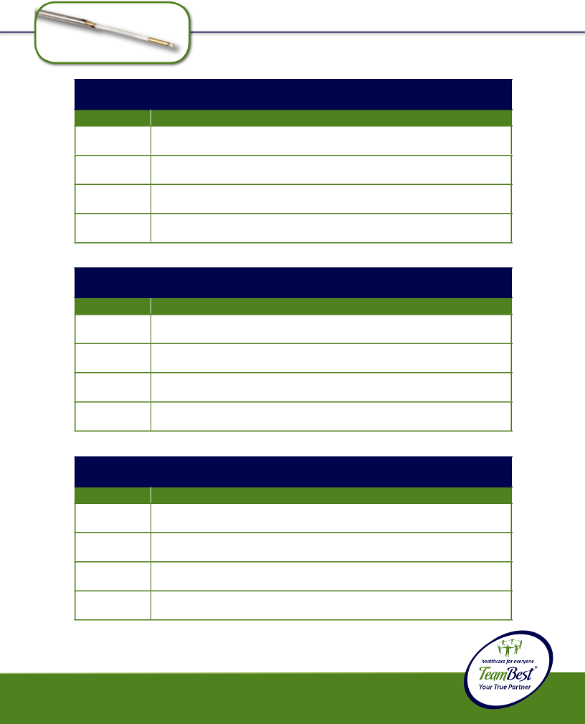© 2013 Best Medical International, Inc.
* X refers to selected number of markers per needle
1132-5-X*
17 Gauge, 30 cm Long Pre-waxed Needles (3) Preloaded with Absorbable Strand Enclosing 0.8 mm OD, 1.5 mm Long Gold Marker(s)
!CAUTION: This product should be carefully inspected by your staff prior to clinical use and should be used by authorized personnel only.
1132-3-X*
17 Gauge, 30 cm Long Pre-waxed Needles (3) Preloaded with Absorbable Strand Enclosing 0.8 mm OD, 7 mm Long Gold Marker(s)
1132-2-X*
17 Gauge, 30 cm Long Pre-waxed Needles (3) Preloaded with Absorbable Strand Enclosing 0.8 mm OD, 5 mm Long Gold Marker(s)
1132-1-X*
Description
17 Gauge, 30 cm Long Pre-waxed Needles (3) Preloaded with Absorbable Strand Enclosing 0.8 mm OD, 3 mm Long Gold Marker(s)
Part #
* X refers to selected number of markers per needle
Sterile Fiducial Marker STRAND Kit • 17 GAUGE • 0.8 mm OD 30 cm Long Needle • 3 per pack
1444-5-X*
17 Gauge, 30 cm Long Pre-waxed Needles (2) Preloaded with Absorbable Strand Enclosing 0.8 mm OD, 1.5 mm Long Gold Marker(s)
1444-3-X*
17 Gauge, 30 cm Long Pre-waxed Needles (2) Preloaded with Absorbable Strand Enclosing 0.8 mm OD, 7 mm Long Gold Marker(s)
1444-2-X*
17 Gauge, 30 cm Long Pre-waxed Needles (2) Preloaded with Absorbable Strand Enclosing 0.8 mm OD, 5 mm Long Gold Marker(s)
1444-1-X*
Description
17 Gauge, 30 cm Long Pre-waxed Needles (2) Preloaded with Absorbable Strand Enclosing 0.8 mm OD, 3 mm Long Gold Marker(s)
Part #
* X refers to selected number of markers per needle
Sterile Fiducial Marker STRAND Kit • 17 GAUGE • 0.8 mm OD 30 cm Long Needle • 2 per pack
1130-5-X*
17 Gauge, 30 cm Long Pre-waxed Needle (1) Preloaded with Absorbable Strand Enclosing 0.8 mm OD, 1.5 mm Long Gold Marker(s)
1130-3-X*
17 Gauge, 30 cm Long Pre-waxed Needle (1) Preloaded with Absorbable Strand Enclosing 0.8 mm OD, 7 mm Long Gold Marker(s)
1130-2-X*
17 Gauge, 30 cm Long Pre-waxed Needle (1) Preloaded with Absorbable Strand Enclosing 0.8 mm OD, 5 mm Long Gold Marker(s)
1130-1-X*
17 Gauge, 30 cm Long Pre-waxed Needle (1) Preloaded with Absorbable Strand Enclosing 0.8 mm OD, 3 mm Long Gold Marker(s)
Part #
Description
Sterile Fiducial Marker STRAND Kit • 17 GAUGE • 0.8 mm OD 30 cm Long Needle • 1 per pack

54

Sterile Fiducial Marker STRAND Kit • 17 GAUGE • 1.0 mm OD 10 cm Long Needle • 1 per pack
Part # Description

1357-1-X* 17 Gauge, 10 cm Long Pre-waxed Needle (1) Preloaded with Absorbable Strand Enclosing 1.0 mm OD, 3 mm Long Gold Marker(s)

1357-2-X* 17 Gauge, 10 cm Long Pre-waxed Needle (1) Preloaded with Absorbable Strand Enclosing 1.0 mm OD, 5 mm Long Gold Marker(s)

1357-3-X* 17 Gauge, 10 cm Long Pre-waxed Needle (1) Preloaded with Absorbable Strand Enclosing 1.0 mm OD, 7 mm Long Gold Marker(s)

1357-5-X* 17 Gauge, 10 cm Long Pre-waxed Needle (1) Preloaded with Absorbable Strand Enclosing 1.0 mm OD, 1.5 mm Long Gold Marker(s)

- X refers to selected number of markers per needle


Sterile Fiducial Marker STRAND Kit • 17 GAUGE • 1.0 mm OD 10 cm Long Needle • 2 per pack

 |  | Part # | Description
 |  | 1446-1-X* | 17 Gauge, 10 cm Long Pre-waxed Needles (2) Preloaded with
 |  |  | Absorbable Strand Enclosing 1.0 mm OD, 3 mm Long Gold Marker(s)
 |  | 1446-2-X* | 17 Gauge, 10 cm Long Pre-waxed Needles (2) Preloaded with
 |  |  | Absorbable Strand Enclosing 1.0 mm OD, 5 mm Long Gold Marker(s)
 |  | 1446-3-X* | 17 Gauge, 10 cm Long Pre-waxed Needles (2) Preloaded with
 |  |  | Absorbable Strand Enclosing 1.0 mm OD, 7 mm Long Gold Marker(s)
 |  | 1446-5-X* | 17 Gauge, 10 cm Long Pre-waxed Needles (2) Preloaded with
 |  |  | Absorbable Strand Enclosing 1.0 mm OD, 1.5 mm Long Gold Marker(s)
 |  | * X refers to selected number of markers per needle
 |  | Sterile Fiducial Marker STRAND Kit • 17 GAUGE • 1.0 mm OD
 |  | 10 cm Long Needle • 3 per pack
 |  | Part # | Description
 |  | 1359-1-X* | 17 Gauge, 10 cm Long Pre-waxed Needles (3) Preloaded with
 |  |  | Absorbable Strand Enclosing 1.0 mm OD, 3 mm Long Gold Marker(s)
 |  | 1359-2-X* | 17 Gauge, 10 cm Long Pre-waxed Needles (3) Preloaded with
 |  |  | Absorbable Strand Enclosing 1.0 mm OD, 5 mm Long Gold Marker(s)
! |  | 1359-3-X* | 17 Gauge, 10 cm Long Pre-waxed Needles (3) Preloaded with
! |  |  | Absorbable Strand Enclosing 1.0 mm OD, 7 mm Long Gold Marker(s)
 |  | 1359-5-X* | 17 Gauge, 10 cm Long Pre-waxed Needles (3) Preloaded with
 |  |  | Absorbable Strand Enclosing 1.0 mm OD, 1.5 mm Long Gold Marker(s)

* X refers to selected number of markers per needle
CAUTION: This product should be carefully inspected by your staff prior to clinical use and should be used by authorized personnel only.

Best Medical International, Inc. 7643 Fullerton Road, Springfield, Virginia 22153 USA
55 Tel: 703-451-2378 800-336-4970 Fax: 703-451-5228 www.bestmedical.com

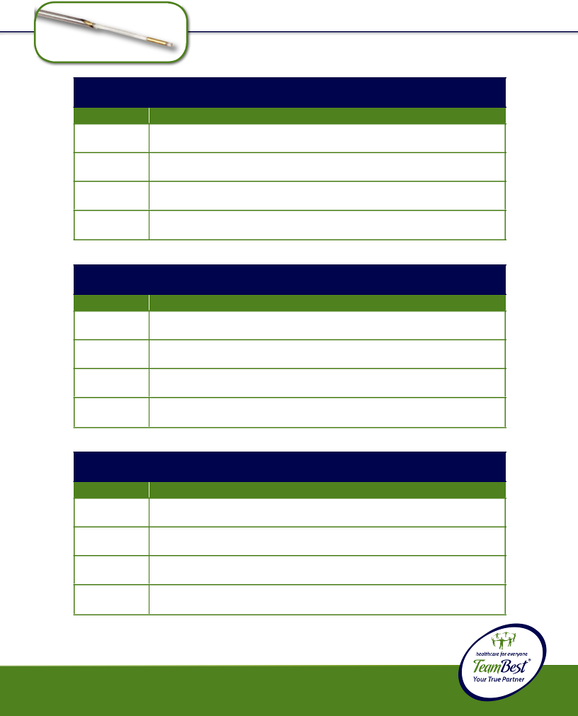© 2013 Best Medical International, Inc.
* X refers to selected number of markers per needle
1270-5-X*
17 Gauge, 20 cm Long Pre-waxed Needles (3) Preloaded with Absorbable Strand Enclosing 1.0 mm OD, 1.5 mm Long Gold Marker(s)
!CAUTION: This product should be carefully inspected by your staff prior to clinical use and should be used by authorized personnel only.
1270-3-X*
17 Gauge, 20 cm Long Pre-waxed Needles (3) Preloaded with Absorbable Strand Enclosing 1.0 mm OD, 7 mm Long Gold Marker(s)
1270-2-X*
17 Gauge, 20 cm Long Pre-waxed Needles (3) Preloaded with Absorbable Strand Enclosing 1.0 mm OD, 5 mm Long Gold Marker(s)
1270-1-X*
Description
17 Gauge, 20 cm Long Pre-waxed Needles (3) Preloaded with Absorbable Strand Enclosing 1.0 mm OD, 3 mm Long Gold Marker(s)
Part #
* X refers to selected number of markers per needle
Sterile Fiducial Marker STRAND Kit • 17 GAUGE • 1.0 mm OD 20 cm Long Needle • 3 per pack
1448-5-X*
17 Gauge, 20 cm Long Pre-waxed Needles (2) Preloaded with Absorbable Strand Enclosing 1.0 mm OD, 1.5 mm Long Gold Marker(s)
1448-3-X*
17 Gauge, 20 cm Long Pre-waxed Needles (2) Preloaded with Absorbable Strand Enclosing 1.0 mm OD, 7 mm Long Gold Marker(s)
1448-2-X*
17 Gauge, 20 cm Long Pre-waxed Needles (2) Preloaded with Absorbable Strand Enclosing 1.0 mm OD, 5 mm Long Gold Marker(s)
1448-1-X*
Description
17 Gauge, 20 cm Long Pre-waxed Needles (2) Preloaded with Absorbable Strand Enclosing 1.0 mm OD, 3 mm Long Gold Marker(s)
Part #
* X refers to selected number of markers per needle
Sterile Fiducial Marker STRAND Kit • 17 GAUGE • 1.0 mm OD 20 cm Long Needle • 2 per pack
1268-5-X*
17 Gauge, 20 cm Long Pre-waxed Needle (1) Preloaded with Absorbable Strand Enclosing 1.0 mm OD, 1.5 mm Long Gold Marker(s)
1268-3-X*
17 Gauge, 20 cm Long Pre-waxed Needle (1) Preloaded with Absorbable Strand Enclosing 1.0 mm OD, 7 mm Long Gold Marker(s)
1268-2-X*
17 Gauge, 20 cm Long Pre-waxed Needle (1) Preloaded with Absorbable Strand Enclosing 1.0 mm OD, 5 mm Long Gold Marker(s)
1268-1-X*
17 Gauge, 20 cm Long Pre-waxed Needle (1) Preloaded with Absorbable Strand Enclosing 1.0 mm OD, 3 mm Long Gold Marker(s)
Part #
Description
Sterile Fiducial Marker STRAND Kit • 17 GAUGE • 1.0 mm OD 20 cm Long Needle • 1 per pack

56

Sterile Fiducial Marker STRAND Kit • 16 GAUGE • 1.2 mm OD 20 cm Long Needle • 1 per pack
Part # Description

1329-1-X* 16 Gauge, 20 cm Long Pre-waxed Needle (1) Preloaded with Absorbable Strand Enclosing 1.2 mm OD, 3 mm Long Gold Marker(s)

1329-2-X* 16 Gauge, 20 cm Long Pre-waxed Needle (1) Preloaded with Absorbable Strand Enclosing 1.2 mm OD, 5 mm Long Gold Marker(s)

- X refers to selected number of markers per needle


Sterile Fiducial Marker STRAND Kit • 16 GAUGE • 1.2 mm OD 20 cm Long Needle • 2 per pack
Part # Description

1450-1-X* 16 Gauge, 20 cm Long Pre-waxed Needles (2) Preloaded with Absorbable Strand Enclosing 1.2 mm OD, 3 mm Long Gold Marker(s)

1450-2-X* 16 Gauge, 20 cm Long Pre-waxed Needles (2) Preloaded with Absorbable Strand Enclosing 1.2 mm OD, 5 mm Long Gold Marker(s)

- X refers to selected number of markers per needle

Sterile Fiducial Marker STRAND Kit • 16 GAUGE • 1.2 mm OD 20 cm Long Needle • 3 per pack
Part # Description

1331-1-X* 16 Gauge, 20 cm Long Pre-waxed Needles (3) Preloaded with Absorbable Strand Enclosing 1.2 mm OD, 3 mm Long Gold Marker(s)

1331-2-X* 16 Gauge, 20 cm Long Pre-waxed Needles (3) Preloaded with Absorbable Strand Enclosing 1.2 mm OD, 5 mm Long Gold Marker(s)

- X refers to selected number of markers per needle

- CAUTION: This product should be carefully inspected by your staff prior to clinical use and should be used by authorized personnel only.

Best Medical International, Inc. 7643 Fullerton Road, Springfield, Virginia 22153 USA
57 Tel: 703-451-2378 800-336-4970 Fax: 703-451-5228 www.bestmedical.com


Sterile ROUND HUB Needles with

Iodine Dummy Seeds in Strand • 18 GAUGE • 0.8 mm OD 10 cm Long Needle • 1 per pack
Part # Description

10113-26-X* 18 Gauge, 10 cm Long Pre-waxed Needle (1) Preloaded with Absorbable Strand Enclosing 0.8 mm OD, 5 mm Long Iodine Dummy Seed(s)

- X refers to selected number of dummy seeds per needle


Sterile ROUND HUB Needles with

Iodine Dummy Seeds in Strand • 18 GAUGE • 0.8 mm OD 10 cm Long Needle • 3 per pack

Part # | Description
10113-31-X* | 18 Gauge, 10 cm Long Pre-waxed Needles (3) Preloaded with
 | Absorbable Strand Enclosing 0.8 mm OD, 5 mm Long Iodine
 | Dummy Seed(s)

- X refers to selected number of dummy seeds per needle

Sterile ROUND HUB Needles with

Iodine Dummy Seeds in Strand • 18 GAUGE • 0.8 mm OD 15 cm Long Needle • 1 per pack

Part # | Description
10113-29-X* | 18 Gauge, 15 cm Long Pre-waxed Needle (1) Preloaded with
 | Absorbable Strand Enclosing 0.8 mm OD, 5 mm Long Iodine
 | Dummy Seed(s)

- X refers to selected number of dummy seeds per needle

!CAUTION: This product should be carefully inspected by your staff prior to clinical use and should be used by authorized personnel only.
© 2013 Best Medical International, Inc.

58

Sterile ROUND HUB Needles with

Iodine Dummy Seeds in Strand • 18 GAUGE • 0.8 mm OD 15 cm Long Needle • 3 per pack

Part # | Description
10113-33-X* | 18 Gauge, 15 cm Long Pre-waxed Needles (3) Preloaded with
 | Absorbable Strand Enclosing 0.8 mm OD, 5 mm Long Iodine
 | Dummy Seed(s)

- X refers to selected number of dummy seeds per needle

Sterile ROUND HUB Needles with

Iodine Dummy Seeds in Strand • 18 GAUGE • 0.8 mm OD 20 cm Long Needle • 1 per pack

Part # | Description
10113-46-X* | 18 Gauge, 20 cm Long Pre-waxed Needle (1) Preloaded with
 | Absorbable Strand Enclosing 0.8 mm OD, 5 mm Long Iodine
 | Dummy Seed(s)

- X refers to selected number of dummy seeds per needle

Sterile ROUND HUB Needles with

Iodine Dummy Seeds in Strand • 18 GAUGE • 0.8 mm OD 20 cm Long Needle • 3 per pack

Part # | Description
10113-48-X* | 18 Gauge, 20 cm Long Pre-waxed Needles (3) Preloaded with
 | Absorbable Strand Enclosing 0.8 mm OD, 5 mm Long Iodine
 | Dummy Seed(s)

- X refers to selected number of dummy seeds per needle

- CAUTION: This product should be carefully inspected by your staff prior to clinical use and should be used by authorized personnel only.

Best Medical International, Inc. 7643 Fullerton Road, Springfield, Virginia 22153 USA
59 Tel: 703-451-2378 800-336-4970 Fax: 703-451-5228 www.bestmedical.com


Sterile SQUARE HUB Needles with

Iodine Dummy Seeds in Strand • 18 GAUGE • 0.8 mm OD 10 cm Long Needle • 1 per pack

Part # | Description
10113-36-X* | 18 Gauge, 10 cm Long Pre-waxed Needle (1) Preloaded with
 | Absorbable Strand Enclosing 0.8 mm O.D, 5 mm Long Iodine
 | Dummy Seed(s)

- X refers to selected number of dummy seeds per needle

Sterile SQUARE HUB Needles with

Iodine Dummy Seeds in Strand • 18 GAUGE • 0.8 mm OD 10 cm Long Needle • 3 per pack

Part # | Description
10113-38-X* | 18 Gauge, 10 cm Long Pre-waxed Needles (3) Preloaded with
 | Absorbable Strand Enclosing 0.8 mm O.D, 5 mm Long Iodine
 | Dummy Seed(s)

- X refers to selected number of dummy seeds per needle

Sterile SQUARE HUB Needles with

Iodine Dummy Seeds in Strand • 18 GAUGE • 0.8 mm OD 15 cm Long Needle • 1 per pack

Part # | Description
10113-41-X* | 18 Gauge, 15 cm Long Pre-waxed Needle (1) Preloaded with
 | Absorbable Strand Enclosing 0.8 mm O.D, 5 mm Long Iodine
 | Dummy Seed(s)

- X refers to selected number of dummy seeds per needle

!CAUTION: This product should be carefully inspected by your staff prior to clinical use and should be used by authorized personnel only.
© 2013 Best Medical International, Inc.

60

Sterile SQUARE HUB Needles with

Iodine Dummy Seeds in Strand • 18 GAUGE • 0.8 mm OD 15 cm Long Needle • 3 per pack

Part # | Description
10113-43-X* | 18 Gauge, 15 cm Long Pre-waxed Needles (3) Preloaded with
 | Absorbable Strand Enclosing 0.8 mm OD, 5 mm Long Iodine
 | Dummy Seed(s)

- X refers to selected number of dummy seeds per needle

Sterile SQUARE HUB Needles with

Iodine Dummy Seeds in Strand • 18 GAUGE • 0.8 mm OD 20 cm Long Needle • 1 per pack

Part # | Description
10113-17-X* | 18 Gauge, 20 cm Long Pre-waxed Needle (1) Preloaded with
 | Absorbable Strand Enclosing 0.8 mm OD, 5 mm Long Iodine
 | Dummy Seed(s)

- X refers to selected number of dummy seeds per needle

Sterile SQUARE HUB Needles with

Iodine Dummy Seeds in Strand • 18 GAUGE • 0.8 mm OD 20 cm Long Needle • 3 per pack

Part # | Description
10113-19-X* | 18 Gauge, 20 cm Long Pre-waxed Needles (3) Preloaded with
 | Absorbable Strand Enclosing 0.8 mm OD, 5 mm Long Iodine
 | Dummy Seed(s)

  - X refers to selected number of dummy seeds per needle

- CAUTION: This product should be carefully inspected by your staff prior to clinical use and should be used by authorized personnel only.

Best Medical International, Inc. 7643 Fullerton Road, Springfield, Virginia 22153 USA
61 Tel: 703-451-2378 800-336-4970 Fax: 703-451-5228 www.bestmedical.com

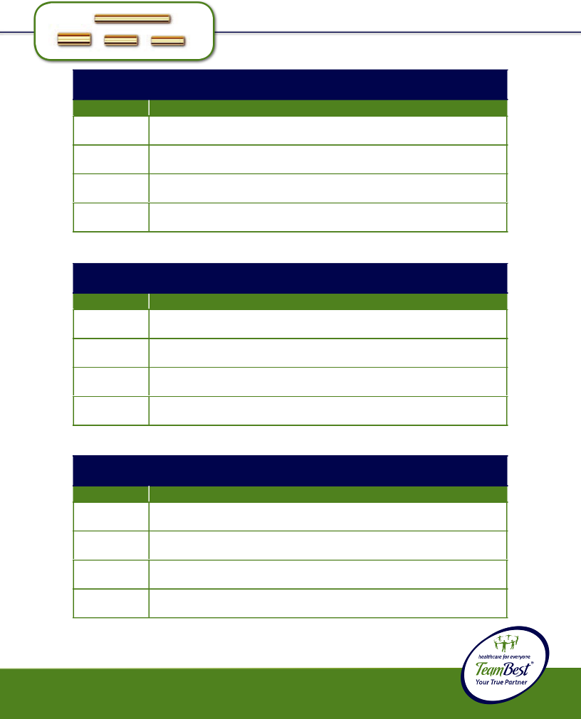© 2013 Best Medical International, Inc.
* X refers to selected number of markers per needle
1385-5-X*
18 Gauge, 20 cm Long Pre-waxed Needles (3) Preloaded with 0.8 mm OD, 1.5 mm Long Gold Marker(s) and Spacer(s)
!CAUTION: This product should be carefully inspected by your staff prior to clinical use and should be used by authorized personnel only.
1385-3-X*
18 Gauge, 20 cm Long Pre-waxed Needles (3) Preloaded with 0.8 mm OD, 7 mm Long Gold Marker(s) and Spacer(s)
1385-2-X*
18 Gauge, 20 cm Long Pre-waxed Needles (3) Preloaded with 0.8 mm OD, 5 mm Long Gold Marker(s) and Spacer(s)
1385-1-X*
Description
18 Gauge, 20 cm Long Pre-waxed Needles (3) Preloaded with 0.8 mm OD, 3 mm Long Gold Marker(s) and Spacer(s)
Part #
Sterile Fiducial Marker with SPACERS Kit • 20 cm Long Needle • 3 per pack
18 GAUGE • 0.8 mm OD
* X refers to selected number of markers per needle
1452-5-X*
18 Gauge, 20 cm Long Pre-waxed Needles (2) Preloaded with 0.8 mm OD, 1.5 mm Long Gold Marker(s) and Spacer(s)
1452-3-X*
18 Gauge, 20 cm Long Pre-waxed Needles (2) Preloaded with 0.8 mm OD, 7 mm Long Gold Marker(s) and Spacer(s)
1452-2-X*
18 Gauge, 20 cm Long Pre-waxed Needles (2) Preloaded with 0.8 mm OD, 5 mm Long Gold Marker(s) and Spacer(s)
1452-1-X*
Description
18 Gauge, 20 cm Long Pre-waxed Needles (2) Preloaded with 0.8 mm OD, 3 mm Long Gold Marker(s) and Spacer(s)
Part #
Sterile Fiducial Marker with SPACERS Kit • 20 cm Long Needle • 2 per pack
18 GAUGE • 0.8 mm OD
* X refers to selected number of markers per needle
1306-5-X*
18 Gauge, 20 cm Long Pre-waxed Needle (1) Preloaded with 0.8 mm OD, 1.5 mm Long Gold Marker(s) and Spacer(s)
1306-3-X*
18 Gauge, 20 cm Long Pre-waxed Needle (1) Preloaded with 0.8 mm OD, 7 mm Long Gold Marker(s) and Spacer(s)
1306-2-X*
18 Gauge, 20 cm Long Pre-waxed Needle (1) Preloaded with 0.8 mm OD, 5 mm Long Gold Marker(s) and Spacer(s)
1306-1-X*
Description
18 Gauge, 20 cm Long Pre-waxed Needle (1) Preloaded with 0.8 mm OD, 3 mm Long Gold Marker(s) and Spacer(s)
Part #
18 GAUGE • 0.8 mm OD
Sterile Fiducial Marker with SPACERS Kit • 20 cm Long Needle • 1 per pack

62


Sterile Fiducial Marker with SPACERS Kit • 18 GAUGE • 1.0 mm OD 20 cm Long Needle • 1 per pack
Part # Description

1309-1-X* 18 Gauge, 20 cm Long Pre-waxed Needle (1) Preloaded with
1.0 mm OD, 3 mm Long Gold Marker(s) and Spacer(s)

1309-2-X* 18 Gauge, 20 cm Long Pre-waxed Needle (1) Preloaded with
1.0 mm OD, 5 mm Long Gold Marker(s) and Spacer(s)

1309-3-X* 18 Gauge, 20 cm Long Pre-waxed Needle (1) Preloaded with
1.0 mm OD, 7 mm Long Gold Marker(s) and Spacer(s)

1309-5-X* 18 Gauge, 20 cm Long Pre-waxed Needle (1) Preloaded with
1.0 mm OD, 1.5 mm Long Gold Marker(s) and Spacer(s)

- X refers to selected number of markers per needle

Sterile Fiducial Marker with SPACERS Kit • 18 GAUGE • 1.0 mm OD 20 cm Long Needle • 2 per pack
Part # Description

1454-1-X* 18 Gauge, 20 cm Long Pre-waxed Needles (2) Preloaded with
1.0 mm OD, 3 mm Long Gold Marker(s) and Spacer(s)

1454-2-X* 18 Gauge, 20 cm Long Pre-waxed Needles (2) Preloaded with
1.0 mm OD, 5 mm Long Gold Marker(s) and Spacer(s)

1454-3-X* 18 Gauge, 20 cm Long Pre-waxed Needles (2) Preloaded with
1.0 mm OD, 7 mm Long Gold Marker(s) and Spacer(s)

1454-5-X* 18 Gauge, 20 cm Long Pre-waxed Needles (2) Preloaded with
1.0 mm OD, 1.5 mm Long Gold Marker(s) and Spacer(s)

- X refers to selected number of markers per needle

Sterile Fiducial Marker with SPACERS Kit • 18 GAUGE • 1.0 mm OD 20 cm Long Needle • 3 per pack
Part # Description

1387-1-X* 18 Gauge, 20 cm Long Pre-waxed Needles (3) Preloaded with
1.0 mm OD, 3 mm Long Gold Marker(s) and Spacer(s)

1387-2-X* 18 Gauge, 20 cm Long Pre-waxed Needles (3) Preloaded with
1.0 mm OD, 5 mm Long Gold Marker(s) and Spacer(s)

1387-3-X* 18 Gauge, 20 cm Long Pre-waxed Needles (3) Preloaded with ! 1.0 mm OD, 7 mm Long Gold Marker(s) and Spacer(s)
1387-5-X* 18 Gauge, 20 cm Long Pre-waxed Needles (3) Preloaded with
1.0 mm OD, 1.5 mm Long Gold Marker(s) and Spacer(s)

CAUTION:*XrefersThistoselectedproductnumbershould ofbemarkcarersfullyperinspectedneedle by your staff prior to clinical use and should be used by authorized personnel only.

Best Medical International, Inc. 7643 Fullerton Road, Springfield, Virginia 22153 USA
63 Tel: 703-451-2378 800-336-4970 Fax: 703-451-5228 www.bestmedical.com

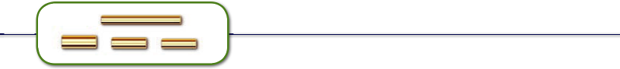

Sterile Fiducial Marker with SPACERS Kit • 17 GAUGE • 1.2 mm OD 20 cm Long Needle • 1 per pack
Part # Description

1312-1-X* 17 Gauge, 20 cm Long Pre-waxed Needle (1) Preloaded with
1.2 mm OD, 3 mm Long Gold Marker(s) and Spacer(s)

1312-2-X* 17 Gauge, 20 cm Long Pre-waxed Needle (1) Preloaded with
1.2 mm OD, 5 mm Long Gold Marker(s) and Spacer(s)

- X refers to selected number of markers per needle

Sterile Fiducial Marker with SPACERS Kit • 17 GAUGE • 1.2 mm OD 20 cm Long Needle • 2 per pack
Part # Description

1456-1-X* 17 Gauge, 20 cm Long Pre-waxed Needles (2) Preloaded with
1.2 mm OD, 3 mm Long Gold Marker(s) and Spacer(s)

1456-2-X* 17 Gauge, 20 cm Long Pre-waxed Needles (2) Preloaded with
1.2 mm OD, 5 mm Long Gold Marker(s) and Spacer(s)

- X refers to selected number of markers per needle

Sterile Fiducial Marker with SPACERS Kit • 17 GAUGE • 1.2 mm OD 20 cm Long Needle • 3 per pack
Part # Description

1389-1-X* 17 Gauge, 20 cm Long Pre-waxed Needles (3) Preloaded with
1.2 mm OD, 3 mm Long Gold Marker(s) and Spacer(s)

1389-2-X* 17 Gauge, 20 cm Long Pre-waxed Needles (3) Preloaded with
1.2 mm OD, 5 mm Long Gold Marker(s) and Spacer(s)

- X refers to selected number of markers per needle

!CAUTION: This product should be carefully inspected by your staff prior to clinical use and should be used by authorized personnel only.
© 2013 Best Medical International, Inc.

64

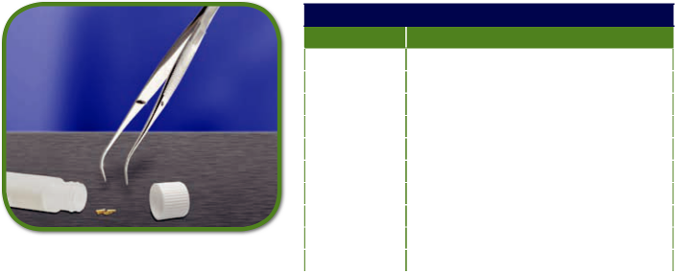

Non-Sterile Loose Gold Markers

Part # | Description
351-1 | 0.8 mm Diameter, 3 mm Long
351-2 | 0.8 mm Diameter, 5 mm Long
351-3 | 0.8 mm Diameter, 7 mm Long
351-5 | 0.8 mm Diameter, 1.5 mm Long
353-1 | 1.0 mm Diameter, 3 mm Long
353-2 | 1.0 mm Diameter, 5 mm Long
353-3 | 1.0 mm Diameter, 7 mm Long
353-5 | 1.0 mm Diameter, 1.5 mm Long
501-1 | 1.2 mm Diameter, 3 mm Long
501-2 | 1.2 mm Diameter, 5 mm Long

- CAUTION: This product should be carefully inspected by your staff prior to clinical use and should be used by authorized personnel only.

Best Medical International, Inc. 7643 Fullerton Road, Springfield, Virginia 22153 USA
65 Tel: 703-451-2378 800-336-4970 Fax: 703-451-5228 www.bestmedical.com
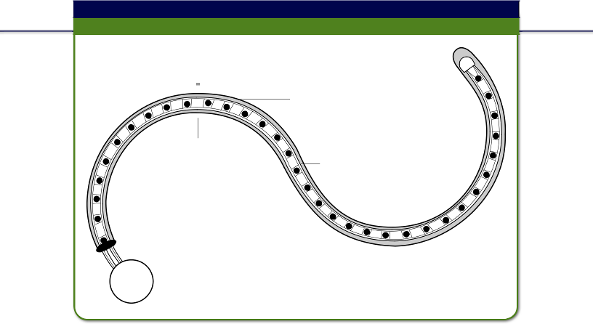
Rectal Marker Kit with Anus Marker

Part # 222-1; 222-2 (see below)

YellowDispsableHubRer18SleeveGauge

AdjustableAdjustleAnusAnus
Markerker Rectal

Marker

The Rectal Marker is a device generally used with localization fi elds on intracavitary (intrauterine-vaginal) applications or bladder external beam localizations.

With the old method of using a soldering or other type wire, one could only obtain the position of the rectum. But, with the Rectal Marker, it is now possible to obtain both position of rectum and magnifi cation, which allows you to determine accurately the rectal distance from the radiation source.

 | Also Available:
 | Disposable Rubber Sleeves for this product: Part # 1072-0009.
Part # | Rectal Marker is available with
222-1 | Stainless Steel Ball
222-2 | Tungsten Ball
960-1 | Sterile Stainless Steel
960-2 | Sterile Tungsten


!
CAUTION:CAUTION: ThisThis productproduct shouldshould bebe carefullycarefully inspectedinspected byby youryour staffstaff prior

priortoclinicaltoclinicaluseanduse shouldandshouldbeusedbeusedbyauthorizedbyauthorizedpersonnelpersonnelonly. only.

© 2013 Best Medical International, Inc.

66
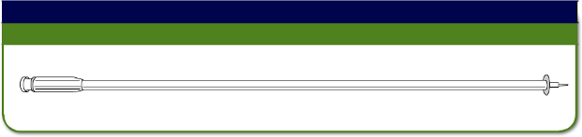NOTE: Gold Markers (Part # 351) are also available to use with Anderson Marker Kit or Adjustable Marker Kit.

Anderson Marker Kit

Part # 1074-0002

Kit contains a 25 cm long implanter (designed to limit implantation to 1 cm) and stylet.
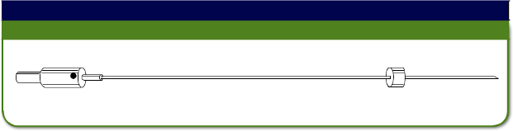

Adjustable Marker Kit

Part # 1074–0011

Kit contains a 20 cm long implanter with adjustable stop, stylet, one spare needle and one Allen wrench.


Stainless Steel Markers

Part #

179-1 Markers are sold separately. The markers are easily identified on visualization films and also aid in treatment planning.

!CAUTION: This product should be carefully inspected by your staff prior to clinical use and should be used by authorized personnel only.

Best Medical International, Inc. 7643 Fullerton Road, Springfield, Virginia 22153 USA
67 Tel: 703-451-2378 800-336-4970 Fax: 703-451-5228 www.bestmedical.com

© 2013 Best Medical International, Inc.

28
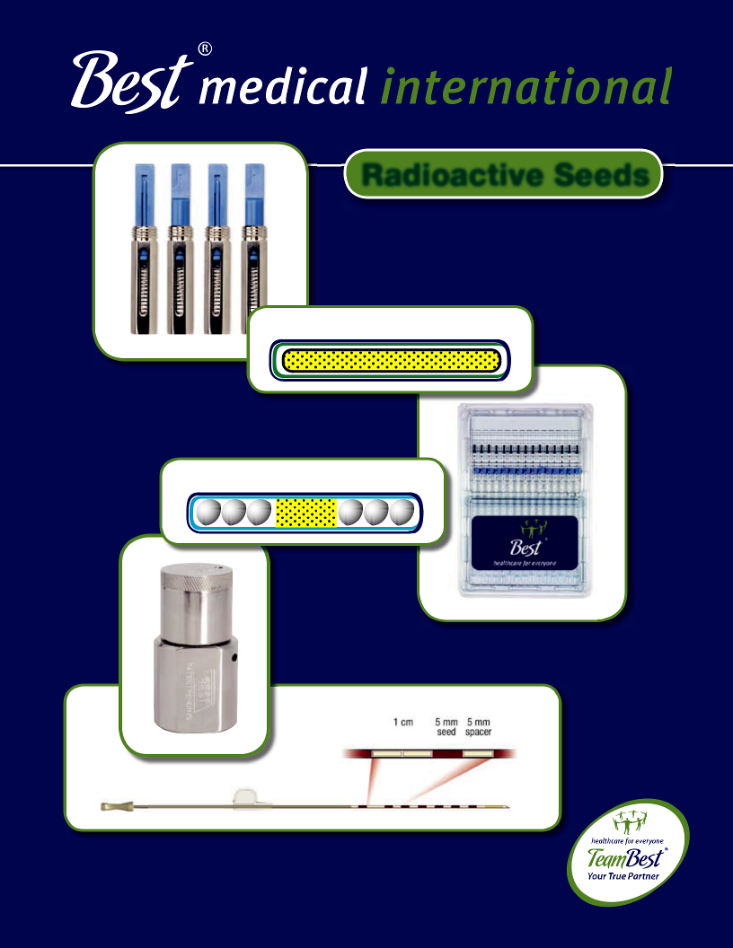

Radioactive Seeds

Best® Iodine--125Seeed

Best® Palladium⁻-103 Seed
®


Best^{Best}®Iodine®-125Seed

Patented Double Wall Best® Iodine-125 Source


Part # 2301

Marker Tungsten

Dose Rate Constant | NIST 1999 with 2000
 | Modifi cation
External Length | 5 mm (nominal) 1.02 cGy/hr/U
External Diameter | 0.8 mm (nominal)
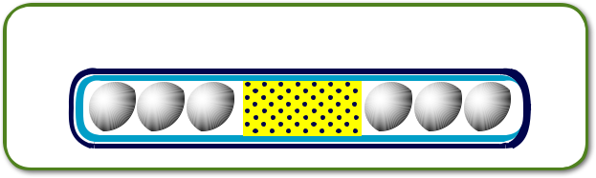

Best^{Best}®Palladium®⁻¹⁰³-103^{Seed}Seed

Patented Double Wall Best® Palladium-103 Source

Part # 2335

Marker Tungsten

Dose Rate Constant | NIST 1999 with 2000
 | Modifi cation
External Length | 5 mm (nominal) 0.70 cGy/hr/U
External Diameter | 0.8 mm (nominal)

- Patented double wall titanium encapsulation with uniform wall thickness

- Tungsten Marker—excellent images of source in ultrasound, X-ray, CT, MRI, and fl uoro—far superior to other commercially available sources

- Source calibration traceable to NIST₁₉₉₉ calibration revised for 2000

- Sources and spacers are the same length (5.0 mm nominal) and diameter (0.8 mm nominal), fi tting Mick cartridge snugly

- Custom-made high quality spacers and Mick cartridges provided at no cost

- Sources can be provided as loose seeds; loaded in needles with spacers, sterile; loaded in strands, sterile; preloaded in Mick cartridges

References:

- A.S. Meigooni, D.M. Gearheart, and K. Sowards, Med. Phys. 27, 2168-2173 (2000)

- S.W. Peterson and B. Thomadsen, Brachytherapy 1, 110-119 (2002)

- R. Nath and N. Yue, Brachytherapy, 1, 102-109 (2002)

24hours
Available from Best® within 24 hours:
Best® I-125 and Pd-103 seeds in sterile packing

© 2013 Best Medical International, Inc.

68

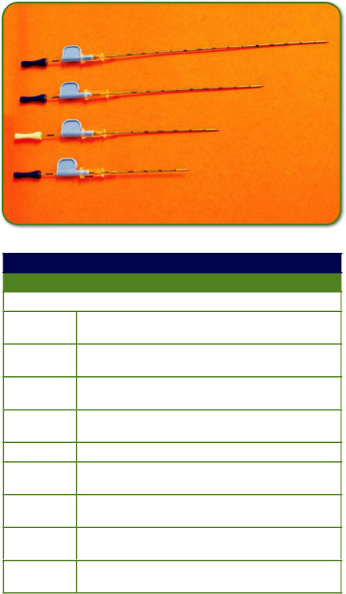

I-125

Single Needle with Single Source Part Numbers
Part # Description

10172-2 I-125 Loose Source (single) in 18 Gauge x 10cm Needle

10172-5 I-125 Loose Source (single) in 18 Gauge x 15cm Needle

10172-8 I-125 Loose Source (single) in 18 Gauge x 5cm Needle

10172-11 I-125 Loose Source (single) in 18 Gauge x 7cm Needle

10172-14 I-125 Single Source in Strand in 18 Gauge x 5cm Needle

10172-17 I-125 Single Source in Strand in 18 Gauge x 7cm Needle

10172-20 I-125 Single Source in Strand in 18 Gauge x 10cm Needle

10172-23 I-125 Single Source in Strand in 18 Gauge x 15cm Needle

Breast Localization Needles with Iodine-125 Seeds


Part # | Description
10172-8 | 5 cm Length
10172-11 | 7 cm Length
10172-02 | 10 cm Length
10172-05 | 15 cm Length

- Available in all ranges of seed activities (0.08 to 0.4 mCi) with a shelf life of 90 days

- Needles are supplied sterile and are individually packaged and shielded

- Best localization needles with Iodine-125 seeds are FDA approved

24hours
Available from Best® within 24 hours:

Best® I-125 and Pd-103 seeds in sterile packing

Best Medical International, Inc. 7643 Fullerton Road, Springfield, Virginia 22153 USA
69 Tel: 703-451-2378 800-336-4970 Fax: 703-451-5228 www.bestmedical.com

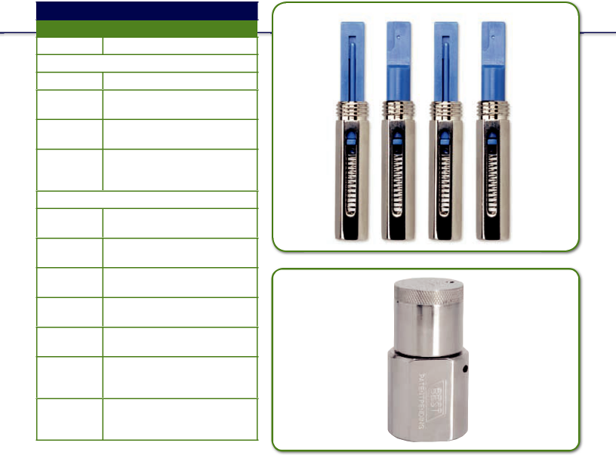
I-125
Sterile & Non-Sterile Seed Products

Part # Description
10113 Loose (non-sterile)

10113-21 Loose (sterile)

10165-3 Strands in Needles
(in plastic tray)

10165-4 Loose Sources in Needles (in plastic tray)

10165-17 Loose and Stranded Sources in Needles (in plastic tray)
10165-1 Stylets in Tubes

10113-23 Cartridge with Sources (non-sterile)

10113-11 Cartridge with Sources (sterile)

10176-13 Best Cartridge with Sources

10117-5 Reusable Cartridges with Sources

10120-1 Strands in Needles (in Best new tray)

10120-3 Loose Sources in Needles (in Best new tray)

10120-5 Loose and Stranded Sources in Needles (in Best new tray)
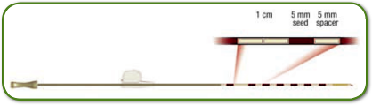

24hours
Available from Best® within 24 hours:
Best® I-125 and Pd-103 seeds in sterile packing

© 2013 Best Medical International, Inc.

70

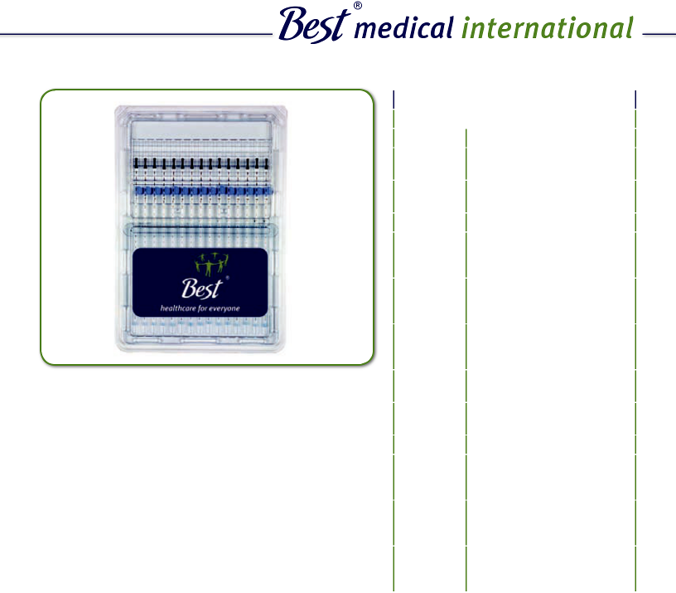

 |  |  | Pd-103
 |  |  | Sterile & Non-Sterile Seed Products
 |  |  | Part # |  | Description
 |  |  | 15113 |  | Loose Pd-103 Source
 |  |  |  |  | (non-sterile)
 |  |  | 15113-11 |  | Vial with Pd-103 Sources
 |  |  |  |  | in a Pouch (sterile)
 |  |  | 15165-1 |  | Pd-103 Strand (in a pack)
 |  |  | 15165-4 |  | Needle with Pd-103
 |  |  |  |  | Loose Sources Assembly
 |  |  |  |  | (in a plastic tray)
 |  |  | 15165-9 |  | Needle with Pd-103
 |  |  |  |  | Sources in Strands
 |  |  |  |  | Assembly (in a plastic tray)
 |  |  | 15165-11 |  | Needle with Pd-103 Loose
 |  |  |  |  | Sources and Strands
 |  |  |  |  | Assembly (in a plastic tray)
• Patented double wall titanium encapsulation with |  | 15113-13 |  |  | Pd-103 Sources in
 |  |  |  |  | Cartridge (non-sterile)
uniform wall thickness |  |  | 15113-14 |  | Pd-103 Sources in
• Best® custom strand (per your prescription) |  |  |  |  | Cartridge (sterile)
• Best® standard strand (10 seeds/strand spaced
1 cm apart) |  | 15180-1 |  |  | Needle with Pd-103 Loose
• Best® real-time strand/needle (use |  |  |  |  | Sources Assembly (in
our loader in the OR) |  |  |  |  | Best tray)
our loader in the OR) |  |  | 15180-3 |  | Needle with Pd-103
• Best® seeds and spacers in pre-loaded needles
• Cartridges |  |  |  |  | Sources in Strands
 |  |  |  |  | Assembly (in Best tray)
• Loose seeds
• Loose seeds |  |  | 15180-5 |  | Needle with Pd-103 Loose
 |  |  |  |  | Sources and Strands
 |  |  |  |  | Assembly (in a tray)

24hours
Available from Best® within 24 hours:
Best® I-125 and Pd-103 seeds in sterile packing

Best Medical International, Inc. 7643 Fullerton Road, Springfield, Virginia 22153 USA
71 Tel: 703-451-2378 800-336-4970 Fax: 703-451-5228 www.bestmedical.com

Iridium-192

Part # 118

Ir-192 Seeds in Nylon Ribbons

Range of Activity | 0.1 to 10 mg Raeq per Seed
Seed Dimension | 3.0 mm Long and 0.5 mm Diameter
Emisson Energy | 0.37 MeV (average) Gamma Energy
0.1 mm Diameter | Core of 30% Iv & 70% Pt Surrounded by 0.2 mm Thick
 | Stainless Steel Wall
Physical | 1. | Half-life 74.3 Days
Characteristics | 2. | HVL (50% attenuation) About 3 mm Lead

- Specifi c Gamma Ray Constant 4.6 R cm2 /mCi/hr

Custom Spacing Available.


Gold-198

Part # 557

Au-198

Range of Activity | 0.1 to 10 mCi per Seed
 | (4.7 mCi of Gold-198 is Equal to 1 mCi of Radon)
Seed Dimension | 2.5 mm long and 0.8 mm Diameter
Emisson Energy | 420 keV (average) Gamma Rays
Construction | Metallic Gold Pellet Encapsulated in Platinum
Physical | 1. | Half-life 2.7 days
Characteristics | 2. | HVL (50% attenuation) About 4 mm Lead

- Specifi c Gamma Ray Constant 2.35 R cm2 /mCi/hr

Custom Activities Available.

- We are the only one to provide comparative calibration data traceable to NIST, Washington, DC, University of Wisconsin, K&S Associates, and M.D. Anderson Hospital, Houston, TX, for the past 15 years — which indicates excellent quality control.

- We are the only supplier of LDR Iridium-192 and Gold-198 seeds.

- We are the only provider of Iridium-192 in nylon ribbons in a wide range of activities.

- We are the only one to provide custom services for Gold-198 permanent implants, as well as a wide range of activities.

- We are the first and only one to call our customers the morning after shipping to inform them of mode of transportation and expected arrival time.

© 2013 Best Medical International, Inc.

72



Co-57 Nuclear Medicine Products

Part # | Case | Configuration | Size
Flood Source
5302-2416-10*-S | With Case | Rectangle | 24” X 16”
5302-2416-15*-S | With Case
5302-2416-20*-S | With Case
5302-2416-10* | Without Case | Rectangle | 24” X 16”
5302-2416-15* | Without Case
5302-2416-20* | Without Case
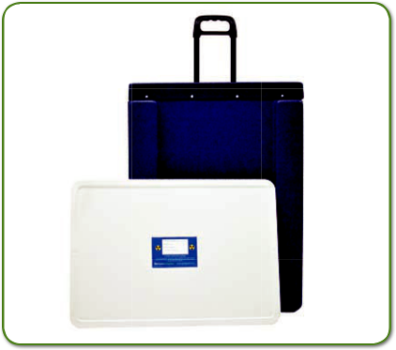

Best Medical International now offers durable highly uniform Co-57 Flood Sources for gamma camera quality control. Common rectangular and round confi gurations are available from inventory, as well as custom sizes. All Flood Sources are measured to ensure a coeffi cient
of variation of less than 1% and certifi ed in accordance with ANSI N42.27-1999. Each Flood Source is provided in a shielded storage case.

Other flood sizes available upon request

continues on next page

- activity

Best Medical International, Inc. 7643 Fullerton Road, Springfield, Virginia 22153 USA
73 Tel: 703-451-2378 800-336-4970 Fax: 703-451-5228 www.bestmedical.com

 |  | Part # | Case |  | Configuration |  | Size
 |  | Flood Source
 |  | 5302-1814-5*-S | With Case |  | Rectangle |  | 18” X 14”
 |  | 5302-1814-10*-S | With Case
 |  | 5302-1814-15*-S | With Case
 |  | 5302-1814-20*-S | With Case
 |  | 5302-1814-5* | Without Case |  | Rectangle |  | 18” X 14”
 |  | 5302-1814-10* | Without Case
 |  | 5302-1814-15* | Without Case
 |  | 5302-1814-20* | Without Case
 |  | 5302-1610-5*-S | With Case |  | Rectangle |  | 16” X 10”
 |  | 5302-1610-7.5*-S | With Case
 |  | 5302-1610-10*-S | With Case
 |  | 5302-1610-5* | Without Case |  | Rectangle |  | 16” X 10”
 |  | 5302-1610-7.5* | Without Case
 |  | 5302-1610-10* | Without Case
 |  | 5302-1111-5*-S | With Case |  | Rectangle |  | 11” X 11”
 |  | 5302-1111-10*-S | With Case
 |  | 5302-1111-5* | Without Case |  | Rectangle |  | 11” X 11”
 |  | 5302-1111-10* | Without Case
 |  | 5303-18-10*-S | With Case |  | Round |  | 18”
 |  | 5303-18-15*-S | With Case
 |  | 5303-18-20*-S | With Case
 |  | 5303-18-10* | Without Case |  | Round |  | 18”
 |  | 5303-18-15* | Without Case
 |  | 5303-18-20* | Without Case
 |  | 5303-24-10*-S | With Case |  | Round |  | 24”
 |  | 5303-24-15*-S | With Case
 |  | 5303-24-20*-S | With Case
 |  | 5303-24-10* | Without Case |  | Round |  | 24”
 |  | 5303-24-15* | Without Case
 |  | 5303-24-20* | Without Case
 |  | Other flood sizes available upon request. |  |  |  | continues on next page
 |  | * activity

24hours
Available from Best® within 24 hours:
Best® I-125 and Pd-103 seeds in sterile packing

© 2013 Best Medical International, Inc.

74



 | Part # | Isotope
 | Dose Calibrator Vials
 | 5301-1-5 | Co-57
 | 5301-1-10
 | 5301-2-100 | Cs-137
5301-2-200
 | Call and check for availability.


 | Part # | Isotope
 | Markers and Rulers
 | 5304-50 | Co-57
 | 5304-100
 | 5304-200
 | 5305-100 | Co-57
 | 5305-200
 | 5306-230 | Co-57
 | 5306-460
 | 5307-80 | Co-57
 | 5307-160

Call and check for availability.

Best Medical International, Inc. 7643 Fullerton Road, Springfield, Virginia 22153 USA
75 Tel: 703-451-2378 800-336-4970 Fax: 703-451-5228 www.bestmedical.com

© 2013 Best Medical International, Inc.

28
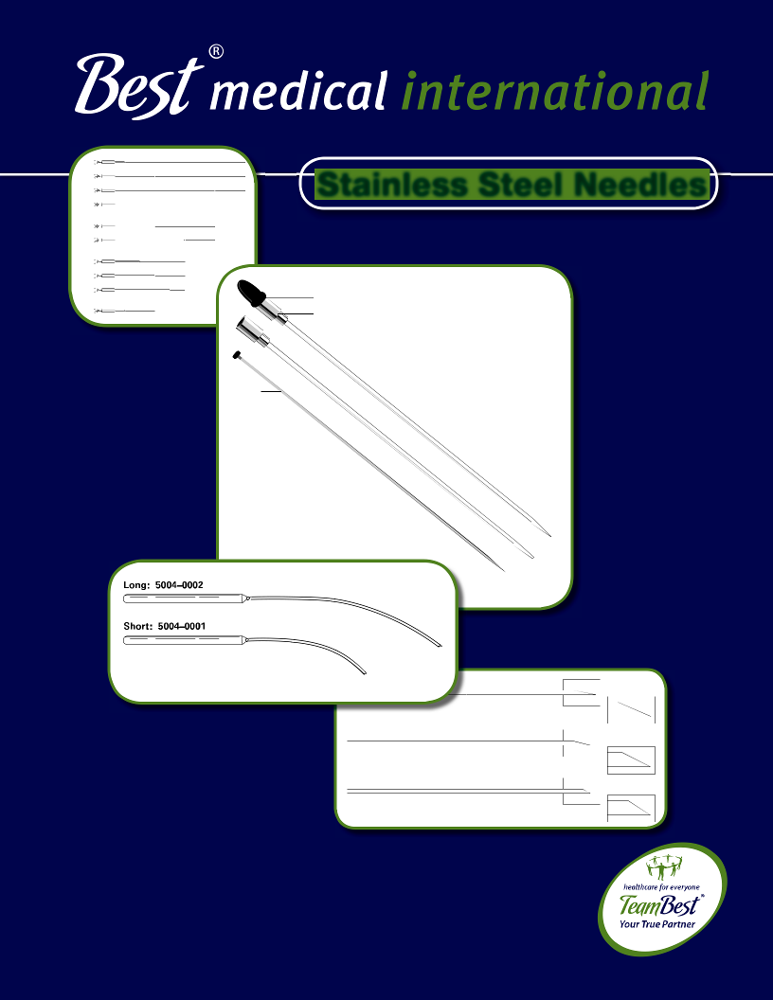

Stainless Steel Needles

Black Cap, Part #1072-0001—Sterile Part # 1230 Funnel

Stylet
Part # 332**

Sterile Stylet
Part # 1228

Closed Tip
Part # 198

Sterile Part # 1113

Open Tip
Part # 228

Sterile Part #
1115

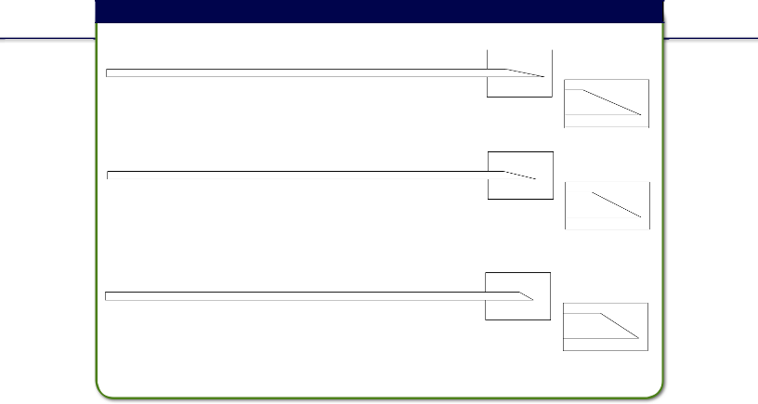
Implant Needles

A Bevel

17G
Available in 10 cm, 15 cm, and 20 cm

B Bevel | Sterile Part #
17G | 1076
14G | 1333
Available in 10 cm, 15 cm, 20 cm, and 25 cm

C Bevel Sterile Part #

17G 1458
14G
Available in 10 cm, 15 cm, 20 cm, and 25 cm
* 25 cm length only available in 17G

The Implant Needles are made of Stainless Steel and are hollow with different types of bevel at one end. Various lengths in different gauges are available, though the most commonly used needle is the 17G. Different types of Implant Needles are listed below:


 | A Bevel Part # | B Bevel Part # | C Bevel Part #
17G 10 cm | A-203-10 | B-202-10 | C-201-10
17G 15 cm | A-203-15 | B-202-15 | C-201-15
17G 20 cm | A-203-20 | B-202-20 | C-201-20
17G 25 cm |  | B-202-25 | C-201-25
14G 10 cm |  | B-200-10 | C-199-10
14G 15 cm |  | B-200-15 | C-199-15
14G 20 cm |  | B-200-20 | C-199-20

Custom length is available upon request.

!CAUTION: This product should be carefully inspected by your staff prior to clinical use and should be used by authorized personnel only.
© 2013 Best Medical International, Inc.

76
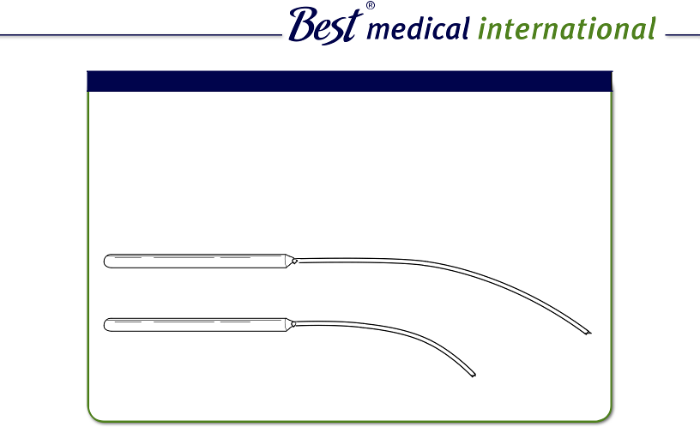

Curved Needles

These are curved Stainless Steel Implant Needles with handle. The outer diameter (O.D.) is 0.095” and the inner diameter (I.D.) is 0.077”. Two sizes are available: short and long. The short needle has a length of 3.5” and the long needle measures 7.25”. Each handle is 4” long.

Also available: Thin wall curved short needles

Part # 5004-0002-Long

Part # 5004-0001-Short

- CAUTION: This product should be carefully inspected by your staff prior to clinical use and should be used by authorized personnel only.

Best Medical International, Inc. 7643 Fullerton Road, Springfield, Virginia 22153 USA
77 Tel: 703-451-2378 800-336-4970 Fax: 703-451-5228 www.bestmedical.com
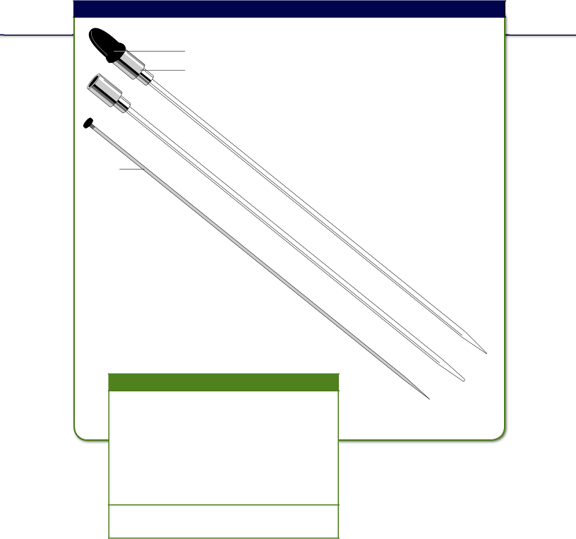
Template Needles with Funnel and Cap

BlacklackCap,Cap,Prt#1072Part-0001#—1072Sterile-Part0001#230—Sterile Part # 1230

Funnelunel

StyletStyl
Part # ₃₃₂32**
Part #
Sterile Stylet
SterilePat#1228Stylet

Part # 1228

This 20 cm needle is specifi cally
designed for use with Syed/Neblett
templates or disposable templates.
A funnel fi xed to one end makes the
ribbon loading easy and less time
consuming. A special cap fi ts over the
funnel to keep the ribbon in position.

Closed Tip
Part # 198

Sterile Part # 1113

Open Tip
Part # 228

Sterile Part #
1115

Custom length is available
upon request.

!Caps are for one time use only.
CAUTION: This product should be carefully inspected by your staff prior to clinical use and should be used by authorized personnel only.

© 2013 Best Medical International, Inc.

78

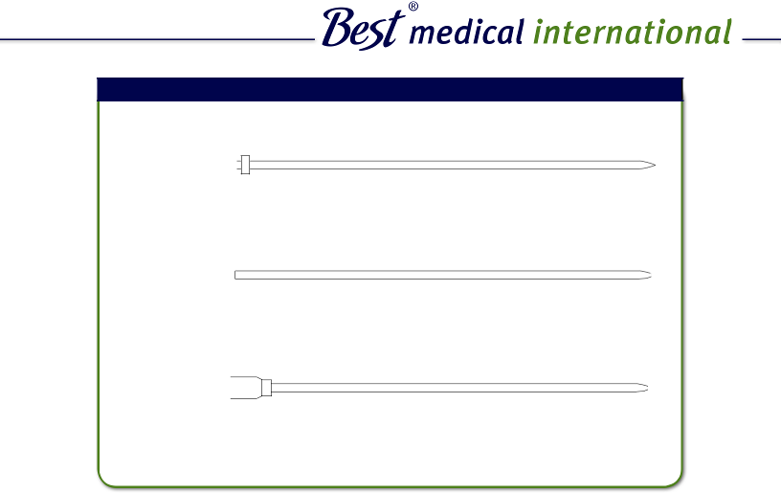

Template Needles

Template Needles, 17G

Closed End
With Collar

Open Tip. . . . . . . . . . . . Part # 227-Length
Sterile Open End . . . . . Part # 1395
Sterile Closed End . . . . Part # 1397

Tapered End
Without Collar

. . . . . . . . . . . . . . . . . . . Part # 196
Sterile Open End . . . . . Part # 1226
Sterile Closed End . . . . Part # 1224

 |  |  |  |  | Tapered End
Without Funnel |  |  |  | Sterile | Part # 1113
Closed Tip . . |  | . | . . . . . . . Part # 198 | Sterile | Part # 1113
Open Tip. . . . |  | . | . . . . . . . Part # 228 | Sterile . . . . . . . . . . . | Part # 1115

These 17 Gauge Needles are used with the templates, which improve the homogeneity of radiation. Needles of different lengths, closed end or open end, with or without collar, with or without funnel, are available. Catalog numbers of different template needles are given below:


 | Tapered End | Closed End
 | Tapered without Collar | Closed in with Collar
 | 10 cm, 15 cm, 20 cm, 25 cm | 10 cm, 15 cm, 20 cm, 25 cm
 | Part # 196.......Part # 1226 | Part # 197.......Part # 1397
 | Tapered with Collar | Closed in without Collar
 | 10 cm, 15 cm, 20 cm, 25 cm | 10 cm, 15 cm, 20 cm
 | Part # 227.......Part # 1395 | Part # 193.......Part # 1224
 | Template Needle with Funnel & Tapered End | Template Needle (pencil point or sharp)
 | 20 cm | with Funnel & Closed Tip
! | Part # 228.......Part # 1115 | 20 cm
! | Stylet for the Above | Part # 198.......Part # 1113
 | Part # 332.......Part # 1228

CAUTION: This product should be carefully inspected by your staff prior to clinical use and should be used by authorized personnel only.

Best Medical International, Inc. 7643 Fullerton Road, Springfield, Virginia 22153 USA
79 Tel: 703-451-2378 800-336-4970 Fax: 703-451-5228 www.bestmedical.com
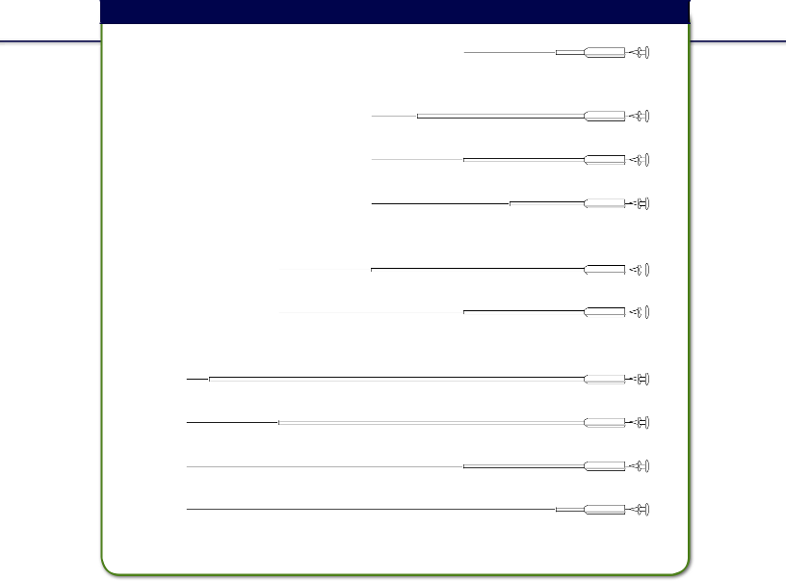
Needle Implanters

Four Inch Implanter — 2 inch point. . . . . . . . . . . . . . Part # 1074-0016

Six Inch Implanter — 1 inch point. . . . . . . . . . . . . . Part # 1074-0017

Six Inch Implanter — 2 inch point. . . . . . . . . . . . . . Part # 1074-0019

Six Inch Implanter — 4 inch point. . . . . . . . . . . . . . Part # 1074-0020

Eight Inch Implanter — 2 inch point. . . . . . . . . . . . . . Part # 1074-0022

Eight Inch Implanter — 4 inch point. . . . . . . . . . . . . . Part # 1074-0023

Ten Inch Implanter — 1 cm point . . . . . . . . . . . . . . Part # 1074-0031

Ten Inch Implanter — 2 inch point. . . . . . . . . . . . . . Part # 1074-0024

Ten Inch Implanter — 6 inch point. . . . . . . . . . . . . . Part # 1074-0025

Ten Inch Implanter — 8 inch point. . . . . . . . . . . . . . Part # 1074-0026

*Other implanters also available.

!CAUTION: This product should be carefully inspected by your staff prior to clinical use and should be used by authorized personnel only.
© 2013 Best Medical International, Inc.

80

CAUTION: This product should be carefully inspected by your staff prior to clinical use and should be used by authorized personnel only.

Diddler-Needle Adjustment Tool Part # 5002-0010

Use the DIDDLER, Not Your Fingers!

The DIDDLER is a device to adjust the position of transperineal prostate seeding needles during the time of seed implantation. Often, fi ngers are needed to reach behind the transperineal template to readjust the needle position. The DIDDLER replaces the need to use fi ngers which, in most cases, are too big to reach a needle between the template and perineum.

The DIDDLER, similar in construction to a crochet needle, is made entirely of stainless steel and consists of a long hexagonally shaped handle with a slender tip. The tip thus allows a needle to be pushed, pulled or twisted left and right even if there is a needle right next to it.

Adjust the needle up, down and sideways without using your fingers!


Radiation Protection

The DIDDLER is especially effective when needle repositioning with “HOT” Pre-loaded Prostate Seeding Needles is required. Notably, the DIDDLER is most useful in the Mick technique when numerous needles are implanted either peripherally, in rows, or all at once.

The DIDDLER is approximately 8” (20 cm) long and made entirely of stainless steel. A high-polish fi nish provides for easy cleaning and fl ash sterilization.

!The DIDDLER can be AUTOCLAVED!

Specifications:

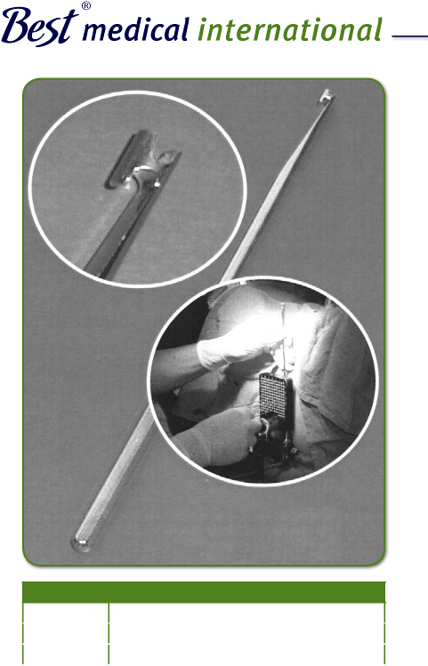

Material | Stainless Steel
Length | 8” (20 cm approximately)
Size | (6.4 mm diameter) Hexagonal Stock

Best Medical International, Inc. 7643 Fullerton Road, Springfield, Virginia 22153 USA
81 Tel: 703-451-2378 800-336-4970 Fax: 703-451-5228 www.bestmedical.com

© 2013 Best Medical International, Inc.

28
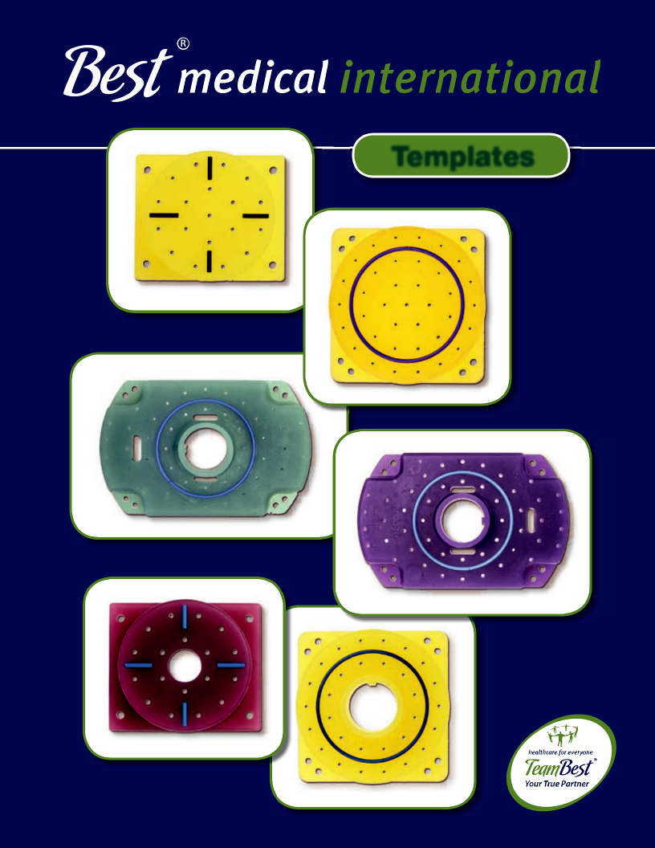

Templates
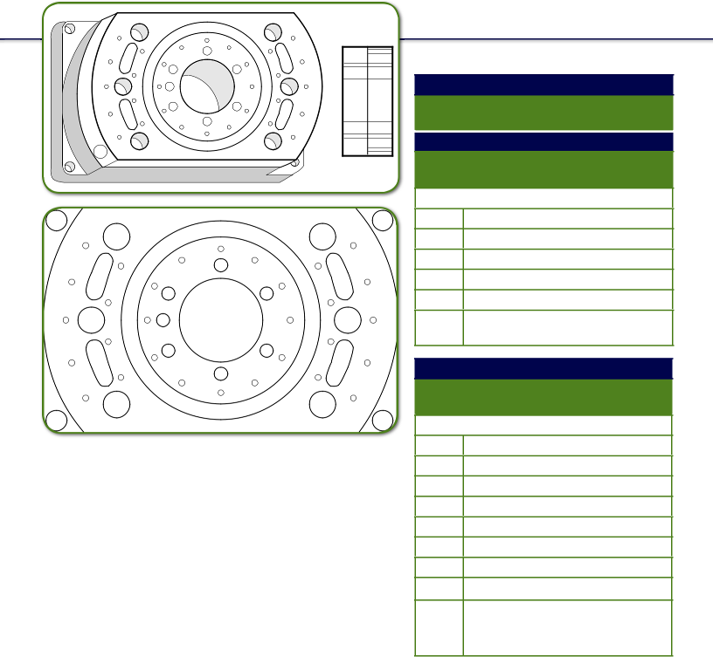

 | 17G Syed/Neblett Gyn Template #1
 | Part # 1246-1 (sterile )
 | Part # 214-1 (non-sterile)
 | 15G Syed/Neblett Gyn Template #1
 | Part # 1246-3 (sterile)
 | Part # 214-3 (non-sterile)
 | With:
 | 1 | Template
 | 1 | 15 cm Central Rod
 | 2 | Wrenches
 | 1 | Stainless Steel Ruler
 | 1 | Magnifi cation Ring
 |  | Extra ‘O’ Rings, Screws
 |  | and Cap
 | Syed/Neblett GynTemplate Kit #1
 | Part # 1246-2 (sterile)
 | Part # 214-2 (non-sterile)
 | Kit contains:
Hole Pattern | 1 | Template
Hole Pattern | 1 | 15 cm Central Rod
 | 36 | Needles with Funnels
 | 5 | Needles without Funnels
 | 1 | Magnifi cation Ring
 | 2 | Wrenches
 | 10 | Stylets
 | 1 | Stainless Steel Ruler
 |  | Extra ‘O’ Rings,
 |  | Screws and Cap

Optional: Storage Tray

!NOTE: Specify hole size when ordering (15 gauge or 17 gauge). CAUTION: This product should be carefully inspected by your staff prior to clinical use and should be used by authorized personnel only.

© 2013 Best Medical International, Inc.

82
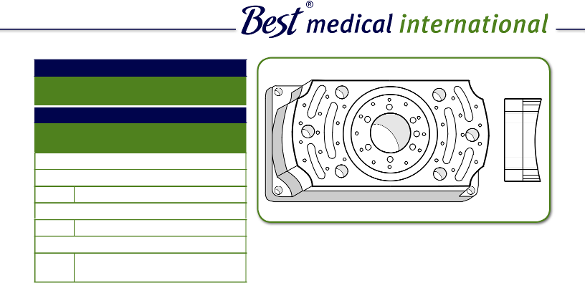

17G Syed/Neblett Gyn Template #2

Part # 1248-1 (sterile)

Part # 215-1 (non-sterile)

15G Syed/Neblett Gyn Template #2

Part # 1248-3 (sterile)

Part # 215-3 (non-sterile)

With:
1 Template

1 15 cm Central Rod
2 Wrenches

1 Stainless Steel Ruler
1 Magnifi cation Ring

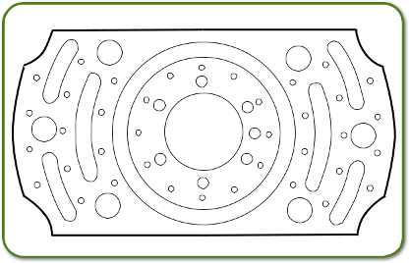

Extra ‘O’ Rings, Screws and Cap
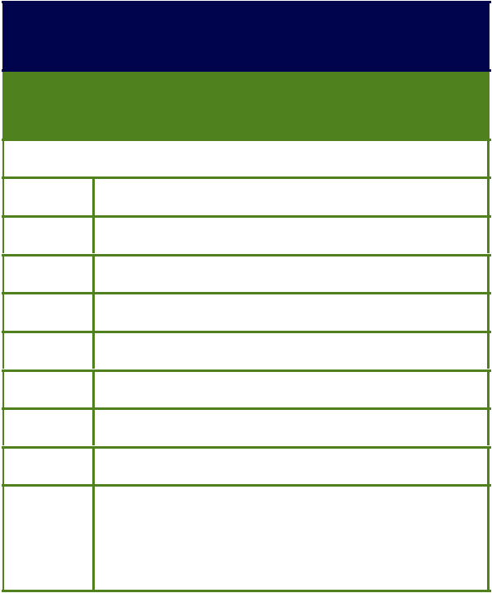

17G Syed/Neblett Gyn Template Kit #2

Part # 1248-2 (sterile)

Part # 215-2 (non-sterile)

Kit contains:

1 | Template
1 | 15 cm Central Rod
45 | Needles with Funnels
5 | Needles without Funnels | Hole Pattern
1 | Magnifi cation Ring | Hole Pattern
2 | Wrenches
10 | Stylets
1 | Stainless Steel Ruler
 | Extra ‘O’ Rings, Screws
 | and Cap

Optional: Storage Tray
- NOTE: Specify hole size when ordering (15 gauge or 17 gauge).

CAUTION: This product should be carefully inspected by your staff prior to clinical use and should be used by authorized personnel only.

Best Medical International, Inc. 7643 Fullerton Road, Springfield, Virginia 22153 USA
83 Tel: 703-451-2378 800-336-4970 Fax: 703-451-5228 www.bestmedical.com
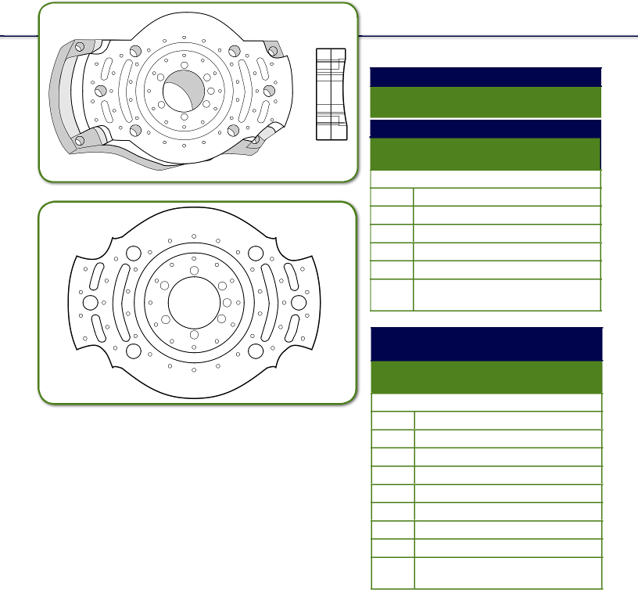

 | 17G Syed/Neblett Gyn Template #3
 | Part # 1250-1 (sterile)
 | Part # 216-1 (non-sterile)
 | 15G Syed/Neblett Gyn Template #3
 | Part # 1250-3 (sterile)
 | Part # 216-3 (non-sterile)
 | With:
 | 1 | Template
 | 1 | 15 cm Central Rod
 | 2 | Wrenches
 | 1 | Stainless Steel Ruler
 | 1 | Magnifi cation Ring
 |  | Extra ‘O’ Rings, Screws
 |  | and Cap
 | 17G Syed/Neblett Gyn
 | Template Kit #3
 | Part # 1250-2 (sterile)
 | Part # 216-2 (non-sterile)
 | Kit contains:
Hole Pattern | 1 | Template
 | 1 | 15 cm Central Rod
 | 55 | Needles with Funnels
 | 5 | Needles without Funnels
 | 1 | Magnifi cation Ring
 | 2 | Wrenches
 | 10 | Stylets
 | 1 | Stainless Steel Ruler
 |  | Extra ‘O’ Rings, Screws
 |  | and Cap

!NOTE: Specify hole size when ordering (15 gauge or 17 gauge). CAUTION: This product should be carefully inspected by your staff prior to clinical use and should be used by authorized personnel only.

© 2013 Best Medical International, Inc.

84
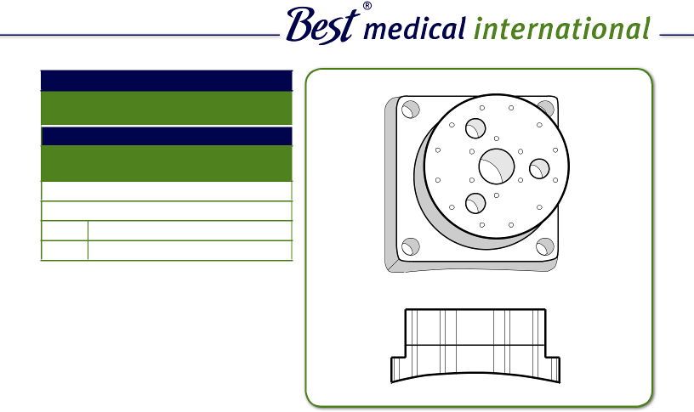

17G Syed/Neblett Prostate Template Part # 1260-1 (sterile)

Part # 159-1 (non-sterile)
15G Syed/Neblett Prostate Template

Part # 1260-3 (sterile)

Part # 159-3 (non-Sterile)

With:
1 Template

1 Wrench

Extra ‘O’ Rings and Screws
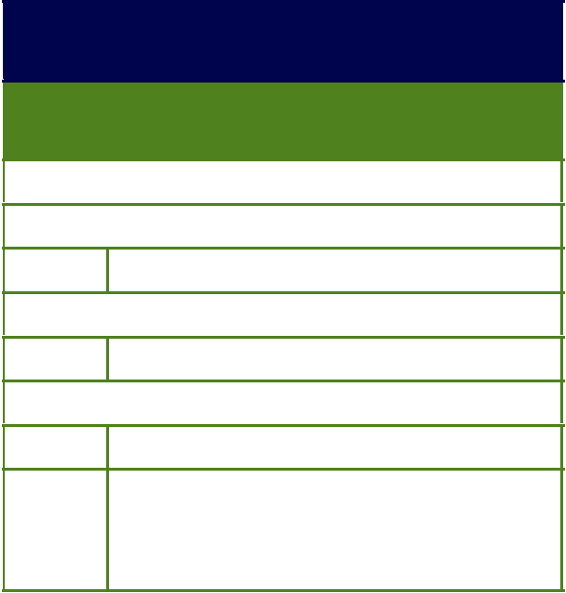

17G Syed/Neblett Prostate Template Kit

Part # 1260-2 (sterile)

Part # 159-2 (non-sterile)

Kit contains:
1 Template

18 Needles with Funnels
3 Needles without Funnels

1 Wrench
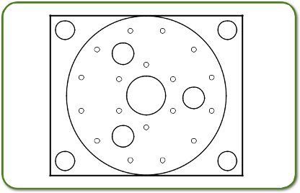
5 Stylets

1 Stainless Steel Ruler

Extra ‘O’ Rings, Screws and Cap

Optional: Storage Tray

Hole Pattern
- NOTE: Specify hole size when ordering (15 gauge or 17 gauge).

CAUTION: This product should be carefully inspected by your staff prior to clinical use and should be used by authorized personnel only.

Best Medical International, Inc. 7643 Fullerton Road, Springfield, Virginia 22153 USA
85 Tel: 703-451-2378 800-336-4970 Fax: 703-451-5228 www.bestmedical.com
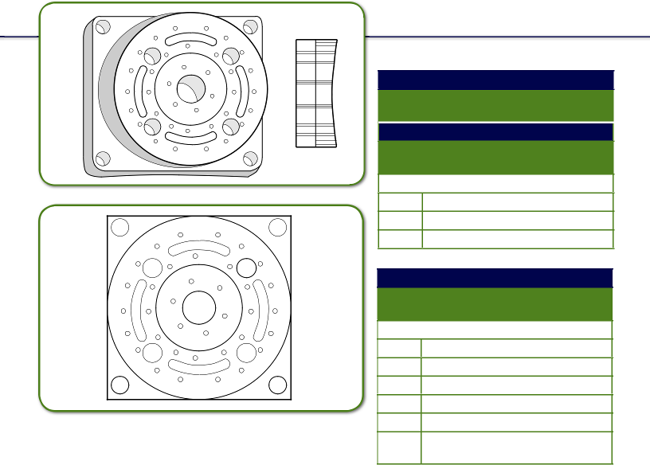

 | 17G Syed/Neblett Rectal Template
 | Part # 1256-1 (sterile)
 | Part # 236-1 (non-sterile)
 | 15G Syed/Neblett Rectal Template
 | Part # 1256-3 (sterile)
 | Part # 236-3 (non-sterile)
 | With:
 | 1 | Template
 | 1 | Wrench
 |  | Extra ‘O’ Rings and Screws
 | Syed/Neblett Rectal Template Kit
 | Part # 1256-2 (sterile)
 | Part # 236-2 (non-sterile)
 | Kit contains:
 | 1 | Template
 | 36 | Needles with Funnels
 | 3 | Needles without Funnels
 | 1 | Wrench
Hole Pattern | 1 | Stainless Steel Ruler
Hole Pattern |  | Extra ‘O’ Rings, Screws
and Cap

!NOTE: Specify hole size when ordering (15 gauge or 17 gauge). CAUTION: This product should be carefully inspected by your staff prior to clinical use and should be used by authorized personnel only.

© 2013 Best Medical International, Inc.

86

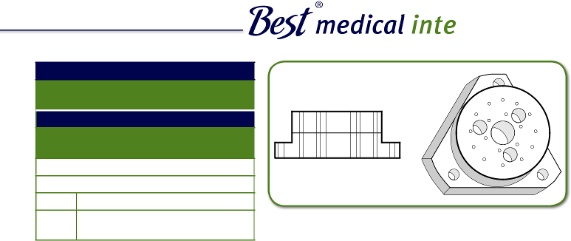

17G Syed/Neblett Urethral Template Part # 1264-1 (sterile)

Part # 237-1 (non-sterile)
15G Syed/Neblett Urethral Template

Part # 1264-3 (Sterile)

Part # 237-3 (Non-sterile)

With:
1 Template

1 Wrench

Extra ‘O’ Rings, Screws and Cap

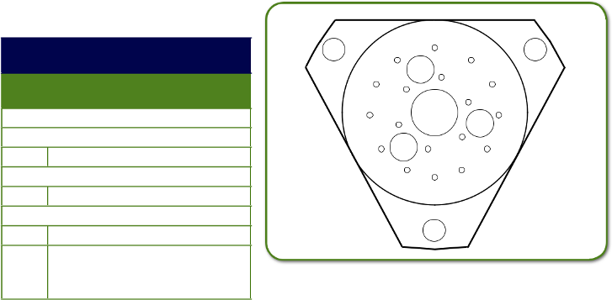

17G Syed/Neblett Urethral Template Kit

Part # 1264-2 (sterile)

Part # 237-2 (non-sterile)

Kit contains:
1 Template

18 Needles with Funnels
2 Needles without Funnels

1 Wrench
5 Stylets

1 Stainless Steel Ruler

Extra ‘O’ Rings, Screws and Cap

Optional: Storage Tray

- NOTE: Specify hole size when ordering (15 gauge or 17 gauge).

CAUTION: This product should be carefully inspected by your staff prior to clinical use and should be used by authorized personnel only.

Hole

Pattern

Best Medical International, Inc. 7643 Fullerton Road, Springfield, Virginia 22153 USA
87 Tel: 703-451-2378 800-336-4970 Fax: 703-451-5228 www.bestmedical.com

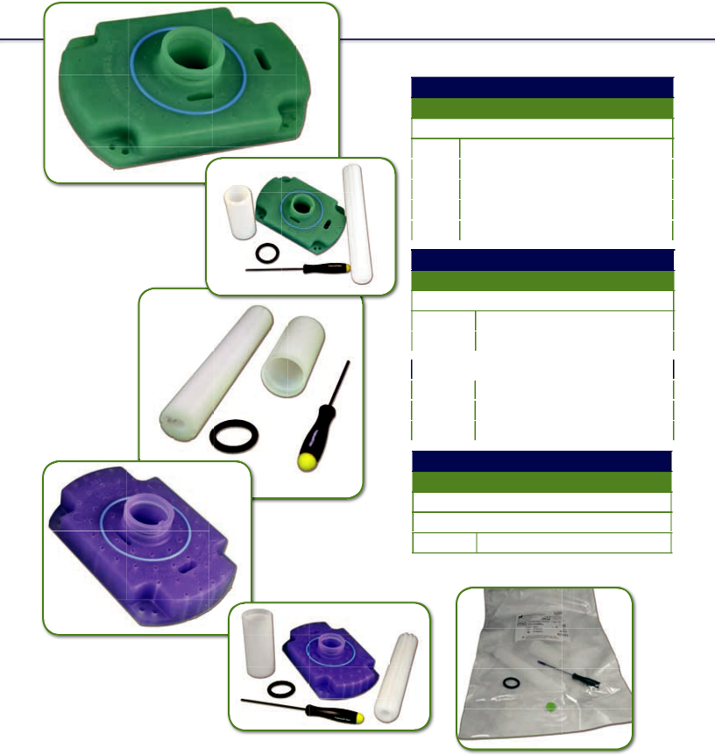

17G Disposable GYN Template Kit Part # 350-1 (non-sterile)

Kit contains:

1 | Template
1 | 15 cm Central Rod
1 | Wrench
1 | Sleeve
1 | ‘O’ Ring

Sterile Disposable GYN Template Kit Part # 350-2 Green in a Pouch

Kit contains:

290-2 | Template
779 | Accessories
Non-sterile Template Only
Part # | Part # 1664
778 | 17G
474 | 15G

Sterile Template Kit 15G Part # 790

Kit contains:
788 Template

789 Accessories

!NOTE: Specify hole size when ordering (15 gauge or 17 gauge). CAUTION: This product should be carefully inspected by your staff prior to clinical use and should be used by authorized personnel only.

© 2013 Best Medical International, Inc.

88



Sterile GYN Template

 | Part # | Part # 1664
 | 290-2 | Green in a Pouch


Non-Sterile Disposable GYN Purple Template Kit
 | Part # | Part # 1664
 | 691 | 1.9 mm


17G Sterile Accessories Template

 | Part # | Part # 1664
 | 779 | In a Pouch


15G Sterile Disposable GYN Purple Template Kit
Part # Kit contains: Part # 1664

788 |  |  | Template In a Pouch
789 |  |  | Accessories in a Pouch
790 |  |  | Complete Kit
 |  | 15G Sterile Accessories Template
 |  | Part # | Part # 1664
 | 789 |  | In a Pouch


16G Sterile Disposable GYN Template


 | Part # | Part # 1664
 | 1474-2 | Green
 | 16G Sterile Accessories Template
 | Part # | Part # 1664
 | 1476 | In a Pouch


16G Sterile Disposable GYN Template Kit
 | Part # | Part # 1664
 | 1478-2 | Green
 | 15.5G Disposable GYN Template
 | Part # | Part # 1664
 | 1736 | In a Pouch


15.5G Sterilized Disposable GYN Template Kit
 | Part # | Part # 1664
 | 1738 | Complete Kit

- NOTE: Specify hole size when ordering (15 gauge or 17 gauge).

CAUTION: This product should be carefully inspected by your staff prior to clinical use and should be used by authorized personnel only.

Best Medical International, Inc. 7643 Fullerton Road, Springfield, Virginia 22153 USA
89 Tel: 703-451-2378 800-336-4970 Fax: 703-451-5228 www.bestmedical.com

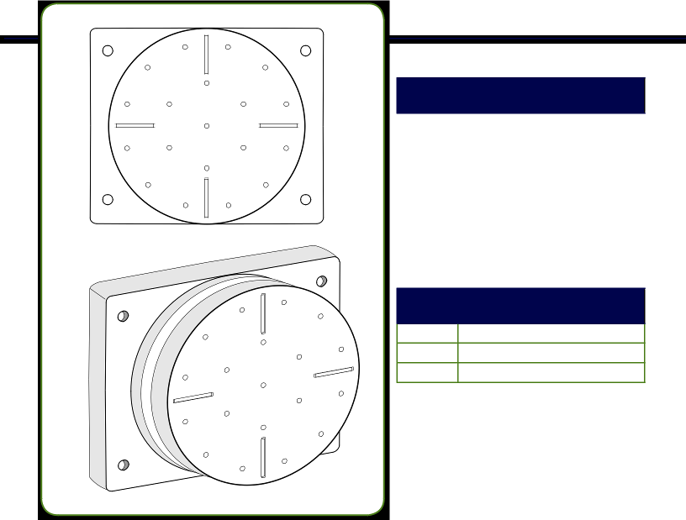

17G Disposable Prostate

Template Kit (with needle hole)

Part # | Part # 1664
223-1 | Non-sterile
1184 | Sterile

NEEDLES: 17 gauge flexi-needles
or 17 gauge stainless steel needles
could be used.
If you find difficulty in pushing the
needles through the holes, dip needle
in appropriate lubricant and use.

15G Disposable Prostate Template

(needle hole in a pouch)

Part # | Part # 1664

1740 Sterile

223-4 Non-sterile

NEEDLES: Only 15 gauge flexi-needles
or can be used with this template.
If you find difficulty in pushing the needles
through the holes, dip needle
in appropriate lubricant and use.

This disposable prostate template is made of Medical Grade Silicone Elastomer. The hole pattern is as shown
in the figure.

This disposable template is for one time use only.

!CAUTION: This product should be carefully inspected by your staff prior to clinical use and should be used by authorized personnel only.

© 2013 Best Medical International, Inc.

90

CAUTION: This product should be carefully inspected by your staff prior to clinical use and should be used by authorized personnel only.

17G Disposable Prostate Template (with small hole)
 | Part # | Part # 1664
 | 473-1 | Non-sterile
 | 1186 | Sterile

NEEDLES: 17 gauge fl exi-needles or 17 gauge stainless steel needles could be used.

If you fi nd diffi culty in pushing the needles through the holes, dip needle in appropriate lubricant and use.


15G Prostate Template

 | Part # | Part # 1664
 | 776-2 | Non-sterile
 | 726-2 | Sterile

NEEDLES: 15 gauge fl exi-needles or 15 gauge stainless steel needles could be used.

If you fi nd diffi culty in pushing the needles through the holes, dip needle in appropriate lubricant and use.

0.0555˝ Needle Hole Prostate Template Blue
 | Part # | Part # 1664
 | 1853 | Non-sterile
 | 1857 | Sterile

NEEDLES: 0.0555˝ fl exi-needles or 0.0555˝ gauge stainless steel needles could be used.

If you fi nd diffi culty in pushing the needles through the holes, dip needle !inappropriate lubricant and use.

This disposable prostate template is made of Medical Grade Silicone Elastomer. The hole pattern is as shown

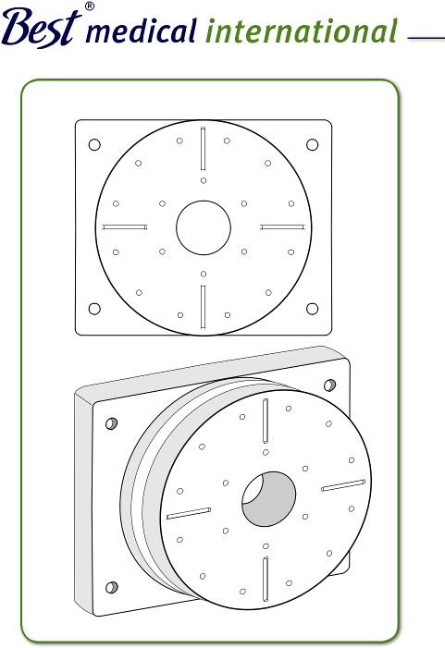
in the fi gure.

This disposable template is for one time use only.

Best Medical International, Inc. 7643 Fullerton Road, Springfield, Virginia 22153 USA
91 Tel: 703-451-2378 800-336-4970 Fax: 703-451-5228 www.bestmedical.com

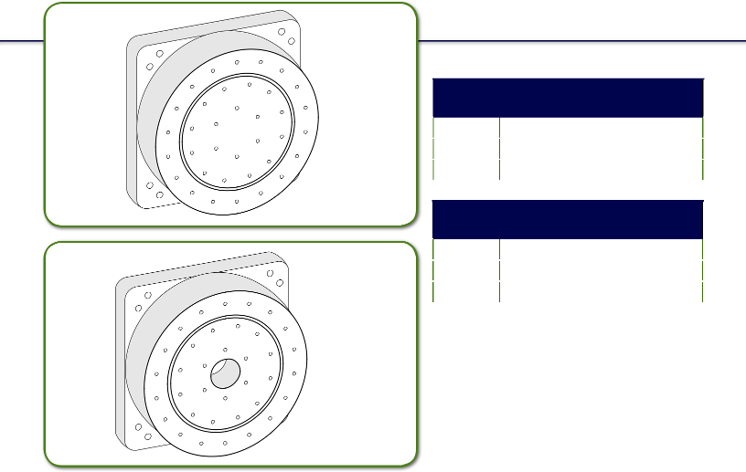
Needle Hole

291-1

Small Hole

292-1

This disposable prostate template is made of Medical Grade Silicone Elastomer.

The hole pattern is as shown in the fi gure.

This disposable template is for one time use only.

Disposable Rectal Templates (with needle hole)
Part # |  | Part # 1664
291-1 | 17 | Gauge Non-sterile
1188 | 17 | Gauge Sterile

Disposable Rectal Templates (with small hole)
Part # |  | Part # 1664
292-1 | 17 | Gauge Non-sterile
1190 | 17 | Gauge Sterile, Small Hole

- CAUTION: This product should be carefully inspected by your staff prior to clinical use and should be used by authorized personnel only.

© 2013 Best Medical International, Inc.

92



Non-sterile Disposable Rectal Template
 | Part # | Part # 1664
 | 345-1 | 16 Gauge
 | 345-2 | 17 Gauge
 | 345-3 | 15 Gauge
 | 345-5 | 15.5 Gauge


Sterile Disposable Rectal Template

 | Part # | Part # 1664
 | 1084-1 | 17 Gauge
 | 1084-2 | 15 Gauge
 | 1084-3 | 16 Gauge
 | 1084-4 | 15.5 Gauge


Sterile Disposable Rectal Template Kit
 | Part # | Part # 1664
 | 1558 | 15 Gauge
 | 1678 | 15.5 Gauge
 | 1664 | 16 Gauge
 | 1384 | 17 Gauge


15.5G Disposable Template Accessories

Part # Part # 1664
1676 Sterile in a Pouch

Central Rod Hole

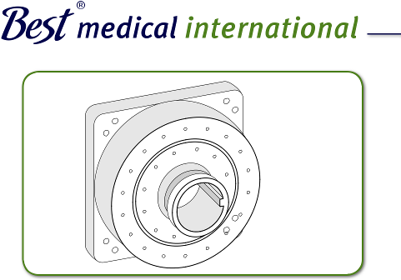

293-1

1084

1384

This disposable prostate template is made of Medical Grade Silicone Elastomer. The hole pattern is as

shown in the fi gure.

This disposable template is for one time use only.

- NOTE: Specify hole size when ordering (15 gauge or 17 gauge).

CAUTION: This product should be carefully inspected by your staff prior to clinical use and should be used by authorized personnel only.

Best Medical International, Inc. 7643 Fullerton Road, Springfield, Virginia 22153 USA
93 Tel: 703-451-2378 800-336-4970 Fax: 703-451-5228 www.bestmedical.com

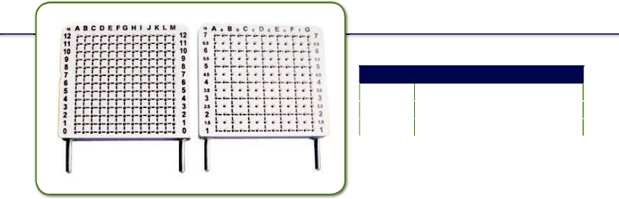

18G Templates (B&K)

Part # | Part # 1664
1829 | Non-sterile
1830 | Sterile in a Pouch

Back Front

!NOTE: Specify hole size when ordering (15 gauge or 17 gauge). CAUTION: This product should be carefully inspected by your staff prior to clinical use and should be used by authorized personnel only.

© 2013 Best Medical International, Inc.

94


Best Medical International, Inc. as author/distributor,

believes the technical information and statements contained

in this catalog to be reliable and correct at the time of

ublication. However, Best Medical International, Inc.,

does not assume any liability for statements, information

or recommendations based on/or made in reliance on

the information contained in this publication.

Data provided herein are for informational purposes only and are not intended for clinical use of any nature. Use of these data in such a manner is the sole responsibility of the user, and the author/distributor of the information akes no claim or inference as to its clinical suitability

and/or accuracy. Best Medical International, Inc. assumes

no arranty or liability for use of this information or products.

Designs and specifications are subject to modification and/or

change(s).

© 2013 Best Medical International, Inc.

Terms and Conditions


Ordering: Orders may be placed with a purchase ord number and transmitted by FAX, phone or e-mail.

Payment: Within 30 days.

Freight: FOB origin, freight prepaid and charged back

through invoice.

Returns: Unused accessories may be returned to Best Medical International, Inc. within 15 days if found unsuitable for a particular application. No return or authorization number is necessary. A note stating the reason for return, name, and address of hospital will expedite processing of any credit.

Note: Best Medical International, Inc. assumes no liability for consequential damages of any kind for the material when used interchangeably with products of other manufacturers/suppliers or for any

direct or indirect results and consequences of its use or misuse by the customer.

Best Medical International, Inc., reserves the right to modify the dimensions of accessories/components as well as the prices.

Best Medical International, Inc. 7643 Fullerton Road, Springfield, Virginia 22153 USA

- Tel: 703-451-2378 800-336-4970 Fax: 703-451-5228 www.bestmedical.com

Are you Searching for the Greatest Healthcare Company in the World?

Look to TeamBest®!

World population
is increasing by more than 100 million per year. To meet the needs of our aging
and growing popation,

TeamBest® com  are

committed to making quality healthcare affordable and accessible globally.

Ready to Serve
Globally for All
Your Needs

Arplay Medical

Best Cyclotron Systems

Best Medical Africa

Best Medical Asia

Best Medical Canada

Best Medical China

Best Medical Engineering

Best Medical Europe

Best Medical International

Best Medical Latin America

Best Medical Middle East

Best Medical Parts

Best Medical Research

Best Medical Russia

Best NDT

Best NOMOS

Best Particle Therapy

Best Theratronics

Best Vascular (Novoste)

CNMC Company

Genetherapy Pharmaceuticals

Huestis Diagnostics

Huestis Medical
and more...

For more information, visit www.teambest.com

 | 13
© | 20

Best

Med ical

rna tio na l, In c .

Inte

Best Medical International, Inc. 7643 Fullerton Road, Springfield, VA 22153 USA 703 451 BEST (2378) 800 336 4970 www.bestmedical.com www.teambest.com



© 2013 Best Medical International, Inc.

Best Medical International, Inc. 7643 Fullerton Road, Springfield, Virginia 22153 USA Tel: 703-451-2378 800-336-4970 Fax: 703-451-5228 www.bestmedical.com

