

For the Life Sciences

Innovative practical solutions for

data acquisition and analysis

for PC with Windows and Macintosh

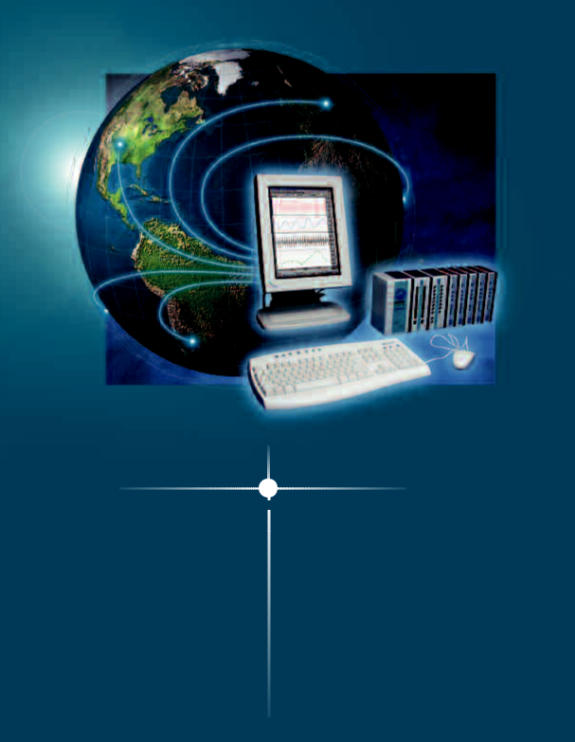

Powerful New MP Systems

The Next Generation Is Here Today!

Ethernet ready

data acquisition

& analysis

Use the new MP150 for:

Remote monitoring (local area network)

High speed 400kHz (aggregate) sampling

Multiple, variable sample rates

New calculation presets

Improved user interface

View and control multiple MP150 units

Human and animal applications


Data Acquisition & Analysis
02• MP Systems/

Applications
10• EEG
12• ERS: Evoked Response
14• Psychophysiology
16• Electrical Bioimpedance / Cardiac Output
18• EOG: Eye Movement
20• Plethysmography
22• Sleep Studies
24• ECG: Cardiology
26• Cardiovascular Hemodynamics
28• EGG: Electrogastrogram
30• Continuous Noninvasive Blood Pressure
32• Pharmacology
34• Laser Doppler Flow
36• Micro-electrode Recording
38• Pulmonary Function
40• Exercise Physiology
42• EMG
44• Biomechanics
46• Remote Monitoring
48• Amplifiers & Interfaces

50• MP Systems for Data Acquisition & Analysis

52• Interface Modules

54• General-Purpose Transducer Amplifier

56• Biopotential & Transducer Amplifiers

60• Specialty Amplifiers & Stimulators

69• Transducers

83• Electrodes, Leads & Accessories

⁹²• Platform Changes & Transformers
02 Acquisition...

Combine the sophistication and technology of BIOPAC data acquisition hardware with…
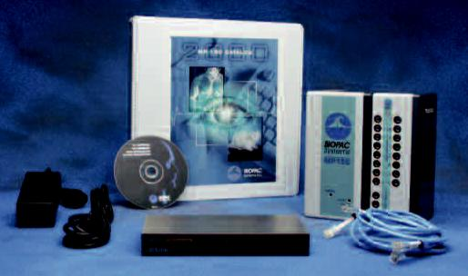

The MP System provides a flexible tool for your research needs. The modular, powerful interface system can be used with BIOPAC amplifiers and transducers and existing equipment in your lab. The newly expanded range of amplifiers further enhances your ability to create a system to suit your application requirements. Amplifiers snap together and pull apart for simple substitutions.

MP Starter Systems include all hardware, software and documentation you need to get started…then you can add amplifier modules, transducers, and electrodes to match your research design.

New modules are available for Electrogastrogram, Micro-electrode Recording, Noninvasive Blood Pressure Measurement, and Electrical Bioimpedance (Cardiac Output).

Hardware specifications begin on page 50.

High Resolution—16 bit | Isolated and human safe
Able to resolve signal variations with extreme accuracy | Use on humans and animals
Variable Sample Rates | CE Marked
(Analog & Calculation Channels) | European Union compliant
Maximize storage efficiency by recording signals with unique
sample rates
16 Analog Inputs & 2 Analog Outputs | Plus, with the MP150 Unit—

Collect data from 1-16 amplifiers simultaneously. Output stimuli at the same time as data collection.
High Speed (400 kHz aggregate) Record two channels of data at 200kHz per channel

Digital I/O Lines (automatically and manu- | Ethernet Connectivity
ally control other TTL level equipment) | The wave of the future—ultra fast and efficient data communications
Turn devices on or off and monitor other equipment | View and Control Systems Across a
16 On-line Calculation Channels | View and Control Systems Across a
16 On-line Calculation Channels | Network

On-line analysis provides immediate feedback Control your experiment when you’re away from the lab

and Analysis | 03

…the power and flexibility of AcqKnowledge® software to customize your acquisition and analysis system.

AcqKnowledge® is an interactive, intuitive program that lets you instantly view, measure, analyze and transform data. Perform complex data acquisition, stimulation, triggering and analyses using simple pull-down menus and dialogs—no need to learn a programming language or new protocol. On-line analysis settings, filters and transformations provide real-time feedback or you can choose from a wide variety of off-line analysis tools. Multiple display options are available during and after acquisition—just click on an icon to flip between Chart, Scope, or X/Y display, or use the Transform menu for Histogram or FFT. The software also includes quality presentation capabilities.

Get Started Immediately — Intuitive menu displays and enhanced user interface save time
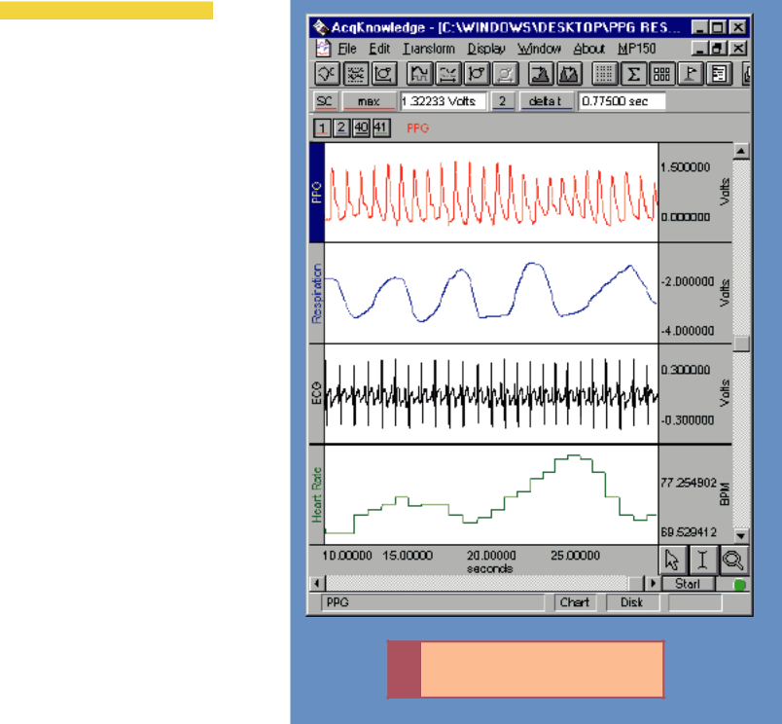

CHANNEL SETUP OPTIONS

- 16 Analog Channels
- 16 Calculation Channels
- New Calculation Channel Presets
- 16 Digital Channels

• Quick Start Templates Q##

ACQUISITION FEATURES

- New Variable Sample Rates
- New Pause Mode when Recording to Disk

- Automate Acquisition Parameters (start and stop times)
- Stimulation Design & Control (sine, ramp, square and arbitrary)

DISPLAY FEATURES

- New Tool Tip Mouse-overs
- New Channel Identification System
- New Grid System
- New Measurement Result Mouse-overs

- New Sample Rate Identification
- Customizable Menu Displays
- Measurement Tools
- Textual Event Markers
- Journal Facility for Note Taking
- Create SOPs with Online Instructions
- Toolbar Icons
- Multiple Display Modes
- Show or Hide Channel Displays

ANALYSIS FEATURES
- Signal Averaging (Online & Offline)
- Sophisticated Pulmonary Integration Routines (Online & Offline)

- Filtering (Online & Offline)
- FFT Analysis
- Histogram Displays
- Automatic Data Reduction
- Template Analysis
- Peak Detection Features
- Find Rate Feature
- Equation Generator

NEW DIGITAL USER SUPPORT SYSTEM

- Real-time System Guide
- Real-time Hardware Guide
- Real-time Support Documents

NEW

Lab Assistant GLP software available.

Contact BIOPAC for details.

04
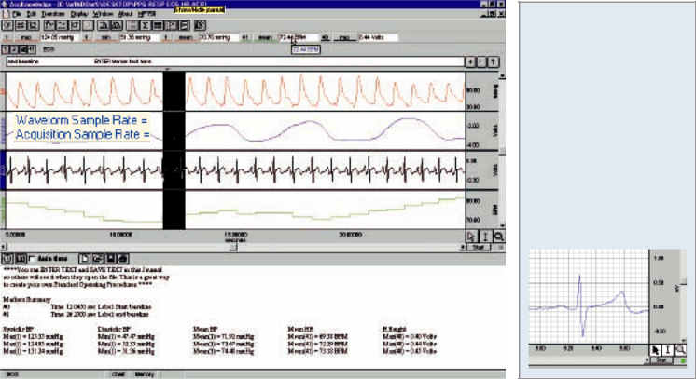

• Easy to use waveform display features

• Efficient data acquisition controls

• Adaptable software for simple to sophisticated measurements

• Quick & reliable operation

• Intuitive user interface

• New customizable grid options


Tool Tips
Mouse-overs provide helpful hints. Just move the cursor over a display feature to generate a descriptive tag.

Measurement Mouse-overs
Mouse-over the measurement to see full precision and units of the result.

Channel Identification System
Improved user interface highlights the active channel. Set the active channel and view/hide channel displays by clicking on the channel boxes.

Sample Rate Identification
Mouse-over the channel label to see the channel sample rate and the acquisition sample rate.

Grid options
Customizable line and color options let users optimize the display and print features.

Template Save/Open Utility
Establish the software settings required and then save the file as a Template. Next time the experiment is performed, open the Template and the setup will be ready. Quick Start Templates for a variety of applications are included in the Samples file, as indicated by _{Q##} .
Toolbar icons

Click on the icons to switch display modes (Chart, Scope, or X/Y) or activate common features such as Autoscale, Center waveform, Find peak, Grids, Measurements, Channel number display, Markers, and Journal.

Textual Event Markers
Mark and describe points of interest during or after data acquisition, and paste the Marker summary to the Journal file.

Journal Facility for Note Taking
Take notes and record specific events of interest. Use icons to time and date stamp Journal entries. Paste measurement results, waveform data and/or Markers to the Journal.

On-line Instructions — Create SOPs
Help technical staff and colleagues with customized measurement instructions and Standard Operating Procedures.

Measurement Tools
Manually or automatically measure collected data (max, mean, slope, area, etc.). Select and display measurements for one or more data channels simultaneously.

Customizable Menu Displays
Simplify and streamline the measurement process—tailor the menus to suit specific protocols and create Standard Operating Procedures.

Presentation Quality Results

Save data in text or graphic formats and export it to spreadsheet, word processing or graphing programs.

Original Menu

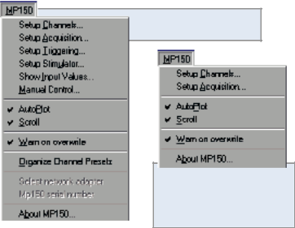

Intuitive menu options make

setup easy

Customized Menu

Customize menu displays to suit a variety of protocols — makes it easy to comply with GLP requirements

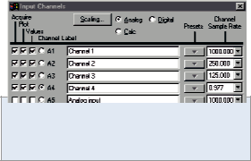

Channel options: Analog, Calculation, and Digital — acquire up to 16 of each type.

Select and label channels as desired, and specify whether to Acquire, Plot or show Input Values as required. Additional flexibility permits users to set a unique sample rate for each channel.

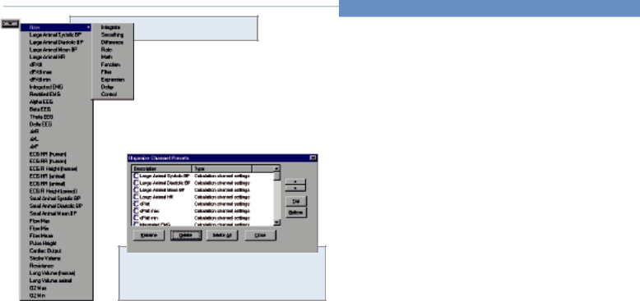

Built-in Calculation Presets

The Calculation Presets Manager allows users to order the display and add or delete unused presets.
05

Start collecting immediately—intuitive menus save time and make setup easy. Customize menus, use calculation presets to simplify the experimental setup, and add measurement specific instructions to increase efficiency.

SETUP

INTUITIVE MENUS

Simplified setup lets users customize the system to fine-tune the experimental design.

CUSTOMIZABLE MENU DISPLAYS

Simplify the measurement process by tailoring the menus to suit specific protocols and create Standard Operating Procedures.

Channels

16 ANALOG CHANNELS

- Simple two-point calibration
- Calibrate multiple channels simultaneously
- User-specified mean value calibrations minimize noise-induced errors

16 CALCULATION CHANNELS

Choose from a wide variety of physiological calculation functions, designate the source and output channels, and set a unique sample rate for each channel.

16 DIGITAL CHANNELS

Record digital data from, or send ON/OFF data to, external devices. The Control function will turn any of the 16 digital channels on or off to automatically trigger other equipment based on user-defined criteria. Alternatively, you can manually control the digital outputs during an acquisition.

ON-LINE ANALYSIS

There are 16 calculation channels available. Calculation channels can be daisy-chained to accommodate sophisticated and detailed measurements.

NEW CALCULATION PRESETS

Calculation Presets establish settings to target application-specific analysis. Presets exist for a broad range of analysis functions. Start with existing presets to develop specialized calculations to tailor presets for a specific species or protocol— for example, human vs. small animal or stationary vs. exercising measurements.

See the Applications section on pages 10-49 for specific analysis options.
06

ACQUISITION SETUP

NEW HIGH SPEED DATA ACQUISITION Use the MP150 for up to 400 kHz aggregate sampling. Use the MP100 for up to 70 kHz aggregate sampling.

SIGNAL AVERAGING

See the data averaged in real time. Control the acquisition length, latency, and number of averages. Synchronize the averaging passes with external triggers. Employ artifact rejection to eliminate movement artifact effects.

AUTOMATE ACQUISITION PARAMETERS

Control start and stop times for the recording. Set measurement points to coincide with specific experimental protocol.

NEW PAUSE MODE

When recording to Disk, start/stop the recording and append to the data file as often as required. Automatically time stamp the appended file sequence.

STIMULATION DESIGN & CONTROL

Create sine, ramp, square and arbitrary output — auditory, visual, constant voltage and constant current stimulation options are available. Control the timing and waveform characteristics of the output.

TRIGGERING

Trigger from a change in analog signal level or from an external

TTL source. Use the Pretrigger mode to capture data before the

TTL trigger, or use the Delay mode to capture data after the trigger.

VIEW DATA IN A VARIETY OF FORMATS Multiple display modes are available to view data during and after acquisition. Change the display with the click of a but-ton—click on the toolbar icon to switch between Chart, Scope and X/Y display modes. Options exist to view slow-moving data in bar graph or numeric text form.

CHART Plots each channel in its own display boundary.

SCOPE Simulates an oscilloscope—useful for overlapping

and comparing channels.

X/Y Creates an X/Y plot. Click on the axis label to

change the channels plotted.

SHOW INPUT VALUES

Display values in bar graph or numeric form—ideal for present-ing slowly varying data.

DATA DISPLAY

Switch between scroll and refresh modes, or freeze the display and review previously recorded data while continuing to record.

Memory required (bytes):

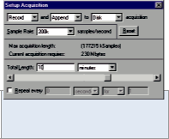

[(8C + 2A) x S x T] + 5Kb

C = # of Calc. channels

A = # of Analog channels

S = sample rate (s/sec)
T = Recording time (sec)

Fully automate the way data is acquired and stored. Link recording protocols with specific events, such as dosing or stimulation.

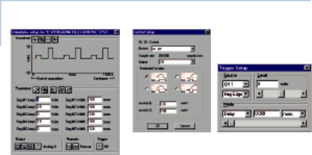

 |  | Synchronize data collection to external TTL
 |  | triggers or when a channel’s user-defined
Stimulator controls |  | threshold is crossed.

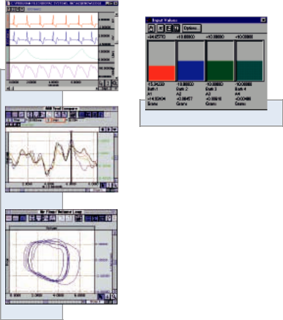

Chart mode

Bar Graph & Numeric Values display

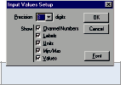

Scope mode

Input Values “Options…” dialog

X/Y mode
07

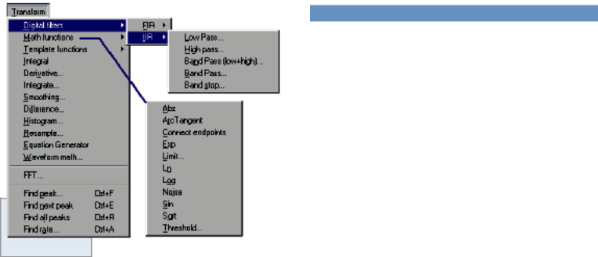

ANALYSIS

Extensive Off-line Analysis & Data Editing Tools

ON-LINE & OFF-LINE FILTERING

Select IIR or FIR filtering, and choose from low pass, high pass, band pass and band stop filters to remove noise and isolate the signal of interest.
• IIR filters are implemented as 2nd order biquads that can be run in succession to implement higher order filters.

• FIR filters provide an adjustable number of coefficients to create arbitrarily steep cutoffs between frequencies.

TEMPLATE ANALYSIS

Select a template (waveform) and determine its correlation, convolution, mean square error, and inverse mean square error with another waveform.

Transform menu

Source options: Analog, | EQUATION GENERATOR
Source options: Analog, | • Develop algorithms to process collected data.
Calculation and Digital channels, | • Options Include:
and Time | Functions: ABS, ACOS, ASIN, ATAN, COS, COSH, EXP,
 | LOG, LOG10, ROUND, SINE, SINH, SQR, SQRT, TAN,
 | TANH, TRUNC
 | Operators: “+” “-” “*” “/” “^” “(” “)”
 | • Arithmetically combine multiple channels to provide special
 | indicators for complex physiological events.
 | • Mathematically process non-linear signals to approximate a
 | linear response.
 | • Create precise arbitrary waves for output through the stimulator.

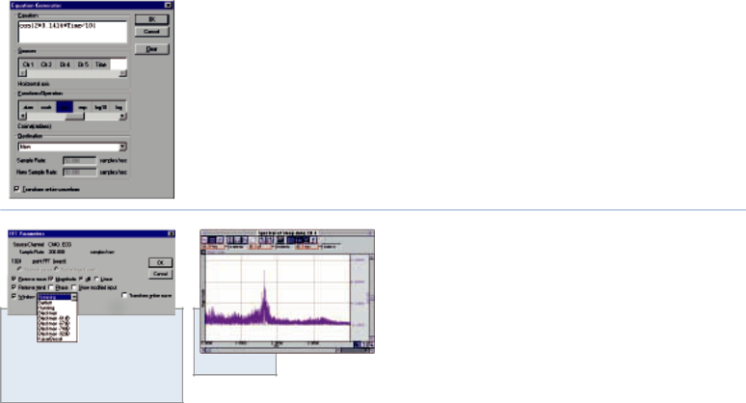

FFT ANALYSIS

Locate specific frequency components within the data. Perform an FFT on an entire wave or a selected portion of time series data. Present FFT magnitude results in logarithmic or linear units.

Remove mean, Remove trend and
Window options are available to ^{Sample FFT}

minimize signal distortion.

HISTOGRAM DISPLAYS

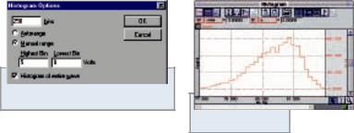
Sort data values into bins to determine the number of occur-rences in a specific time period. Set bin ranges manually or let the software determine the bin thresholds automatically.

Select Autorange or Manual range

Sample Histogram
08

PEAK DETECTION FEATURES

Peak Detector operation provides for automated data-driven measurements. Data selection cursors can be located at fixed positions from peaks found in the record.

Cursor settings allow users to isolate events and characteristics such as the P, Q, R, S, and T components of the ECG complex. Features allow you to track a moving baseline, perform cross-channel measurements, and automatically measure data over specified time periods.

The Peak Detector can be synchronized to one channel of data while taking measurements from adjacent channels. These measurements can be written automatically to the Journal as text or placed graphically in a new channel.

SIGNAL AVERAGING

Perform signal averaging on-line or after the source data is acquired. Control acquisition length, latency, and the number of averages. Use the Artifact Rejection option to eliminate aberrant data from the final results.

The off-line averaging feature allows the user to average data in one channel, but synchronized by another channel. Sophisticated averaging protocols (e.g. P300) can be performed, when the synchronizing channels record the timing of different stimulus types.

AUTOMATIC DATA REDUCTION

Automatically measure the data over specific time periods. Enter the desired time period (epoch) for quantizing the source data. The measurement cursors will step through the data using the user-defined time interval, making automatic and detailed measure-ments on the source data, within the specified interval.

MEASUREMENT TOOLS

Manually or automatically measure the data (max, mean, slope, area, etc.). Select and display measurements for one or more data channels.

Isolate events, measure data, count and analyze spikes, and perform cross-channel measurements.

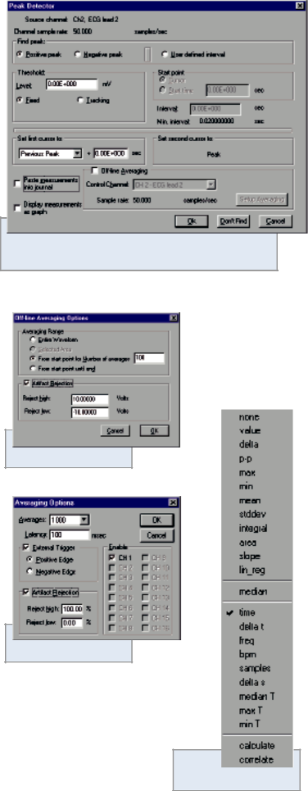

Off-line Averaging dialog

On-line Averaging dialog

Measurement pull-down menu

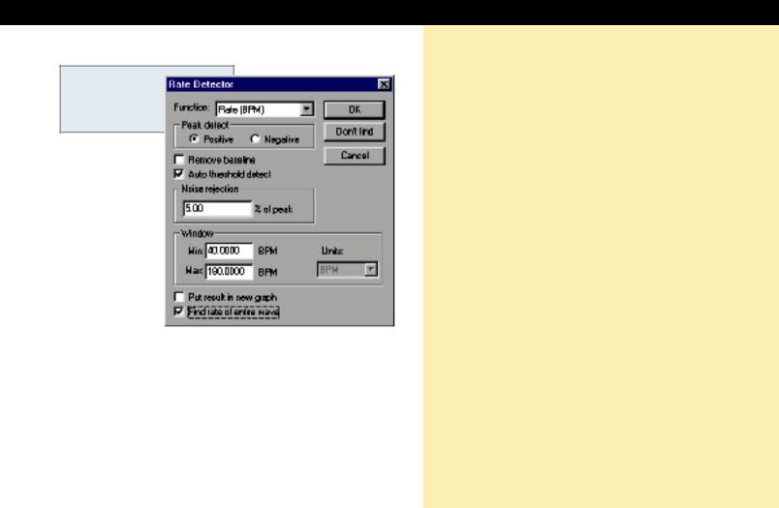

Find Rate dialog and Rate Detector functions

Select the appropriate function for the application.

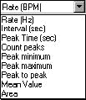
For example, use Peak maximum for Systolic BP.

Application |  | Function
Diastolic BP |  | Peak Minimum
Mean BP |  | Mean Value
R-R Interval |  | Interval
Heart Rate |  | Rate (BPM)
Breaths per minute |  | Rate (BPM)
Pulse Pressure |  | Peak to Peak

09

FIND RATE FEATURE

Automatically analyze a wide variety of cyclical signals. The sophisticated algorithm allows the software to track a variety of physiological data types including Blood Pressure, Flow and ECG.

If the signal event amplitude is fairly constant, use a fixed threshold to reliably capture the event on a cycle-by-cycle basis.

If the signal changes rapidly (in terms of frequency or baseline), a number of useful Rate Detector features are available.

Adjust the algorithm settings to suit your situation.

- Remove baseline—Synchronizes the detection on the faster moving portion of the signal; useful when recording ECG.

- Auto threshold detect—Allows the Detector to track signals with a varying baseline; useful when recording Blood Pressure.

- Noise rejection—Helps the Rate Detector ignore the peaks and valleys associated with ambient noise in the recording.

- Window Min/Max—Enter values (BPM, Frequency or Seconds) to define the anticipated cyclic timing range to help the detector stay synchronized to expected values.

Note: Rate Detector features do not modify the source data in any way.

MP Systems provide for powerful and efficient data acquisition, with no technical training or programming knowledge required — concentrate on research questions instead.
If you have questions…

The MP Systems hardware and AcqKnowledge software have intuitive controls and are easy to use, but questions may arise. We are happy to help our customers at all levels, from answering general “How do you…” questions to working out specific and sophisticated procedures.

Please feel welcome to call our office for any help you need—our engineering and applications support staff is ready to provide technical assistance.

For 24 hour update information and answers to the most frequently asked questions, access the BIOPAC web site at www.biopac.com and send us a message, post a question, or read technical updates, application notes and the latest BIOPAC information available.

The MP System modular construction is extremely flexible and includes features that can support nearly every physiological recording scenario. The following applications are detailed on pages 10-49. This is not an exhaustive list. For help with additional applications, please contact our Technical Support Division—an Applications Specialist will gladly assist you with your specific requirements.

Biomechanics | EMG: Electromyogram | Pulmonary Function (animal & human)
Cardiac Output | EOG: Electrooculogram | Plethysmography
Cardiovascular Hemodynamics | ERS: Evoked Response | Psychophysiology
Continuous Noninvasive Blood Pressure | Exercise Physiology | Remote Monitoring
EBI: Electrical Bioimpedance | In-vitro Pharmacology | Sleep Studies
ECG: Cardiology | Interface with Existing Equipment | Stand Alone Amplifiers
EEG: Electroencephalogram | Laser Doppler Flow
EGG: Electrogastrogram | Micro-electrode Recording

IMPORTANT BIOPAC Systems, Inc. components are designed for research applications. BIOPAC Systems, Inc. does not condone the use of its instruments for clinical medical applications. Instruments, components and accessories provided by BIOPAC Systems, Inc. are not intended for the diagnosis, mitigation, treatment or prevention of disease.

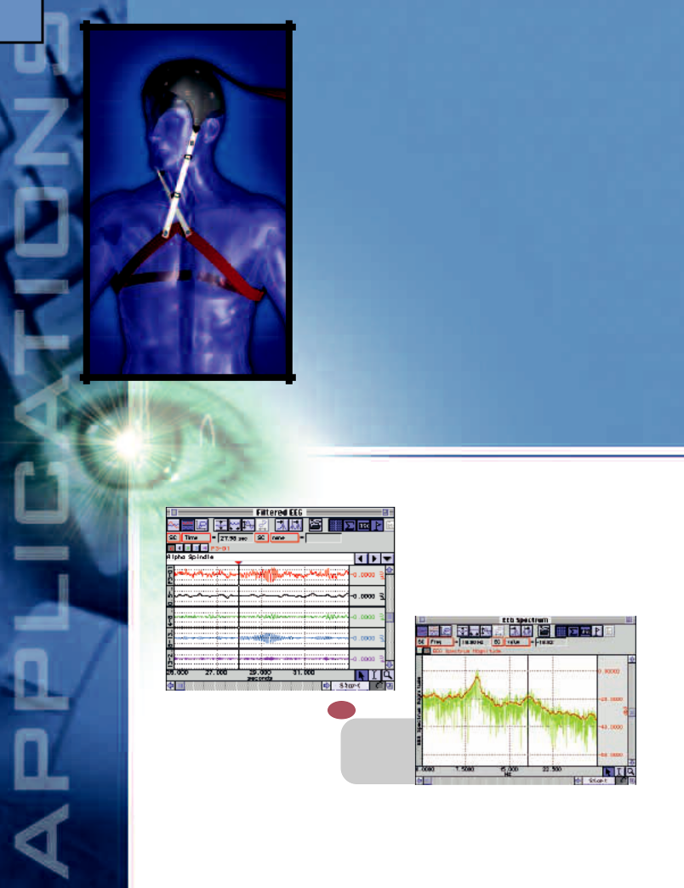
10

Record up to 16 leads and use the on-line software features to derive new leads or filter raw data for a wide range of EEG applications on human and animal subjects. For example, set up multiple-lead unipolar or bipolar montages, or emphasize changes in occipital lobe alpha activity as a consequence of experimental procedure. A variety of stimulus/response protocols are possible when using the averaging options and stimulator accessories.

Features

- Real-time EEG Filtering

- Spectral Analysis

- Amplitude Histogram

- Spike Counting

- Episode Counting

- Evoked Responses

- Event-related Potentials

- Dividing EEG into Specific Epochs

- Cross- and Auto-correlation

EEG

Real-time EEG Filtering
Record single- or multi-channel montages with on-line calculation channels for Delta, Theta, Alpha, and Beta wave activity. On-line calculation channels allow the display of raw and filtered data in real time, and users can employ a variety of other transformations to filter the data off-line and further analyze the data.

Spectral Analysis
Use AcqKnowledge to obtain the power spectrum of the EEG. The power spectrum indicates the power of each frequency component present in the source time domain waveform. Perform power spectral analysis on EEG data from different leads and overlap the results. The FFT in AcqKnowledge allows frequency representation using linear or logarithmic scaling.

- 01

- Maximum

- Minimum

- Frequency

Amplitude Histogram
Create an amplitude histogram to highlight changes within the EEG recording. Use this powerful feature to compare baselines on pre- and post-protocol data. View

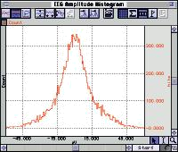

multiple histograms within the same graph window for easy visual comparisons of skewness and kurtosis. The degree of deviation from Gaussian distribution of the EEG has been shown to depend on the behavioral state of the subject. The software will automatically set the amplitude range based on the selected area of data, or the user can manually enter a range and adjust the number of bins to maximize the display resolution.

Spike Counting
The Peak detection function will isolate individual EEG spikes, measure and count them, and enter the result into the Journal file. Select the measurements desired and the software will do the rest. Perform the analysis over the entire recording, pre-selected regions, or a pre-defined time period (e.g., every 30 seconds). Automation features allow the user to select data specific to experimental protocols, such as day/night cycles.

Episode Counting
To determine the number of episodes (sleep spindles, k complexes, epileptic spikes) within a given time period, integrate appropriately filtered EEG data. Next, use the Peak detection function to locate each episode, count
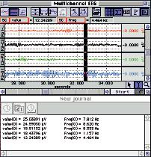

episodes, analyze the time duration of each episode, and determine the frequency of occurrence. This feature is useful for studying episodic activity in humans and small animals over long time durations, including day/night cycles.

Evoked Responses Q02
Record and analyze auditory, visual and somatosensory evoked responses. The on-line averaging function allows the user to perform detailed evoked response studies. The system can trigger a stimulator at the start of each averaging sweep, or an external stimulator can trigger the start of a new sweep. Set the length of the averaging sweep, the number of averages and the latency between averaging passes. Remove any stimulus artifact with the artifact rejection utility. Use the averaging software for a range of evoked potential studies on humans and animals, such as visual (VER), somatosensory (SER) and auditory (AER) responses.
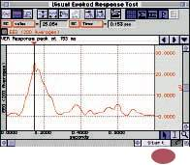

Event-related Potentials Q03

The STP100W package will present a variety of visual and auditory stimuli on one computer while the AcqKnowledge software records the responses on another computer. As the stimuli are presented, the STP100W simultaneously (with 1ms resolution) sends trigger signals to the MP System for data synchronization and collection. The STP100W software (SuperLab™ Pro) can be used to change the placement of visual stimuli on the screen, change the screen’s background color, choose from a variety of input and timing options, and provide feedback based on either response or reaction time. Different trigger channels can be paired to different visu-al or auditory stimuli to perform sophisticated evoked response averaging tests (e.g., P300). The off-line averaging function in AcqKnowledge displays the averaged response to each different stimulus triggered from the STP100W system.

Dividing EEG into Specific Epochs
Use the display scrolling controls to adjust the rate at which data is scrolled across the screen. For example, set the horizontal axis to sweep exactly 30 seconds of data across the screen. This mode is very useful when scoring sleep studies in 30-second epochs.

Cross- and Auto-correlation
To correlate one channel of EEG data with another, use the off-line correlation function in AcqKnowledge. To obtain the auto-correlation of a signal, correlate a channel with itself. To obtain the power spectral density, perform the FFT on the auto-correlation result.

Hardware 11

Options:

EEG100C 56
Electroencephalogram Amplifier

ERS100C 57
Evoked Response Amplifier

STM100C 64
Stimulator Module

STMISO Series 64

Electrical Stimulus Isolation Accessories
OUT101 65

Tubephone Set (auditory response)

STP100W 63
Stimulus Presentation System (SuperLab™)
TSD122 74

Stroboscope (visual response)
HLT100C 53

High Level Transducer Module
INISO 53

Input Signal Isolated Adapter
OUTISO 53

Output Signal Isolated Adapter

CAP100C 85
EEG Electrode Cap

EL Series 83
Electrodes

LEAD Series 83
Electrode Leads

MEC Series 87
Module Extension Cables

12

Response

Perform a wide variety of evoked response studies with the powerful on- and off-line averaging features of the MP System. Record and measure evoked potentials, late potentials, startle, nerve conduction and field potentials. Use 100C-series biopotential amplifiers to record visual, somatosensory and auditory evoked responses—the averaging features make it possible to detect signals below the level of ambient noise. Use the stimulator to output pre-defined waveforms, tones, tone pips, clicks (pulses) or other more complex waveforms. Calculate nerve conduction velocity and recovery time; investigate properties of muscle action potentials and fast nerve impulses. Record and analyze extra-cellular spikes.
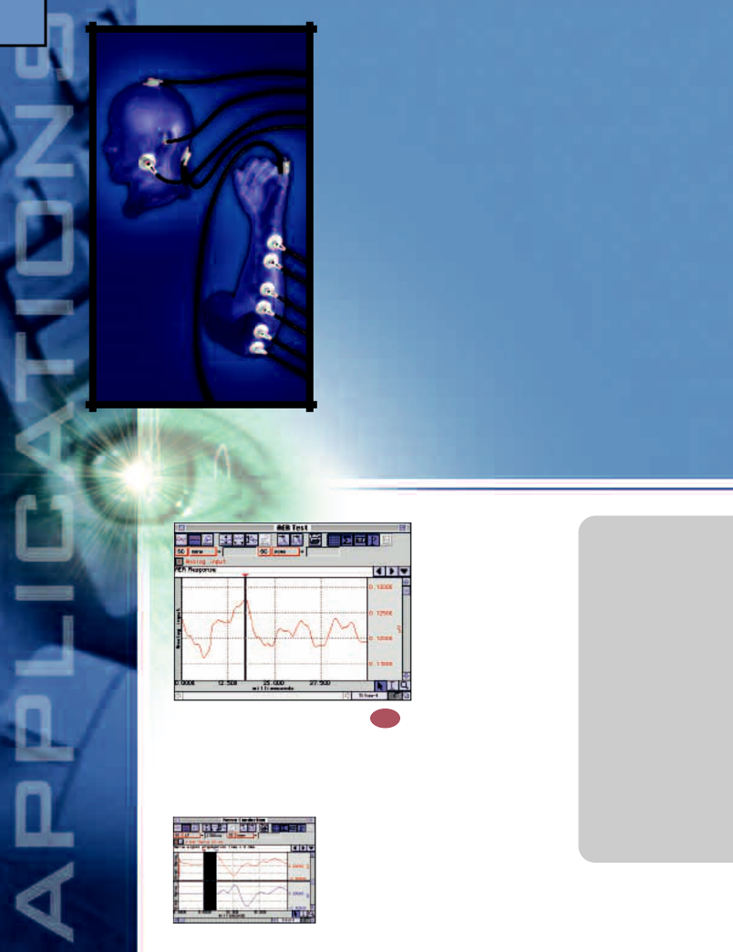

Features
- Nerve Conduction Studies

- Signal Averaging

- Software-controlled Stimulator

- Auditory Evoked Response (AER) & Jewett Sequence

- Visual Evoked Response (VER)

- Somatosensory Evoked Response (SER)

- Event Related Potentials (ERP)

- Extra-cellular Spike Recording

- Automatically Control External Equipment

Evoked

Nerve Conduction Studies Q04 The system software permits easy determination of peak times and maximum responses. Stimulate and record signals from nerves in-vivo or in-vitro; using the built-in software averaging mode, it’s possible to record signals from in-vivo nerves using skin surface electrodes only. Evaluate the effects of stimulation to motor nerve endings

in terms of electrical or mechanical response. Configure stimulation sources to provide electrical,

addition to the stimulator, up to 16 amplifiers can be simultaneously employed to record nerve and/or muscle responses.

Signal Averaging
Remove background noise and extract the signal of interest with the on-line signal-averaging mode. Set the sweep duration and the number of averaging trials. Specify artifact rejection criteria, and determine the triggering options. The software will calculate the average and display the result in real time. The software counts and displays the total number of averages, the number of averages left to complete the sequence, and the number rejected from the test.

- Action Potential Recording

- Compound Potentials

- Absolute and Relative Refractory Periods

- Inhibitory and Excitatory Stimulus

- Nerve Conduction Velocity

- Signal Averaging (Somatosensory, Auditory or Visual Evoked Response)

- Twitch, Sub-Threshold/Threshold

- Maximum Contractile Response

- Tetanic Tension

- Post-Tetanic Potentiation

- Summation

- Fatigue

- Isometric vs. Isotonic Contraction

mechanical or visual stimulation, and vary the duration and level of stimulus. In
Software-controlled Stimulator

Use the graphical setup features in the AcqKnowledge Stimulator dialog to design the appropriate stimulus. The stimulator setup provides a variety of pre-formatted

output options including square, sine and triangle waves. It’s also possible to create stimulus waveforms of any polarity and shape. The output options are adjusted either graphically or numerically for easy control of amplitude, duration and start time.
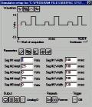
Users can also output a previously recorded waveform or create customized stimuli using the waveform math tools.

Auditory Evoked Response (AER) & Jewett Sequence Q05
To perform on-line AER studies, combine the auditory output options of the STM100C Stimulator with the signal averaging functions of the MP System. Use the OUT101 Tubephone to efficiently direct acoustical stimuli. The software will display the results and allow users to measure the amplitude and time of Fast (2-12 msec), Middle (12-50 msec), Slow (50-300 msec), and Late responses (250-600 msec).
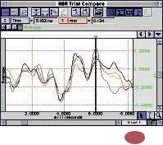

Visual Evoked Response Q06
Perform VER studies with the TSD122 Stroboscope and the averaging features of the MP System. Trigger the averaging cycle with the stroboscope, or vice-versa. Users can substitute different visual stimulators (e.g. checkerboard generators) for the stroboscope.

Somatosensory Evoked Response Q07
Perform somatosensory tests by using the MP System with a STM100C stimulator and either the STMISO series or a solenoid.

- The STMISO series, used with the STM100C, will provide either voltage or current stimulation.
- A solenoid will provide a mechanical stimulation to provoke a touch sensation in the subject synchronously with neuronal recording. Drive a

solenoid directly from the STM100C stimulator and use the ERS100C amplifier to record the evoked potentials.

Average the potentials to obtain a clear picture of the response amplitude and latency.
Event-related Potentials (STP100W) Q₀₃
The STP100W package will present a variety of visual and auditory stimuli on one computer while the AcqKnowledge software records the responses on another computer. As the stimuli are presented, the STP100W simultaneously (with 1ms resolution) sends trigger signals to the MP System for data synchronization and collection. The STP100W software (SuperLab™) can be used to change the placement of visual stimuli on the screen, change the screen’s background color, choose from a variety of input and timing options, and provide feedback based on either response or reaction time. Different trigger channels can be paired to different visual or auditory stimuli to perform sophisticated evoked response averaging tests (e.g., P300). The off-line averaging function in AcqKnowledge displays the averaged response to each different stimulus triggered from the STP100W system.
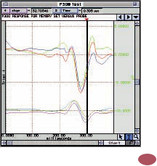

Extra-cellular Spike Recording Q09 Record and analyze extra-cellular spikes using a glass or wire micro-electrode and the MCE100C micro-electrode amplifier. Use the averaging function in AcqKnowledge to determine the average response, or count the number of spikes with the peak detection function. To identify trends within the firings, use the Histogram and FFT analysis functions. Measure the amplitude, duration, and frequency of each spike.

Automatically Control External Equipment

Use the digital I/O lines on the MP System to drive mul-tiple stimulating devices—control lights, buzzers, relays and solenoids. Drive
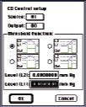
solid state relays direct-ly from the I/O lines to control high-powered external devices. Use the on-line Calculation channels to create synchronization and control channel out-puts.

Hardware 13

Options:

EEG100C 56
Electroencephalogram Amplifier

EMG100C 57
Electromyogram Amplifier

ERS100C 57
Evoked Response Amplifier

STM100C 64
Stimulator Module

STMISO Series 64
Electrical Stimulus Isolation Accessories

OUT100 65
Headphones

OUT101 65
Tubephone Set

STP100W 63
Stimulus Presentation System (SuperLab™)
HLT100C 53

High Level Transducer Module
INISO 53

Input Signal Isolated Adapter
OUTISO 53

Output Signal Isolated Adapter
DA100C 54

General-purpose Transducer Amplifier
TSD122 74

Stroboscope

CAP100C 85
EEG Electrode Cap

MCE100C 61
Micro-electrode Amplifier

EL Series 83
Electrodes

LEAD Series 83
Electrode Leads

MEC Series 87
Module Extension Cables

14

Psychophysiology

Record a wide variety of autonomic nervous system functions, including heart rate, skin conductance (also resistance), skin temperature, muscle tension (EMG), neuronal activity (EEG), and eye movement (EOG). Display measurements (e.g., mean value and standard deviation) during or after data collection. Perform detailed Event-related Potential (ERP) studies using a variety of different stimulus options, including image presentations, video clips, sound, and somatosensory stimulation. Combine physiological and psychological (self-assessment) responses for a detailed study. Use the Equation Generator to enter equations for combining multiple physiological variables for automatic assessment, or choose from an array of preset calculations. Mark events and write comments as they occur or after the fact.
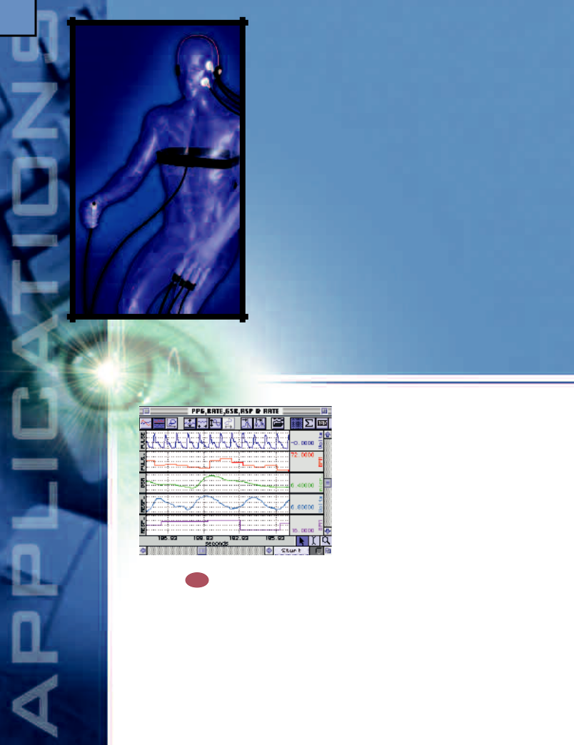

Features
- Autonomic Nervous System Studies

- Evoked Response

- Event-related Potential (P300 Tests)

- Startle Eye Blink Experiments

- Software-controlled Stimulator

- Sexual Arousal Studies

- Automated Data Analysis

- Heart Rate Variability

- Automatically Control Other Equipment

- Auditory & Visual Evoked Response Testing

Autonomic Nervous System
Studies Q10
Evaluate sympathetic and parasympathetic nervous system effects on humans and animals. Record ECG, electrogas-trogram (EGG), skin temperature and electrodermal activity for evidence of sympathetic/parasympathetic nervous system effects. When sympathetic activity increases, heart rate rises, EGG frequency slows, skin temperature drops and electrodermal activity increases.

Evoked Response
Powerful on- and off-line averaging features make it possible to perform a wide variety of evoked response studies. Record and measure evoked potentials, late

potentials, startle, nerve conduction and field potentials. Use the 100C-series biopotential amplifiers to record visual, somatosensory and auditory evoked responses. Use the stimulator to output pre-defined waveforms or tones, tone pips, clicks (pulses) or other, more complex, waveforms.

Event-related Potentials (P300)
The STP100W package will present a variety of visual and auditory stimuli on one computer while the AcqKnowledge software records the responses on another computer. As the stimuli are presented, the STP100W simultaneously (with 1ms resolution) sends trigger signals to the MP System for data synchronization and collection. The STP100W software (SuperLab™) can be used to change the placement of visual stimuli on the screen, change the screen’s background color, choose from a variety of input and timing options, and provide feedback based on either response or reaction time. Different trigger channels can be paired to different visual or auditory stimuli to perform sophisticated evoked response averaging tests (e.g., P300). The off-line averaging function in AcqKnowledge displays the averaged response to each different stimulus triggered from the STP100W system. Useful in other presentation modalities, the TSD200 Pulse Transducer can be attached to a computer monitor to provide event mark timing from a presentation program such as PowerPoint®.

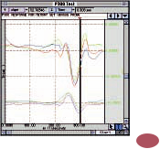

Startle Eye Blink Tests Q11

Use the stimulator with the OUT100 headphones to present auditory stimuli for classic startle response measurements. Use the EMG100C amplifier to record eye blinks (facial EMG). Use AcqKnowledge to integrate the recorded EMG in real time. Use the measurement tools to determine the startle response and amplitude directly, or automate analysis with the peak detection tools. (See the EMG Application on page 42.)
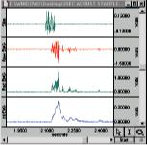

Software-controlled Stimulator
The stimulator provides a variety of pre-formatted output options including square, sine and triangle, or users can design an appropriate stimulus with the graphical setup features; stimulus waveforms can be of any polarity and shape. The output options are adjusted either graphically or numerically for easy control of amplitude, duration and start time. Users can also output a previously recorded waveform or create customized stimuli using the waveform math functions.

Sexual Arousal Studies Q12
Monitor a variety of different psychophysiological param-

eters including vaginal plethysmography (TCIPPG1),

penile plethysmog-
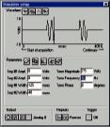
r a p h y

(TCI111/TCI112),

temperature, GSR,

respiration, and pulse. Monitor pulse rate, respiration rate, pulse amplitude, and area under the pulse curve on-line with calculation channels. Use the STP100W
package to present a wide range of images while sending marker/trigger information to the MP System. Use the automatic analysis features, triggering off of the image markers, to determine the amplitude, duration, and onset timing of the subject’s response.

Automated Data Analysis
There are a variety of tools for measuring response times and response amplitudes. Perform measurements manually by selecting an area of data, or automatically over specified time periods or around the time of a trigger (pre- and post-trigger values). Measurement results can be automatically entered into a journal file for further analysis or displayed as a new graph channel.

Heart Rate Variability
For Heart Rate Variability studies, record a wide band-width ECG signal, calculate the R-R interval, and then apply the FFT or Histogram transformation to the R-R interval data. The FFT allows frequency representation using linear or logarithmic scaling. Users can select from a variety of windowing and display options to easily reproduce published results.
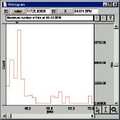

Automatically Control Other Equipment

The MP System will interface with a wide variety of devices such as pumps, valves, stimulators and switches. The MP System has 16 digital I/O lines that can be manually or automatically controlled with the AcqKnowledge software. By using the on-line Calculation and Control channel functions it’s possible to automatically trigger devices to turn on and off. Use the stimulator and control channels to perform multiple stimulus paradigms. Stimulate the subject based on the result of a physiological response.

Auditory & Visual Evoked Response Testing

Combine the auditory output options of the Stimulator with the signal averaging functions of the MP System to perform on-line AER studies. Display the results and measure the amplitude and time of Fast (2-12 msec), Middle (12-50 msec), Slow (50-300 msec), and Late responses (250-600 msec). Use the stroboscope and the averaging features to perform VER studies. Trigger the averaging cycle with the stroboscope, or vice-versa.

Hardware 15

Options:

DA100C 54

General-purpose Transducer Amplifier
TSD120 72

Noninvasive Blood Pressure Cuff Transducer
TSD108 70

Physiological Sounds Microphone

Biopotential Amplifiers
ECG100C 56
EEG100C 56
EGG100C 56
EOG100C 56
ERS100C 56

Transducer Amplifiers GSR100C 58 PPG100C 58 RSP100C 58 SKT100C 58
Transducers
TSD200 81
Pulse Transducer
TSD201 81
Respiration Transducers

TSD202 Series 82
Temperature Probes
TCIPPG1 54
Geer Interface
NIBP100A 68
Noninvasive Arterial Blood Pressure Monitor
STM100C 64
Stimulator Module
STMISO Series 64

Electrical Stimulus Isolation Accessories
OUT100 65
Headphones
TEL100C 66

Remote Monitoring Module Set
STP100W 63

Stimulus Presentation System (SuperLab™)
TSD122 74

Stroboscope
EL Series 83
Electrodes
Lead Series 83
Electrode Leads
MEC Series 87
Module Extension Cables

16

Bioimpedance

Record the parameters associated with cardiac output measurements, thoracic impedance changes as a function of respiration, or any kind of biological impedance monitoring. The EBI100C incorporates a precision high frequency current source, which injects a very small (100µA) current through the measurement tissue volume defined by the placement of a set of current source electrodes. A separate set of monitoring electrodes then measures the voltage developed across the tissue volume. Because the current is constant, the voltage measured
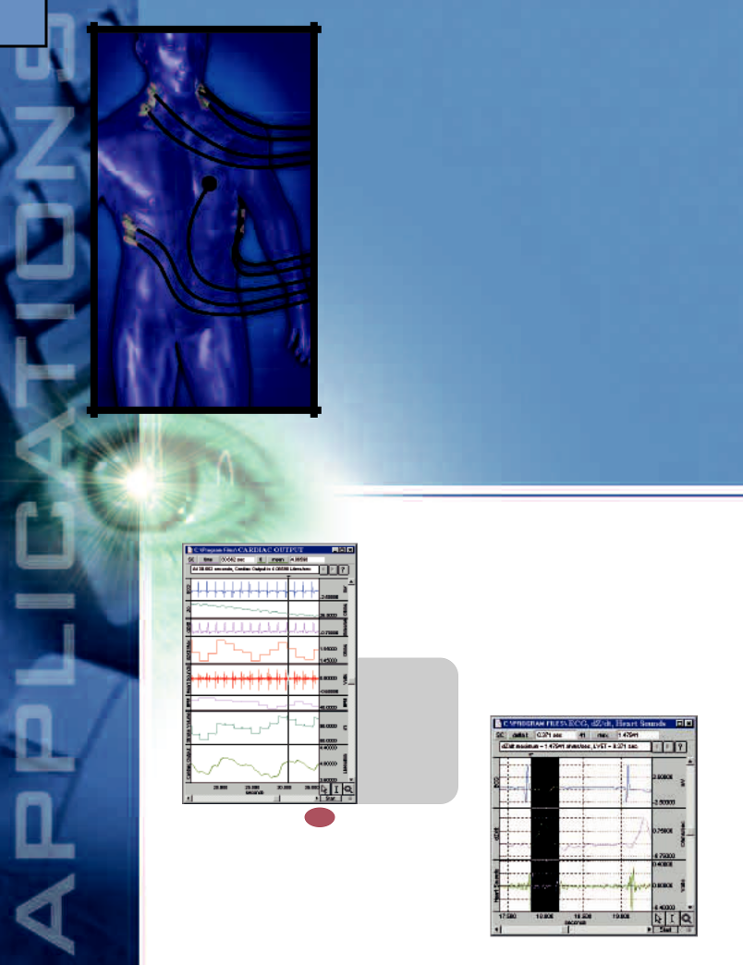
is proportional to the characteristics of the biological impedance of the tissue volume.

Features

- Cardiac Output via Impedance Cardiography

- Systemic Vascular Resistance

- Left Cardiac Work

- Peripheral Blood Flow

- Tissue Magnitude & Phase Modeling

- Pulse Rate Measurement

- Tissue Resistance & Reactance Measurement

- Body Composition Analysis

- Respiration Monitoring

Cardiac Output Electrical

• Z(t)

• dZ/dt

• dZ/dt maximum

• BPM

• LVET

• Stroke volume

• Cardiac output

Cardiac Output Q13
To determine Cardiac Output noninvasively, employ electrical bioimpedance measurement techniques with the EBI100C. With pairs of EL500 electrodes attached to the neck and torso, the EBI100C can isolate the base [Z(t)] and delta impedance (dZ/dt) values, which vary as the heart pumps blood. In real time, dZ/dt magnitude and heart rate can be determined on a cycle-by-cycle basis. Simultaneously, the DA100C and the TSD108

can identify aortic valve opening and closing times. Use the Equation Generator to combine data from these various sources to compute Stroke Volume and Cardiac Output on-line. One possible equation for determining Stroke Volume is (from Nyboer, 1970):
V = ρ • (L²/Z_{O}²) • T • (dZ_{min}/dt)
where V = Stroke Volume

- = Resistivity of Blood

T = LVET

L = Length Between Recording Electrodes dZ_{min}/dt = Magnitude of Largest Impedance

Change During Systole

Systemic Vascular Resistance & Left Cardiac Work

By recording cyclic Stroke Volume (SV) along with the blood pressure waveform using the NIBP100, and computing mean arterial pressure (MAP) using AcqKnowledge, it’s possible to derive Systemic Vascular Resistance (SVR) and Left Cardiac Work (LCW). Divide MAP by SV to obtain a parameter proportional to SVR. Multiply MAP by SV to obtain a parameter pro-portional to LCW.

Peripheral Blood Flow
When used in conjunction with an occluding cuff, electrical bioimpedance measurements on limbs can assess arterial blood flow and venous thrombosis. To prevent venous outflow without significantly changing arterial inflow, rapidly inflate the TSD120 cuff to 40-50 mmHg. The blood inflow causes an increase in the volume of the limb. To measure the arterial flow rate, use the slope of the initial impedance change. The volume change that occurs after the impedance change reaches a plateau is a measure of the compliance of the venous system. Once the volume has stabilized, quickly deflate the cuff. For thrombosis to exist in the veins, the time constant of the outflow lengthens. The percentage outflow drop can be measured directly, at any time, once the cuff pressure is released.
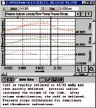

Tissue Resistance & Reactance Measurement

Tissue resistance is mathematically described as the real part of the tissue impedance and tissue reactance is defined as the imaginary part of the tissue impedance. To determine these parameters, measure the impedance magnitude and phase using the EBI100C. Use the AcqKnowledge Equation Generator to multiply the magnitude by the cosine of the phase to obtain the tissue resistance and by the sine of the phase to obtain the tissue reactance. Invert the resistance value to obtain tissue conductance.

Body Composition Analysis
Although there is no direct theoretical relationship between whole body resistance and/or reactance and adiposity, empirical relationships exist to relate total body water and fat free mass to impedance, weight, height, gender and age. In effect, lean body impedance is a function of the specific resistivity of the lean tissue, together with its cross-sectional area and its length. When investigating body composition, the EBI100C can be used to perform multi-frequency measurements of different body parts to obtain the segment’s resistive and reactive components using standard tetrapolar electrode placement.
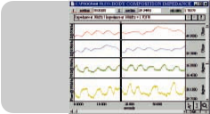
Hardware 17

Options:

EBI100C 60

Electrical Bioimpedance Amplifier

ECG100C 56
Electrocardiogram Amplifier

DA100C 54

General-purpose Transducer Amplifier

TSD108 70
Physiological Sounds Microphone

TSD120 72
Noninvasive Blood Pressure Cuff Trans.

RX120 Series 73

Blood Pressure Cuffs (for the TSD120)

HLT100C 53

- Body water estimation

- Fat free mass

- Extra/intracel-lular water ratio

- Resistivity of bone, fat and muscle

Respiration Monitoring

High Level Transducer Module

INISO 53

Input Signal
Isolated Adapter

OUTISO 53

Output Signal
Isolated Adapter

NIBP100A 68
Noninvasive Arterial
Blood Pressure Monitor

Tissue Magnitude & Phase Modeling

The EBI100C measures tissue impedance magnitude and phase simultaneously at any of four operational frequencies (12.5, 25, 50 and 100kHz). Accordingly, the EBI100C can be used to develop an electrical model of the tissue measured. Real and imaginary parts of the tissue impedance can be determined over this range of frequencies, which points to specific electrical circuit elements (resistors, capacitors and inductors) that can be assembled to electrically model the actual tissue impedance characteristics.

Pulse Rate Measurement
The EBI100C easily measures the change in thoracic impedance that occurs as the heart beats. As blood is forced out of the aorta during ventricular ejection, the impedance through the torso drops momentarily. The derivative of this waveform (dZ/dt) can be processed to record pulse rate (BPM) on a cycle-by-cycle basis in real time. The dZ/dt waveform is directly related to the aortic ejection velocity.

For bioimpedances measured across the thorax using the EBI100C, a small impedance change is observed with each inspiration and expiration. For respiration monitoring, electrodes are placed across the mid-thorax along the mid-axillary line. Filtering can be employed in AcqKnowledge to minimize motion artifacts. Because the EBI100C measures the thoracic impedance directly, the module can measure arbitrarily low breathing rates. When initially calibrated against a pneumotach, the EBI100C can also be used to estimate ventilation.

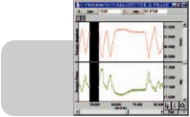

- General respiration monitoring

- Apnea investigations

EL Series 83
Electrodes

LEAD Series83
Electrode Leads

CBL204 86

Touchproof “Y” Electrode Lead Adapter

18

Movement
Record eye position and movement, or observe vestibular response or “jitter” with the electrooculogram amplifier (EOG100C) and an MP System. Software functions will calculate movement rate, direction, frequency, distance and velocity. For attention studies, use the X/Y plotting function to track eye travel and point of focus during or after data collection. Use AcqKnowledge to process raw EOG data to isolate signal behavior associated with nystagmus, saccades and microsaccades.
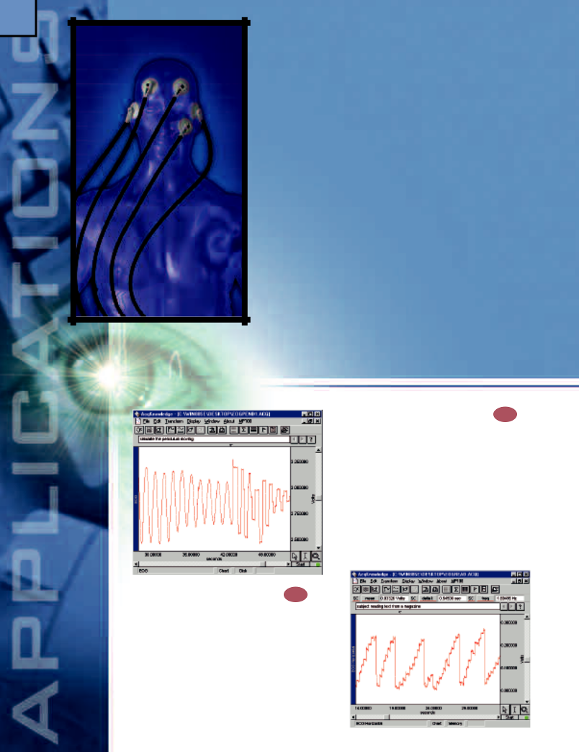

Features

- Nystagmus Investigation

- Saccadic Eye Movements

- Eye Travel & Position

- Vestibular Function

- Visual Evoked Response

- Oculomotor Research & Visual Attention

EOG/Eye

Nystagmus Investigation Q15

Use AcqKnowledge to turn LEDs on and off when studying pendular or jerky nystagmus. The subject sits still and focuses on the slowly moving LED target lights. To isolate both slow and fast phase nystagmus components, change the switching speed of the lights during recording.
Saccadic Eye Movements Q16

Saccadic eye movement can be recorded from a seated subject reading text from a book while the subject’s head remains relatively still and relaxed. As the subject tracks across the page, the eye will make larger voluntary movements, known as saccades, or fixate on a number of points in quick succession. The software lets users identify where the subject’s eyes were located during the recording section; users can also isolate the areas where the subject struggled with a particular word or phrase.

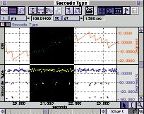

Eye Travel & Position

The X/Y display mode will track a subject’s eye travel and display the exact pattern of movement. This application requires two EOG amplifiers, one for horizontal eye movements and the other for vertical. The subject remains in a fixed position with the head still during recording. The software will display the data in both chart and X/Y display modes. There are a number of tests where this feature is useful, such as determining a subject’s visual path when first exposed to a sign, advertisement, or new ergonomic layout.
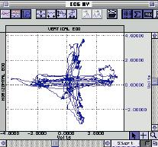

Visual Evoked Response

To perform VER studies, use the TSD122 Stroboscope and the averaging mode of the MP System. The stroboscope will trigger the MP System or the averaging software can trigger an external stimulator. An Evoked Response or Electroencephalogram Amplifier (ERS100C or EEG100C) is used to record the evoked response while the software performs on-line averaging. The averaging software allows the user to set the number of averages and the length of the average, and to adjust the artifact rejection criteria. Display and overlap multiple responses for a quick comparison between subjects and trials.
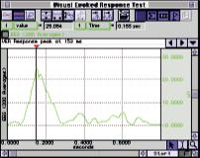
Hardware 19

Options:

EOG100C 57
Electrooculogram
Amplifier
TEL100C 66

Remote Monitoring Module Set

SS SERIES 67
Smart Sensor Electrodes & Transducers

EL Series 83
Electrodes

LEAD Series 83
Electrode Leads

MEC Series 87
Module Extension Cables

ERS100C 57
Evoked Response Amplifier

EEG100C 56
Electroencephalogram Amplifier
TSD122 74

Vestibular Function

For caloric induced nystagmus, synchronize the vestibular stimulation with the nystagmus recording to obtain precise nystagmus latency. For rotationally induced nystagmus, use the TEL100C System to record the EOG to provide a significant degree of movement (up to 60 meters). For continuous rotation studies, couple the TEL100C transmission signal through a slip ring.

Oculomotor Research & Visual

Attention

During normal viewing conditions, a subject makes 3-5 saccades per second, separated by periods (fixations) of 200-300 ms where the eyes do not make large or fast movements. To isolate saccade-to-saccade latencies for histogram timing analysis, record the derivative (velocity) of eye movement and use the Rate Detector to calculate the latencies. Alternatively, by using the Rate Detector to calculate the maximum cyclic value of the derivative, it’s possible to determine the average velocity of saccadic movement over long time periods.

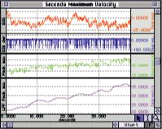

Stroboscope

20
• Amplitude of response
• Duration of response
• Onset of response
• Respiration rate
• Pulse rate & amplitude
• Area under the pulse curve

Plethysmography

Record variations in appendage size as a result of blood circulation or pressure changes and perform indirect blood pressure measurements, using the ausculatatory or oscillometric technique. Combine optical plethysmographic recordings with standard sphygmomanometer-based pressure measurements. Perform sexual arousal studies using a penile or vaginal plethysmograph transducer.
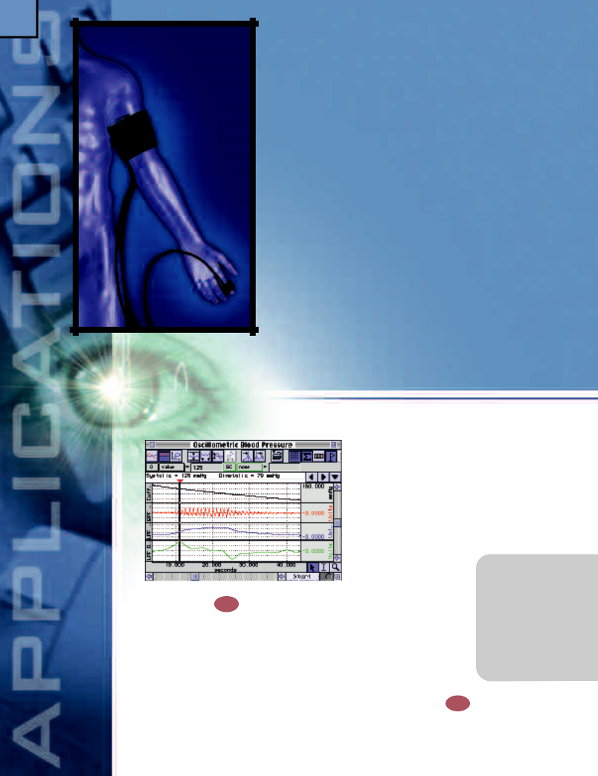

Features

- Indirect Blood Pressure Recordings (Auscultatory & Oscillometric)

- Sexual Arousal Studies

- Blood Volume

- Regional Blood Flow

  - Venous Capacitance

  - Venous Outflow

  - Venous Compliance

- Pulse Transit Time & Relative BP Measurement

Indirect Blood Pressure

Recordings Q17

Record indirect blood pressure with a blood pressure cuff (TSD120) and a contact microphone (TSD108) placed over the brachial artery. Increase cuff pressure to occlude the vessel and slowly release it; as the pressure signal drops, the microphone will record the Korotkoff sounds. Easily determine systolic and diastolic BP with the measurement tools.

Continuous noninvasive blood pressure measurement is also possible — see the NIBP application on page 30.
Sexual Arousal Studies

Monitor a variety of different psychophysiological parameters, including vaginal plethysmography (TCIPPG1), penile plethysmography (TCI111/112), temperature, electrodermal activity (GSR), respiration, and pulse. On-line calculation channels allow users to monitor pulse rate, respiration rate, pulse amplitude, and
area under the pulse curve. Use the STP100W to present images synchronously with physiological data collection. Use the automatic analysis features, in conjunction with the image markers, to determine the amplitude, duration, and onset timing of the subject’s response.

Blood Volume Q18

Measure variations in blood flow indirectly via changes in opacity with the plethysmogram transducer (TSD200).



- Pulse rate

- Amplitude

- Pulse wave area

Typically, the transducer is attached to the finger to record the peripheral pulse. The soft-ware will calculate measure-ments on a beat-by-beat basis.
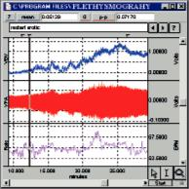

PWV is related to blood pressure delta (Systsolic - Diastolic) in accordance with the following equation (from Bramwell & Hill, 1922):

PWV=K•√[V•( P/ V]

where PWV = Pulse Wave Velocity P = Pressure Delta

K = Constant V = Vessel Volume Delta

V = Initial Vessel Volume
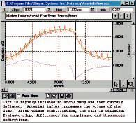
Hardware 21

Options:

DA100C 54

General-purpose Transducer Amplifier

TSD108 70
Physiological Sounds Microphone

TSD120 72
Noninvasive Blood Pressure Cuff Transducer
TCI111 54

Liquid Metal
Transducer TCI
TCI112 54

Hokansen Transducer TCI

PPG100C 58
Photoplethysmogram Amplifier

Pulse Transit Time

& Relative BP Measurement

Pulse Transit Time (PTT) is the time it takes the pulse pressure waveform to propagate through a length of the arterial tree. The pulse pressure waveform results from the ejection of blood from the left ventricle and moves with a velocity much greater than the forward movement of the blood itself. To measure pulse transit time, record the onset of the R-wave with an ECG100C amplifier and record the pulse waveform at the fingertip using a TSD200 and the PPG100C amplifier. Use AcqKnowledge to determine the cyclic peak time of both waveforms, then calculate pulse transit time by subtracting the ECG R-wave peak time from the PPG peak time.

To calculate Pulse Wave Velocity (PWV), first measure the distance from the heart to the location of the TSD200 sensor, then divide the distance by the PTT.

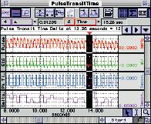
Regional Blood Flow

Occlude the venous return with the blood pressure cuff (TSD120) and measure the swelling of the distal portion of the limb with a mercury strain gauge. The mercury strain gauge interfaces with the DA100C amplifier and a TCI111/112. This experiment allows users to monitor changes from a baseline reading and compare responses from one subject to the next. Typically, the initial slope of the response is determined, and a series of measurements are taken, including:
- Venous capacitance — The inflow curve plateaus because eventually the venous pressure rises sufficiently to force blood past the occluding cuff; the increased volume at this point thus represents the capacity of the venous system to store blood and is termed the venous capacitance.

- Venous outflow — Use venous outflow to determine deep venous thrombosis (DVT). Rapidly release the cuff pressure from the point of maximum swelling and record the time taken for the signal to return to the normal (pre-inflation) level. The level of flow resistance determines the time it takes the flow signal to return to normal.
- Venous compliance — To measure venous capacitance as a function of pressure, follow the procedure for measuring venous capacitance but use different occluding cuff pressures. The slope of this relationship measures the venous compliance.
TCIPPG1 54

PPG100C to GEER Transducer TCI

TSD200 81
Photo-electric Pulse Plethysmogram Transducer

NIBP100A 68
Noninvasive Arterial Blood Pressure Monitor
EBI100C 60

Electrical Bioimpedance Amplifier
HLT100C 53

High Level Transducer Module
INISO 53

Input Signal Isolated Adapter
OUTISO 53

Output Signal Isolated Adapter

STP100W 63
Stimulus Presentation System (SuperLab™)

22

Studies
Save up to 16 channels of data during long-term sleep recordings, including EEG, EOG (eye movement), ECG, EMG (muscle activity), respiration, temperature, and SpO₂. Measure snoring with the physiological sounds microphone and measure changes in body or limb position with an accelerometer. Perform on-line analysis to save the time required to re-process large data files. Record respiration rate, heart rate, integrated EMG, and a variety of other calculations in real time. Filter EEG data to display Delta, Theta, Alpha or Beta waves, or sleep spindles. Add event markers and comments while recording or during analysis.
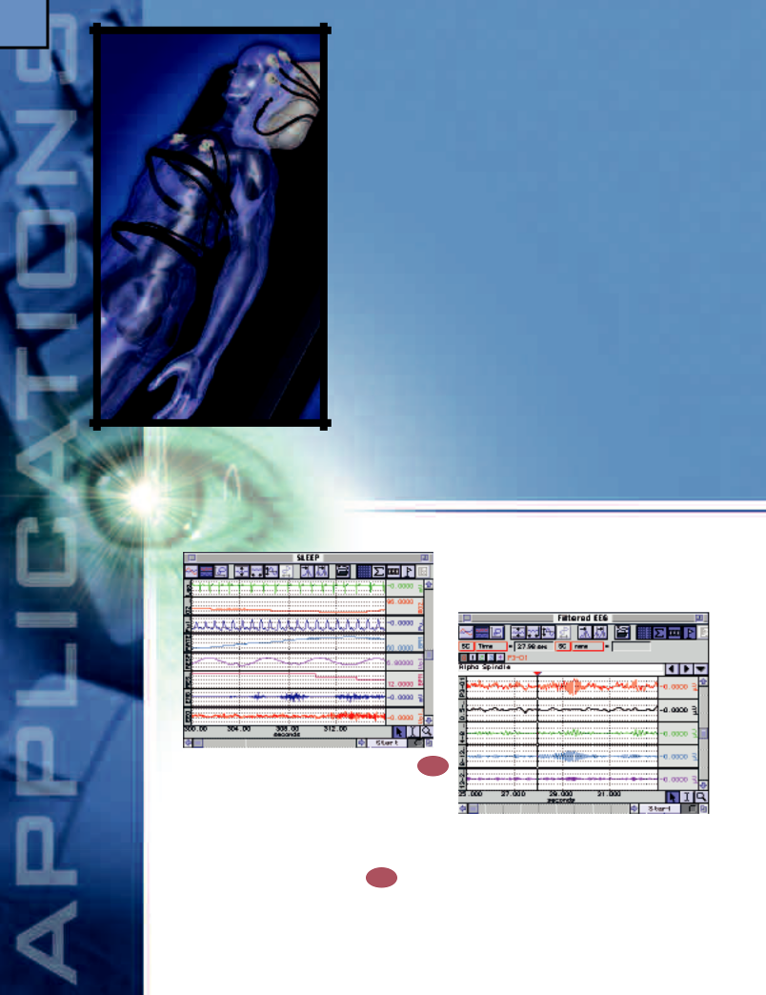

Features

- Multi-Channel Sleep Recording

- Real-time EEG Filtering

- EEG Spectral Analysis

- Template Analysis

- On-line ECG Analysis

- Heart Rate Variability

- EMG & Movement Analysis
- SpO₂ Analysis

- Recurrent patterns

- Automatic Data Reduction

complexes, run the EEG data through a (12-14) Hz band-pass filter. If preferred, filter data off-line and use a variety of other transformations to further analyze the data.

Sleep

Multi-Channel Sleep Recording Q19

Record up to 16 channels of sleep data. Review data in 15- or 30-second epochs for quick visual assessments. Use the Journal to indicate points of interest in the sleep record. Copy critical measurements to the Journal with a single command.

Real-time EEG Filtering Q⁰¹
Use on-line Calculation channels to record single- or multi-channel EEG montages for Delta, Theta, Alpha, and Beta wave activity and to display raw and filtered data in real time. To extract sleep spindles from the raw EEG data, create a real-time (6-15) Hz bandpass filter. To isolate K

EEG Spectral Analysis

AcqKnowledge can be used to obtain the power spectrum of the EEG, with frequency representation in linear or logarithmic scaling. The power spectrum, which can be used to analyze a variety of physiological signals, indicates the power of frequency components in the source time domain waveform and is defined as the square of the linear spectrum magnitude.

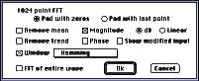

Template Analysis

Use the Template functions to isolate certain repeated

EEG patterns within the recording. Select a wavelet of EEG

data (i.e., spindle or K complex) to create the template

and let the software
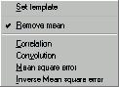

determine the tem-

plate’s Correlation,

Convolution, Mean

Square Error or

Inverse Mean Square

Error with respect to

the entire recording.

To quickly locate patterns of interest within a large

sleep file, run the Peak detector over the Template

function results.

SpO₂ Analysis Q²¹
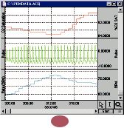
Automatically identify points in the sleep record where the SpO₂ level has dropped below a user-set threshold (e.g. 80%). Use AcqKnowledge to count these events on-line and automatically record the time they occur. To sound alarms (OUT102) or trigger other devices when preset thresholds are crossed, use the Control channel functions in AcqKnowledge.
Hardware 23

Options:
DA100C 54

General-purpose Transducer Amplifier
TSD120 72

Noninvasive Blood Pressure Cuff Transducer
TSD108 70
Physiological Sounds Microphone
HLT100C 53

High Level Transducer Module

TSD150 Series 80
Active Electrodes

TSD109 Series 71
Tri-axial
Accelerometers
INISO 53

Input Signal Isolated Adapter
OUTISO 53

Recurrent Patterns
Output Signal Isolated

On-line ECG Analysis Q²⁰
Use on-line calculation channels to display ECG results

on a beat-by-beat basis, or make the same calculations

off-line. Utilize the bar graph display option for a clear

view of the heart

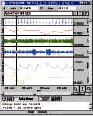

rate data and other

vital signals.

Heart Rate Variability

To perform Heart Rate Variability stud-ies, record a wide bandwidth ECG signal, calculate the R-R intervals, and then apply the

linearly-scaled FFT transformation to the R-R interval data. Compute the power spectrum by squaring the linear spectrum magnitude. Select from a variety of windowing and display options to easily reproduce published results.

Use the Template functions in AcqKnowledge to locate suspected repeated patterns in the sleep record. Apply the template functions to any kind of raw data, such as EEG, ECG, or EOG, or to calculated data, such as heart or respiration rate. Select an example of the wave pattern and then correlate the pattern with the entire sleep record; high points in the resulting correlation function indicate points of similarity.

Automatic Data Reduction

The powerful data reduction function will reduce large data files to a manageable size for further statistical analysis. Analyze both primary signals (such as respiration) and derived data (such as respiration rate). Select the appropriate measurement, enter the desired time epoch, and the software will automatically analyze the data and enter the values into a Journal file. For refined analysis, display the measured values as a new channel and apply the analysis and measurement tools to the summarized results.

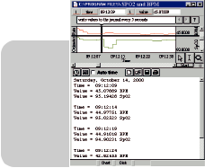
Adapter
ECG100C 56
Electrocardiogram Amplifier
EEG100C 56

Electroencephalogram Amplifier
EMG100C 57
Electromyogram
Amplifier
EOG100C 57
Electrooculogram Amplifier
NIBP100A 68

Noninvasive Arterial Blood Pressure Monitor
OXY100C 61
Pulse Oximeter Module
PPG100C 58
Photoplethysmogram Amplifier
RSP100C 59

Respiration Pneumogram Amplifier
SKT100C 59
Temperature Amplifier
TEL100C 66

Remote Monitoring Module Set

EMG & Movement Analysis

When recording EMG (via the EMG100C) and movement (via the TSD109), users can set limits and thresholds to isolate specific events within the recording. Identify when a subject is moving versus experiencing a muscle tremor episode. After events are identified, users can perform cross-channel analysis on the rest of the data to validate the event.

- Max

- Min

- Mean

- Std dev

- Delta

- P-P

- Time of max

- Time of min
O2100C 62
O₂ Measurement
Module
CO2100C 62
CO₂ Measurement Module
OUT102 65

Piezo Audio Transducer
EL Series 83
Electrodes
LEAD Series 83
Electrode Leads

MEC Series 87
Module Extension Cables

24
• Cost-effective 12-lead recording with the multi-lead cable
• Eight amplifiers required for continuous
12-lead recording
• On-line calculation channels

Cardiology

Collect ECG data from one-, three- or multi-lead montages; connect up to 16 input leads with an MP System. Record using a variety of different ECG lead placements to study the properties of the ECG wave. Investigate heart rate variability with the on-line calculations. Use the powerful ECG averaging function to evaluate changes in the ECG complex before, during and after exercise or dosing. Combine ECG data with other parameters to perform a complete physiological examination. Use the automated data reduction function to analyze the data over user-defined time periods (max, min, mean, p-p, delta, time of max, time of min, and many more). Compare waveforms, find peaks, compute averages and perform complex analyses in real time or after data collection.
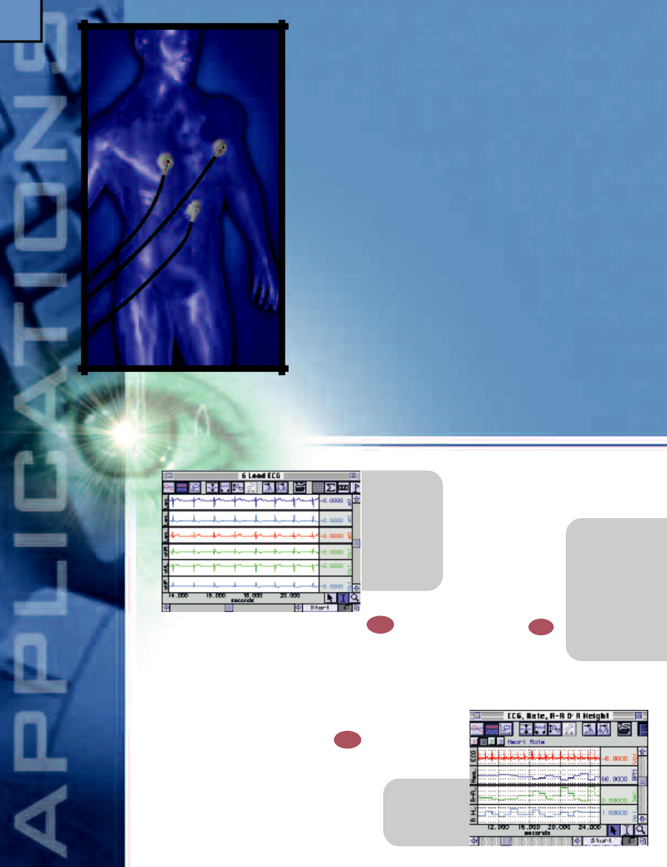
Features
- Einthoven’s Triangle & 6-lead ECG

- 12-lead ECG

- On-line ECG Analysis

- Automated Off-line ECG analysis

- Heart Rate Variability (FFT & Histograms)

- Heart Sounds

- Off-line ECG Averaging

- Chaos Plots

- FFT for Frequency Analysis

- Ventricular Late Potentials (VLP)

- Template Analysis

- Automatic Data Reduction

- On-line calculation channels

- Only two amplifiers required for 6-lead recording

with three ECG100C modules and the low-cost TSD155C multi-lead ECG cable. This cost-effective option displays Leads I, II, III, aVR, aVL, and

aVF simultaneously, plus one chest lead. Move the chest lead from one precordial location to the next to record a complete 12-lead ECG.

ECG:

Einthoven’s Triangle & 6-Lead ECG ^{Q22}
The on-line Calculation channels allow users to take full advantage of the principle of Einthoven’s triangle. Use just two ECG100C amplifiers to obtain six leads of ECG data. Acquire data from Lead I and Lead III (or any two leads from a 3-lead combination) and the on-line Equation Generator will calculate and display Lead II plus the Augmented Leads (aVR, aVL and aVF).

12-Lead ECG Recordings ^{Q23}
To record a 12-lead ECG, eight ECG100C amplifiers are required. Two of the amplifiers can record Leads I, II, III, aVR, aVL, and aVF. Apply the Wilson Terminal (WT100C) to these amplifiers to generate a virtual reference for the six remaining amplifiers, which are assigned the precordial chest leads (V1-V6). Alternatively, users can obtain a 12-lead recording

On-line ECG
Analysis Q20

On-line Calculation channels display results on a beat-by-beat basis; calculations can also be made off-line. Use the bar graph option for a clear view of heart rate data, as in biofeedback

type studies or during surgery.

- Heart rate

- R-R interval

- R-height

- • Heart rate
- • Time of P
- • P wave amplitude
- • Time of Q
- • Q amplitude
- • R-height
- • Time of R
- • R-R
- • Time of S
- • S amplitude
- • S-T segment
- • Time of end of T
Automated Off-line ECG Analysis

The powerful Peak detection feature can automatically isolate the different components of the ECG complex. The software will isolate each component, measure it for time and amplitude, and paste the results into a Journal file for further analysis or display them as new data channels.

Heart Rate
Variability (FFT &
Histograms)
To perform Heart Rate Variability studies, record a wide

bandwidth ECG signal, calculate the R-R intervals in

AcqKnowledge, and then apply an FFT or Histogram

transformation
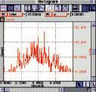
to analyze the
R-R interval
data. Use the
linearly-scaled
FFT function to
evaluate the R-R
interval data for
periodicity. Use
the Histogram
function to point
to variations in

the interval distribution, such as skewness or kurtosis.

Select from a variety of windowing and display options to

easily reproduce published results.

Heart Sounds ^{Q24}
Record the sounds associated with the opening and closing of the valves and the flow of blood within the heart during the cardiac cycle. Record heart sounds by placing a TSD108 Physiological Sounds Microphone on the anterior surface of the chest over the heart. To isolate different sounds, combine the heart sounds recording with the ECG. Use the Scope display mode to overlap the two signals and determine when the sounds are created in relation to the ECG complex.

FFT for Frequency Analysis
Use the FFT in AcqKnowledge to evaluate the frequency components in one or more ECG complexes. To estimate the power spectral density of an ECG signal, perform the FFT and square the linear voltage magnitude using the Equation Generator. Normalize the result by dividing the squared magnitude by the number of samples multiplied by the sampling period.
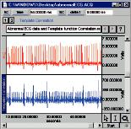

Template Analysis
The Template functions allow users to isolate abnormal ECG signals within the recording. Select a representative ECG complex to create the template and let the software determine the template’s Correlation, Convolution, Mean Square Error or Inverse Mean Square Error with respect to the entire recording. Run the Peak detector over the Template function results to quickly locate abnormal complexes within a large data file.

Ventricular Late Potentials
Ventricular Late Potentials (VLPs) are small-amplitude, short-duration waves that occur after the QRS complex and are precursors to cardiac arrhythmias. VLPs are detected through the application of signal averaging on the ECG signal. To perform a VLP measurement on an ECG recording, use the AcqKnowledge off-line averaging function to trigger on the R-wave peaks and to average the time delta of 20ms to 200ms after each peak’s occurrence. Use the measurement tools to calculate the duration and RMS values of the VLPs.
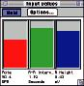
Hardware 25

Options:

ECG100C 56
Electrocardiogram Amplifier

TSD155C 80
Multi-lead ECG Cable

WT100C 87
Wilson Terminal
TEL100C 66

Remote Monitoring Module Set
HLT100C 53

High Level Transducer Amplifier
INISO 53

Input Signal Isolated Adapter
OUTISO 53

Output Signal Isolated Adapter

NIBP100A 68
Noninvasive Arterial Blood Pressure Monitor
DA100C 54

General-purpose Transducer Amplifier

TSD120 72
Noninvasive Blood Pressure Cuff Transducer

TSD108 70
Physiological Sounds Microphone

EL Series 83
Electrodes

JUMP100C 87

Off-line ECG Averaging
Quickly isolate changes in the ECG complex. Display the averaged ECG complex before, during and after dosing or exercising. Select an area and the software will calculate the average ECG complex. By performing this routine for baseline, control and dosing additions, users can display all the results in one graph and overlap them to highlight any changes that occurred during the course of the experiment. This capability is useful for long-term hemodynamic, exercise physiology and cardiology investigations.

Chaos Plots
Take advantage of the X/Y display option to view chaos plots from a regular ECG recording. For a greater under-standing of cardiac disease, plot heart rate against itself with a time delay to isolate attractors within patterns.

Automatic Data Reduction

Use the powerful data reduc-tion function to reduce large

(24-hour) data files to man-ageable sizes. Select the appropriate measurements and enter the desired time

period—the software will automatically analyze the data and enter the values into a Journal file or display them as new data channels. Analyze both primary signals (such as arterial blood pressure) and derived data (such as Systolic BP). The summarized data in the Journal file can be automatically displayed within AcqKnowledge for access to a range of analysis and measurement tools for further refined analysis.
Jumper Connector

LEAD Series 83
Electrode Leads

MEC Series 87
Module Extension Cables
OUT102 65

Piezo Audio Alarm

• Heart rate
• Systolic
• Diastolic
• Mean
• dP/dt
• dP/dt max
• dP/dt min
• Pulse height
• LVEDP
• X/Y plots
26

Hemodynamics

Utilize the powerful on-line analysis capabilities for chronic, acute and in-vitro preparations in both long-and short-term experiments. Pre-program the software to synchronize recording sessions with a user-specified dosing routine. Sophisticated algorithms provide on- and off-line, beat-by-beat analysis of the primary cardiovascular signals. Advanced data reduction features perform automatic statistical measurements and multiple display modes allow users to view the data in a familiar format.
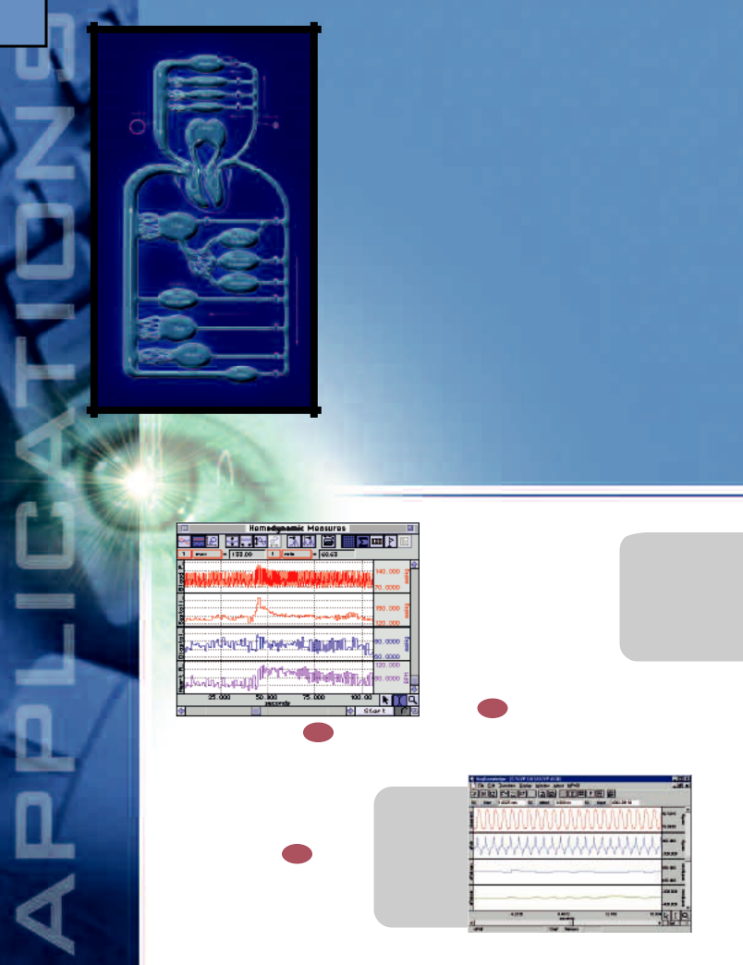
Features

- On-line Analysis (beat-by-beat)

- ECG Analysis Features

- LVP (interface with Millar Mikro-Tip™ catheters)

- Blood Pressure

- Pressure Volume Loops: X/Y display

- Blood Flow

- Automatic Data Reduction

- Automatically Control Pumps & Valves

- Interface with Existing Equipment

- Automate Acquisition Protocols

- Create Standard Operating Procedures

- 24-hour Studies (Chronic Implants/Swivel Tether)

- MRI Application

- Defibrillation & Electrocautery

- Record & Analyze Data From Multiple Animals

- Noninvasive Cardiac Output Measurement

complex before, during and after exercise or dosing. Combine ECG data with other parameters to perform a complete physiological examination. Apply the Template functions to isolate certain phenomena within the ECG recording and analyze data over user-defined time periods with the automated data reduction function. Compare waveforms, find peaks and perform complex analyses in real time or after data collection.

- Heart rate

- R-R interval

- R-height

- Powerful ECG averaging function

- Multi-lead recording (3-, 6- and 12-lead)

Cardiovascular

On-line Analysis ^{Q25}
Sophisticated algorithms will record and analyze, on-line, a variety of hemodynamic signals. The calculation channels process raw hemodynamic data

to provide meaningful parameters on a beat-by-beat basis. The result of one calculation can be fed into another calculation channel to provide sophisticated multi-level analysis.

ECG Analysis Q20
Collect ECG data from one-, three- or multi-lead montages. Investigate heart rate variability with the on-line R-R interval calculator. Use the powerful ECG averaging function to evaluate changes in the ECG

LVP Q28
Calculate and record LVP data from acute, chronic and isolated heart preparations. Interface with a variety of invasive transducers, including the popular series of Millar Mikro-Tip™ Catheters.

Blood Pressure ^{Q26}
• Pulsatile flow max
• Pulsatile flow min
• Mean flow
• Cardiac output
• Stroke volume
• Resistance
• Heart rate
• Systolic
• Diastolic
• Mean
• dP/dt
• dP/dt max
• dP/dt min
• Pulse height
• Max
• Min
• Mean
• Std dev
• Delta
• Pk-Pk
Record continuously for short- and long-term single-and multi-animal studies (24+ hours), or pre-program to record for specific time periods and dosing schedules. The software provides a detailed, beat-by-beat analysis of blood pressure signals. Powerful automatic data reduction tools reduce large data files into manageable sizes. Extract a variety of values over user-defined time periods. AcqKnowledge can provide mathematically precise mean blood pressure via the arithmetic mean calculator from the Rate function, or can estimate mean arterial pressure via the following MAP formula in the Equation Generator:

MAP = [(2 • Diastolic) + Systolic] / 3
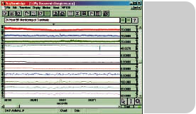

Pressure Volume Loops
Flexible graphing capabilities let users display data in a variety of formats (Chart, Scope or X/Y); simple toolbar icons make it easy to switch between display modes. For example, use the X/Y mode to plot Left Ventricular Pressure against Myocardial Wall Thickness, or any other data channel.
Blood Flow ^{Q27}
Interface with an array of flow meters including ultrasonic, electromagnetic, and the LDF100C Laser Doppler Flow module. The software will provide beat-by-beat, on-line analysis for acute, chronic and in-vitro preparations. Take full advantage of the data reduction features in AcqKnowledge to summarize large data files.
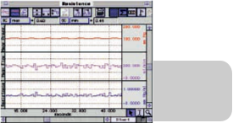

Automatic Data Reduction
The powerful data reduction function will reduce large (24-hour) data files to manageable sizes. Select the appropriate measurements (Max, Min, Mean, Std Dev, Delta, Pk-Pk, Time of max, Time of min) and the summary time delta—the software will automatically analyze the data and enter the values into a Journal file and display them as new data channels. Analyze both primary signals (such as arterial blood pressure) and

derived data (such as Systolic BP). The summarized data can be automatically displayed within AcqKnowledge for full access to all the analysis and measurement tools for further refined analysis.

Automatically Control Other Equipment

The MP System will interface with a wide variety of devices such as pumps, valves, stimulators and switches. The MP System has 16 digital I/O lines that can be manually or automatically controlled from within the software. Use the on-line Calculation and Control channels to automatically trigger devices to turn on and off.

Interface with Existing Equipment
MP Systems will interface with a wide variety of third-party equipment such as flow meters, force plates, sono-micrometers, telemetry equipment, transducers, amplifiers, metabolic carts, and bedside monitors. BIOPAC offers two interface solutions: isolated for human use and non-isolated for animal and in-vitro applications. See the Amplifiers & Interfaces application on page 48.

Automate Acquisition Protocols

Automatically trigger pre-programmed trials to record the data around dosing periods, 24 hours a day, seven days a week. Record

continuously (24+ hours) or pre-program to record for specific time periods and dosing events. The system will accept outputs from other equipment to provide automatic event marking during hemodynamic experiments.

Create Standard Operating Procedures

Save customized algorithms and display settings to a Template file. Tailor the menu displays by removing options and use the Journal to display specific procedural instructions for Standard Operating Procedures.

MRI Applications
New (EL254-RT and EL258-RT) carbon fiber lead electrodes provide high quality signals without interfering with the MRI. Add an ECG alarm (OUT102) for an audible reference of the subject’s heart rate while in the imager.

Defibrillation & Electrocautery
Use the MEC111C Module Extension Cable to protect the MP System amplifiers against high frequency currents.

Noninvasive Cardiac Q13 Output Measurement

Cardiac Output can be determined, noninvasively, by employing electrical bioimpedance measurement techniques with the EBI100C. With pairs of electrodes attached to the neck and torso, the EBI100C can isolate the base [Z(t)] and delta impedance (dZ/dt) values, which vary

as the heart pumps blood. Determine dZ/dt maximum and BPM on a cycle-by-cycle basis, in real time. Simultaneously identify aortic valve opening and closing times with the DA100C and the TSD108. To compute Stroke Volume and Cardiac Output on-line, combine data from these various sources with the Equation Generator.

Hardware 27

Options:
DA100C 54

General-purpose Transducer Amplifier

TSD104A 69
Precision Pressure Transducer

TSD108 70
Physiological Sounds Microphone

ECG100C 56
Electrocardiogram Amplifier
EBI100C 60

Electrical Bioimpedance Amplifier

LDF100C 60
Laser Doppler Flow Module

SKT100C 59
Temperature Amplifier

OXY100C 61
Pulse Oximeter Module

NIBP100A 68
Noninvasive Arterial Blood Pressure Monitor
HLT100C 53

High Level Transducer Module
INISO 53

Input Signal Isolated Adapter
OUTISO 53

Output Signal Isolated Adapter

STM100C 64
Stimulator Module

STMISO Series 64
Electrical Stimulus Isolation Accessories

TSD116C 72
8-channel Digital Marker

CBL100
Series 88

Analog Connection Cables
CBL204 86

Touchproof “Y” Electrode Lead Adapters

EL Series 83
Electrodes

LEAD Series 83
Electrode Leads

MEC Series 87
Module Extension Cables

28

EGG Electrogastrogram
Measure the time-varying electrical activity of the gastrointestinal system of human and animal subjects, invasively or noninvasively. Gastrointestinal motility is directed by chemical, neural and myogenic control systems. The myogenic control system is manifested by slow wave cyclic depolarizations of smooth muscle cells called the electrical control activity (ECA). This myogenic system and the resulting electrical response activity (ERA) influence the contraction patterns in the stomach, small intestine and colon. The myogenic system affects the frequency, coordination, direction and velocity of the contractions. The combined ECA and ERA signals constitute the electrogastrogram (EGG) recorded by the EGG100C.
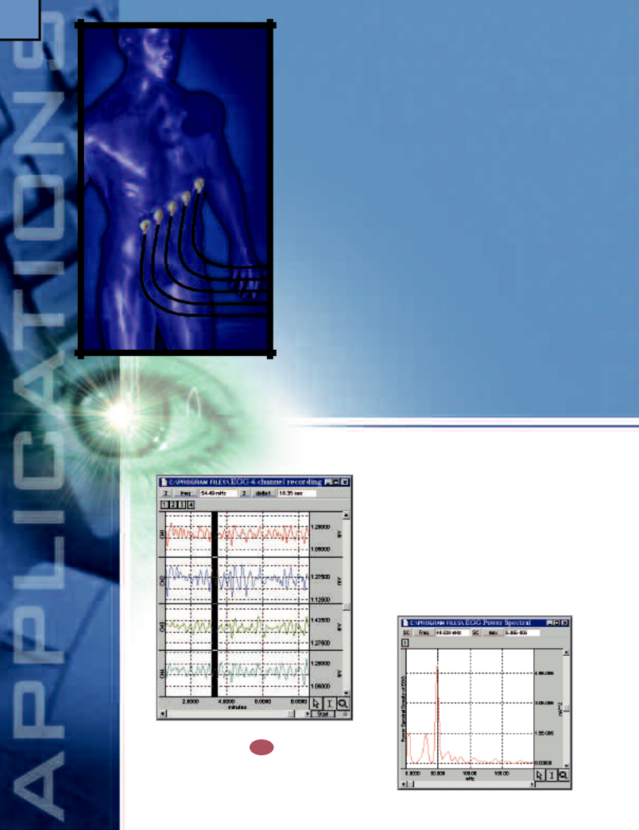

Features
- Invasive/Noninvasive Electrode Measurements

- Gastric Myoelectric Activity (Smooth Muscle)

- Gastric Slow Wave Propagation

- Gastrointestinal Motility Analysis

- Peristaltic (Slow Wave) Propagation

- Migrating Myoelectric Complex

- Animal Studies

- Automatic Data Reduction

be recorded cutaneously with disposable or reusable surface electrodes. Alternatively, the EGG can be recorded using needle electrodes or custom electrode arrays for direct smooth-muscle measurements of the stomach, small intestine and colon. For measurements inside layers of smooth muscle tissue, use the EL450 Teflon®-coated needle electrodes. Up to 16 EGG100C amplifiers can be used simultaneously to record surface or subcutaneous signals. JUMP100C jumper connectors are used to reference amplifier inputs to satisfy any combination of monopolar or bipolar recording modes.

Invasive/Noninvasive Electrode Measurements Q29

The EGG100C amplifier can be used to isolate elements of the gastrointestinal system for recording, through the use of either surface or needle electrodes. The EGG can
Gastric Myoelectric Activity
The normal stomach generates a myoelectric signal (EGG) that oscillates with a period of three cycles per minute. The EGG can be measured noninvasively by using the EGG100C amplifier and standard leads with disposable electrodes. After the data is recorded, the signal median frequency and power spectral density can be determined using AcqKnowledge. This type of signal processing is useful for evaluating abnormal gastric rhythms, such as tachygastria or bradygastria. It’s also possible to evaluate the EGG signal using the phase-space techniques associated with non-linear dynamics. Plotting EGG rate against a delayed version of itself in X/Y mode can point to patterns not otherwise evident in the time series data.
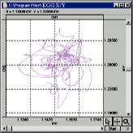

Gastric Slow Wave Propagation
The gastric slow wave (ECA) originates in the proximal stomach and propagates distally towards the pylorus. For recording, place multiple surface electrodes on the abdomen along the gastric axis and connect them to respective EGG100C amplifiers that have a common reference electrode placed near the xiphoid process. For consistent electrode-to-electrode spacing, use the EL500 dual electrodes with LEAD110 leads. For extremely tight electrode-to-electrode spacing, use the EL254 or EL258 reusable Ag-AgCl lead electrodes. The signals amplified at each electrode will be displayed on consecutive channels in AcqKnowledge. For manual measurements, use the cursors to evaluate waveform differences. For automated timing analysis, run the Peak time detector on one channel and search the remaining channels for their respective peak times. To verify the delta time consistency, automatically calculate the difference in peak times between the channels.

Gastrointestinal Motility Analysis Q30
The ECA and ERA components of the EGG can be isolated using the digital filters in AcqKnowledge. To isolate the ECA (slow wave) component, apply a 0.1 Hz lowpass filter to the EGG data. To filter out the ERA component, which consists of spike bursts present on the plateaus of the ECA signal, run a 0.5 Hz highpass filter. Perform filtering in real time as the EGG is recorded, or in post processing, after data has been collected.

Peristaltic (Slow Wave)
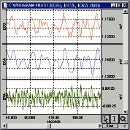
Propagation
Peristaltic electrical signal propagation can be recorded using monopolar or bipolar recording techniques with the EGG100C and AcqKnowledge. To derive either long or short distance bipolar data, configure the amplifier to record with a common reference (monopolar) and then use the software to subtract one monopolar channel from another. After data collection, use the peak detection algorithms present in AcqKnowledge to analyze the time shifts between propagated signals on different channels.

Migrating Myoelectric Complex
A histogram of the migrating myoelectric complex (MMC) can be extracted from bipolar EGG recordings. Use AcqKnowledge to perform peak-to-peak measurements on slow waves (ECA) automatically. The resultant cyclic peak data can be presented in histogram form to illustrate the presence or absence of spikes (ERA).

Animal Studies
The EGG100C amplifier, when used with standard needle or fine-wire electrodes, will record invasive EGG measurements on animals, directly on the tissue of the component organs of the gastrointestinal system. To record peristaltic propagation on the small intestine, create a custom electrode array using a soft-spring plastic clip with leads of silver wire looped at the desired recording sites and terminate the silver wire leads with a Touchproof socket for connection to the EGG100C. This type of electrode array has fixed and very repeatable electrode-to-electrode spacing.

Automatic Data Reduction
The powerful data reduction function will reduce large (24-hour) data files to manageable sizes. Select the appropriate measurements (Max, Min, Mean, Std Dev, Delta, Pk-Pk, Time of max, Time of min) and the summary time delta—the software will automatically analyze the data and enter the values into a Journal file and display them as new data channels. Analyze both primary signals (such as direct EGG) and derived data (such as the ECA component). The summarized data can be automatically displayed within AcqKnowledge for full access to all the analysis and measurement tools for further refined analysis.

Hardware 29

Options:

EGG100C 56
Electrogastrogram Amplifier

EL Series 83
Electrodes

JUMP100C 87
Jumper Connector

LEAD Series 83
Electrode Leads

MEC Series 87
Module Extension Cables
30

Noninvasive Blood Pressure

Collect real-time, beat-by-beat blood pressure data with minimal intervention. The NIBP100A noninvasive arterial blood pressure monitor is a unique device capable of generating a continuous arterial pressure signal via a tonometric measurement technique. The noninvasively derived tonometric signal is equivalent to the continuous arterial pressure signal provided by an arterial, in-line, pressure transducer.

Features

- Psychophysiology

- Neurology Research

- Cardiology Research

- Autonomic Testing

- Long-term Monitoring

- Orthostatic Testing

- Automatic Data Reduction

the STM100C to drive the OUT100 headphones. Record the physiological changes in direct response to the sound burst.

Neurology Research
Nervous system functions such as sudomotor axon reflex, vasomotor, cardiac-vagal and adrenergic functions can be indicated with measurements such as beat-by-beat blood pressure, electrodermal response, skin temperature, ECG and respiration.

Psychophysiology Q31

AcqKnowledge will extract beat-by-beat systolic, diastolic and mean blood pressure data from the raw blood pressure waveform. Simultaneously, data can be collected from ECG, EOG, EMG, RSP, GSR and SKT amplifiers. The Equation Generator can be used to algorithmically combine various channels to generate an indicator when the subject manifests a specific physiological state. Examine the startle response of beat-by-beat blood pressure along with eye blink measurements. Use AcqKnowledge to produce a short noise burst or click and direct the signal to

Cardiology Research
Combine blood pressure data (via NIBP100A) with cardiac output data (via EBI100C) to indicate systemic vascular resistance on a beat-by-beat basis. Use the Equation Generator to determine vascular resistance as blood pressure divided by blood flow. For blood pressure measurements, AcqKnowledge can provide mathematically precise mean blood pressure via the arithmetic mean calculator from the Rate function, or via the following MAP formula in the Equation Generator.

MAP = [(2 • Diastolic) + Systolic] / 3
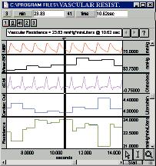

Long-term Monitoring
The NIBP100A can be attached to a subject for an extend-ed period, due to its novel tonometric measurement technique, which, unlike the auscultatory and oscillometric techniques, does not restrict the subject’s blood flow.

Orthostatic Testing
Blood pressure varies based on the subject’s physical orientation in a gravitational field. The NIBP100 can be attached to a subject placed on a tilt table. Use TSD109 accelerometers to determine the exact tilt in all three spatial dimensions and record the X, Y and Z accelerometer signals simultaneously with the varying blood pressure signal.

Automatic Data Reduction
The powerful data reduction function will reduce large (24-hour) data files to manageable sizes. Select the appropriate measurements (Max, Min, Mean, Std Dev, Delta, Pk-Pk, Time of max, Time of min) and the summary time delta—the software will automatically analyze the data and enter the values into a Journal file and display the data as a new channel. Analyze both primary signals (such as blood pressure) and derived data (such as Systolic BP). The summarized data can be automatically displayed within AcqKnowledge for full access to a range of measurement tools for further refined analysis.
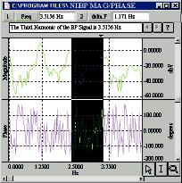
Hardware 31

Options:

NIBP100A 68
Noninvasive Arterial Blood Pressure Monitor
EBI100C 60

Electrical Bioimpedance Amplifier

ECG100C 56
Electrocardiogram Amplifier

EMG100C 57
Electromyogram
Amplifier

SKT100C 59
Temperature Amplifier

CO2100C 62
CO₂ Measurement Module

GSR100C 58
Electrodermal Response Amplifier

STM100C 64
Stimulator Module

OUT100 65
Headphones

OUT102 65

Autonomic Testing
During certain activities, elements of the autonomic nervous system can be tested by simultaneously measuring beat-by-beat blood pressure, ECG and end-tidal CO₂. These activities include the tilt table test, deep breathing test and the Valsalva maneuver. For example, upright position angles of greater than 30 degrees (on the tilt table) usually activate the sinoaortic baroreflex, which is essential for the maintenance of blood pressure and cerebral perfusion while standing.

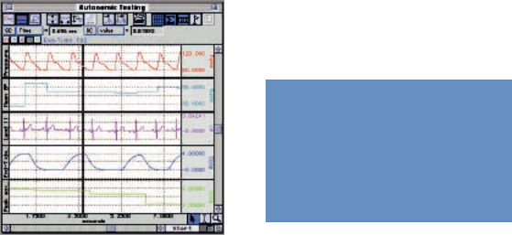

Did you know?

BIOPAC amps are now available for stand-alone operation.
Piezo Audio
Transducer

HLT100C 53

High Level Transducer Module
INISO 53

Input Signal Isolated Adapter
OUTISO 53

Output Signal Isolated Adapter

TSD109 Series 71
Tri-axial
Accelerometers

EL Series 83
Electrodes

LEAD Series 83
Electrode Leads

MEC Series 87
Module Extension
Cables

32
• Area under the curve
• Peak-to-peak
• Minimum
• Maximum

Pharmacology

Record data from tissue bath, isolated organ, Ussing chamber and field stimulation experiments. Use advanced algorithms to analyze Langendorff, working heart and isolated perfused lung data, on-line. Visually compare and measure tissue bath dose responses on-line. Control valve opening and closing times to automate wash and fill cycles. Keep an on-line log of experimental results.

Features
- Tissue Bath Monitoring

- On-line Analysis

- Pulsatile Tissue Studies

- Cardiovascular Analysis

- Langendorff Heart Preparations

- Working Heart Preparations

- Isolated Lung Studies

- Field Potential Measurements

- Automatic Data reduction

- Control Pumps & Valves

- Interface with Existing Equipment

- Simple two-point calibration

- Multi channel calibration

- Textual event marking

- Remote channel marking

- On-line analysis

- Overlap and compare responses

On-line Analysis
Use AcqKnowledge to automatically analyze the peak response to a drug and enter measurement results into the Journal for further analysis. Record the absolute peak response or the mean peak response over a user-defined time period. The mean peak response function prevents sudden spikes from swamping the measurements.

In-vitro

Tissue Bath Monitoring Q32

Record and analyze tissue bath preparations. The TSD105A and TSD125 Series force transducers work down to the milligram range and will record responses from small aortic rings to much larger preparations. Interface with a wide variety of tissue bath stations and force transducers. Use the keyboard/mouse event marking system, or utilize one or two of the 8-channel digital marker boxes to precisely identify drug additions and wash cycles. Use the software to compare responses and analyze the data on-line for fast and efficient protocol management. The system will even allow users to trigger valves to control wash cycles and other devices during recording.

Pulsatile Tissue Studies Q³³
Automatically analyze pulsatile tissue data with the on-line calculation channels. The calculations will provide real-time values for maximum, minimum, peak-to-peak and the area under the curve for each response. To assist in identifying trends within the data, the measured values are displayed on the
screen as new data channels. The Peak detection function will allow users to perform the same analysis off-line. The software will automatically measure the maximum, minimum, peak to peak and area for each

• Max
• Min
• Mean
• Std dev
• Delta
• P-P
• Time of max
• Time of min
response and paste the values into the Journal file. The data is easily exported to third-party statistical packages for further analysis.

Langendorff & Working Heart Preparations Q34

Interface with flow meters, fluid-filled balloon-tipped

 | catheters and pressure-tipped
 | catheters to monitor flow
• Heart rate | rates | and | left ventricular
• Heart rate | pressure. Perform a variety
• Systolic
• Systolic | of LVP measurements, both
• Diastolic
• Diastolic | on- and off-line. Use the
• Mean blood pressure
• Mean blood pressure | built-in stimulator to
• dP/dt (max / min)
• Pulse height | pace | the | heart. Powerful
• Max | automatic |  | data | reduction
• Min | tools reduce large data files
• Mean | into manageable sizes and
• Time of max | can extract a variety of
• Time of min | values over user-defined
• LVEDP | time | periods. |  | Record
• X/Y plots | continuously for short- and
• Flow | long-term studies (24+
• Flow max | hours), or pre-program to
• Flow min | record for specific time
• Flow mean | periods and dosing events.
• Temperature
• Pressure | Isolated Lung
Studies Q35

Calculate tidal volume, airway resistance and dynamic compliance, and monitor temperature, pressure, pH, and pO₂. Automatically control a ventilator to start and stop during an experiment. Record and analyze flow and pressure signals on-line. The real-time Integration function has a unique feature that will provide accurate volume measurements even if the flow transducer’s baseline is drifting. Use the on-line calculation channels for advanced measurements and monitor a variety of pulmonary values such as compliance and resistance.

Field Potential Measurements
To perform field potential measurements, position

electrodes around the isolated tissue or organ and use the MCE100C to record the potential. Each MCE100C can record a single differential potential. Multiple MCE100C amplifiers can be configured for unipolar (common reference) or bipolar (multiple reference) recordings. Up to 16 channels of field potential data can be collected simultaneously. Measurements can be performed synchronously with external voltage or current stimulators.
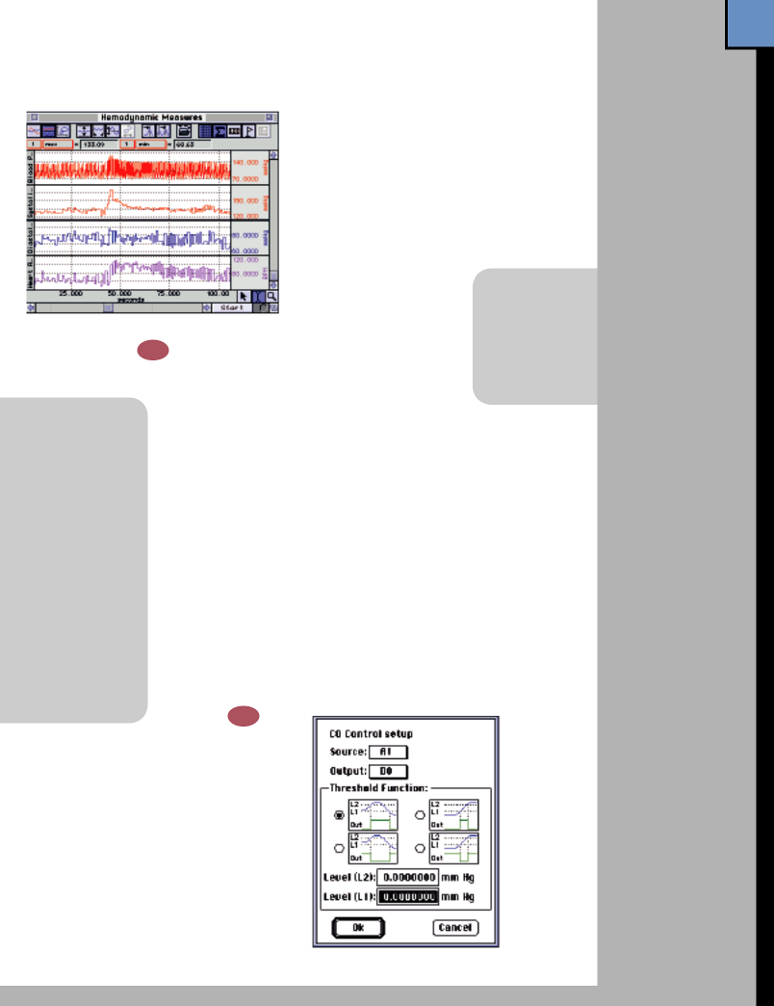
Also see Field Potential in Micro-electrode Recording, page 37.

Automatic Data Reduction
Use the powerful data reduction function to reduce

large, 24-hour files to a manageable size, ready for further statistical analysis. Select the appropriate measurements and enter the desired time period, and the software will automatically analyze the data and enter the values into a Journal file and display them as new data channels. Analyze both primary signals (such as arterial blood

pressure) and derived data (such as systolic BP).

Control Pumps and Valves
Control up to 16 digital I/O lines to interface with valves and pumps. Trigger devices manually from the keyboard, or automatically as pre-defined events occur. Turn pumps on and off or set an audible alarm to sound when a signal falls within or outside a user-defined range.

Interface with Existing Equipment

The Transducer Connector Interfaces (TCIs) interface the DA100C with transducers from other manufacturers such as Grass, Gould, Beckman, Viggo-Spectramed, etc. The MP System also provides direct connection to any equipment with an analog output, using the appropriate connection cable to the UIM100C. See the Amplifiers & Interfaces application on page 48.
Hardware 33
Options:

DA100C 54

General-purpose Transducer Amplifier

TSD105A 69
Variable Range Force Transducer

TSD125 Series 75

Precision Fixed Range Force Transducers

HDW100A 75
Force Transducer
Tension Adjuster

TSD104A 69
Precision Pressure Transducer

ECG100C 56
Electrocardiogram Amplifier

STM100C 64
Stimulator Module

STMISO Series 64

Electrical Stimulus Isolation Accessories
HLT100C 53

High Level Transducer Module
INISO 53

Input Signal
Isolated Adapter
OUTISO 53

Output Signal Isolated Adapter

SKT100C 59
Temperature Amplifier

MCE100C 61
Micro-electrode
Amplifier

TSD116C 72
8-channel Digital
Marker Box

EL Series 83
Electrodes

CBL100
Series 88

Analog Connection Cables

34

Flow
Record the effects of drug treatments, exercise, or inadequate blood supply on microvascular circulation with the LDF100C Laser Doppler Flow module. Use
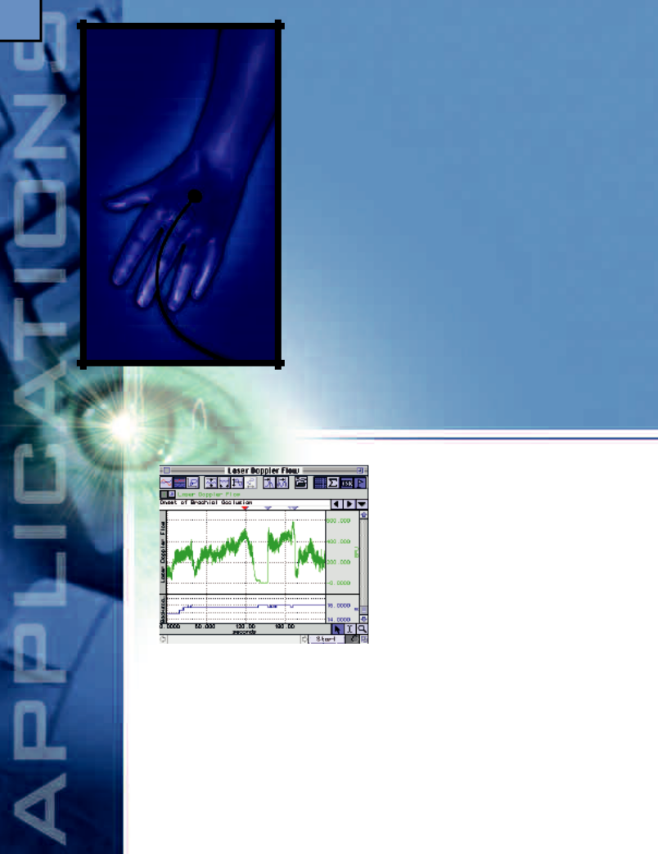
the LDF100C for invasive and noninvasive applications—it can be used in any situation where tissue ischemia resulting from inadequate blood supply is a significant factor. For long-term, chronic experiments, use implantable single fiber probes. Combine LDF data with other physiological parameters such as temperature, blood pressure, ECG and a variety of other signals for a detailed physiological analysis.

Features
- Cerebral Blood Flow
- Rheumatolgy
- Allergies
- Irritants & Inflammation
- Planted Tissue
- Data Analysis
- Data Reduction
- Micro-circulation Studies
- Tumor Micro-perfusion
- Invasive & Endoscopic Blood Flow
- Microangiopathy Investigations
- Venous Insufficiency
- Burn Healing
- Stroke Models
- Metabolic Studies
- Iontophoresis Monitoring
- Multi-channel Options

Laser Doppler

Advantages of Laser Doppler Flowmetry

Principally, Laser Doppler Flowmetry (LDF) makes use of the fact that when a coherent, low-powered laser illuminates tissue, light is scattered in static structures as well as in moving blood cells within the microcirculatory beds. Photons, scattered by the moving blood cells, are spectrally broadened according to the Doppler effect. LDF is established as an effective and reliable method for the measurement of blood perfusion in the microvasculature because LDF provides continuous, noninvasive and real-time measurement capabilities.

LDF offers substantial advantages over other methods in the measurement of microvascular blood perfusion.

Studies have shown that it is both highly sensitive and responsive to local blood perfusion and is also versatile and easy to use for continuous subject monitoring. The laser Doppler technique is strictly noninvasive (the probe is not actually required to touch the surface of the tissue) and in no way harms or disturbs the normal physiological state of microcirculation. Furthermore, the small dimensions of available probes enable them to be employed in experimental environments not readily accessible using other techniques.

Cerebral Blood Flow
Laser Doppler monitoring of cerebral blood flow can be performed with many different types of fiber-optic probes, dependent on the size and location of the area to be investigated. To measure subcutaneous micro-vascular blood flow, use needle (TSD144, TSD145) or disposable fiber (TSD147A, TSD147B) probes. For cutaneous measurements, use surface (TSD140, TSD141, TSD146) or suturable (TSD143) probes.

Rheumatology
Research the micro-vascular blood flow changes resulting from different rheumatic disorders, such as rheumatoid arthritis, Raynaud’s phenomenon and connective tissue disease. For investigations of Raynaud’s phenomenon, use the digit probe (TSD142). To assess ischemia of the small intestine, use needle probes (TSD144, TSD145).

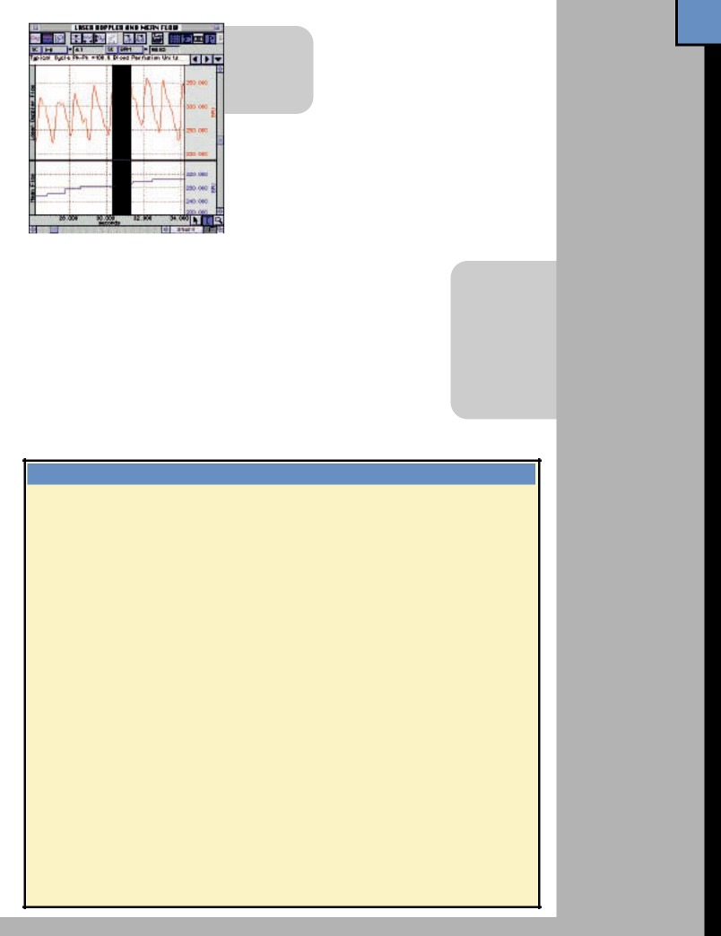• Heart rate
• Mean flow
• Flow min
• Flow max
Planted Tissue
Flaps and planted tissues typically exhibit changes in blood flow after the planting procedure. The MP System can be programmed to control a visual or auditory alarm if the mean or peak-to-peak blood flow signals from the LDF100C drop below a specified level. Use

AcqKnowledge to isolate pulsatile signals and evaluate the peak-to-peak values in real time.

Data Analysis
The software will provide full on-line analysis of pulsatile flow data for each cardiac cycle. Use the automatic data reduction function to determine statistical measurements over a user-defined time period.
Hardware 35
Options:

LDF100C 60
Laser Doppler Flow Module

TSD140 Series 78

Laser Doppler Flow Probes
DA100C 54

General-purpose Transducer Amplifier

Allergies
The nasal skin and mucosa are often subject to allergic reaction. To evaluate micro-vascular blood flow of the skin, standard surface probes (TSD141, TSD146) are suitable. To perform measurements on the nasal mucosa, use needle probes (TSD144, TSD145) with the appropriate clamp.

Irritants & Inflammation
Evaluate skin reactions resulting from hypersensitivity and inflammatory mediators. To measure micro-vascular blood flow on the skin surface, use the TSD140, TSD141 or TSD146 probes. To objectively quantify the flow changes resulting from inflammation, take a real-time measurement of the mean or median value of the LDF100C flow signal.
Data Reduction
Use the data reduction function to reduce large data files to a manageable size for further statistical analysis. Select the appropriate measurements and enter the desired time period—the software will automatically analyze the data and enter the values into a Journal file and display the data as a new channel. Analyze both primary signals (such as blood flow) and derived data (such as max flow).

- Max

- Min

- Mean

- Std dev

- Delta

- Pk-Pk

- Time of max

- Time of min

TSD104A 69
Precision Pressure Transducer

ECG100C 56
Electrocardiogram Amplifier

EEG100C 56
Electroencephalogram Amplifier

ERS100C 57
Evoked Response Amplifier

MCE100C 61

Laser Doppler Flow Probes

The TSD140 series probes interface to the LDF100C laser Doppler flow module.

All probes are MRI compatible (no ferrous parts). See page 78 for probe specifications.

SURFACE PROBES |  | TSD140 | Cutaneous blood flow anywhere on
Designed for skin and exposed tissue |  | TSD141 | the skin surface
blood flow monitoring. Made from black |  | TSD141 | Chronic wound healing studies
Delrin®. The signal delivery fiber intersects |  | TSD142 | Micro-vascular skin blood flow in
the probe body at a right angle, making |  | TSD143 | the digits (i.e., Raynaud’s disease)
the probes easy to secure to the skin or |  | TSD143 | Small animal work, including
tissue surface. |  | TSD146 | post-operative monitoring (suturable)
 |  | TSD146 | Small animal work and general
 |  |  | clinical tissue surface monitoring
NEEDLE PROBES |  | TSD144 | Microvascular blood flow measurements.
Designed for invasive and endoscopic |  |  | Typically positioned using a
blood flow monitoring of tissue. Made |  |  | micromanipulator clamp over soft
from medical grade stainless steel. The |  | TSD145 | tissues such as brain and muscle.
signal delivery fiber terminates straight |  | TSD145 | Micro-vessel or micro-vascular blood
into the top of the needle, making the |  |  | flow within skin, muscle, tumor and
probes easy to insert into tissue. |  |  | organ tissues. Fine probe diameters
 |  |  | facilitate blood flow measurements
 |  |  | from only a small number of capillaries
DISPOSABLE PROBES |  | TSD147A Blood flow measurements under the
Designed for safe, continuous, invasive |  |  | skin (use a standard 22G ID cannula to
microvascular blood flow monitoring. |  |  | insert directly into tissue)
Composed of a polymethyl methacrylate |  | TSD147B Cortical blood flow measurements on
core and a tough fluorinated polymer |  |  | the surface of the brain during surgery
cladding. Disposable probes incorporate a |  |  | (single fiber is bonded for right-angle
coupling bead to interface with the TSD148 |  |  | delivery through a flexible
single fiber driver for connection to the |  |  | PharmElast® strip)
LDF100C module.
Micro-electrode
Amplifier
MCEKITC 88

Connector Kit for MEC100C

STM100C 64
Stimulator Module

STMISO Series 64

Electrical Stimulus Isolation Accessories

LEAD Series 83
Electrode Leads

MEC Series 87
Module Extension Cables

EL Series 83
Electrodes

36

recording
Record signals from a wide range of micro-electrodes on organisms, organs, tissues, brain slices and cells. Use up to 16 MCE100C amplifiers simultaneously to record in-vivo or in-vitro signals. The MCE100C has a very flexible interface (with options for driven or grounded shields, negative capacity generation and current clamping) to customize electrodes for the recording environment. Analyze potentials using a variety of methodologies (e.g., perform time series analysis, FFT analysis, or histogram the data for amplitude or time values). Examine data from channel to channel for timing measurements or morphological comparisons.
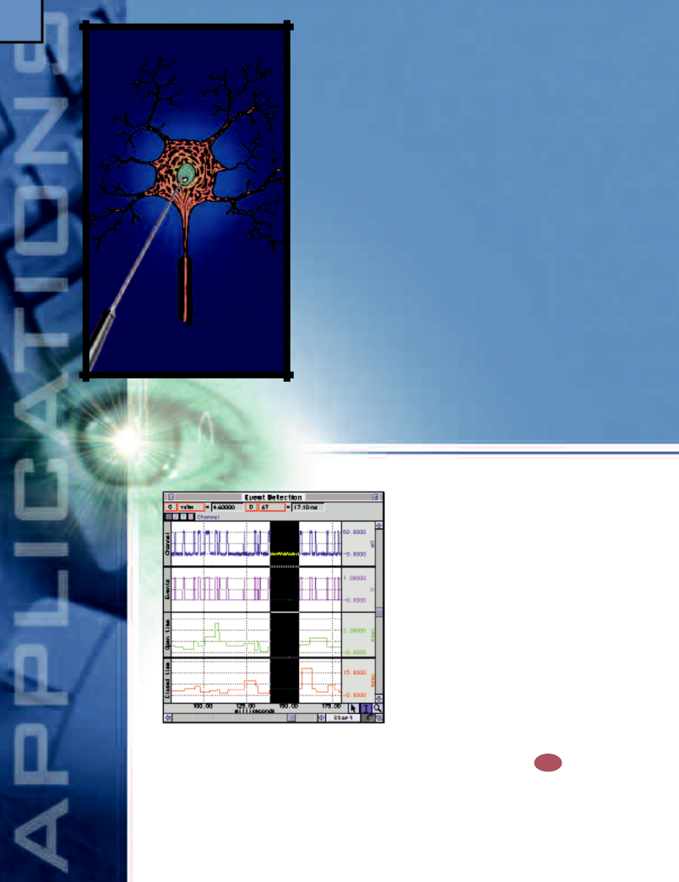

Features
- General micro-electrode signal amplification
  - Single/Multiple Cell Recording
  - Brain Slices
  - Smooth, Skeletal, Cardiac Muscle
  - Corneal / Retinal Potentials
  - Cortical, Muscle & Nerve Action/Resting Potentials
  - Extra- / Intra-cellular Signal Amplification
  - Cell Transport/Ussing Chamber Measurements
- Current Clamping
- Field Potential Measurements
- Tissue Conductance Measurement
- Ion-selective Micro-electrode Interfacing
- Iontophoresis
- Single Channel Analysis
- Hardware Flexibility

Micro-electrode

General micro-electrode signal amplification

The MCE100C micro-electrode amplifier is designed to work with a wide range of micro-electrodes in a variety of measurement applications. To record biopotentials, use standard reusable or disposable Ag-AgCl electrodes or needle electrodes. For cellular measurements, interface the MCE100C with etched metal electrodes, micropipette and metal film-coated electrodes. The MCE100C can be configured to support a range of

electrode signal input compensation requirements. To maintain a high frequency amplifier response, two input capacity compensation methods — Driven Shield Compensation and Negative Capacity Generation — can be optionally applied for recording. Employ the compensation methods simultaneously or ground the input shields (to reduce noise) and then apply Negative Capacity compensation to counter the effects of the shield and/or electrode capacitance.

Cell Transport/Ussing Chamber Measurements

For certain applications, the MCE100C can perform cell transport measurements. Typically, these applications require the use of a small current applied through a pair of electrodes. By monitoring the voltage change across the electrodes it’s possible to assess aspects of cellular motility. Using AcqKnowledge, standard or arbitrary current (up to 100nA) wave shapes can be output using the MCE100C. Current signals can be output simultaneously with recording.

Current Clamping ^{Q36}
The MCE100C has an integral current clamp feature that is controlled via an applied voltage signal (100mV/nA), which can be employed during recording at the user’s discretion. Clamp current can be monitored simultaneously with micro-electrode signal recording, and the current can be changed during recording with the synchronous output of a stimulus voltage waveform.

Field Potential Measurements
Field potential measurements can be performed using the MCE100C with electrodes positioned around the preparation. Each MCE100C can record a single differential potential. Multiple MCE100C amplifiers can be configured for unipolar (common reference) or bipolar (multiple reference) recordings. Up to 16 channels of field potential data can be collected simultaneously. Measurements can be performed synchronously with external voltage or current stimulators.

Tissue Conductance Measurement

Tissue conductance measurements can be performed with the MCE100C using either AC or DC excitation currents. Use surface, needle or micro-electrodes to interface to the tissue. Use four electrodes to perform standard tetrapolar measurements—two to drive current and two to monitor voltage. Monitor the excitation current using the current monitor output. To obtain tissue conductance, use the Equation Generator to divide the current signal by the monitored voltage. To obtain tissue resistance, invert the tissue conductance. The MCE100C can measure tissue resistances between 1,000 and 10,000,000 ohms.

Ion-selective Micro-electrode Interfacing

Iontophoresis
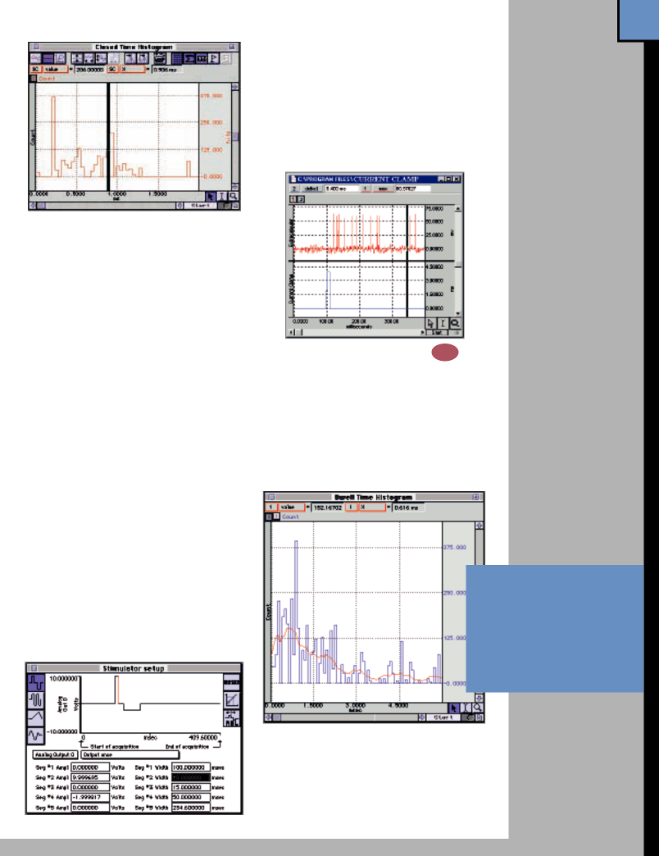
Iontophoresis is a method of inducing ionic drug solutions to pass into tissue by the application of a small electrical current. Use the MCE100C to inject precise amounts of current (up to 100nA) into the tissue during signal acquisition; use the recording electrodes or a separate stimulating electrode to inject the current. To specify the shape, amplitude, duration and repetition rate of the current control waveform, use the Stimulator Setup dialog in AcqKnowledge.

Single Channel Analysis ^{Q37}
Use the amplitude histogram function in AcqKnowledge to inspect the raw data from a single ion channel to determine if multiple channels are present, and use the threshold function to create an events list from the raw single channel data. Apply the rate detector to the events list to determine individual event area (duration) and then histogram the results to obtain the dwell time histogram. To calculate first latency histograms, bin the time delta between the stimulus onset and the first opening.
Hardware 37
Options:

MCE100C 61
Micro-electrode
Amplifier

MCEKITC 88
Connector Kit for MCE100C

HLT100C 53

High Level Transducer Module
INISO 53

Input Signal Isolated Adapter
OUTISO 53

Output Signal Isolated Adapter

STM100C 64
Stimulator Module

STMISO SERIES 64
Electrical Stimulus Isolation Accessories

CBL100
Series 88

Analog Connection Cables

EL Series 83
Electrodes

JUMP100C 87
Jumper Connector

LEAD Series 83
Electrode Leads

To perform potentiometric measurements using electro-chemical cells, record voltages with nearly zero current flow. Use ion-specific electrodes to isolate a change in the respective ion concentration in the test solution. To determine ionic activity, use the Equation Generator in AcqKnowledge to implement the Nernst equation.

Did you know?

BIOPAC software

now includes variable
sample rates.

Hardware Flexibility
Use the MCEKITC to interface a variety of micro-electrode cables to the MCE100C amplifier. For your pre-existing setup, choose an appropriate Analog Connection Cable to connect your microelectrode amplifier to the MP System.

38

Pulmonary Function
Perform lung volume measurements to analyze respiratory air flow. Investigate breathing mechanics by examining pressure/air flow and pressure/volume relationships. Analyze respiratory gas consumption and production in real time. For metabolic analysis, use the MP System as a money-saving, flexible alternative to metabolic carts. Use AcqKnowledge to integrate air flow to obtain on-line breath-by-breath volume. Multiply volume measurements by gas concentration values to determine amounts of O₂ consumed and CO₂ produced. Record airwave pressure and divide by air flow to obtain pulmonary resistance. Divide volume by pressure to derive pulmonary compliance.
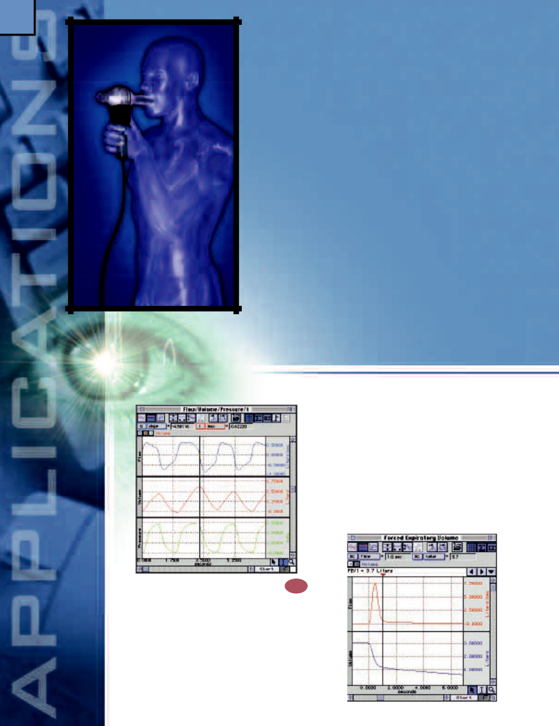

Features
- Lung Volume Measurement

- Forced Expiratory Flow & Volume

- Volume/Flow Loop Relationships

- Automatic Data Reduction

- Animal Studies

AcqKnowledge rate detector. To determine the inspiratory capacity (IC), inspiratory reserve volume (IRV) and expiratory reserve volume (ERV) in the same recording, use the Equation Generator to derive them from the FCV and TV measurements.

Forced Expiratory Flow & Volume
The forced expiratory flow (FEF) is a measure of the average flow over specified portions of the spirometry curve. The spirometry maneuver requires the subject to

Lung Volume Measurement Q³⁸
To record inspired and expired air flow, choose an air flow transducer appropriate to the flow rates expected from the subject and connect the transducer to the DA100C amplifier. BIOPAC offers a wide variety of air flow transducers to cover applications ranging from high-flow exercise physiology measurements to low-flow animal studies. Integrate the air flow associated with a maximal inspiration and expiration to obtain the Forced Vital Capacity (FVC) measurement. Determine Tidal Volume (TV) on a breath-by-breath basis by using the

inhale to total lung capacity and then exhale forcefully to residual volume. Integrate FEF to obtain forced expiratory volume (FEV). AcqKnowledge generates the

pre-programmed trials to record the data around dosing periods, 24 hours a day, seven days a week.
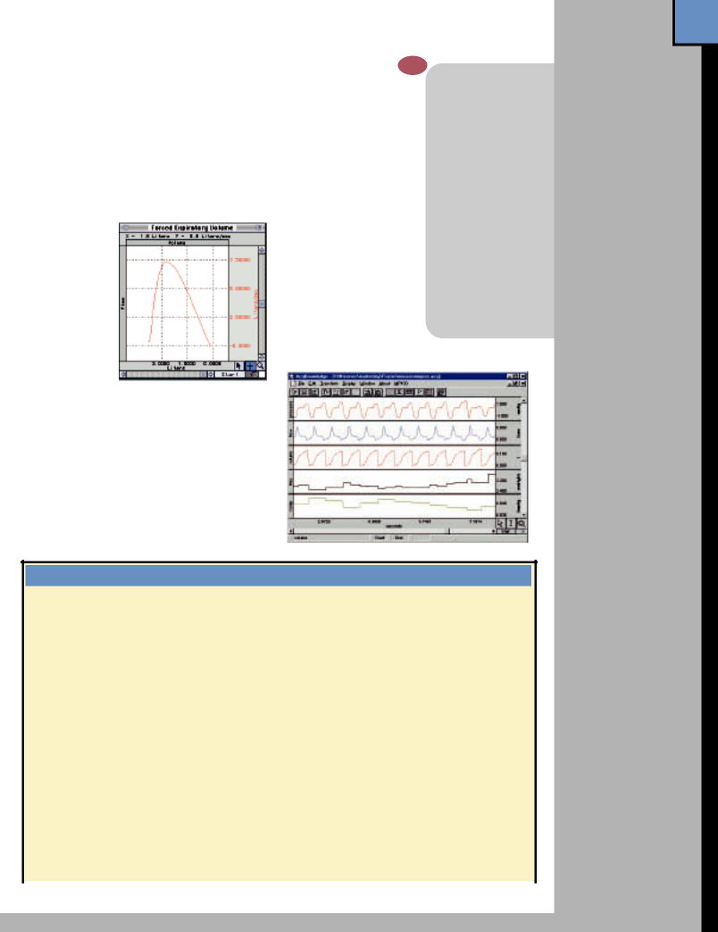
Hardware 39
Options:

spirometry curve via an X/Y plot of expired volume versus expired flow. The FEF values can be measured directly on the spirometry curve at the standard 25%, 50% and 75% volume points. To evaluate FEV, use AcqKnowledge to present the spirometry curve data as a function of time. To determine FEV_{0.5} and FEV_{1.0}, place time cursors 1/2 second and one second after the start of expiration, respectively.

Volume/Flow Loop Relationships
Easily compare normal tidal breathing loops to maximum breathing loops by using the X/Y mode to plot flow versus volume.
This graphical representation clearly indicates the subject’s reserve capacity in relation to normal breathing. Acq K n o w l e d g e can also be used to automatically determine the breath-by-breath volume/flow loop

area as a function of time.

Automatic Data Reduction
Powerful automatic data reduction tools reduce large data files into manageable sizes. The data reduction tools can extract a variety of concise measurements from very long data recordings. For example, it’s possible to extract the mean tidal volume from consecutive 30-second periods. Record continuously for short- and long-term studies (24+ hours), or pre-program to record for specific time periods and dosing events. Automatically trigger
Animal studies ^{Q35}

The MP System will interface with a variety of pulmonary function chambers to provide detailed on-line analysis of pulmonary function data. Use the TSD160 Series pressure transducers to record plethys-mogram chamber pressure. A large selection of very low flow pneumotachs (TSD137 Series) covers a wide range of air flow rates. The software will record the primary pressure and flow signals while on-line calculation channels integrate the flow signal and calculate resistance, compliance, respiration rate, and peak inspiratory and expiratory flow.

- On-line and off-line analysis: respiration rate, peak flow, minimum flow, volume, compliance, and resistance

- Interface with existing plethysmogram chambers and air flow transducers

- Signal markers to record dosing and other events

- Simple two point calibration procedure (mmHg, ml/min, etc.)

- In-vitro and in-vivo applications

DA100C 54

General-purpose Transducer Amplifier

TSD107B 70
Pneumotach Air Flow Transducer (High Flow)

TSD117 73
Pneumotach Air Flow Transducer (Medium Flow)

TSD127 76
Pneumotach Air Flow Transducer (Low Flow)

TSD137 Series 77
Pneumotach Air Flow
Transducers (Very Low
Flow)

TSD160 Series 80

High Sensitivity Differential Pressure Transducers

O2100C 62

O₂ Measurement Module

CO2100C 62
CO₂ Measurement Module

RSP100C 59

Typical Applications & Corresponding Parts

 |  | High Flow |  | Medium Flow |  | Low Flow |  | Very Low Flow
 |  | (exercising human) |  | (resting human) |  | (child, pig, dog) |  | (small animals)
 | AFT2 Mouthpiece |  |  | X
 | AFT3 Noseclip | X |  | X
 | AFT6 Calibration Syringe | X |  | X |  | X
 | AFT7 Tubing | X (2)
 | AFT9 Mouthpiece | X
 | AFT21 T Valve | X
 | AFT24 Head Support | X (optional)
 | AC137 In-line Transformer |  |  |  |  |  |  | X
 | DA100C Amplifier | X (2) |  | X |  | X |  | X
 | TSD107B Pneumotach (high) | X (2)
 | TSD117 Pneumotach (med.) |  |  | X
 | TSD127 Pneumotach (low) |  |  |  |  | X
 | TSD137 Pneumotach (very low) |  |  |  |  |  |  | TSD137A Small mouse (30 gr)
 |  |  |  |  |  |  |  | TSD137B Mouse (50 gr)
 |  |  |  |  |  |  |  | TSD137C Rat/guinea pig (170 gr)
 |  |  |  |  |  |  |  | TSD137D Cat/rabbit (750 gr)
 |  |  |  |  |  |  |  | TSD137E Small dog (5.5 kg)
 | Part Options: AFT25 = AFT21 + AFT9 + AFT3 + AFT24
 | AFT2 + AFT3 = AFT10 + AFT11B
Respiration Pneumogram Amplifier

TSD201 81
Respiration Transducers

AFT15A/B 90
Mixing Chambers

AFT21/22 91
Non-rebreathing T Valves

AFT Series 89
Air Flow & Gas Analysis Transducer Accessories

SKT100C 59
Temperature Amplifier

TSD202 Series 82
Temperature Transducers

40

Exercise Physiology

Record a range of physiological parameters in response to the physical stress of exercise. Examine ventilation, oxygen uptake and carbon dioxide production simultaneously with ECG and core/surface temperature. Add biomechanical measures such as EMG, limb movement, velocity and acceleration to supplement exercise physiology recordings. For certain applications, it’s possible to include cardiac output measurements.
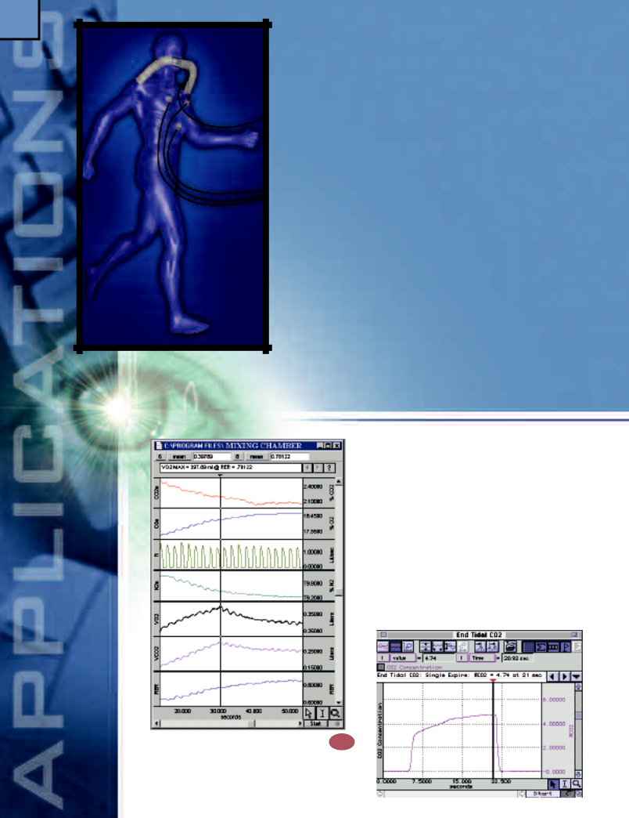

Features

- Respiratory Exchange Ratio
- End-tidal CO₂
- VO₂ Consumption

- Anaerobic Threshold

- Breath-By-Breath Respiratory Gas Analysis

- Noninvasive Cardiac Output

See also — Pulmonary Function (page 38), Remote Monitoring (46), and Biomechanics (44) Applications

integrated simultaneously with the consumed O₂ flow. The RER can be presented in real time, with values representing the running average of RER for the last (user-specified) number of seconds. Save the graphical RER waveform as text to create tabulated RER data; tabulated data can easily be ported to other applications.

End-tidal CO₂
To measure end-tidal CO₂ on a breath-by-breath basis, use the AFT20 gas sampling interface kit to connect the CO2100C module directly to the sampling port on the AFT25 facemask. Use AcqKnowledge’s rate detector to find the peak of the cyclic CO₂ concentration signal. The running peak value represents the breath-by-breath end-tidal CO₂.

Respiratory Exchange Ratio ^{Q39}
The Respiratory Exchange Ratio (RER) is determined by dividing VCO₂ produced by VO₂ consumed. The measurement is very similar to the setup required for VO₂ consumption, except that the produced CO₂ flow is

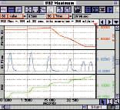

VO₂ Consumption
Oxygen consumption measurements nominally incorporate the use of a mixing chamber (AFT15A/B), facemask with non-rebreathing T valve (AFT25) and an air flow transducer (TSD107B). Typically, air flow measurements are performed on the inspiration side of the AFT25. The expiration side is directed to the AFT15, where O₂ and CO₂ concentrations are monitored using the O2100C and CO2100C, respectively. Use the Equation Generator in AcqKnowledge to perform the Haldane transformation and STP corrections. The final result can provide real-time oxygen consumption measurements, permitting precise determination of VO₂ maximum, deficit, and post-exercise VO₂ consumption.

Breath-By-Breath Respiratory Gas Analysis

For breath-by-breath gas analysis, it’s important to identify the response time of the gas measurement modules. Because the modules sample the inspired and expired air stream directly from the subject, without a mixing chamber to average the gas concentration levels, the modules are required to track quickly varying concentration levels. When fully optimized, the O2100C and CO2100C modules can achieve response times on the order of 200ms and can thus track breathing rates approaching 105 BPM. To enhance a module’s response time, run the module at a higher air sampling flow rate and use AcqKnowledge to create a summed derivative filter.
Noninvasive Cardiac Output ^{Q13}

Cardiac Output (CO) is typically determined just prior to and after exercise. Due to mechanical modulation of the electrode/skin interface, vigorous exercise can introduce considerable artifact into the thoracic impedance measurement performed by the EBI100C. You can employ digital filtering techniques and signal averaging to help isolate the dZ/dt signal during exercise. One possibility is to average the dZ/dt signal by synchronizing the averaging function with the ECG R-wave; reduce random noise in the dZ/dt waveform by increasing the number of averages.

Hardware 41

Options:

DA100C 54

General-purpose Transducer Amplifier

TSD107B 70
Pneumotach Air Flow Transducer (High Flow)

TSD130 Series 72
Goniometers

ECG100C 56
Electrocardiogram
Amplifier
EMG100C 57
Electromyogram
Amplifier
EBI100C 60

Electrical Bioimpedance Amplifier
O2100C 62

O₂ Measurement Module
CO2100C 62
CO₂ Measurement
Module

Anaerobic Threshold
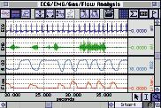
The relationship between ventilation and oxygen uptake becomes non-linear above the anaerobic threshold. This threshold can be determined by establishing a ratio of inspired volume and VO₂ consumption. Use AcqKnowledge to integrate the air flow signal to obtain total inspired volume in real time. Divide the identically integrated O₂ consumption flow signal by the inspired volume; the resultant value will be constant to the point of anaerobic threshold. After the threshold is reached, this value starts to drop.

Typical Applications & Corresponding Parts

 | MIXED EXPIRED GASES |  |  | BREATH-BY-BREATH
Part # | High Flow |  | Medium Flow | High Flow |  | Medium Flow |  | Low Flow
Part # | (exercising human) |  | (resting human) | (exercising human) |  | (resting human) |  | (dog)
AFT6 Calibration Syringe | X |  | X | X |  | X |  | X
AFT7 Tubing | X (2) |  |  | X
AFT10 Facemask |  |  | X |  |  | X
AFT10S Head Strap |  |  | X |  |  | X
AFT11 Series Couplers |  |  | X(3)* |  |  | X |  | X (2) **
AFT12 Tubing |  |  | X (2) |  |  | X
AFT15A Mixing Chamber | X |  | X
AFT20 Interface Kit | X (2) |  | X (2) | X (2) |  | X |  | X (2)
AFT22 T valve |  |  | X |  |  | X |  | X
AFT25 Facemask w/valve | X |  |  | X
DA100C Amplifier | X |  | X | X |  | X |  | X
CO2100C CO₂ meas. module | X |  | X | X |  | X |  | X
O2100C O₂ meas. module | X |  | X | X |  | X |  | X
TSD107B Pneumotach (high) | X |  |  | X
TSD117 Pneumotach (med.) |  |  | X |  |  | X
TSD127 Pneumotach (low) |  |  |  |  |  |  |  | X
HLT100C 53

High Level Transducer Module

TSD109 Series 71
Tri-axial
Accelerometers
TSD111 71
Heel/Toe Strike
Transducer

TSD150 Series 80
Active Electrodes
RSP100C 59
Respiration Pneumogram Amplifier
SKT100C 59
Temperature Amplifier
AFT15A/B 90
Mixing Chambers
AFT25 91

Facemask with Valve
AFT Series 89

Air Flow & Gas Analysis Accessories
EL Series 83
Electrodes
LEAD Series 83
Electrode Leads
MEC Series 87
Module Extension
Cables

Part Options: AFT25 = AFT21 + AFT9 + AFT3 + AFT24 (Optional) | * use 2 AFT11B | & 1 AFT11C
AFT 10 + AFT10S = AFT2 + AFT3 +AFT11C | ** use 1 AFT11B | & 1 AFT11C

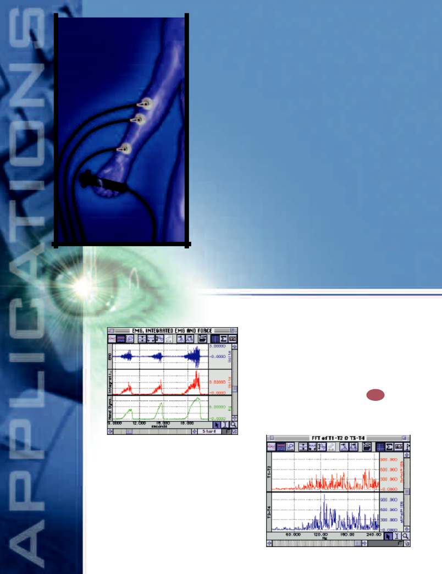  42 |  |  | The MP System offers many options for recording surface,
 |  |  | needle and fine wire EMG. Record and analyze general
 |  |  | muscle strength and fatigue or muscle twitch data from
 |  |  | a variety of body locations. Alternatively, combine EMG
 |  |  | recording channels with other data channels to display
 |  |  | muscle contraction simultaneously with other physiological
 |  |  | events. Integrate and/or filter raw EMG data during
 |  |  | recording for immediate analysis. Correlate muscle
 |  |  | activity with data from other sources, such as force
 |  |  | plates, goniometers, and motion analysis equipment.
 |  |  | Spike counting and frequency analysis tools are available
 |  |  | for post-acquisition analysis.

Features

- Median & Mean Frequency Analysis
- EMG Power Spectrum Analysis
- Integrated (RMS) EMG
- EMG & Force
- Active Electrodes & Fine Wire EMG
- Automatic Spike Counting & Analysis
- Histogram Analysis
- Facial EMG & Startle Response
- Interface with Imaging Equipment
- Single-fiber EMG
- Motor Unit Action Potential

See also — Remote Monitoring (page 46) and Biomechanics
(page 44) applications

EMG

Median & Mean Frequency Analysis

Analysis of EMG signals in the frequency domain can provide useful insight into the nature of the EMG data. The frequency spectrum data may be used to generate other measures associated with EMG frequency analysis. Select an area of EMG data and use the Fast Fourier Transform function to perform a linear magnitude FFT on the selected data, then integrate the result to determine the median and mean frequency. AcqKnowledge can be used to calculate these parameters after the EMG data has been collected.

EMG Power Spectrum Analysis

A common tool for investigating the EMG is the Power Spectrum Density (PSD). Use AcqKnowledge to compare responses from one part of the recording to the next. Calculate the PSD by squaring the linear FFT magnitude.

Integrated (RMS) EMG ^{Q40}
Calculate the integrated EMG envelope on- and off-line.

The integration function incorporates an RMS (Root

Mean Square) feature set to operate over a user-specified

number of samples. Adjust the RMS time constant by increasing or decreasing the number of samples used to perform the integration. The number of samples used in the RMS integration divided by the sample rate is proportional to the time constant of the integration.
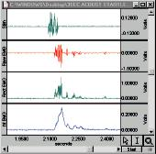

Histogram Analysis

Use the Histogram display features to identify trends within the EMG data. Select an area of data, or the entire data file, and the Histogram feature will bin the values into their appropriate amplitude ranges. The software will automatically determine the display range and the number of bins, or you can set them manually. Histogramming highlights differences in the EMG when the muscle is under a variety of loads and conditions.
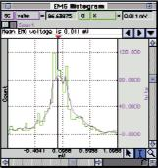
Hardware 43

Options:

EMG100C 57
Electromyogram
Amplifier
DA100C 54

General-purpose Transducer Amplifier

TSD121C 74
General-purpose Hand Dynamometer

TSD130 Series 76
Goniometers
HLT100C 53

High Level Transducer Module
INISO 53

EMG and Force ^{Q41}
For in-depth studies of muscle work and fatigue, use the EMG100C amplifier with a hand dynamometer (TSD121C). The software will display the force measurements (calibrated in pounds or kilograms) as well as the raw and integrated EMG data. It’s possible to simultaneously measure EMG with signals from force plates, load cells, and pressure transducers.

Active Electrodes & Fine Wire EMG

The TSD150 Series of active electrodes interface with the HLT100C High Level Transducer interface module. The TSD150 electrodes have built-in amplification, which allows the subject to be a greater distance from the recording equipment. The TSD150 will record both surface and fine wire EMG. The transducers are easily adapted to fine wire recording by unscrewing the surface electrode pads and attaching spring clamps (included with each TSD150).

Facial EMG & Startle Response ^{Q11}
Use the STM100C stimulator and the MP System Control channels to perform multiple stimulus paradigms. Present a pre-defined auditory stimulus or stimulate the subject based on the result of a physiological response. Use the EMG amplifier to record facial EMG (eyeblinks) and set the software to integrate the signal on-line. Calculate the time and amplitude of the response using the measurement tools. Automate analysis with the Peak Detection features and display the results as a new channel.

Interface with Imaging Equipment

The MP System can be synchronized with imaging systems (MRI, video capture, etc.). An imaging system can be used to trigger the recording or, alternatively, the MP System can be used to trigger the imager.

Input Signal Isolated Adapter
OUTISO 53

Output Signal
Isolated Adapter

TSD109 Series 71
Tri-axial
Accelerometers

TSD111 71
Heel/Toe Strike
Transducer

TSD150 80
Active Electrodes

STM100C 64
Stimulator Module

STMISO Series 64

Electrical Stimulus Isolation Accessories
TEL100C 66

Automatic Spike Counting

The Peak Detection features let users automatically analyze

 | raw EMG spike data. Select
 | the desired measurements and
• Max | the software will calculate the
• Min | values for each spike in the
• Pk-Pk amplitudes | data file or within a selected
• Pk-Pk frequency | area. This analysis can also be
• Pk-Pk frequency | performed over pre-defined
 | time intervals—enter a time
 | interval and the software will run


through the file, analyze the data, and enter the results into a Journal file and display the data as a new channel.
Single-fiber EMG

Record and analyze single-fiber potentials with a concentric needle electrode (EL451). Set the EMG100C to a 100 Hz - 5 kHz recording bandwidth. For improved rejection of low frequency background activity of distant fibers, run the data through a real-time 500 Hz HP filter in AcqKnowledge.

Motor Unit Action Potential

The motor unit action potentials (MUPs) are the summation of all single-fiber potentials innervated. Evaluate waveshapes of MUPs and measure amplitude, rise time and duration using the EMG100C with concentric needle electrodes (EL451).

Remote Monitoring Module Set

EL Series 83
Electrodes

LEAD Series 83
Electrode Leads

MEC Series 87
Module Extension Cables

• Flexibility Quantification
• Injury Assessment
44

Biomechanics

Record body movement data for extended periods or trigger recordings when movement occurs (e.g. karate kick). Input and analyze data from force plates and synchronize measurements with video capture equipment. Perform real-time calculations and post-collection analysis, including X/Y plotting. Use markers to log events as they occur, then add comments immediately or later.
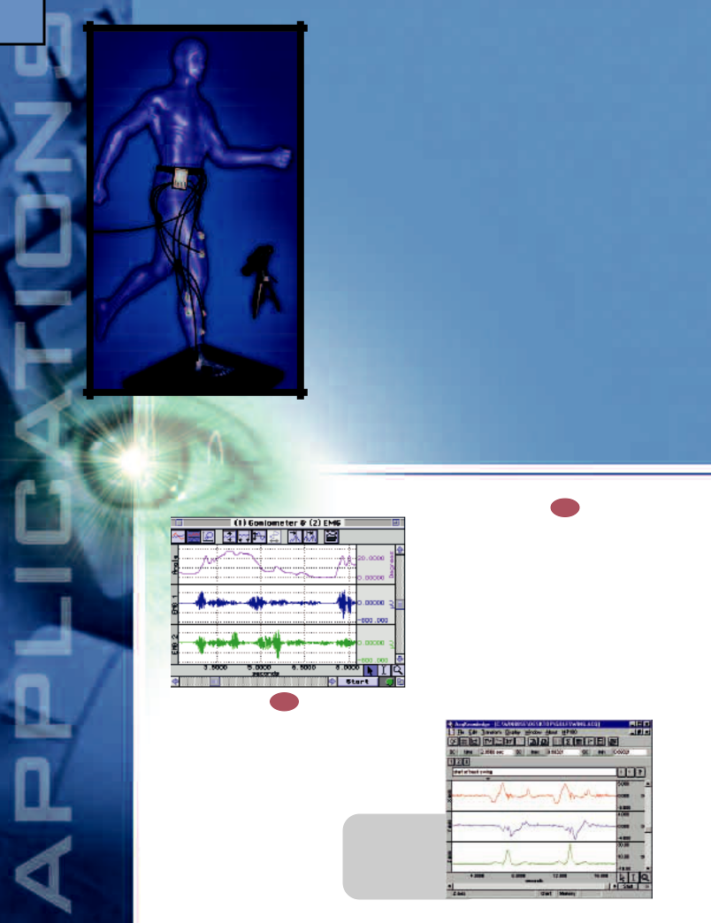

Features

- Gait Analysis

- Range of Motion

- Isometric Contraction

- Isotonic Contraction

- Ergonomics Evaluation

- Synchronize with Video Capture

- Remote Monitoring

^{Range of Motion Q}44
 | All parts of the body can be evaluated for range of
 | motion. Goniometers are available for evaluating one or
 | two degrees of freedom from the same joint (e.g. wrist
 | flexion/extension and radial/ulnar deviations). Use the
 | X/Y plotting feature to inspect motion resulting from
 | two degrees of freedom. Place torsiometers along the
 | spine to measure twisting along the spinal axis. Place
 | miniature goniometers on the back of fingers to determine
 | maximum extension and flexion of the digits. Determine
 | velocity of motion by using AcqKnowledge to perform a
 | derivative on the recorded movement data, then run a
Gait Analysis ^{Q42} | second derivative on the data to calculate acceleration.
Simultaneously acquire up to 16 channels of gait-specific data. One setup might incorporate two channels for heel/toe strike timing, ten channels for EMG signals and four channels of goniometry data. When using a force plate, the six force and moment signals are sent directly from the force plate amplifier to the

UIM100C via standard analog cables, leaving ten channels for additional signal recording. Event markers let users log important events in the data and include comments during or post acquisition.

Isometric Contraction

Isolate a wide range of muscle groups and evaluate their isometric contraction characteristics for performance quantification. Configure the TSD121C hand dynamometer to measure handgrip force or a wide range of pulling forces. To measure pulling forces, secure the dynamometer to a fixed surface, then connect a tether between the dynamometer and the muscle group under investigation. If the exerted force will exceed 100kg, use pulleys to attenuate muscle forces to less than 100kg. For additional insight, acquire EMG data during isotonic force measurement.

Isotonic Contraction

Examine muscle groups for isotonic performance by placing the TSD109 accelerometer on a target limb actively hoisting weights of specific sizes. The accelerometer records the precise time the weight moves, and the subsequent acceleration of that movement. For isometric to isotonic transition investigations, use the TSD121C Hand Dynamometer with the Dynagrips option. Place the dynamometer in-line between the weight to be hoisted and the target limb. As the weight is lifted, the hand dynamometer will measure the applied lifting and transition forces, while the Accelerometer indicates the transition timing.
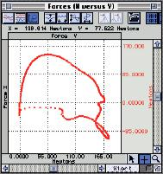

Ergonomics Evaluation

Body position and posture can be analyzed over a wide range of static and dynamic conditions and these measurements can be used to determine the ergonomic characteristics of a specific work activity or environment. To reliably record head tilt with respect to the X-, Y- and Z-axes simultaneously, place a TSD109 accelerometer on the head. To directly measure adequate

bending in the knees or unsafe rounding in the lower spine, use goniometers.
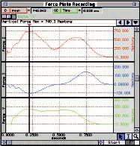

Synchronize with Video Capture

There are several ways to synchronize motion analysis equipment employing video capture with the MP System.

- The video capture system can send a TTL trigger start pulse to the MP System.
- The vertical sync pulse from the camera can be directed to an unused analog input and then AcqKnowledge’s peak counter can compare the exact video recording time to the other data channels recorded by the MP System.

- The MP System can send a synchronizing trigger to the video capture system.

Remote Monitoring

For biomechanical measurements, the recording cables attached to the subject must be durable but unobtrusive. The TEL100C remote monitoring module set supports an extremely wide range of biomechanical measurements, with minimal cable hindrance and maximal motion flexibility. With the appropriate Smart Sensor, the TEL100C can perform the same recordings as standard amplifiers and transducers when using an MP System. The TEL100C can be located up to 60 meters from the recording computer—data is transmitted to the MP System using a single, lightweight, coaxial transmission cable. Each TEL100C will amplify up to four channels of data and the input channels automatically configure themselves for the type of Smart Sensor plugged into the amplifier/transmitter. See the Smart Sensors on page 67.

Hardware 45

Options:
DA100C 54

General-purpose Transducer Amplifier

TSD121C 74
General-purpose Hand Dynamometer with Dynagrips option

TSD130 Series 76
Goniometers

EMG100C 57
Electromyogram
Amplifier

MEC Series 87
Module Extension Cables

TSD116
Series 72
Switches (Hand & Foot)

HLT100C 53

High Level Transducer Module

INISO 53

Input Signal Isolated Adapter

OUTISO 53

Output Signal Isolated Adapter

TSD109 Series 71
Tri-axial
Accelerometers

TSD111 71
Heel/Toe Strike
Transducer

TSD150 Series 80
Active Electrodes

TEL100C 66

Remote Monitoring Module Set

CBL100
Series 88

Analog Connection Cables

EL Series 83
Electrodes

LEAD Series 83
Electrode Leads

46

Monitoring

To increase subject comfort and minimize cumbersome wiring, use the TEL100C Remote Monitoring Module set. Each 4-channel module connects to the subject via a single thin coaxial cable. Cables are available to span from 10 to 60 meters between the subject and the MP System. Add remote monitoring module sets to an existing MP System to take tethered ambulatory measurements or to record from multiple, separated subjects.
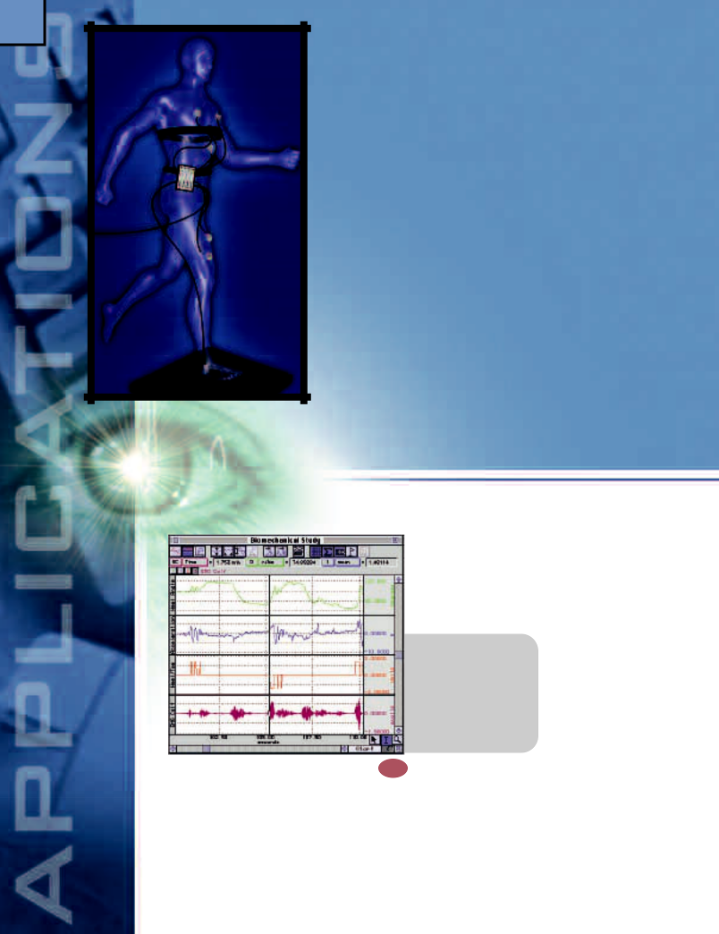
The TEL100C features universal inputs that are automatically configured to record from any of the Smart Sensor (SS) Series electrodes and transducers. Mix and match Smart Sensors in any fashion with the TEL100C.

Up to four TEL100C Remote Monitoring Module sets can be used with a single MP System. TEL100C sets can be mixed and matched with other BIOPAC amplifiers to satisfy a wide range of measurement applications.

Features
- Biomechanics Measurements

- Exercise Physiology

- Simultaneous Monitoring

- Automatic Data Reduction

- Sleep Studies

Remote

Biomechanics Measurements Q⁴³
The TEL100C has four universal amplifiers that allow the recording of a variety of biomechanical data. Goniometers (SS20 Series), accelerometers (SS26 & SS27), and heel/toe strike transducers (SS28) will interface with the TEL100C system. Maximum acceleration, angle of limb movement, and the time of heel and toe strikes can be calculated in real time. The
software will display and analyze data while the subject is walking or running (up to 60 meters away from the MP System). For detailed studies, include biopotential signals, such as EMG or ECG, and force measurements (via SS25). While collecting data from the TEL100C, the MP System can simultaneously

interface with a variety of
• Velocity of Motion
video monitoring systems
• Heart rate
and force plates.
• R-R interval

• Gait analysis
Exercise
• Joint angle
Physiology
• Integrated EMG
The TEL100C works

efficiently with subjects

performing anaerobic exercises because it eliminates the masses of cabling usually attached to the subject. The TEL100C module will record a wide variety of signals and AcqKnowledge will perform on-line analysis for an array of measurements. View data on-line, in real time, without waiting for data to download.

transmitted back to the MP System. Use the TEL100C to record a variety of physiological signals, including EEG, ECG, temperature, GSR, and respiration. Use the data reduction tools in AcqKnowledge to automate and simplify the analysis process.
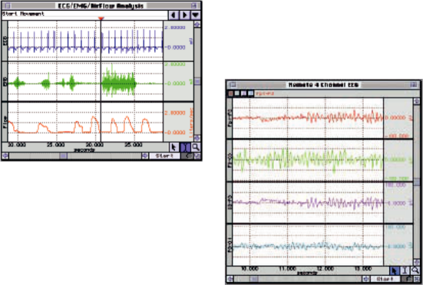

Simultaneous Monitoring

Monitor up to four subjects and display their data simultaneously. While subjects perform specified activities, record data and analyze it on-line. Each subject can be as far as 60 meters from the MP System, which can be useful for environmental monitoring or repetitive stress studies. Subjects wear separate transmitter modules and can perform their daily routine with minimal interference, even as data is
Automatic Data Reduction

Use the powerful data reduction function to reduce large data files to a manageable size for further statistical analysis. Analyze both primary signals (such as respiration) and derived data (such as respiration rate). Select the appropriate measurement and enter the desired time period—the software will automatically analyze the data and enter the values into a Journal file and display the data as a new channel. The summarized Journal file can be automatically graphed within AcqKnowledge for full access to a range of measurement tools for refined analysis.
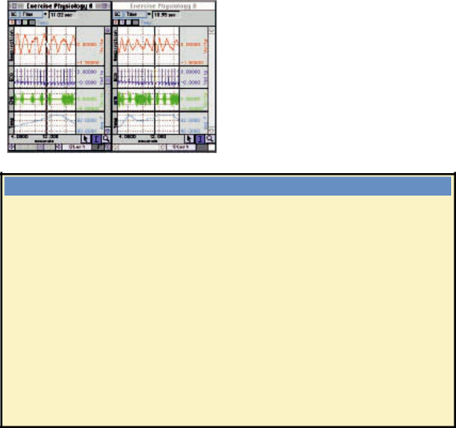

Smart Sensor (SS) electrodes and transducers

Smart Sensor (SS) electrodes and transducers connect to the TEL100M-C amplifier/transmitter.

Any Smart Sensor electrode or transducer can be plugged into any TEL100M-C input.

 | SS1A | Unshielded Touchproof Electrode Adapter | SS20 | Twin-Axis Goniometer 110mm
 | SS2 | Shielded Electrode Lead Assembly | SS21 | Twin-Axis Goniometer 180mm
 | SS3A | Electrodermal Response Transducer | SS22 | Single-Axis Torsiometer 110mm
 | SS4A | Pulse Plethysmogram (Finger) Transducer | SS23 | Single-Axis Torsiometer 180mm
 | SS5B | Respiratory Effort Transducer | SS24 | Finger Goniometer 35mm
 | SS6 | Fast Response Temperature Probe | SS25 | Hand Dynamometer
 | SS7 | Skin Surface Temperature Probe | SS26 | Tri-Axial Accelerometer 5G
 | SS10 | Hand Switch | SS27 | Tri-Axial Accelerometer 50G
 | SS11A | Air Flow (medium) Transducer | SS28 | Heel/Toe Strike Transducer
 | SS17 | Physiological Sounds Microphone | SS29 | Multi-lead ECG Cable
Hardware 47

Options:

TEL100C 66

Remote Monitoring Module Set

SS Series 67
Smart Sensor
Electrodes &
Transducers
HLT100C 53

High Level Transducer Module

INISO 53

Input Signal Isolated Adapter

OUTISO 53

Output Signal Isolated Adapter

See page 67 for specifications.

48

& Interfaces

The 100C-series amplifiers compose one of the largest ranges of amplifiers in the industry. They can be used with an MP System or as stand-alone devices. In addition, the MP System will interface with a wide variety of third-party equipment such as flow meters, force plates, sono-micrometers, telemetry equipment, transducers, amplifiers, metabolic carts, and bedside monitors. Choose isolated interfaces for human use and non-isolated for animal and in-vitro applications. A broad range of interface cables is available, and BIOPAC’s Technical Support group can usually recommend the appropriate cable for your equipment. Signals recorded from third-party equipment are easily calibrated and scaled within the AcqKnowledge software.
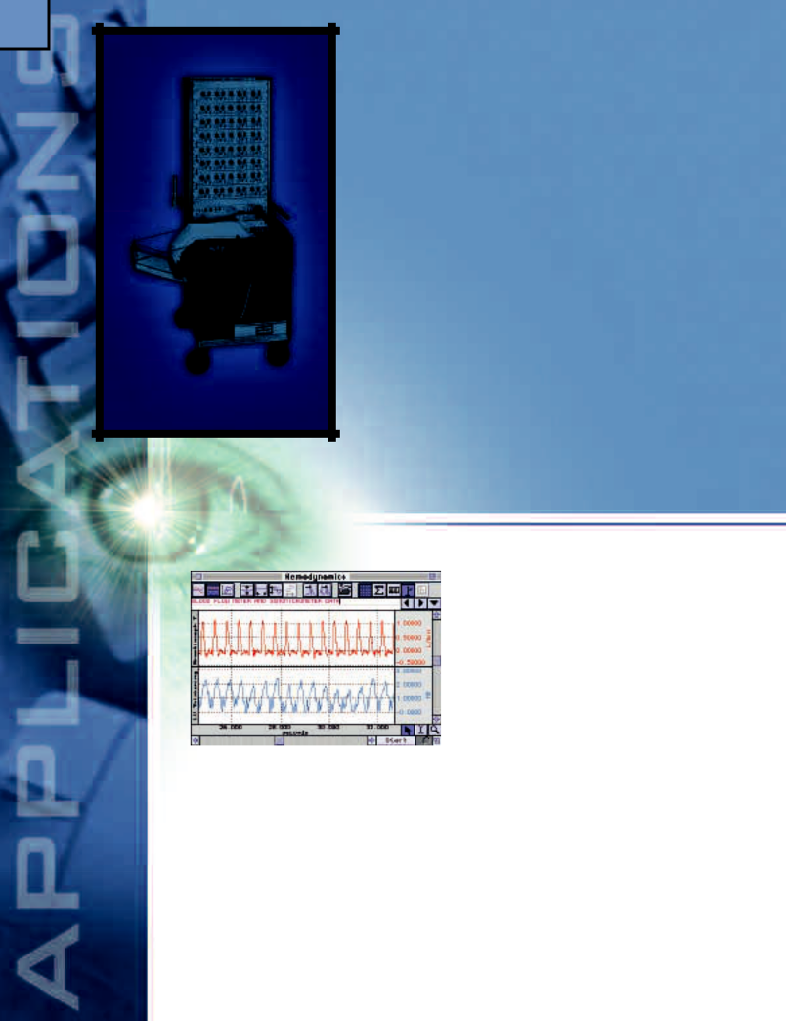

Features
- Connect to MP150 or MP100 Systems

- Isolated Inputs & Outputs

- Non-isolated Inputs & Outputs

- Interface with Third-party Transducers

- Common Interface Connections

- Stand Alone Amplifiers

- Automatically Control Other Equipment

Non-isolated Inputs & Outputs
When performing animal or in-vitro experiments with an MP System, and not electrically connecting to human subjects, signal connections to external mains powered equipment can be made through the UIM100C module and the corresponding connection cable (analog or digital).

Amplifiers

Connect to MP15O or MP100 Systems

The MP System plus BIOPAC amplifiers acts as a complete, fully-isolated life science data acquisition system.

Isolated Inputs & Outputs
This option is highly recommended when interfacing third-party (non-BIOPAC) mains powered equipment to an MP System. Use the HLT100C module with INISO and OUTISO signal isolators to provide the interface. The INISO and OUTISO isolators plug directly into any of the 16 analog channels on the HLT100C module and incorporate a 3.5mm phone jack for signal input or output connections. Select the appropriate analog connection cable (see page 88) to connect to your external equipment.

Interface with Third-party Transducers

To use existing transducers with the DA100C General-purpose Transducer Amplifier, consider the Transducer Connector Interfaces (TCIs). The TCIs plug directly into the DA100C amplifier and present the appropriate mating connector to a wide variety of transducer types. For unusual transducers, use the TCIKIT to create a customized interface.

For a detailed list of TCIs, see page 54.

Common Interface Connections
To interface with the UIM100C, choose the BIOPAC cable that matches your existing connector type.
CONNECTOR TYPE |  |  | USE THIS CABLE
3.5 mm mini-phone jack |  |  | CBL100
BNC female |  |  | CBL102
4 mm Double Banana jack |  |  | CBL102 with CBL106
1/4" phone jack (6.3mm) |  | CBL105

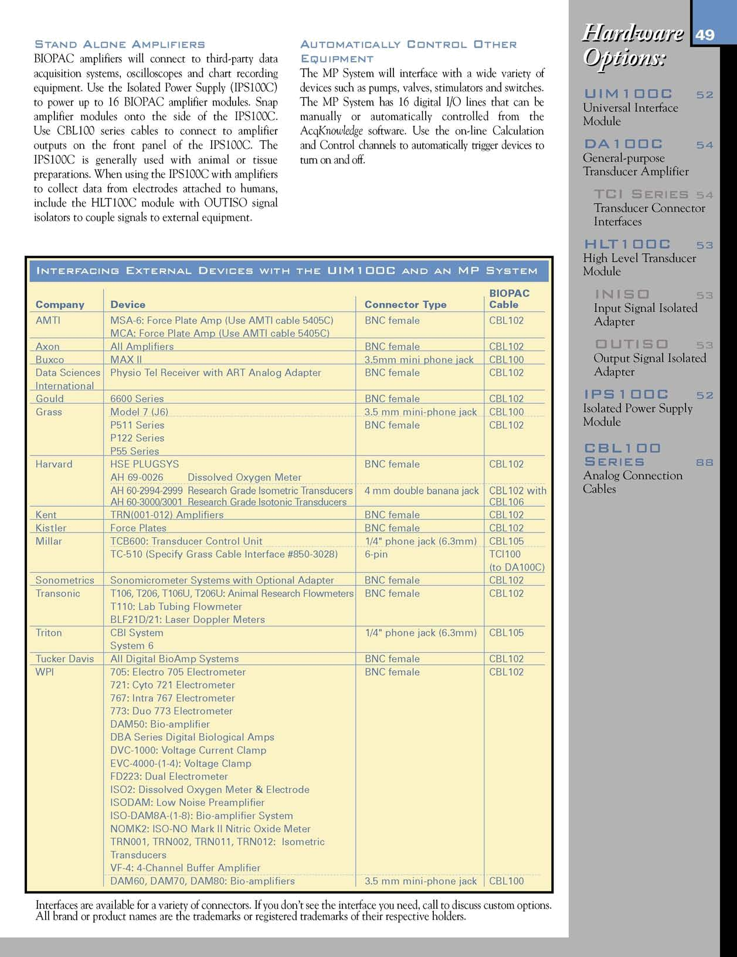
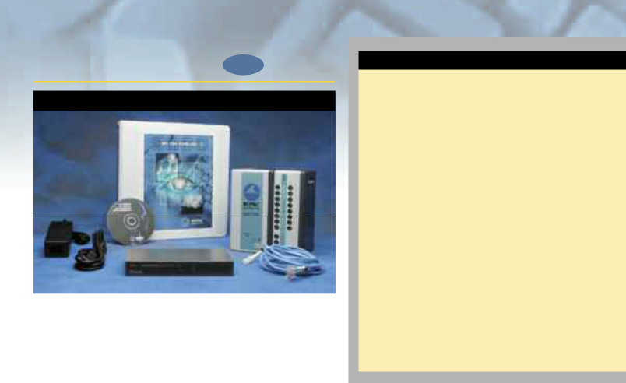  50 | MP Systems for Data

MP150 Starter System NEW

MP150 Starter System

The new MP150 offers Ethernet-ready data acquisition and analysis. Record multiple channels with differing sample rates. Record at speeds up to 400kHz (aggregate). Place one or more MP150 Systems in a local area network (LAN). Use any PC in the LAN to record from any MP150 System in the LAN.

Includes:

MP150ACE AC150A ETHSW1

UIM100C CBLETH1 (2) ACKv3.7 for PC (Windows) or Macintosh

MP150 and MP100 Data Acquistion Unit Specifications

Analog Inputs
Number of Channels: | 16
Input Voltage Range: | ±10V
A/D Resolution: | 16 Bits
Accuracy (% of FSR): | ±0.003
Input impedance: | 1.0 MΩ
Analog Outputs
Number of Channels: | 2
Output Voltage Range: | ±10V
D/A Resolution: | MP150: 16 bits, MP100: 12 Bits
Accuracy (% of FSR): | MP150: ±0.003, MP100: ±0.02
Output Drive Current: | ±5mA (max)
Output Impedance: | 100Ω

Device specific specs MP150

Max Sample Rate

MP Internal Memory: 200K samples/sec (400K aggregate)

PC Memory/Disk: 200K samples/sec (400K aggregate)

Internal Buffer Size: 6M samples

Serial Interface Type/Rate: Ethernet: DLC type II (10M bits/sec)

Transmission Type: Ethernet (10/100 Base T)

Maximum Cable Length: 100 meters (Ethernet cable)

Power Requirements: 12VDC @ 2 amp (uses AC150A)

Dimensions: 10cm x 11cm x 19cm

Weight: 1.0 kg

Compatibility Ethernet Interface

Mac: System 8.6 or better

PC: Windows 98, 98SE, 2000, NT 4.0

Recommended configuration: MP150 System and local network connected to the computer’s Ethernet port via the ETHSW1 Ethernet Switch. This configuration provides optimal performance when connecting both an MP150 System and a network to the computer. In cases where the computer has no Ethernet port, an industry standard PCI Ethernet card or adapter is required.

- MP150WSW for PC

- MP150WS for Macintosh

AcqKnowledge Software & Site Licenses for MP Systems

One copy of AcqKnowledge software is included with each MP Starter System. The software can be used with other programs and includes extensive on-screen help. The Site License program permits the purchase of a Site License for a specified number of software copies. Each Site License includes one software operations manual and software media. Purchase of a BIOPAC Site License does not obviate the requirement to purchase the appropriate software package for each computer on which BIOPAC hardware is installed. For network installations, the relevant number of copies required is the number of machines upon which the software will be used. The Site License program is for educational institutions only and is subject for qualification. Contact BIOPAC for full details. For the part number, add the upper quantity you require to the software type, e.g., ACK100M-9 for a 2-9 software Site License for use on Macintosh computers.

AcqKnowledge Software—If purchased separately

- ACK100W (PC running Windows)

- ACK100M (Macintosh)

Current Shipping Version for Macintosh Users: 3.2.7 Version 3.7 will be available 2nd Quarter, 2001.

Site Licenses

Quantity | ACK100W or | Additional
 | ACK100M | manuals (each)
• 2-9 | • 25-99
• 10-24 | • 100-249

 | Software Specifications
Operational accuracy: | 20 digit double precision real
Storage accuracy: | 16 digit double precision real
Storage formats: | AcqKnowledge, text (ASCII), PICT
 | (Macintosh), WMF (Windows)
Digital filters: | Post-processing mode — FIR or IIR based,
 | Real-time mode — IIR based
Window functions: | Rectangular, Bartlett, Hamming, Hanning,
 | Kaiser-Bessel
Maximum file length: | Limited only by available space
Maximum number of
channels displayed: | 60
Memory requirements: | 64 MB RAM recommended minimum
System requirements: | PC: Windows 98, 98SE, 2000 Workstation,
 | NT4.0 Workstation
 | Mac: System 8.6 or better

Use the AcqKnowledge software to analyze and display data recorded from third-party data acquisition products. Open the data in a Text format, set the horizontal axis to the desired units and analyze your results.

Acquisition & Analysis | 51

Digital I/O

Number of Channels: 16

Voltage Levels: TTL, CMOS

Output Drive Current: ±20mA (max)

External Trigger Input: TTL, CMOS compatible

Time Base

Min Sample Rate: 2 samples/hour

Trigger Options: Internal, External or

Signal Level

Power

Amplifier Module Isolation: Provided by the MP data

acquisition unit

CE Marking: EC Low Voltage and EMC

Directives

Leakage current: <8µA (Normal), <400µA

(Single Fault)

Fuse: 2A (fast blow)

MP100

70K samples/sec (70 K aggregate)

11K samples/sec (16K aggregate)

16K samples

SERIAL: RS422 (800K bits/sec)

USB (via USB1W or USBIM)

7 meters (USB + SERIAL cable)

12 VDC @ 1amp (uses AC100A)

7cm x 29cm x 25cm

1.8 kg

USB Interface

Mac: System 8.6 or better

PC: Windows 98, 98SE, 2000

MP100 Starter System

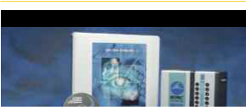

MP100 Starter System

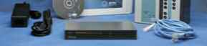

The MP100 system offers USB-ready data acquisition and analysis. Record multiple channels with differing sample rates. Record at speeds up to 70 kHz (one-shot) or 16 kHz (aggregate to disk).

Includes:

MP100ACE USB1W (PC) or USB1M (Mac)

UIM100C CBLSERA

CBLS100 ACKv3.7 for PC (Windows) or Macintosh

AC100A

Recommended configuration: MP100 System connected to the computer’s USB

port via the USB1W (PC) or USB1M (Macintosh) Adapter. In cases where the

computer has no USB port, an industry standard USB card or adapter is required.

- MP100WSW for PC

- MP100WS for Macintosh

Which system is best for you?

The NEW MP150 High-speed data acquisition system utilizes the very latest in Ethernet technology. The MP150 is compliant with any Ethernet (DLC) ready PC or Macintosh. This next generation product takes full advantage of cutting edge technology. Access multiple MP150 devices located on a local area network and record data to any computer connected to the same LAN. Record and analyze your data at an aggregate sample rate of 400,000 samples per second. Use variable sample rates to maximize storage efficiency and to guarantee you won’t miss a thing. See what the MP150 and AcqKnowledge software can do for you!

Function | Performance
 | MP150 system | MP100 System
Recording speed | High | Medium
Aggregate sampling rate | 10kHz or greater | 10kHz or less
Cardio-pulmonary measurements | Excellent | Excellent
Neuro-physiology measurements | Excellent | Good (contact BIOPAC for details)
Direct LAN operation | Yes (Ethernet) | No (USB)
Interactive measurements | Excellent | Good (contact BIOPAC for details)
during recording
Running multiple applications | Excellent | Excellent
On-line Analysis | Excellent | Excellent
Macintosh OS | 8.6 or better | 8.6 or better
Windows OS | 98, 98SE, NT 4.0, | 98, 98SE,
 | 2000 | 2000


IMPORTANT BIOPAC Systems, Inc. components are designed for research applications. BIOPAC Systems, Inc. does not condone the use of its instruments for clinical medical applications. Instruments, components and accessories provided by BIOPAC Systems, Inc. are not intended for the diagnosis, mitigation, treatment or prevention of disease.

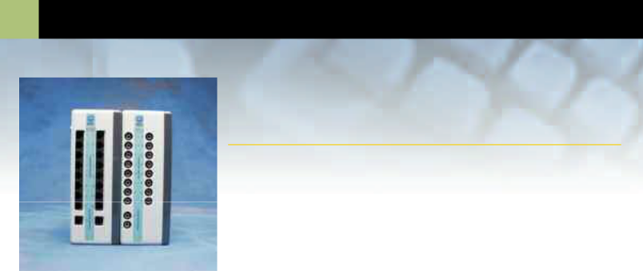
- Interface Modules

HLT100C & UIM100C

Universal Interface Module

The UIM100C is used to connect 100-series amplifier modules and signal cables to the system and is included in the MP Starter System. Sixteen analog input channels plus 2 analog output channels are provided via standard 3.5mm phone jacks on the front panel. The back panel provides access to 16 digital I/O lines and an external trigger input via screw terminals. Amplifier modules snap onto the side of the UIM100C for signal routing to the MP data acquisition unit. The output of any amplifier module snapped to the UIM100C can be monitored, during acquisition, via the corresponding 3.5mm analog channel phone jack. The UIM100C also provides a direct link to the analog and digital I/O lines of the MP device when collecting or sending data to external equipment. See page 88 for cables to interface your equipment to the UIM100C.

IMPORTANT USAGE NOTE

Mains powered external laboratory equipment should be connected to an MP System through Signal Isolators when the system also connects to electrodes attached to humans. For analog signals, use the INISO or OUTISO isolator (with the HLT100C) to couple external equipment to an MP System. For digital signals, use the STP100 (with the UIM100C) to couple external equipment to an MP System. Contact BIOPAC for details.

• UIM100C (if purchased separately)
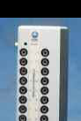

UIM100C SPECIFICATIONS

Analog I/O Access: 16 channels (front

panel) – 3.5mm phone

jacks

D/A Outputs: 2 channels (front panel)

– 3.5mm phone jacks

Digital I/O Access: 16 channels (back

panel) – screw terminals Ext. Trigger Access: 1 channel (back panel) –

screw terminal

Isolated Power Access:±12V, +5V @ 100 ma

(back panel) – screw

terminals

Weight: 520 grams

Dimensions: 7cm (wide) x 11cm

(deep) x 19cm (high)

IPS100C

Isolated Power Supply Module NEW

IPS100C SPECIFICATIONS

 | Amplifier Output Access: 16 channels (front panel)
Not for use with an MP data acquisition module. |  | – 3.5mm phone jacks
Not for use with an MP data acquisition module. | Isolated Power Access: | ±12V, +5V @ 100 ma
The IPS100C is used to operate 100-series amplifier modules |  | (back panel) – screw
The IPS100C is used to operate 100-series amplifier modules |  | terminals
independent of an MP data acquisition unit. The IPS100C module |  | terminals
 | Weight: | 610 grams
couples the 100-series amplifier outputs directly to any other data | Dimensions: | 7cm (wide) x 11cm
 |  | (deep) x 19cm (high)
acquisition system, oscilloscope or chart recorder. Amplifier modules | Power Source: | 12VDC @ 1 amp (uses
snap onto the side of the IPS100C to receive the necessary isolated |  | AC100A transformer)

power and to direct the modules’ output to the front panel of the
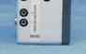

IPS100C. The IPS100C allows you to operate up to 16 amplifiers on a stand-alone basis. The analog channel outputs are provided via 3.5mm phone jacks on the front panel. The IPS100C is generally used with animal or tissue preparations. When collecting data from electrodes attached to humans, use the HLT100C module with INISO and OUTISO signal isolators to couple signals to mains powered external laboratory equipment.

IMPORTANT USAGE NOTE

Do not use the IPS100C with an MP based system. For a fully isolated recording system using the IPS100C, couple signal inputs and outputs through the HLT100C module and INISO and OUTISO adapters, respectively. Contact BIOPAC for details. Includes In-line Transformer (AC100A) and MP System Guide. Specify USA or EURO power cord.

• IPS100C

53

High Level Transducer Module

HLT100C & Signal Isolators

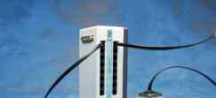

All high level output transducers interface to an MP System via the HLT100C module. Up to 16 transducers can be connected to a single HLT100C. The HLT100C is similar in function to the UIM100C, but also provides power to the transducer when making a connection.

Alternatively, the HLT100C module can be used to connect mains powered external laboratory equipment to the MP System when the system also connects to electrodes attached to humans.

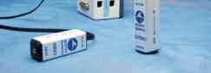
- To provide the maximum in subject safety and isolation, use signal isolators to connect mains powered external equipment (i.e. chart recorders, oscilloscopes, etc.) to the MP System. Use the INISO isolator to connect to MP analog system inputs and the OUTISO isolator to connect to analog system outputs.

High level output transducers and adapters connect to the HLT100C via standard 6-pin RJ11 type connectors. Transducers and adapters that presently require the HLT100C module are:

TSD109C/F Tri-axial Accelerometers

INISO Input Signal Isolator

• HLT100C

HLT100C SPECIFICATIONS

Transducer Inputs: 16 channels (front

panel) – RJ11 jacks

System D/A Outputs: 2 channels (front

panel) – RJ11 jacks

Isolated Power Access: ±12V, +5V @ 100 ma

(via all RJ11 jacks)

Weight: 540 grams

Dimensions: 7cm (wide) x 11cm

(deep) x 19cm (high)

INISO & OUTISO

SPECIFICATIONS

Isolator Type: Analog

Bandwidth: DC to 50kHz

Input/Output Range: ±10 volts

Input Resistance: 200KΩ

Output Resistance: 120 Ω

Output Current: ±5mA

Offset Voltage: ±20mV (nominal)

Temperature Drift: 200 µV/°C (nominal)

Noise: 2.5mV (rms)

Isolation Voltage: 1500 VDC

Isolation Capacitance: 30pF

Input Connector: INISO: 3.5mm mono

phone jack

Output Connector: OUTISO: 3.5mm mono

phone jack

Weight: 50 grams

Dimensions: 2.6cm (high) x 2.6cm

(wide) x 7.6cm (long)

Included Cable: 2.1 meter (straight thru,

M/M, 6 pin, RJ11)

Interface: HLT100C—see above

TSD150A/B Active Electrodes | TSD111 | Heel/Toe Strike Transducer
OUTISO Output Signal Isolator | TSD115 | Variable Assessment Transducer

Signal Isolators NEW

These analog signal isolators are used to connect mains powered external laboratory equipment to the MP System when the system also connects to electrodes attached to humans. Use the INISO to connect external equipment outputs to MP analog input channels. Use the OUTISO to connect MP analog signal outputs (amplifier and D/A) to external equipment inputs. Each signal isolator comes with an RJ11 cable for connection to the HLT100C module.

- For digital (TTL compatible) isolation to the MP digital I/O ports, use the STP100 optical interface (see page 63).
- If the MP System does not electrically connect to human subjects, signal connections to external laboratory equipment can be made through the UIM100C module and the respective analog or digital connection cable (see pages 86 and 88).

INISO

Input Signal Isolated Adapter

The INISO plugs directly into any of the 16 input channels on the HLT100C module and incorporates a 3.5mm phone jack for signal input connections. Select the appropriate analog connection cable (see page 88) to connect to your external equipment’s output.

• INISO

OUTISO

Output Signal Isolated Adapter

The OUTISO plugs directly into any of the 16 signal output channels, plus the two D/A outputs, on the HLT100C module and incorporates a 3.5mm phone jack for signal output connections. The OUTISO is very useful when the biopotential amplifier output signal requires routing to external laboratory equipment while being sampled by the MP System. Select the appropriate analog connection cable (see page 88) to connect to your external equipment’s input.

• OUTISO

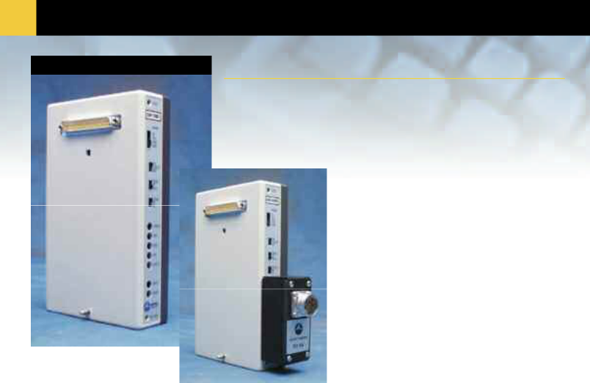
54 General-Purpose

DA100C General-purpose Transducer Amplifier

The DA100C is a very low noise and drift differential bridge amplifier that will operate with a wide variety of transducers, including: pressure, force, strain, displacement, thermocouplers, piezo sensors, light sensors, microphones and nearly any other active or passive sensor or transducer. The DA100C provides variable gain settings, offset control for baseline zeroing and adjustable voltage references for activating passive transducers (see pages 69-80).

Compatible Transducers
TSD104A | Precision Pressure | Page 69
TSD105A | Variable Range Force | Page 69
TSD107B | High Flow Pneumotach | Page 70
TSD108 | Physiological Microphone | Page 70
TSD117 | Medium Flow Pneumotach | Page 73
TSD120 | Noninvasive BP Cuff | Page 72
TSD121C | Hand Dynamometer | Page 74
TSD125 | Fixed Range Force | Page 75
TSD127 | Low Flow Pneumotach | Page 76
TSD130 | Goniometers | Page 76
TSD137 | Very Low Flow Pneumotach | Page 77
TSD160 | Differential Pressure | Page 80
• DA100C

Transducer Connector Interfaces

The transducer connector interfaces (TCIs) adapt a variety of transducer types to the DA100C module. The TCIs match the DA100C to the transducer brands listed. If no existing connector matches your equipment, we will build a special TCI for you, or you can use the TCIKIT. Please call or write BIOPAC with your specific needs.

TCI Series
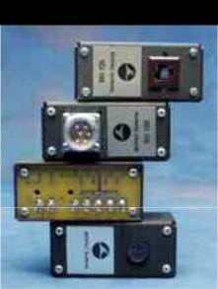

TCI100 Grass/Astromed transducers – 6 pin TCI101 Beckman transducers – 5 pin

TCI102 World Precision Instrument transducers – 8 pin

TCI103 Lafayette Instrument transducers – 9 pin

TCI104 Honeywell transducers – 6 pin

TCI105 Modular phone jack connector – 4 pin

TCI106 Beckman transducers – 12 pin

TCI107 Nihon Koden transducers – 5 pin

TCI108 Narco transducers – 7 pin

TCI109 Fukuda transducers – 8 pin

TCI110 Gould transducers – 12 pin

TCI111 Liquid metal transducers – two 2mm sockets TCI112 Hokansen transducers – 4 pin

TCIPPG1 Geer photo-electric (IR) for PPG100C only – 7 pin • TCI Series

NEW


NEW

NEW

Create a custom interface with the TCIKIT (page 55) or check out www.foggsystem.com for additional interface options.

 | Transducer Amplifier |  |  |  |  |  |  |  |  |  |  |  |  | 55
 |  |  |  |  |  | Custom Interface Kit |  |  |  | TCIKIT
 | DAC100C SPECIFICATIONS
 | Gain: | 50, 200, 1000, or 5000
 |  |  |  |  |  |  | Build your own customized adapter to the DA100C.
 | Output Range: | ±10V (analog)
 | Low Pass Filter: | 10Hz, 300Hz, 5000Hz |  |  |  |  | The do-it-yourself TCI kit includes housing, PC board
 | High Pass Filter: | DC, 0.05Hz
 | High Pass Filter: | DC, 0.05Hz |  |  |  |  | with 7 attached PIN plugs (2mm) and instructions.
 | Input Voltage (max): | ±200mV (protected)
 | Noise Voltage: | 0.11µV rms - (0.05- |  |  |  |  | Mount your connector to the housing and solder wires
 |  | 10Hz)
 | Temperature Drift: | 0.3µV/°C |  |  |  |  | to the pins.
 | Z (input): | 2MΩ (Differential) |  |  |  |  | • TCIKIT
 | CMRR: | 90dB min
 | CMIV: | ±10V (referenced to
 |  | amplifier ground)
 |  | ±1500 VDC (refer-
 |  | enced to mains
 |  |  |  |  |  |  |  |  |  |  |  | REFCAL
 |  | ground) |  |  |  | Reference Calibrator for the DA100C |  |  |  |  |  | REFCAL
 |  | adjustable @ 20ma
 | Voltage Reference: | -10 to +10V infinitely
 |  | (max)
 |  | (Factory preset to 2 |  |  |  | Used to check and adjust the DA100C’s reference voltage used for
 |  | volts excitation) |  |  |  | transducer excitation. The REFCAL plugs directly into the
 | Signal Source: | Variety of transducers
 | Weight: | 350 grams |  |  |  | DA100C and operates with the DA100C Gain set to 50. The exact
 | Dimensions: | 4cm (wide) x 11cm
 | Dimensions: |  |  |  |  | reference voltage setting will be indicated on the DA100C output.
 |  | (deep) x 19cm (high)
 | Input Voltage Range | Gain | Vin (mV) |  |  | The REFCAL makes it very easy to adjust the reference voltage of
 |  | 50 | ±200
 |  | 50 | ±200 |  |  | the DA100C to suit your transducer.
 |  | 200 | ±50
 |  | 1000 | ±10 |  |  | • REFCAL
 |  | 5000 | ±2
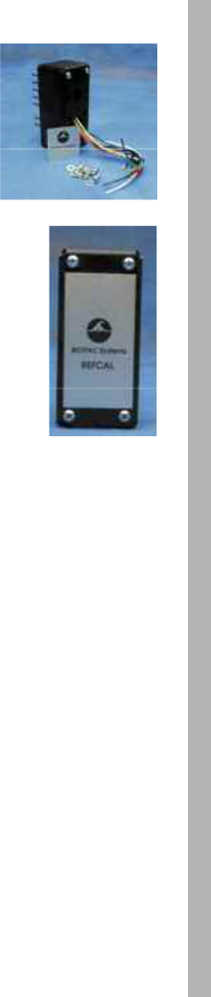

Calibration Cables for the
DA100C or 100B-Series Amplifiers

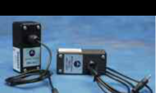
CBLCAL & CBLCALC

Used to verify the signal calibration of the DA100C. This cable (1.8m) connects between the DA100C input and the UIM100C D/A output 0 or 1. To verify the DA100C’s frequency response and gain settings, create a stimulus signal with AcqKnowledge and monitor the DA100C’s output. The CBLCAL incorporates a precision 1/1000 signal attenuator. You can also use the CBLCAL for 100B-series Biopotential amplifier calibration. (Amplifier specification tests are performed at the factory before shipping, but your own Calibration Cable can ensure peace of mind by permitting precise frequency response and gain calibrations for exact measurements.)

• CBLCAL

Calibration Cable for Biopotential Amplifiers

Used to verify the calibration of any of the 100C-series Biopotential amplifiers. This cable (1.8m) connects between the amplifier input and the UIM100C D/A output 0 or 1. Create a stimulus signal using AcqKnowledge and monitor the output of the amplifier connected to the Calibration Cable. This procedure can verify the amplifier’s frequency response and gain settings. The Calibration Cable incorporates a precision 1/1000 signal attenuator. (Amplifier specification tests are performed at the factory before shipping, but your own Calibration Cable can ensure peace of mind by permitting precise frequency response and gain calibrations for exact measurements.)

• CBLCALC

Additional DA100C Interface Cables

CBL106—see page 88 CBL202—see page 86 JUMP100—see page 87

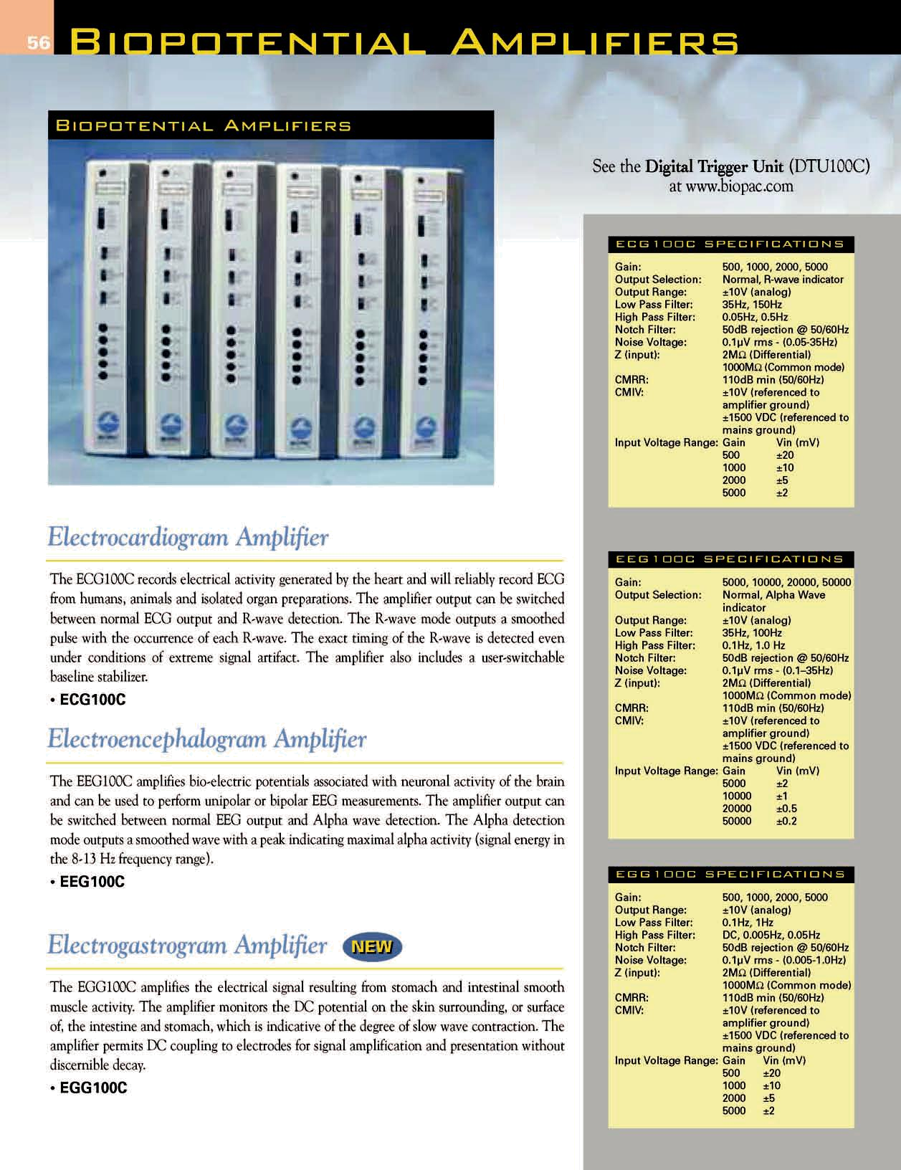

EMG100C SPECIFICATIONS

Gain: | 500, 1000, 2000, 5000
Output Range: | ±10V (analog)
Low Pass Filter: | 500Hz, 5000Hz
High Pass Filter: | 1.0Hz, 10Hz, 100Hz
Notch Filter: | 50dB rejection @ 50/60Hz
Noise Voltage: | 0.2µV rms - (10-500Hz)
Z (input): | 2MΩ (Differential)
 | 1000MΩ (Common mode)
CMRR: | 110dB min (50/60Hz)
CMIV: | ±10V (referenced to
 | amplifier ground)
 | ±1500 VDC (referenced to
 | mains ground)
Input Voltage Range: Gain |  | Vin (mV)
 | 500 | ±20
 | 1000 | ±10
 | 2000 | ±5
 | 5000 | ±2

EOG100C SPECIFICATIONS

Gain: | 500, 1000, 2000, 5000
Output Selection: | Normal, Derivative output
Output Range: | ±10V (analog)
Low Pass Filter: | 35Hz, 100Hz
High Pass Filter: | DC, 0.05Hz
Notch Filter: | 50dB rejection @ 50/60Hz
Noise Voltage: | 0.1µV rms - (0.05-35Hz)
Z (input): | 2MΩ (Differential)
 | 1000MΩ (Common mode)
CMRR: | 110dB min (50/60Hz)
CMIV: | ±10V (referenced to
 | amplifier ground)
 | ±1500 VDC (referenced to
 | mains ground)
Input Voltage Range: Gain |  | Vin (mV)
 | 500 | ±20
 | 1000 | ±10
 | 2000 | ±5
 | 5000 | ±2

ERS100C SPECIFICATIONS

Gain: | 5000, 10000, 20000, 50000
Output Range: | ±10V (analog)
Low Pass Filter: | 3kHz, 10kHz
High Pass Filter: | 1.0Hz, 20Hz, 100Hz
Notch Filter: | 50dB rejection @ 50/60Hz
Noise Voltage: | 0.5µV rms - (100-3000Hz)
Z (input): | 2MΩ (Differential)
 | 1000MΩ (Common mode)
CMRR: | 110dB min (50/60Hz)
CMIV: | ±10V (referenced to
 | amplifier ground)
 | ±1500 VDC (referenced to
 | mains ground)
Input Voltage Range: Gain |  | Vin (mV)
 | 5000 | ±2
 | 10000 | ±1
 | 20000 | ±0.5
 | 50000 | ±0.2

ALL BIOPOTENTIAL AMPLIFIER SPECIFICATIONS

Signal Source: Electrodes (three elec-

trode leads required)

Dimensions: 4cm (wide) x 11cm (deep)

x 19cm (high)

Weight: 350 grams

57

Electromyogram Amplifier

The EMG100C amplifies general and skeletal muscle electrical activity. The amplifier functions directly with AcqKnowledge to perform real-time EMG integration and, as it incorporates fast response and settling time characteristics, can also be used to monitor single-fiber EMG, motor unit and peripheral nerve action potentials.

• EMG100C

Electrooculogram Amplifier

The EOG100C amplifies the corneal-retinal potential. The amplifier monitors the DC potential on the skin surrounding the eyes, which is proportional to the degree of eye movement in any direction. The amplifier output can be switched between normal EOG output and Derivative of EOG. In Derivative mode, the amplifier outputs the measured velocity of eye movement, which is useful for saccade and nystagmus investigations. The amplifier permits DC coupling to electrodes for X/Y graphing of eye movement without discernible decay.

• EOG100C

Evoked Response Amplifier

The ERS100C is an extremely low noise differential amplifier that accurately amplifies very small potentials, such as those associated with stimulus/response, signal-averaged recordings. Selectable gain and bandwidth options make the module useful for a variety of evoked response testing modes. The ERS100C is intended for use in applications such as auditory brainstem response, startle response, somatosensory evoked response or nerve conduction velocity recording.

• ERS100C

Biopotential 100C Interface Cables

CBL200—see page 86

CBL204—see page 86 JUMP100C—see page 87

The Biopotential amplifiers connect to unshielded or shielded electrode leads terminating with Safelead® / Touchproof (1.5mm) sockets. For best performance, use two shielded electrode leads and one unshielded electrode lead per amplifier. See the extensive selection of electrode leads on page 83. For additional electrode lead distance, see the Module Extension Cables on page 87.
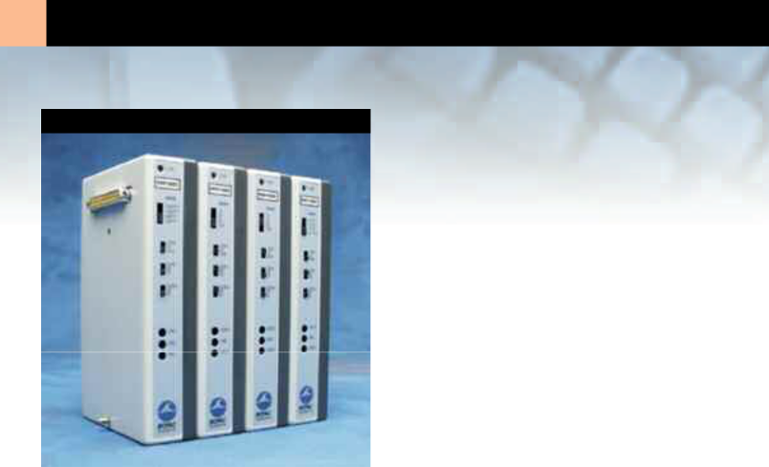
- Transducer Amplifiers

Transducer Amplifiers

The Transducer amplifiers work with specific BIOPAC transducers, as indicated in the descriptions.

Use any BIOPAC amplifier as a stand alone device with the New IPS100C shown on page 52.

Electrodermal Response Amplifier

The GSR100C measures both the skin conductance level (SCL) and response (SCR) as they vary with sweat gland (eccrine) activity due to stress, arousal or emotional excitement. The GSR100C uses a constant voltage technique to measure skin conductance. The controls allow selection of absolute (SCL+SCR) or relative (SCR) skin conductance measurements. Each GSR100C amplifier requires one TSD203 electrodermal response transducer (see page 82). For alternative body placement, use two of the EL258 lead electrodes (instead of the TSD203) with the GSR100C. Also required is GEL101 electrode gel (see page 86) or your preferred isotonic recording gel.

• GSR100C

Photoplethysmogram Amplifier

The PPG100C records the pulse pressure wave and, for providing an indication of blood pressure, blood density or vasoconstriction. The PPG100C couples to the TSD200 pulse transducer to measure changes in infrared reflectance resulting from varying blood flow. Front panel controls allow selection of either absolute or relative plethysmographic measurements. Each PPG100C requires one TSD200 photo-electric pulse plethysmogram transducer, shown on page 81.

• PPG100C

To interface with a photo-electric Geer gauge, see TCIPPG1 on page 54.

GSR100C SPECIFICATIONS

Gain: | 20, 10, 5, 2 micro-
 | mhos/volt (i.e. micro-
 | siemens/volt)
Output Range: | ±10V (analog)
Low Pass Filter: | 1Hz, 10Hz
High Pass Filter: | DC, 0.05Hz, 0.5Hz
Sensitivity: | 0.7 nano-mhos - with MP
 | System
Excitation: | Vex = 0.5VDC (Constant
 | Voltage)
Signal Source: | TSD203
Weight: | 350 grams
Dimensions: | 4cm (wide) x 11cm (deep)
 | x 19cm (high)
Input Signal Range: | Gain | Range (µmhos)
 | 20 | 0-200
 | 10 | 0-100
 | 5 | 0-50
 | 2 | 0-20

PPG100C SPECIFICATIONS

Gain: 10, 20, 50, or 100

Output Range: ±10V (analog)

Low Pass Filter: 3Hz, 10Hz

High Pass Filter: DC, 0.05Hz, 0.5Hz

Noise Voltage: 0.5µV rms – amplifier

contribution

Excitation: 6V

Signal Source: TSD200 Pulse Transducer

Weight: 350 grams

Dimensions: 4cm (wide) x 11cm (deep)

x 19cm (high)

59

RSP100C SPECIFICATIONS

Gain: 10, 20, 50, 100

Output Range: ±10V (analog)

Low Pass Filter: 1Hz, 10Hz

High Pass Filter: DC, 0.05Hz, 0.5Hz

Noise Voltage: 0.2µV rms – amplifier

contribution

Signal Source: TSD201

Weight: 350 grams

Dimensions: 4cm (wide) x 11cm (deep)

x 19cm (high)

SKT100C SPECIFICATIONS

Gain: | 5, 2, 1, 0.5 °F/Volt— can
 | also calibrate in °C
Output Range: | ±10V (analog)
Low Pass Filter: | 1Hz, 10Hz
High Pass Filter: | DC, 0.05Hz, 0.5Hz
Sensitivity: | 180 micro °F (100 micro
 | °C)— with MP System
Signal Source: | TSD202 Series
 | Temperature Probe
Weight: | 350 grams
Dimensions: | 4cm (wide) x 11cm (deep)
 | x 19cm (high)
Input Signal Range: | Gain | Range (°F) | Range (°C)
 | 5 | 40-140 | 5-60
 | 2 | 70-110 | 22-43
 | 1 | 80-100 | 27-37
 | 0.5 | 85-95 | 30-35

Respiration Pneumogram Amplifier

The RSP100C is designed for direct physical measurement of respiratory effort. The RSP100C works with the TSD201 transducer to measure abdominal or thoracic expansion and contraction while breathing. The RSP100C permits DC coupling to the TSD201 for the recording of respiratory effort signals of arbitrarily low frequency. Front panel controls allow selection of absolute or relative expansion/contraction measurements. Each RSP100C amplifier requires one TSD201 respiratory effort transducer, shown on page 81.

See the Digital Trigger Unit (DTU100C) and the MRI-compliant small animal respiration transducer (TSD110) at www.biopac.com.

• RSP100C

Temperature Amplifier

The SKT100C measures surface, core or air temperature. The SKT100C, with a TSD202 series temperature probe, can record temperature changes to 0.0001°C resolution. Front panel controls allow selection for either absolute or relative temperature measurements. The SKT100C operating temperature range is 40°F to 140°F (5°C to 60°C). Use the AcqKnowledge software to calibrate the SKT100C’s output in °F or °C. Each SKT100C amplifier will need one TSD202 series temperature probe, shown on page 82. By using CBL203 (see page 86), the SKT100C is also compatible with any YSI® 400 series biomedical temperature probe.
• SKT100C

Transducer 100C Interface Cables

YSI® 400 Probe Interface (for SKT100C) — see CLB203, page 86 2mm pin to Touchproof Socket Conversion — see CLB200, page 86

For additional transducer lead distance,

use a Module Extension Cable — see page 87.

You can also record these signals remotely, using the TEL100C shown on page 66.

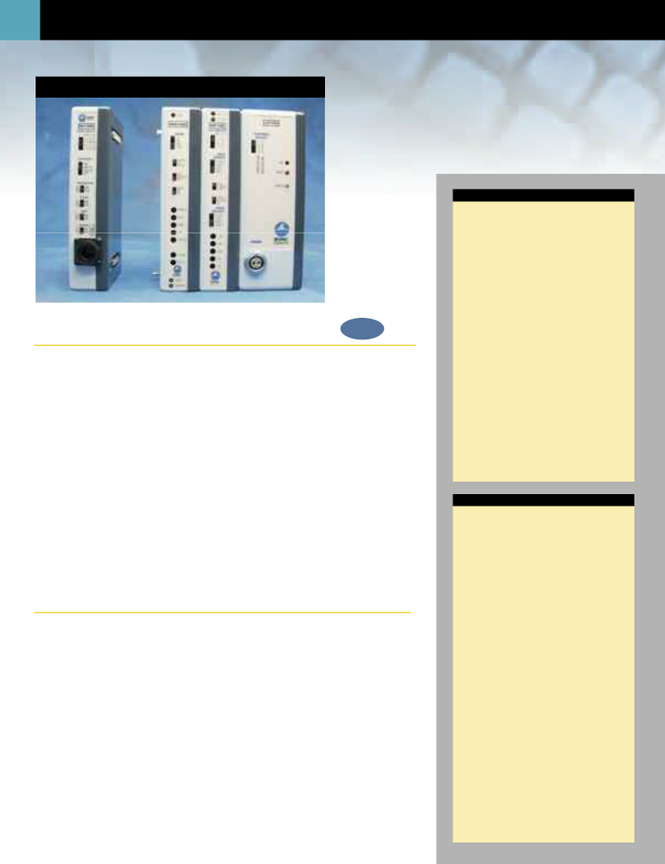
- Specialty Amplifiers

Specialty Amplifiers

Electrical Bioimpedance Amplifier NEW

The EBI100C records the parameters associated with cardiac output measurements, thoracic impedance changes as a function of respiration or any kind of biological impedance monitoring. The EBI100C incorporates a precision high frequency current source, which injects a very small (100µA) current through the measurement tissue volume defined by the placement of a set of current source electrodes. A separate set of monitoring electrodes then measures the voltage developed across the tissue volume. Because the current is constant, the voltage measured is proportional to the characteristics of the biological impedance of the tissue volume. The EBI100C measures both impedance magnitude and phase simultaneously. Impedance can be recorded at four different measurement frequencies, from 12.5kHz to 100kHz. For operation, the EBI100C connects to four unshielded electrode leads terminating in Touchproof sockets. The EBI100C is typically used with EL500 paired disposable electrodes, but can function with spot or ring electrodes, reusable electrodes, or needle electrodes.

For injecting current and averaging voltage at four paired-electrode sites (required for cardiac output measurements), use four CBL204 Touchproof “Y” electrode lead adapters (see page 86) and eight LEAD110 electrode leads (see page 83) with each EBI100C.

• EBI100C

Laser Doppler Flow Module

The LDF100C is a laser Doppler tissue perfusion monitor for measuring micro-vascular blood flow in tissue. The LDF100C module delivers a low power beam of laser light down an optical fiber to the tissue being studied; typically, the volume of tissue sampled by the light is in the order of 1mm³. The LDF100C module analyzes the Doppler shift created by moving red blood cells and outputs a channel indicating blood flow expressed in Blood Perfusion Units (BPU). On a second channel the LDF100C simultaneously outputs the tissue remittance (Backscatter) from 0 to 100%. Up to four LDF100C modules can be used with a single MP System. See the extensive range of TSD140 series laser Doppler flow probes on pages 78-79. If probes are shipped with the LDF100C, they are factory-calibrated to the module (except Disposable probes). Otherwise, probes are shipped uncalibrated. The LDF100C requires a Blood Perfusion Unit standard (LDFCAL) when (re)calibrating new or existing probes.

Includes In-line Transformer (AC101). Specify USA or EURO power cord.

• LDF100C

For calibration, see LDFCAL on page 88.

EBI100C SPECIFICATIONS

Number of Channels: 2 – Magnitude (MAG)

and Phase (PHS)

Outputs: MAG of Impedance

(0-1000Ω)

PHS of Impedance

(0-90°)

Output Range: ±10V (analog)

MAG Gain Range: 100, 20, 5, 1 Ω/volt

MAG LP Filter: 10Hz, 100Hz

MAG HP Filter: DC, 0.05Hz

MAG Sensitivity: 0.001 Ω @ 10Hz band-

width

PHS Gain: 90°/10 volts

PHS LP Filter: 100Hz

PHS HP Filter: DC coupled

PHS Sensitivity: 0.0025 deg @ 10Hz

bandwidth

CMIV: ±10V (referenced to

amplifier ground)

±1500 VDC (referenced

to mains ground)

Operational Frequencies: 12.5, 25, 50, 100kHz

Current Output: 100µA (rms)— constant

sinusoidal current

Signal Source: Electrodes (four elec-

trode leads required)

Weight: 370 grams

Dimensions: 4cm (wide) x 11cm

(deep) x 19cm (high)

LDF100C SPECIFICATIONS

Primary Measure: Microvascular blood

flow

Outputs: Laser Doppler Flow

(0-9999 BPU)

Tissue Remittance

(0-100%)

Output Range: 0 to 5 Volts (analog)

Laser Type: Laser Diode (Class 1)

(Peltier Temperature

Stabilized)

Laser Wavelength: 780nm ± 10nm

Laser Power: 0.5 to 1.0mW (probe

dependent)

Doppler Update Rate: 187.5Hz

Processing Bandwidth: 10Hz - 22kHz

Dynamic Range: 116dB

Linearity: 0.35% of full scale

Response Time: 100msec

Stability: 1.5% of full scale

Calibration: User set via motility

standard of 1000 BPU

(LDFCAL)

Probe ID: Cal factors automati-

cally stored

Signal Source: TSD140 Series Laser

Doppler Probe

Operating Temperature: 15°C to 30°C

Weight: 790 grams

Dimensions: 7cm (wide) x 11cm

(deep) x 19cm (high)

Power Source: ±12, +5 VDC @ 1 amp

(uses AC101A trans-

former)

The module utilizes Oxford Optronix, Ltd.

technology for Laser Doppler signal processing.

61

MCE100C SPECIFICATIONS

Gain: | 10, 50, 200, 1000
Output Range: | ±10V (analog)
Low Pass Filter: | 3kHz, 30kHz
High Pass Filter: | DC, 0.5Hz, 100Hz
CMRR: | 92dB typical
CMIV: | ±10V (referenced to
 | isolated ground)
 | ±1500 VDC (referenced
 | to mains ground)
Notch Filter: | 50dB rejection (50/60Hz)
Noise Voltage: | 2.1µV rms - (DC-3000Hz)
Noise Current: | 0.1 fA/√ | Hz
Z (input): | 10 E15 Ω (Differential)
 | 10 E15 Ω (Common
 | mode)
Cap Comp (Neg): | Input capacitance com-
 | pensation (0-100pF) –
 | manual control
Current Clamp: | Adjustable (±100nA) –
 | voltage control
I Clamp Control: | Input - 3.5mm phone jack
 | (100mV/nA)
I Clamp Monitor: | Output - 3.5mm phone
 | jack (100mV/nA)
Signal Source: | Micro-electrodes
Weight: | 350 grams
Dimensions: | 4cm (wide) x 11cm (deep)
 | x 19cm (high)
Input Voltage Range: Gain |  |  |  | Vin (mV)
 | 10 |  |  | ±1000
 | 50 |  |  | ±200
 | 200 |  |  | ±50
 | 1000 |  |  | ±10

OXY100C SPECIFICATIONS

Outputs: SpO₂, Pulse Rate,
Pulse Waveform &

Module Status

Output Range: 0 to 5 Volts (analog)

SpO2 Range: 0-100%

SpO2 Accuracy: 80-100% ±2%,

60-79% ±2.5%, 0-59%

unspecified

SpO2 Resolution: 1%

Pulse Rate Range: 30-250 BPM

Pulse rate Accuracy: 1% of full scale

Pulse Rate Resolution: 1 BPM

Method of Operation: Lambert-Beers law

employing dual

wavelengths

Optical Transmission: Red (660nm) and IR

(940nm)
Signal Source: TSD123 Series SpO₂
Transducer

Weight: 460 grams

Dimensions: 4cm (wide) x 11cm

(deep) x 19cm (high)

Algorithm Type:

The OXY100C employs Novametrix Medical Systems, Inc. artifact rejection and averaging algorithms, which utilize an eight second history of the pulse signal. Abnormal data in this history buffer (amplitudes and periods) is rejected. Acceptable data is passed along to an averaging algorithm and is updated on a beat-by-beat basis.

Micro-electrode Amplifier NEW

The MCE100C is an extremely high input impedance, low noise differential amplifier that accurately amplifies signals derived from micro-electrodes. A number of selectable options make the module useful for general-purpose recording of cortical, muscle and nerve action/resting potentials or cellular recordings with the optional use of input capacity compensation and a current clamp.

Cable shield drives for input signals can be configured for voltage following (for reduced input capacitance) or simply grounded (for low feedback noise). The MCE100C includes manual controls for input capacity compensation (±100pF) and clamp current zeroing. In addition, the MCE100C incorporates an external voltage control to vary the clamp current proportionally to the control voltage (100mV/nA). An MP150 D/A output channel can drive this external voltage control to change clamp currents automatically during recording. The MCE100C also includes a clamp current monitor output so the clamp current can easily be recorded by another MP150 input channel.

For general-purpose recording, without input capacity compensation or a current clamp, use standard shielded or unshielded electrode leads terminating in Touchproof sockets. Add input capacity compensation and current clamp control by connecting the respective signal ports to the [Vin+] input of the MCE100C using the JUMP100C jumper connectors. For the best performance and shielding, use the MCEKITC to interface your micro-electrode lead cable to the MCE100C.

IMPORTANT USAGE NOTE

Although the MCE100C will function with an MP100 System, an MP150 system is recommended due to the module’s wide operational bandwidth. Contact BIOPAC for details.

• MCE100C

Build a customized adapter to a Micro-electrode Shielded Cable — MCEKITC, page 88.

Pulse Oximeter Module

The OXY100C measures beat-by-beat, blood oxygen saturation (SpO₂) level in a noninvasive fashion. The OXY100C outputs four signals simultaneously: SpO₂, pulse waveform, pulse rate and module status. These signals are directed to a switchable block of four different MP System input channels. Up to four OXY100C modules can be used with a single MP System. The OXY100C has built-in calibration for a simplified setup procedure. Each OXY100C module includes a 3-meter transducer extension cable and requires one of the TSD123 series SpO₂ transducers, shown on page 74.

• OXY100C

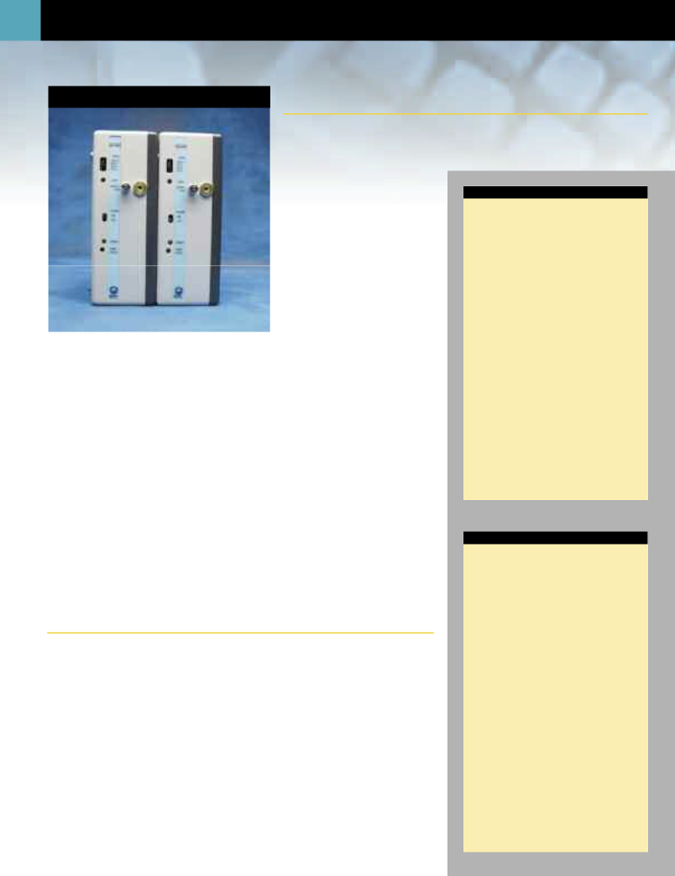
- Gas Analysis

C02100C & 02100C CO2 Measurement Module

The CO2100C module records quickly varying carbon dioxide concentration levels. This fast response analyzer is ideal for monitoring time-averaged CO₂ levels using mixing chambers or real-time CO₂ levels for breath-by-breath measurements. The CO2100C module interfaces (via the

AFT20 gas sampling interface kit) with the AFT15A and AFT15B mixing chambers, the AFT21 and AFT22 non-rebreathing T valves or the AFT25 mask with integral non-rebreathing T valve.

The CO2100C module is equipped with a variable speed pump to adjust the flow over a wide range of sampling conditions. The module

employs a single beam, infrared, single wavelength, measurement technique. Sampling line connections for input and output flow are readily accessible on the front panel of the module.

Includes In-line Transformer (AC100A); specify USA or EURO power cord. • CO2100C

BIOPAC offers a broad range of air flow transducers and gas analysis accessories — see pages 89-91.

O2 Measurement Module

The O2100C module records quickly varying oxygen concentration levels. This fast response analyzer is ideal for monitoring time-averaged O₂ levels using mixing chambers or real-time O₂ levels for breath-by-breath measurements. The O2100C module interfaces (via the AFT20 gas sampling interface kit) with the AFT15A and AFT15B mixing chambers, the AFT21 and AFT22 non-rebreathing T valves or the AFT25 mask with integral non-rebreathing T valve.

The O2100C module is equipped with a variable speed pump to adjust the flow over a wide range of sampling conditions. The module employs an analysis technique based on the parametric oxygen measurement principle. Sampling line connections for input and output flow are readily accessible on the front panel of the module.

Includes In-line Transformer (AC100A); specify USA or EURO power cord. • O2100C

CO2100C SPECIFICATIONS

CO₂ Range: | 0-10% CO₂
Gain: | 1, 2, 5, 10 (%CO₂/Volt)
Output Range: | 0-10 volts
Repeatability: | 0.03% CO₂
Resolution: | 0.1% CO₂
Linearity: | 0.1% CO₂
Zero Stability: | 0.1% CO₂/24 hours
Response Time: | 90msec (T10-T90) @ 200
 | ml/min
 | 100msec (T10-T90) @ 100
 | ml/min (factory preset)
 | 130msec (T10-T90) @ 50
 | ml/min
Flow Range: | 50-200 ml/min
Temp Range: | 10-45°C
Zero Drift: | 0.01% CO₂/°C
Span Drift: | 0.02% CO₂/°C
Warm Up Time: | 5 minutes @ 25°C
Sampling Port: | Male Luer
Weight: | 740 grams
Dimensions: | 7cm (wide) x 11cm (deep)
 | x 19cm (high)
Power Source: | 12VDC @ 1 amp (uses
 | AC100A transformer)

The module measures the partial pressure of CO₂ so the module output is a function of the pressure in the sample cell. Gas sampled must be free of any liquid or condensable vapors. Gas should be filtered to 5 microns or better. The module utilizes Servomex, Inc. technology for CO₂ concentration signal processing.

02100C SPECIFICATIONS

O₂ Range: | 0-100% O₂
Gain: | 10, 20, 50, 100 (%O₂/Volt)
Output Range: | 0-10 volts
Repeatability: | ±0.1% O₂
Resolution: | 0.1% O₂
Linearity: | ±0.2% O₂
Zero Stability: | ±0.01% O₂/hr
Response Time: | 160msec (T10-T90)
 | @ 200 ml/min
 | 500msec (T10-T90)
 | @ 100 ml/min
 | (factory preset)
 | 1000msec (T10-T90)
 | @ 50 ml/min
Flow Range: | 50-200 ml/min
Temp Range: | 5-50°C
Zero Drift: | ±0.05% O₂/°C
Span Drift | ±0.25% O₂/°C
Sampling Port: | Male Luer
Weight: | 990 grams
Dimensions: | 7cm (wide) x 11cm (deep)
 | x 19cm (high)
Power Source: | 12VDC @ 1 amp (uses
 | AC100A transformer)

The module measures the partial pressure of O₂ so the module output is proportional to the pressure in the sample cell. Gas sampled must be free of any liquid or condensable vapors. Gas should be filtered to 5 microns or better. The module utilizes Servomex, Inc. technology for O₂ concentration signal processing.

Stimulus Presentation 63

STP100W | Stimulus Presentation System
 | (SuperLab™) NEW

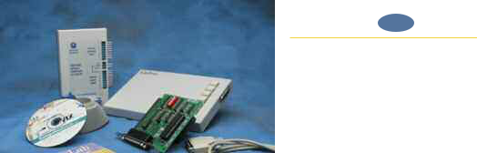

The STP100W is a stand-alone system that measures subject responses to visual or auditory stimuli. It can present visual stimuli on a computer screen, or auditory stimuli via headphones or speakers, and simultaneously (1ms resolution) send trigger signals to an MP System for data synchronization and collection purposes. The STP100W includes a six-pushbutton response box for performing accurate (1 ms resolution) reaction time measurements. For measuring physiological responses to stimuli, the STP100W includes an optically isolated interface, permitting up to eight synchronization signals (input or output) between the STP100W and the MP System.

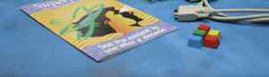
The SuperLab™ software can be used to change the placement of visual stimuli on the screen, change the screen’s background color, choose from a variety of input

and timing options, and provide feedback to subjects based on either response or reaction time. Different trigger channels can be paired to different visual or auditory stimuli to perform sophisticated evoked response averaging tests (e.g. P300).

NOTE: Second PC required— The synchronization signal(s) coming from the STP100W can be directed to an MP System running on a Macintosh or PC, but it’s not possible to run the STP100W on the same computer as the MP System. The STP100W requires that the SuperLab™ software and a Digital I/O card (PCI slot required) be placed on a PC running Windows 95, 98, or 98SE.

The STP100W system includes:

SuperLab™ Software (Windows 95, 98, or 98SE)

Support Pack for Digital I/O Card (Windows 95, 98, or 98SE)

Digital I/O Card (PCI slot required)

Six-Pushbutton Response Box

Pushbutton Keycap Color Change Kit

STP100 Optical Interface to UIM100C (includes 3-meter ribbon cable)

• STP100W

STP100 | Isolated Digital Interface for the UIM100C NEW

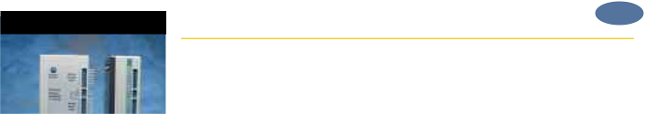

If you already have the SuperLab™ and the Digital I/O card with the Support Pack, you can interface to the MP System using the STP100 optical interface. The STP100 interface connects between the SuperLab™ Digital I/O card and the UIM100C module.

The STP100 module can also be used to connect digital signals (TTL compatible) from any mains powered external equipment to the MP System when the system also connects to electrodes attached to humans. The STP100 provides 8 lines for digital data inputs and 8 lines for digital data outputs. All lines are optically isolated to 1500 VDC compliance. The STP100 module comes equipped with a 3-meter ribbon cable (37 pin F/F) for easy system interfacing.


• STP100 (if purchased separately)

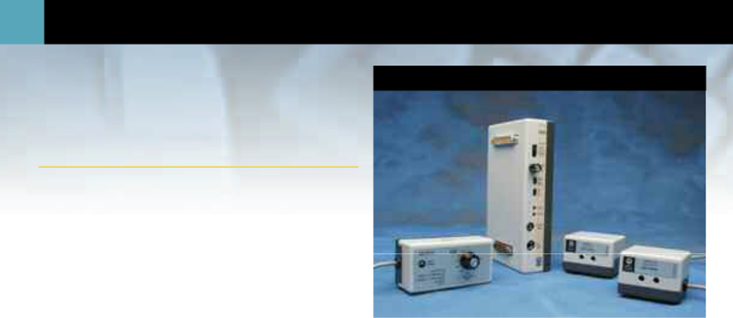
- Stimulator & Accessories

STM100C & STMISO Series

STM100C

Stimulator Module

The STM100C module provides pulse and waveform stimulus outputs
for nerve conduction, evoked response (e.g. ABR studies), audio stimulus-
response (e.g. startle response) and somatosensory response studies. The
Stimulator setup in AcqKnowledge provides easy-to-modify single-, | STMISOC
double- or multiple-pulse sequence outputs of any polarity. The
Stimulator setup screen also provides standard sine, triangular and
square wave outputs for other kinds of physiological tests. Create an
arbitrary waveform by modifying an existing wave or reading in a

sequence of user-specified numbers (text file). Stimulus duration, repe-tition, onset and amplitude are completely programmable. For interactive changes during recording, stimulus amplitude levels can also

be controlled manually. Overload and pulse stimulus indicators are positioned on the module’s front panel for easy viewing. The 50 Ω output port can simultaneously output a trigger or analog signal to piezo transducers, recorders, oscilloscopes, meters, etc. The External Stimulus output port on the STM100C can be used to drive headphones or tubephones directly.
In addition to providing computer control of stimulus waveforms, the STM100C can also buffer signals from any Biopotential or Transducer module that has its output directed to the STM100C input during recording.

  - With the OUT100 headphones, the STM100C module can provide tone or click output (e.g. startle response) or can be used to listen to signals from other module outputs during acquisition (e.g. EMG or heart sounds signals).

  - With the OUT101 ear tubephone, the STM100C can output a series of clicks or tone pips for auditory brainstem response (ABR) testing.
  - With the OUT102 piezo transducer, the STM100C can provide an audible indicator, or alarm, when signal levels cross pre-defined thresholds.
  - With the STMISO series stimulus isolation adapters, the STM100C can provide high voltage or constant current stimulus output for nerve conduction, somatosensory and other types of stimulus response studies.

  - With the CBL105 and CBL202, the STM100C is capable of driving a low voltage (±10V) nerve conduction chamber directly (without a STMISO).

- STM100C

STIMISOD

STMISOE

STM100C SPECIFICATIONS

Stimulus Output Voltage: 20 Volts (p-p) maximum

Current Output Drive: 50 Ω Output: ±100mA

(3.5mm phone jack)

Ext Stim Output: ±1.0

amp [6.3mm (1/4")

phone jack]

External Stimulus Z (out): Less than 0.1 Ω

Input Sources: DA0, DA1, PULSE (DIG

I/O 15), CH 16 (Analog)

Polarity Control: Manual or digital

control (DIG I/O 7)

Attenuation Control: Manual or digital control

Attenuation Control

Range: 128dB (Digital I/O 0-6,

LSB-MSB)

Attenuation Resolution: 1dB

LED Indicators: Pulse, Current Limit

Uniphasic Pulse Width: 10µs (min) with 5µs

resolution

Biphasic Pulse Width: MP100: 50µs (min),

MP150: 20µs (min)

Biphasic Pulse Resolution:MP100: 25µs, MP150:

10µs

Arbitrary Wave

Resolution: MP100: 25µs, MP150:

10µs

Weight: 380 grams

Dimensions: 4cm (wide) x 11cm

(deep) x 19cm (high)

Electrical Stimulus Isolation Accessories

Stimulus Isolation Adapter (Voltage and Current)
The STMISOC can stimulate with pulse, sinusoidal or arbitrary waveforms and is ideal for nerve conduction, muscle twitch, somatosensory stimulation, or other response studies requiring a stimulus. It plugs into the STM100C to provide either an isolated voltage or constant current stimulus and incorporates a selectable linear voltage multiplier to amplify the voltage signal from the STM100C. Voltage stimulation can be unipolar or bipolar, with a maximum voltage output of 200 volts. Current stimulation is unipolar only, with a maximum compliance of 200 volts; 12 preset constant current levels are provided.

• STMISOC

STMISOC SPECIFICATIONS

Stimulus Pulse Width: 50µsec to 2msec (voltage and current)

Stimulus Sine Wave

Range: 100Hz to 5kHz (voltage only)
Step Up Voltage Ratio: Selectable: (1:5) or (1:10)
Maximum Output | 200V (p-p) into 5k Ω load
Voltage: | 200V (p-p) into 5k Ω load
Constant Current
Range: | 0.01, 0.02, 0.05, 0.0, 0.2, 0.5,
 | 1.0, 2.0, 5.0, 10.0, 20.0, 50.0
Current Source | ma (unipolar only)
Current Source | 200V maximum
Compliance: | 200V maximum
Isolation Capacitance: | 120pf
Isolation Voltage: | 1500 VDC (from amplifier
 | ground)
Cable Length: | 1.8 meters
Weight: | 190 grams
Dimensions: | 10cm (wide) x 5cm (deep)
 | x 4.5cm (high)
Interface: | STM100C—see above

65

STMISOD & STMISOE SPECIFICATIONS

Stimulus Pulse Width: 50µsec to 2msec

(voltage only)

Stimulus Sine Wave

Range: 100Hz to 5kHz (voltage

only)

Step Up Voltage Ratio: STMISOD (1:5)

STMISOE (1:10)

Maximum Output

Voltage: STMISOD 100V (p-p)

into 5k Ω load

STMISOE 200V (p-p)

into 5k Ω load

Isolation Capacitance: 120pf

Isolation Voltage: 1500 VDC

(from amplifier ground)

Cable Length: 1.8 meters

Weight: 140 grams

Dimensions: 6.5cm (wide) x 5cm

(deep) x 4.8cm (high)

Interface: STM100C—see to left

Stimulus Isolation Adapters (Voltage Only)
The STMISOD and STMISOE can stimulate with pulse, sinusoidal or arbitrary waveforms and are suitable for nerve conduction, muscle twitch, somatosensory stimulation, or other response studies requiring a voltage stimulus.

The STMISOD and STMISOE plug into the STM100C to provide an isolated voltage stimulus. These stimulus isolation adapters incorporate a linear voltage multiplier to amplify the voltage signal from the STM100C. Voltage stimulation can be unipolar or bipolar, with a maximum voltage output of 100 volts for the STMISOD and 200 volts for the STMISOE.

- STMISOD (100V maximum)

- STMISOE (200V maximum)

See pages 83-85 for a wide range of electrode options.

Additional STM Series Interface Cables:

CBL200 and CBL204—see page 86.

CBL102, CBL105 and CBL106 — see page 88.

Auditory Stimulus Accessories

Headphones
These monaural headphones can be used with the STM100C stimulator module to deliver a tone signal while recording data for startle response or other stimulus-response studies. The headphones can also be used to listen to raw signals (such as EMG), piped through the STM100C from an amplifier output. The OUT100 is a wide response, high efficiency headphone, weighing 85 grams and is equipped with a 1.8 meter cord terminated in a 6.3mm (1/4") phone plug.

• OUT100

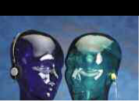

Tubephone Set
Use the OUT101 tubephone with a STM100C stimulator module to deliver clicks and tones in auditory evoked response applications (i.e. ABR). The Tubephone design consists of a monaural acoustic transducer attached to a short, flexible, plastic tube, which fits into the subject’s ear with the aid of a foam tip. Use of the Tubephone reduces ambient noise and bone conduction problems, which can interfere with auditory response recordings. Furthermore, because the Tubephone provides a 1 msec acoustic signal delay (due to plastic tube), it automatically separates true response from electromagnetic artifact resulting from speaker activation. The OUT101 measures 3.8cm (wide) x 5cm (high) x 1cm (thick), includes a clip for attachment to fabric or fixtures and comes equipped with a 1.8m cable terminated in a 6.3mm (1/4") phone plug. The OUT101 Tubephone Set includes one Tubephone, plastic tube and 50 foam ear inserts. The OUT101 response compares to TDH-39, 49 or 50 audiometric headphones.

- OUT101 (Tubephone Set)

- OUT101T (Replacement Plastic Tubes: pkg. of 4)

- OUT101E (Replacement Foam Ear Inserts: pkg. of 50)

Piezo Audio Transducer ^{NEW}

OUT Series

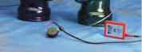

OUT101

OUT100

OUT102

The OUT102 piezo transducer is typically connected directly to the STM100C stimulator module. When the stimulator module output rises above 1.5 volts, the piezo indicator will emit a constant audible signal (3.0 kHz @ 80dB). Accordingly, the device is very useful for providing an audible stimulus, or alarm, when a physiological signal passes a certain threshold. As such, the OUT102 makes an excellent audible BPM indicator for ECG, blood pressure or respiration signals. The device can also be used to indicate when temperature or another slowly moving variable (e.g. electrodermal response) passes a certain threshold. The threshold for the OUT102 is determined by adjusting the amplitude control on the STM100C module. The specific Biopotential or Transducer amplifier signal monitored can be recorded while simultaneously directed through the STM100C module. The OUT102 also connects directly to the UIM100C digital I/O ports for operation with Control Channel outputs. The OUT102 measures 2.5cm (dia) x 1cm (high) and comes equipped with a 1.8m cable terminated in a 3.5mm phone plug. An adapter is included for connecting the OUT102 to the UIM100C digital I/O ports.

• OUT102

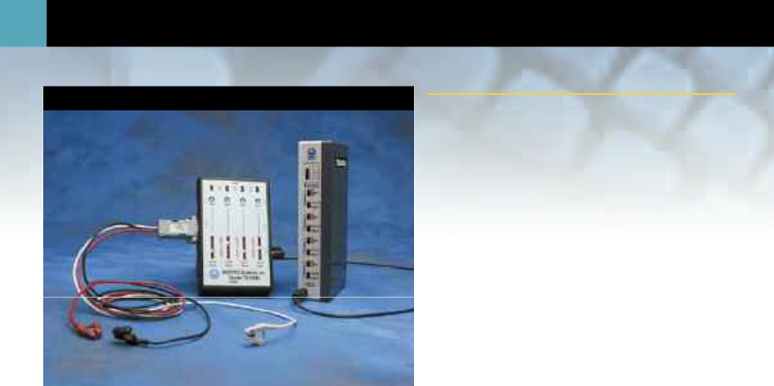
- Remote Monitoring

Remote Monitoring Module Set
TEL100C
The TEL100C system offers a way to record data while subjects are mobile and/or physically distant (up to 60 meters) from the recording system. The TEL100C system includes a portable amplifier/transmitter, which converts up to four channels of data into a modulated data stream. This data stream travels over a single lightweight coaxial cable to the receiver module. The receiver module demodulates the data and sends it to the MP System for recording and analysis.

In keeping with the modular design, the TEL100C will work with your current MP System and any other standard 100-series amplifiers. Up to four TEL100C module sets can be used with a single MP System.

Each channel incorporates a switchable, non-distorting 50/60 Hz interference filter. Gain and bandwidth can be adjusted independently for each channel.

The TEL100C system includes:

• 1 - TEL100D-C receiver module

• 1 - TEL100M-C portable amplifier/transmitter

• 1 - CBL117 10-meter connection cable

• TEL100C system
Four Channel Receiver Module

The TEL100D-C four-channel receiver module connects directly to an MP System and is included in the TEL100C remote monitoring module set. The receiver incorporates independent filtering controls for each recording channel. Up to four TEL100D-C modules can be used with any MP System. A combination of other 100-series amplifiers, plus one or more TEL100D-Cs, can be used together for a maximum of 16 channels. The TEL100D-C requires a TEL100M-C amplifier/transmitter plus CBL117 or CBL118 for operation.

• TEL100D-C (if purchased separately)

Four Channel Amplifier/Transmitter Module

The TEL100M-C amplifies and transmits up to four data channels to the TEL100D-C and is included in the TEL100C remote monitoring module set. The transmitter includes independent filtering, offset and gain controls for each recording channel. The transmitter measures 9cm x 15cm x 3.3cm and needs 5cm clearance on each side for electrode or transducer attachment. A belt clip is attached to the back of the module so it can be worn at the subject’s waist. The “Smart Sensor” electrodes and transducers listed on page 67 plug into four 9-pin connectors (two on each side of the transmitter). Excitation voltages present on each input channel provide power for transducers.

The TEL100M-C requires one 9V alkaline battery (included) for operation. Expected battery life is approximately 24 hours of continuous operation. A low battery indicator light will flash when the battery needs to be replaced.

• TEL100M-C (if purchased separately)

Connection Cables

These cables connect the TEL100D-C receiver to the TEL100M-C transmitter. The lightweight coaxial cables minimize hindrance caused by multiple heavy cables. The CBL117 is included with the TEL100C set. For increased operating distance, use CBL118.

• CBL117 (10 meter) (if purchased separately)

• CBL118 (60 meter)

TEL100C SPECIFICATIONS

Number of Channels: 4

Low Pass Filter: 30Hz, 500Hz

High Pass Filter: DC, 0.05Hz and 0.5Hz

Channel Gain Control: 10 levels: x50 to x50,000

Output Range: ±9V (analog)

Offset Control: Yes

Input Impedance: 2 MΩ (differential)

CMRR: 110dB min (50/60Hz)

CMII: 1000 MΩ min (50/60Hz)

CMIV: ±7V (referenced to

amplifier ground)

±1500 VDC (referenced

to mains ground)

Noise Voltage: 0.1µV rms (0.05-30Hz)

Transducer Excitation: ±5V (10V pk) @ 10ma

(max)

Signal/Crosstalk Ratio: (0.05-500Hz) 65dB min

Signal/Noise Ratio: (0.05-30Hz) 75dB min,

(0.05-500Hz) 65dB min

Encoding: TDM-DSB/LC

Signal transmission range: ≤ 60 meters via coaxial

cable

TEL100M Weight: 290 grams (with bat-

tery)

TEL100M Dimensions: 9cm (wide) x 15cm

(long) x 3.3cm (high)

TEL100D Weight: 370 grams

TEL100D Dimensions: 4cm (wide) x 11cm

(deep) x 19cm (high)

TEL100M Power Source: 9V alkaline battery (24

hrs nominal)

67

Electrodes and Transducers for the TEL100C Module Set

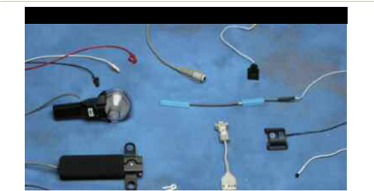

Smart Sensors

² 8 ₁₈

 | 13
9 | 5
9 | 1
 | 7
16
 | 4
10 | 6
 | 20
19 | 3

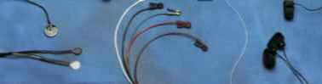

Smart Sensor (SS) electrodes and transducers connect to the TEL100M-C amplifier/transmitter. Any Smart Sensor electrode or transducer can be plugged into any TEL100M-C input. The following SS series transducers connect to the TEL100C system. The transducer specifications mirror the characteristics of the respective “TSD” types listed. Generally, biopotentials and other signals can be recorded for up to 24 hours. All transducers come with a 1.8-meter cable unless otherwise specified.

1. | SS1A | Unshielded Touchproof Electrode Adapter (10 cm)
2. | SS2 | Shielded Electrode Lead Assembly (1 meter)
3. | SS3A | Electrodermal Response Transducer | see TSD203 | Page 82
4. | SS4A | Pulse Plethysmogram Transducer | see TSD200 | Page 81
5. | SS5B | Respiratory Effort Transducer | see TSD201 | Page 81
6. | SS6 | Fast Response Temperature Probe | see TSD202A | Page 82
7. | SS7 | Skin Surface Temperature Probe | see TSD202B | Page 82
8. | SS10 | Hand Switch | see TSD116A | Page 72
9. | SS11A | Air Flow (medium) Transducer | see TSD117 | Page 73
10. | SS17 | Physiological Sounds Microphone | see TSD108 | Page 70
11. | SS20 | Twin Axis Goniometer, 110mm (requires 2 channels) | see TSD130A | Page 76
12. | SS21 | Twin Axis Goniometer, 150mm (requires 2 channels) | see TSD130B | Page 76
13. | SS22 | Single Axis Torsiometer, 110mm | see TSD130C | Page 76
14. | SS23 | Single Axis Torsiometer, 150mm | see TSD130D | Page 76
15. | SS24 | Finger Goniometer, 35mm | see TSD130E | Page 76
16. | SS25 | Hand Dynamometer | see TSD121C | Page 74
17. | SS26 | Tri-Axial Accelerometer 5G (requires 3 channels) | see TSD109C | Page 71
18. | SS27 | Tri-Axial Accelerometer 50G (requires 3 channels) | see TSD109F | Page 71
19. | SS28 | Heel/Toe Strike Transducer | see TSD111 | Page 71
20. | SS29 | Multi-lead ECG Cable (requires 3 channels) | see TSD155C | Page 80

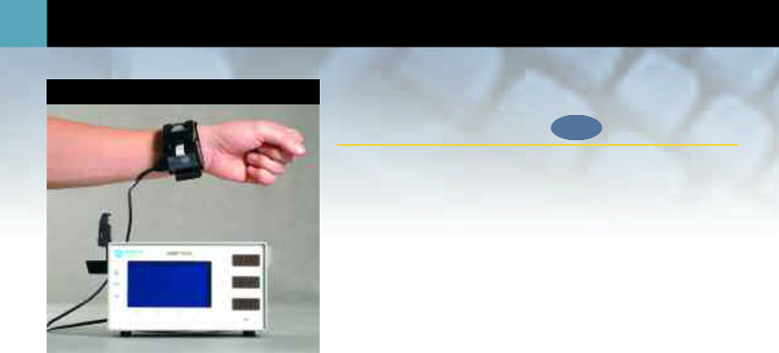
68 Noninvasive Arterial BP

NIBP100A | Noninvasive Direct Arterial Blood
 | Pressure Monitor | NEW

The noninvasive NIBP100A provides continual blood pressure measurement with accuracy comparable to an indwelling radial artery catheter. The NIBP100A is an accurate, continual, and noninvasive solution to blood pressure monitoring.

Using a patented method of measuring radial artery waveforms, the NIBP100A system calculates accurate systolic, diastolic, and mean pressures. The data is processed by a proprietary algorithm based on a set of coefficients derived from clinical data.

No complicated setup or calibration requirements!

The NIBP100A is easy to use. The pressure sensor in the NIBP100A applies variable pressure directly above the radial artery and the initial measurement and waveform are displayed within 15 heartbeats. The display is continually updated every 10-15 heartbeats. Subjects experience minimal sensation while wearing the wrist sensor. The wrist sensor fits adults or children (22-11 cm), can be worn on either wrist, and is completely latex-free. The NIBP100A also provides improved ability to obtain measurements from subjects undertaking light exercise or psych analysis conditions.

For a low-cost alternative to measure non-continuous, indirect blood pressure, see the TSD120 on page 72. For invasive blood pressure, see TSD104A on page 69.

 | NIBP100A SPECIFICATIONS |  |  | TSD105A SPECIFICATIONS
 | Monitor: | Case: Aluminum |  | Rated Output: | 1mV/V (normalized to 1V
 |  | Size: 5.0 (h) x 4.5 (w) x 8.5 (l) -- inches |  |  | excitation)
 |  | Weight: 4.5 lbs with power cord and wrist module |  | Ranges: | 50, 100, 200, 500, 1000
 | Displays: | LCD: Cold Cathode Fluorescent Backlight (CCF) |  |  | grams
 |  | LED: Three (3) high-intensity displays |  | Noise (rms): | (Range/50)mg @ 10 volts
 | Electrical: | Ratings: 100-240 VAC, 50/60 Hz, 0.25 - 0.5A max. |  |  | excitation, 1Hz bandwidth
 |  | Current Leakage: UL544 |  | Nonlinearity: | <±0.025% FSR
 | Performance Range: | Min/Max Accuracy |  | Hysteresis: | <±0.05% FSR
 |  | Systolic: 40mmHg-240mmHg+ 5mmHg/SD 8mmHg |  | Nonrepeatability: | <±0.05% FSR
 |  | Mean: 30mmHg-200mmHg+ 5mmHg/SD 8mmHg |  | 30 minute creep: | <±0.05% FSR
 |  | Diastolic: 20mmHg-180mmHg+ 5mmHg/SD 8mmHg |  | Temperature Range: | -10°C to 70°C
 |  | Pulse: 40 bpm - 200 bpm+ 5 bpm or 10% |  | Thermal Zero Shift: | <±0.03% FSR/°C
 | Trend: | Updated tabular and graphical trends following each reading, up to |  | Thermal Range Shift: <0.03% Reading/°C
 |  | approximately 900 readings. |  | Maximum Excitation: 10 VDC
 | Clock speed: | 33MHz/min; provides reliable, high-speed digital signal processing. |  | Mounting Rod: | 9.5mm (dia) – variable
 | Interface: | DA100C with TCI105. |  |  | orientation
 |  |  |  | Weight: | 300g (with mounting rod)
 | The NIBP100A is classified to U.S. and Canadian safety standards with respect to electric shock, |  |  | Length: | 19mm (wide), 25mm
 | fire, and mechanical hazards in accordance with UL2601-1 and IEC 60601-2-30. |  |  |  | (thick), 190mm (long)
 |  |  |  | Cable Length: | 3-meters
 | The sensor requires replacement every six months--use BIOPAC Part No. RXNIBPA. The |  |  | Interface: | DA100C—see page 54
 | sensor also has a 24-month shelf life and should be used within that time frame.

Transducers 69

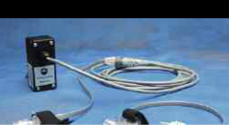

TSD104A SPECIFICATIONS

Operational Pressure: -50 to 300mmHg

Overpressure: -400 to +4000mmHg

Dynamic Response: 100Hz

Transducer Dimensions: 67mm long, 25mm

wide

Weight: 11.5 grams

MRI compatible: Yes (no ferrous parts)

Unbalance: 50mmHg max

Connection Ports: Male Luer (2)

8-hour Drift: 1mmHg after 5 minute

warm-up

Isolation: ≤5µA leakage at 120

VAC/60 Hz

Defibrillation: Withstands 5 dis-

charges of 400 joules

in 5 minutes across a

load

Operating Temperature: +15 to +40 °C

Storage Temperature: -30 to +60 °C

Combined Effects of

Sensitivity, Linearity

& Hysteresis: 1mmHg (nominal)

Output: 5 µV/mmHg (normal-

ized to 1V excitation)

Cable Length: 3-meters

Interface: DA100C—see page 54

Did you know?

AcqKnowledge will provide beat-by-beat on-line analysis of blood pressure signals.

TSD104A & RX104A



Precision Pressure Transducer

The TSD104A measures direct arterial or venous blood pressure in animals or records pressure changes within an in-vitro circuit (e.g. Langendorff heart preparation). The TSD104A connects to tubing via standard Luer Lok fittings. The transducer is small and lightweight and the slotted base, with integral Velcro® strap, permits easy mounting. The TSD104A interfaces with the DA100C general-purpose transducer amplifier. The transducer is supplied non-sterile but can be cold sterilized. Replacement transducers (RX104A) can be purchased without the cable, making the TSD104A a very economical solution for pressure sensing applications.

- TSD104A Transducer and Cable

- RX104A Replacement Element

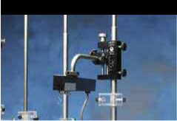

TSD105A with HDW100A

Variable Range Force Transducer

The TSD105A interfaces with the DA100C general-purpose transducer amplifier to measure a wide range of forces (1mg to 1000g) in a variety of applications, including very fine in-vitro tissue bath work as well as larger in-vivo applications. Forces are conveyed to the strain beam via an adjustable pivot, five-position, precision lever arm to insure accurate measurements. The transducer comes with a versatile mounting rod assembly to support multiple orientations. When fine tension and position adjustments are required, the mounting rod can be clamped to an HDW100A.

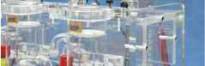

• TSD105A

Force Transducer Tension Adjuster — see HDW100A, page 75

Fixed Range Force Transducer — see TSD125 Series, page 75

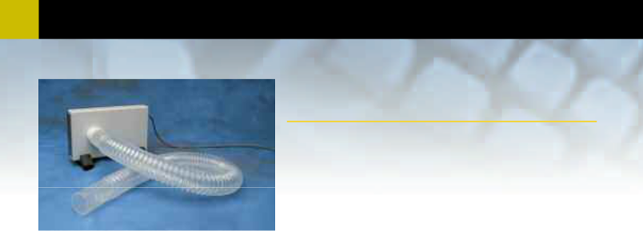
- Transducers

TSD107B | Pneumotach Air Flow Transducer
 | (High Flow)

The TSD107B is a highly linear, wide range, air flow transducer that can be used to perform a variety of high performance tests relating to air flow, lung volume and expired gas analysis. The TSD107B is ideal for applications that have large flow requirements (e.g. exercise physiology). The TSD107B consists of a high performance pneumotach coupled with an internal, precision differential pressure transducer that converts the differential pressure generated across the pneumotach into a proportional voltage signal. The TSD107B interfaces with the DA100C general-purpose transducer amplifier. All connections can be

performed with AFT7 (35mm ID) smooth bore tubing (see page 89) and AFT11 series couplers (see page 90).

  - For air flow and lung volume measurements, use the TSD107B with the AFT21 non-rebreathing T valve and the AFT9 mouthpiece with the AFT4 bacterial filter.
  - For exercise physiology measurements, use the TSD107B with the AFT25 facemask (includes integral non-rebreathing T valve) and the AFT15A or AFT15B mixing chambers.

- TSD107B

For additional air flow transducers, see TSD117 (page 73), TSD127 (page 76), TSD137 (page 77), and for Accessories, see AFT Accessories (pages 89-91).

TSD108 | Use the TSD108 with the
TSD108 | NEW EBI100C Electrical
 | Bioimpedance amplifier for
 | cardiac output measurements
 | — see page 60.
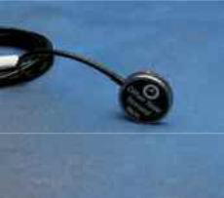

Physiological Sounds Microphone

The TSD108 interfaces with the DA100C general-purpose transducer amplifier to measure a wide array of physiological sounds. Most commonly, the TSD108 is used to measure heart sounds or Korotkoff sounds. When the TSD108 signal is recorded along with the TSD120 blood pressure cuff signal, the Korotkoff sounds vividly mark the systolic and diastolic blood pressure. The TSD108 can also record the sounds associated with rubbing or grinding (e.g., Bruxism). To listen to the physiological sounds with headphones as they are recorded, pipe the TSD108 signal through the STM100C stimulator module. The acoustical transducer element is a piezo-electric ceramic disk, which is bonded to the interior of a metallic circular housing.

TSD107B SPECIFICATIONS

Pneumotach Type: Hans Rudolf® #4813
with integral differential

pressure transducer

Calibrated Flow Range: ±800 Liters/min

Dead Space Volume: 87.8ml

Nominal Output: 45 µV/[liters/sec] (nor-

malized to 1V excitation)

Dimensions: 4cm (deep) x 11cm

(high) x 19cm (wide)

Weight: 690 grams

Connection Ports: 35mm OD

Cable Length: 3-meters

Interface: DA100C—see page 54

TSD108 SPECIFICATIONS

Frequency Response: 35Hz to 3500Hz

Housing: Stainless Steel

MRI Compatible: Yes (no ferrous parts)

Sterilizable: Yes (contact BIOPAC

for details)

Noise: 5µV rms - (500-3500Hz)

Output: 2V (p-p) maximum

Weight: 9 grams

Dimensions: 29mm diameter, 6mm

thick

Cable Length: 3-meters

Interface: DA100C—see page 54
TEL100C Compatibility: SS17—see page 67

• TSD108

tsd109 Series

TSD109 SPECIFICATIONS

Channels: 3 - (X, Y, and Z axes)

Range (Output): TSD109C: ±5G (250

mV/G)

TSD109F: ±50G (38

mV/G)

Noise: TSD109C: 225 µG√Hz

rms

TSD109F: 1.0 mG√Hz

rms

Bandwidth: DC - 500 Hz (-3dB)

Nonlinearity: 0.2% of Full Scale

Transverse Axis

Sensitivity: ±2%

Alignment Error: ±1°

Package: Compliant silicone

housing

Weight: 17 grams

Dimensions: 33mm long, 28mm

wide (at base), 19mm

high

Power: +5V @ 9mA (via

HLT100C)

Sterilizable: Yes (contact BIOPAC

for details)

Cable Length: 3-meters

Interface: HLT100C—see page 53

TEL100C Compatibility: SS26 (5G) and SS27 (50G)—see page 67

TSD111 SPECIFICATIONS

Nominal Output Range: -1 to +1 V

Nominal Contact Force: 200 grams to indicate

heel/toe strike

Attachment: TAPE1, TAPE2, vinyl

electrical or duct tape

FSR Dimensions: 18.3mm (dia) x

0.36mm (thick) and

30cm pigtail lead

FSR Active Area: 12.7mm (dia)

Cable Length: 7.6 meters

Interface: HLT100C—see page 53

TEL100C compatibility: SS28—see page 67
71

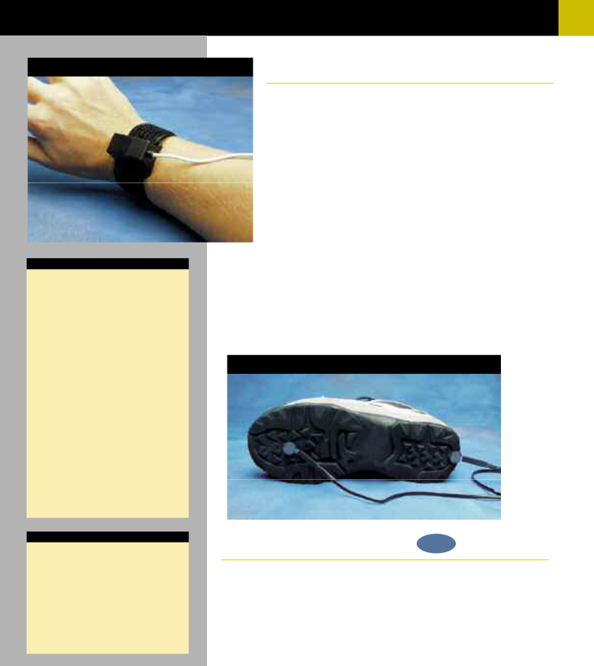

Tri-Axial Accelerometers

The Tri-Axial Accelerometers are high level output transducers that connect directly to the HLT100C High Level Transducer module. The TSD109 series accelerometers provide three outputs, simultaneously measuring acceleration along the X, Y and Z axes. The TSD109C is optimal for measuring accelerations when performing slow movements, such as walking and hand tremor. The TSD109F is more suitable for quick movements, such as swinging a tennis racket. The transducers are the same size and can be used on any part of the body or attached to external equipment. The pliable and unobtrusive design conforms readily to body contours. They come with a Velcro® strap for easy attachment. The accelerometers’ frequency response extends from DC to 500Hz. They are extremely accurate and can easily be checked for calibration by changing their orientation in three-dimensional space, so that gravity (G=1) acts only upon the desired axis.

- TSD109C (±5G Range)

- TSD109F (±50G Range)

TSD111

Heel/Toe Strike Transducer NEW

Each TSD111 heel/toe strike transducer incorporates two force sensitive resistor (FSR) sensors designed for attachment to the sole of a shoe. Typically, one FSR is placed (taped) under the heel and the other is placed under the toe. The FSRs indicate the precise moment of pressure placed on the heel and toe as the subject walks. The heel/toe strike data is encoded onto a single analog channel; the heel strike results in a [-1V] signal and the toe strike results in a [+1V] signal. If heel and toe strike timing is required for both feet, two TSD111 transducers are required. The TSD111 comes equipped with a 7.6-meter cable and is designed for direct connection to the HLT100C module.

• TSD111
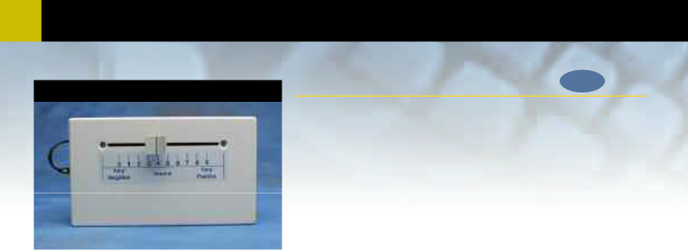
- Transducers

TSD115 | Variable Assessment Transducer NEW

The TSD115 incorporates a slide control with graduated scale that allows users to gauge their subjective response to a variety of stimuli. Multiple TSD115 transducers can be used simultaneously, allowing several people to answer the same question or otherwise respond to stimuli. The transducer is lightweight and fits easily into the subject’s hand or lap. The TSD115 comes equipped with a 7.6-meter cable and is designed for direct connection to the HLT100C module.

• TSD115

Switches and Markers NEW
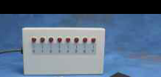
TSD116

TSD116C | The TSD116 series is used for externally triggering data acquisition, remote event
TSD116C | marking, or psychophysiological response tests. The switches connect to the
 | UIM100C digital I/O ports and can be monitored as input channels. The TSD116
 | series incorporate momentary ON operation (switch is ON only when pressed). The
 | TSD116A is a single channel

hand switch, the TSD116B is a single channel foot switch and the new TSD116C is a compact eight channel digital marker box. The TSD116C allows the user to inde-
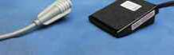
TSD116A _{TSD116B}

pendently mark events, or provide responses, on up to eight channels

simultaneously. Because digital channels can be interleaved with analog channels, when using AcqKnowledge, it’s easy to assign separate digital channels as event markers for individual analog input channels.
• TSD116A | TSD120
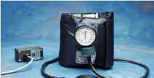
• TSD116B

• TSD116C

Noninvasive Blood Pressure Cuff Transducer


The TSD120 can measure systolic and diastolic blood pressure by

the oscillometric or auscultatory (Korotkoff sounds) technique. The TSD120 includes an adjustable cuff (standard adult cuff: RX120D), pump bulb, pressure gauge and pressure transduc-er. The pressure transducer is attached to the cuff and connects to the DA100C general-purpose transducer amplifier. To visually identify Korotkoff sounds during cuff deflation, use the TSD108 physiological sounds microphone. For indication of relative blood pressure changes without cycling the cuff pressure, inflate the cuff to a pressure between systolic and diastolic.

For absolute and continuous measurement of noninvasive blood pressure, use the NIBP100A; see page 68.

• TSD120

TSD115 SPECIFICATIONS

Scale Output Range: 0-5 V

Scale Resolution: Infinitely adjustable

Slide Control Length: 10 cm

Dimensions: 4cm (high) x 11cm (deep)

x 19cm (wide)

Weight: 230 grams

Cable Length: 7.6 meters

Interface: HLT100C—see page 53

TSD116 SPECIFICATIONS

Switch Type: Pushbutton: (ON) – OFF

Dimensions: TSD116A: 19mm (dia),

63mm (long)

TSD116B: 69mm (wide),

90mm (long), 26mm

(high)

TSD116C: 19cm (wide),

11cm (deep), 4cm (high)

Cable Length: TSD116A and TSD116B:

1.8 meters, TSD116C: 3-

meters

Connector Type: TSD116A and TSD116B:

2mm pin plugs

TSD116C: Stripped and

tinned wires

MRI Compatible: Yes (no ferrous parts) -

TSD116A hand switch

only

Interface: UIM100C—see page 52

TEL100C Compatibility:SS10 (Hand Switch)—see page 67

TSD120 SPECIFICATIONS Cuff Circumference range:25.4cm to 40.6cm

(RX120D cuff)

Cuff Dimensions: 14.5cm (wide) x 54cm

(long)

Pressure Range: 20mmHg to 300mmHg

Manometer Accuracy: ±3mmHg

Output: 5 µV/mmHg (normal-

ized to 1V excitation)

Weight: 350 grams

Cable Length: 3-meters

Interface: DA100C—see page 54

73

TSD117 SPECIFICATIONS

Flow Rate: ±300 Liters/min

Dead Space: 93ml

Nominal Output: 60 µV/[liters/sec]

(norma1ized to 1V

excitation)

Flow Head Dimensions: 82.5mm (dia) x

101.5mm (long)

Flow Head Weight: 80 grams

MRI Compatible: Yes (no ferrous parts)

Handle Dimensions: 127mm (long) x 23mm

(thick) x 35mm (wide)

Handle Weight: 85 grams

Connection Ports: 22mm ID/30mm OD

Cable Length: 3-meters

Interface: DA100C—see page 54

TEL100C Compatibility: SS11A—see page 67

RX120 SPECIFICATIONS

Cuff | Circumference | Width | Length
 | Range (cm) | (cm) | (cm)
RX120A | 9.5-13.5 | 5.2 | 18.5
RX120B | 13.0-19.0 | 7.5 | 26.1
RX120C | 18.4-26.7 | 10.5 | 34.2
RX120D | 25.4-40.6 | 14.5 | 54
RX120E | 34.3-50.8 | 17.6 | 63.3
RX120F | 40.6-66 | 21 | 82.5

Pneumotach Air Flow Transducer
(Medium Flow) | TSD117 & RX117



The TSD117 can be used to perform a variety of tests relating to air flow, lung volume and expired gas analysis. The transducer includes a removable head (RX117) for easy cleaning and sterilization. The TSD117 is intended for human use and is ideal for classroom situations. The TSD117 interfaces with the DA100C


general-purpose transducer amplifier. All connections can be performed with AFT12 (22mm ID) tubing and AFT11 series couplers. See pages 89-91 for the AFT Series.

  - For air flow and lung volume measurements, use the TSD117 with the AFT2 mouthpiece and the AFT1 bacterial filter.
  - For measurements of expired gases, use the TSD117 with the AFT22 non-rebreathing T valve with AFT10 facemask and the AFT15A or AFT15B mixing chambers.

- TSD117

Replacement Head

Use the

AcqKnowledge software to automatically locate markers and measure responses.

The RX117 is a sterilizable air flow head for the TSD117 pneumotach transducer. Multiple RX117 heads help eliminate equipment downtime during cleaning procedures. To reduce the cost of disposable items, use the RX117 with the AFT8 sterilizable mouthpiece. (22mm ID/30mm OD)

• RX117 Replacement Head

Blood Pressure Cuffs for the TSD120 ^{NEW}

The RX120 series are optional blood pressure cuffs, of
The RX120 series are optional blood pressure cuffs, of | RX120 Series
varying sizes, which can be quickly and easily swapped
in and out of the TSD120 noninvasive blood pressure
cuff transducer. Use a single TSD120 and substitute
one cuff for another to accommodate a wide range in
limb circumferences.

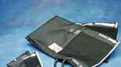

• RX120A • RX120D



• RX120B • RX120E

• RX120C • RX120F

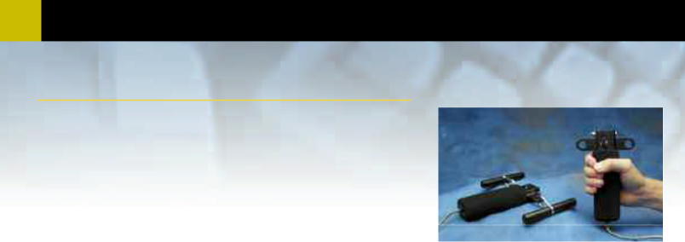
74 Transducers

General-purpose Hand Dynamometer

The TSD121C is an isometric dynamometer that measures a variety of gripping or pulling |  |  | TSD121C
strengths for multiple muscle groups. The isometric design improves experiment
repeatability and accuracy. Hand grip strength is easily recorded in pounds or kilograms
force. Using the Dynagrips option, the pulling strength of single or multiple muscle groups
can be measured. To measure arm, leg, torso or neck strength, mount the TSD121C against
a wall or floor and pull the free end directly (or redirect with a pulley). For in-depth
studies of muscular activity, combine TSD121C force recordings with EMG recordings.
The TSD121C has a 3-meter cable terminated in a connector that interfaces with the
DA100C general-purpose transducer amplifier. The ergonomic soft handle design and
simple calibration procedure make this device very easy to use.
• TSD121C
• Dynagrips
• Dynagrips | TSD122
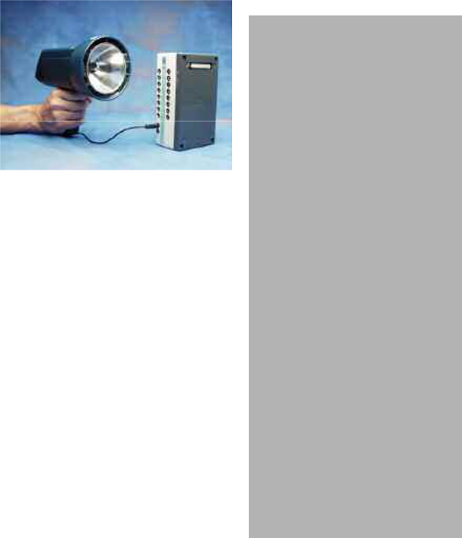

Stroboscope

The TSD122 stroboscope connects directly to the UIM100C or STM100C module for single pass or averaging type visual evoked response applications. The stroboscope can be set up to either generate or respond to a TTL synchronizing signal for

data acquisition. The TSD122 is battery-operated and will operate from zero to 12,000 flashes a minute. Cables are included for interfacing with the MP System.

- TSD122A (120/60Hz)

- TSD122B (240/50Hz)

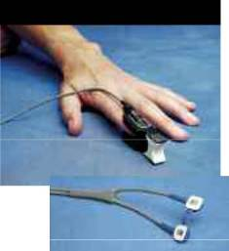

TSD123 SERIES

Oxygen Saturation (SpO2) Transducers

The TSD123 series transducers connect to the OXY100C pulse oximeter module to provide continuous readings for SpO₂, pulse rate and pulse waveform. The TSD123A transducer is a comfortable and easy to use finger clip, ideal for short-term monitoring. The TSD123B transducer attaches to fingers, toes and ears with adhesive patches (included) and is well suited for long-term monitoring.

- TSD123A (Finger Clip)

- TSD123B (Universal Adhesive)

TSD121C SPECIFICATIONS

Isometric Range: 0-100 Kg

Nominal Output: 13.2 µV/kg (normalized to

1V excitation)

Weight: 315 grams

Dimensions: 185mm (long) x 42mm

(wide) x 30mm (thick)

Cable Length: 3-meters

Interface: DA100C—see page 54

TEL100C Compatibility:SS25—see page 67

TSD122 SPECIFICATIONS

Display: Digital LCD

Battery: Built-in, rechargeable

Battery Life: 60 hours at 100

strobes/sec

Flash Duration: 30µsec

Flash Energy: 180mJoule

External TTL: Sync/Trigger

Weight: 1.1 kg

Body Dimensions: 9.3cm (wide) 9 cm (high)

x 23cm (long)

Reflector Housing: 12.2cm (dia)

Handle: 10.8cm (long)

I/O Ports: TTL (Sync input and out-

put) - 3.5mm phone jacks

Cables: CBL102 and CBL106

Interface: UIM100C—see page 52

STM100C—see page 64

TSD123 SERIES

SPECIFICATIONS

Optical Transmission: Red (660nm) and IR

(940nm)

MRI Compatible: Yes (no ferrous parts)

Weight: TSD123A: 23 grams,

TSD123B: 6 grams

Dimensions: TSD123A: 62mm (long) x

23mm (wide) x 26mm

(high)

TSD123B: 12mm (long) x

12mm (wide) x 12mm

(high)

Sterilizable: Yes (contact BIOPAC for

details)

Cable Length: 1 meter

Interface: OXY100C—see page 61

75

TSD125 SPECIFICATIONS

Full Scale Output: | 1mV/V (normalized to 1V
 | excitation)
Range: | TSD125C | 50 gram
 | TSD125D | 100 gram
 | TSD125E | 200 gram
 | TSD125F | 500 gram
Noise (rms): | TSD125C | 1mg
[10 volts Excitation] | TSD125D | 2mg
[1 Hz Bandwidth] | TSD125E | 4mg
 | TSD125F | 10mg
Nonlinearity: | <±0.025% FSR
Hysteresis: | <±0.05% FSR
Nonrepeatability: | <±0.05% FSR
30 Minute Creep: | <±0.05% FSR
Temperature Range: | -10°C to 70°C
Thermal Zero Shift: | <±0.03% FSR/°C
Thermal Range Shift: <0.03% Reading/°C
Maximum Excitation: | 10 VDC
Mounting Rod: | 9.5mm (dia) – variable
 | orientation
Weight: | 250 grams
Dimensions: | 100mm (long) x 19mm
 | (wide) x 25mm (high)
Cable Length: | 3-meters
Interface: | DA100C—see page 54

HDW100A SPECIFICATIONS

Travel Range: 25mm

Resolution: 0.0025mm per degree

rotation

Stand Clamp: 13.25mm ID

Transducer Clamp: 11mm ID

Weight: 140 grams

Dimensions: 93mm (high) x 19mm

(thick) x 74mm (deep)

Precision Fixed Range Force Transducers

The TSD125 |  |  | series | force
 |  |  | series | force | TSD125 Series & HDW100A
transducers interface |  |  |  | with | TSD125 Series & HDW100A
the DA100C general-purpose
transducer |  | amplifier. The
TSD125 series have been
designed for in-vitro tissue
bath studies, in-vivo force
measurements |  |  | and | other
applications |  |  | where | low
noise, | accuracy |  |  | and
repeatability are critical.
The most |  | sensitive |  | units
are ideal for use with small
preparations such as aortic
rings. The |  | TSD125 |  | series
utilizes | a | precision |  | strain

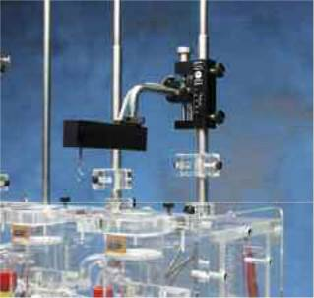

gauge element, which has superb low noise character-

istics and excellent linearity. The transducers come with a versatile mounting rod assembly to support a variety of orientations. When fine tension and position adjustments are required, clamp the mounting rod to an HDW100A (see below).

- TSD125C

- TSD125D

- TSD125E

- TSD125F

Force Transducer Tension Adjuster NEW _{HDW100A}

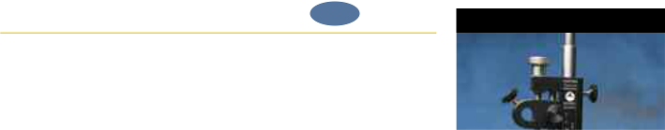

The HDW100A tension adjuster operates with the TSD105A and TSD125 series force transducers. The rugged design and stability of the mounting allow for fine position control. The position adjuster is located on the top for easy access and smooth operation. Vertical scales are provided for both metric and English units. The HDW100A slides directly onto vertical rod laboratory stands and force transducers are clamped into the unit horizontally.



• HDW100A

See the Variable Range TSD105A Force Transducer on page 69.

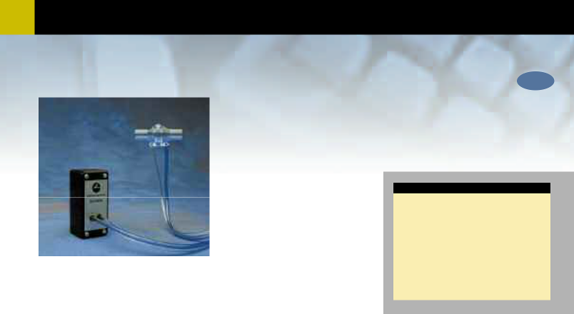
- Transducers

Pneumotach Air Flow Transducer (Low Flow) NEW

TSD127
TSD127 | The TSD127 can perform a variety of pulmonary measurements relating to air flow, lung
 | volume and expired gas analysis. The transducer includes a detachable flow head (RX127) for
 | easy cleaning and sterilization. The TSD127 is intended for animal use and consists of a low
 | flow, pneumotach air flow head (RX127) coupled to a precision, highly sensitive, differential
 | pressure transducer (TSD160A). The TSD127 will connect directly to a breathing circuit or
 | plethysmogram chamber.

• For air flow and lung volume measurements, connect a short air flow cannula to theTSD127.

• For measurements of expired gases, use the TSD127 with the AFT22 non-rebreathingvalve.

All connections can be performed with AFT11 series couplers (see page 90).

• TSD127

TSD127 SPECIFICATIONS

Range: ± 90 Liters/min

Nominal Output: 500 µV/[liters/sec] (nor-

malized to 1V excitation)

Dead Space: 11cc

MRI Compatible: Yes (no metal parts) – air

flow head

Weight: 11 grams – air flow head

Dimensions: 5.7cm (long) – air flow

head

Ports: 15mm OD / 11mm ID

Tubing Length: 1.8 meters (to DA100C)

Interface: DA100C—see page 54

Replacement Air Flow Head for the TSD127 NEW
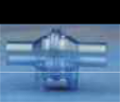
RX127

The RX127 is the replacement low air flow head for the TSD127 pneumotach transducer. Multiple RX127 heads help eliminate equipment downtime during cleaning procedures. (11mm ID/15mm OD)

RX127
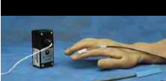

TSD130 Series

Goniometers

The TSD130 series goniometers measure limb angular movement. Goniometers attach to the body using TAPE2 medical adhesive tape. The units have a telescopic endblock that compensates for changes in distance between the two mounting points as the limb moves. The gauge mechanism allows for accurate measurement of polycentric joints. A DA100C is required for each output channel; accordingly, the twin-axis goniometers require two DA100C amplifiers to measure both axes simultaneously.


- The TSD130A and TSD130B are dual output devices used for simultaneous measurements around two orthogonal rotational axes (e.g., wrist flexion/extension and radial/ulnar deviations).

- The TSD130C and TSD130D are single output devices used to measure axial rotation about a single plane (e.g., forearm pronation/supination).

- The TSD130E (single-axis goniometer) is used to measure finger joint movement.

• TSD130A | • TSD130D
• TSD130B | • TSD130E
• TSD130C

TSD130 SPECIFICATIONS

 | Type | Channels | Max Length | Min Length | Range | Weight
TSD130A | Goniometer | 2 | 110mm | 75mm | ± 180° | 17g
TSD130B | Goniometer | 2 | 180mm | 130mm | ± 180° | 19g
TSD130C | Torsiometer | 1 | 110mm | 75mm | ± 90° | 17g
TSD130D | Torsiometer | 1 | 180mm | 130mm | ± 90° | 19g
TSD130E | Goniometer | 1 | 35mm | 30mm | ± 180° | 8g
Nominal Output: 5 µV/degree (normalized to 1V excitation)
Cable Length: | 3-meters
Interface: | DA100C—see page 54
TEL100C
Compatibility: | SS20 thru SS24—see page 67

77

Pneumotach Air Flow Transducers
(Very Low Flow) NEW

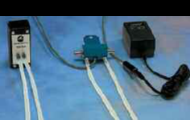
TSD137 Series & AC137A

The TSD137 series pneumotachs can perform a variety of small animal pulmonary measurements relating to air flow, lung volume and expired gas analysis. Each TSD137 transducer type consists of a low flow, pneumotach head coupled to a precision, highly sensitive, differential pressure transducer. The TSD137 series pneumotachs will connect directly to a breathing circuit or plethysmogram chamber. For air flow and lung volume measurements, connect a short air flow cannula to the TSD137 series flow head. For switchable or replacement head options, see the RX137 Series below. All of the TSD137 series pneumotachs come equipped with an internal heating element that can be optionally attached to the AC137A 6-volt power supply (see page 94).

TSD137 SERIES SPECIFICATIONS

Pneumotach | Range | Dead Space | Output | Flow Ports | Animal
 | (ml/sec) | (cc) | (µV/[ml/sec]) | (OD-mm) | (size) | (weight)
TSD137A | ±12 | 0.1 | 25.700 | 7 | Small Mouse | 30.0 grams
TSD137B | ±20 | 0.8 | 15.400 | 7 | Mouse | 50.0 grams
TSD137C | ±60 | 0.9 | 5.780 | 7 | Rat/Guinea Pig | 350.0 grams
TSD137D | ±150 | 2.0 | 2.100 | 10 | Cat/Rabbit | 750.0 grams
TSD137E | ±350 | 4.0 | 0.924 | 11 | Small Dog | 5.5 kg
Nominal Output: Normalized to 1V excitation
Tubing Length: | 1.8 meters (to TSD160A)
Interface: | DA100C—see page 54

RX137 SERIES SPECIFICATIONS

Head | Range | Dead Space | Length | Flow Ports |  | Weight
 | (ml/sec) | (cc) | (mm) | ID | OD (mm) | (grams)
RX137A | ±12 | 0.1 | 75 | 1.35 | 7 | 100
RX137B | ±20 | 0.8 | 75 | 6.00 | 7 | 90
RX137C | ±60 | 0.9 | 75 | 6.00 | 7 | 90
RX137D | ±150 | 2.0 | 75 | 9.00 | 10 | 100
RX137E | ±350 | 4.0 | 60 | 10.00 | 11 | 60

- TSD137A

- TSD137B

- TSD137C

- TSD137D

- TSD137E

Replacement Air Flow Heads for the
TSD137 Series Pneumotachs _{NEW}

 | The RX137 series are low air flow heads for the TSD137 series pneumotach |  |  | RX137 SERIES
 | transducers. The RX137 heads can be mixed and matched with any of the
 | TSD137 series pneumotachs. A wide range in flows can be accommodated by
 | switching one head for another when using a single TSD137 pneumotach.
 | RX137 heads connect to the TSD160A differential pressure transducer via
 | standard 4mm ID tubing. Multiple RX137 heads help eliminate equipment
 | downtime during cleaning procedures.
 | • RX137A | • RX137D
 | • RX137B | • RX137E
 | • RX137C

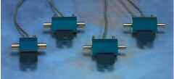

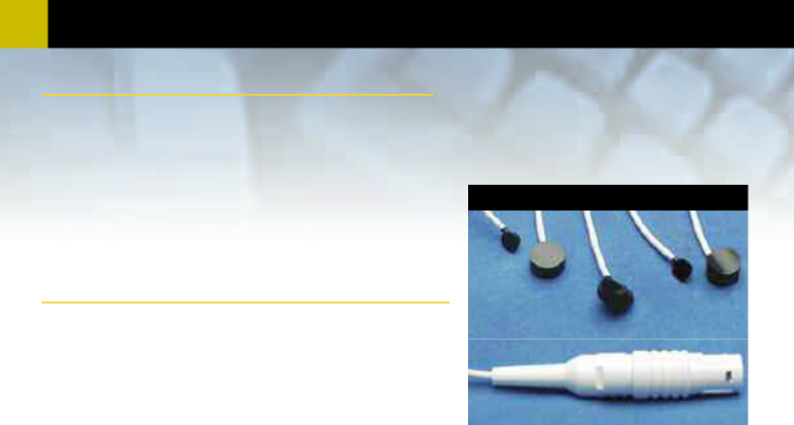
- Transducers

Laser Doppler Flow Probes

The following probes interface to the LDF100C laser Doppler flow module.

Interface: LDF100C—see page 60

Surface Probes

The TSD140 series surface probes are designed for skin and exposed tissue blood flow monitoring. All surface probes are made from black Delrin®. The signal delivery fiber intersects the probe body at a right angle, making the probes easy to secure to the skin or tissue surface. Surface probes are non-suturable, unless otherwise indicated. All surface probes are MRI compatible (no metal parts) and come with a 2-meter cable for connection to the LDF100C module.

TSD140-This robust and easy to handle probe is ideal for taking measurements of cutaneous blood flow anywhere on the skin surface. Probe Body Dimensions: 8mm (high), 17mm (dia)

TSD140 Series

TSD146 _{TSD143}

TSD140
TSD142

TSD141

TSD141-This thin and lightweight surface probe applies negligible pressure to the underlying tissue. The probe’s low profile geometry has particular applications in chronic wound healing studies where it can be applied under compression bandages.

Probe Body Dimensions: 6mm (high), 17mm (dia)

TSD143-This suturable probe is particularly suitable for small animal work including various post-operative monitoring applications such as reconstructive surgery. A non-suturable version, TSD146, is also available.

TSD142-This probe was specially developed for measuring micro-vascular skin blood flow in the digits; the curved geometry of these probes makes them ideal for studying conditions such as Raynaud’s disease.

Probe Body Dimensions: 10mm (high), 17mm (dia)

Probe Body Dimensions: 5mm (high), 10mm (dia)

TSD146-This miniature, lightweight surface probe is particularly useful for small animal work and general tissue surface monitoring. Probe Body Dimensions: 5mm (high), 5mm (dia)

Needle Probes

The TSD140 series needle probes are designed for invasive and endoscopic blood flow monitoring of tissue. The signal delivery fiber terminates straight into the top of the needle, making the probes easy to insert into tissue. All needle probes are MRI compatible (made from medical grade stainless steel – no ferrous parts) and come with a 2-meter cable for connection to the LDF100C module.

TSD144 & TSD145
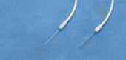

TSD144

TSD144-This needle probe is used when making microvascular blood flow measurements in relatively inaccessible areas with limited clearance. Typically, they are positioned using a micromanipulator clamp over soft tissues such as brain and muscle. Needle Probe Dimensions: 25mm (long), 1mm (dia)

TSD145

TSD145-This micro-needle probe has been developed for direct insertion and is frequently used for measuring either micro-vessel or micro-vascular blood flow within skin, muscle, tumor and organ tissues. The fine diameters of these probes facilitate blood flow measurements from only a small number of capillaries. Needle Probe Dimensions: 25mm (long), 480 µm (dia)

79

Disposable Fiber Probes ^{NEW}
The TSD140 series disposable single fiber probes are designed for safe, continuous, invasive microvascular blood flow monitoring. The probes are thin flexible plastic fibers composed of a polymethyl methacrylate core and a tough fluorinated polymer cladding. All disposable probes are MRI compatible (no metal parts) and incorporate a coupling bead to interface with the TSD148 single fiber driver for connection to the LDF100C module.

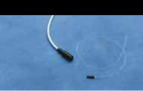

TSD147A- Insertable Single Fiber Probe- This 0.5mm diameter disposable, insertable, single fiber probe comes in two standard lengths (TSD147A - 30cm, TSD147AL - 100cm) and is supplied in a pack of two. (TSD147A is pre-sterilized.) Particularly useful for making blood flow measurements under the skin, this single fiber probe can be directly inserted into tissue using a standard 22G ID cannula.

Longer probe lengths are available upon request. Shorter lengths are possible by cutting the fiber with a sharp blade at a right angle to the fiber length.

TSD147A Dimensions: 30cm (long), 0.5mm (dia)

TSD147AL Dimensions: 100cm (long), 0.5mm (dia)

Tissue Mounting: Inserted via 22G ID cannula

- TSD147A (2 per pack)

- TSD147AL (2 per pack)

Requires the TSD148 Single Fiber Driver for operation with the LDF100C.

TSD147A & TSD148

TSD148

TSD147A



TSD147B- Surface Single Fiber Probe- This 0.5mm diameter disposable, surface mounted, single fiber probe has a standard length of 33cm and is supplied ready-to-use in a pre-sterilized pack. The TSD147B was primarily developed for making measurements of cortical blood flow on the surface of the brain during surgery. The probe consists of a single fiber bonded for right-angle delivery through a flexible PharmElast™ strip.
Single Fiber Dimensions: 33cm (long), 0.5mm (dia)

Skin and Tissue Mounting: Yes (attach via PharmElast™ strip)

• TSD147B (1 per pack)

Requires the TSD148 Single Fiber Driver for operation with the LDF100C.

TSD148- Single Fiber Driver- The TSD148 is a precision-machined coupling system for interfacing the TSD147 series single fiber probes to the LDF100C. The TSD148 consists of a compact laser driver housed in a non-metallic Delrin® housing (MRI compatible), terminated with a 2-meter cable for connection to the LDF100C module.

Driver Body Dimensions: 28mm (long), 8mm (dia)

Connection Type: In-line single fiber connector

Cable Length: 2 meters

• TSD148

PROBE CALIBRATION

If probes are shipped with the LDF100C, they are factory-calibrated to the module (except Disposable probes). Otherwise, probes are shipped uncalibrated and must be calibrated with an LDF100C module using the LDFCAL motility standard (see page 88).

Use single-fiber probes for long-term chronic studies.

See the Laser Doppler Flow Application on page 34.

- Transducers
Operational Pressure:
Overpressure (max): Voltage Output (normalized to 1 volt excitation): Warm-up Drift:
Stability: Combined Linearity and Hysteresis Error: Dynamic Response: Connection Ports: Dimensions: Weight:
Operating Temperature:
Storage Temperature: Interface:
TSD160 SERIES SPECIFICATIONS
NEW
TSD150 Series

Active Electrodes

The TSD150 series active electrodes are designed for multiple-channel surface EMG measurements. The units incorporate a built-in high-gain amplifier with an integral 500 Hz lowpass filter. The unique design allows you to easily convert the surface contact electrodes to wire needle electrodes for intricate sub-dermal procedures. The TSD150 series active electrodes connect directly to the MP System via the HLT100C

high-level transducer module. The TSD150 series are very easy to use—locate the position and hold in place with TAPE1 surgical tape. A single ground lead (CBL201 and LEAD110A with EL503 electrode) to the UIM100C is required when using one or more TSD150 series active electrodes.
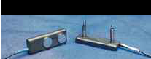

- TSD150A - Wide electrode placement (35mm apart)

- TSD150B - Narrow electrode placement (20mm apart)
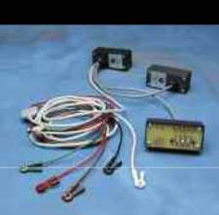

TSD155C Multi-lead ECG Cable

The TSD155C multi-lead ECG cable is used for performing a standard 12-lead ECG recording using only 3 ECG100C amplifiers. The TSD155C permits simultaneous recording of Leads I, II, III, aVR, aVL, aVF and one (movable) precordial lead [V1, V2, V3, V4, V5 or V6]. The TSD155C is 3-meters long and incorporates a built-in Wilson Terminal. For full simultaneous 12-lead ECG, see the WT100C Wilson Terminal on page 87.

Interface: ECG100C—see page 56

TEL100C compatibility: SS29—see page 67

• TSD155C

New software features make it even easier to provide a complete ECG analysis.

See the Cardiology section on page 24 for a detailed explanation.

High Sensitivity Differential
Pressure Transducers NEW

The TSD160 series differential pressure transducers are ^{TSD160 Series} designed for low range pressure monitoring. The transducers
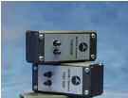
plug directly into the DA100C general-purpose differential amplifier. The differential pressure ports are located on the front of the transducers and are easily connected to breathing circuits, pneumotachs or plethysmograph boxes. These transducers are very useful for interfacing a variety of small animal

pneumotachs or plethys-mographs to the MP System. The transducers are extremely sensitive and come in three ranges to suit a number of different
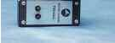
applications. RX137 flow heads (page 77) connect to the TSD160A differential pressure transducer via standard 4mm ID tubing.

• TSD160A (±2.5cm H₂O)

• TSD160B (±12.5cm H₂O)

• TSD160C (±25cm H₂O)

TSD150 SPECIFICATIONS

Gain: 350 (nominal)

Fine Wire Attachments: Screw Springs

Input Impedance: 100MΩ

CMRR: 95dB (nominal)

Bandwidth: 12Hz – 500Hz

Electrode Diameter: 11.4mm

Weight: 9.5 grams

Dimensions: 17.4mm (wide) x

51mm (long) x 6.4mm

(high)

Cable Length: 3-meters

Interface: HLT100C—see page 53

TSD160A | TSD160B | TSD160C
±2.5cm H₂O | ±12.5cm H₂O | ±25cm H₂O
±250cm H₂O | ±375cm H₂O | ±375cm H₂O
330 µV/cm H₂O | 130 µV/cm H₂O | 65 µV/cm H₂O
±50µV
±100µV

±0.05%

100Hz

Accepts 3mm to 4.5mm ID tubing

8.3cm (high) x 3.8cm (wide) x 3.2cm (deep)

76 grams

0 to +50 °C (compensated) -40 to +125 °C DA100C—see page 54

81

TSD200 SPECIFICATIONS

Emitter/Detector

Wavelength: 860nm± 60nm

Optical Lowpass Filter: 800nm

Weight: 4.5 grams

Dimensions: 16mm (long) x 17mm

(wide) x 8mm (high)
Attachment: Velcro® strap
MRI Compatible: Yes (no ferrous parts)

Sterilizable: Yes (see BIOPAC for

details)

Nominal Output: 20mV (p-p)

Power: 6VDC Excitation @ 5mA

Cable Length: 3-meters (shielded)

Interface: PPG100C—see page 58

TEL100C compatibility:SS4—see page 67

TSD201 SPECIFICATIONS

True DC Response: | Yes
Circumference Range: 15cm x 150cm (increased
 | with a longer strap)
Sensor Dimensions: | 66mm (long), 40mm
 | (wide), 15mm (thick)
Sensor Weight: | 18 grams
Attachment: | Velcro® strap (adjustable
 | length)
MRI compatible: | Yes (no ferrous parts)
Sterilizable: | Yes (contact BIOPAC for
 | details)
Variable Resistance | 5-125 KΩ
Output: | 5-125 KΩ
Cable Length: | 3-meters (shielded)
Interface: | RSP100C—see page 59

TEL100C compatibility:SS5B—see page 67

Photo-Electric Pulse Plethysmogram Transducer

This transducer operates with the PPG100C _{TSD200} amplifier to record the pulse pressure waveform.


The TSD200 consists of a matched infrared emitter and photo diode, which transmits changes in infrared reflectance resulting from varying blood flow. The ergonomic housing design improves contact with the subject and helps reduce motion artifact. The TSD200 is primarily designed for finger attachment, but can be taped to other body locations. The TSD200 comes with a shielded 3-meter cable.



• TSD200

Use BIOPAC transducers with other recording systems. Call for the appropriate wiring instructions to interface with existing amplifiers.

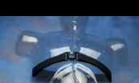

TSD201

Respiratory Effort Transducer

The TSD201 connects to the RSP100C Respiration Amplifier to record respiratory effort. The transducer measures the changes in thoracic or abdominal circumference that occur as the subject breathes. The design presents minimal resistance to movement and is extremely unobtrusive. Due to its novel construction, the TSD201 can measure arbitrarily slow to very fast respiration patterns with no loss in signal amplitude, while maintaining excellent linearity and minimal hysteresis. The transducer comes with a shielded 3-meter cable and an adjustable Velcro® strap to fit a wide range of subjects.



• TSD201

Are you being asked to include full pulmonary mechanics studies in your protocol? If so, BIOPAC has the complete solution, from mice to men. See the Pulmonary Function Application on page 38 and discover the new range of Differential Pressure Transducers and Air Flow & Gas Analysis products.

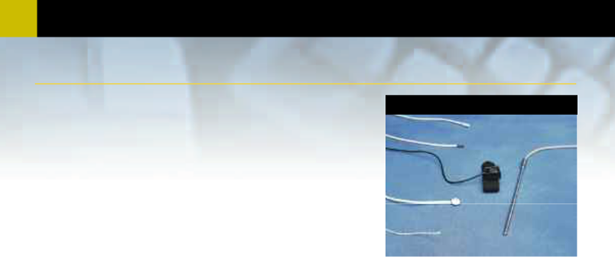
- Transducers

Temperature Transducers

Fast Response Probe- The TSD202A is a very small, fast response temperature probe appropriate for use in locations where temperature changes rapidly, as with the temperature changes of inspired/expired breath. TAPE1 is recommended to secure the TSD202A in place. • Response time: 0.6 sec

• Dimensions: 1.7mm (dia) x 5mm (long)

Surface Banjo Probe- The TSD202B is used to record skin temperature on a variety of body locations. The stainless steel banjo design insures rapid and uniform recording of skin surface temperatures. Use TAPE1 to secure the transducer to the skin surface. • Response time: 1.1 sec

• Dimensions: 9.8mm (dia) x 3.3mm (high)

Liquid Immersion Probe- The TSD202C is a stainless steel, extremely durable, tubular probe designed for dry or wet bath temperature measurements. • Response time: 3.6 sec

• Dimensions: 4mm (dia) x 115mm (long)

TSD202 Series

TSD202F

TSD202E

TSD202D

TSD202C

TSD202B

TSD202A

Digit Surface Probe- The TSD202D records skin temperature of the fingers or toes. The probe contains a surface temperature sensing element encased in a polyurethane housing that conforms to curved skin surfaces and includes a stretchy Velcro® strap for easy attachment.
• Response time: |  | 1.1 sec
• Dimensions: |  | 16mm (long) x 8mm (high) x 17mm (wide)
NEW | General-purpose Probe- The TSD202E is a small, general-purpose probe, encased in a mylar sheath for ruggedness and durability
without sacrificing response time.
• Response time: |  | 0.9 sec
• Dimensions: |  | 9.8mm (long) x 3.3mm (dia)
NEW | Waterproof Vinyl Probe- The TSD202F is a small, waterproof, vinyl encased probe for core (oral, rectal) temperature recording.
• Response time: |  | 1.1 sec
• Dimensions: |  | 9.8mm (long) x 3.3mm (dia)
 |  | TSD202 SPECIFICATIONS

• TSD202A • TSD202D

• TSD202B • TSD202E

• TSD202C • TSD202F
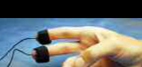

TSD203


Nominal Resistance: 2252 Ω @ 25°C

Maximum Operating

Temperature: 60°C (when used with

STK100C)

Accuracy and

Interchangeability: ±0.2°C

MRI Compatible: Yes (no ferrous parts)

Cable Length: 3-meters
Transducer Compatibility: YSI® 400 series tem-
perature probes

Sterilizable: YES (contact BIOPAC

for details)

Interface: SKT100C—see page 59

TEL100C Compatibility: SS6 (Fast Response)

and SS7 (Banjo)—see

page 67

Electrodermal Response Transducer

The TSD203 connects to the GSR100C amplifier for the purpose of skin conductance recording. Two Ag-AgCl, unpolarizable electrodes are mounted in individual, ergonomically-designed, polyurethane housings for improved contact. The electrodes are attached to the fingers by Velcro® straps. The electrodes have a 6mm (dia) contact area with a 1.6mm cavity to accommodate electrode gel (GEL101). The TSD203 comes with a shielded 3-meter cable to minimize noise interference and improve recordings.

TSD203 SPECIFICATIONS

Electrode Type: Ag-AgCl (unpolarizable)

Contact Area: 6mm (dia)

Dimensions: 16mm (long) x 17mm

(wide) x 8mm (high)

(each electrode)

Weight: 4.5 grams (each elec-

trode)
Attachment: Integral Velcro® straps
MRI Compatible: Yes (no ferrous parts)

Sterilizable: Yes (contact BIOPAC for

details)

Cable Length: 3-meters (shielded)

Interface: GSR100C—see page 58
TEL100C Compatibility:SS3A—see page 67

• TSD203

Disposable Electrodes 83

LEAD110 Series Electrode Leads

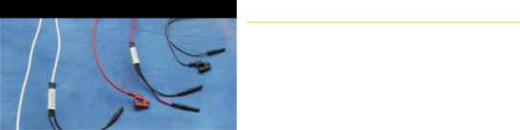

These electrode leads are used with the EL500 series disposable snap electrodes. The LEAD110 series electrode leads have no ferrous parts. The leads include a pinch connector for easy application and terminate in standard Touchproof connectors for interfacing to 100C-series Biopotential amplifiers or Module Extension Cables (see page 87).

Use shielded leads with recording electrodes for minimal noise interference.

The unshielded leads work best with ground or reference electrodes.

Generally, for each Biopotential amplifier module, one each of LEAD110S-

W, LEAD110S-R and LEAD110 are required.



- LEAD110 (unshielded 1-meter lead – black)

- LEAD110A (unshielded 3-meter lead – black)

- LEAD110S-W (shielded 1-meter lead – white)

- LEAD110S-R (shielded 1-meter lead – red)

Disposable Ag-AgCl Snap Electrodes

EL500 Series

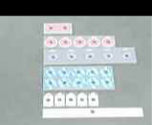

EL500

EL501

EL502

EL503

EL507

EL506

Disposable Ag-AgCl electrodes provide added convenience and hygiene, with the same signal transmission as reusable elec-trodes. Each peel-and-stick electrode is pre-gelled, has a snap fastener, and is designed for one use only.

Use disposable snap electrodes with LEAD110 series electrode leads (shown above). For best performance, use LEAD110S shielded leads with recording elec-

Long-term Electrodes - EL502 Moisture-resistant backing; solid gel adheres well to skin. 41 mmdiameter tape, 10 mm contact area.

• EL502 (50/pack) • EL502-10 (500/pack)

Cloth Base Electrodes - EL504 Use these compliant, trimmable, and flexible electrodes in difficult locations, such as the face for EMG or fingers for nerve conduction.
2.5 cm squares.

• EL504 (30/pack) • EL504-10 (300/pack)

Bioimpedance Strip Electrodes - EL506 Replace band electrodes! 25 cm (trimmable), Ag-AgCl. Use for bioimpedance and cardiac

trodes and LEAD110 unshielded leads for ground or reference electrodes.

General-purpose Electrodes - EL503 These unique electrodes provide excellent signals and are suitable for all biopotential and nerve conduction recordings. 35 mm diameter vinyl tape, 10 mm contact area.

• EL503 (100/pack) • EL503-10 (1,000/pack)

Paired (Dual) Electrodes - EL500 Use for general-purpose EMG measurements, nerve conduction measurements, and cardiac output. Spacing (center to center): 41 mm x 82 mm x 1.5 mm foam; 25 pairs/pack.

• EL500 (25 pairs/pack)

output studies.

• EL506 (8/pack) • EL506-10 (80/pack)

EDA (GSR) Electrodes - EL507 Use for skin conductance and resistance setups. Electrodes have an increased contact area and isotonic wet gel.

• EL507 (100/pack) • EL507-10 (100/pack)

Radiotranslucent Electrodes - EL508 These disposable, radio-translucent electrodes are MRI-compatible and pre-gelled. Use with LEAD108.

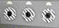

• EL508 (100/pack)

Stress Test Electrodes - EL501 Use for short-term recordings where the subject may be in motion or when electrodes should be closely placed, such as multi-channel ECG, EGG, EMG or EOG recordings. 38 mm diameter, mounted on 1.5 mm thick foam with strong adhesive; 50/pack.

For the complete range of BIOPAC electrodes and leads, including radiotranslucent MRI-compatible options, visit www.biopac.com

• EL501 (50/pack)

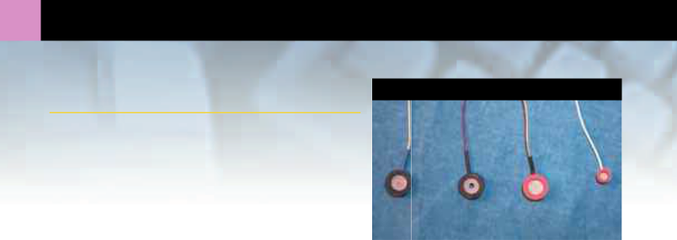
- Reusable Electrodes

Reusable Ag-AgCl Electrodes

EL250 Series

Silver-silver chloride (Ag-AgCl) electrodes provide accurate and clear transmission of surface biopotentials. Reusable electrodes are permanently connected to robust and pliable lead wires (1mm OD). The lead wires terminate in standard Touchproof connectors for interfacing to 100C-series Biopotential modules or Module Extension Cables. Unshielded electrodes terminate in a single Touchproof connector. Shielded electrodes terminate in two Touchproof connectors, one connects to the Ag-AgCl disk and the other connects to the lead wire shield.

For best signal performance use shielded electrodes (EL254S or EL258S) as

recording electrodes and unshielded electrodes (EL254 or EL258) as ground or reference electrodes. For ease of gel injection, use the EL258H for both recording and reference electrodes (useful for EEG monitoring). When recording from subjects in MRI or X-ray based environments use the EL254RT or EL258RT for the recording and reference electrodes. These electrodes are non-ferrous and employ carbon fiber lead wire for superior radio-translucent performance.

All reusable electrodes require ADD200 series adhesive collars and recording gel (see page 86). Generally, for each Biopotential amplifier module, two EL254S or EL258S and one EL254 or EL258 are required. For radio-translucent requirements, use three of the EL254RT or EL258RT with each Biopotential module.

Small Reusable Ag-AgCl Electrodes

Use these lead electrodes when closely spaced biopotentials are required. The EL254 is unshielded and the EL254S is shielded. The EL254RT is a radio-translucent version of the EL254. Fill the electrode cavity with GEL100 and use ADD204 adhesive collars to secure these electrodes to the skin surface.

Dimensions: 7.2mm outer diameter, 4mm recording diameter, 6mm high

Lead length: EL254 and EL254S – 1 meter; EL254RT – 1.5 meter

- EL254

- EL254S

- EL254RTNEW


General-purpose Reusable Ag-AgCl Electrodes

These lead electrodes are suitable for most applications (ECG, EEG, EGG, EMG, EOG and ERS recordings). The EL258 is unshielded and the EL258S is shielded. The EL258H is a low-profile version of the EL258 and includes a 2mm center hole for injecting gel after the electrode is attached to the subject. The EL258RT is a radio-translucent version of the EL258. Fill the electrode cavity with GEL100 and use ADD208 adhesive collars to secure these electrodes to the skin surface.

Dimensions: 12.5mm outer diameter, 8mm recording diameter, 6mm high [EL258H—4mm high]

Lead length: EL258, EL258S and EL258H – 1 meter, EL258RT – 1.5 meter


• EL258 | • EL258H | NEW
• EL258S | • EL258RT | NEW

Extend your electrode leads by 3-meters with the MEC100 Series, page 87.

Use RT (radio-translucent) electrodes for MRI applications.

Use H (hole) electrodes to syringe elctrode gel into the electrode cavity after placement.

3
EL350 Series
85

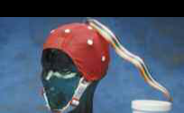

EEG Electrode Cap CAP100C

For reduced set up time and increased subject comfort, use the CAP100C when recording multiple EEG channels. The Lycra® stretch cap holds nineteen imbedded tin electrodes closely to the subject’s head. Electrodes are pre-positioned in the international 10/20 montage, so even novice EEG researchers can minimize electrode placement errors. A ribbon cable (100 cm) fans out in the cap to connect to each electrode. The other end of the ribbon cable has a connector that plugs into a mating cable (25 cm) which terminates in 19 Touchproof sockets. The connector arrangement permits the electrode cap to be easily disconnected from the recording amplifiers, allowing the cap to be fitted in one location and used in another. When the electrode cap is in place, EEG recording gel is injected into each electrode (via a central gel access hole) with a blunt-tipped syringe.


When using the CAP100C, up to 16 channels of EEG data can be acquired by the MP System, when outfitted with 16 EEG100C amplifiers. Various configurations of unipolar and bipolar setups can be achieved by using JUMP100C jumper connectors with the EEG100C amplifiers.
The CAP100C includes a medium cap, two earclip reference electrodes, mating ribbon cable with Touchproof connectors, blunt-tipped syringe,

EEG recording gel, chest harness (to hold cap in place), and liquid soap (to wash cap after use).
Additional Electrode Caps are available in four sizes:
INFANT | 45-50cm | MEDIUM | 54-58cm (general size, fits most people from age 5 to adult)
SMALL | 50-54cm | LARGE | 58-62cm
• CAP100C |  | (Kit includes MEDIUM cap)
• CAP-SIZE |  | (Cap only, specify SIZE— e.g. CAP-INFANT)

Bar Electrodes

All bar electrodes are non-ferrous and consist of two tin electrodes placed 30mm apart in a watertight acrylic bar. The bar configuration permits easy

electrode placement without disturbing electrode to electrode spacing. Bar electrodes are recommended for use when applying a stimulus, or recording a signal, during nerve conduction, somatosensory or muscle twitch recordings. When using bar electrodes for signal recording, a single ground lead (LEAD110 with EL503) is required. The leads (61cm long) terminate in standard Touchproof connectors, which connect to any 100C-series Biopotential amplifier or stimulus isolation adapter (STMISOC/D/E).

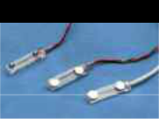

 |  | 1) | EL350: Bar lead electrode (concave), use for stimulating or recording
1 |  | 2) | EL350S: Shielded bar lead electrode (concave), use for recording
1 | 2 | 3) | EL351: Bar lead electrode (convex), use for stimulating

Needle Electrodes

Use needle electrodes for stimulation or recording in animal subjects and tissue preparations. These non-ferrous, 28-gauge stainless steel, needle electrodes are equipped with a flexible lead terminating in standard Touchproof connectors. Use one EL451 electrode, plus one EL452 ground electrode, when recording from a single site (e.g. studies of individual muscle fibers). Use a pair of EL450 or EL452 electrodes, plus one EL452 ground electrode, for general-purpose recording (e.g. ECG). For stimulation, use a pair of EL450 or EL452 electrodes. Teflon® coated needle electrodes are fully insulated, with a clear Teflon® overcoat, except for the conductive needle tip. Needle electrodes are shipped non-sterile, so pre-sterilization is required.

EL450 Series

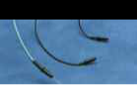

EL452

EL451 EL450

Part | Electrode Type | Dimensions
EL450 | Unipolar Needle | 300µm (dia), 2.5cm (long), Teflon® coated, 61cm lead
EL451 | Concentric Bipolar Needle | 460µm (dia), 3.7cm (long), Teflon® coated, 61cm lead
EL452 | Unipolar Needle | 300µm (dia), 1.5cm (long), uncoated, 61cm lead

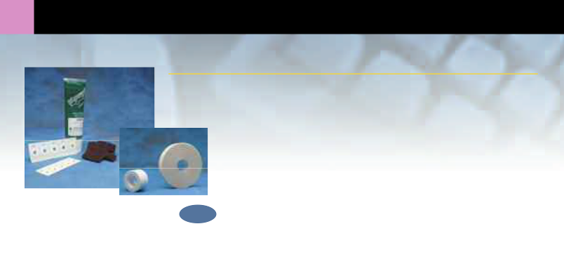
- Cables & Accessories

Disks, Gel, Pads

Electrode Accessories

Electrode Site Preparation Pad

To remove non-conductive skin cells and sensitize skin for optimal contact during recording, this 2.5cm x 5cm abrasive pad can be rubbed lightly across the skin before applying an electrode. Each ELPAD package contains
10 abrasive pads.
Tape Series • ELPAD (Pkg. 10)

Electrode Gel
GEL100 non-irritating gel is used as a conductant with the EL250 series reusable electrodes.

Each tube contains 8 ounces of gel.

• GEL100

NEW GEL101 non-irritating, isotonic, gel is primarily used as a conductant for the TSD203 electrodermal response transducers (page 82).

• GEL101 (4 oz.)

Adhesive Collars
These double-sided adhesive collars are used to hold the EL250 series reusable electrodes firmly on the skin surface. Use the ADD204 (19mm OD, 4mm ID) with the EL254, EL254S and EL254RT electrodes; use the ADD208 (22mm OD, 8mm ID) with the EL258, EL258S, EL258H and EL258RT electrodes.

• ADD204 (Pkg. 100) • ADD208 (Pkg. 100)

Tape Series
Adhesive tape for attaching transducers or electrodes to the skin surface. Use TAPE1 (single sided tape) for securing Active Electrodes or other devices and use TAPE2 (double-sided tape) for attaching Goniometers to the skin surface.

• TAPE1 (single-sided) • TAPE2 (double-sided)

Lead Connector Conversion Cables

Conversion Cables
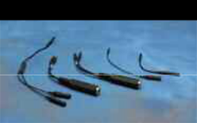

CBL204 CBL203

CBL200

CBL201
CBL202

CBL200
This extension (10cm) is required when converting an old-style 2mm pin electrode or transducer lead to a Touchproof socket (1.5mm ID) for connection to any of the 100C-series Biopotential or

CBL202
This is a multi-purpose adapter to connect a phone cable to the digital I/O lines on the UIM100C or to the input of the DA100C. Also connects the STM100C to nerve conduction chambers (CBL105 required). The CBL202 is 10cm long and consists of a 6.3mm (1/4") phone socket leading to a pair of 2mm plugs.

• CBL202

CBL203
The CBL203 is primarily designed to connect YSI® 400 series biomedical temperature probes to the SKT100C temperature amplifier, but it can also be used to connect certain 6.3mm (1/4") mono phone plug

Transducer amplifier modules. Use one CBL200 per Touchproof socket. To connect a Touchproof electrode or transducer to an older 100B-series module with 2mm input sockets, use the CBL201.

• CBL200

CBL201
Required when converting a Touchproof (1.5mm ID) socket electrode or transducer lead to an old-style 2mm pin, for connection to any of the 100B-series Biopotential or Transducer amplifier modules. Also used to connect a ground electrode lead (e.g. LEAD110A) to the UIM100C module (required when using the TSD150 active electrodes). One CBL201 (10cm long) is required for each Touchproof socket.

• CBL201

terminated cables or transducers to the 100C-series Transducer or Biopotential amplifiers. The CBL203 is 10cm long and consists of a 6.3mm (1/4") phone socket leading to a pair of Touchproof sockets.

• CBL203

CBL204
This Touchproof “Y” electrode lead adapter (25cm long) is required when multiple electrode sites are to be connected to a single amplifier input or stimulator output. The CBL204 plugs into any 100C-series Biopotential amplifier input or STMISO series output and provides two plugs to connect to electrode leads terminating in Touchproof sockets. Multiple CBL204s can be plugged together to reference 3 or more electrode leads to the same input or output.

• CBL204

87

Module Extension Cables

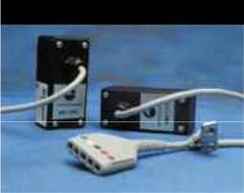
MEC Series

These module extension cables are used to increase the distance between subject and recording system, allowing increased subject movement and comfort. Each extension cable attaches to one amplifier; electrodes and transducers plug into the extension cable’s molded plastic input plug. The 3-meter long extension includes a clip for attaching to a subject’s belt loop or clothing. The MEC series extension cables contain no ferrous parts (less the removable clothing clip). The MEC100C is designed for Transducer amplifiers. The MEC110C and MEC111C are designed for Biopotential amplifiers. Use the MEC100C or MEC110C when you simply need to increase the lead length to the amplifier. The MEC111C is required for the protection of your MP System and Biopotential amplifiers when electrocautery or defibrillation equipment is used while recording data.

100C-SERIES EXTENSIONS

- MEC100C: 100C-series Transducer amplifiers to Touchproof inputs

- MEC110C: 100C-series Biopotential amplifiers to Touchproof inputs

- MEC111C: 100C-series Biopotential amplifiers to Touchproof inputs— Protected

OTHER EXTENSIONS

- MEC100: DA100C or 100B-series Biopotential or Transducer amplifiers to 2mm socket inputs

- MEC110: 100B-series Biopotential or Transducer amplifiers to Touchproof inputs

- MEC111: 100B-series Biopotential amplifiers to Touchproof inputs—Protected

Wilson Terminal NEW |  | WT100C

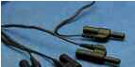

The WT100C is used to create a virtual reference electrode when measuring the transverse plane (i.e. precordial) ECG components [V1, V2, V3, V4, V5, and V6]. The virtual reference is created by the summation of the Right Arm (RA), Left Arm (LA) and Left Leg (LL) electrode leads. To measure all six transverse plane components, six ECG100C amplifiers are required. Use five of the JUMP100C jumper connectors to tie together the reference (Vin-) inputs of these amplifiers. This common reference connects to the virtual reference created by the WT100C.


For full, simultaneous, 12-lead ECG recording, a total of 8 ECG100C amplifiers are required. Two of the ECG100C are used to generate Leads I, II, III, aVR, aVL and aVF, while the remaining six ECG100C are used to generate the six precordial leads.

For an economical alternative, use the TSD155C moveable chest lead (page 80). The TSD155C requires three ECG100C amplifiers and incorporates a built-in Wilson Terminal.

• WT100C

Jumper Connectors ^{Jump100 & Jump100C}

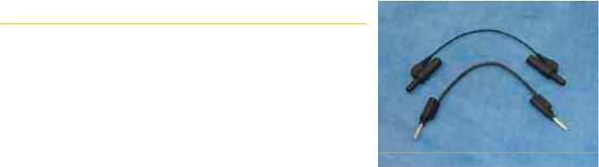

These jumper connectors (10 cm long) are used to create a common reference between Biopotential amplifier modules. Link one reference electrode to multiple amplifier inputs using one jumper connector per amplifier. Jumper connectors are required when connecting the same reference electrode lead to two or more amplifiers, as in multi-lead ECG or unipolar EEG measurements.

- JUMP100 (for all connections between 100B-series Biopotential amplifiers)

- JUMP100C (for all connections between 100C-series Biopotential amplifiers)

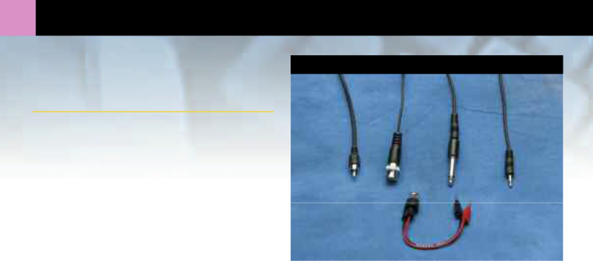
- Cables & Accessories

Analog Connection Cables

These cables connect stand-alone laboratory equipment to an MP System. Analog outputs from chart recorders, preamplifiers, oscilloscopes, force plates, chromatographs, etc. can be connected to the UIM100C module. It’s also possible to use these cables to connect amplifier outputs or D/A outputs to external equipment inputs. When signal isolation is required, use the INISO or OUTISO adapter with the cable. The other end of the isolation adapter connects to the appropriate MP System channel via the HLT100C module. Select the cable number with the plug corresponding to your equipment’s output or input jack. Use one cable per recording channel.

Analog Connection Cables

CBL101

CBL102 CBL105 _{CBL100}

CBL106

The CBL106 is a multi-purpose adapter used in conjunction with the CBL102 to connect a BNC cable to the digital I/O lines on the UIM100C or to the input of the DA100C. It also connects the STM100C to nerve conduction chambers (CBL102 required).

- CBL1002m, 3.5mm phone plug to same

- CBL1012m, 3.5mm phone plug to male RCA

- CBL1022m, 3.5mm phone plug to male BNC

- CBL1052m, 3.5mm phone plug to 6.3mm (1/4") phone plug

- CBL10610cm, female BNC connector to a pair of 2mm plugs (requires CBL102)

- CBL10710m, 3.5mm phone plug to same

- CBL10860m, 3.5mm phone plug to same

Calibration Standard for LDF100C

The LDFCAL is a specially prepared colloidal solution of suspended latex spheres undergoing Brownian motion. The LDFCAL provides a standard

calibration value of 1000 BPU ±5% @ 21°C. Probes are calibrated to a specific LDF100C module by placing the probe in the LDFCAL solution

and pressing the CAL button on the LDF100C front panel. A small clamp is provided with the LDFCAL to hold probes securely in the solution.

The LDFCAL has a limited lifetime, so it’s best to order it only when required. See the LDF100C on page 60.

- LDFCAL

NEW
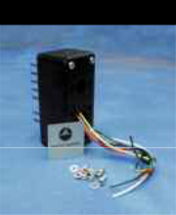
MCEKITC
Connector Kit for MCE100C Micro-electrode Amplifier

Build your own customized adapter to a micro-electrode shielded cable. Cable shields can be tied to a voltage follower drive or simply grounded. Input capacity compensation and clamp current options can be independently added to or removed from your cable configuration. The MCEKITC comes with seven attached Touchproof sockets and instructions; mount your interface connector to the housing and solder wires to the sockets. See the MCE100C on page 61. • MCEKITC

Air Flow & Gas Analysis 89

Air Flow & Gas Analysis Accessories

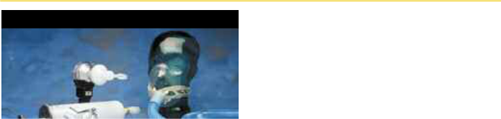

See Interface Guides on pages 39, 41, and 90.

TSD117 Accessories



AFTI Disposable Bacterial Filter (22m)

These filters remove airborne bacteria. For use with the TSD117 and other 22mm breathing circuits. One side has a 22mm ID port, the other side has a 22mm OD, 15mm ID port.

AFT1 (Pkg. 10)

AFT1-250 (Pkg. 250)

AFT7 Smooth Bore Tubing (35mm)
For use in TSD107B and other 35mm breathing circuits. (1 meter length, 35mm ID, 38mm OD)

AFT7

AFT8 Autoclavable Mouthpiece
This autoclavable mouthpiece connects directly to the TSD117 air flow transducer and reduces the cost of disposable parts. (30mm ID)

AFT8

AFT8-10 (Pkg. 10)

AFT9 Reusable Mouthpiece
These mouthpieces connect to the TSD107B and other 35mm breathing circuits. Connects directly to the AFT4 bacterial filter or the AFT21 non-rebreathing T valve. (35mm ID)

AFT9

AFT9-10 (Pkg. 10)

NEW

AFT2 Disposable Mouthpiece
These mouthpieces connect to the TSD117 and other 22mm breathing circuits. Connects directly to the AFT1 bacterial filter, AFT22 non-rebreathing T valve (via AFT11C) and the TSD117 air flow transducer. (22mm OD)

AFT2 (Pkg. 10)

AFT2-250 (Pkg. 250)

AFT3 Disposable Noseclip
These noseclips gently squeeze the nostrils shut to remove errors when using mouth-breathing circuits.

AFT3 (Pkg. 10)

AFT3-250 (Pkg. 250)

AFT4 Disposable Bacterial Filter (35mm)

These filters remove airborne bacteria. For use with the TSD107B and other 35mm breathing circuits. One side has a 35mm ID port, the other side has a 35mm OD port.

AFT4 (Pkg. 10)

AFT6 Calibration Syringe
Medium pump syringe used for injecting a precise volume of air (600ml) through the TSD107B, TSD117 and TSD127 air flow transducers for precise calibration. The AFT6 comes equipped with a 22mm OD, 15mm ID coupler for direct connection to the TSD117 and TSD127. To calibrate the TSD107B, the AFT11E coupler and AFT7 tubing are required.

AFT6
AFT10 Disposable Adult Facemasks
This facemask connects to 22mm breathing circuits. Connects directly to the AFT1, AFT22 non-rebreathing T valve or TSD117 air flow transducer (via AFT11B coupler). Includes hook-ring to secure AFT10S adjustable head strap. (22mm ID/25mm OD).

AFT10

NEW

AFT10S Adjustable Head Strap
This fully adjustable latex head strap holds the AFT10 disposable facemask securely to the subject’s head. Use one or more straps to securely fasten the mask.

AFT10S (Pkg. 30)

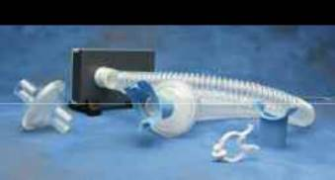

TSD107B Accessories

AFT12 Tubing (22mm)
For use in 22mm breathing circuits. (1.8 meter length, 22mm ID, 25mm OD)

• AFT12

- Air Flow & Gas Analysis
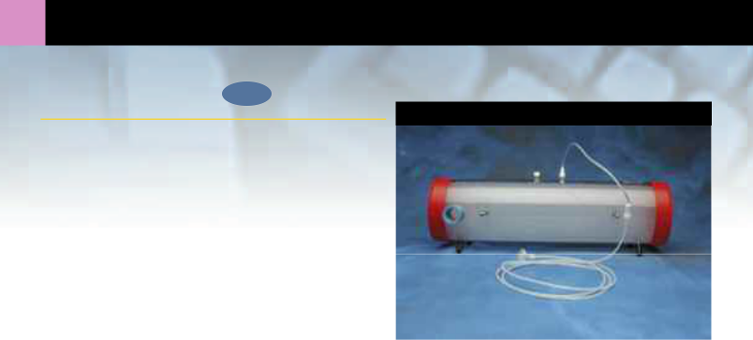Shown with AFT20 (not included)

Mixing Chambers NEW
AFT15A

AFT15A (5 Liter)
The AFT15A is designed for demanding expired gas analysis measurements (e.g. VO₂ or RER measurements). The AFT15A incorporates dual baffles and flexible connection ports capable of interfacing with 35mm or 22mm breathing circuits. Two female Luer connection ports are provided between the baffles for simultaneous monitoring of O₂ and CO₂ concentrations.

Dimensions: 13cm (dia) x 47cm (long)

Coupling Ports: 35mm OD, 25mm ID

• AFT15A

AFT15B (8 Liter)
The AFT15B is designed for very high volume and rate expired gas analysis measurements (e.g. VO₂ or RER measurements). The AFT15B incorporates dual baffles and flexible connection ports capable of interfacing
with 35mm or 22mm breathing circuits. Two female Luer connection ports are provided between the baffles for simultaneous monitoring of O₂ and CO₂ concentrations.

Dimensions: 13cm (dia) x 73cm (long)

Coupling Ports: 35mm OD, 25mm ID • AFT15B

AFT11 Series Couplers


D


B
E ^{A}
C

AFT11 Series Coupler Guide

Pick the AFT11 Series coupler that matches the port sizes you want to interface.

 |  |  |  | BIOPAC
Item 1 |  | Item 2 |  | Coupler
15mm | OD | 22mm | ID | AFT11B
20mm | OD | 22mm | ID | AFT11B
22mm | ID | 15mm | OD | AFT11B
 |  | 20mm | OD | AFT11B
 |  | 22mm | ID | AFT11B
22mm | OD | 22mm | OD | AFT11C
 |  | 25mm | ID | AFT11C
22-25mm | OD | 22-25mm | OD | AFT11E
 |  | 35-38mm | ID | AFT11E
25mm | ID | 25mm | ID | AFT11C
25-30mm | OD | 25-30mm | OD | AFT11A
 |  | 28-35mm | ID | AFT11A
28-35mm | ID | 25-30mm | OD | AFT11A
 |  | 35mm | ID | AFT11A
35mm | ID | 28-35mm | ID | AFT11A
 |  | 38mm | ID | AFT11E
35-38mm | ID | 22-25mm | OD | AFT11E
35-38mm | OD | 35-38mm | OD | AFT11D

AFT11 Series Couplers NEW

These couplers are very useful for connecting a variety of air flow port IDs and ODs to transducers, tubing and calibration syringes.

For connection options, see the application tables on pages 39 and 41.

AFT11A Flexible | AFT11D Flexible
Coupler | Coupler
• AFT11A | • AFT11D
AFT11B Rigid Coupler | AFT11E Flexible
• AFT11B | Coupler
• AFT11B | • AFT11E
AFT11C Rigid Coupler
• AFT11C

91

AFT20 & T Valves

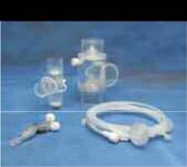

AFT21
AFT22

AFT20

Gas Sampling Interface Kit

For connecting the CO2100C or O2100C module with a variety of air flow breathing circuits. Use with the AFT25 facemask, AFT15A or AFT15B mixing chambers and AFT21 or AFT22 non-rebreathing T valves. Use one AFT20 kit for each gas analysis module connected. Includes:

  - 1.8 meters of 1.5mm diameter polyethylene tubing with M/F Luer connector

  - 30cm Nafion® water vapor permeable tubing with M/F Luer connector
  - 5 micron filter with M/F Luer connector

  - M/F Luer to female Luer “Y” connector

- AFT20

Non-Rebreathing T Valves

AFT21 (35mm)
This non-rebreathing T valve is a high performance, very low dead space, low air flow resistance valve; suitable for high air flow applications (e.g. exercise physiology). The AFT21 incorporates a gas sampling port (female Luer) for interfacing with the AFT20 gas sampling kit. For breathing directly into the valve, use the AFT9 mouthpiece, AFT3 noseclip and (optionally) the AFT24 head support. All ports are 35mm OD, 30mm ID.

• AFT21

AFT22 (22mm)
This non-rebreathing T valve is a very low dead space valve; suitable for low to medium air flow applications. The AFT22 incorporates a gas sampling port (male Luer) for interfacing with the AFT20 gas sampling kit. For breathing directly into the valve, use the AFT2 mouthpiece (via AFT11C coupler) with the AFT3 noseclip or use the AFT10 facemask. All ports are 22mm OD. The common port also incorporates a 15mm ID port connection.

• AFT22 |  | AFT24 & AFT21
AFT24 Head Support | NEW



The AFT24 head support is useful when breathing directly into the AFT21 non-rebreathing T valve for exercise physiology measurements. The AFT21 is secured directly in front of the subject and mini-mizes the strain associated with the weight of valves and tubing.



• AFT24

AFT25 Facemask with Valve NEW

This adult facemask with integral non-rebreathing T valve is a high performance, very low dead space,

low air flow resistance mask and valve; suitable for high air flow applications (e.g. exercise physiology).

The AFT25 incorporates two gas sampling ports (female Luer) for interfacing with the AFT20 gas
sampling kit. All ports are 35mm OD, 28mm ID. _{AFT25}

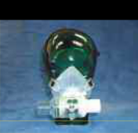
• AFT25

See the Applications section for further information about pulmonary function studies (page 38) and exercise physiology (page 40).

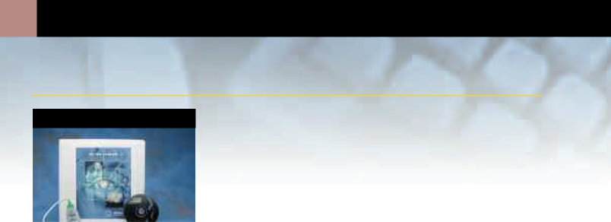
- Platform Changes

Change to Macintosh

(Available 2nd Quarter 2001)

PLAT100M1
PLAT100M1
MP100 Platform change from Macintosh (Serial) or PC (Windows) to Macintosh (USB).

Includes:

USB1M

CBLSERA

ACKv3.7 for Macintosh

• PLAT100M1

PLAT150M

MP150 Platform change from PC (Windows) to Macintosh.

Includes:

ACKv3.7 for Macintosh

• PLAT150M

Change to PC USB—Windows

PLAT100W1

PLAT100W1
MP100 Platform change from Macintosh or PC (ISA/PCMCIA—Windows) to PC (USB—Windows)

Includes:

USB1W

CBLSERA

ACKv3.7 for PC (Windows)

• PLAT100W1


PLAT150W
MP150 Platform change from Macintosh to PC (Windows).

Includes:

ACKv3.7 for PC (Windows)

PLAT150W

Computer Interface Cables

CBLSERA
One CBLSERA cable comes with each MP100 System. Connects the MP100 to your MAC or PC via the USB1M or USB1W. The CBLSERA is 2.5 meters long.

• CBLSERA (if purchased separately)

CBLEXT
Use this 3.6 meter extension cable to increase the distance between the MP100 System and your computer. The CBLEXT is used to extend the length of CBLSERA (use only one CBLEXT per MP100 System).

• CBLEXT

CBLETH1 NEW

Two CBLETH1 cables come with each MP150 system. The cables connect between the ETHSW1 switch and the MP150 and the computer. Each CBLETH1 is 2 meters long.

• CBLETH1 (if purchased separately)

Interface Cables
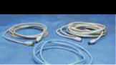

CBLSERA CBLEXT

CBLETH1

93

ETHSW1 Interface Options



Ethernet Switch ^{NEW}
The ETHSW1 is an Ethernet switch included with the MP150 system. The ETHSW1 is required when a computer has a network connection operating simultaneously with operation of an MP150 system. The ETHSW1 is an intelligent switch that eliminates exter-nal packet transfers not directed at the MP150 or the computer to provide optimal data acquisition performance. Setup is very simple, just connect your computer, MP150 system


and network to the ETHSW1 and the ETHSW1 automatically directs the packets.

Specify USA or EURO power cord.

• ETHSW1 (if purchased separately)

USB1M ^{NEW}

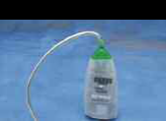
One USB1M USB adapter comes with each MP100 System for the Macintosh. Use the ^{USB1M} USB1M to connect the MP100 unit (via CBLSERA) to the USB port on your computer. The USB1M comes with an integral USB cable.

• USB1M (if purchased separately)

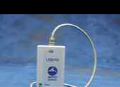



USB1W | NEW
USB1W | NEW
One USB1W USB adapter comes with each MP100 System for the PC running Windows. Use the USB1W to connect the MP100 unit (via CBLSERA) to the USB port on your computer. The USB1W comes with an integral USB cable. The USB1W is compatible with Windows 98, 98SE and 2000.

• USB1W (if purchased separately)



Move your MP System between PC and Macintosh with a platform change. All BIOPAC amplifiers will work with both PC and Macintosh systems. Amplifier modules are optimized for specific signals, and will work with an MP100 or an MP150.


- Transformers & Power

In-Line Power Transformers

All AC series in-line power transformers are CE marked for the EC Low Voltage Directive and EMC Directive. All transformers have UL and TUV approval. The units have standard IEC power input plugs and operate over mains power ratings of 100-240 VAC, 50-60Hz.

AC100A
This in-line switching transformer (+12 volt, 1 amp) connects the MP100 System, IPS100C, CO2100C or O2100C to the AC mains wall outlet. One transformer is included with each MP100 Starter System, IPS100C, CO2100C or O2100C module. Specify USA or EURO power cord.

• AC100A (if purchased separately)

AC101A
This in-line switching transformer (±12 volt, +5 volt, 1 amp) connects the LDF100C to the AC mains wall outlet. One transformer is included with each LDF100C module. Specify USA or EURO power cord.

• AC101A (if purchased separately)

AC137A
This in-line switching transformer (+6 volt, 1.5 amp) powers the heating element for any of the TSD137 series pneumotachs. Specify USA or EURO power cord.

• AC137A

AC150A
This in-line switching transformer (+12 volt, 2.5 amp) connects the MP150 system to the AC mains wall outlet. One transformer is included with each MP150 Starter system. Specify USA or EURO power cord.

• AC150A (if purchased separately)

Battery Pack/Recharger Unit

For portability, use this rechargeable battery pack and charger with your MP System. The maintenance-free battery pack is built into a carrying case with a shoulder strap. The fully charged battery will operate an MP System for a minimum of 16 hours. The BAT100 includes battery pack, universal recharger and all necessary cables.

Specify USA or EURO power cord.

• BAT100
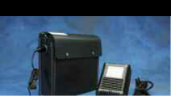

BAT100
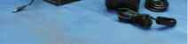

See the Isolated Power Supply IPS100 on page 52.

BAT100 SPECIFICATIONS

Battery Pack
Output Capacity: |  |  | 12V @ 13 amp-hours
Operating Time: |  |  | MP100 with 4 modules:
 |  |  | 26 hours nominal
 |  |  | MP150 with 4 modules:
 |  |  | 16 hours nominal
Charge Time: |  |  | 15 hours
Recharge Cycles: |  |  | 500 (typical)
Weight: |  |  | 5.6kg
Dimensions: |  |  | 22cm (high) x 8cm
 |  |  | (wide) x 24cm (deep)
Temperature Range: |  |  | Operation: -60º to 60ºC
Recharger |  |  | Recharge: -20º to 50ºC
Output: |  |  | 12V @ 1.0 amps
Input: |  |  | 120/240 VAC @ 50/60 Hz
Weight: |  |  | 1.8 kg
Dimensions: |  |  | 8cm (high) x 13cm
 |  |  | (wide) x 15cm (long)

Hardware Index |  |  |  |  |  |  | 95
A |  | Electrodermal Response, TSD203 . . . . . . . . . . . . . | ......82 | O
Abrasion Pads, EL PAD . . . . . . . . . . . . . . . . . . . . . . . . . . . . . . | ....86 | LEAD Series Electrode Leads . . . . . . . . . . . . . . . . . | ......83 | O₂ Measurement Module . . . . . . . . . . . . . . . . . . . . . . . . . . . . . |  | ...62
AcqKnowledge Software . . . . . . . . . . . . . . . . . . . . . . . . . . . . . | 3-9, 50 | MRI Compatible (RT Style) . . . . . . . . . . . . . . . . . . . | ......84 | Oxygen Saturation (SpO₂) Transducers, TSD123 Series . . . |  | ...74
Adhesive Collars, ADD200 series . . . . . . . . . . . . . . . . . . . . . | ....86 | Multi-Lead ECG Cable, TSD155C . . . . . . . . . . . . . . | ......80 | P
Air Flow |  | Needle Electrodes, EL450 series . . . . . . . . . . . . . . | ......85 | Photoplethysmogram Amplifier, PPG100C . . . . . . . . . . . . . . |  | ...58
Accessories, AFT series . . . . . . . . . . . . . . . . . . . . . . . . | .89-91 | Reusable EL250 series . . . . . . . . . . . . . . . . . . . . . . | ......84 | Piezo Transducer, OUT102 . . . . . . . . . . . . . . . . . . . . . . . . . . . . |  | ...65
High Flow Transducer TSD107B . . . . . . . . . . . . . . . . | ....70 | Tape, TAPE series . . . . . . . . . . . . . . . . . . . . . . . . . . | ......86 | Platform Changes . . . . . . . . . . . . . . . . . . . . . . . . . . . . . . . . . . . |  | ...92
Medium Flow Transducer, TSD117 . . . . . . . . . . . . . . | ....73 | Electroencephalogram, EEG100C . . . . . . . . . . . . . . . . . . . | ......56 | Plethysmogram, Photo-Electric Pulse Transducer, TSD200 . . |  | ...81
Low Flow Pneumotach TSD127 . . . . . . . . . . . . . . . . | ....76 | Electrogastrogram, EGG100C . . . . . . . . . . . . . . . . . . . . . . | ......56 | Pneumotach Air Flow Transducers . . . . . . . . . . . . . . . | 70, 73, 76, 77
Very Low Flow Pneumotach TSD137 . . . . . . . . . . . . | ....77 | Electromyogram, EMG100C . . . . . . . . . . . . . . . . . . . . . . . . | ......57 | Power
Analog Connection Cables . . . . . . . . . . . . . . . . . . . . . . . . . . . | ....88 | Electrooculogram, EOG100C . . . . . . . . . . . . . . . . . . . . . . . | ......57 | Battery Pack, BAT100 . . . . . . . . . . . . . . . . . . . . . . . . . . |  | ...94
B |  | Ethernet Switch, ETHSW1 . . . . . . . . . . . . . . . . . . . . . . . . . | ......93 | In-Line Transformers, AC Series . . . . . . . . . . . . . . . . . |  | ...94
Battery Pack, BAT100 . . . . . . . . . . . . . . . . . . . . . . . . . . . . . . . | ....94 | Evoked Response, ERS100C . . . . . . . . . . . . . . . . . . . . . . . . | ......57 | Isolated Power Supply Module, IPS100C . . . . . . . . . . |  | ...52
Bioimpedance Amplifier, EBI100C . . . . . . . . . . . . . . . . . . . . . | ....60 | F |  | NIBP: Linear Voltage Converter, LVC100 . . . . . . . . . . |  | ...68
Biopotential Amplifiers . . . . . . . . . . . . . . . . . . . . . . . . . . . . . . | ....56 | Fixed Range Force Transducer, TSD125 Series . . . . . . . . | ......75 | Pressure Transducer, TSD104A . . . . . . . . . . . . . . . . . . . . . . . . |  | ...69
Blood Flow |  | G |  | Pulse Oximeter Module, OXY100C . . . . . . . . . . . . . . . . . . . . . |  | ...61
Blood Oxygen Saturation, OXY100C . . . . . . . . . . . . | ....61 | Gas Analysis Modules . . . . . . . . . . . . . . . . . . . . . . . . . . . . | ......62 | R
Micro-vascular, LDF100C . . . . . . . . . . . . . . . . . . . . . . | ....60 | GEL Series Conductants . . . . . . . . . . . . . . . . . . . . . . . . . . . | ......86 | Reference Voltage Calibrator, REFCAL . . . . . . . . . . . . . . . . . . |  | ...55
Blood Pressure |  | General-purpose Transducer Amplifier, DA100C . . . . . . . | ......54 | Remote Monitoring, TEL100C . . . . . . . . . . . . . . . . . . . . . . . . . |  | ...66
Cuff Transducer, TSD120 . . . . . . . . . . . . . . . . . . . . . . | ....72 | Goniometers, TSD130 Series . . . . . . . . . . . . . . . . . . . . . . . | ......76 | Respiration Pneumogram Amplifier, RSP100C . . . . . . . . . . . |  | ...59
Cuffs, RX120 series . . . . . . . . . . . . . . . . . . . . . . . . . . . | ....73 | H |  | Respiratory Effort Transducer, TSD201 . . . . . . . . . . . . . . . . . . |  | ...81
Continuous Noninvasive Measurement, NIBP100 . | ....68 | Hand Dynamometer TSD121C . . . . . . . . . . . . . . . . . . . . . . | ......74 | S
C |  | Headphones, OUT100 . . . . . . . . . . . . . . . . . . . . . . . . . . . . . | ......65 | Signal Isolators, INISO/OUTISO . . . . . . . . . . . . . . . . . . . . . . . . |  | ...53
Cables |  | Heel/Toe Strike Transducer, TSD111 . . . . . . . . . . . . . . . . . | ......71 | Smart Sensor Transducers, SS Series . . . . . . . . . . . . . . . . . . |  | ...67
Electrode Lead Conversion . . . . . . . . . . . . . . . . . . . . | ....86 | High Level Transducer Interface, HLT100C . . . . . . . . . . . . | ......53 | Specialty Amplifiers & Modules . . . . . . . . . . . . . . . . . | ....... | 60-61
Ethernet to Computer, CBLETH1 . . . . . . . . . . . . . . . . | ....92 | I |  | SpO₂ Oxygen Saturation, Pulse Oximeter, OXY100C | ...... | ...61
MP100 Extension, CBLEXT . . . . . . . . . . . . . . . . . . . . | ....92 | Impedance Monitoring, EBI100C . . . . . . . . . . . . . . . . . . . . | ......60 | Stimulator Module, STM100C . . . . . . . . . . . . . . . . . . . . . . . . . |  | ...64
Extension, MEC series . . . . . . . . . . . . . . . . . . . . . . . . | ....87 | In-Line Power Transformers . . . . . . . . . . . . . . . . . . . . . . . . | ......94 | Stimulus Isolation Adapters, STMISO Series . . . . . . | ....... | 64-65
MP100 to USB Adapter, CBLSERA . . . . . . . . . . . . . . | ....92 | Interface |  | Stroboscope, TSD122 . . . . . . . . . . . . . . . . . . . . . . . . . . . . . . . . |  | ...74
Calibration |  | Adapter Customizer, TCIKIT . . . . . . . . . . . . . . . . . . | ......55 | SuperLab™ Stimulus Presentation, STP100W . . . . . . . . . . . |  | ...63
Cable, CBLCAL . . . . . . . . . . . . . . . . . . . . . . . . . . . . . . . | ....55 | Analog Isolated Interface, INISO/OUTISO . . . . . . | ......53 | Switches, TSD116A/B/C . . . . . . . . . . . . . . . . . . . . . . . . . . . . . . |  | ...72
Cable, CBLCALC . . . . . . . . . . . . . . . . . . . . . . . . . . . . . | ....55 | Cables and Hardware . . . . . . . . . . . . . . . . . . . . . . . | 88, 92-93 | T
Reference Adapter, REFCAL . . . . . . . . . . . . . . . . . . . . | ....55 | Connector Interfaces, TCI series . . . . . . . . . . . . . . | ......54 | Tape, TAPE Series . . . . . . . . . . . . . . . . . . . . . . . . . . . . . . . . . . . |  | ...86
Standard for LDF100C, LDFCAL . . . . . . . . . . . . . . . . | ....88 | Digital Isolated Interface, STP100 . . . . . . . . . . . . . | ......63 | TCI Series Connector Interfaces . . . . . . . . . . . . . . . . . . . . . . . . |  | ...54
Cardiac Output Measurements, EBI100C . . . . . . . . . . . . . . . | ....60 | Gas Sampling . . . . . . . . . . . . . . . . . . . . . . . . . . . . . . | . . .90-91 | Temperature Amplifier, SKT100C . . . . . . . . . . . . . . . . . . . . . . |  | ...59
Cellular Recordings, MCE100C . . . . . . . . . . . . . . . . . . . . . . . | ....61 | GEER Transducer Interface to PPG100C . . . . . . . . | ......54 | Temperature Transducers, TSD202 Series . . . . . . . . . . . . . . . |  | ...82
Current Clamping, MCE100C . . . . . . . . . . . . . . . . . . . . . . . . . | ....61 | Micro-Electrode, MCEKITC . . . . . . . . . . . . . . . . . . . | ......88 | Tension Adjuster, HDW100A . . . . . . . . . . . . . . . . . . . . . . . . . . |  | ...75
CO₂ Measurement Module . . . . . . . . . . . . . . . . . . . . . . . . . . . | ....62 | Socket Conversions, CBL200, CBL201 . . . . . . . . . | ......86 | Tissue Perfusion Monitor, LDF100C . . . . . . . . . . . . . . . . . . . . . |  | ...60
Current Stimulus, STMISOC/D/E . . . . . . . . . . . . . . . . . . . . . . | ....64 | Universal Interface Module, UIM100C . . . . . . . . . | ......52 | Torsiometers, TSD130 Series Goniometers . . . . . . . . . . . . . . |  | ...76
D |  | J |  | Transducer Amplifiers . . . . . . . . . . . . . . . . . . . . . . . . . . . . . . . . |  | ...58
Differential Bridge Amplifier, DA100C . . . . . . . . . . . . . . . . . . | ....54 | Jumper Connectors, JUMP100 series . . . . . . . . . . . . . . . . | ......87 | Transducers, TSD Series . . . . . . . . . . . . . . . . . . . . . . . | ....... | 69-82
Differential Pressure Transducers, TSD160 series . . . . . . . . | ....80 | L |  | Tri-Axial Accelerometers, TSD109 Series . . . . . . . . . . . . . . . . |  | ...71
E |  | Laser Doppler Flow |  | Tubephone Set, OUT101 . . . . . . . . . . . . . . . . . . . . . . . . . . . . . . |  | ...65
Electrical Bioimpedance Amplifier, EBI100C . . . . . . . . . . . . | ....60 | Perfusion Monitor, LDF100C . . . . . . . . . . . . . . . . . | ......60 | U
Electrocardiogram, ECG100C . . . . . . . . . . . . . . . . . . . . . . . . . | ....56 | Probes, TSD140 Series . . . . . . . . . . . . . . . . . . . . . . | ......78 | Universal Interface, UIM100C . . . . . . . . . . . . . . . . . . . . . . . . . . |  | ...52
Electrodermal Response Amplifier, GSR100C . . . . . . . . . . . | ....58 | M |  | USB Adapters . . . . . . . . . . . . . . . . . . . . . . . . . . . . . . . . . . . . . . . |  | ...93
Electrodes & Accessories |  | Marker Box (Digital), TSD116C . . . . . . . . . . . . . . . . . . . . . | ......72 | V
Abrasion Pads, EL PAD . . . . . . . . . . . . . . . . . . . . . . . . | ....86 | Micro-Electrode Amplifier, MCE100C . . . . . . . . . . . . . . . . | ......61 | Variable Assessment Transducer, TSD115 . . . . . . . . . . . . . . . |  | ...72
Active Electrodes, TSD150 Series . . . . . . . . . . . . . . . | ....80 | Microphone (Physiological Sounds), TSD108 . . . . . . . . . | ......70 | Variable Range Force Transducer, TSD105A . . . . . . . . . . . . . |  | ...69
Adhesive Collars, ADD200 Series . . . . . . . . . . . . . . . | ....86 | Micro-Vascular Blood Flow, LDF100C . . . . . . . . . . . . . . . . | ......60 | Voltage Stimulus, STMISOC/D/E . . . . . . . . . . . . . . . . | ....... | 64-65
Bar Electrodes, EL350 Series . . . . . . . . . . . . . . . . . . . | ....85 | Mixing Chambers, AFT15A/B . . . . . . . . . . . . . . . . . . . . . . . | ......90 | W
Cap (With 19 Embedded Electrodes ), CAP100C . . . | ....85 | Module Extension Cables . . . . . . . . . . . . . . . . . . . . . . . . . . | ......87 | Wilson Terminal (ECG Virtual Reference), WT100C . . . . . . . |  | ...87
Conductants, GEL series . . . . . . . . . . . . . . . . . . . . . . | ....86 | MP Systems . . . . . . . . . . . . . . . . . . . . . . . . . . . . . . . . . . . . . | . . .50-51 | Y
Disposable, EL500 series . . . . . . . . . . . . . . . . . . . . . . | ....83 | N |  | YSI® 400 Series Probe Interface, CBL203 . . . . . . . . . . . . . . . . |  | ...86
ECG Virtual Reference, WT100C . . . . . . . . . . . . . . . . | ....87 | Noninvasive Blood Pressure Measurement, NIBP100A . | ......68

For specific Applications, see pages 10-49.

Policies & Procedures

If you have any questions about policies or procedures, please contact BIOPAC Systems, Inc.

TECHNICAL SPECIFICATIONS

All technical specifications are subject to change without notice.

PRICING
All catalog prices are ex-factory Santa Barbara, California, USA and do not include shipping or handling charges. These will be prepaid and added to the invoice. We normally ship via United Parcel Service (UPS), but can use nearly any shipping method you request. Sales tax will be added to orders from California unless a copy of the tax exemption number is submitted with the order. Prices are subject to change without notice.

QUOTATIONS

We are happy to provide written quotations. If requested, we will include estimated shipping charges with the quotation.

PLACING AN ORDER

Call or fax BIOPAC (8 a.m.-5 p.m. Pacific Time), or contact your local representative. Please include the following information or have it ready when you call:

- Complete billing & shipping addresses;

- Name and department of the end user;

- Description of items you wish to order;

- Telephone number, in case we have any questions;

- Purchase order number (if applicable).

Note: Many universities, school systems and government offices now require that we keep a hard copy of your purchase order on file, so we may ask you to mail or fax a copy of your purchase order.

TERMS

Open accounts are extended to all recognized educational or research institutions, hospitals and businesses. Terms are net 30 from the date of shipment. Students, individuals and private companies may call for a credit application, enclose payment with order, charge with VISA or MasterCard, or pay C.O.D.

EXPORTS

If ordering equipment intended for overseas delivery, please specify whether you require a USA or EURO power cord. International payment should be made in advance by VISA or MasterCard, wire transfer of funds to BIOPAC’s bank account, or by confirmed irrevocable letter of credit (all banking charges and fees must be applied to the buyer’s account). The validity period of letters of credit should be at least

90 days. All funds shall be in U.S. dollars. Orders paid by direct transfer of funds or by credit card can be shipped via air express, standard air freight, or air mail (some size restrictions may apply to air mail shipments). Orders placed with a letter of credit will be shipped via standard air freight.

Note: List prices do not include freight, shipping, handling or insurance. In addition, prices for overseas shipment will be slightly higher than domestic prices. Please call, FAX, or email requests for a pro forma quotation to include shipping and any additional costs before placing an order.

LIMITED WARRANTY

BIOPAC Systems, Inc. guarantees its equipment against all defects in materials and workmanship to the original purchaser for a period of one (1) year from the date of shipment unless otherwise stated. During this period, BIOPAC will repair or replace, at its option, any equipment found to be defective in materials or workmanship. If a problem arises, please contact us for authorization before returning an item. This warranty does not extend to damage to equipment resulting from alteration, misuse, negligence, abuse, or accident. The warranty period for repairs and for used equipment purchased from BIOPAC is 90 days.

SERVICE
BIOPAC ships high-quality, durable equipment, but it’s possible that a system may need servicing. Before returning it, please call BIOPAC for return authorization (RMA#) and shipping instructions. Please pack your equipment well for shipping and insure it for full value. Send a note explaining the reason for return so we can investigate and make repairs as quickly as possible.

DAMAGED GOODS
If a shipment arrives damaged, note the damage on the delivery bill and have the driver sign it, acknowledging the damage. Contact the delivery service, and they will file an insurance claim. When damage is not obvious, call the carrier and request an inspection within 15 days of delivery. Save the container and merchandise for inspection. Please call BIOPAC for authorization for return and repair or replacement of the merchandise.

EXCHANGES AND REFUNDS

Please call for authorization if you plan to return merchandise for credit. Equipment may be returned for full credit, with shipping prepaid, up to 30 days after receipt of the item. There is a 10% restocking fee for any item returned over 30 days from receipt. Merchandise must be returned in salable condition, and credit is subject to inspection of equipment. When returning a shipment, please pack it well, insure it for full value, and enclose a letter explaining the reason for return. For hygienic reasons, the following items cannot be returned: electrode gel, electrodes, and all AFT disposable and reusable items.
Worldwide distribution for a world-class product line

For information about the distributor in your region, contact BIOPAC U.S.A.

U.S.A. | Korea
Australia | Malaysia
Brazil | Mexico
Bulgaria | New Zealand
Canada | Norway
China | Portugal
Finland | Romania
France | Russia
Germany | Saudi Arabia
Greece | Spain
India | Sweden
Israel | Taiwan
Italy | Thailand
Japan | Turkey
 | United Kingdom

www.biopac.com

Frequently Asked Questions

Can I use AcqKnowledge software with other hardware?

AcqKnowledge is designed to work with MP hardware and will not communicate with other analog to digital converters. However, you can import data files created by any software program that can save files in text or ASCII format.

Can I use other software with the MP hardware?
No. MP hardware is designed to work with AcqKnowledge software; other data acquisition software cannot control the MP hardware.

Can I import and export files to and from your program?

Yes. AcqKnowledge allows you to import ASCII text files or create ASCII text files for export to other programs. Using the Windows or Macintosh clipboard, you can cut and paste waveforms into other programs without quitting AcqKnowledge. AcqKnowledge can output graph files in PICT, TIFF, or Windows META file formats.

My transducer has an existing cable. How does it plug into your modules?
Use the Transducer Connector Interface series (TCIs). See the Amplifiers & Interfaces application on page 48 for more information.

How much data can I save?

There are no file size constraints in the software. When you save to your computer’s memory, you are limited by how much memory your computer has; when you save direct to disk, you are limited by the available space on your hard or floppy disk. Use the following equation to calculate the memory required for your acquisition:
Memory required (bytes) = [(8C + 2A) x S x T]+ 5 kbytes
C = Number of calculation channels
A = Number of analog channels
S = Sample rate (samples/second)
T = Recording time (acquisition length)
5 kbytes = memory needed to store file information

What sort of customer support do you offer?

If you have questions about a product or application, you can call the Technical Support department from 8 a.m.-5 p.m. Pacific time, or you can email your questions at any time. In addition, the BIOPAC web site (www.biopac.com) includes an extensive Application Note section and provides specifications and usage guidelines for MP Systems. Further, an on-line User Support System is distributed and installed with the software, giving you direct access to full system documentation.
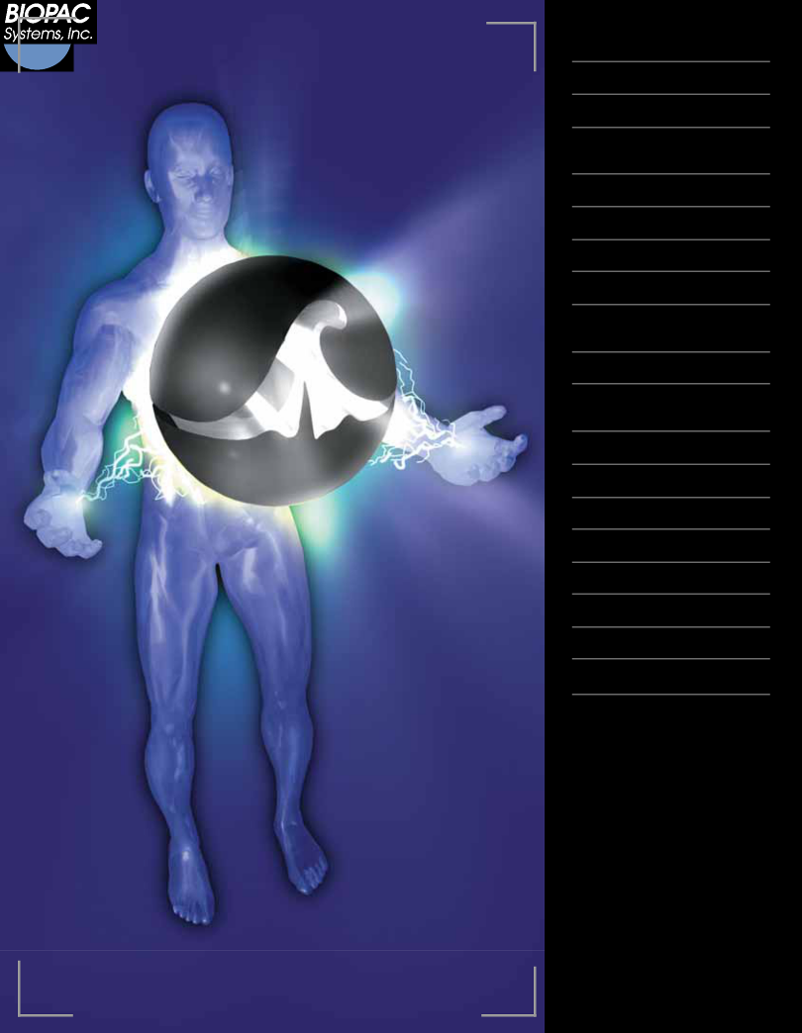
Intuitive data acquisition and analysis solutions for the life sciences.

EEG

ERS: Evoked Response

Psychophysiology

Electrical Bioimpedance / Cardiac Output

EOG: Eye Movement

Plethysmography

Sleep Studies

ECG: Cardiology

Cardiovascular Hemodynamics

EGG: Electrogastrogram

Continuous Noninvasive Blood Pressure

In-vitro Pharmacology

Laser Doppler Flow

Micro-electrode Recording

Pulmonary Function

Exercise Physiology

EMG

Biomechanics

Remote Monitoring

Stand-alone Amps & Interfaces

42 Aero Camino

Goleta

California 93117

Tel: 805/685-0066

Fax: 805/685-0067

Email: Info@biopac.com

Web: www.biopac.com

