MOST REQUESTED
MUSIC GENRE OF 2019

20% 20%
Hip Hop Rock

40%
POP
20%
Folk

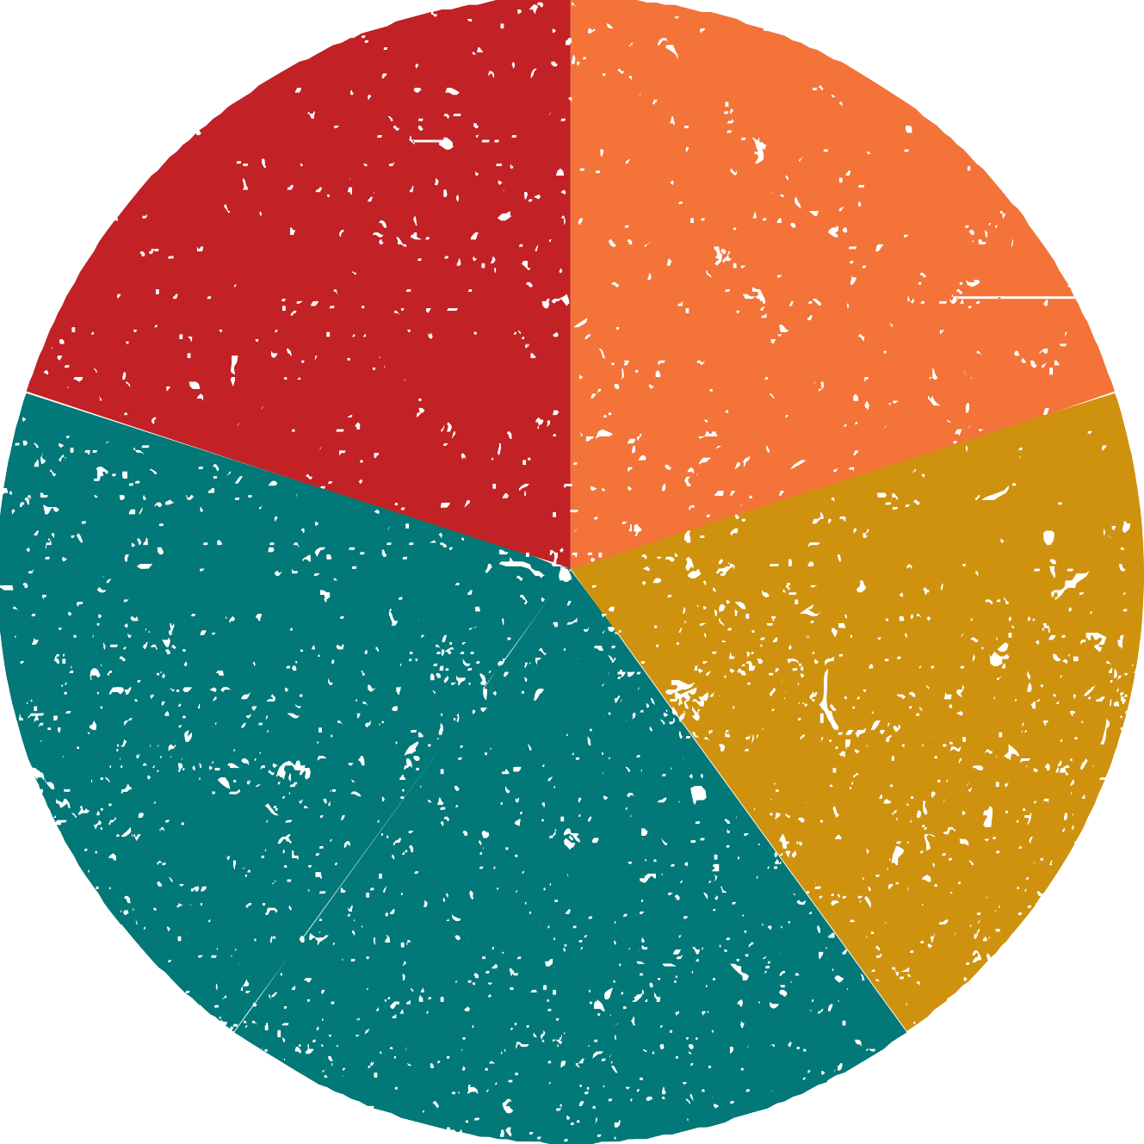

F L A S H F M

